

Knowledge and Information Management Skills for the Workplace and its Application in Amazon.com Report

Janeth Catherine Mosquera Restrepo
Student Number:1908748

Module:
Knowledge and Information Management Skills for the Workplace
BMSW5106

Lecturer:
Mohamed Kalam

30/04//2021

TABLE OF CONTENTS
INTRODUCTION 4
Knowledge and Information Management 6
Organisation Background 6
Knowledge Management 6
Importance of KM in organisations 8
Knowledge Management as a tool to be competitive 9
Evaluation of Knowledge and Information Management Models 9
Knowledge Embedded in Products 9
Example 10
Service Concept in the Tacit knowledge of Individuals 11
Example 12
Knowledge Management Techniques use by Amazon - 15
Importance of Knowledge in Amazon SOP 15
Benefits of Amazon with the use of technology 17
Challenges of Amazon 19
CONCLUSION and RECOMMENDATIONS 20
REFERENCES 21
APPENDICES 25

EXECUTIVE SUMMARY

This report present knowledge as a topic and how it is acquired and manage. It will be explained in the context of two models, the Choo model and SECI model. To explain a bit more there will be examples to apply the theory. They will be a section about information systems and how useful are for companies. Thereafter, a case study where the information system and knowledge are integrated and how this affects the company. Finally, some conclusion and recommendations about the challenges presented.

INTRODUCTION

The business environment is a living thing that constantly changes due to external and internal factors such as suppliers, government, technology, and economic changes. Shat et al., an organisation should react to their internal and external factors and adapt to success (2018). One external factor that affected all business across the world in our present-day was the COVID 19 pandemic, that cause distraction of activities in the society. Therefore, people behaviour changes and new cultural rules appeared. One of this change was the increase of online shopping, and with an electronic device, the shopping was easy, secure and fast. Under those circumstances' eCommerce increase their revenue. However, Amazon.com was already on the market with its platform, saw an increase in its sales and revenue.

This report discusses knowledge management, information systems and how Amazon.com uses in its favour to be a competitive and successful eCommerce. Amazon is an international technology company that is one of the biggest global brands, and Google defines it as an enterprise that operates online with branches in various countries. Amazon is a marketplace of advertises products by small companies and sells them at an affordable price (Amazon,2021). Jeff Bezos, its CEO, and founder, believes that customers' needs are fundamental and focus its services and products toward their comfort.

Amazon has a variety of products and services such as KDP (kindle direct publishing, Amazon Echo, Alexa, AWS (Amazon Web Services), household items, SSS (Simple System Storage) and AI (artificial intelligence). Amazon's great variety and its usage of permitting anyone to sell mostly anything provide amazon with a significant advantage over its competitors.

Knowledge management is a concept about data, information, and knowledge and how they interact between them. Every company uses its knowledge different according to its leadership, objectives, and structure. However, understanding how to use them to gain company objectives and employee's needs is indispensable to know tacit and explicit knowledge and how to disseminate it. Also, companies benefit depends on the Management system of their knowledge database. An effective and efficient management system ensures that no knowledge is lost and improves its employees. On the contrary, an ineffective management system cause time, money, and a lack of progress.

The models discussed will be the SECI and the Choo because they will explain how knowledge management can be applied to organisations. The Choo model focuses on the information of the atmosphere around to create new knowledge and execute it. Further, the model focuses on three modes: sense-making, knowledge creation and decision-making. In like manner, the SECI model focuses on how tacit and explicit knowledge is produced and converted, using, distributing, and creating new knowledge by companies. Additionally, the model consists of four sections: socialisation, externalisation, combination, and internalisation. This report aims to show how Amazon uses knowledge management techniques to improve their profits and satisfy their customers.

This report examines the concept of knowledge and its importance for organisations and gives customers excellent service. Also, it will give a background on Amazon.com. Secondly, evaluate individual knowledge (tacit), how it is embedded in products and services, and how organisations share and exchange knowledge, using the knowledge management models mentioned previously. After that, Amazon applied those knowledge techniques to satisfy their customers and the challenges they have. Finally, a conclusion about the use of knowledge on individual and organisations with some recommendations to improve Amazon knowledge management.

.

.

Knowledge and Information Management

Organisation Background

The organisation discussed in this report is Amazon.com. It is a multinational technology company, created by Jeff Bezos in1994, specialising in e-commerce, e-book creating, artificial intelligence, cloud computing and more; it is based in Seattle, Washington. Amazon started as an online bookseller with the promise of delivering its books to anyone anywhere. This promise and the fact that it was seller online with other competitors where sellers physically gave it an advantage over other competitors, and it eventually branched out to sell anything with its promise to customers keeping accurate till today. Amazon focuses on providing its customers with the best possible service from their commitment to their long-term thinking. This passion drives them to personalise recommendations for their customers and their different delivery offers.

Amazon is most well known for their vast multi-sales strategy: their website allows anyone to sell books, films, games, toys, food and grocery, health and beauty at affordable prices and provides their prime customers free 1-day delivery. Amazon also provides many services such as Amazon Fresh, Fire Tables, Amazon Web Services, Alexa, Fire TV, Kindle Store, Kindle Direct Publishing, Amazon Digital Game Store and more. Amazon is a vast company that serves as the worlds' biggest brand with several subsidiaries from Audible.com, ComiXology, Goodreads and Whole Foods Market (Amazon, 2021).

Knowledge Management

Knowledge management identifies, collects, evaluates, allocates and effectively uses knowledge within an organisation (Koenig, 2018). Knowledge can be anything the company's uses as information. As a result, information assets can be anything such as databases, documents, procedures, experts, experience and more, (Rowley,1999). Knowledge management is split into two sections: tacit Knowledge and Explicit Knowledge. Explicit knowledge can be codified, meaning it is easily taught to others and is factual.

Explicit knowledge does not need a knowing subject to be there, just practice. Some examples of explicit knowledge are learning biology or how to change the toner out of a printer. Tacit knowledge is internalised, intuitive knowledge that cannot be easily codified, taught, copied or expressed. Tacit knowledge can only be expressed through a knowing subject to guide, imitating it, and practice. Some examples of tacit knowledge are talking with an accent, knowing how to distinguish one face from another, and knowing how to walk (Maier, 2007).

One crucial step in understanding the importance of knowledge management is to understand and organise it. The DIKM model describes how knowledge is created and how it can be organised within the companies. The following picture shows the stages of knowledge.

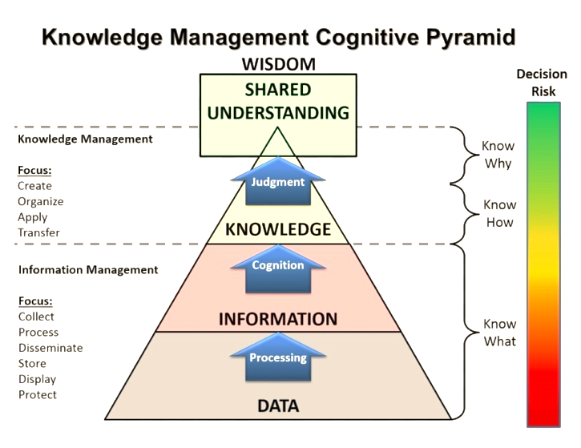
Source: https://www.pngfind.com/pngs/m/50-503535_km-pyramid-adaptation-knowledge-management-cognitive-pyramid-hd.png

In the previous picture is represented the DIKW that means:
D is for data.
I is for information.
K is for knowledge.
W is for wisdom.

Data is a group of information (sign or symbols) or facts about an object, situation, or person without interpretation. Examples include noise, customer details, table of products, emails, surveys, and buyers' behaviours (Michael et al., 2010). However, looking at this data is meaningful if there is not information to understand it. So, the next stage in the DIKW model is information. It is making sense of the data that will be analysed showing relationships. The main aim here is to answers the question, what? Who? When? and where? to analyse data (Nurulin et al., 2019). In other words, the data needs to be categorised accordingly to the type of data as people, cities, numbers, and others.

Moreover, data need to be categorised to respond to the question of how? This data can help the organisation sell a product, create a new service, or give a solution to a problem. So that information is transformed into knowledge. So, knowledge is finding patterns through information obtained to individual or company benefits interpreted by a person (Nurulin et al., 2019). Thus, individuals are essential user information and with their tacit knowledge-creating a new knowledge.

Furthermore, knowledge is converted to wisdom, which is the ability to know why specific patterns and behaviours occurred and how they can be improved, created, and predicted in the future. According to Nurulin et al., the stage in the DIKW model is where decisions are made affecting the company's product or service and how it impacts society and the business environment (2019). In conclusion, wisdom is the cumulation of the stages in the DIKW model, where companies or individual improve that knowledge to obtain benefits.

Importance of KM in organisations

Knowledge management is an essential aspect of any organization's decision-making skills as it allows any organization to facilitate innovation further as employees have better access to the best guides and practices, which also increases an employee's expertise. Knowledge management also contains and makes available an organization's data and information allowing the organization to spend more time with more important objectives and not recreate existing knowledge. The usage of storing information and data such as procedures is perfected and standardized, providing employees with guidelines and rules to keep in check and decrease mistakes.

Organizations also work more efficiently since it increases employee morale and encourages teamwork to happen by sharing their experience about their job or previous jobs, allowing other employees to gain experience. It also allows reflection to happen, stimulating the producing of ideas and creating and maintaining culture in an organization and improving an employee's attitude to the workplace and increasing workplace productivity, thereby increasing organizational efficiency and productivity. Knowledge management provides learning and sharing, creating self-reflecting opportunities empowering and improving an individual's experience (Hebibi, 2019).

Knowledge Management as a tool to be competitive.

Effective knowledge management is crucial in satisfying customers, providing better customer service, and making an organisation stand out from the rest. Knowledge about customers' needs and desires is accumulated and processed to express and personalise customers' knowledge, such as giving customers recommendations about other products like what they are searching for (Davenport et al., 2001). Knowledge about customers' needs and desires is gathered in the products, services, and markets they use (Garcia-Murillo and Annabi, 2002).

Knowledge gathered also provides a competitive advantage towards organisations because the knowledge is gathered about what customers buy are assessed and allows an organisation to fine-tune and develop their services and products into the desired product or service towards the customer. (Garcia-Murillo and Annabi, 2002). All of this is possible through machine learning and the internet of things, where the data is analysed, store and translate, and use when a user needs it. In this case, customers recommend according to their data used in the platform or other service with this technology. Another fact is that usage of marketing in the creation of customer knowledge, such as in social media, creates a background and a social status for the company that further links the company to the customers as it provides additional information about the organisation, making customers feel a sense of belonging with the company (Gebert, 2003). In conclusion, knowledge helps companies offer their customers and employees the best services through technology and innovation.

Evaluation of Knowledge and Information Management Models

Knowledge Embedded in Products

Knowledge has been in our societies, evolving and creating new outputs. The changes that societies make bring a new mentality and way of doing things. As state by Stehr (2018, p312), societies use technology to communicate instantly without geographical limitations. Furthermore, organizations combined the explicit and tacit knowledge embedded in producing a new product or service.

Organizations have different methods of applying knowledge to their products. As tacit knowledge is difficult to manage, organizations look for ways to convert it into explicit knowledge to reduce the wastage of resources (Bajracharya & Masdeu, 2006). Choo Model stated that the sense-making of the external process for amazon is how they collect data (customer feedback, wishes and journey) about their clients using AI technology filtering it. Afterwards, a group of workers analysis and interpret this data. The team then discusses it, builds new knowledge, and chooses the best solution for the information provided.
A constant influx of data is transmitted between the different sections of Choo's model: sense-making, knowledge-creating and decision making, so that the information is build up and developed between each following section (Choo, 2001). Therefore, it is crucial to the process of how companies transform one information into another.

Choo Model

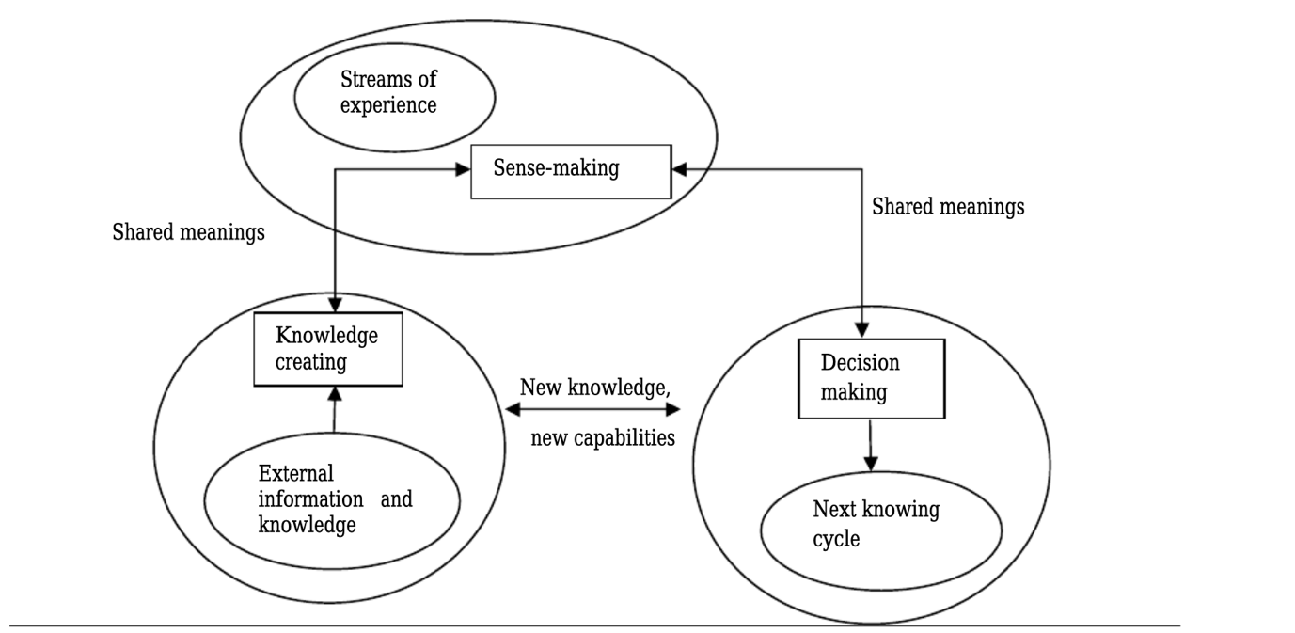
Source:https://www.researchgate.net/publication/314063133_The_Impact_of_Knowledge_Management_Models_for_the_Development_of_Organizations

Example

Sense-Making is when a customer asks the customer assistant or any other employee about certain product quality or when it will be stock again. The Customer assistant answers the question according to what he knows about the product (tacit knowledge), but if he wants to be more in-depth information and does not know, he needs to ask his manager or another person who knows the information.

Knowledge Creation: in the previous situation, the employee has resolved the customer's query, but then another customer asks the same question to another employee and got the same answer or similar. In this situation, the employees communicate with the managers that customers are usually asked X or Y about the product, so the manager decides to put that question in the manual to train employees that way they know will be there for a new trainee.

Decision Making: knowing what customers think about a product or service help the company improve their quality and decide about the characteristics that satisfy more clients. In other words, this creates a circle of knowledge where employees interact with customers, and that knowledge is used to create and improve the quality of the service or product.

Another way of embedding knowledge into products is by applying the SECI model, converting one type of knowledge into another. The difference between tacit and explicit knowledge can be expressed in four different modes of creating knowledge in an organization (Nonaka,1991). Socializing the conversion of tacit to tacit is, as stated in the SECI model, knowledge is shared, employees observe, imitate, and practice through other employees' demonstration. Tacit is converted into explicit knowledge (externalization) when these employees codify their knowledge into documents. Later the documents are combined (combination) into one for easy distribution inside the company, which is then internalized by applying one's knowledge (internalization). Free access to information to employees in the company's integrated database allows new knowledge to occur (Nonaka, 1991). In conclusion, to embed knowledge inside a product, it is necessary to cooperate with teams and combine explicit and tacit knowledge to create an effective product.

Service Concept in the Tacit knowledge of Individuals

The service concept is the combination of elements in which the user experience, value, service outcome and service operation (Goldstein et al, 2002) produces an outcome that both implements the customers' needs and the organizations' objectives. The service concept is involved in the research and development process through the comprehension and combination of customer needs and organization desires and requirements. (Goldstein et al., 2002). Through the combinations of elements of the service concept, knowledge is acquired and accumulated. The service concept can be illustrated in the following example, the customer service (service operation) of a mobile phone company provides customers various services such as contract renovation or termination and problems with their phone bill(value). The assistance resolves the customer's problems (service outcome), leaving the customer satisfied (user experience). With the previous example, we can apply knowledge through the Choo model. In the case of knowledge management, the assistance helps the customer with their previous experience by listening to them (sense-making), and with their tacit knowledge and the complaints the customer has given them (knowledge creation), they can make a decision and resolve the problem (decision making). In this perspective, to have an excellent service concept, it is essential to have an individual's tacit knowledge.

As seen above, knowledge can be gained not just from an individual but from the service concept itself.

Example

Socialization: The trainee is gaining the tacit knowledge of the assistance through the observation, imitation, and practice of dealing with customers through a phone call

Externalization: The procedure was recorded and documented

Combination: Multiple documents of different recordings are combined into one primary method to use.

Internalization: Later practised by other trainees.
In conclusion, individuals gain knowledge through the conversion of knowledge from service concepts.

The following is a representation of the SECI model.

SECI model

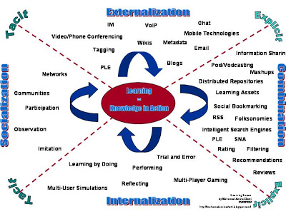
Source: http://mohamedaminechatti.blogspot.com/2007/06/icalt-2007.html

KM as Sharing and Exchanging in Organisations

The information system is the application of how knowledge is shared inside a company. As stated by Boell and Cecez-kecmanovic (2015) information system is a series of sequences that collect, process, store and disseminate data. Over the years, this information has evolved through technology to be an essential part of a business, where human interaction with the process makes it reliable.

There are many types of information systems used to collect, share and exchange knowledge around an organization. Some of these systematic approaches include the decision support system (DSS), the management information system (MIS), office automation system (OAS), execution support system (ESS) and the transactional processing system (TPS). DSS is an information system specifically designed for an organization to assist middle managers in short-term strategic decision-making by gathering knowledge such as the consequences of current and past trends decisions and past profits and losses. ESS is used by executive managers for long-term decisions, while MIS allows managers to make detailed reports. OAS and TPS are both information systems used by information workers to make simple reports and receipts.
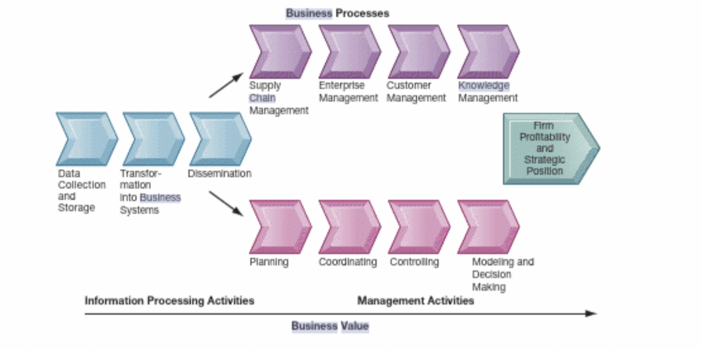
Source: Laudon and Laudon, 2020, p.57

As seen with the figure above, knowledge can be gathered, accumulated and exchanged throughout the organization through information systems. Information systems begin with acquiring and storing knowledge through employee's tacit knowledge, and then a specialized information system, such as the decision support system, is created for the company. This knowledge is disseminated into management activities and business processes. Applied within an organization produces new products and services, improving decision-making and profits (Laudon and Laudon, 2020, p.57).
Before knowledge can be shared within an organization through information systems, knowledge must be gathered. Afterwards, information is transformed and transferred to the information system. Information can be acquired and processes for the information system through several different processes and models. However, it will be demonstrated through the usage of the SECI model with the example below. An organization begins to create its knowledge at the bottom. A trainee gains the tacit knowledge of senior employee through the observation, imitation and practice of dealing with customers through a phone call (socialization, tacit to tacit); this is also an example of the first step of a systematic approach. The procedure is recorded and documented, becoming a question-and-answer guide within the organization (externalization, tacit to explicit); this is an example of an information system.
Moreover, multiple documents of different recordings are combined into one internal database for use (combination, explicit to explicit). Other trainees later practise this by using expert systems (internalization, explicit to tacit); this is an example of the dissemination into management activities. SECI model presents how information is created, transferred, shared, and exchanged within a company.
In conclusion, information systems are an essential factor in an organization that allow it to communicate effectively with stakeholders, customers, suppliers, and employees as organizations can use their systematic approach to attract and maintain their customers. Without an information system, knowledge can be misused and lost when an employee retires or leaves the company as the taken away all the tacit and explicit knowledge. Knowledge also becomes useless as knowledge cannot be collected, shared or exchanged without using information systems to interexchange the data inside a business. As such, it can be concluded that employees' tacit knowledge must be converted into organizational knowledge to allow companies to evolve and improve into their innovations, research and developments, and culture to be created and maintained.

Knowledge Management Techniques use by Amazon -

Importance of Knowledge in Amazon SOP

Many businesses have been affected and announce bankruptcy during covid-19 and the government's response to quarantine and social distancing regulations. However, Amazon is not one of them; its "net revenue was 125.56 billion" (Statista, 2021). Amazon is one of the most used online platforms used by customers thanks to its easy-to-use platform and AI technology that gives personalized recommendations, all through the usage of their information systems. Amazon Web Service helped Amazon during the pandemic due to its immense computer power, database storage and more, which supported numerous organizations (Amazon Annual Report, 2020) They also launched AWS Diagnostic Development Initiative to collect diagnostics solutions and upload them to the cloud (Amazon Annual Report, 2019).

Amazon uses different types of information systems in order the maintain its IT infrastructure. The author assumption about Amazon is that it uses the following information systems according to the products they offer, such as a transaction processing system (TPS), management information system (MIS), decision support system (DSS) and executive support system (ESS) depending on the various levels of management it is responsible for in Amazon.

Amazon's transaction processing system (TPS) automatically controls operations such as receipts, daily necessary transactions, processing the customers' orders and ensuring that all employees are paid the correct amount. It is also responsible for providing raw data for MIS. The author found a graphic representation of the system that is the most probable thing that occurred in Amazon e-commerce.

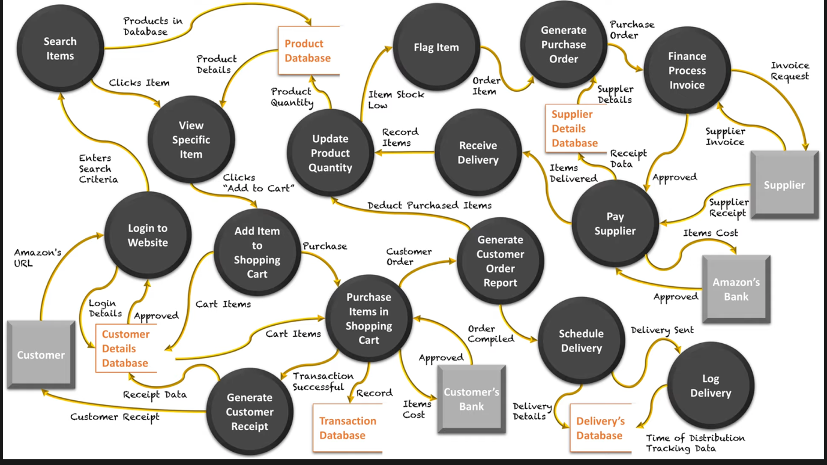
Source: Context & Data Flow Diagram: Amazon Available at: https://youtu.be/46cpudedD7E

Amazons' management information system is for middle management that collects, stores, and compacts TPS information. MIS focuses on using ICT, information, and communications technologies to improve and effectively ensure the control of amazons' middle management operations, such as communicating internally to its employees and externally communicating to its customers. As an example of this, it can be seen on the video of its fulfilment centres where they have cameras, robots to collect data, and information to their employees about the products that need to be shipped (Frontline PBS, 2020). According to Amazon.com, Amazons' MIS is the amazon web service (AWS) and simple storage services (SSS) (AWS, 2021). Through these information systems, amazons can maintain and categorize different products and supplier, handle logistics and inventory control, take orders from millions of customers and not get overloaded and deliver to their customers in time, creating its SOP. AWS and SSS link amazon's information system and its operational goals.

The decision support system is also for Amazon's middle management. Amazon's DSS are data-driven business intelligence systems that support amazon in its decisions. Amazon uses Amazon relational database service (RDS), which allows ease of operations and low cloud costs. Amazon offers a different type of RDS according to the need of the clients as Aurora, and redshift that is a warehouse in the cloud (AWS, 2021)

According to Tim Collins (Vice president of Worldwide Logistics), Amazon uses a System to control and monitor their fulfilment centre works (2017). Amazons' executive support system (ESS) assists in its senior management. ESS provides data in graphs and charts to be delivered through amazon internal and external information. EIS is a type of decision support system that gathers and collects internal and external information to guide senior executives to make a logical decision by evaluating their previous profits, losses, stocks, and trends. In other words, according to the information gathered from their fulfilment centre they decide what are the best alternative to be efficient and fulfil its credo of serving the customers.

Benefits of Amazon with the use of technology

Technology in society brings many advantages to help their citizens overcome problems in education, health, business, and overall give a better stable life. Companies’ investment in technology has made the magic possible. In Amazon.com, their technology has improved many sectors in the ways business serves its clients. The author will list some of those benefits.

Amazon started with its online platform, where it sells books, then pass to the kindle innovation that reaches many people who cannot access books because of the unavailable price.

Amazon prime: it a subscription pay yearly, where the customer can get delivery free in two days. Its fulfilment centre (warehouses) is a strategical centre with products according to the area to offer this service. Thanks to the algorithms used, it shows geographically where a product has more sales (AWS, 2021)

Amazon Alexa: it a product That delights many and enrages others. It is a cloud voice service device that is constantly learning according to its algorithm (amazon Alexa, 2021).

Amazon go: is a shop where customers use the Amazon app to get inside and start getting the products they need. They do not need to pay for the products or make a queue because every time the customer takes a product, the system is adding to the cart. Before leaving the shop, the price has been paid. With the camera and sensors installed in the shops, its technology is called "just walk out", composed of computer vision, deep learning algorithm, and sensor fusion (Amazon go, 2021).

Amazon robotic: Amazon has developed a variety of robots in this field. The robots are used to move the products to the employee's stations and some help in deliveries. Amazon started with the kiva moves shell with a capacity of 450kg; the Hercules, with a capacity of 1360 kg this is used to large shelf; the Pegasus, this is a new version of the kiva, and its only difference is its size is smaller compare to its predecessor; the Pegasus x-sort drive, is used to transport parcels to the shipping section. Also, the Xanthus will be transported not only parcel but entire pods to the shipping area; the robostow it is used to lift parcel or boxes (Roser, 2020)

Furthermore, they deliver around their warehouses, Amazon has the drones and the scout. These are in the tester phase, with small parcel and deliveries within short distances from the warehouse (Roser, 2020)

Amazon ring: is a company that amazon bought to integrate their services in the home, with Alexa, prime and cameras. It uses a camera in the bell, so let the people inside the house see who is at the door. And some cities of united stated work with the policy (Frontline PBS, 2020)

Amazon rekognition: this technology, can analysed videos and images. With this technology, business or customers can identify objects inside boxes, identify products, face detection and face search (Amazon recognition, 2021). Because of their technology, one of their customers is the policy from some cities of USA where they use the system to recognize criminal, and the service is more economical than other methods they used previously (Frontline PBS, 2020)

Amazon pharmacy: amazon bought the company Pill Pack to avoid legal problems selling medical product on its website. During the covid 19, it improves the services, now offer the services of deliveries the medication to prime customers (Amazon press release, 2020). To access the program, the customer has to registry and pay with their app. Also, customers accept the sharing of data between insurance companies and amazon. However, this program benefits many people that cannot go out for a medical reason or due to lockdowns (Amazon Pharmacy, 2021)

Challenges of Amazon

As can be seen, amazon credo previously has been present in all its clients' services. The technology has helped its customers through its e-commerce and small companies that want to sell their products. In addition, its dream and constantly search for new methods of improving the existing techniques employed by them converting them in omnichannel must lead them to work in technology and invest more in it. Amazon faces many challenges, but the next ones are the most crucial now.

However, this technology brought a disadvantage to small publishers. Amazon offers them to sell their books by a price, and if they do not accept, they were not listed (DW documentary, 2019).

Another challenge Amazon face is that some people think that they are not using the data ethically. As stated by Shoshana Zubov in a DW documentary where her opinion about Alexa is an invasion of privacy because of the way they collect data from conversations in a home and do not tell their customers about it (2019).

Moreover, employee’s satisfaction does not compensate for the risk they have to do to obtain the rate in an hour of product packages or delivered (frontline PBS, 2020)

And lastly, Amazon is investigating about if it is monopolizing the business environment and avoiding tax(Frontline PBS, 2020).

CONCLUSION and RECOMMENDATIONS

Knowledge is an asset that organization value and are starting to implement. Societies now are battling for using the latest device, which brings them satisfaction, entertainment, and knowledge. In the business environment, this is translated as understanding the customer and giving them what they want. In this mission, companies succeed, but they must invest in technology to get an advantage over their competition. AI is the technology used to automatization the recollection, interpretation of data and production, delivery, and shipping in the line production. However, this will bring challenges to customers and companies where the management of this knowledge is not used according to values and beliefs common to everyone.

In the amazon case, the technology brought a lot of satisfied customers and their innovation help other sectors of the society as policies and health care. Despite this, eCommerce face challenges that could be avoided but improving their framework but following the subsequent recommendations.

Employees should have a production rate by hour according to their experience and the type of product they are packing. Through time the rate can increase by not double the rate they started. Increasing the number of parcels in an hour in small steps will help the employees first master the skill, feel confident, and do it with satisfaction, helping the company do more in less time.

Amazon is a big company, and pressure from governments and the public about how they pay their taxes will create considerable publicity that could influence their sales and partnerships. So, they should be transparent in this aspect.

Another factor to consider is the fact that government investigation could lead them to separate amazon from AWS; that is something they should do to focus on there IS and avoid the label of manipulating the marketplace.

REFERENCES

Annual Report (2019) Amazon. Available at: https://s2.q4cdn.com/299287126/files/doc_financials/2020/ar/2019-Annual-Report.pdf
(Accessed: 15 April 2021)
Annual Report (2020) Amazon. Available at:
https://s2.q4cdn.com/299287126/files/doc_financials/2021/ar/Amazon-2020-Annual-Report.pdf (Accessed: 25 April 2021)
Amazon Alexa (2021) What is Alexa. Available at: https://developer.amazon.com/en-GB/alexa (Accessed: 23 April 2021).
Amazon (2021) Available at:https://www.aboutamazon.co.uk/?utm_source=gateway&utm_medium=footer (Accessed: 25 March).
AWS (2021) Database on AWS. Available at: https://aws.amazon.com/products/databases/?nc2=h_ql_prod_db (Accessed: 22 April 2021).
AWS (2021) Amazon fulfilment Center Tour with AWS [video]. Available at: https://youtu.be/8nKPC-WmLjU (Accessed: 22 April 2021).
Amazon (2021) Amazon Web Services. Available at: https://www.aboutamazon.com/what-we-do/amazon-web-services. (Accessed: 22 April 2021)
Amazon go (2021) Available at: https://www.amazon.com/b?ie=UTF8&node=16008589011 (Accessed: 23 April 2021)
Amazon pharmacy (2021) available at: https://pharmacy.amazon.com/how-it-works (Accessed: 24 April 2021)

Amazon Press release (2020) Introducing Amazon Pharmacy: Prescription Medications Delivered. Available at: https://press.aboutamazon.com/news-releases/news-release-details/introducing-amazon-pharmacy-prescription-medications-delivered (Accessed: 24 April 2021)

Amazon rekognition (2021) Automate your image and video analysis with machine learning. Available at: https://aws.amazon.com/rekognition/?p=ft&c=ml&t=149&blog-cards.sort-by=item.additionalFields.createdDate&blog-cards.sort-order=desc (Accessed: 23 April 2021).

Bajracharya. P & Masdeu. N. R. (2006) ‘Tacit Knowledge Transfer in Small Segment of Small Enterprises’, Ekonomiska Instituionen Linkopings University. Available at: http://www.diva-portal.org/smash/get/diva2:21701/FULLTEXT01.pdf (Accessed: 6 April 2021).
Frontline PBS (2020) Amazon Empire: The Rise and Reign of Jeff Bezos [video]. Available at: https://youtu.be/RVVfJVj5z8s (Accessed: 23 April 2021)

Boell. S. K. and Cecez-Kecmanovic (2015) ‘What is an information System? Proceeding of the 48th Hawaiian International conference on System Sciences (HICSS) DOI:10.1109/HICSS.2015.587 (Accessed: 2 April 2021)

Choo. C. W. (2002) ‘Sensemaking, Knowledge Creation, and Decision Making. Organizational Knowing as Emergent Strategy. New York: Oxford University Press. Available at: http://choo.ischool.utoronto.ca/OUP/SMICOKchap5.pdf (Accessed 5 April 2021).
Davenport, T. H., Harris, J. G. and Kohli. A. K. (2001) How they know their customers so Well? Available at: https://sloanreview.mit.edu/article/how-do-they-know-their-customers-so-well/ (Accessed: 2 April 2021).
DW Documentary (2019) Amazon, Jeff Bezos and collecting data, Soshana Zubov [video] Available at: https://youtu.be/O90PShJVu58 (Accessed: 23 April 2021)
García-Murillo. M. and Annabi. H. (2017) ‘Customer Knowledge Management’, JORS, 53(8), pp. 875-884. Available at: doi.org/10.1057/palgrave.jors.2601365 (Accessed: 22 April 2021)
Gebert et al. (2003) ‘Knowledge-enable customer relationship management: Integrating customer relationship management and knowledge manager concepts’, Journal of Knowledge Management, 7(5), pp 107-123. DOI:10.1108/13673270310505421 (Accessed: 4 April 2021).

Goldstein. M. S. et al., (2002) ‘The Service Concept: The Missing Link in Service Design Research, Journal of Operations Management, 20(2), pp. 121-134. DOI:10.1016/S0272-6963(01)00090-0 (Accessed: 2 April 2021).

Hebibi. L et al., (2019) ‘Knowledge Management and The Importance of knowledge management for the Organization performance’, Ekonomika, 65, pp. 117-126. Available at: DOI:10.5937/ekonomika1901117H (Accessed: 2 April 2021)

Koenig. M. E. D. (2018). What is KM? Knowledge Management Explained. Available at: https://www.kmworld.com/About/What_is_Knowledge_Management (Accessed: 05 April 2021)
Laudon. C. K. & Laudon. J. P. (2020) Management Information System. 16 edn. Harlow: Pearson. Available at: https://ebookcentral.proquest.com/lib/trinity/reader.action?docID=5821092&ppg=4
(Accessed: 08 April 2021)
Maier. R. (2007) Knowledge Management Systems: Information and Communication Technologies for Knowledge Management. 3rd edition. Berlin: Springer
Michael. Et al., (2010) ‘Practical Data Analysis: An Example’ DOI:10.1007/978-1-84882-260-3_2 (Accessed: 20 April 2021).

Nonaka. I. (1991) ‘The Knowledge-Creating Company’, Harvard Business Review, pp, 162-171. Available at: https://memberfiles.freewebs.com/84/90/65819084/documents/The%20Knowledge-Creating%20Company.pdf (Accessed: 6 April 2021).
Nurulin. Et al., (2019) ‘Role of Knowledge in Management of Innovation’, MDPI, 8(87) DOI: 10.3390/resources8020087 (Accessed: 20 April 2021)
Roser. C. (2020) The Amazon Robotics Family: kiva, Pegasus, Xanthus and more… Available at: https://www.allaboutlean.com/amazon-robotics-family/ (Accessed: 24 April 2021)

Rowley. J. (1999) ‘What is knowledge Management?’, Library Management, 20(8), pp 416-419. DOI:10.1108/01435129910291175 (Accessed: 4 April 2021)

Shtal. T. V. et al (2018) ‘Methods of analysis of the external environment of business activites’, Revista Espacios, 39(12), p. 22. Available at: https://www.revistaespacios.com/a18v39n12/a18v39n12p22.pdf (Accessed: 12 April 2021)
Statista (2021) Net revenue of Amazon from 1st quarter 2007 to 4th quarter 2020. Available at: https://www.statista.com/statistics/273963/quarterly-revenue-of-amazoncom/ (Accessed: 22 April 2021)
Stehr. N. (2018) Modern Societies as knowledge Societies, chapter 20. pp 309-331 Available at: https://www.researchgate.net/publication/325124238_Modern_Societies_as_Knowledge_Societies (Accessed: 6 April 2021).

APPENDICES

