

Entrepreneurship
(LCBB5001)
LECTURER
Dr. AMER KAREEM
Component 2: COURSEWORK: WRITTEN REPORT

Student name: OANA LACATUSU-RADOSU
Student ID: 2234422

Table of Contents
Introduction 3
Business Description / Market Opportunity 4
Industry Analysis 5
Operations and Management Team Plan 7
Marketing Plan and Strategy 8
Financial Plan 10
Conclusion 13
Reference list 14

Introduction
The main theme of the report is to demonstrate the business description, market advantages, industry description, operation group, management group, Marketing or promoting planning and procedure, financial planning, etc. according to EduTech Montessori Activities in the UK. For evaluating the total report, it is needed to analyze the EduTech Montessori activities. Besides the overview of EduTech Activities in the UK, the step-by-step analysis of it will be assessed (Young Won Park and Hong, 2024). There are some advantages and disadvantages of the industry that affect the general people effectively and negatively. When the industry has a positive impact, the industry can face a negative impact, on the other hand, when the industry faces a negative side, the industry is affected by a critical impact. After analyzing the industry or advantages and disadvantages of the industry, then it is needed to describe the operational and management team. Marketing planning or promotional planning makes any kind of business organization more effective to the customer or audience, that’s why proper marketing should be applied here as if the industry could reach a massive audience. To maintain the whole business, it is also required to analyze the monetary and financial planning, because financial planning makes the business more efficient and productive. To establish the proper marketing planning, STP analysis play a great role for a long time (Young Won Park and Hong, 2024). To adapt and sustain in the competitive market for the selected industry, it is very critical to adapt because of the challenges of the business environment. There are some internal and external business environmental challenges that have negative impact on the total industry to maintain the industry, that’s why the industry also ought to focus on the strategic marketing and strategic planning. The marketing mix of the industry also should be implemented properly and timely according to the competitive business landscape (Young Won Park and Hong, 2024).

Business Description / Market Opportunity
The business planning about the concept of EduTech Montessori can be the most effective planning in the United Kingdom. The custom of the EduTech Montessori is increasing day by day in the United Kingdom, that’s why the business planning can be about the context. The business can be a school about EduTech Montessori in the UK. To adapt the business in the competitive market, at first it is needed to analyze the infrastructure of the business (Klein, Crawford and Alchian, 2023). Firstly, it should be made the Name of the business, then analyzing the structure and infrastructure of the business, financial planning of the business, managerial planning of the business, marketing strategy of the business in a massive audience. The secondary part of the business is analyzing the product of the business or service of the business (Klein, Crawford and Alchian, 2023). The business is related to the service-related business, its main and major motive is to provide the education related service. Thirdly there are some observations will be assessed that how to overcome various challenging situation, how to manage the business in the competitive business environment. The ownership structure of the business can be partnership, because partnership business for the industry is very popular in the world, especially in the United Kingdom. Eventually it is said that the key and major consideration areas are business managerial planning, business financial planning, business environment analysis, and business product or business service (Klein, Crawford and Alchian, 2023). After analyzing the total overview about the whole business managerial perspective, it is needed to analyze the mission statement. The mission and vision about the business is to catch the leading position in the competitive business environment. Product development is another part of the business description. There are many opportunities and advantages about the business, for instance the business can get much monetary support, financial support, business development opportunities (Powalla and Bresser, 2024).

Industry Analysis
The selected industry is EduTech Montessori which explores the educational overview. The theme of the industry is that the industry is very popular in the United Kingdom. Using the industry, there are many children can get the education to become educated. For describing the industry analysis, the five PORTER’S MODEL should be implemented. The model highlights five factors, for instance Threat of New Entrants, Bargaining Power of Suppliers, and Bargaining Power of Buyers, Threat of Substitute Products or Services, Competitive Rivalry within an Industry. According to the model, there are some challenges of the new entrants in the industry that should be overcome. In this sector, the bargaining power of the suppliers is massive. The bargaining power of the buyer is moderate (Powalla and Bresser, 2024). On the other hand, there are low threats of the alternative product. Additionally, there is massive competition in the industry that hinders the general activities of the business. On the other hand, for evaluating the industry analysis, the VRIO analysis is needed to accomplish. The VRIO analysis refers to the value, rarity, imitability, organization (Paul Saitoti Letoya et al., 2023). VRIO is an effective management tool that evaluates the internal sources and abilities to fix its probable for giving the long-lasting competitive advantages. Eventually it is said that the industry analysis is the effective part for evaluating the strategic management tools and technique. After analyzing the industry, the business can know how to improve more than the past time (Powalla and Bresser, 2024).
VRIO framework is used by organizations to evaluate their internal resources and capabilities to determine whether they can be a source of sustained competitive advantage ((Barringer and Ireland 2019).

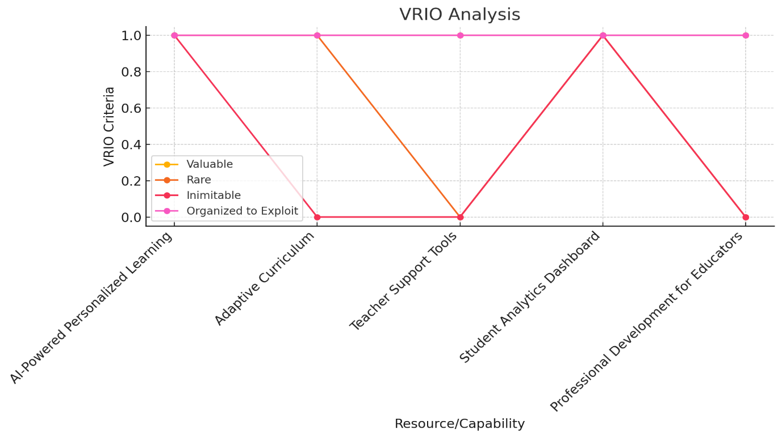
The VRIO analysis provides a visual analysis of the Montessori business's key resources and capabilities based on four criteria: Valuable, Rare, Inimitable, and Organized to Exploit. Each line in the chart represents a different resource, such as AI-powered personalized learning or the adaptive curriculum. The chart shows how these resources align with the VRIO criteria, highlighting which capabilities provide a sustainable competitive advantage (like the AI-driven tools) and which offer only temporary advantages or competitive parity. This visual helps to identify the strategic strengths that set the business apart in the educational technology market.

Operations and Management Team Plan
The managerial team of the business plays a vital role in managing the business effectively in front of the competitive business landscape. Without the effective business planning team and group, it is not possible to operate the business properly in the competitive business landscape. The process of the business is to provide an Education related service to the school. The supply from the business is internal. From the internal supply parties, the business can be managed (Williams, 2023). There are many tutors in the school who are the main suppliers of the business. The equipment of the business is school infrastructure in any ideal place. The main and major customer of the business is the student, that’s why providing the education to the customer or student is necessary. If the total infrastructure is about the EduTech related, that’s why there is no transportation service here. Providing education to the students is the main part of earning revenue. When the student does not involve here, the business can face the loss. To avoid the loss, it is needed to control the marketing activities as if the business could overcome the business challenges (Williams, 2023).
The top management party of the business is the head of the business, the middle management of the business is teachers. Every top management needs higher business knowledge, because without the lack of knowledge it is impossible to operate the business in the competitive business landscape (Williams, 2023). The capabilities of the business management help the business to control the whole business management in front of the massive audience. In this sector, the upgrading system, upselling system are evaluated. The entrepreneurial skills of the teachers are required. Eventually it is said that to manage the whole business, team management skills are needed effectively (Peter Redgrave. et al., 2024).

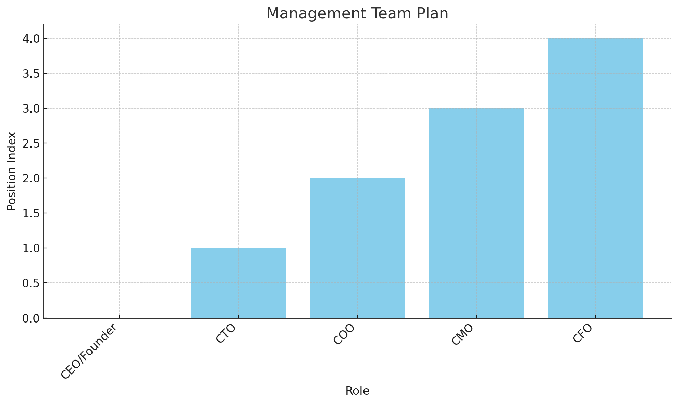

The management team outlines the key roles within the Montessori business, including CEO, CTO, COO, CMO, and CFO. Each bar represents a different position, highlighting the responsibilities essential to the business's success, such as strategic direction, technology development, operations management, marketing, and financial planning. This analysis emphasizes the structured leadership needed to drive the company's growth and innovation in the educational technology sector.

Marketing Plan and Strategy
Marketing is the core function of any kind of business that has some great impact. Without business marketing, it is not possible to promote the business product in front of a large people. The business also should focus on STP strategies using various contexts. STP refers to segmentation, targeting, positioning. The first process of marketing is segmentation. The business needs to segment the market first. The business needs to focus on the students (Peter Redgrave. et al., 2024). For the segmentation procedures, the demographics factors, and geographic factors are needed to evaluate. After the segmentation procedures, the targeting process is needed. For the targeting procedures, the business needs to focus on the segmented student. After the targeting procedures, the positioning strategies are needed. For the positioning strategies, the business needs to catch the mind of the customer of the business. For elaborating the marketing plan and marketing strategies, the marketing mix is the other part of the business function. The marketing mix highlights product, price, place, promotion. The main product of the business is education. The product highlights the service-related activities. The pricing strategies of the business highlights the moderate pricing of the product (Peter Redgrave. et al., 2024). The business should fix a lower price for the product. According to the income level, the price should be fixed and applied. After fixing the pricing strategies, it is needed to set the promotional strategies. Using various social media platforms and search engines, the marketing procedures can be accomplished. For the promotional strategies, various kinds of search engine should be implemented (Paul Saitoti Letoya et al., 2023). After accomplishing the promotional strategies, the business requires to establish the place strategies. For the place strategies, there are some outlets of the school are needed as if the business could gain the ultimate roof of success. The one and only distribution channel is various outlets of the school (Lowenstein, 2023).
The 4Ps—Product, Price, Place, and Promotion—are essential components of the marketing mix, providing a foundational structure for creating an effective marketing strategy (Kotler & Armstrong, 2018).
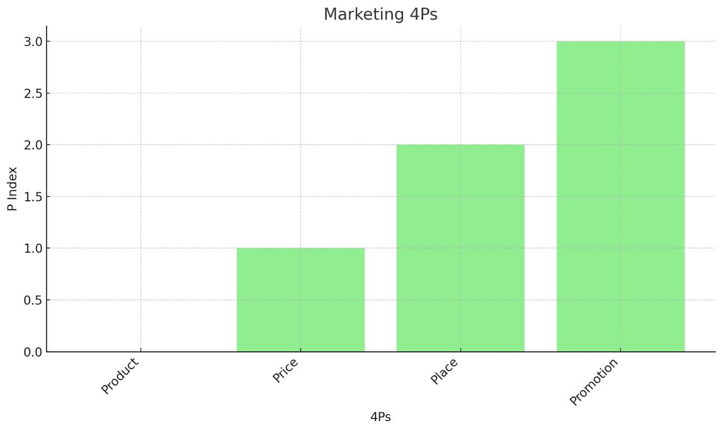
Marketing 4Ps represents the core elements of its marketing strategy. The "Product" focuses on the AI-powered personalized learning modules, which are central to the business's offering. The "Price" illustrates the subscription-based model designed to cater to schools with varying needs. "Place" highlights the online platform as the primary distribution channel, ensuring accessibility for educational institutions. Lastly, "Promotion" emphasizes the use of digital marketing, educational conferences, and influencer partnerships to build brand awareness and reach the target market. This chart encapsulates the strategic approach to delivering and promoting the business's innovative educational solutions.

Financial Plan
For a business, financial planning is the most important part to elaborate the business function. Without financial planning, it is not possible to elaborate the business growth. First the business needs the startup cost. After the startup cost, the business needs the operational cost and managerial cost (Paul Saitoti Letoya et al., 2023). For the operational cost, the business requires to describe the wages, salary cost, and other operational cost. For the cost management of the selected business context, it is needed to demonstrate the movable cost and fixed cost. Depending on these costs, the business can know how to improve effectively. Trademark cost, branding cost, business registration cost, etc. are accomplished (Braun and Clarke, 2022b).
Besides this cost, there are some other cost are situated for instance transportation cost or logistic cost. Eventually it is said that, to become the most effective business in the competitive business landscape, the business ought to focus on financial planning (Braun and Clarke, 2022b).
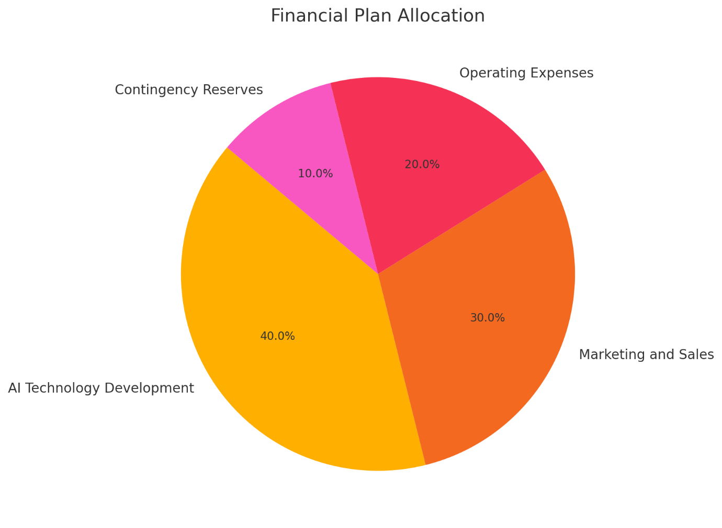

The financial plan illustrates how the Montessori business intends to distribute its initial funding. The largest portion, 40%, is allocated to AI technology development, reflecting the priority of advancing their core product. Marketing and sales receive 30%, highlighting the importance of customer acquisition and brand visibility. Operating expenses are allocated 20%, ensuring the smooth running of daily operations. Finally, 10% is reserved for contingencies, providing a buffer for unforeseen expenses. This analysis demonstrates a strategic approach to balancing innovation, growth, and operational stability.

Conclusion
The main objective of the report is to demonstrate the business plan about EduTech Montessori in the United Kingdom. The industry has many potential growths that affect the business effectively, that’s why the business should focus on the marketing planning, financial planning, market growth, market opportunities, market size, market share, etc. Moreover, another theme of the report is to analyze five Porter’s model and VRIO model to analyze the industry analysis. Using the 4ps and STP strategies, the report has been covered. The business also should focus on the strong management team as if the business could gain the revenue (Braun and Clarke, 2022b). Eventually it is said that the business can gain the ultimate success, if the business follows the managerial technique effectively.

Reference list
Barringer, B.R. and Ireland, R.D., 2019. Entrepreneurship: Successfully Launching New Ventures. 6th ed. Harlow, England: Pearson.
Braun, V. and Clarke, V. (2022). Thematic Analysis: A Practical Guide. London: SAGE.
Klein, B., Crawford, R.G. and Alchian, A.A. (2023). Vertical Integration, Appropriable Rents, and the Competitive Contracting Process. The Journal of Law and Economics, 21(2), pp.297–326.
Lowenstein, S.M. (2023). Frankfurt on the Hudson The German Jewish Community of Washington Heights, 1933-1983, Its Structure and Culture. Detroit Wayne State University Press [Ann Arbor, Michigan] [Proquest.
Paul Saitoti Letoya, Wanjahi, J., David Gachui Irungu, Njoroge, C. and Mathiu Josphine Mwendwa (2023). Business Enterprises Evaluation. IPR Journals and Book Publishers.
Kotler, P. and Armstrong, G., 2018. Principles of Marketing. 17th ed. Harlow: Pearson.
Peter Redgrave., Marco Mirolli., Tom Stafford., Gianluca Baldassarre., Richard Michael Ryan. and Andrew Barto. (2024). Intrinsic motivations and open-ended development in animals, humans, and robots. Frontiers Media SA.
Powalla, C. and Bresser, R.K.F. (2024). Can ignorance beat the resource based view? comparing the vrio framework to the recognition heuristic. Berlin Freie Univ.
Williams, T.G. (2023). Algebra Workouts: Factual, Exploratory, and Logic. Teaching and Learning Company.Young Won Park and Hong, P. (2024). Cosmetics Marketing Strategy in the Era of the Digital Ecosystem. Springer.

