Marian Ionut Malasincu
Student number 2312613

“Policing by consent” concept.
Why is it important and how does it impact society.

The concept of “policing by consent” is a fundamental idea that underpins modern democratic governments. The concept suggests that the legitimacy of law enforcement is dependent on the consent and cooperation of the population they are responsible for serving, rather than being simply derived from governmental authority.
The implication of an individual's lack of permission is evident. Individuals do not possess the authority to unilaterally withdraw their agreement from law enforcement or legal statutes.
The nine principles of policing by consent, widely recognised as the Peelian principles, were created by Sir Robert Peel.
The absence of sufficient evidence to substantiate the ascription of these concepts to Sir Robert Peel suggests a strong likelihood that they were, in fact, developed by the original Commissioners of Police of the Metropolis, specifically Sir Charles Rowan and Sir Richard Mayne.
The Home Secretary alluded to the notion of "policing by consent," which is in accordance with the longstanding ideology of British policing as exemplified by Robert Peel's 9 Principles of Policing. However, the assertion that Robert Peel was responsible for the establishment of the police force lacks substantiation, indicating that it was more plausibly envisaged by the original Commissioners of Police of the Metropolis, namely Charles Rowan and Richard Mayne. The ideas outlined in the "General Instructions" provided to newly appointed police officers since 1829 were as follows:

- In order to handle crime and disorder, an alternative method is recommended as a form of mitigation, which diverges from the only reliance on military strength and severe legal consequences.

- It is crucial to consistently recognise that the effectiveness of law enforcement in fulfilling their duties depends on the approval of their presence, behaviour, and actions by the broader community, as well as their ability to develop and maintain public respect.

- It is crucial to continually recognise that the achievement and maintenance of public respect and support necessitates securing the voluntary cooperation of the public in the endeavour to assure adherence to legislation.

- It is crucial to continually recognise that the extent of public cooperation acquired immediately decreases the necessity of employing physical force and compulsion to achieve police objectives.

- In order to garner and sustain popular support, it is crucial to abstain from engaging with the public's perspectives. In order to uphold the law, it is imperative to continually demonstrate unwavering dedication, irrespective of personal viewpoints or the perceived equity of individual legislative measures. This objective can be accomplished by offering personalised support and fostering harmonious connections with individuals from all segments of society, irrespective of their socioeconomic standing. Furthermore, exhibiting politeness and an amiable attitude, together with a readiness to make personal concessions in the sake of safeguarding human existence, additionally enhances the cultivation of public endorsement.

- The utilisation of physical force has to be restricted to circumstances in which endeavours to persuade, advise, and warn individuals are deemed insufficient in eliciting public participation to assure adherence to the law or reinstate order. Additionally, it is imperative to limit the utilisation of physical force to the farthest extent necessary in order to accomplish a certain law enforcement purpose within a given situation.

- In order to consistently maintain the concept of interconnectedness between the police and the public, it is imperative to acknowledge the historical convention that perceives the police as representatives of the public, and the public as individuals who bear the collective responsibility of preserving societal stability. It is crucial to recognise that the police force consists of individuals who are incentivized to dedicate their whole focus to duties that are mandatory for all members of society, ultimately aiming to enhance the welfare and longevity of the community.

- In order to ensure a consistent recognition of the importance of upholding a rigorous dedication to the responsibilities of police executives, it is crucial to refrain from any actions that may give the impression of encroaching upon the jurisdiction of the judiciary. This includes refraining from seeking vengeance on individuals or the State, as well as abstaining from making legal determinations of guilt and administering punishments to those who have been deemed guilty.

- It is crucial to always recognise that the genuine assessment of police efficacy is in the prevention of criminal activity and disorder, rather than the visible indications of police engagement aimed at resolving these matters.

It is crucial to recognise that in this particular context, the term "it" pertains to the authority of the police, which is derived from the collective consensus of the public, rather than the authority of the state. The usage of the term does not connote the endorsement or consent of an individual. The exercise of revoking consent from law enforcement or legislation falls outside the realm of an individual's discretionary authority.
When individuals are queried about their motivations for engaging in illegal activities, they frequently use simplistic crime control models as explanatory frameworks. This phenomenon is not always applicable, although it can be attributed to the prevailing political context within which policy formulation occurs. Furthermore, these concepts propose strategies for crime prevention that strive to attain instrumental compliance, whereby individuals partake in illegal activities based on self-interested reasoning. The guarantee of adherence to these standards will be upheld by employing either official or informal mechanisms of social control and imposing significant penalties on individuals who partake in inappropriate conduct (Nagin, 1998; Kahan, 1999).
Nevertheless, it is important to acknowledge that deterrence is but one element within a broader framework, as highlighted by Pratt et al. (2006) and Bottoms (2001). More sophisticated models of crime control recognise that the formal criminal justice system is just one element among multiple social control systems, many of which have a significant normative dimension. Individuals conform to legal norms for reasons that extend beyond a purely pragmatic evaluation of the benefits and drawbacks involved with participating in illegal activities. A significant proportion of persons exhibit a consistent tendency to comply with the majority of laws, mostly driven by their assessment of the moral justifiability of such adherence. Routine compliance, a phenomenon firmly ingrained in everyday life, is influenced by a multitude of elements including heredity, socialisation, psychological development, moral reasoning, community context, social norms, and networks (Robinson and McNeill, 2008: 436).
Based on a comprehensive examination of policing reform, the impact of bureaucracy on policing practises, and the continuous discourse surrounding police performance, research investigations suggest that while there is a broad achievement in the endeavour to establish a morally upright and efficient police force, an excessive emphasis on self-presentation may inadvertently compromise the desired public perception that British and Australian law enforcement agencies strive to cultivate.
The effectiveness of policing by consent is contingent upon the trust that individuals place in police officers and other law enforcement officials. Professional standards departments (PSDs) possess the capacity to make a substantial contribution towards the maintenance of trust and confidence. The erosion of trust and confidence may arise from insufficiently rigorous screening and proficient handling of misconduct and complaints, coupled with inadequate examination of anti-corruption endeavours. Therefore, it is crucial that these issues are approached with transparency and rigour, in accordance with the established Code of Ethics.

Professional standards encompass a variety of domains, which encompass the subsequent:
• Counter corruption
• Vetting
• Complaints and misconduct
• Governance
The notion of legitimacy relies on what Reiner (2000: 55) describes as the mysterious idea of a profound bond between the police force and the populace of Britain. This argument is grounded in the concept of a mutually agreed upon framework of principles and beliefs that are both logical and harmonious, which exist between law enforcement agencies and the general populace. Additionally, it acknowledges the distinct responsibility of the police in utilising necessary force to uphold these established standards. According to Smith (2007a, p. 280).
The concept of policing by consent, as argued by Bottoms and Tankebe (2017), challenges the notion that all police interventions with liberty can be viewed as utopian. Similarly, the notion of policing through consent cannot be equated with the extent of public confidence in law enforcement. The current metrics used to measure public confidence frequently fail to consider the viewpoints of marginalised and disenfranchised groups, who are disproportionately subjected to police interventions (Torrible, 2018, p. 466). Therefore, while the empirical verification of trust levels or loyalty towards law enforcement holds considerable importance, the notion of "policing by consent" must encompass more than a mere compilation of these measurements.
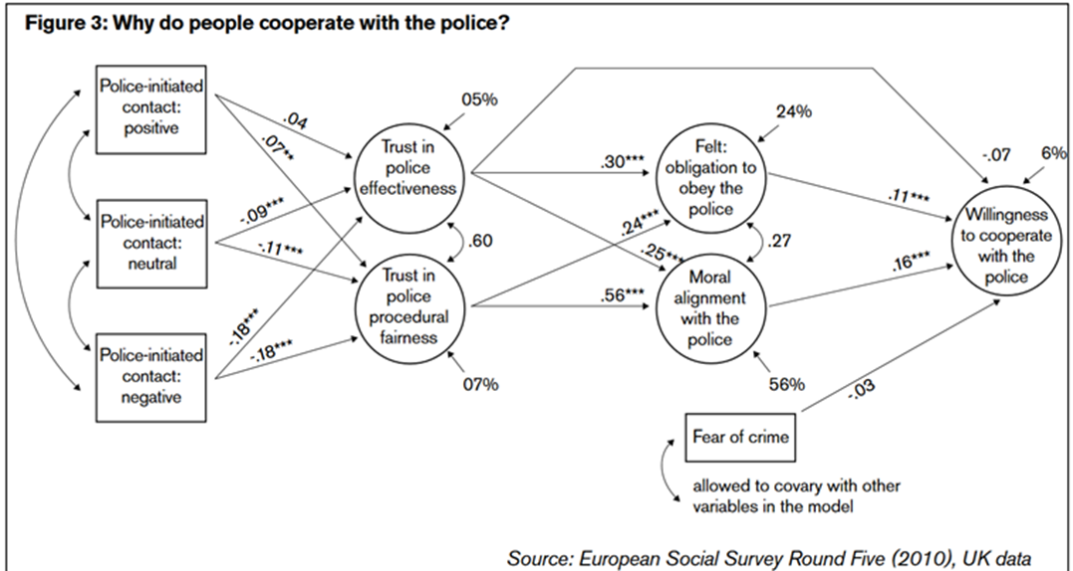

In recent decades, legal authorities have increasingly relied on the utilisation of threat and punishment as primary mechanisms for deterring criminal behaviour. Irrespective of the specific circumstances of the case, the usual method for ensuring adherence commonly entails the application of deterrent strategies. The underlying rationale substantiating this perspective has three primary elements. The motivation behind adherence to legal regulations stems from the apprehension of probable future repercussions, which can encompass punitive measures. The evaluation of risks is impacted by two key factors: the probability of facing consequences and the individual's perception of the gravity of those consequences. The recognition and emphasis on the influence of legal authorities and institutions in moulding conduct by employing punitive measures as a means of discouraging rule violations are of utmost importance. The prevailing paradigms in the realm of law and public policy pertaining to crime control encompass the deterrence and social control models. These methods are based on theoretical frameworks that stress the prevention and management of criminal behaviour.

Reference list

Watts, D. (2023) Ministry of Injustice, What is Policing by Consent ? Available at: https://ministryofinjustice.co.uk/what-is-policing-by-consent/ (Accessed: 12 November 2023)
UK Government (2012), Definition of policing by consent, Available at: https://www.gov.uk/government/publications/policing-by-consent/definition-of-policing-by-consent (Accessed:12 November 2023)
Keane, J. and Bell, P. (2013) Confidence in the police: Balancing public image with community safety – A comparative review of the literature, International Journal of Law, Crime and Justice, Vol. 41, Issue 3, pp. 233-246, Available at: https://doi.org/10.1016/j.ijlcj.2013.06.003
College of Policing (2023) Professional standards, Available at: https://www.college.police.uk/app/professional-standards (Accessed: 12 November 2023)
Jackson, J. et al (2012) Why do People Comply with the Law? Legitimacy and the Influence of Legal Institutions, The British Journal of Criminology, Vol. 52, Issue 6, November 2012, pp. 1051–1071, Available at: https://doi.org/10.1093/bjc/azs032
Torrible, C. (2022) Trust in the police and policing by consent in turbulent times, Safer Communities, Brighton, Vol. 21, Issue 3, pp. 171-183, Available at: https://www.proquest.com/scholarly-journals/trust-police-policing-consent-turbulent-times/docview/2689567426/se-2?accountid=130472
Jackson, J. et al (2012) Compliance with the law and policing by consent: notes on police and legal legitimacy, in Crawford, A. and Hucklesby, A. (eds.) Legitimacy and Compliance in Criminal Justice, (London, UK : Routledge, 2012) pp. 29-49, Available at: http://eprints.lse.ac.uk/30157/

