ECAD7004

What is the Impact of Implementing Cold-Calling Techniques on Classroom Dynamics and Student Participation Levels Across Educational Settings? A Mixed-Methods Exploration.

By Lauren Bruton
Student Number: 2304631
Word Count: 4937

Aim, Focus and Purpose of the Research
The aim of this essay is to investigate the impact of implementing cold-calling techniques on classroom dynamics and student participation levels across diverse educational settings. By exploring this topic, I seek to provide insights into how instructional strategies like cold-calling can influence student engagement and interactions within the classroom environment.
What sparked my interest in this research stems from a recognition of the importance of fostering active student participation in learning experiences. Throughout my own educational journey and in discussions with peers and educators, I observed varying levels of student engagement in classroom activities. This led me to consider the effectiveness of different pedagogical approaches in promoting student involvement and fostering a dynamic learning environment.
What particularly intrigued me about cold-calling was its potential to disrupt traditional patterns of participation and encourage all students to actively contribute to discussions. While traditional methods often rely on voluntary participation, cold-calling introduces an element of unpredictability by randomly selecting students to respond to questions or contribute to class discourse. This approach intrigued me because it appeared to challenge the dynamics of the classroom and potentially mitigate issues of unequal participation among students.
My interest in this topic is closely linked to my Personal Learning Plan (PLP), which emphasises the exploration of innovative teaching practices and their impact on student learning outcomes. Understanding how cold-calling techniques influence classroom dynamics aligns with my broader educational goals of enhancing teaching effectiveness and promoting inclusive learning environments. Through this research, I aim to contribute to the ongoing dialogue surrounding pedagogical strategies that foster active student engagement and cultivate a collaborative learning atmosphere.
The research took place in a Comprehensive School situated in a densely populated urban area, providing a rich context for examining the impact of cold-calling techniques in a diverse educational setting. The study specifically focused on a Year 10 class comprising of roughly 10 pupils, showcasing a typical secondary school environment catering to students 11-16. One notable aspect of the class was its diverse composition, encompassing a wide range of academic abilities from A* students to those at G level, as well as a mix of Additional Learning Needs (ALN). This heterogeneity in student backgrounds and abilities adds depth to the research, allowing for a comprehensive exploration of how cold-calling strategies may influence engagement and participation across a spectrum of learners.

Literature Review
The literature reviewed in this study is relevant to exploring the impact of cold-calling techniques on classroom dynamics and student participation levels. Synthesising insights from leading theorists provides a comprehensive understanding of the theoretical framework and empirical evidence surrounding cold-calling practices in education. Diverse perspectives on student engagement, instructional strategies, and classroom discourse patterns inform the research question, emphasising the need to examine nuanced effects across different contexts and populations. This study aims to address gaps in the literature through a mixed-methods exploration, integrating quantitative and qualitative data. Building on previous research, it extends the conversation on effective teaching practices, investigating how cold-calling strategies can be tailored to enhance student engagement and learning outcomes in classroom contexts.
Cold-calling, a pedagogical strategy involving randomly selecting students to respond to questions or contribute to discussions, has garnered considerable attention in educational research. This literature review critically examines the impact of implementing cold-calling techniques on classroom dynamics and student participation levels across various educational settings, drawing insights from prominent theorists such as Doug Lemov, Robert Marzano, Tom Sherrington, Dylan Wiliam and many others.
Doug Lemov’s work on effective teaching practices provides valuable insights into the implementation of cold-calling techniques. Lemov advocates for structured classroom procedures to enhance student engagement and learning outcomes (Lemov, 2010). He suggests that cold-calling can promote active participation and deepen student understanding by ensuring equitable opportunities for all learners to contribute. However, Lemov’s approach has been critiqued for its potential to create a coercive learning environment, where students feel pressured or anxious about being called upon.
Similarly, Robert Marzano emphasises the importance of classroom strategies that foster student engagement and academic success (Marzano, 2007). Marzano’s research suggests that cold-calling can be an effective tool for promoting higher-order thinking skills and fostering a culture of accountability. By holding students accountable for their learning through regular participation, cold-calling may encourage deeper levels of engagement and mastery of content. However, Marzano also acknowledges the need for teachers to create a supportive and inclusive classroom climate to mitigate the potential negative effects of cold-calling on student motivation and self-esteem.
In contrast, Tom Sherrington & Oliver Cavigioli caution against the over-reliance on cold-calling as a classroom management strategy (Sherrington & Cavigioli, 2020). They argue that while cold-calling can be effective in certain contexts, it should be used judiciously and complemented with other instructional techniques such as think, pair, share, and show-me boards. Sherrington & Cavigioli emphasise the importance of creating a positive learning environment where students feel safe to take risks and make mistakes without fear of judgement or embarrassment. They suggest that a balanced approach to student participation, incorporating both voluntary and targeted questioning strategies, is essential for promoting meaningful engagement and fostering a collaborative classroom culture.
Rosenshine’s principles of effective instruction highlight the role of teacher clarity and scaffolding in promoting student learning (Rosenshine, 2010). Cold-calling can be a useful tool for checking student understanding and providing timely feedback, aligning with Rosenshine’s emphasis on frequent opportunities for practice and review. However, Rosenshine also emphasises the importance of active student involvement in the learning process, suggesting that cold-calling should be accompanied by opportunities for peer collaboration and student-led discussions to enhance comprehension and retention.
Dylan Wiliam’s research on formative assessment and classroom practice offers valuable insights into the role of feedback and student engagement in the learning process (Wiliam, 2011). Wiliam advocates for a shift towards more interactive and student-centred teaching methods, emphasising the crucialness of timely feedback and opportunities for self-assessment. While Wiliam’s work may not directly address cold-calling techniques, his emphasis on fostering a culture of inquiry and reflection in the classroom aligns with the broader goals of promoting active participation and deepening student understanding. By encouraging students to take ownership of their learning and providing meaningful feedback to guide their progress, Wiliam’s approach complements the principles underlying cold-calling strategies and underscores the importance of creating a supportive and empowering learning environment.
Doug Dallimore et al.’s research on classroom discourse patterns further elucidates the potential impact of cold-calling on student participation levels (Dallimore et al., 2010). Their findings suggest that cold-calling can disrupt established communication patterns and promote greater equity in classroom interactions. By encouraging all students to contribute and share their ideas, cold-calling may help to break down barriers to participation and create a more inclusive learning environment. However, Dallimore et al. also acknowledges the need for teachers to be sensitive to cultural and linguistic differences among students and to provide appropriate support to ensure that all voices are heard.
Babad’s work on student engagement in the classroom provides additional insights into the factors that influence student participation levels (Babad, 2009). Babad emphasises the role of teacher-student relationships and classroom climate in shaping student motivation and engagement. Cold-calling can be an effective strategy for promoting active participation and fostering and a sense of belonging among students. However, Babad also highlights the importance of autonomy and choice in student learning, suggesting that cold-calling should be balances with opportunities for self-directed inquiry and exploration.
In summary, the literature reviewed provides valuable insights into the impact of implementing cold-calling techniques on classroom dynamics and student participation levels across educational settings. While cold-calling can be a powerful tool for promoting active learning and fostering a collaborative classroom culture, its effectiveness depends on various factories including teacher expertise, classroom climate, and instructional context. By critically evaluating existing research and synthesising key findings, this literature review sets the stage for a mixed-methods exploration of the research question, aiming to fill gaps in the current literature and extend the understanding of cold-calling’s implications for classroom practice.

Case Study
Case study research is a qualitative research method that allows for in in-depth exploration or specific occurrences or cases within its natural context (Yin, 2018). Case studies are valuable for examining complex occurrences, such as educational practices, by providing detailed and contextually rich insights into the interactions and dynamics at play (Stake,1995). They are particularly useful in educational research for investigating the complexities of classroom environments, instructional strategies, and student experiences.
The purpose of employing a case study approach in educational research is to gain a comprehensive understanding of a specific occurrence or situation within its real-world context (Merriam, 2009). By focusing on a single case – in this instance, a Year 10 Business class – researchers can delve deeply into the dynamics of classroom interactions and the effects of instructional strategies such as cold-calling on student participation and engagement. Case studies allow for the exploration of the multifaceted factors that influence educational outcomes, providing insights that may not be captured through quantitative methods alone (Creswell, 2016).
Case study research offers several strengths, including its ability to provide rich, detailed and contextually embedded insights into the occurrence under investigation (Merriam, 2009). Furthermore, case studies allow for the exploration of complex interactions and processes that may not be captured through other research methods. They offer flexibility in data collection and analysis, allowing researchers to adapt their approaches to suit the unique characteristics of each case. However, it is important to acknowledge the limitations of case study research, such as potential bias in data collection and the challenge of generalising findings to broader populations (Creswell, 2016).
The participants in this case study are a Year 10 Business class consisting of 6 students, from a total of 10 that are in the class. These students range from Additional Learning Needs (ALN) to A* pupils. The participants included comprised of five male students and one female student, with one particular ALN student requiring the assistance of a Learning Support Assistant (LSA) during the study.
In this case, purposive sampling was a suitable method for ensuring a representative sample (Patton, 2014). Purposive sampling involves selecting participants based on specific criteria relevant to the research objectives, such as the diversity of academic abilities and backgrounds within the classroom. By intentionally selecting participants who represent the range of characteristics present in the target population, researchers can ensure that the findings are applicable and meaningful within the context of the study (Yin, 2018). In this specific study, the participants were chosen based on the research question and the overall effects of cold-calling. It is crucial in this study to ensure a range of opinions from different ability students to receive the most diverse answers. This allows the researcher to understand how each individual feels about cold-calling within the classroom.
The use of case study methodology in this research aligns with recommendations from existing literature on qualitative research methods in education (Merriam, 2009; Creswell, 2016). By employing a case study approach, this study aims to provide detailed insights into the impact of implementing cold-calling techniques on classroom dynamics and student participation levels within a specific educational setting.
Research Methods
In this section, the research methods employed in the study, namely questionnaires and observations will be discussed, to investigate the impact of implementing cold-calling techniques on classroom dynamics and student participation levels. Each method is examined in detail, drawing upon relevant literature to explore their strengths and limitations. Through the systematic application of these methods, the aim is to provide comprehensive insights into the research question and contribute to the existing body of knowledge in the field of education.
Questionnaires, a widely used method in educational research, facilitate the systematic collection of data through structured sets of questions administered to participants (Cohen, Manion, & Morrison, 2018). For this study, a questionnaire was designed to assess student perceptions of cold-calling techniques and their impact on classroom dynamics. Appendix 1 contains the questionnaire, which include a combination of Likert scales, open-ended questions, and multiple-choice queries. The use of a Likert scale allowed for the quantification of participant responses, while open-ended questions provided opportunities for participants to express nuanced viewpoints (Appendix 1). The questionnaire was structured to ensure anonymity and confidentiality, with responses collected anonymously to encourage honest and genuine feedback. Participants were assured that their responses would not be shared with peers or teachers to mitigate desirability bias (Cohen et al., 2018).
However, despite its efficiency, the questionnaire method is not without limitations. Response bias and social desirability bias are common concerns, as participants may provide answers they perceive as socially acceptable rather than reflecting their true opinions or experiences (Cohen et al., 2018). Additionally, the standardised format of questionnaires may limit the depth of responses, potentially overlooking nuanced perspectives and contextual factors that qualitative methods can capture comprehensively. In order to mitigate these limitations in the current study, several measures were implemented, Firstly, participants were ensured anonymity and confidentiality, with responses collected anonymously to encourage honest and genuine feedback. Additionally, to minimise social desirability bias, participants were assured that their responses would not be shared with peers or teachers, fostering a sense of confidentiality and trust. Furthermore, the questionnaire employed a variety of techniques, including Likert scales and open-ended questions, to capture diverse perspectives and nuanced insights, thereby enhancing the richness and depth of the data collected.
The observation method involves the systematic and unobtrusive observation of participants’ behaviours and interactions within a naturalistic setting. This method offers unique advantages, allowing researchers to directly observe classroom dynamics and student behaviours in real-time, providing rich insights into the context and complexities of educational practices (Creswell, 2016). Observation is particularly valuable in capturing nonverbal cues, subtle interactions, and emergent occurrences that may not be evident through self-report measures alone. Appendix 2 outlines the observation criteria and protocols followed during data collection.
Drawing from the literature of Rosenshine (2010) and Marzano (2007), who emphasise the importance of active student involvement and teacher clarity in promoting effective instruction, the observation method enables researchers to directly assess the implementation of cold-calling techniques and their impact on classroom dynamics. By observing classroom interactions, researchers can gain a deeper understanding of how cold-calling strategies influence student engagement, participation levels, and teacher-student dynamics.
Despite its value, the observation method has challenges. The Hawthorne effect, for instance, where participants may adjust their behaviour due to being observed, poses a risk to data validity (Creswell, 2016). Additionally, subjective interpretation of behaviours can introduce observer bias, requiring rigorous training and reliability checks (Adler &
Adler, 1994; Webb et al., 1966). Researchers often use discreet note-taking and aim for a natural classroom atmosphere to minimise these challenges, fostering genuine interactions (Heath & Hindmarch, 2002). Ensuring students are unaware of being cold-called also creates a more relaxed environment, reducing pressure (Martin, 2006), aligning with non-reactive research principles (Webb et al., 1966). These strategies enhance observational study validity and reliability, mitigating the Hawthorne effect’s impact.
By utilising both questionnaires and observations, a mixed-methods approach has been adopted, leveraging the complementary strengths of each method to provide a comprehensive understanding of the research topic (Appendices 1 and 2). This integrated approach enables triangulation of data, enhancing the validity and reliability of the study’s findings while addressing the inherent limitations of individual methods.
To further enhance this section, it is essential to elaborate on the specific observation schedule and questionnaire design used in the study. The observation schedule outlines the structure and objectives of the observations conducted in the classroom setting. This schedule provides guidance to the researcher regarding what aspects of classroom dynamics and student behaviours to observe, ensuring consistency and focus throughout the data collection process.
In Appendix 2, the observation schedule is detailed, indicating the time and duration of each observation session, as well as the specific behaviours and interactions to be documented. For example, the schedule includes observations of teacher-student interactions during cold-calling exercises, student responses to cold-calling prompts, and overall classroom engagement levels. By following a structured observation schedule, the researcher can systematically capture relevant data points and ensure comprehensive coverage of key aspects related to cold-calling implementation and its impact on classroom dynamics.
Similarly, Appendix 1 contains the questionnaire administered to students, outlining the questions and response options provided to participants. The questionnaire is designed to gather insights into students’ perceptions of cold-calling techniques, their levels of engagement during cold-calling activities, and any potential effects on classroom dynamics. The questionnaire includes a combination of closed-ended questions, such as Likert scale items, and open-ended questions to elicit detailed responses from participants.
The design of the questionnaire reflects best practices in survey research, aiming to strike a balance between quantitative data collection and qualitative insights. Closed-ended questions like Likert scale responses allow for the quantification of students’ attitudes and opinions, enabling statistical analysis and comparison across different groups or time points. On the other hand, open-ended questions provide students with the opportunity to express their thoughts and experiences in their own words, capturing subtle perspectives that may not be captured through closed-ended questions alone.
Moreover, the questionnaire design takes into account the age and attainment levels of the student participants to ensure appropriateness and relevance of the questions. For example, language and terminology used in the questionnaire are tailored to suit the understanding and comprehension levels of Year 10 students. Additionally, the Likert scale response options are carefully considered to offer a range of choices that align with the cognitive abilities and maturity of the target audience.
By incorporating both structured observation and questionnaire methods, the researcher adopts a comprehensive approach to data collection, capturing diverse aspects of the research occurrence from multiple perspectives. Triangulating findings from observations and questionnaires enhances the validity and reliability of the study’s conclusions, providing a more vigorous understanding of the impact of cold-calling techniques on classroom dynamics and student participation levels.
Furthermore, as the researcher, it is important to maintain ethical considerations throughout the research process, ensuring that participants’ privacy and confidentiality are upheld. In Appendix 1 and 2, the research tools are labelled individually, indicating the questionnaire and observation schedule used in the study.
In summary, this research methods section provides a detailed overview of the approaches employed in the study, highlighting their strengths, limitations, and relevance to the research objectives. By leveraging structured observation and questionnaire methods, the researcher aims to generate comprehensive insights into the impact cold-calling techniques on classroom dynamics and student participation levels. Through careful design and execution of research tools, the study adheres to ethical standards and ensures validity and reliability of its findings.

Data Presentation and Analysis Method
In reporting the data collected from this study, a mixed-methods approach will be employed to provide a comprehensive understanding of the research question. Quantitative data obtained from the questionnaires will be analysed using statistical techniques to identify trends, patterns, and correlations. Likert scale responses will be quantified and subjected to descriptive and inferential statistical analyses, allowing for the examination of relationships between variables. Open-ended responses will undergo thematic analysis to extract qualitative insights and perspectives from participants and the researcher. This mixed-methods approach aligns with the study’s aim to triangulate data from multiple sources, enhancing the validity and reliability of findings (Johnson & Onwuegbuzie, 2004).
To ensure the trustworthiness of the research findings, strategies for enhancing credibility, transferability, dependability, and confirmability were implemented throughout the study. Credibility was established through member checking, whereby participants were given the opportunity to review and verify the accuracy of their responses, thus enhancing the credibility of the data collected (Creswell & Creswell, 2017). Transferability, or the extent to which findings can be applied to other contexts, was addressed through thick description and detailed documentation of the research process, allowing readers to assess the applicability of findings to similar educational settings (Lincoln & Guba, 1985). Dependability, or the consistency and stability of findings over time, was ensured through the systematic documentation of research procedures, including data collection and analysis techniques, facilitating the replication of the study by future researchers (Shenton, 2004). Finally, confirmability, or the objectivity and neutrality of the research findings, was enhanced through reflexivity, whereby the researcher maintained a reflective stance and documented personal biases and assumptions throughout the research process, minimising the influence of subjectivity on data interpretation (Morrow, 2005). Through these rigorous processes, the study aims to produce trustworthy and credible findings that contribute to the existing body of knowledge in the field of education.

Ethical Considerations
This study follows ethical guidelines set by the British Educational Research Association (BERA), ensuring participant rights, informed consent and assent, and confidentiality. Participants including students and guardians, will receive clear information about the study’s purpose, procedures, and risks. Confidentiality is maintained, and data are anonymised and securely stored. Students will provide assent before participation, ensuring their voices are respected. Adhering to BERA guidelines upholds integrity and respect in educational research.
In this study, prioritising participant anonymity and confidentiality is crucial, especially as it involved students in a classroom setting. Upholding ethical guidelines ensures the protection of participants’ privacy and rights, aligning with standards for research involving minors in educational contexts.
To maintain anonymity, participants’ identities will not be disclosed in any reports or publications resulting from the study. All data collected, including responses from questionnaires and observations, will be anonymised, using participant numbers instead of names. This ensures that individual responses cannot be traced back to specific participants.
Confidentiality is also maintained by securely storing all data collected throughout the research process. Only the researcher and authorised personnel will have access to the data, and it will be stored in password-protected electronic files and locked storage to prevent unauthorised access.
In terms of gaining pupil assent, the process involves obtaining informed consent form both students and their legal guardians. The ethics form outlines the procedures for gaining consent, including providing clear and understandable information about the study, its purpose, and what participation entails. Students and their guardians are informed that participation is voluntary, and they have the right to withdraw from the study at any time without penalty.
Assent from students is obtained through age-appropriate explanations of the study, ensuring that they understand the purpose and procedures involved. This included providing information sheets (Appendix 5) allowing time for students to ask questions before they agreed to participate. Written assent was required from all students wishing to participate (See Appendix 4 for copy of the consent and assent form).
Overall, the ethical considerations in this study prioritise the well-being, privacy, and rights of the student participants, ensuring that their involvement is voluntary, informed, and confidential. These considerations are essential for maintaining the integrity of the research and upholding ethical standards in educational research practices.

Analysis of Results
In the investigation of students’ perceptions and experiences regarding cold-calling techniques in the classroom, a total of 6 participants contributed their insights. Among these participants, various responses were recorded, shedding light on their understanding, experiences, and attitudes towards cold-calling.
Regarding their comprehension of the term ‘cold-calling’ within the context of classroom learning, the majority of participants demonstrated familiarity with the concept, with 4 students articulating it as the random selection of students by the teacher to answer questions during class discussions (66.7%). However, 2 participants conveyed uncertainty about the term, indicating a lack of prior exposure or understanding (33.3%).
When queried about their experience with cold-calling in previous classes, the responses revealed that cold-calling is a common instructional practice, with 5 out of 6 participants affirming prior encounters with this technique (83.3%). This suggests a widespread utilisation of cold-calling across various educational settings, indicating its prevalence as a pedagogical strategy.
Examining the comfort level of participants when subjected to cold-calling, a spectrum of responses emerged. While 2 students expressed feeling ‘very uncomfortable’ and 1 student reported being ‘uncomfortable’ with this practice (50%), 2 participants maintained a ‘neutral’ stance. In contrast, 1 student conveyed feeling ‘comfortable’ and another participant expressed being ‘very comfortable’ with cold-calling (16.7%), suggesting a range of attitudes towards this instructional approach.
Insights into the perceived benefits of cold-calling for students’ learning experiences were diverse. Among the identified benefits were increased participation, improved focus, and enhanced accountability. Specifically, 4 participants recognised cold-calling as a means to foster greater participation among all students (66.7%), while 3 students highlighted its role in maintaining attentiveness during class (50%). Additionally, 2 participants viewed cold-calling as a mechanism for holding students accountable for their learning (33.3%), underscoring its potential impact on student engagement and involvement in the learning process.
Furthermore, the questionnaire elicited responses regarding students’ feelings of anxiety or discomfort when cold-called in class. Approximately half of the participants (3 out of 6) reported experiencing such emotions, with descriptions ranging from feeling pressured to perform well to experiencing embarrassment when unable to respond adequately to questions.
When questioned about the effectiveness of cold-calling in promoting participation and active learning, opinions varied. While 3 participants expressed confidence in its efficacy (50%), citing its ability to stimulate engagement and interaction, 2 participants expressed reservations, questioning its overall impact on learning outcomes (33.3%).
In terms of preferred methods of student engagement, participants ranked cold-calling, group discussions, hands-on activities, individual presentations, and written assignments in order of preference. Notably, cold-calling emerged as the most preferred for 2 participants (33.3%), indicating a positive perception of its utility in promoting student engagement.
Finally, participants offered suggestions for improving the effectiveness of cold-calling, including providing advance notice and offering constructive feedback. These recommendations underscored the importance of considering students’ perspectives and comfort levels when implementing this instructional strategy.
Overall, participants’ ratings of cold-calling ranged from 4 to 8 on a scale of 1 to 10, reflecting varying levels of positivity towards this teaching technique. These findings provide valuable insights into students’ experiences with cold-calling and highlight the importance of considering their perspectives when designing instructional practices aimed at promoting active learning and engagement in the classroom.
In the observed classroom setting, the Business Studies teacher employed the cold-calling technique of random selection to engage students in active participation. The students’ initial reactions to the initiation of cold-calling appeared to be nervous and lacking in confidence, indicating a level of discomfort with the unpredictability of being called upon. However, as the cold-calling commenced, it became evident that students began to pay closer attention and actively listen, anticipating their turn to contribute to the discussion. This observation aligns with the literature suggesting that cold-calling can enhance student engagement by fostering attentiveness and promoting active participation (Lemov, 2010).
Despite the initial apprehension, the cold-calling technique seemed to facilitate a positive learning environment as students became more engaged and supportive of each other. The small class size (6 students) made it challenging for individuals to avoid involvement, contributing to a sense of accountability and participation among all students. Furthermore, the teacher’s supportive approach, characterised by providing additional thinking time and breaking down questions to encourage participation, helped alleviate student anxiety and foster a collaborative learning atmosphere. These observations resonate with the findings of Dallimore et al. (2010), who highlight the potential of cold-calling to promote equity in classroom interactions and enhance student engagement.
Throughout the lesson, the teacher varied the frequency and timing of cold-calling, alternating between asking questions directly to students and allowing for peer support before revisiting the initial student for a response. This strategy provided students with opportunities for collaboration and reflection, contributing to a smoother flow of question-and-answer exchanges as the cold-calling session progressed. Such dynamic implementation strategies are consistent with the recommendations of Sherrington and Cavigioli (2020), who advocate for a balanced approach to student participation techniques to maintain a positive classroom climate.
In summary, the observations of the cold-calling technique in the classroom suggest that it can effectively promote active engagement and foster a supportive learning environment. By addressing student discomfort through supportive measures and encouraging collaborative interactions, teachers can harness the potential of cold-calling to enhance student participation and deepen learning experiences.

Conclusion & Recommendations
In concluding this research study, it is imperative to critically examine the methods employed for data collection and their reliability, validity, and generalisability within the context of the study. The methods utilised, including questionnaires and observations, were chosen judiciously to provide a comprehensive understanding of the impact of cold-calling techniques on classroom dynamics and student participation levels. While these methods offer valuable insights, it is essential to acknowledge their limitations and potential biases.
The reliability of the data collection methods is contingent upon the consistency and accuracy of responses obtained from participants. By employing standardised questionnaires and systematic observation protocols, efforts were made to ensure reliability. However, variations in individual responses and interpretation of observed behaviours may introduce some degree of variability.
In terms of validity, the chosen methods were aligned with the research objectives and sought to capture meaningful insights into the research. The questionnaire items were designed to elicit specific information related to student perceptions and experiences of cold-calling, while observational data provided real-time observations of classroom dynamics. Despite efforts to minimise bias and ensure data accuracy, the subjective nature of interpretation remains a potential limitation.
The generalisability of findings may be limited by the specific context and characteristics of the study participants. The small sample size and unique classroom setting may restrict the applicability of findings to broader educational contexts. Future research endeavours should aim to replicate the study with larger and more diverse samples to enhance generalisability.
Moving forward, it is recommended to explore alternative research methodologies and further incorporate mixed-methods approaches to triangulate findings and enhance the robustness of conclusions. Additionally, interventions could be devised to address any identified issues and optimise the implementation of cold-calling techniques in educational settings. These recommendations align with the Professional Standards by promoting evidence-based practice and continuous improvement in teaching and learning methodologies.

Reference List
Adler, P. A., & Adler, P., 1994. Observational Techniques. In N. K. Denzin & Y.S. Lincoln (Eds), Handbook of Qualitative Research (pp. 377-392). Sage Publications, Inc.

Babad, E., 2009. Teacher-student relationships: A focused review. Educational Psychology Review, 21(2), 177-199.

Babbie, E.R., 2020. The practice of social research. Cengage AU.

Bogdan, R., & Biklen, S. K., 2007. Qualitative research for education: An introduction to theories and methods. Pearson Education.

British Educational Research Association (BERA)., 2018. Ethical Guidelines for Educational Research (4th ed.). London, UK.

Cohen, L., Manion, L. and Morrison, K., 2002. Research methods in education. Routledge.

Creswell, J. W., & Creswell, J. D., 2017. Research design: Qualitative, Quantitative, and mixed methods approaches. Sage Publications.

Creswell, J.W. and Poth, C.N., 2016. Qualitative inquiry and research design: Choosing among five approaches. Sage publications.

Dallimore, D., Hertenstein, J. H., & Platt, M. B., 2010. Classroom participation and discussion effectiveness: Student-generated strategies. Communication Education, 59(1), 82-96.

Dallimore, E.J., Hertenstein, J.H. and Platt, M.B., 2004. Classroom participation and discussion effectiveness: Student-generated strategies. Communication Education, 53(1).

Dillman, D.A., Smyth, J.D. and Christian, L.M., 2014. Internet, phone, mail, and mixed-mode surveys: The tailored design method. John Wiley & Sons.

Dornyei, Z., 2007. Research methods in applied linguistics. Oxford university press.

Fowler Jr, F.J., 2013. Survey research methods. Sage publications.

Gewertz, C., 2021. Navigating the Pandemic’s ‘New Normal’ in Schools: A Special Report. Education Week.

Heath, C., & Hindmarsh, J., 2002. Analysing Interaction: Video, Ethnography and Situated Conduct. In T. May (Ed.), Qualitative Research in Action (pp. 99-121). Sage Publications.

Holstein, J.A. and Gubrium, J.F. eds., 2011. Varieties of narrative analysis. Sage Publications.

Johnson, R.B. and Onwuegbuzie, A.J., 2004. Mixed methods research: A research paradigm whose time has come. Educational researcher, 33(7), pp.14-26.

Landsberger, H.A., 1958. Hawthorne Revisited: Management and the Worker, Its Critics, and Developments in Human Relations in Industry.

Lemov, D., 2010. Teach like a champion: 49 techniques that put students on the path to college (K-12). John Wiley & Sons.

Lincoln, Y.S. and Guba, E.G., 1985. Naturalistic inquiry. Sage.

Martin, A. J., 2006. Motivation and engagement in diverse performance domains: Testing the generality of the hierarchical model of approach and avoidance achievement motivation in the educational context. Journal of Educational Psychology, 98(1), 129-143.

Martin, P. Y., 2006. Snowball Sampling: A Tool for Research Design and Analysis. In J. A. Holstein & J. F. Gubrium (Eds.), Varieties of Narrative Analysis (pp. 47-76). Sage Publications.

Martin, S. D., 2006. Observer effects. In G. Ritzer (Ed.), Encyclopaedia of sociology (pp. 2863-2866). Blackwell.

Marzano, R.J., 2007. The art and science of teaching: A comprehensive framework for effective instruction. Ascd.

Mayo, E., 2004. The human problems of an industrial civilization. Routledge.

Merriam, S.B. and Tisdell, E.J., 2015. Qualitative research: A guide to design and implementation. John Wiley & Sons.

Morrow, S.L., 2005. Quality and trustworthiness in qualitative research in counselling psychology. Journal of counselling psychology, 52(2), p.250.

Patton, M.Q., 2014. Qualitative research & evaluation methods: Integrating theory and practice. Sage publications.

Roethlisberger, F. J., & Dickson, W. J., 1939. Management and the Worker: An Account of a Research Program Conducted by the Western Electric Company, Hawthorne Works, Chicago. Harvard University Press.

Rosenshine, B., 2012. Principles of instruction: Research-based strategies that all teachers should know. American educator, 36(1), p.12.

Shenton, A.K., 2004. Strategies for ensuring trustworthiness in qualitative research projects. Education for information, 22(2), pp.63-75.

Sherrington, T., 2020. Teaching WalkThrus: Five-step guides to instructional coaching. Hachette UK.

Stake, R.E., 1995. The art of case study research. Sage.

Webb, E.J., Campbell, D.T., Schwartz, R.D. and Sechrest, L., 1975. Unobtrusive measures: Nonreactive research in the social sciences. Chicago: Rand McNally.

Wiliam, D., 2011. Embedded formative assessment. Solution tree press.

Yin, R.K., 2018. Case study research and applications (Vol. 6). Thousand Oaks, CA: Sage.

Appendices

Appendix 1 – Questionnaire

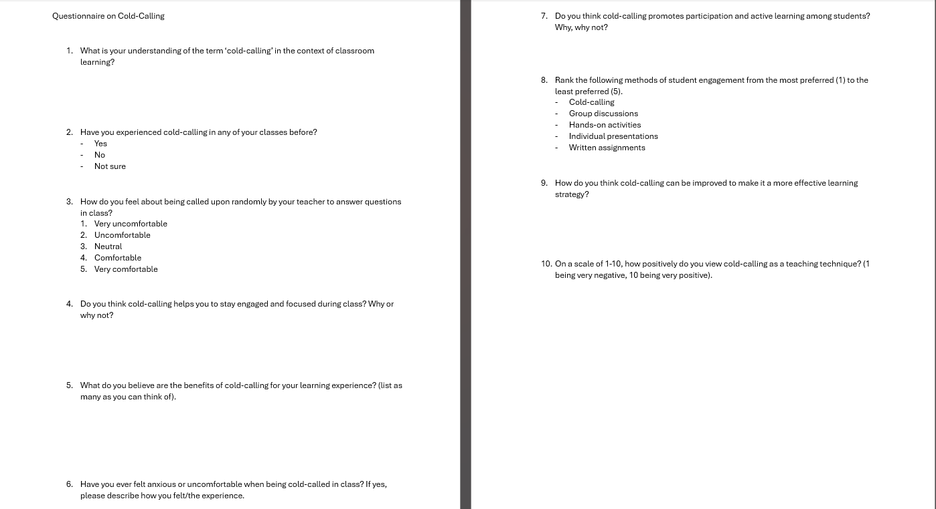

Appendix 2 – Observation Sheet

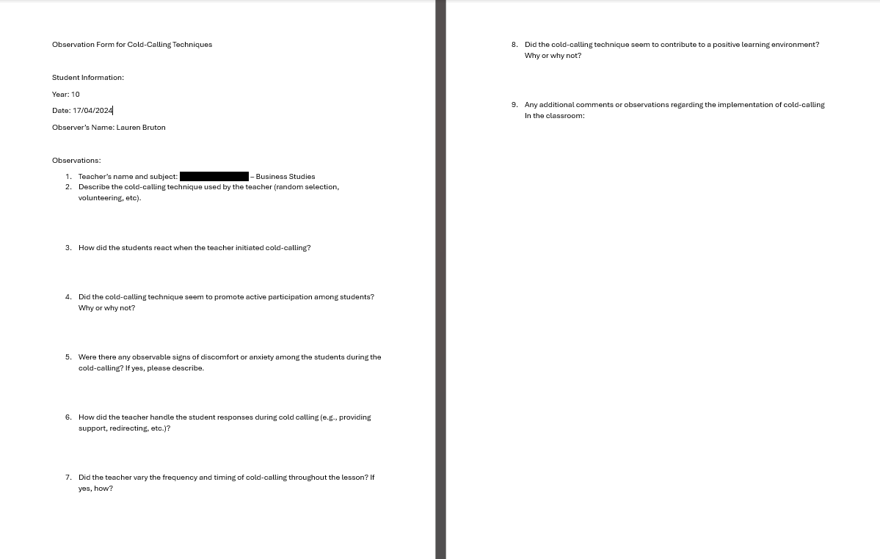

Appendix 3 – Ethics Form

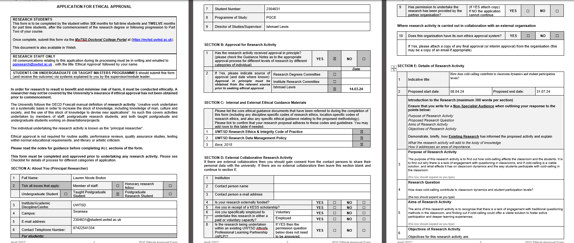

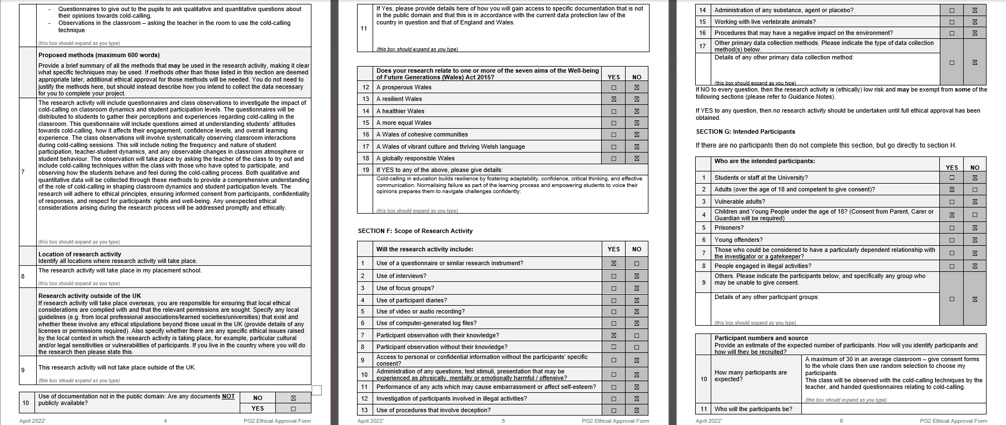

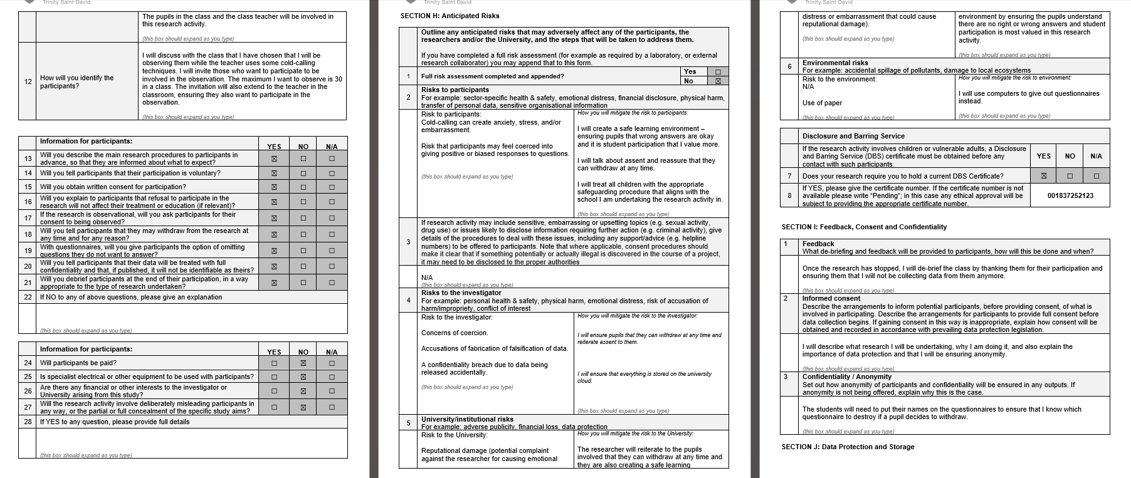
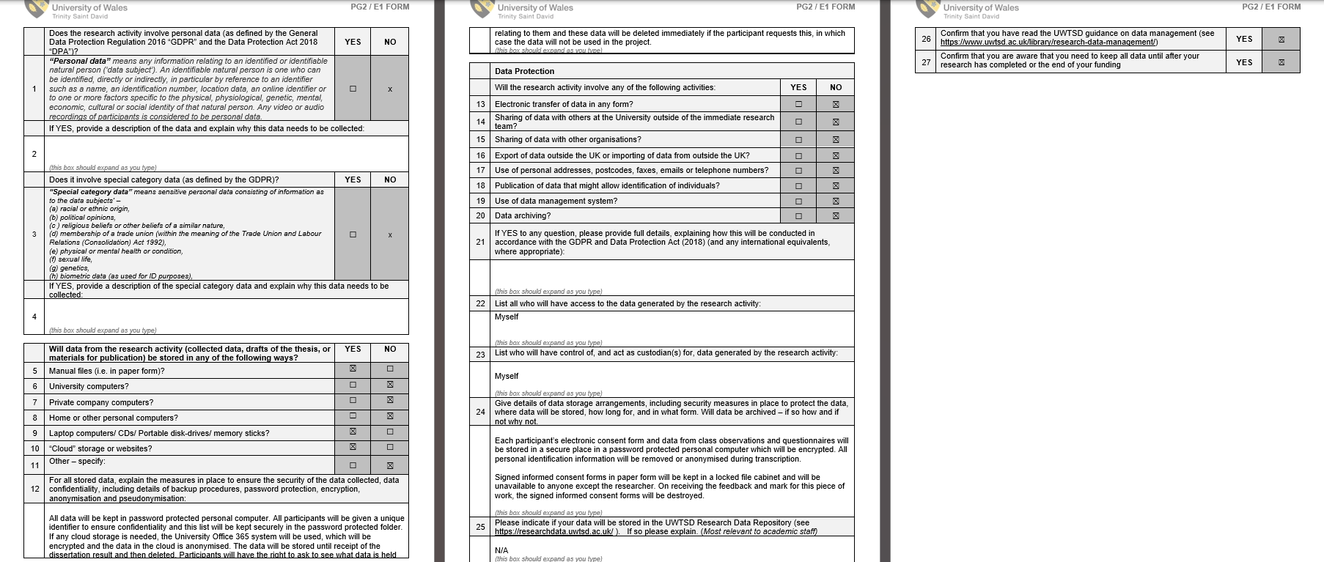

Appendix 4 – Consent/Assent Form
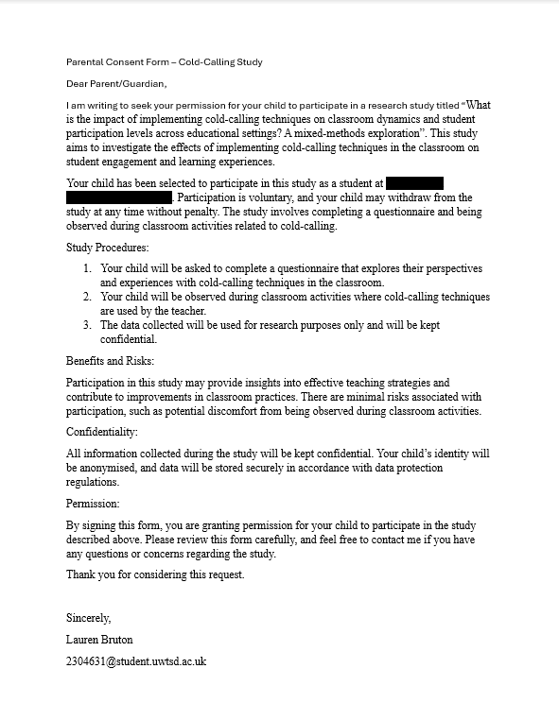

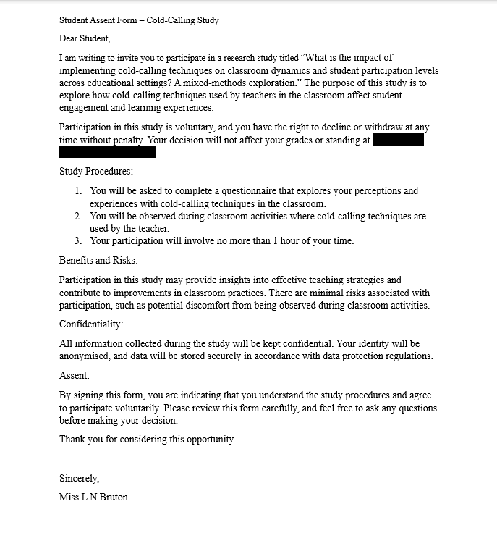

Appendix 5 – Information Sheet


