Work-Placement Portfolio
Maria Crick
(1804032)
Tania Davies



Contents Page

Introduction…………………………………………………………………………………….3
What is Action for Children?...............................................................4
Write ups of work placement………………………………………………………….4-6
Kolbs Learning Cycle (linking to work placement)……………………………7-8
SMART Action Plan………………………………………………………………………….8-9
CV……………………………………………………………………………………………………10
Evidence (Workplacement)……………………………………………………………..12-13
References………………………………………………………………………………………14-15

Introduction

I am a Nursing studies and Health care student at the university of Wales Trinity St David’s. My current educational background started from GCSEs to completing my extended health and social care level 3 diploma which has helped me to gain vast experience working within the health and social care sector within as nursery, profound multiple learning difficulties unit (PMLD), a primary school and a nursing home My studies support my long-term goal to be a paediatric nurse. From gaining experience it has helped me to develop and enhance my skills that will allow me to become an efficient practitioner. Skills in communication, team-working and critical thinking has developed myself and become knowledgeable about working within the health and social care sector.

Action for Children (NPT Positive Outlook Play Service)

Actionforchildren.org, discusses the POPS service which is a ‘Positive Outlooks Play Service’, this coordinates in partnership with the ‘Swansea Child Care Disability Teams’ this service provides supportable sessions for children between the ages of 0-18 years old. These sessions consist of activities within the local community or in a base. The scheme gives opportunities for enhancing a childs communicative, social and practical skills through enjoyable activities which supports independency. A social worker from the disability team makes referrals for the children into this service.

Write ups of my experience at Action for Children

Week One: (28/01/19) (29/01/19)

During my first week of volunteering for Action for Children POPS Service, I was very anxious although I have had experience working alongside children with special needs being introduced to a group of children who I haven’t met before, that have a range of disabilities I haven’t encountered made me nervous. I was given each of the children’s individual profiles to read and therefore, gather important information before working with the children, to help me feel prepared.

On the Monday session we went to the arcade, my first job was to help assist the children with bowling this helped to get to know the children individually. Outside my voluntary work, I learn level 1 sign language, this became helpful working with the children as I noticed most of the children sign to communicate, this made me feel relaxed communicating with the children. According to Perez (2016) Sign language is taught to children who have autism because linking spoken words towards objects can be made difficult therefore, the use of sign language allows the child with autism to process the sign to its meaning. On the Tuesday session we went to the cinema, as we were in the cinema one of the children was triggered by the loud noise and started to scream and become agitated, I did become panicky because It was my first time seeing this, but observing how the staff dealt with this by talking softly and calmly to the child being reassuring helped to calm the child down.

Week Two (04/02/19) (05/02/19)

During my second week of placement, I was introduced to the main facility base were I got involved playing interactive games with the children such as with the parachute, building towers and playing play dough which allowed me to get to know the children. I was shown how to use PECS (Picture Exchange Communication System) during food time with the children which was new communicative technique to me. Odluyurt, Aldemir and Kapan (2016) mentions that PECS is important for children with autism it allows for efficiency and development of communication through visual aid.

Week Three (11/02/19) (12/02/19)

On the Monday session I went out to Aberavon beach. I was told to supervise one of the children. I had noticed that the child was fascinated by everything visually surrounding her, she couldn’t communicate verbally so I remember grabbing the sand placing it into her hands and she was amazed by the feeling and texture. I had also visited the park on the Tuesday session where I took the children for a walk playing with them on the swings and slides helping bond professional relationships and getting to know the children.

Week Four (18/02/19) (19/02/19)

My fourth week into volunteering I was less nervous as I started to build on relationships with the staff and the children. I we went to the trampoline park, I was told to join in with the activity with the children to help supervise them. According to Christie, Newson, Prevezer and Chandler (2009) interactive play encourages better communication skills with children who have autism. I really enjoyed getting involved playing with the children and getting to know them.

Week Five (26/02/19) (28/02/19)

My fifth week I encountered an incident which occurred that involved me chasing after the child as he ran towards the road, I was very anxious and frightened I quickly grabbed his hand in time due to event this I had to write up an incident report, this was my first time writing up an incident report form. Today taught me about the importance of observation at all time with the children. On the 28th March I had received my emergency first aid paediatric training. I was offered this training from Action for Children. The day consisted of learning many essential emergency first aid in paediatrics such as what to do if a baby or child is chocking, bleeding, having a seizure and resuscitation. According to Firstaidforlife (2019) Paediatric emergency first aid training is an important training to receive whilst working with children, it equips you in emergency situations for example, to perform CPR which is a life-saving performance.

Week Six (04/03/19)

My six week into volunteering I felt more comfortable, consistency was important for the children so I started to get into a routine, supporting this Orenstein (2010) discusses the importance of Consistency amongst children with ADHD as it helps change the child’s negative behaviour. On the Monday we went to bowling again. During bowling I was supervising one of the children, I was helping to support and get her to interact with the other children, she is very independent join in with others in the group. Being encouraging and boosting her confidence whilst bowling such as cheering clapping made her feel self-confident and talkative with the others. Care.com (2017) discusses the importance of encouraging children to participate with others as it allows the child to boost their confidence and overcome shyness.

Week Severn (11/03/19) (12/03/19)

During my seventh week I went to sensory play, this was the first time I have been to a sensory suit. When we got there I interacted with the children straight away playing with the soft equipment, I was amazed at the different lights, sounds and colours from this one room. The children seemed to be amazed by the texture and soft equipment which stimulated them visually and by touch. According to Cerebralpalsy.org (2015) sensory play allows children with special needs to engage and stimulated by visuals, touch, sound and smells.

Week Eight (18/03/19) (19/03/19)

During this week I was told to be responsible for the finance and the main group bag I was quite nervous. One of the workers shown me how to sort it all out and I started to feel my comfortable and find it easy. By this week I started to feel more involved with the team also they started to develop trust with me which made me feel more relaxed and enjoy my time working alongside the workers.

Week Nine (01/04/19) (02/04/19)

During my ninth week I was much more relaxed and started to get into a routine. On the Monday session as a group we stayed at base where I was involved making Easter arts and crafts with the children. I enjoyed doing this as I love art, I helped assist many of the children holding their hand whilst they had a paintbrush in it and getting creative with the glitter. Today learnt me overcoming barriers for example, helping hold the paintbrush and help assist with the children’s art work.

Week Ten (09/04/19)

When it came down to my tenth week I was confident and felt a part of the team. We took the children to golf where I help support them. My skills learnt throughout the week was put into use and I felt comfortable working one to one with the children.

Week Eleven (15/04/19)

My last day at action for children, I was quite sad to leave as I had to say goodbye to the children. My last day consisted of me playing with the children at base individually as I was aware of the games each child likes to play, I thoroughly enjoyed the day.

Kolbs learning cycle linking to placement

Concrete Experience:

According to Bower (2013) the first stage of Kolbs learning cycle is ‘concrete experience’ this includes being involved within an actual experience by doing something. The experience that will be reflecting on will be work placement at Action for Children. During my time on placement I got involved working as part of a team alongside children with special needs within a positive outlook play service.

Reflective Observation:

Fisher and Gallagher (2011) discusses the second stage to Kolbs learning cycle which is ‘Reflective Observation’ this involves reflecting on the experience. Reflecting on the experience as a whole it went well. The experience allowed me to develop in many skills working alongside children which will benefit me for my future career as a paediatric nurse. Communication was the key skill that I learned during my time volunteering, working alongside children with special needs requires me to adapt my approach to communication learning new techniques such as PECS, non-verbal such as sign language and using different senses such as touch visual aids. Good listening and observational skills when it came down to listening and picking up non-verbal cues was important when knowing behavioural triggers. Royal College of nursing (RCN) (2019) emphasis on the importance of communication in nursing for example, it supports patience who are stressed and anxious whilst undergoing treatment and makes the patient feel valued and respected. Learning about different disabilities and behavioural approaches such as remaining calm and patience, allowed me to increase my knowledge and understanding of the different personal needs and gave me confidence in my approach to mechanisms when it came to managing difficult situations such as remaining calm and patience. According to Haugland and Giske (2016) Personal-centred care is highly important in nursing it support holistic care and allows for therapeutic relationships to evolve. Team work was an important skill I had developed throughout my time in Action for Children, most of the children were two to one and required extra support therefore, working alongside other workers were essential to delivery personal support for the children. Reeves (2013) mentions team working is a major component in nursing as nursing requires working apart of a multidisciplinary team to deliver sufficient care for patients.

Abstract Conceptualisation

Konak, Clark and Nasereddin (2014) mentions the fourth stage to Kolbs Learning Cycle which is ‘Abstract Conceptualisation’ this involves drawing up a conclusion referring to the reflection. Volunteering for action for children was overall a good experience. At the beginning I was very anxious and nervous working in a new place however, with time I started to become more relaxed and confident working alongside the children and staff as well as getting more involved. I felt my personal qualities such as being positive, empathy, compassion and be able to adapt my approach to communication allowed me to build relationships with the children. My time at Action For Children made me consider working alongside children with special needs and disabilities I want to focus on and incorporate into my future career as a child nurse.

Active Experimentation

According to Bergsteiner, Avery and Neumann (2010) the last stage to Kolbs Learning Cycle is ‘Active Experimentation’ this involves making adaptations and plan for future improvements for a new experience. I am going to create a SMART Action which will set short goals to focus on my long-term goal in improving my qualities and skills for my journey to become a child nurse.

SMART Action plan

Long Term Goal | Deadline for completion
To improve my qualities and skills for my journey to become a child nurse. | September 2019

Short Term Goals (SMART)
Goal 1: Improve communication skills

Specific | I want to be able to enhance and improvement my communication skills. This is important for my future career. I am going to do this by continuing my level 1 sign language and consider my level 2 and take up voluntary opportunities working with children.
Measurable | Evidence from improvements in working alongside children such as building on relationships and become more confident will show better communication skills.
Achievable | This goal is achievable, the help from observing from others and using learning at university will help me. A potential barrier could be time. However, with time becomes improvement.
Realistic | This goal is relevant to my long-term goal for building on my future career. As a paediatric nurse communication is key part of this role. This goal is easy to achieve.
Timescale | I would like to achieve this goal by September 2019 as this will be the month I start paediatric nursing.

Goal 2: Further my education and knowledge

Specific | I want to be able to further my education and knowledge in working alongside children. This is important to me as I want to learn and become an efficient paediatric nurse. I will do this by attending opportunities in training and work hard at university.
Measurable | I will know If I have achieved this outcome by learning new things that will help me for my future career and improvements working alongside children. Evidence from work experiences and university feedback will know if I have achieved this goal.
Achievable | This goal is achievable, the help from extra support of staff will improve my grades and training from others in community centres. I do have the recourses I need from training centres. A potential barrier is time which can delay my time.
Realistic | This goal I relevant to my long term goal for my future career as a child nurse. This goal can be difficult to achieve however, dedication and hard work will help me to overcome any barriers.
Timescale | I would like to achieve this goal by September 2019 as this will be the month I start paediatric nursing.

Goal 3: Develop in self-confidence

Specific | Improve my self-esteem and becoming more confident in my own abilities. This is important to me because confidence is a major issue to me and affects my work my ability to talk to others. I am going to do this by involving myself in more voluntary opportunities and receive support when needed.
Measurable | I will know when I have achieved this goal when I feel less nervous and shy and gain confidence in my own ability. I will know I have achieved this when I improve in my university work and working alongside others.
Achievable | I will be able to achieve this goal. The help from others such as listening to positive feedback receiving extra support at university work through study skills and interacting myself with others will help me to achieve this. Time could be a potential issue but not a major.
Realistic | This goal is highly relevant to my long-term goal to become a paediatric nurse. Confidence is important in nursing when it comes down to providing holistic care towards patients. This goal can become difficult if self-doubt interferes but it can realistically achieved.
Timescale | I would like to achieve this goal by September 2019 as this will be the month I start paediatric nursing.

Curriculum Vitae (CV)

Maria crick

Address - Aberclwyd Farm Telephone number- 07714399250

Pentreclwydau

Resolven Email- Mariacrickx@gmail.com

Neath

SA114DU Geographically mobile: Full UK Driving License

Personal profile

My strong desire to ensure that all children have the best start to their lives, inspires me to be a child nurse in my future career. Compassion and empathy are qualities that makes me a natural care-giver. The extensive experience I have gained through working alongside children, has developed myself to have a strong connection with children and enhance my skills further. Nursing is a career that I aspire too, my determination is demonstrated through furthering my education and opportunities such as a year’s voluntary work for action for children and accomplishing my level 1 British Sign Language course in which has enhanced my experience and help me strive to become an effective practitioner. I can work as part of multidisciplinary team and my warmth as well as empathy allows myself to help others manage their health for better recovery, these are some of many of the skills I have gained.

Education and Qualifications

University of Wales Trinity ST David’s (2018 – 2019)

A Higher Educational Certificate in Nursing Studies and Health – grade (Pending)

Gorseion College (2016 – 2018)

Health and Social Care Extended Diploma – grade (Triple Distinction Stars)

St Michaels School (2015 – 2016)

GCSE’s received:
Art- grade (A)
Maths- grade (C)
English- grade (C)
Biology- grade (B)
Geography- grade (C)
Psychology- grade (C)
History- grade (B)

Relevant Experience

I have had work experience, volunteering in Gorseinon Primary school, working in a year group. Whilst working in the primary school I helped, with any practical work that was needed to be done in the class room, I also helped the children with their class work. I have also have had work experience in Penllergaer Primary School, working in the special needs unit with children with disabilities and special needs, during my time there I helped with the learning and took part in a numerous of activities and was taught a lot about manual handling and health and safety during my time there. I have also had experience working in Hengoed Court Nursing home, my time spent in a nursing home has taught me a lot about the care aspect of nursing as well as experience working alongside adults and those who are ill. I have also had work experience in Lillie’s Day Care Nursery, my role involved nurturing and caring for babies and infants as well as stimulating their care needs. In my free time I help volunteer for Action for children, which allows me to gain experience working with the children as well as learn new practical skills to which has helped me improve upon my communication skills. I enjoy volunteering and helping others.

Skills Profile

Communication: My effective communication skills which allow me to adapt to any situation. I believe that my communication skills have developed through experience working in health and social care setting alongside children. volunteering alongside children with disabilities has allowed me to learn new strategies and alter the way I communicate. I am currently pursuing my level 1 sign language; this is important to me as I want to be able to overcome barriers to communication. From work experience in a nursing home, working with special needs children and to a nursery has allowed me to adapt my communication skills based on different age-ranges to allow me to provide the best possible care.

Team working: My ability to work as part of a team has developed through experience. Volunteering for Action for Children I have had to work as part of a team to provide care for the children. Working as part of a multidisciplinary team is essential in any health and social care setting. My team working skills allows me to provide the best possible support and care for the children.

Critical thinking: My critical thinking skills allows me to make decisions and adapt to any situation. Volunteering with children who have special needs involves having to adapt to situations and use my communication skills to diffuse difficult situations.

Organization skills: Time management is important to me, this is shown through my university work. My university studies have given me an introduction to the health and social care setting. Teaching me skills and essentials to allow me to be competent and use this within the workplace.

Evidence (work placement)

Log of my Hours at Action For Children

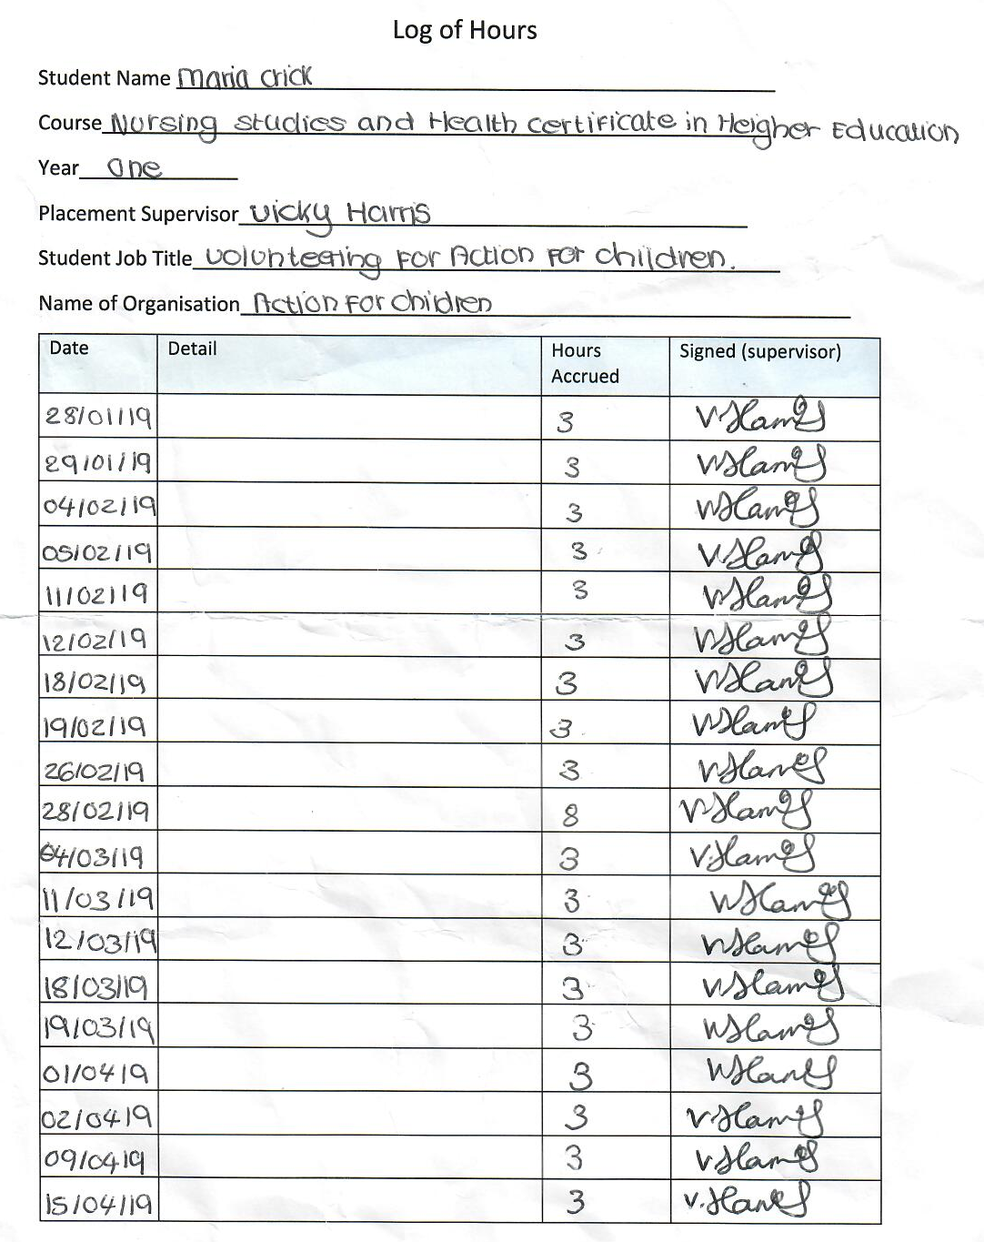
Figure one: Work placement hours
Figure 1 represents my work placement hours, I have completed a total of 62 hours.

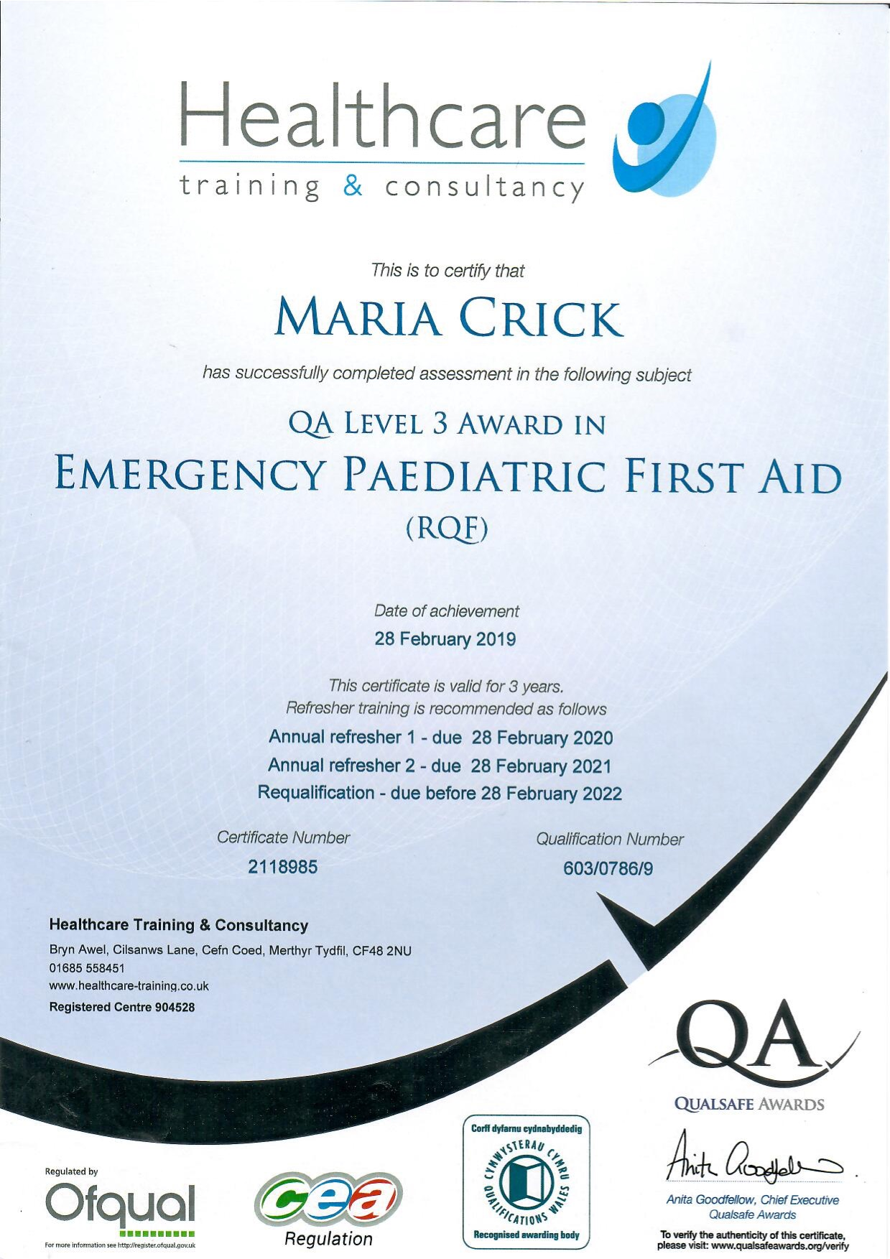
Figure two: QA Level 3 Emergency Paediatric First Aid
Figure two shows QA Level 3 Emergency Paediatric First Aid. During my placement I was given the opportunity to receive this training.

References:

- Action for children.org (2019) Swansea Short Breaks Project. Available at: https://www.actionforchildren.org.uk/in-your-area/services/community-resource/swansea-short-breaks-project/ (Assessed 19th April 2019)

- Begsteiner, H. Avery, G. and Neumann, R. (2010) Kolb’s Experiential Learning Model: Critique from a Modeling Perspective. Studies in Continuing Education. 31. (1) pp.29-46. Available at: https://web-a-ebscohost-com.ezproxy.uwtsd.ac.uk (Assessed 20th April 2019)

- Bower, G. (2013) Utilizing Kolb’s Experiential Learning Theory to implement a Golf Scramble. International Journal of Sport Management, Recreation & Tourism. 12. pp. 29-57. Available at: https://web-b-ebscohost-com.ezproxy.uwtsd.ac.uk (Assessed 20th April 2019)

- CerebralPalsy.org (2015) Sensory Play for Children with Cerebral Palsy. Available at: https://www.cerebralpalsy.org/blog/sensory-play-for-children-with-cerebral-palsy (Assessed 19th April 2019)

- Christie, P. Newson, E, Prevezer. and Chandler, S. (2009) First steps in intervention with your child with autism frameworks for communication. London: Jessica Kingsley Publishers

- Firstaidforlife (2019) Paediatric First Aid full Ofsted syllabus. Available at: https://firstaidforlife.org.uk/first-aid-courses/paediatric-first-aid-full-ofsted-syllabus/ (Assessed 2nd May 2019)

- Fisher, T. and Gallagher, D. (2011) Know thyself: Coaching for leadership using Kolb’s Experiential Learning theory. Coaching Psychologist. 7. (1) pp.5-15 Available at: https://web-a-ebscohost-com.ezproxy.uwtsd.ac.uk (Assessed 20th April 2019)

- Haugland, ø. Giske, T. (2016) Daring involvement and the importance of compulsory activities as first-year students learn person-centred care in nursing homes. Nurse Education in Practice. 21 pp.114-121. Available on: https://web-b-ebscohost-com.ezproxy.uwtsd.ac.uk (Assessed 2nd May 2019)

- Konak, A. Clark, T. and Nasereddin, M. (2014) Using Kolb’s Experiential Learning Cycle to improve student learning in virtual computer laboratories. Computers & Education. 72. pp.11-22. Available at: https://web-b-ebscohost-com.ezproxy.uwtsd.ac.uk (Assessed 20th April 2019)

- Odluyurt, S. Aldemir, O. and kapan, A. (2016) An Investigation on the Effects of PECS and Observational learning in initiating and Maintenance of Communication among Children with Autism. International Journal of Early Childhood Special Education. 8 (2) pp.151-165. Available at: https://web-a-ebscohost-com.ezproxy.uwtsd.ac.uk (Assessed 19th April 2019)
- Orenstein (2010) 10 ADHD Behaviour Management Strategies. Available at: https://www.everydayhealth.com/hs/adhd-and-your-child/adhd-behavior-management-strategies/ (Assessed 29/04/19)

- Perez (2016) Sign language for Children with Autism. Available at: http://www.shieldhealthcare.com/community/grow/2016/07/13/sign-language-for-children-with-autism/ (Assessed 29th April 2019)

- Reeves, H. (2016) Leadership, Management and Team working in Nursing. Journal of Community Nursing. 27 (2) pp.33. Available at: https://search-proquest-com.ezproxy.uwtsd.ac.uk/ (Assessed 2nd May 2019)

- Royal College of Nursing (RCN) (2019) Why communication is important. Available at: https://rcni.com/hosted-content/rcn/first-steps/why-communication-important (Assessed 20th April 2019)

- The Care.com UK Team (2017) Encouraging kids to Participate. Available at: https://www.care.com/c/stories/5206/encouraging-kids-to-participate/en-gb/ (Assessed: 29th April 2019)

