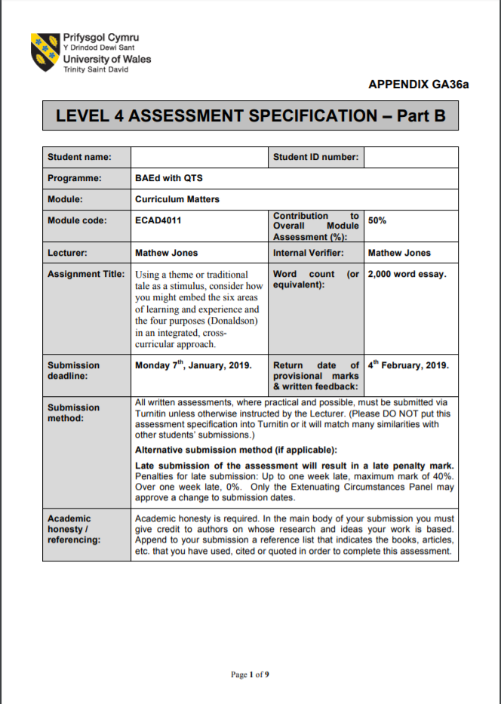

1800795
Harriet Doek

Curriculum Matters – ECAD4011 – Part B – Written Assignment
Using a theme or traditional tale as a stimulus, consider how you might embed the six areas of learning and experience and the four purposes (Donaldson) in an integrated, cross-curricular approach.
Cross-curricular and integrated teaching is undeniably important in ‘Key Stage 2’ since “the world beyond the classroom is cross-curricular” (Barnes, June 2015). Schools across Wales are responsible for giving students the skills, experiences and knowledge needed to face the real world. Thankfully, this ideal is reflected in both the current curriculum and Donaldson’s proposals for the new curriculum. For example, Donaldson (February 2015) and his four purposes outline aims which include students building and applying knowledge in different contexts creatively; and “having the skills and knowledge to manage everyday life as independently as they can and are ready to lead fulfilling lives as valued members of society”.
How teachers would be able to integrate different subjects and skills into one lesson however comes under the idea of creativity and flexibility. In order to achieve this, many teachers choose a theme or topic that acts as an umbrella, which covers all the skills, subjects and activities that fit. For demonstration I’ll be concentrating on the topic of Bendigeidfran (Bran the Blessed): a mythical, Celtic king, and one of the main characters of ‘Branwen ferch Llŷr’, a Celtic legend. Children usually respond enthusiastically to stories like this, especially in history where they are full of mystery, travel, intrigue, and villainy (Campbell & Little, 1989). This story in particular is full of battles and drama and even ends with Bran’s decapitated head; which can still talk; being placed on the White Hill; where the tower of London stands today; in order to ward off invasion from France. “Good cross-curricular pedagogy should also be relevant” (Barnes, 2015). In the case of Bendigeidfran he and other members of his mythical family play a big part in Welsh history and culture, even if we don’t realise it. Themes such as this help students find relevance either through practical, personal or emotional connections (Wilson, 2009).
The idea of flexibility is reflected by Donaldson (February 2015) in his six areas of learning and experiences which act more as curriculum themes compared to the current subject separation that we use. In the end it doesn’t really matter how we format the curriculum. “The titles of subjects are relatively unimportant even though they may be signals of symbolic claims to curriculum territory” (Campbell & Little, 1989). If teachers can give students the knowledge and skills they need, it doesn’t matter. “Unfortunately, the majority of work produced in schools is limited by the confines of a timetable” (Wilson, 2009). However, themed lessons create flexibility, allowing teachers to chose subjects to focus on and adapt lessons to what students find interesting i.e. flexible learning where teachers can “respond to the different interests and needs of learners, to promote generally applicable skills not just subject specific ones and improve motivation by offering a ‘pick-n-mix’ curriculum” (Grigg, 2010). For this demonstration I’ll be focusing on ‘Language, Literacy and Communication’; the ‘Humanities’; and ‘Expressive Arts’.
Unsurprisingly, just as you can combine various subjects and areas of learning together, there are different ways in how you can effectively present a cross-curricular lesson. For example, a ‘Hierarchical’ cross-curricular approach would involve one subject being used to enhance the learning in another. In terms of my chosen theme, I could do a lesson where I have the students focusing on how legends like ‘Bran the Blessed’ affected the culture and lives of the Celts. Not only would this connect to previous learning about the daily life of a Celt, by allowing students to investigate historical sites and important events of the Celtic period, they would be meeting the standards of the ‘Curriculum Cymraeg’ by understanding how lives and localities have been shaped by the past, through learning about the history of Wales, its social and cultural aspects and “visiting historical sites, using artefacts, making comparisons between past and present, and developing an understanding of how these have changed over time”. Additionally, by observing artefacts such as pottery, art, and clothing, students would be able to develop art skills as they would be examining the work of different artists, craft makers and designers from different periods, places and cultures; and be observing “Images and artefacts from a variety of historical and contemporary cultures and contexts”. It’s also a great way to stimulate pupil’s senses as “they generate perceptions about how the world around them works and from this and create mental images” (Grigg, 2010).
This learning opportunity would focus on ‘Humanities’ and ‘Expressive arts’ but also acts as an opportunity for metacognition: where you “raise the pupil’s stake in the learning process” (Kerry, 2011). To do this, I would suggest making the lesson into a class investigation where they would be split into groups to investigate and present what they found out about the relationship between Celtic myth and Celtic life. In a normal subject lesson, it is often difficult to keep the research process focused. However, although the art aspect isn’t particularly strong in this example, by allowing that extra wriggle room students would have a much better opportunity to investigate and present what they personally find interesting. This links back to Donaldson (February 2015), where in his four purposes he states that children should be able to “undertake research and evaluate critically what they find”. Additionally, in terms if literacy skills students would be given opportunities to “listen carefully and make connections between what they are learning and what they already know” as well as “contribute to group discussion, sharing ideas and information”.
An ‘Interdisciplinary/Multidisciplinary’ cross-curricular approach is where you connect and combine subjects through their curriculum and disciplines in order to create one deep learning experience (Barnes, June 2015). This balance of subjects is probably what most teachers aim for when planning a cross-curricular lesson. Some teachers, however, may see this as an invitation for stuffing as much of the curriculum into one lesson as possible, which would overwhelm students. Therefore, many critics of cross-curricular learning worry that with the abolition of subject-focused teaching will cause a diminution of learning across the board (Kerry, 2011). To prevent this, many teachers only focus on around two or three subjects per cross-curricular lesson.
To demonstrate, another possible lesson you could do within this theme is having students create a dance, piece of art, or extract of music in order to represent a key event/word/character within the story of ‘Branwen ferch Llŷr’. I would allow the students to choose which they would like to concentrate on both in terms of key features and how they express their representations. By doing this “they are trusted and viewed as co-participants who have to make decisions for themselves, use of available resources and complete their work in the time available” (Wilson, 2009). By looking at Celtic art, music, dance and even the welsh language you end up with a lesson where Celtic and Welsh culture aids students in representing the story’s key features. The ‘Humanities’ and ‘Expressive arts’ are most prominent in this lesson but ‘language, literacy and communication’ can be featured by looking at character descriptions and by using key welsh and English vocabulary when representing the key features of the story. The Welsh language is especially important as “in learning language, the pupils inevitably learn culture” (Campbell & Little, 1989). Literacy is also developed as students are encouraged to “identify the topic and main ideas of a text e.g. by highlighting using key words of the text”. This leads us to ‘Curriculum Cymraeg’ as students would be “exploring the creative and expressive arts in Wales and in the broader Celtic tradition; traditional and contemporary literature, music, art, craft, dance and sport”.

A ‘Double-Focus’ cross-curricular approach is also very popular as it involves two different modes of learning operating simultaneously: one being subject-specific and the other cross-curricular (Barnes, June 2015). In other words, the subjects are connected through the theme, but the skills being developed run parallel to each-other rather than being necessarily connected. In terms of my chosen theme I could do a lesson where students could create their own legend within a Celtic setting. To do this they would have to demonstrate their knowledge of the Celts whether that means describing their daily lives, what they ate, how they dressed; and include it in their story. Legends such as Bendigeidfran could be used as inspiration. At the same time as testing student’s knowledge and memory of previous learning, by looking at examples such as Bendigeidfran, students can learn story telling techniques; learn to adapt their personal experiences and key vocabulary; as well as how to integrate their historical knowledge in order to elevate their fictional stories. The subjects are linked but the idea of developing and testing Celtic knowledge isn’t fully connected to the development of creative writing and overall literacy skills. Planned objectives like this make cross-curricular lessons less overwhelming for both teachers and students and ensures that “each activity within the topic has a specific purpose, that of a vehicle for the planned learning to take place” (Kerry, 2011).
However, leaving the lesson like this makes it seem simple and just an opportunity to assess students of their knowledge of the Celts and their creative writing skills. In order to further develop student’s skills and knowledge I would explore the idea of historical fiction i.e. a history teacher needs to make clear the reality of the past; how and why people may have thought the world was flat (Campbell & Little, 1989). In other words, people like the Celts created myths and legends in order to explain our world. However, as we have learned more about our world through time, we now have different explanations. Discussing the relationship between myths and the Celts isn’t too different from “discussing the relationship between creative works and where and when they are made e.g. myths and legends, like works of art, are products of their time, place and cultural setting” (Callaway & Kear, 1997). Students learn to distinguish people in fact and people in fantasy or literature as they grow (Campbell & Little, 1989) so although this may seem tricky to understand at first, it’s just an extension of previous learning.
Overall, this lesson focuses on ‘Language, Literacy and Communication’ and ‘Humanities’ including a focus on Celtic history and identifying the ways in which the past is represented and interpreted. Literacy is developed immensely as students would have the opportunity to “write for different purposes and readers choosing words for variety and interest”; Include a basic structure, relevant details and vocabulary, information or observations in their writing; and “use language appropriate to writing including standard forms of English”. Children are also given an “understanding how lives and localities have been shaped by the past, through learning about the history of Wales, its political, economic, social and cultural aspects” (Curriculum Cymraeg).
In conclusion, as shown through the examples above, the integrated and cross-curricular approach to planning and learning is beneficial in many ways for both the teacher and the student. Whether it’s for the ability to use themes to generate exploration through the eyes of several different subjects (Barnes, 2015); for students to have their individual learning styles addressed (Kerry, 2011); to better engage students; or to allow more flexibility and creativity within the classroom; Teachers should take full advantage of the opportunities that cross-curricular teaching gives us.

Bibliography
References
- Barnes, J (June 2015) An introduction to Cross-curricular Learning.
- Donaldson, G. (February 2015) Successful Futures: Independent Review of Curriculum and Assessment Arrangements in Wales.
- Campbell, J & Little, V (1989) Humanities in the Primary School. The Falmer Press
- Barnes, J (2015) Cross-Curricular Learning 3-14: 3rd edn. Sage Publications
- Wilson, A (2009) Creativity in Primary Education: 2nd edn. Learning Matters LTD
- Grigg, R (2010) Becoming an Outstanding Primary School Teacher. Pearson Education Limited
- Kerry, T (2011) Cross-Curricular Teaching in the Primary School: Planning and Facilitating Lessons. Routledge
- Callaway, G & Kear, M (1997) Teaching Art and Design in the Primary School. David Fulton Publishers

Additional Reading
- Cox, S & Watts, R (2007) Teaching Art and Design 3-11: Reaching the Standard Series. Bloomsbury
- Cooper, H (2007) Early Years and Primary – History 3-11: a guide for teachers. David Fulton Publishers

