Thermal Physics
Temperature scales: Man-made: Celsius and Fahrenheit : we invent these by choosing two points and deciding how any degrees, or intervals between them. The Kelvin or thermodynamic scale is derived from thermodynamic theory.
Celsius : at standard atmospheric pressure: let melting point of ice ( arbitrarily make this 0 ^{O} C) and Boiling point of water (make this 100 º C ) and choose 100 intervals.
Fahrenheit: same two points but melting point is arbitrarily set to 32 º F and boiling point set to 212 º F and there are 180 intervals or degrees
The Kelvin scale - this is derived from thermodynamic theory and the intervals are the same as degrees but with 0 K being absolute zero or -273.15 º C.
0 K = -273.15 º C
Temperature is a measure of the amount of vibration energy that the material’s atoms are experiencing. We call this the Internal Energy .

- Giving Heat energy to a system:
If System is a solid body:
How much heat energy does it take to increase unit mass (1 kg) of a solid body by 1 degree ( 1 K ) ? This is the specific heat, C.
Specific Heat = C = energy required to raise a solid body of unit mass by 1 degree
By simple proportions we can then say:

Heat energy ΔQ required to raise a solid body of m kg through a temperature difference of ΔT degrees is simply:
ΔQ = m C ΔT
Heat energy given = Increase in Internal Energy
e.g how many Joules is required to raise 2.5 kg of water by from 20 ºC to 100 ºC ?
specific heat of water is 4184 J kg⁻¹ K⁻¹
so that energy required is 2.5 x 4184 x 80 = 836,800 J
If System is a gas:
We introduce the First Law of Thermodynamics – essentially an energy balance equation.
If the system is a gas then in addition to raising the temperature (internal energy) of the body, the gas can now expand - and some of the energy supplied now goes into achieving that expansion
The Internal Energy , U, is the kinetic energy of the atoms/molecules of the has due to its temperature. Suppose we give a small amount of heat energy ΔQ to a gas. Some of this energy will increase its Internal Energy by ΔU ( because it gets hotter) abd some if the heat energy might expand the gas, causing the gas to use some work ΔW on its surroundings.

ΔQ = ΔU + ΔW
ΔQ = mCΔT + ΔW

Heat energy given = increase in internal energy + energy (work done) BY gas in expanding

e.g. 700 J of heat is supplied to 600 g of gas that has specific heat of 510 kg⁻¹ K⁻¹ . If the gas expands by doing work of 200 J, what is the change in temperature of the gas?
From first law of thermodynamics:
ΔQ = mCΔT + ΔW
700 = 0.6*510* ΔT + 200
0.6 *510* ΔT = 700 – 200 = 500
ΔT = 500/(0.6*510) = 1.63 K to 2 D.P.

- Transport of Thermal Energy
Thermal energy can be transported in three different ways:
Conduction: here, thermal energy moves through a body by neighbouring atoms causing they neighbours to vibrate . Body does not move
Convection: here, the vibrating atoms move taking their Internal Energy with them.
Radiation: here, thermal energy is transported as an electromagnetic wave (photons/waves)

Thermal radiation:

Remember the electromagnetic spectrum. Photons that we can see occupy only a very small portion of the E -M spectrum from about 400 nm to about 750 nm.
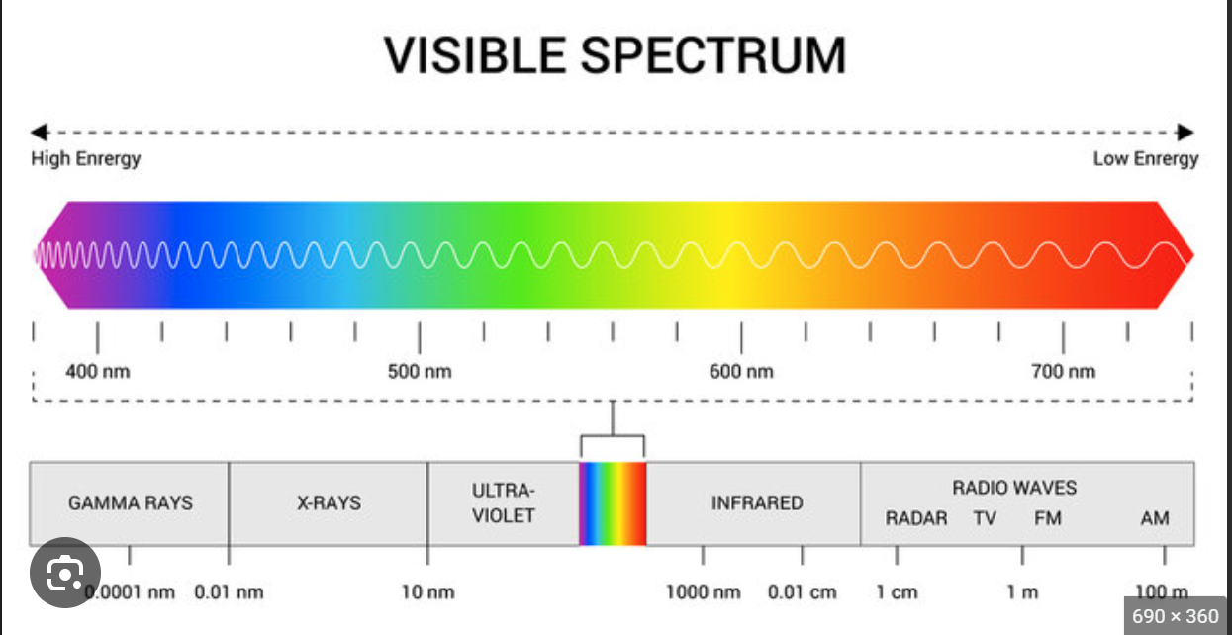

We remind ourselves of incandescent radiation: If the atoms of a body vibrate faster and faster (temperature increasing) then we see the body becoming Red hot , then Yellow hot then Blue hot. In reality the thermal radiation emitted from a body at a certain temperature T covers a range of wavelengths but might dominate (peak) at red, yellow wavelengths for example, depending on the temperature.
Experimentally we observe the range of wavelengths emitted for a perfectly emitting body:
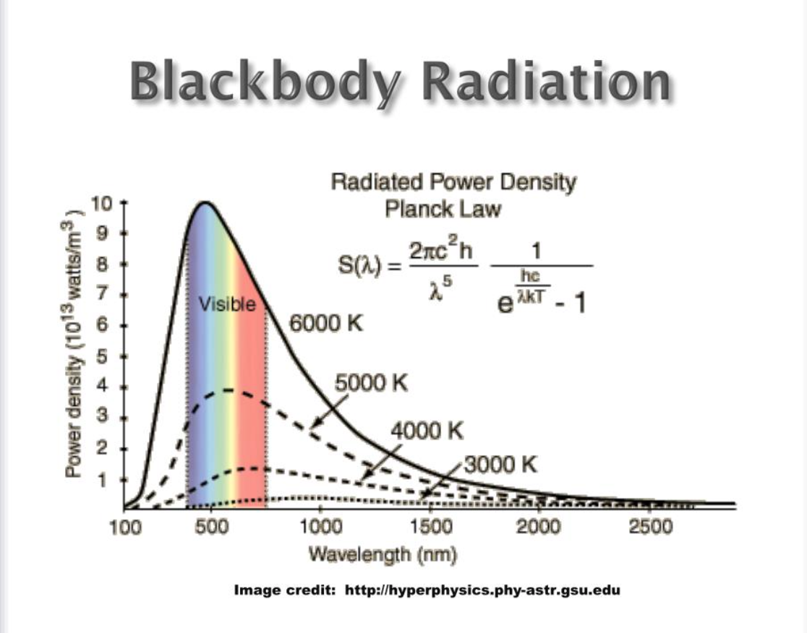
Clearly, for temperatures such as the human body ~ 35 º C ( i.e. 308.15 K ) the peak colour is not in the visible spectrum but is at longer wavelengths in the I.R. range.

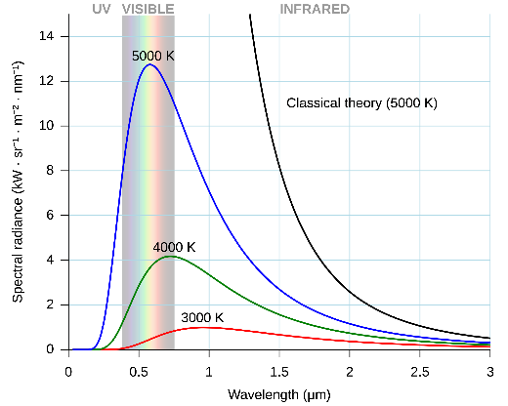
Wien’s formula allows us to work out the peak wavelength:

$$λpeak= \frac{2.898 E-3}{T}$$

example: if T = 308.15K then λpeak = 9.4 E-6 m or 9.4 μm which is well into the IR part of the E M spectrum.

What about the thermal radiation emitted from a body at a temperature T?
Consider a perfect (Black Body) body at a temperature T. It will be emitting E M radiation constantly. If the area of the body is A m² then the thermal radiative power emitted ( in Watts i.e. Joules per second) is:

radiative power = $\dot{q}$= σ ε A T⁴ Watts

where σ is Stefan Boltzmann constant = 5.67× 10⁻⁸ W m⁻² K⁻⁴
and ε is the emissivity of the surface of the body and ranges from 0 (totally reflecting) to 1 (black body ) .

example: what is the thermal radiative power from a body of surface area 3 m² and emissivity 0.8 if its surface temperature is 200º C ?
remember S.I. units : 300 C is 573.15 K .

radiative power = 5.67× 10⁻⁸ x 0.8 x 3 x 573.15⁴ Watts
= 14684.78 Watts to 2 D.P.

Example :
What is the peak wavelength of the thermal radiation from a perfect black body at a temperature of 1200 º C ?
From Wien’s formula :
$λpeak= \frac{2.898 E-3}{T}$ ₌ 2.898E-03 /1473.15 =

Background links:
Quantum Physics - Part 1 (Blackbody radiation, Wien's Displacement Law, Planck's Law)

