
\

Student name: Rina Lopez Garcia

Student ID: 2337019

Module name: Building your Personal Brand

Module code: BMHP5015

Lecturer name: Caroline Salami

Introduction
This assignment aims to reflect on the learning acquired from the Changemakers: Building Your Brand for Sustainable Employment module, emphasising its relevance to social and health care. I will focus on four main areas: well-being, identifying possibilities, global awareness, and personal branding. Through these reflections, I will demonstrate how a diverse and evolving workplace can shape my understanding of my abilities, professional growth, and career aspirations.
This assignment will discuss how Unit 1 supports my development of self-awareness and personal branding, how Unit 2 enhances my understanding of global connections and cultural competence, how Unit 3 enables me to identify and pursue opportunities, and, what is more, how Unit 4 emphasises the importance of resilience and work-life balance. Collectively, these areas will illustrate how I am preparing for a successful and sustainable career in health and social care.

Reflection on Unit 1: Brand You
To be prepared for future work in the health and social care sectors, Unit 1 concentrated on discovering personal strengths, self-awareness, ambition, and personal branding. The workshops were significant, because it inspired us to consider our future careers and the ways in which our personal traits impact employment prospects. Personal branding, I discovered, is more than just showcasing our abilities on a resume; it is also about knowing who we are, what drives us, and how we act in work settings (Aveyard and Sharp, 2017).

I was able to learn this in real-life experience. When I assisted a family member during a medical appointment, I noticed that they were nervous and had difficulty speaking to the medical specialist. Naturally, I intervened to help address their worries and ensure they understood the facts provided. I discovered that I had demonstrated empathy, patience, and communication skills without even realising it after the appointment. This made it easier for me to see that these qualities are crucial for future work in the health and social care sector.

Looking back to the lectures and online exercises, I became aware that I had not previously given my professional identity any thought. After finishing the Moodle forum exercise on future professional objectives, I expanded a better knowledge of my post-degree objectives. I realised that desire went beyond achieving professional success to include personal development and making a constructive contribution to society. I also realised that my patience and empathy are two qualities that are crucial in jobs involving health and social care. At the same time, I understood that I needed to boost my self-assurance when speaking in front of others in a professional context. This is consistent with Bandura's (2014) theory of self-efficacy, which emphasises the significance of self-assurance in the growth of professional competence.

The knowledge aquiured from this subject can be linked to scholarly theories that describe how people evolve. As an illustration, Johari's Window (Luft and Ingham, 2017) enables people to comprehend how their own and other people perceive their personal attributes. Group conversations and criticism helped me realise traits in myself that I had not previously fully acknowledged, such my calmness and support for others. This exercise made it clearer to me how crucial feedback is to raising self-awareness and enhancing professional conduct.

I also increased a better understanding of motivation in career planning through Self-Determination Theory (Deci and Ryan, 2017), which emphasises Autonomy, Mastery, and Purpose. Mastery motivates me to keep honing my professional skills, autonomy lets me pick a career path that aligns with my values, and purpose gives my work meaning, particularly when helping others in need.

Additionally, research indicates that motivation is critical to goal achievement since it motivates people to keep working through challenges (Locke and Latham, 2019). This made it clearer to me why establishing attainable professional goals is crucial for sustained success.
The importance of self-awareness and motivation in developing a professional identity and becoming ready for work in the health and social care sectors was, all things considered, made clear to me by Unit 1.

Figure 1: Forum activity on ambition

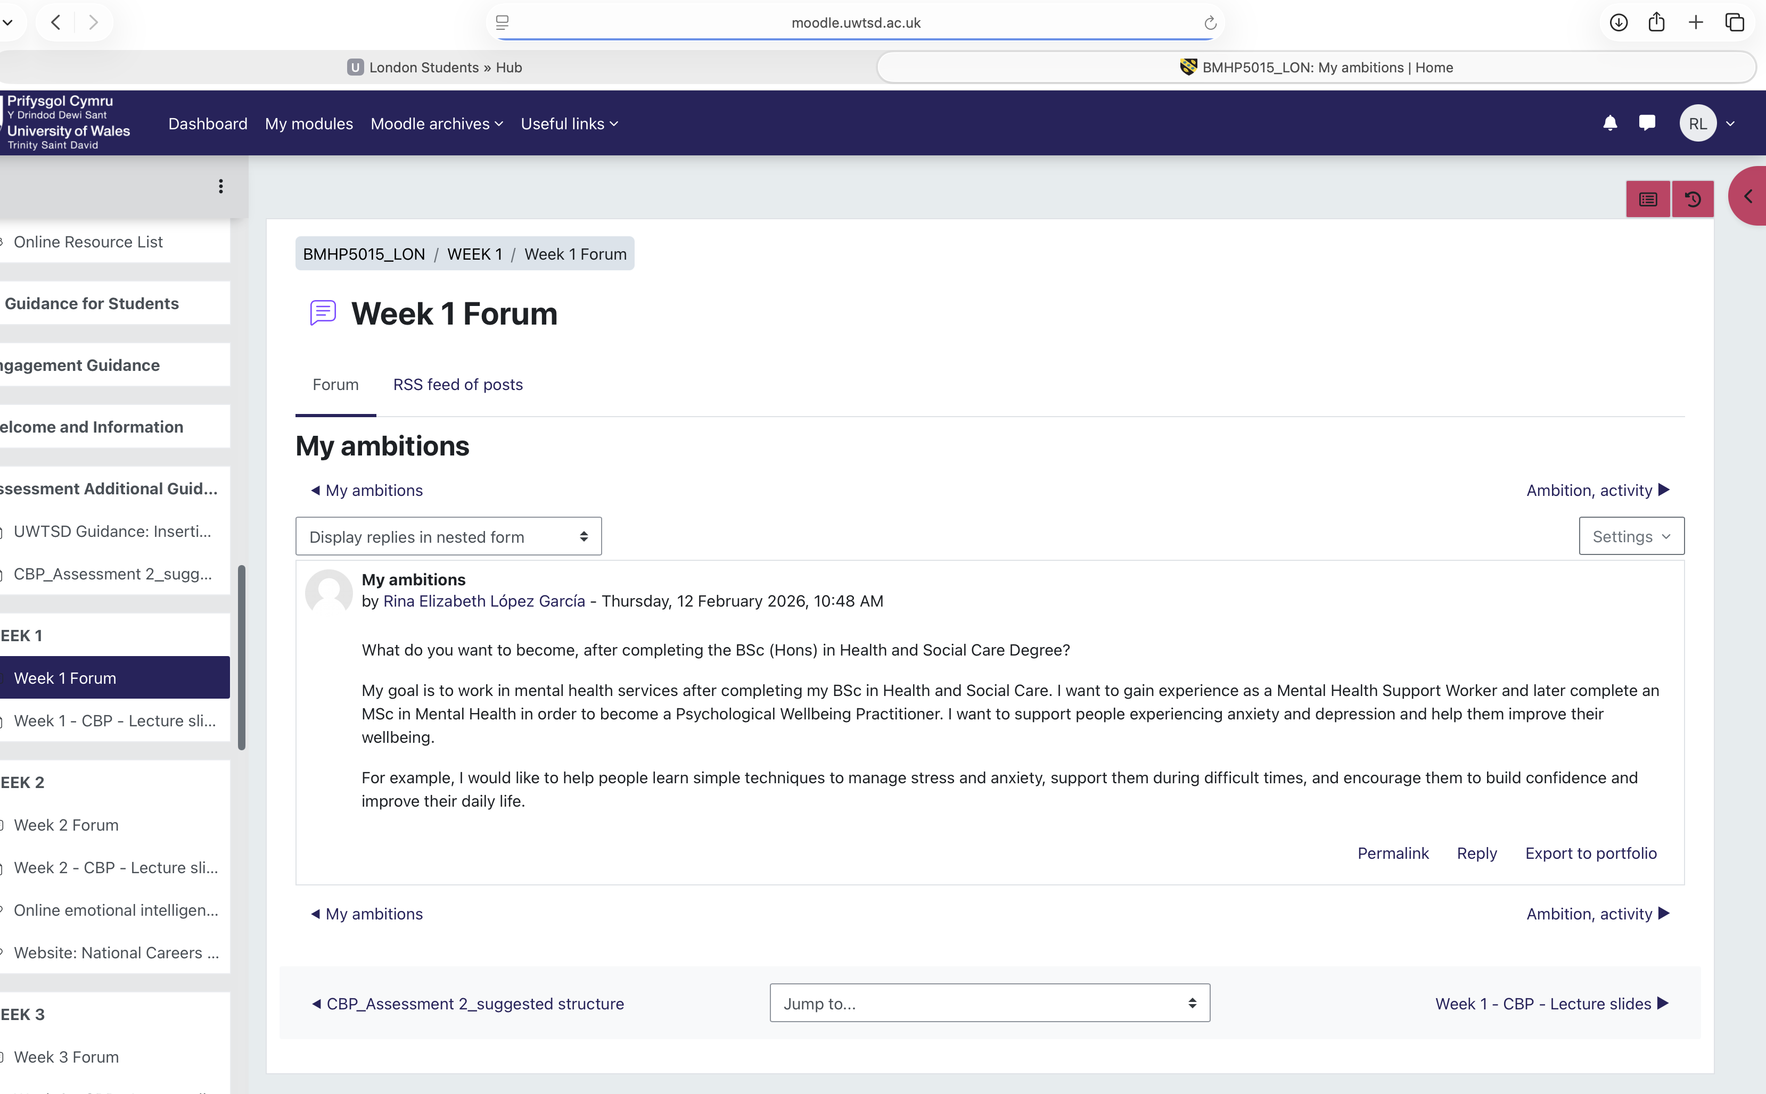

In my forum post, I talked about my future career ambitions and the steps I am taking to achieve them.

Figure 2: Forum Activity on Career goals

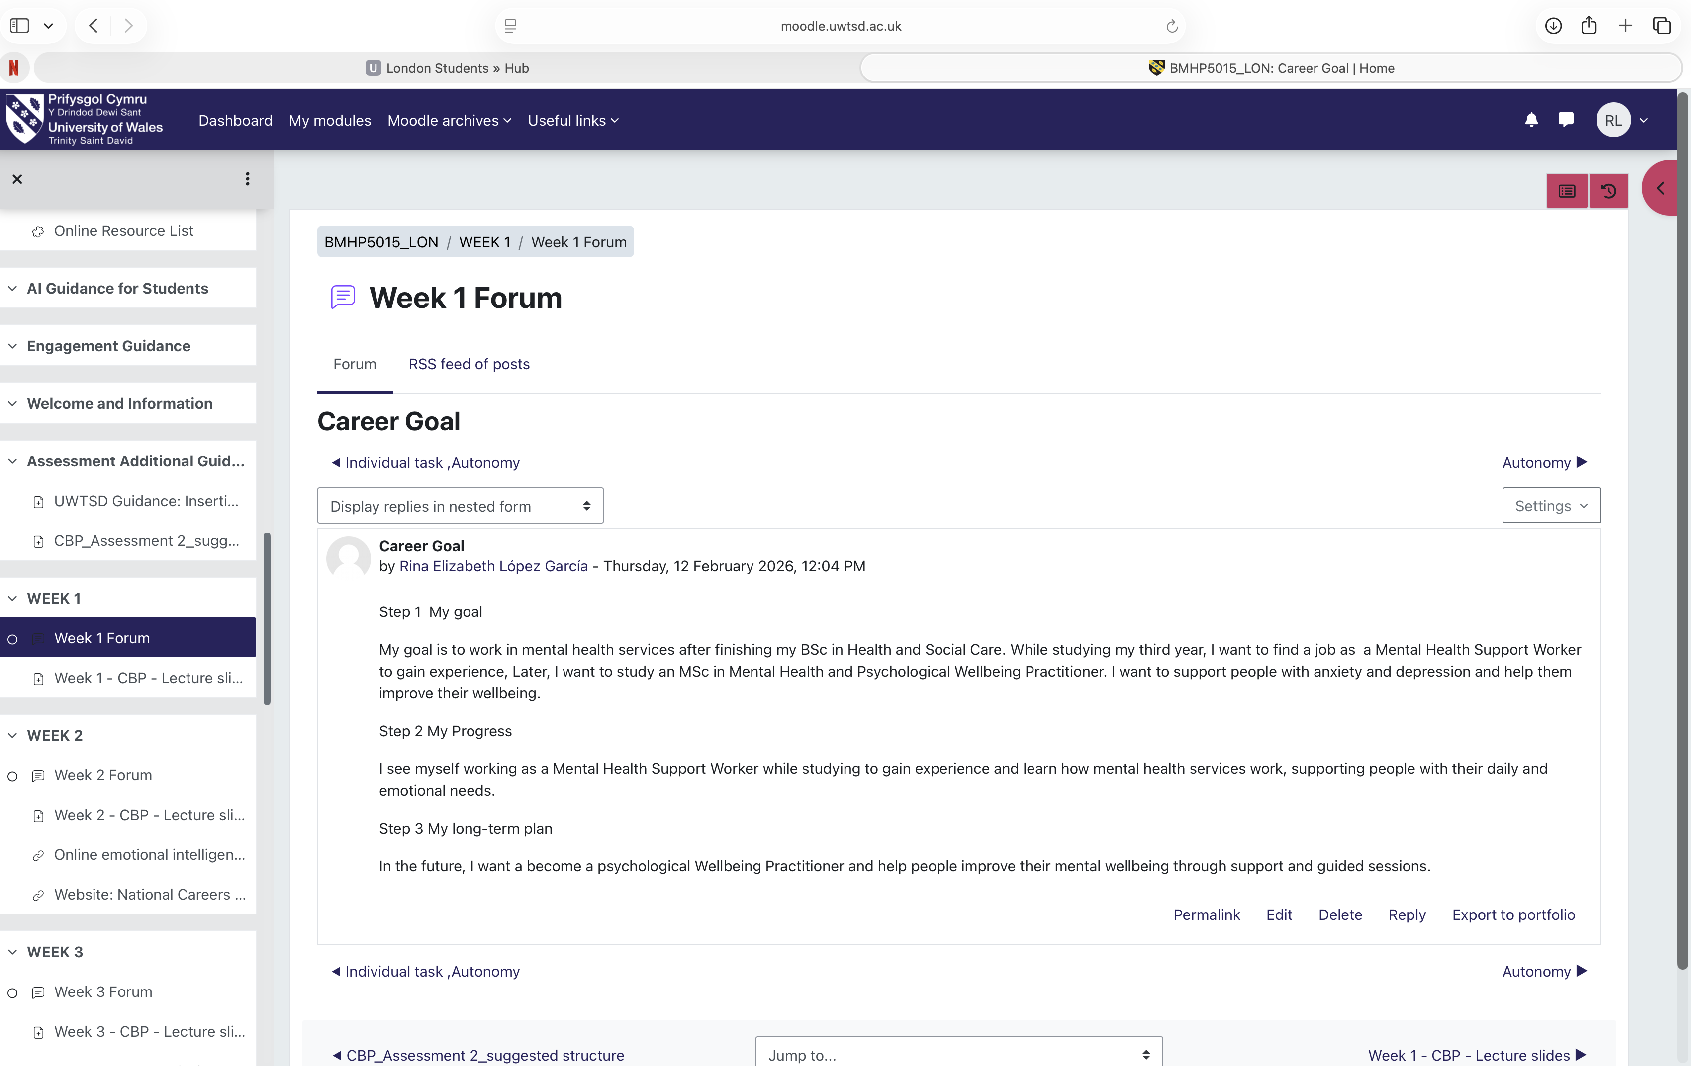

This screenshot shows my forum post about my career goal of becoming a Mental Health Support Worker

Figure 3: Forum Activity on Self-determination

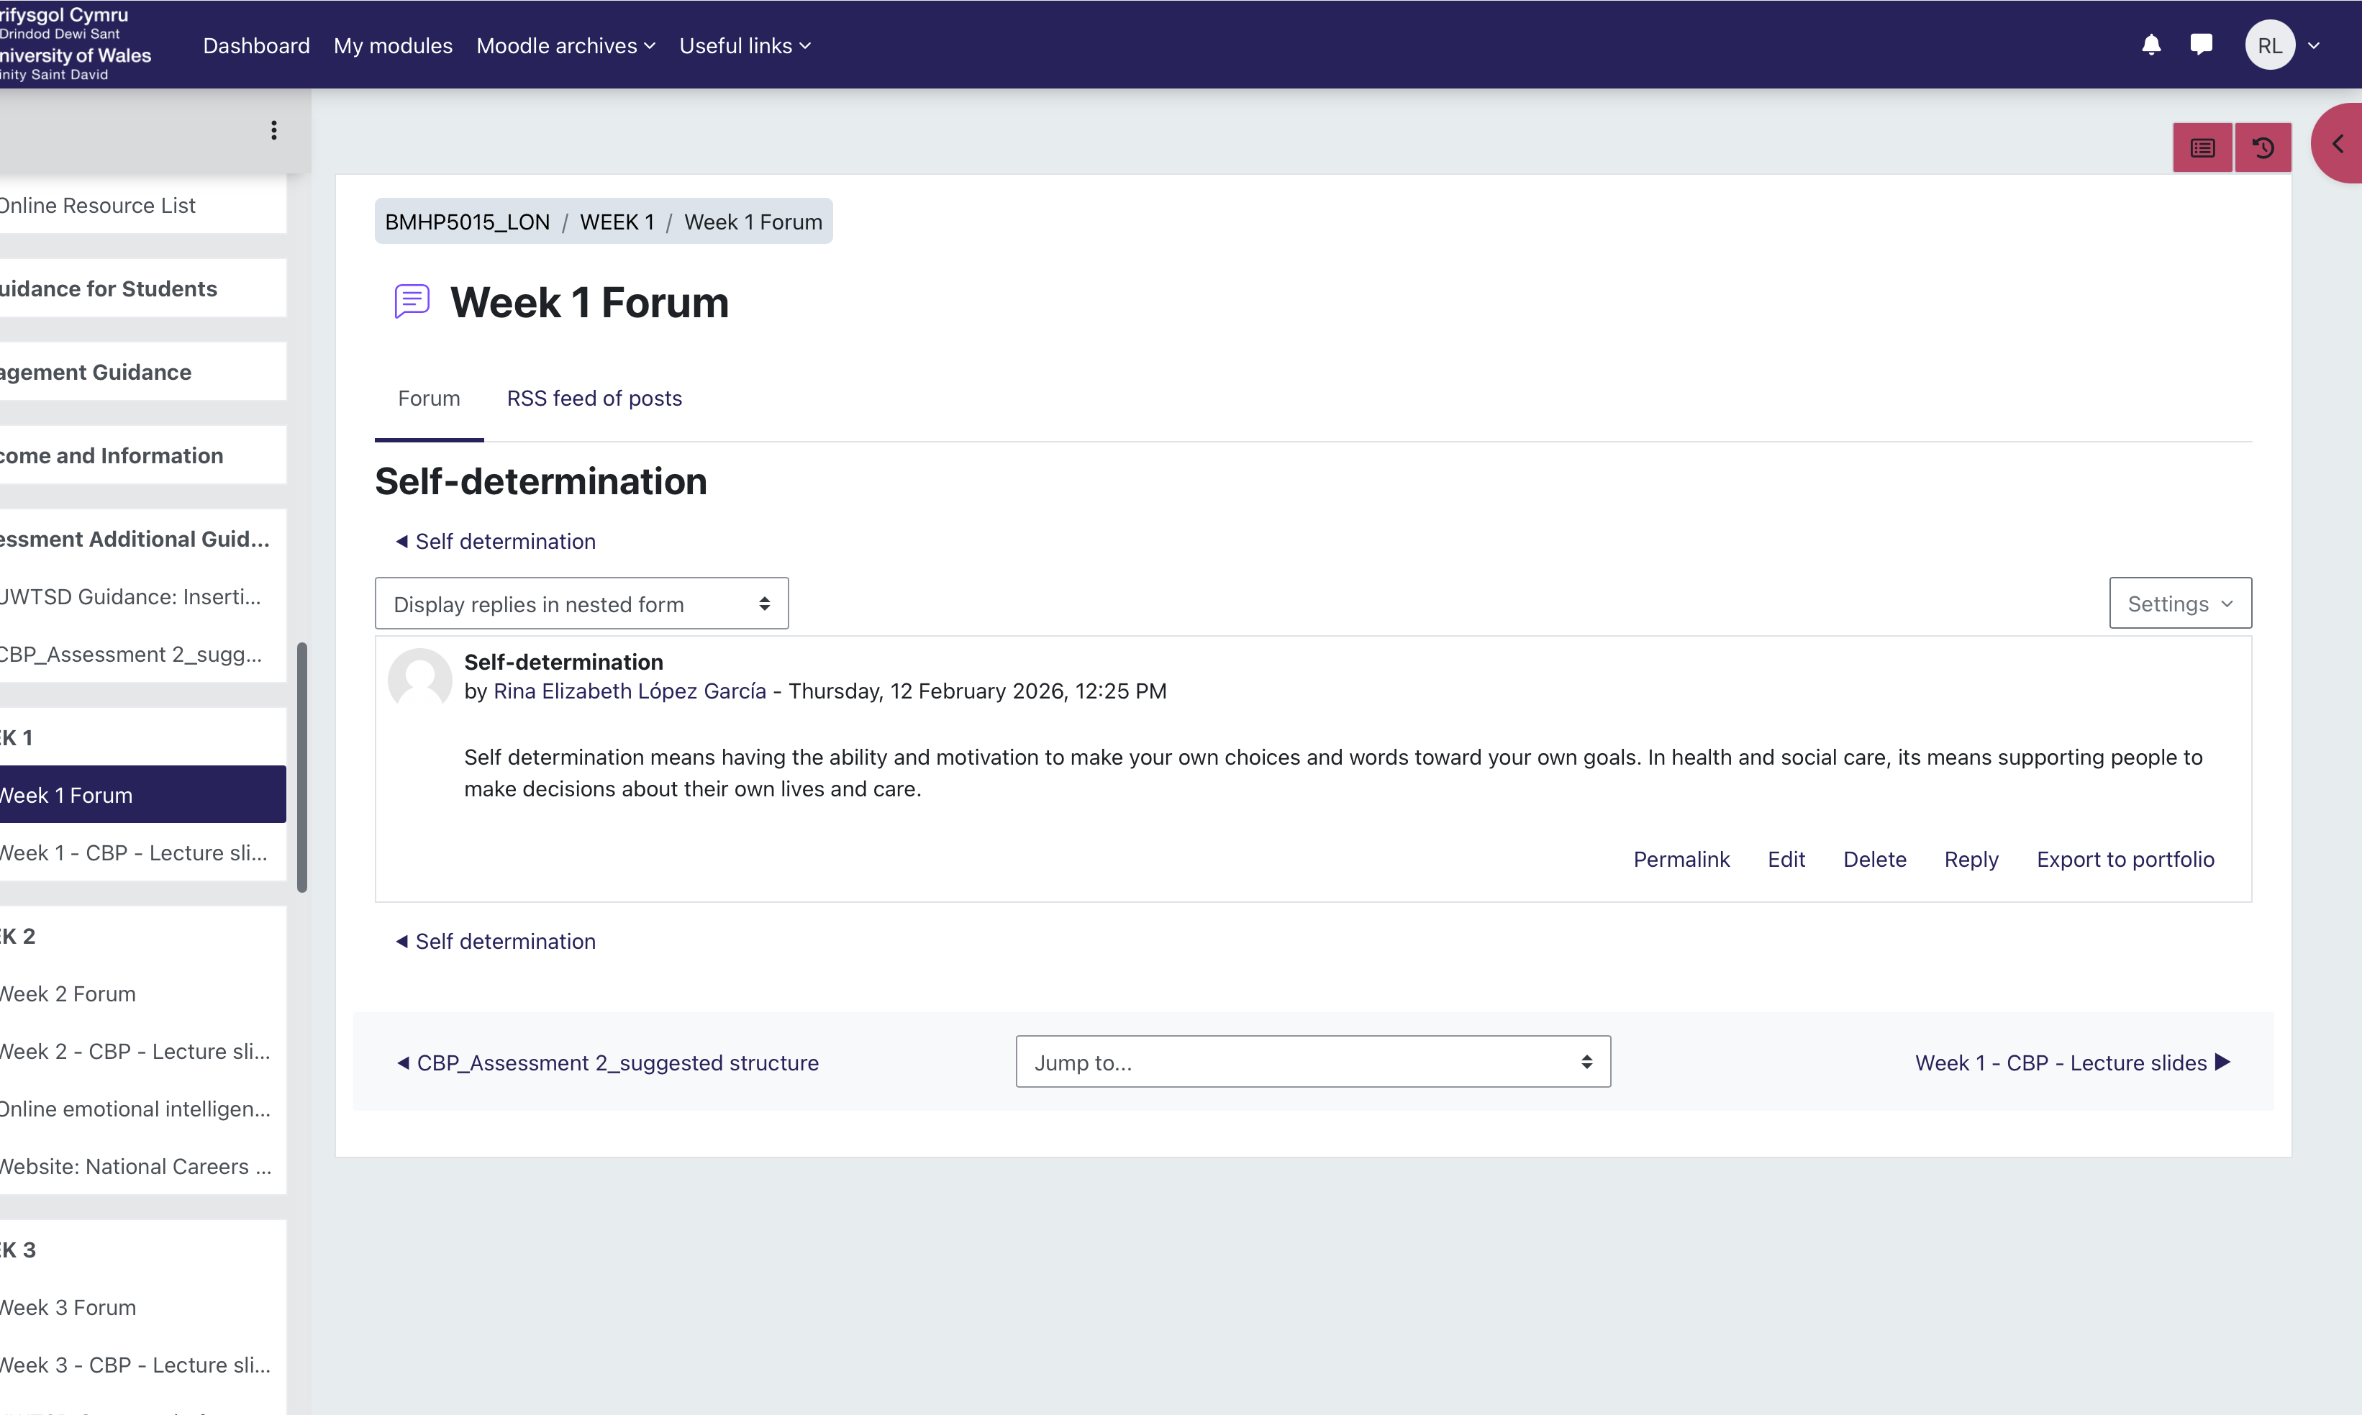
My forum post is about self-determination and making my own choices.

Reflection on Unit 2: It is a Small World

My understanding of diversity, cultural competency, global linkages, and boundaryless jobs in health and social care was broadened by Unit 2. In order to understand how globalisation affects professional practice, mobility, and skill development, the seminars pushed me to look beyond local employment. I came to understand that the healthcare industry now functions in a globalised, interconnected environment rather than being restricted to a single organisation or even a single nation (Hofstede, Hofstede and Minkov, 2014).
According to Arthur, Khapova, and Wilderom (2015), one of the most important ideas I learnt was the concept of a boundaryless career. I realised that contemporary careers are not linear or employer-specific. As an alternative, professionals may relocate across industries, organisations, and even nations. After giving this some thought, I saw how important flexibility and adaptation are in the fields of health and social care. The conversation regarding the gig economy, specifically per-diem healthcare positions, improved my comprehension of the advantages and disadvantages of flexible work arrangements. For example, I found that some nurses work on short-term contracts, which lets them move between different hospitals. This helps them gain a wide range of experiences, but it can also make their pay and job security less certain. This has helped me to be aware of the balance between independence and job security.

Cultural competency was yet another crucial learning area. Working in health and social care, I discovered, necessitates being sensitive to cultural differences in values, attitudes, and communication methods. Hofstede's Cultural Dimensions Theory (Hofstede and Minkov, 2014) outlines how cultural values like power distance or individuality versus collectivism affect behaviour. This is related to this theory. Comprehending these distinctions enabled me to see how crucial it is to steer clear of presumptions and provide person-centred care that honours cultural variety. A patient from a different cultural background, for instance, could favour family participation in decision-making above independent decision-making. This could result in miscommunication, a decline in trust, and worse health results if a healthcare provider is unaware of it. Nonetheless, communication, patient satisfaction, and treatment compliance can all be enhanced by honouring cultural preferences.

It was also highlighted that emotional intelligence is a skill that transcends boundaries. I discovered that emotional intelligence entails being able to identify and control my own feelings while also comprehending those of others (Salovey and Caruso, 2015). After finishing the emotional intelligence test, I gave some thought to how self-awareness enhances interactions with clients. This relates to Johnson (2015), who contends that emotional intelligence promotes both successful professional practice and patient-centered care.

I now have a more comprehensive awareness of global health challenges like labour mobility, cultural diversity, and changing job arrangements thanks to this class. I came to understand that in order to thrive in a global healthcare setting, I need to constantly hone transferable skills like emotional intelligence, communication, and flexibility.

My perspective of health and social care as a globally interconnected profession has generally been influenced by Unit 2. I was able to embrace diversity, realise the value of cultural competency, and comprehend how boundaryless talents enhance professional resilience in a global setting. I have now enrolled on a course for emotional intelligence at BMJ Learning to improve my emotional intelligence skills.

Figure 4 Soft Skills

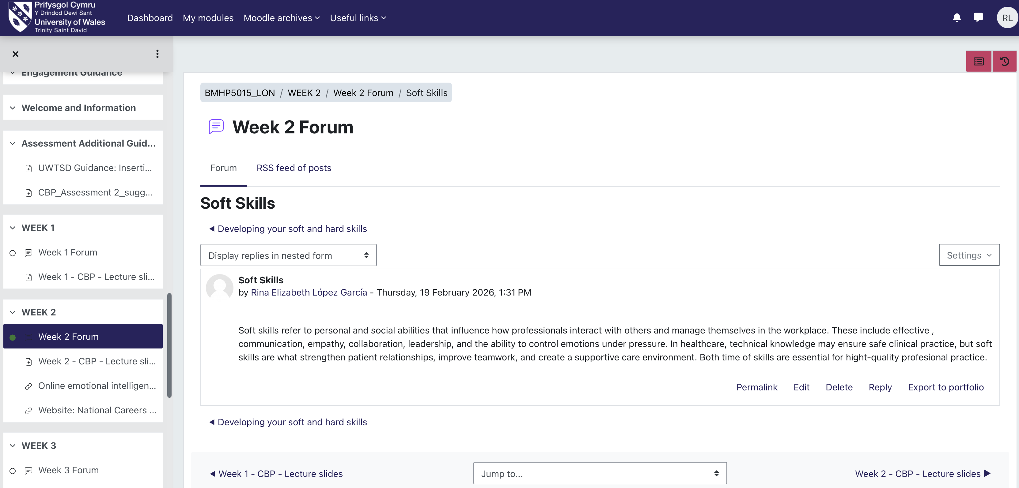

This screen shot shows, where I discussed the role of soft skills in health and social care.

Figure 5 Boundaryless Careers

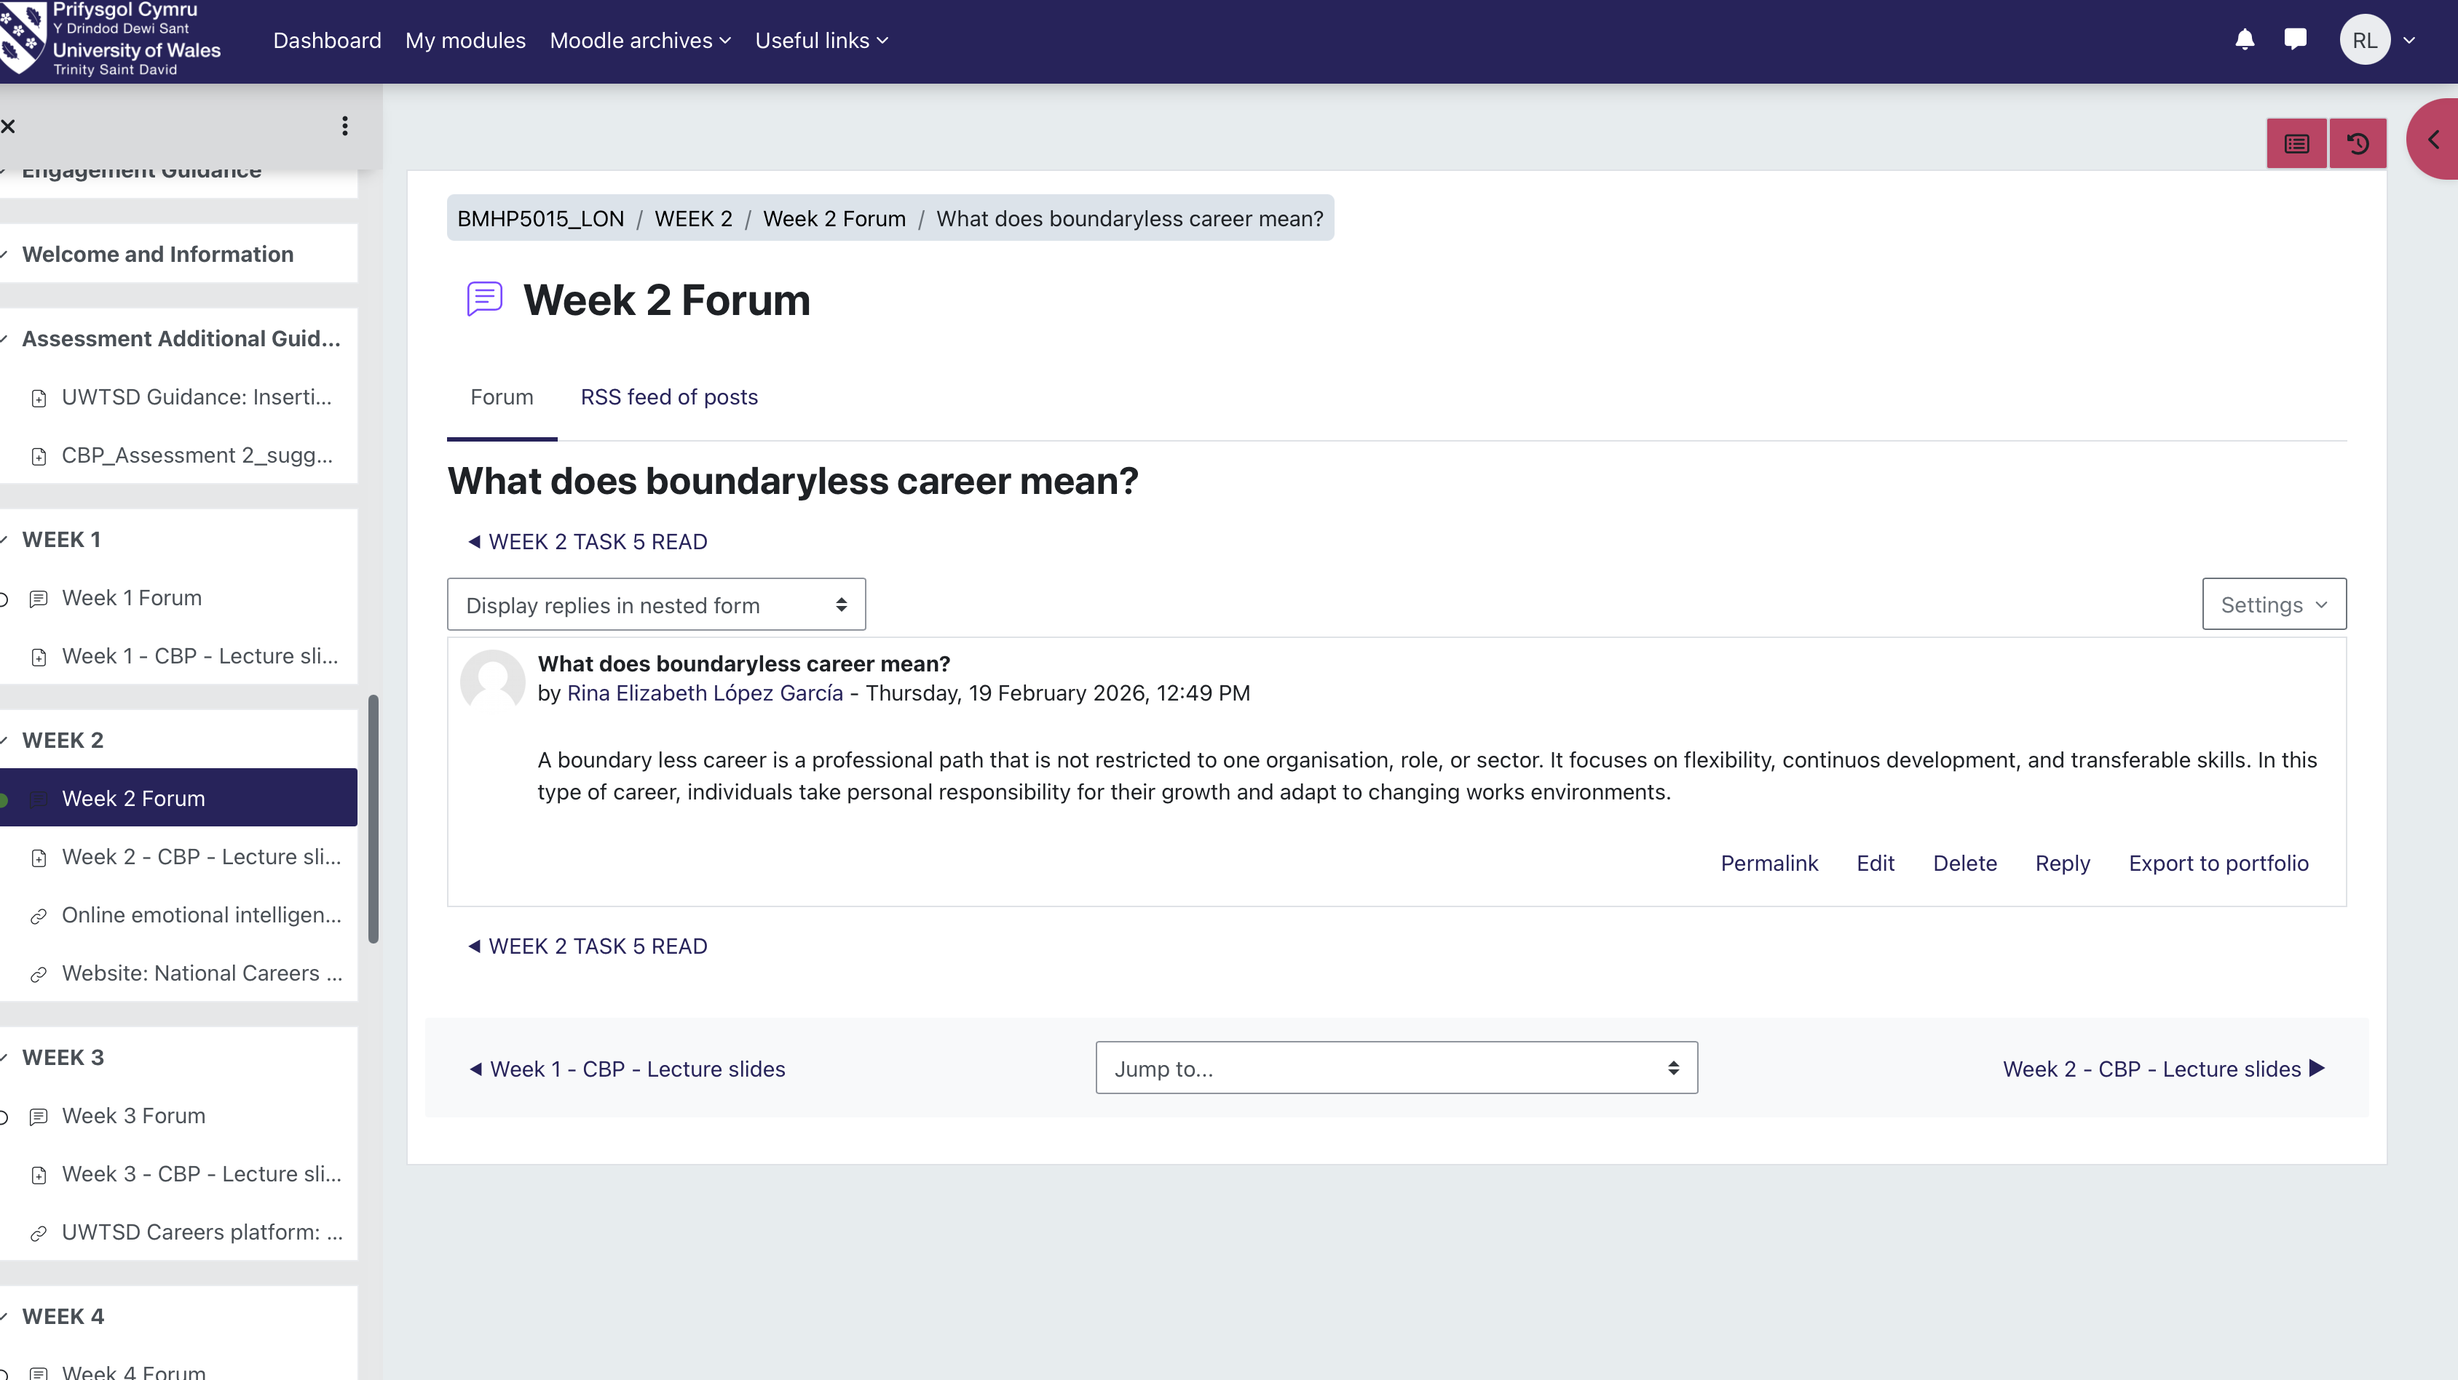

This screenshot shows my forum post on boundaryless carrers and the importance of flexibility in health and social care.

Reflection on Unit 3: Opportunity Knocks

Unit 3 taught us how to identify and seize chances. We discussed identifying opportunities, setting objectives, planning personal development, and projecting a professional image. I came to see that opportunities are not always clear-cut or solely dependent on good fortune. We may recognise and even generate new opportunities by being vigilant and proactive.

I learned how crucial it is to see things from several angles from the lectures and exercises we did in class. This makes it easier for us to spot opportunities we might otherwise overlook. Being adaptable and managing difficult situations is crucial in the fields of health and social care (Bury, 2013). Additionally, I have found that helping and networking can lead to career opportunities. However, reflecting on all this I recognised my strengths and weaknesses. One of my gifts, for instance, is my willingness to help others and my approachability, which fosters partnerships. However, I am not always confident enough to approach strangers. I intend to progressively push myself outside my comfort zone by actively engaging in conversations and networking events to move past this.

My understanding of the serendipitous attitude was profound. I realised that being open to unforeseen possibilities and appreciating their worth are just as important as luck (Heinström and Sormunen, 2020). This relates to the Planned Happenstance Theory, which holds that when people are open and proactive, unforeseen circumstances can affect professional achievement. Attending a networking event or conversing with a professional or professor, for instance, may unintentionally lead to a career opportunity or placement.

Goal setting was further developed using the SMART framework. Breaking my goals into specific, measurable, achievable, relevant, and time-bound steps made them feel more realistic and achievable. This links to Locke and Latham’s Goal-Setting Theory (2019), which explains that structured and challenging goals improve performance and motivation. I found that having clear goals gave me direction and increased my confidence.

We also made steps evable, relevant, and time-based, which made them easier to reach. This aligns with Locke and Latham’s Goal-Setting Theory (2019), which states that clear and challenging goals improve performance and motivation. Setting clear goals helped me stay focused and feel more confident.

To facilitate my reflection, I applied Gibbs' Reflective Cycle (1988). At the "description" stage, I reviewed class activities. During the "feelings" stage, I acknowledged uncertainties about my future. In the "action plan" stage, I resolved to enhance my confidence and communication skills. This structured approach enabled me to evaluate my progress and develop targeted strategies for improvement.

I realised how important it is to keep a professional presence, especially online. Building a strong profile and connecting with others in the field can lead to new opportunities and help build valuable relationships in health and social care (Aveyard and Sharp, 2017).

Figure 6 What does Serendipity mindset mean?

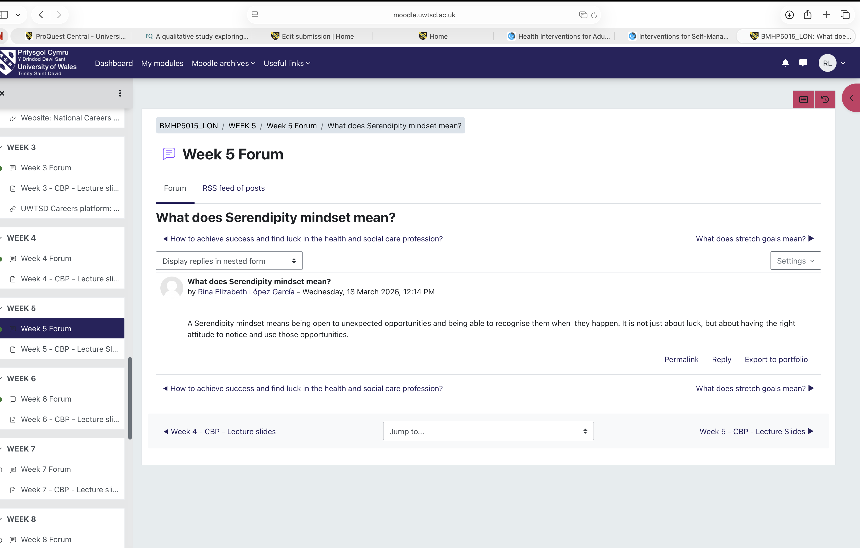

This screenshot shows explaining the concept of a serendipity mindset.

Figure 7 What does stretch goals means?

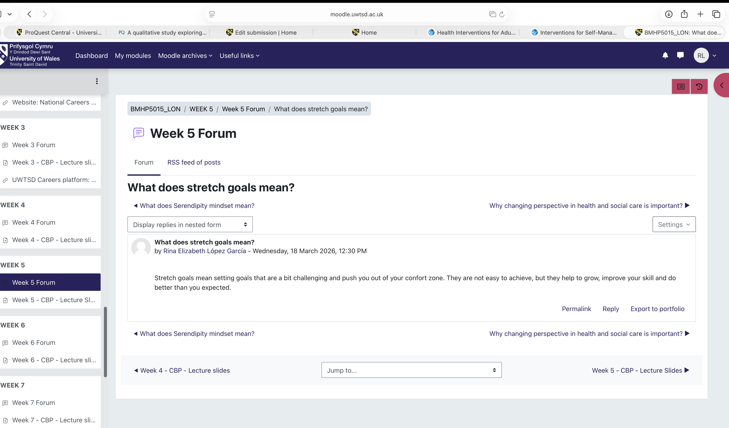
In this forum post, I discuss stretch goals and their importance in development.

Reflection on Unit 4: The Pursuit of Happiness
For long-term success in the health and social care sectors, Unit 4 emphasised the significance of resilience, wellbeing, and work-life balance. In light of Maslow's Hierarchy of wants, which holds that contentment depends on satisfying psychological and self-actualisation wants, I came to see that emotional and mental well-being is just as crucial as enhancing professional skills.
I added a deeper understanding of resilience and how experience and introspection can strengthen it over time (Bury, 2013). For instance, juggling my personal and academic obligations improved my time management, prioritising, and my ability to ask for help when I needed it.
I learned that positive emotions, engagement, connections, meaning, and achievement all impact well-being, according to Seligman's PERMA model (2018). I realised that fostering close bonds with others and discovering a purpose in serving them might boost motivation and job happiness.
I also discovered that keeping a healthy work-life balance is crucial to avoiding burnout. This relates to the Goal-Setting Theory (Locke and Latham, 2019), as establishing specific short- and long-term goals facilitates efficient time management and reduces stress. Additionally, making self-care a priority—that is, taking pauses and giving yourself time to unwind—supports both performance and wellness.
Overall, I now recognise that true success goes beyond achieving goals; it also requires sustaining resilience, maintaining balance, and supporting overall wellbeing.

Figure 8 How does blogging helps in health and social care?
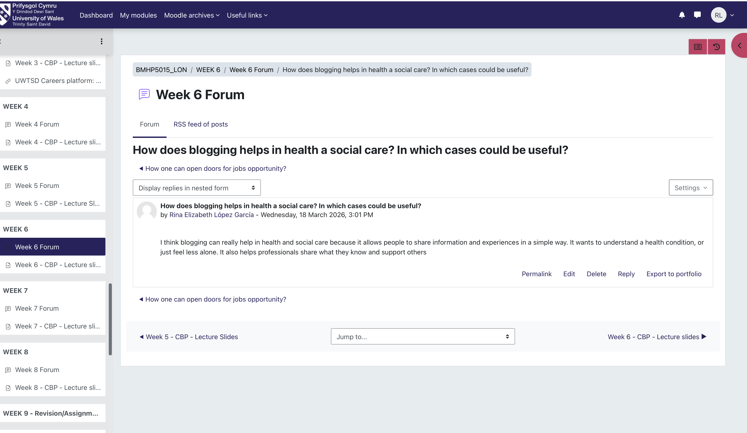

In this forum post, I reflect on how blogging can support wellbeing by helping individuals share experiences and feel less isolate

Figure 9 Why changing perspective important in Health and Social Care?

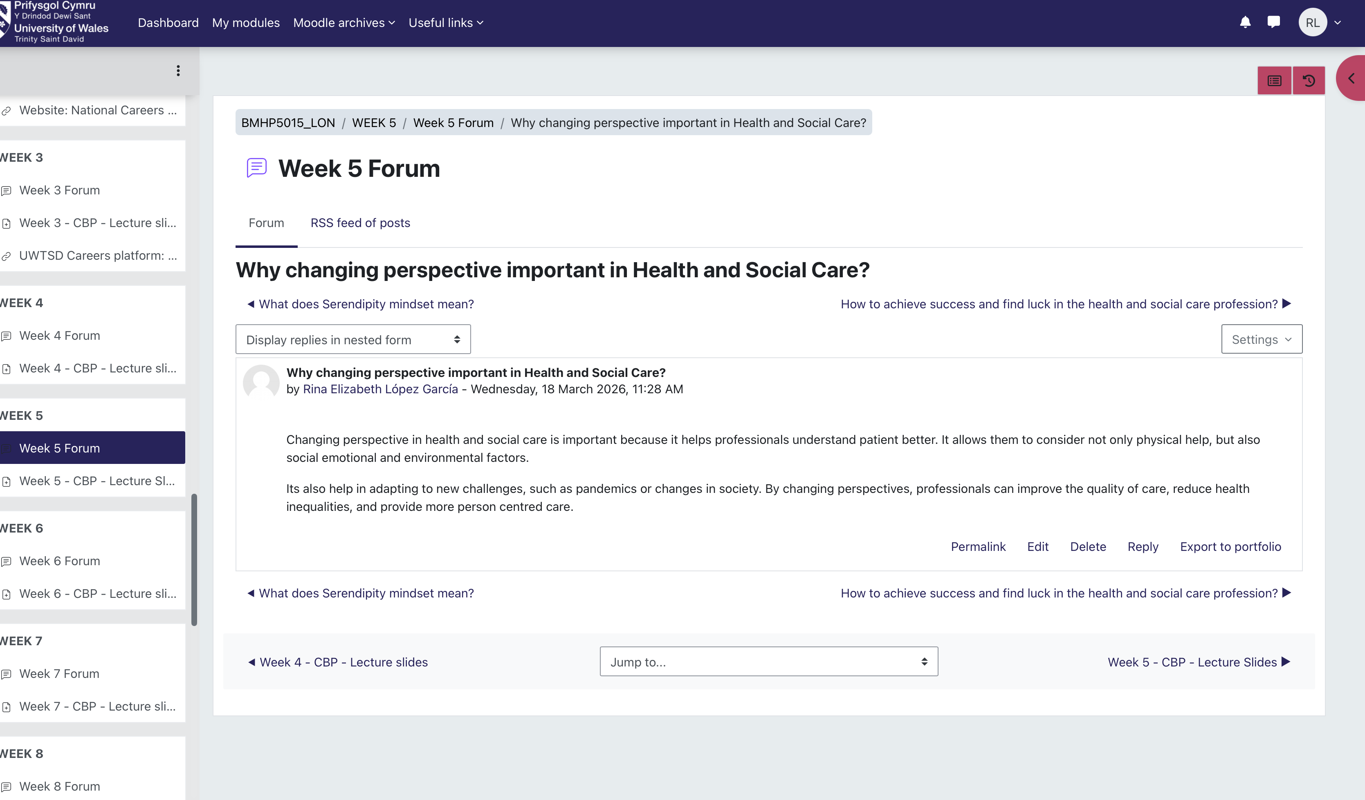

This example reflects my understanding of how changing perspective supports person-centred care and improve wellbeing in health and social care.

Conclusion
The learning from the Changemakers: Building Your Brand for Sustainable Employment module will be reflected in this assignment, with an emphasis on its relevance to social and health care. It will look at four main areas: well-being, identifying possibilities, global awareness, and personal branding. I will show through these thoughts how a varied and changing workplace can influence my perception of my talents, professional development, and career objectives.
This assignment will go over how Unit 1 will help me become more self-aware and build my personal brand; Unit 2 will help me better understand global connections and cultural competency; Unit 3 will help me find and seize opportunities; and Unit 4 will highlight the value of resilience and work-life balance. Overall, it will demonstrate how these areas will help me become ready for a successful and long-lasting job in health and social care.

References
Arthur, M.B., Khapova, S.N. and Wilderom, C.P.M. (2015) ‘Career success in a boundaryless career world’, Journal of Organizational Behavior, 26(2), pp. 177–202.
Aveyard, H. and Sharp, P. (2017) A beginner’s guide to evidence-based practice in health and social care. 3rd edn. Maidenhead: Open University Press.
Bandura, A. (2014) Self-efficacy: The exercise of control. New York: Worth Publishers.
Bury, M. (2013) Health and illness in a changing society. 3rd edn. London: Routledge.
Deci, E.L. and Ryan, R.M. (2017) Self-determination theory: Basic psychological needs in motivation, development, and wellness. New York: Guilford Press.
Gibbs, G. (1988) Learning by doing: A guide to teaching and learning methods. Oxford: Oxford Polytechnic.
Heinström, J. and Sormunen, E. (2020) ‘Serendipity as discovery: Exploring the role of personality and sense of coherence’, Journal of Documentation, 76(3), pp. 653–672.
Hofstede, G., Hofstede, G.J. and Minkov, M. (2014) Cultures and organizations: Software of the mind. 3rd edn. New York: McGraw-Hill.
Johnson, D.R. (2015) ‘Emotional intelligence as a crucial component to medical education’, International Journal of Medical Education, 6, pp. 179–183.
Locke, E.A. and Latham, G.P. (2019) ‘The development of goal setting theory: A half century retrospective’, Motivation Science, 5(2), pp. 93–105.
Luft, J. and Ingham, H. (2017) ‘The Johari Window: A model for self-awareness’, in Group processes: Theory and research.
Salovey, P., S, J.D. and Caruso, D.R. (2015) ‘Emotional intelligence: Theory, findings, and implications’, Psychological Inquiry, 15(3), pp. 197–215.
Seligman, M.E.P. (2018) ‘PERMA and the building blocks of well-being’, The Journal of Positive Psychology, 13(4), pp. 333–335.

