Lab assignment 2 –Titration
For:
Module ACDB4011 – OME Chemistry
Produced By:
Leo Oliver Smith (2217998)
On:
15th April 2023

Lab Partner:
Alex Lamdin

Table of Contents
Table of Figures 2
1.0. Experimental Aims 3
2.0. Underlying Theory 3
2.1. Chemical Fundamentals 3
2.2. Application 4
3.0. Chemicals and Equipment 4
3.1. Chemicals 4
3.2. Equipment 5
4.0. Procedure 5
5.0. Observation and Data 6
6.0. Calculations 7
7.0. Sources of Experimental Error 11
8.0. Conclusion 11
References 12

Table of Figures
Figure 1 6
Figure 2 7
Figure 3 8
Figure 4 9
Figure 5 10

Experimental Aims
Within the level four chemistry module the concept of basic quantitative chemistry was introduced. Quantitative chemistry is a branch of chemistry dedicated to calculating the exact quantities of components within a sample, in the form of fundamental calculations [1]. In the case of this module, finding the mass, molar mass and concentration of substances through theoretical calculations was studied. The module also aimed to provide an understanding of Quantitative Analysis; Any method of determining the amount of chemical in a sample [1]. As such, students were tasked with conducting a basic laboratory experiment to consolidate their understanding of the topic.
Within this experiment students were asked to use quantitative analysis techniques to identify the concentration of a known acid (HCl). This was done through analyzing its neutralization reaction with a fully characterized solution of alkali (NaOH). The following lab report outlines the theory behind the experiment conducted, its results and the conclusions that may be drawn from it.

2.0. Underlying Theory

2.1. Chemical Fundamentals

The most common method used to find an unknown concentration of acid or base is titration. Titration is defined as a laboratory technique which is used to find the exact volume of the acid with unknown concentration needed to neutralize a known volume and concentration of base [2]. As this report aims to find the concentration of HCl using a known solution of NaOH the following neutralization equation is studied.
HCl + NaOH -> H₂O + NaCl
Before starting titration, the concentration of the known solution must be accurately identified [3]. This is important as this value will be used to calculate the concentration of the unknown, hence inaccuracies here will lead to an incorrect result. To ensure this accuracy we use a standard solution; A solution of highly accurate known concentration often to four or more decimal places. [4]
This standard solution is then used as a titrant; the solution of known concentration added to the unknown. This titrant is added to a known volume of analyte, solution of unknown concentration, until neutralization has been reached. The volume of titrant is then recorded as a titre. It should be noted that the endpoint of titration, or point of neutralization, is often identified using an indicator [5]. Indicators are chemicals added to the titrating solution which produce a visual change when the end point of a titration has been reached. An example of this would be phenolphthalein which produced a pink colour in alkali conditions [3]; A very slight colour change indicates neutralisation has been reached.
Once a titre has been completed it is best practice to repeat the process until multiple concurrent titres are achieved. These are titre within 0.1 cm³ and by averaging concurrent titres accuracy is increased and uncertainty reduced.
The mean titre can then be used to calculate the number of moles of base required for neutralization using the following equation:
Number of moles of base = Concentration of Titrant x Mean Titre
As the stereochemical equation for neutralization gives the ratio of products, the number of moles of acid can be calculated by scaling in the relevant ratio. This then allows the calculation of the analyte concentration through the following equation [3]:
Concentration of Analyte =(Number of moles of acid)/(Volume of analyte)

2.2. Application

Within the field of OME more complex titration methods may also be used to great effect. One example of this would be the analysis of explosive compositions via nonaqueous titrations. This more complex methodology can be used to identify the precise quantity of constituents within explosive compounds aiding with identification and quality. [6]
Another example of this is the titration of the high explosive e 3-Nitro-1,2,4-triazol-5-one (NTO). This explosive, when in an aqueous solution, acts as a weak acid (pK_{a} 3.76) due to two liable N-H bonds within its structure. This acidic behavior means the concentration of explosive within the analyte can be identified by acid base titration as performed in this report. This then allows titration to be used as a means of quality control during the manufacture of the explosive composition. An equal mass of the explosive is titrated and the concentration of NTO recorded. This can then be compared to assess whether the batch has the correct purity levels. [7]

3.0. Chemicals and Equipment

3.1. Chemicals
- 100 mL of NaOH standard solution (0.1002 mol/L)
- 100ml of HCL solution (Unknown concentration to be calculated)
- Phenolphthalein Indicator

3.2. Equipment
- Protective safety goggles
- Lab coat
- Nitrile gloves
- Burette (50/100 mL)
- Funnell
- Clamps
- Clamp stand
- White tile
- Graduated pipette (10mL)
- Pipette filler
- Conical flasks (250mL)
- Waste disposal beaker

4.0. Procedure
[8]
- Flush burette with small amount of standard solution (NaOH)
- Fill burette using funnel with standard solution above 0 mark and drain to 0 mark. This removes air gap in the tap increasing accuracy. Ensure funnel is removed to avoid any extra solution entering burette after measurements have been taken.
- Fill 25mL of HCl solution into a clean conical flask using pipette. May wash flask with distilled water as this doesn’t affect the number of moles of HCl.
- Add a few drops of Phenolphthalein Indicator and place on white tile to better show color change.
- Conduct titration by adding NaOH to HCl until the indicator undergoes a definite, permanent colour change. Calculate the titre by recording difference in burette reading before and after. Ensure readings are taken from the bottom of the meniscus and at eye level to prevent parallax error.
- Initially a rough titre should be conducted. This can be done quickly, giving an indication of the approximate neutralization point.
- All following titrations should be done as accurately as possible adding the NaOH slowly as the neutralization point is approached. Accurate titrations should be repeated until concurrent titres (less the 0.1mL apart) are produced.

5.0. Observation and Data
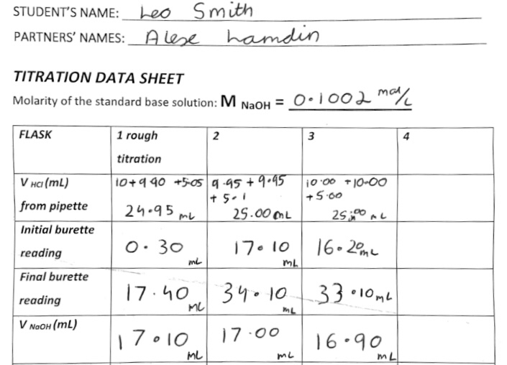
Figure 1

6.0. Calculations
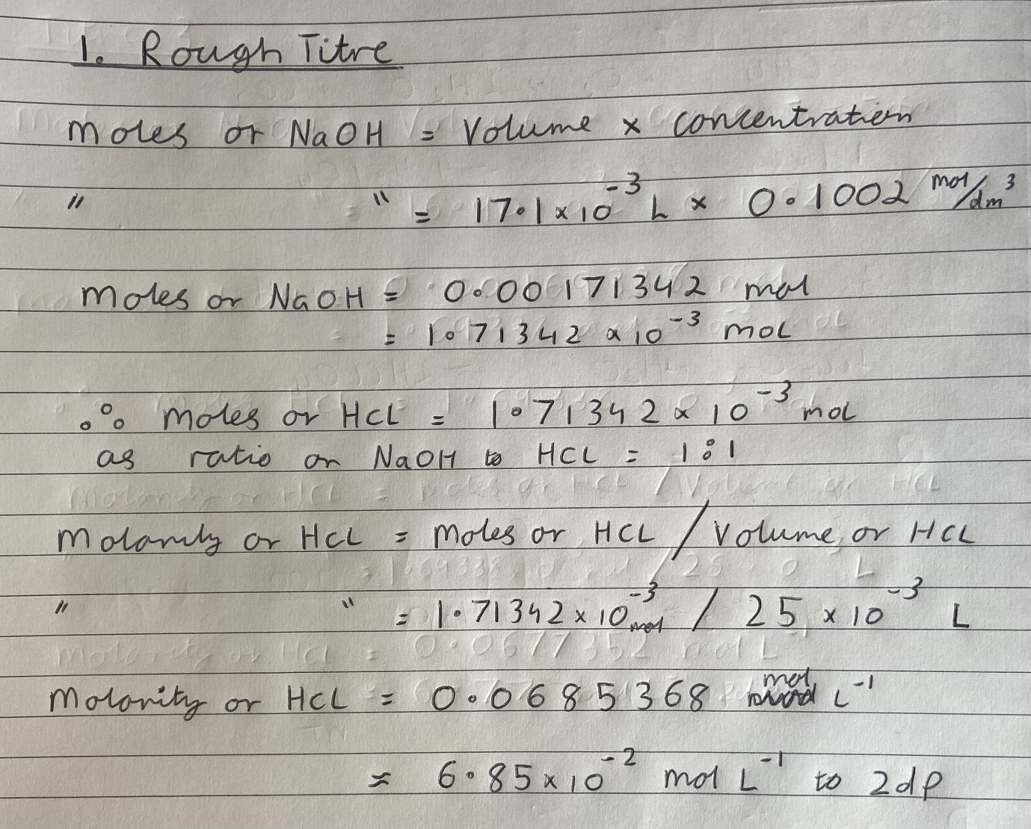
Figure 2
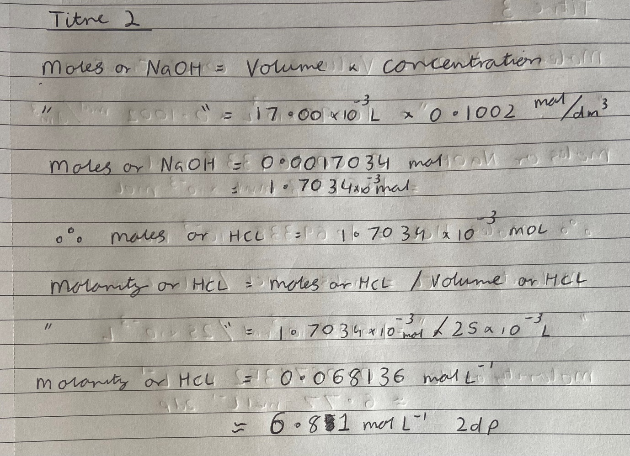
Figure 3
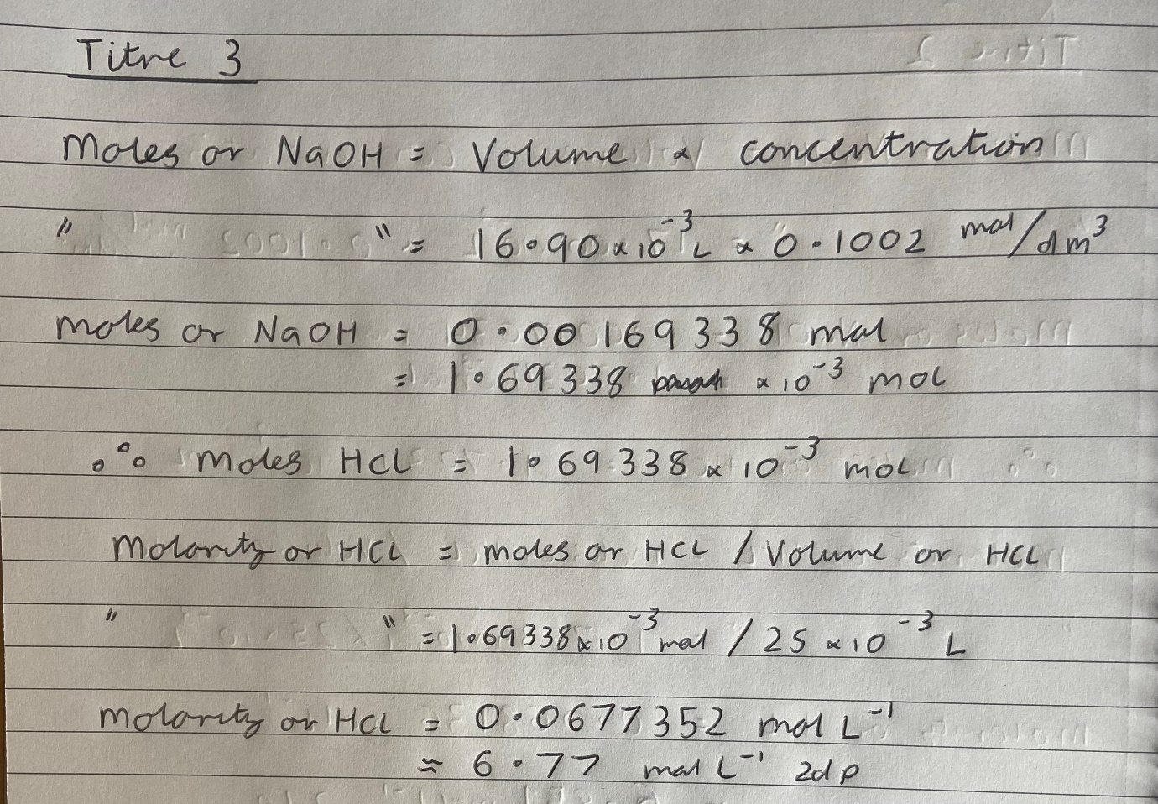
Figure 4
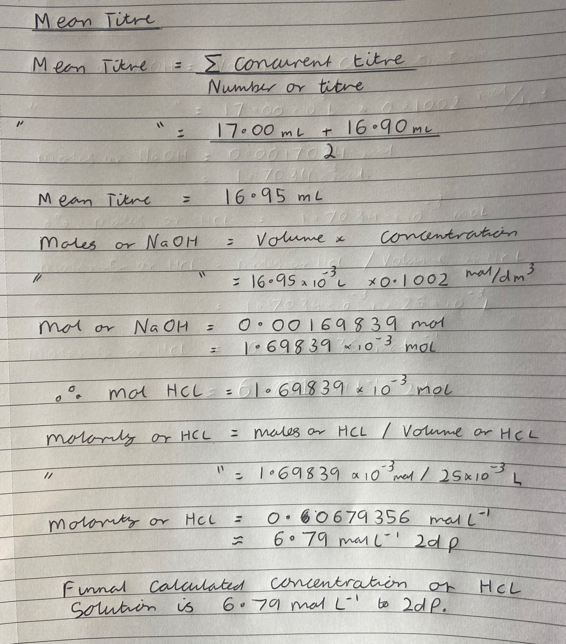
Figure 5

Sources of Experimental Error
Although titration is one of the most accurate means of calculating the concentration of an unknown solution it, like all experiments, is prone to error. The main causes of error are given below:
Parallax Errors:
This is where measuring equipment such as burettes and pipettes are misread due to the angle they are looked at. Unless the readers eyes are perfectly horizontal to the scale the bottom of the meniscus will appear to be less (if eye is above) or greater (if eye is below). This hence results in an incorrect measurement and calculated concentration.
Compound Uncertainty:
Every piece of equipment used to measure the volumes of chemical in this experiment has uncertainty bounds. This is a slight deviation of the measurement the equipment gives compared to reality. Increasing the number of measurements compounds this. For example, when measuring out 25mL of acid the graduated pipette was used three times. This means the error is three times that of using a single 25mL volumetric pipet of the same uncertainty. Although minor this will affect the result.
End Point Recognition:
This is the most common source of error in titration experiments [9] and is where the indefinite nature of an indicator effects the result. Indicators change over a very small range of PH’s and at neutralization may only produce an extremely slight color. As such identifying when this color occurs is difficult and may appear different from person to person. This changes when the titration is stopped introducing a source of error that affects the results.

8.0. Conclusion
The titration experiment conducted followed a well-recognized method to succeed in calculating the concentration of the HCl solution. The final calculated concentration found using the mean of the concurrent titres was 0.06794 mol/L to four significant figures. This is the highest degree of accuracy that may be used as both the concentration of NaOH and volumes were also to this degree. Although sources of error were present in this experiment there effect on the final answer would be small and so the answer found may be quoted in confidence.

References

[1] | Royal Society of Chemistry, “Quantitative chemistry,” [Online]. Available: https://www.rsc.org/cpd/resource/RES00001328/quantitative-chemistry. [Accessed 15 April 2023].
[2] | C. Schaschke, “Titration,” in A Dictionary of Chemical Engineering, Oxford University Press, 2014.
[3] | M. W. Lister and W. A. E. McBryde, “ ACID-BASE TITRATIONS,” in Elementary Experimental Chemistry, University of Toronto Press, 1959.
[4] | C. Schaschke, “Standard Solution,” in A Dictionary of Chemical Engineering, Oxford University Press, 2014.
[5] | . J. Meija and D. A. A. Forigua, “Titration endpoint challenge,” Springer Analytical and Bioanalytical Chemistry, vol. 411, pp. 1-2, 2019.
[6] | R. D. Sarson, “Central European Journal of Energetic Materials,” Analytical Chemistry , vol. 30, no. 5, pp. 932-937, 1958.
[7] | A. K. Nandi, S. K. Singh, G. M. Kunjir, J. Singh, A. K. Mandal and R. K. Pandey, “Assay of the Insensitive High Explosive 3-Nitro-1,2,4-,” Central European Journal of Energetic Materials, vol. 1, no. 10, pp. 113-122, 2013.
[8] | C. Boes, A-Level Chemistry Flash Notes, Self Published, 2016.
[9] | J. Meija and D. . A. A. Forigua, “Solution to titration endpoint challenge,” Analytical and Bioanalytical Chemistry, vol. 411, pp. 3705-3706, 2019.

