PROBLEM-SOLVING AND DECISION MAKING

Report about recognized problem-solving tools and techniques to identify a solution

Lecturer: Husam Helmi
Module code: BMSW4004

Student name: Myriam Azucena Tayupanta Guanuna
Student number: 1909629
CONTENTS

- Introduction…………………………………………………….. P 3

- Definition of a problem…………………………………………P 3

- Analyzed information on the identified problem…………….P 4

- Range of solutions…………………………………………….P 4

- Decision-making technique………………………………P 5

- Picture 1 Fishbone…………………………….……… P 6
- Picture 2 Swot analysis……………….……………… P 8

- Develop a plan for implementing the solution…………….. P 8

- Communicate stakeholders …………………………….….. P 10

- Picture 3………………………………………………..P 10

- Monitoring and review techniques……………………. …..P 11

- Conclusion……………………. ……………………………..P 11

- References ……………………. …………………………P 11

- INTRODUCTION

This report has an objective applies recognized problem-solving tools and techniques to identify and propose a range of solutions to a work-based problem. To carry out with this case will be important to consider the definitions of a complex problem in the workplace, analyze information on the identified situation, the range of solutions is going to be analyzed to use a decision- making technique to evaluate which one will be the most appropriate option, besides a development plan has to be done for implementing the solution for then communicate to the stakeholders. In the end, this has to assess the appropriate monitoring and review techniques to ensure the successful implementation of the solutions.

- DEFINITION OF A PROBLEM

The World Health Organization defines stress as “the set of physiological reactions that prepares the body for action "
Being more specifics stress is the body's reaction to any change that demands an adapt or answer. The body reacts to these changes with physical, mental, and emotional responses.
In workplace stress is one of the biggest HR issues faced by UK employers, it is known as one of the typical problems which hurts workers both psychologically and physically as a result of there is a very poor performance in the workplace. Even stress can be generated from home in this opportunity this report will focus on which is related to the workplace due to there is a different factor that develops this. For example physical environment.
Exists a lot of companies who do not care with this situation perhaps the employer thinks it is not going to affect their business due to employees do not know about there is a legal way to deal with this problem or simply they do not care about the health of their employees as long as they continue to do their jobs. It is true that, although there are regulations such as Health and Safety Committee which attach to the professional sectors intended to follow some guidelines to let workers have a decent and healthy working life, unfortunately, they are not always complied with.
However, employers must be alert in this problem and would be crucial to be aware of good communication between employers and employees to create a positive change and to know the needs of each part. Otherwise, if this problem is not treated with the importance it deserves, in the future, there may be more serious consequences. In other words, it translates to poor quality of life, both work and personal.

- ANALYSE INFORMATION ON THE IDENTIFIED PROBLEM.

Exists a lot of companies who can develop stress at the workplace between employees due to a big variety of factors such as pressure, poor communication, lack of support from the managers, physical environment. As employees are not receiving any support sometimes for rights and laws unknowledge those do not what action has to be taken to sort out with this problem since positive help does not come from the company voluntarily, as a result of this probably people can involving third parties to solve said problem, since they have to turn to a problem manager consultant to help find a worthy solution or in most cases people is advised to be part for a trade Union who always is going to be open to hearing the quires from the employees.
In the previous paragraph of this report, it was mentioned about some factors which can cause stress at the workplace some of them give as a result a poor quality of life that affects such an important area in a person's life as their profession.
Companies must be aware of this, not only because the worker must be in good health to maintain their quality life, but for the right management of the organization.
On the one hand, in the company, there is a lack of concern for the welfare and safety of its employees.
On the other hand, there is a lack of communication as well as a lack of information about what impact can produce this problem on both sides if they do not take measures as soon as possible.

- RANGE OF SOLUTIONS

- The first option can be the affected staff take actions by themselves trying to put in contact with a trade union where they need to discuss the matter with a local representative about how to progress with the case through internal grievance procedures. To carry out this will be essential employees keep all the relevant information about the case because any support will be useful.
- The second possible solution could come from the affected staff. Who has to deal with this situation face to face with their superiors to let them know what is happening in the current position and how the health and safety are being affected due to the conditions are not in the best conditions because they have to guarantee with a minimum safety standards established in national regulations and community.
- The last option would have to come voluntarily from the company, becoming more involved in the needs of its employees for example they could improve the lack of training and communication with the staff. In such a way that employees can have a better professional relationship with managers at the same time, it will let the staff be part of everything which is involved with the company or with the things that can affect them. So later when would be necessary to communicate a problem it would be easier. Also, Information about legal rights about health and safety regulations would be an important positive point given for the company to let employees know what and how to have to be followed the procedures in the workplace.

- DECISION-MAKING TECHNIQUE

It has been used as a rational decision-making process that emphasizes the need to evaluate the problem and its parts in an ordered way. In this report, the stress problem has been defined as well as the cause was specified with the reasons and effects, followed it has mentioned possible solutions and now is necessary to evaluate and select the adequate solution for then implement the action plan.

- Picture 1 (Fishbone)

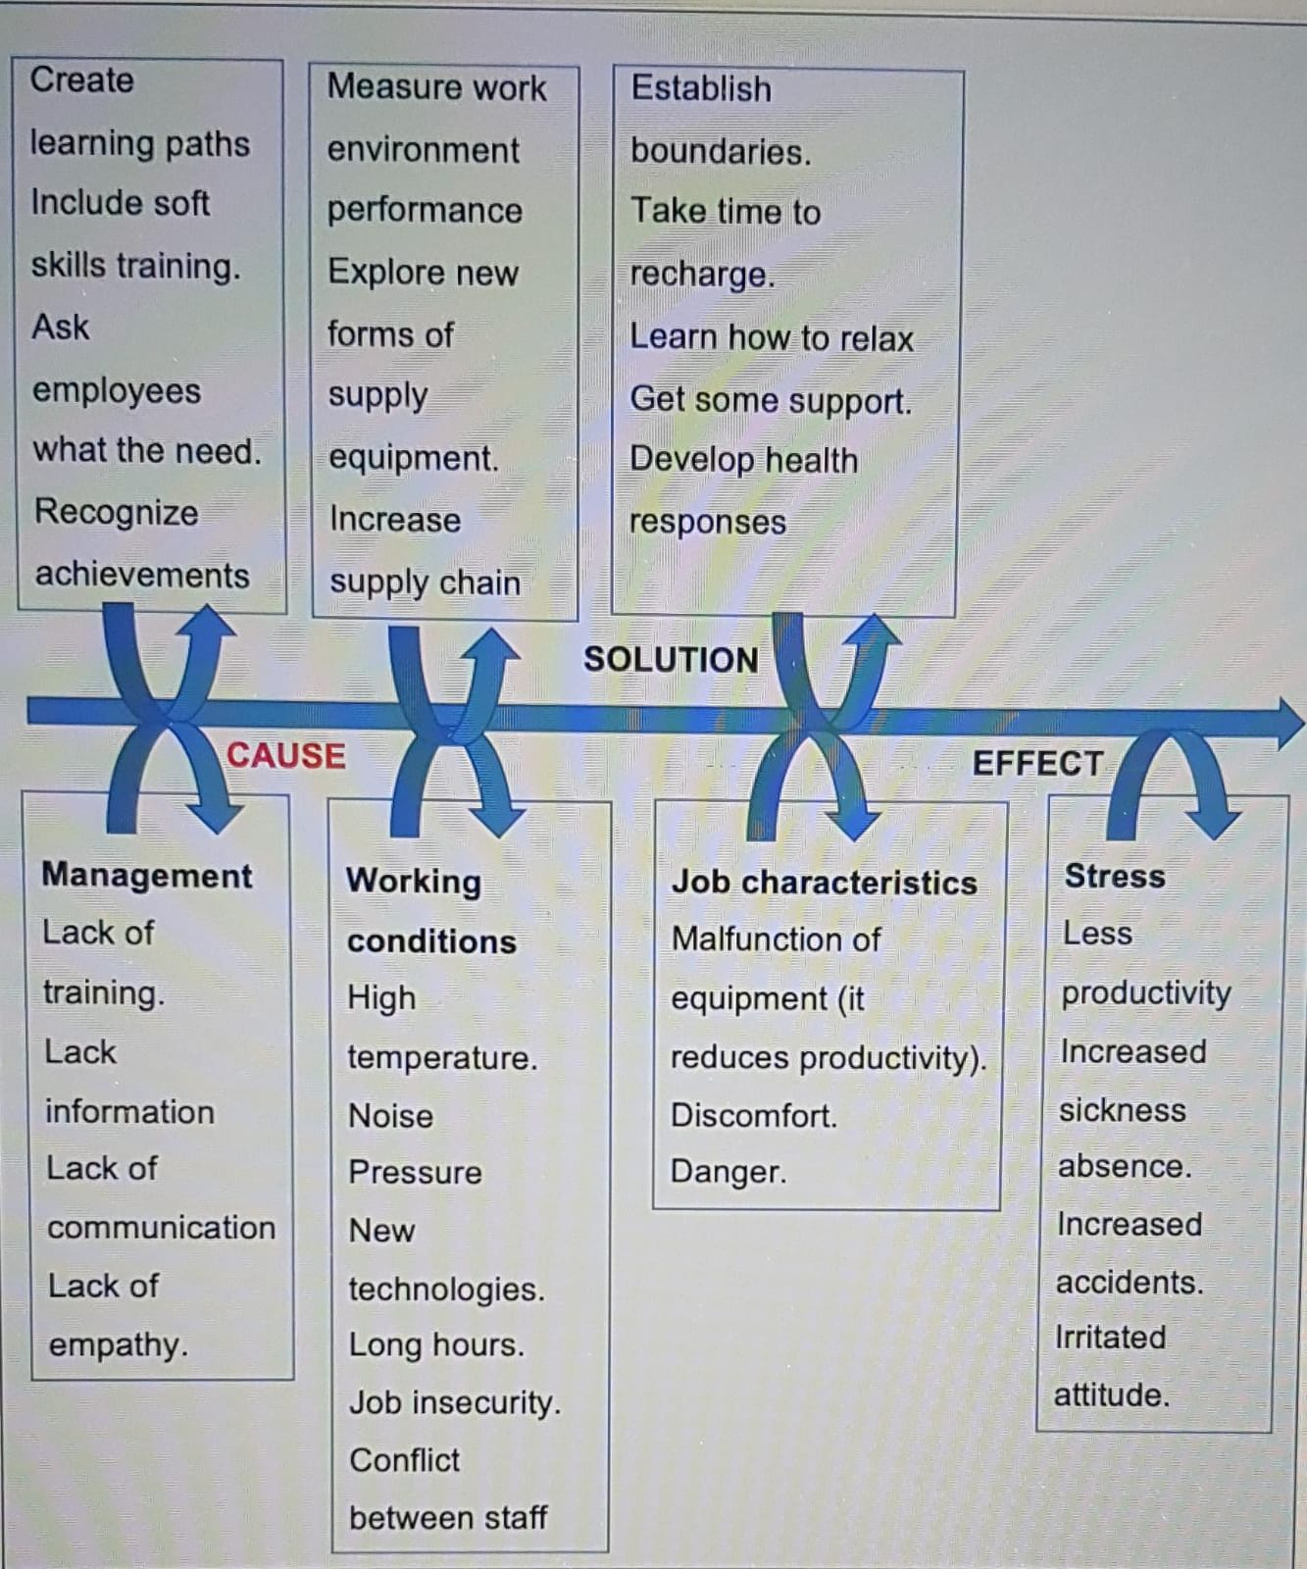

Even all possible solutions mentioned before would have a positive effect there is to analyze the advantages and disadvantages each one could have to be implemented in the best way. So, the first solution would be very effective since the employee would have the support of the union and although all this may lead to a positive result, a long process will have to be carried out to clarify and resolve all the problems with the company.
The second proposal would be amazing if both sides agree to find a solution that will benefit both also, this could avoid some large procedures and confrontations with intermediaries. However, in some cases, some companies do not take it as a serious petition made by the staff. Also, in this case, would not be a written document to prove later that an employee tried to let the company know about some problem simply they can assure anyone had a complaint before due to actual conditions.
The first option would be best if the company has not taken any measures to sort out this. However, this report is the focus of a general problem where the best way to avoid stress must come from the company as an unconditional rule. That is why the third option would be the most successful due to if it is the company that provides a better quality of work giving support and improving the work conditions, its employees will be more satisfied, and all this will be a benefit for both parties. Because the efficiency and commitment to the company will be guaranteed through the effort of the staff and the productivity of the company will surely have a positive impact.

- Picture 2 Swot analysis
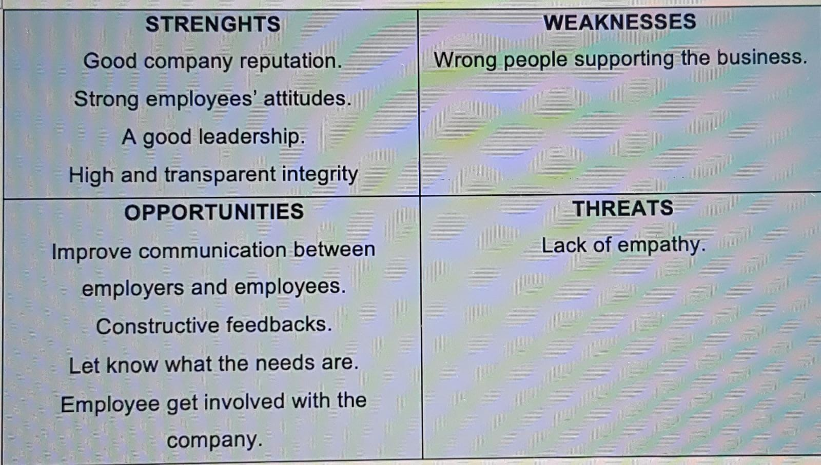

- DEVELOP A PLAN FOR IMPLEMENTING THE SOLUTION

Organizational change can be represented as three states of change which are:
- Current state
- Transition state
- Future state

First of all is important to know a company has to be involved with the consequences of not managing people to the side of change as mentioned before such as lower productivity, massive sick days.
Secondly, this state is going to be analyzed using the ADKAR model which is used for organizational change management and is based on an individual measurement that allows each individual to overcome the stages that compose it.
Awareness of the need for change
Desire to participate and support the change
Knowledge on how to change
Ability to implement required skills and behaviors
Reinforcement to sustain the change

So, connecting ADKAR and the current, transition, and future states.
The nature of the change is improving employees’ conditions.
Current
state
Avoid sick leave.
Improve company productivity.
Commit staff to their responsibilities.
Guarantee a good working environment.
Be a valued company nationally or internationally.
because a company goes through stress problems from employees.
It is necessary to implement a change to improve the quality of workers and thus avoid sick leave and possible health problems.
This change would come as sick leave results in low productivity as well as an additional cost for the company since it must cover its absent employees resulting in a double payment. So, the risks of not changing carry an extra expense
D making a personal decision to participate, and support change is imperative.
Leaders can influence this decision through organizational motivators for change.
K staff are required to be willing to accept new security measures and protocols.
Transition
state
Managers and staff involved with the improvement must be fully empowered to offer support to their employees to ensure that instructions are understood by all.
Besides, good training should be established to guarantee that the handling of the equipment is known.
The company has to demonstrate the skills to adapt any change given although there are barriers due to lack of knowledge and will be some people who only understand the theory in the end, they have to be able to demonstrate the proper behavior to see positive results.
R employees are expected to be satisfied in their workplace.
Future
state
Employers can communicate better.

- COMMUNICATE STAKEHOLDERS

Stakeholders refer to all those people or organizations affected by the activities and decisions of a company. Can be internal or external as well as primary and secondary. In this case, stakeholders are internal because it refers to employees and managers

Picture 3
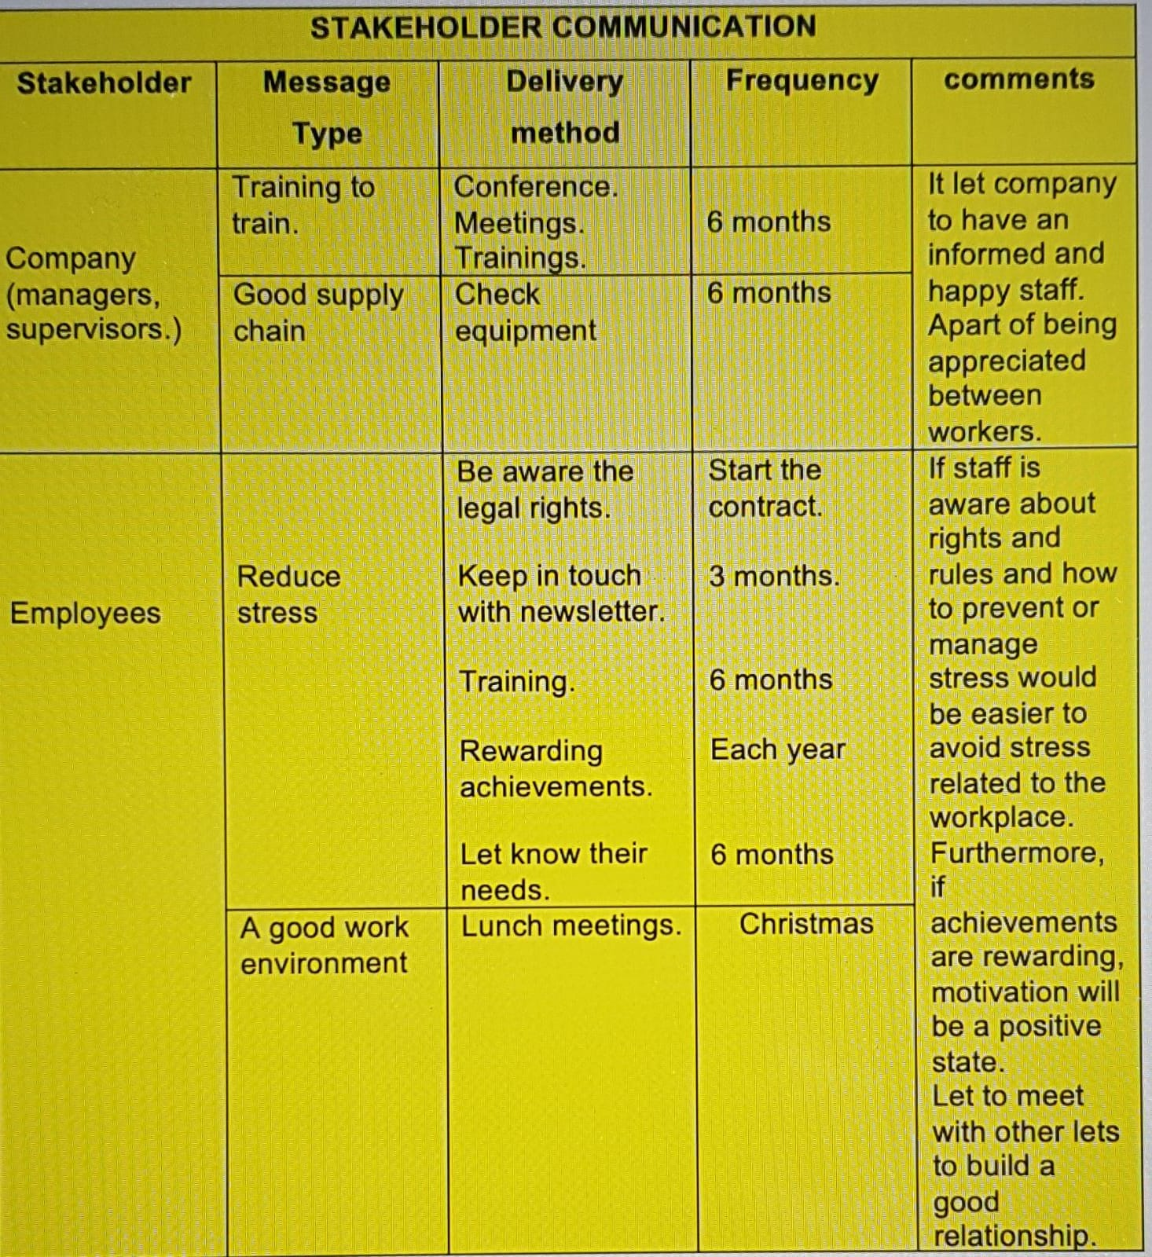

- MONITORING AND REVIEW TECHNIQUES

All techniques will be monitoring to ensure the plan to reduce stress is effective in the company. So, will be important to receive feedback from managers or employees after this implementation was applied. So basically, managers can check if the information is received by employees with a positive impact and if would be necessary to put extra attention in a specific area.
Surveys will be made to the staff which will show through statistics if the steps taken by the company is having a proper way to control and reduced stress because is important to know the different staff opinions to ensure the techniques are working or not working or if would be necessary to implement something else.
Taking as an example about meetings Spain is one of the countries that let employees interact with others through Christmas meetings it built a good relationship between everyone inside the company. As well as each Christmas period employees are recognized with a higher salary, so it let them fell motivated to work hard.

- CONCLUSION

This report was the focus in know about how companies could act and take measures to reduce work stress between employees.
An important point that has been found is that the measures are within the reach of every business and that training could easily be provided for further training, both work and personal, showing that they are more committed to the well-being of their workers. Likewise, it is important to motivate staff by recognizing their achievements or allowing them to interact with others through meetings.

- REFERENCES

- Eligio Sanchez, M. (2016) “fifteen negative work stress consequences” available at: https://www.nuevatribuna.es/articulo/economia-social/quince-consecuencias-negativas-estres-laboral/20160608165521129105.html
[accessed August 10, 2020]
- Opera, M. (2017) “ The impact of work stress: consequences for people and business” available at: https://blog.grupo-pya.com/impacto-del-estres-laboral-consecuencias-personas-empresas/ [accessed August 10, 2020]
- “Stakeholders”. Meanings.com available at: https://www.significados.com/stakeholder/ [ accessed August 15, 2020]
- The 2018 UK Workplace Stress Survey. (November 2017). Available at: https://www.perkbox.com/uk/resources/library/interactive-the-2018-uk-workplace-stress-survey [ accessed August 16, 2020]
- UK National Work- Stress Network. Available at: https://www.polfed.org/WestMids/media/2027/work-stress.pdf [accessed August 15,2020]

