Helen Imola Newton

Proposal for dissertation

Within my proposal for my dissertation I will be looking at four key words that reflect my interests and passions within my own practice. I will be researching the Context, Structure, and Layers of Meaning contained within Experience Space. I will look at how fashion uses these to market itself through concept stores, advertising campaigns and the clothing designs. I will look at why and how fashion does this and discuss the fashion companies that practice this method. The way of using art structures to create meaning within fashion marketing through layout, presentation and method gives the ‘design’ work a conceptual artistic feel and emotion and is an area I am passionate about within my own practice.

Context is ‘circumstances that form the setting for an event, statement, or idea, and in terms of which it can be fully understood’ (Oxford English Dictionary, 2018), therefore to put in to ‘context’ is to put an object into a setting that is perceived within relation to its surroundings and association in space. Through reviewing how context is used in art galleries, a consideration of meaning is created in these spaces furthermore, how audiences understand that objects placed in that space attain value and meaning. To put an object into context is constructed codes in which connotations are tied to the setting or place. This leads to how viewers understand how objects communicate when put into a context through semiotics. To understand semiotics researched was conducted using ‘Semiotics: the Basics’ (2002) by Daniel Chandler’ this covered the main thinkers of semiotics; Pierce, Saussure and Barthes using the theorists to understanding how signs and signifiers work and apply these to the context of a gallery space. Viewers use semiotics to navigate how to apply their own connotations of value when objects are placed in relation to a gallery space. Further research was conducted using ‘Inside the White Cube: Ideology of the Gallery Space (1976) by Brian O’Doherty’ and ‘Ways of Seeing (1972) by John Berger’ as they both support and discuss how audiences view and perceive work a certain way due to the surround environment. To visually explore codes, artists have been selected that challenge previous perception boundaries of context. Within Fountain (1917) Figure 1 and My Bed (1998) Figure 2 artists Duchamp and Tracey Emin have both placed everyday objects in a setting of a gallery space. The incongruity caused by the juxtaposition questions the codes and rules society has placed upon spaces that look like galleries. When an object enters an art gallery it is see to have value. However, the work of Duchamp and Tracy Emin challenge this perception, as the work is not stereotypical. To further understand about both these works research will be focused on ‘The Popular Culture of Modern Art (1994) by Jeffrey Weiss’ and ‘Tracey Emin (2006) by Neal Brown’ as this will progress the understanding of how the works challenge what is know as art.

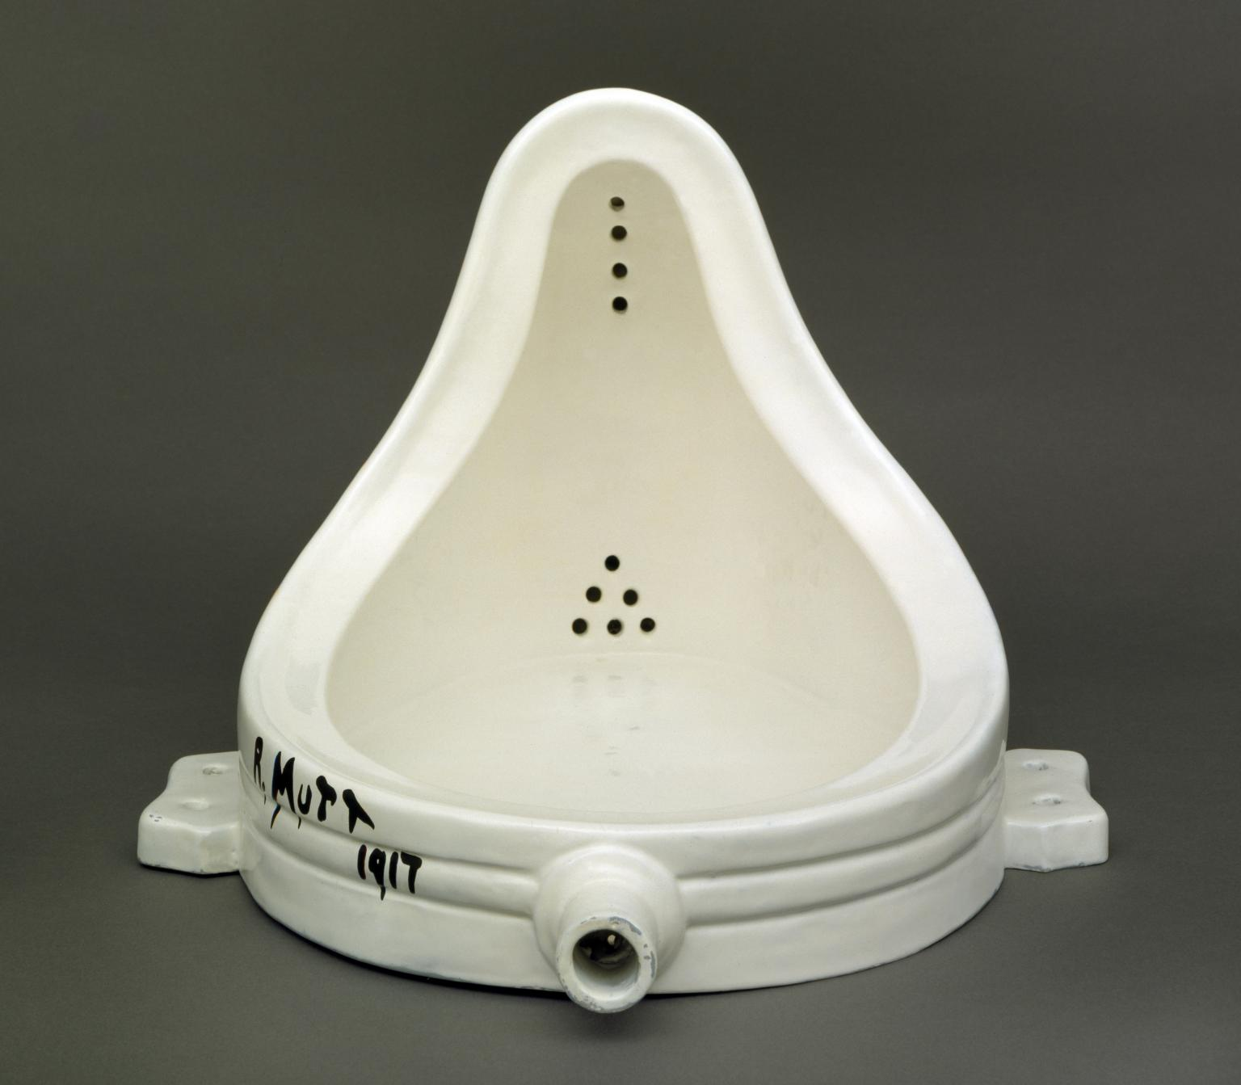
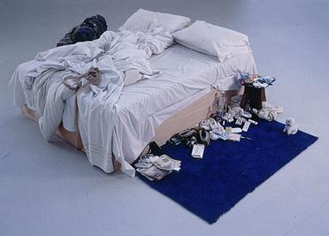
Figure 1. Duchamp, M. (1917) Fountain
Emin, T. (1998) My Bed

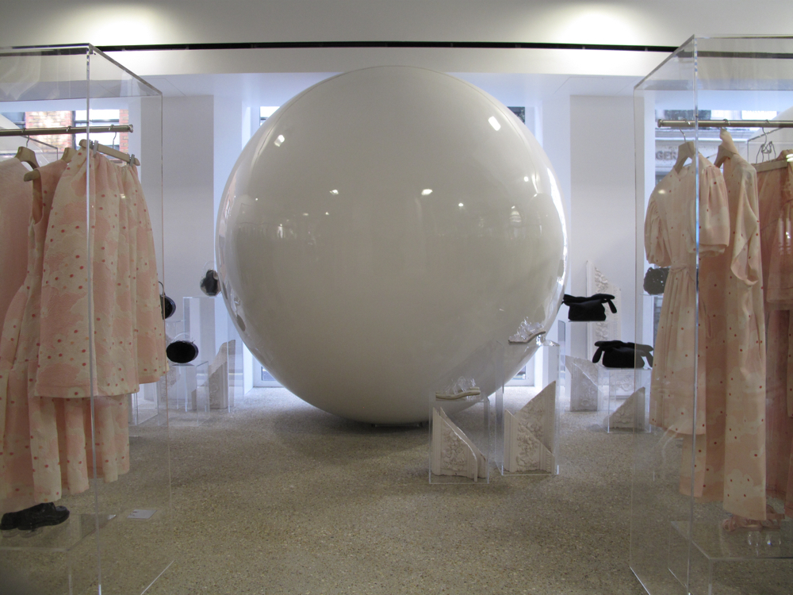
This then leads me onto the second keyword: Structure as it relates to Context. Structure is ‘the arrangement of and relations between the parts or elements of something complex’ (OED, 2018) in terms of an art gallery this is the known ideals of what audiences expect from a place called an ‘art gallery’. Once again the books Inside the White Cube: Ideology of the Gallery Space (1976) by Brian O’Doherty and Ways of Seeing (1972) by John Berger have been useful in understanding the structures of the gallery space, however, these structures have been used in fashion. To highlight this, fashion stores that resembles that of gallery space, such as in Figure 3, Dover Street Market and Figure 4, Simone Rocha will be analysed through similarities of layout and the design of space as illustrated in Figure 5, of Tate Modern. Drawing on this comparison, fashion is breaking the structures of store layout by taking those of an art gallery. Fashion is using Postmodern theories to challenge its own perceptions of the appearance of fashion stores. Through researching into Postmodernism, Poststructuralism: A Very Short Introduction (2002) by Catherine Belsey explains the key theories of Postmodernism which helps define how fashion is breaking its own structures by using Postmodernist ideologies. Referring to the myth stated in Mythologies (1972) by Roland Barthes using of gallery structures, audiences will view the clothes to have a similar value to that of art. Furthermore, to understand the key themes that construct Postmodernism ‘Practices of Looking: An Introduction to Visual Culture (2001) by Sturken and Cartwright’ will be referenced in to understand all aspects of Postmodernism, by the application of theories to illustrate how fashion is used to break its own structure.
Figure 3. Dover Street Market (2016) London store display

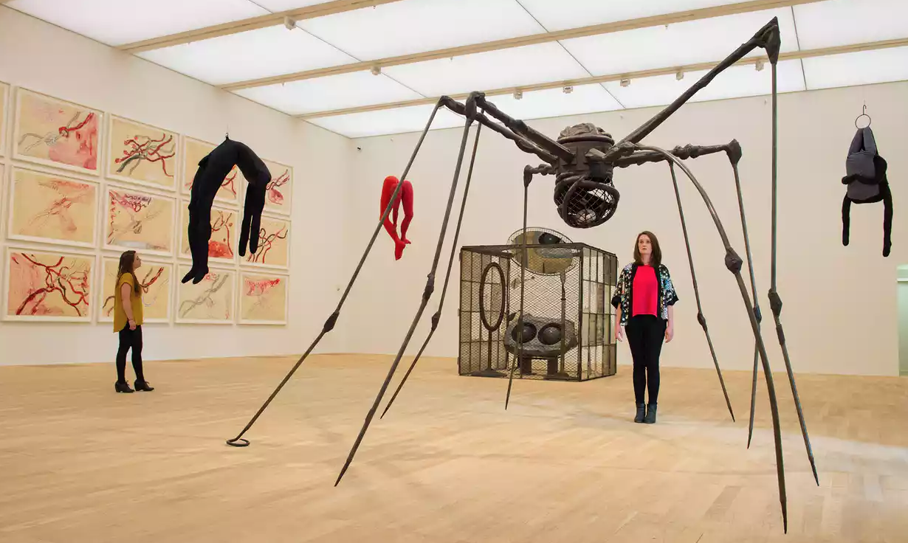
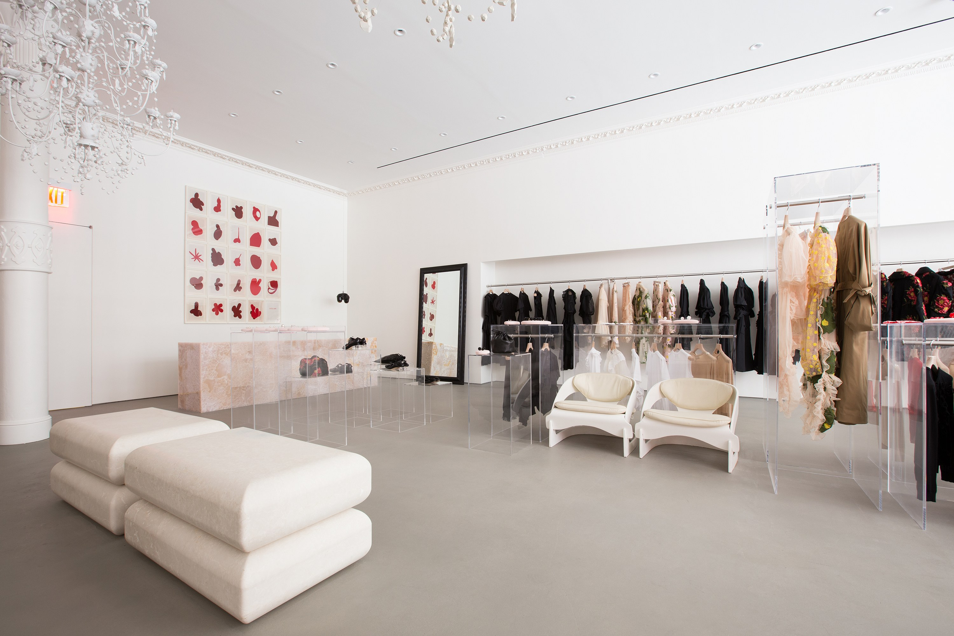

Figure 4. Rocha, S. (2017) Simone Rocha New York store display
Figure 5. Louise Bourgeois (2016) Switch Room Tate Modern
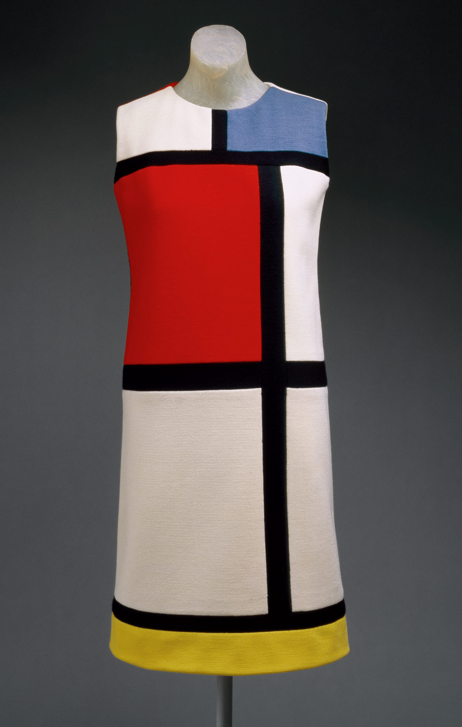
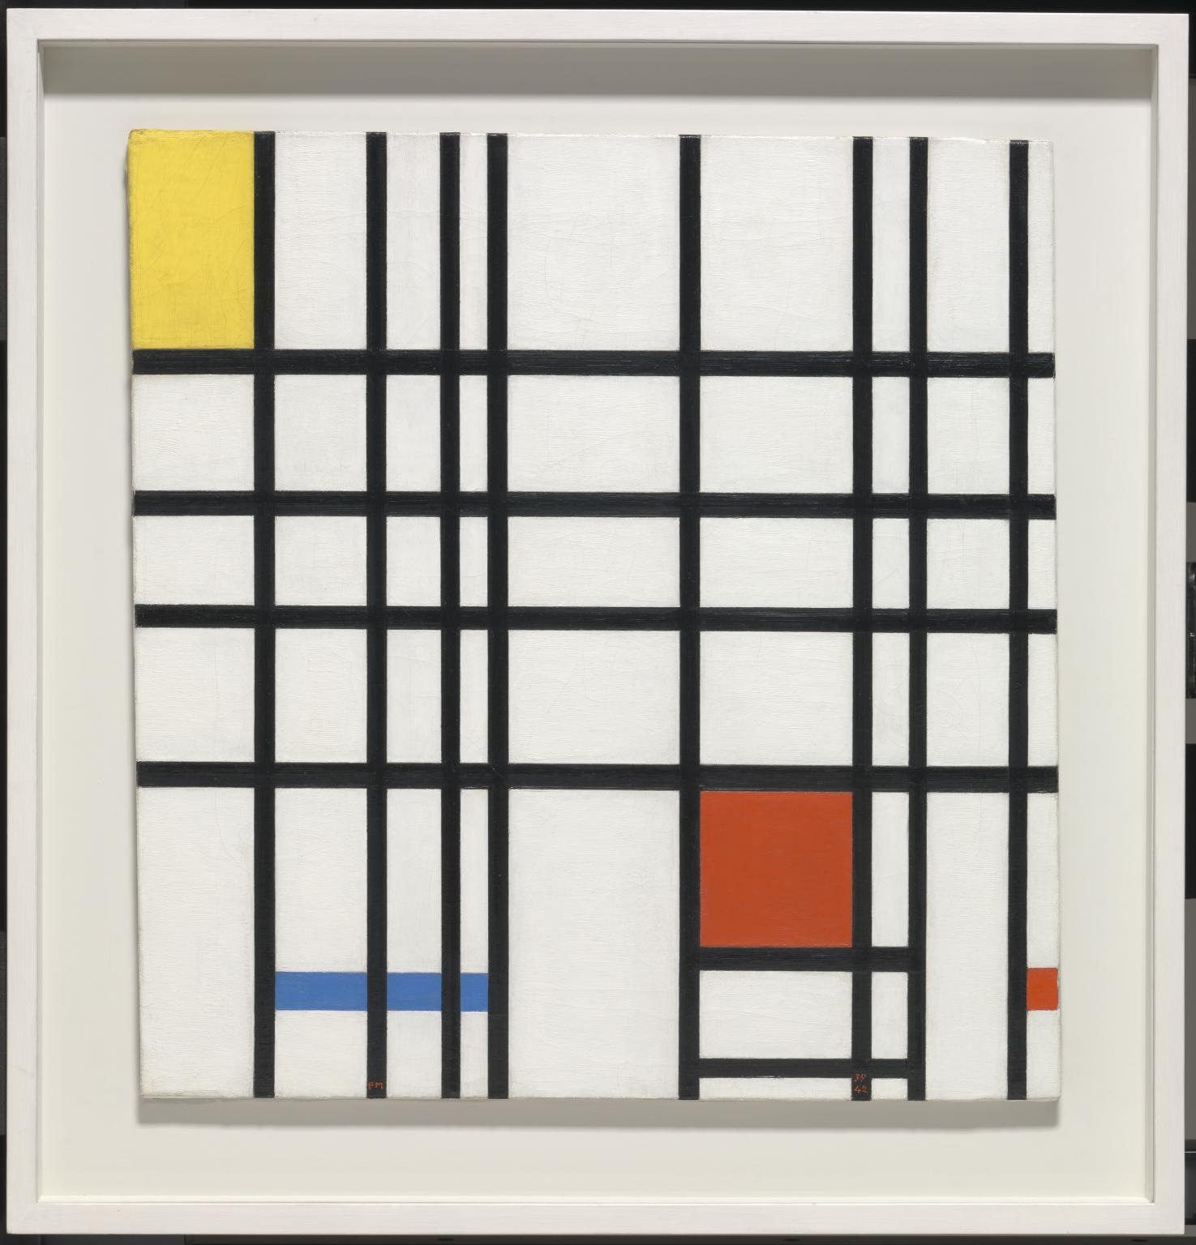
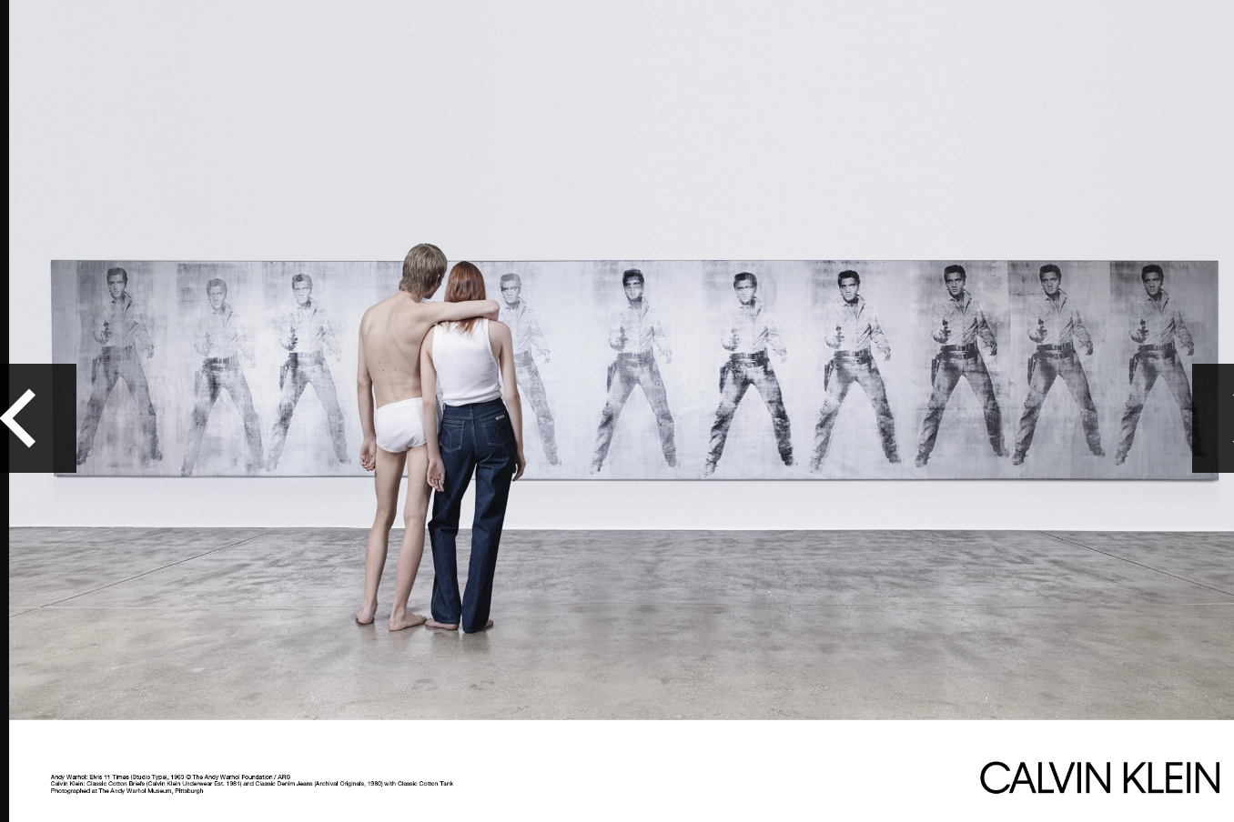

Following on from Structures are the third keywords Layers of Meaning. Layers of Meaning is how one structure and another completely unrelated are pushed together to create new meanings while still referring to their old ones. Fashion uses art as inspiration to directly create the design, books of value that specifically talk about fashion and art include ‘Art & Fashion (2000) by Florence Müller’ and ‘Fashion and Art (2012) by Geczy and Karaminas’. These have comparisons of fashion designers work and arts work. In Figure 6 the Yves Saint Laurent Mondrian Collection (1965-66) reflects this idea of fashion using art structures that mimics the painting seen in Figure 7 Composition with Yellow, Blue and Red 1937-42) by Piet Mondrian. Fashion is using art not only in the shop displays but also in clothing to represent the same values.
Postmodernist Representation of art in fashion seems to be another theme running through the research. Stuart Hall’s book ‘Representation: Cultural Representations and Signifying Practices (1997)’ will help understand how this works and why it is used. In terms of the Yves Saint Laurent Mondrian Collections (1965-66) meanings are questioned behind the representation of clothing inspired by art. This is supported by Baudrillard’s ‘Fashion, or the enchanting Spectacle of the Code (2007) as fashion is marketing itself as on the same value as art. Within the fashion advertising campaigns for Calvin Klein seen in Figure 8, the models are viewing an Andy Warhol in the setting of a gallery. Again this ‘in relation to’ theme is the layering of meanings that is Postmodernism. These are also seen in the look book campaigns by Roksanda in Figure 9. The act of displaying fashion work along side of artwork in advertising can be describe as ‘double coding’ which is mentioned in Charles Jenks book ‘The New Paradigm in Architecture (2002)’ as the fashion advert is borrowing codes from art (Andy Warhol) and applying these to the jeans, creating new layers of meaning and association. This is also shown within fashion stores where the display is set out as an art gallery, which I mention, in my first and second keyword.
Figure 7. Mondrian, P. (1937-42) Composition with Yellow, Blue and Red
Figure 6. Saint-Laurent, Y. (1965-66) Mondrian Collection
Figure 8. Calvin Klein Advertisement 2018
Figure 9. Roksanda (2018) Resort Lookbook Campaign
The final keyword explores Experience Space within fashion. Experience as a noun is ‘[a]n event or occurrence which leaves an impression on someone’ (OED, 2018) and as a verb a ‘feel (an emotion or sensation)’ (Oxford Dictionary, 2018). The definition of space is ‘the dimensions of height, depth, and width within which all things exist and move’ (OED, 2018). These two words together denote a space that can evoke emotion and impression on the consumer. While researching how fashion companies create stores that resonate with galleries, these create experience within the consumer the same response that galleries can have. Fashion creates stores spaces that can evoke experience and emotion which will be supported by ‘Emotionally Durable Design, Objects, Experiences and Empathy (2005) by Jonathan Chapman, as consumers can have an emotional attachment to objects and places. However, the experience space constructs an identity of the brand and is a form of marketing, as the store space is the interaction of the consumer with the product and brand itself. It is once again the myth ideology that highlights the identity of the brand. Fashion stores spaces are designed to attract consumers to buy the products and buy into the brand. This led onto what kind of target audience they aiming to attract. Stores reflect galleries, as the target is a consumer that understands the emotional impact art can have and possibly an intellectually rich one. To help understand about consumerism in fashion, the chapter consumerism in fashion in ‘Consumerism as a Way of Life (1998) by Steven H.Miles as it is specific to the area of analyse. The experience space resonates with that of an art gallery, further exploration will be conducted to understand why they are created. The book One-off: Independent Retail Design (2008) by Clare Dowdy and Design for shopping: New retail Interiors (2006) by Sara Manuelli, explained the power of the lifestyle shop and the reasons behind why these shops are becoming popular.
Thinking about the reason why these fashion spaces have started to become popular could be due to how the stores reflect the desires of the consumer and how they want to be seen within these spaces. To understand this, Psychology of Fashion (2018) by Carolyn Mair is referenced to understand why people want to be different from others through experiences, and to be seen in places that seem individual than other places. This leads on to why experience spaces are curated for consumers to buy into the products because the lifestyle shop is displayed to resonate with their own lives. Therefore, creating codes aimed at their target audience through the use of stores, adverts and clothing. Hence, society is obsessed with sharing their life and lifestyles on Facebook and Instagram. By creating spaces relating to consumers lifestyle and society, brands are playing on peoples’ desires to be seen and their placement.

Concluding my dissertation proposal I have explained and deconstructed how experience spaces of fashion brands and their stores are created. From the explanation of how semiotics works to the construction of context in art galleries and object. This is followed by how these form structures and how these have been broken apart and layered on top of each other to form new meanings. Through the proposal I have learnt how these methods are primarily Postmodernist in structure. Using these theories, fashion brands have been able to break their own codes to market themselves differently, such as Simone Rocha, Calvin Klein, Roksanda, Yves Saint Laurent and the store Dover Street Market. This has lead to speculate why brands are doing this and the marketing side of fashion rather that of the education of these designers as fashion is a commodity to be sold and to be acquired. Therefore, this leads into how fashion enchants consumers to want their products due to marketing, psychology and desire of consumers wanting to be in associated with spaces that reflect how they want to be perceived. This has finally led into the question for of the dissertation ‘How are lifestyle brands appropriating the values of the art world to sell high end fashion?’.

References

Books

Barthes, R. (1972) Mythologies, 1st Edition. London: Vintage

Baudrillard, J. (2007) ‘Fashion, or the Enchanting Spectacle of the Code’, in Barnard, M. (ed) Fashion Theory: A Reader, 1st Edition. New York: Routledge.

Belsey, C. (2002) Poststructuralism: A Very Short Introduction, 1st Edition. Oxford: Oxford University Press.

Berger, J. (1972) Ways of Seeing, 1st Edition. London: Penguin Books Ltd.

Brown, N. (2006) Tracey Emin, 1st Edition. London: Tate.

Chandler, D. (2002) Semiotics: The Basics, 2nd Edition. Oxon: Routledge.

Chapman, J. (2005) Emotionally Durable Design, Objects, Experiences and Empathy, London. Earthscan.

Dowdy, C. (2008) One-off: Independent Retail Desing, 1st Edition. London: Laurence Kind

Geczy, A. and Karaminas, (ed.) (2012) Fashion and Art, 1st Edition. London: Berg.

Hall, S. (ed.) (1997) Representation: Cultural Representations and Signifying Practices, 1st Edition. London: Sage Publications.

Jencks, C. (2002) The New Paradigm in Architecture, 1st Edition. New Haven: Yale University Press.

Mair, C. (2018) The Psychology of Fashion. 1st Edition. Oxon: Routledge.

Manuelli, S. (2006) Design for Shopping: New Retail Interiors, 1st Edition. London: Laurence King.

Miles, S.H. (1998) Consumerism as a Way of Life, 1st Edition. London: SAGE Publications Ltd.

Müller, F. (2000) Art & Fashion, 1st Edition. London: Thames & Hudson.

O’Doherty,B. (1986) Inside the White Cube: The Ideology of the Gallery Space, 1st Edition. Santa Monica: The Lapis Press.

Sturken, M., Cartwright, L. (2001) Practices of Looking: An Introduction to Visual Culture, 1st Edition. United States: Oxford University Press Inc.

Weiss, J. (1994) The Popular Culture of Modern Art, 1st Edition. London: Yale University Press.

Photos

Bourgeois, L. (2016) Switch Room Tate Modern [Online]. Available at: https://www.theguardian.com/artanddesign/2016/jun/19/tate-modern-switch-house-extension-art-comes-first (Accessed: 15th May 2018)

Dover Street Market, (2016) Dover Street Market London Store Display [Online]. Available at: http://www.meltingbutter.com/boutique-find-dover-street-market/ (Accessed: 15th May 2018)

Duchamp, M. (1917) Fountain [Online]. Available at: http://www.tate.org.uk/art/artworks/duchamp-fountain-t07573 (Accessed: 15th May 2018)

Emin, T. (1998) My Bed [Online]. Available at: https://en.wikipedia.org/wiki/My_Bed (Accessed: 15th May 2018)

Mondrian, P. (1937-42) Composition with Yellow, Blue and Red [Online]. Available at: http://www.tate.org.uk/art/artists/piet-mondrian-1651 (Accessed 15th May)

Rocha, S. (2017) New York store display [Online]. Available at: https://www.vogue.com/article/simone-rocha-interview-new-york-city-store (Accessed: 15th May 2018)

Roksanda (2018) Roksanda Resort 2018 Lookbook [Online]. Available at: https://theimpression.com/roksanda-resort-2018-lookbook/ (Accessed: 15th May 2018)

Saint Laurent, Y. (1965-66) Mondiran Collection [Online]. Available at: https://www.metmuseum.org/toah/works-of-art/C.I.69.23/ (Accessed: 15th May 2018)

Websites

Oxford English Dictionary (2018), [Internet]. Available from: https://en.oxforddictionaries.com/ [Accessed 10th May 2018].

Bibliography

Augé, M. (1995) Non-Places: Introduction to an Anthropology of Supermodernity. 1st Edition. London: Verso.

Barnard, M. (2007) ‘Fashion Statements: Communication and Culture’, in Barnard, M. (ed) Fashion Theory: A Reader, 1st Edition. New York: Routledge.

Baudrillard, J. (1988) ‘Consumer Society’, in Poster, M. (ed) Jean Baudrillard: Selected Writings, 2nd Edition. Cambridge: Polity.

Baudrillard, J. (1988) ‘The System of Objects’, in Poster, M. (ed) Jean Baudrillard: Selected Writings, 2nd Edition. Cambridge: Polity.

Creedy, J. (ed.) (1970) The Social Context of Art, 1st Edition. London: Tavistock Publications Limited.

Eco, U. (2007) ‘Social Life as a Sign System’, in Barnard, M. (ed) Fashion Theory: A Reader, 1st Edition. New York: Routledge.

Muller, C.S, and Smiley, E.L. (1995) Marketing Today’s Fashion, 3rd Edition. New Jersey: Prentice Hall.

Sarup, M.(1988) Post Structuralism and Postmodernism, 1st Editon. Hempstead: Harvester Wheatsheaf.

Silverman, H.J. (ed.) (1990) Postmodernism Philosophy and the Arts. 1st Edition. New York: Routledge.

Tuan, Y.F. (1977) Space and Place: The Perspective of Experience, 1st Edition. Minneapolis: University of Minnesota Press.

Wilson, E. (1985) Adorned in Dreams: Fashion and Modernity, 2nd Edition. London: I.B.Tauris.

Journals
Lascity, M.E (2018) Fashion Practice, Volume 10, Issue 1, 1st Edition. Oxford: Berg.

