REFLECTIVE PORTFOLIO
TASK 3

SOCORRO ALAM
STUDENT ID= 2029042

MODULE= PROFESSIONAL CAREER DEVELOPMENT
MODULE CODE= BMSW4005_BIRM

LECTURER= BESTY JOSE

TABLE OF CONTENTS=
- TITLE
- TABLE OF CONTENTS
- INTRODUCTION
- SWOT ANALYSIS
- IDENTIFYING JOB CHOICE
- PERSONALITY TEST
- CAREER MOTIVATION TEST
- JOHARI WINDOW & EMPLOYMENT LEGISLATION TEST
- CAREER OPTIONS
- EMERGING TRENDS
- SMART GOALS AND OBJECTIVES
- UK EMPLOYMENT LAW & CAREER DEVELOPMENT
- LEARNING THEORIES
- SELF- AWARENESS
- OPEN BOOK ASSESSMENT
- MOCK INTERVIEW
- CONCLUSION
- REFERENCE

INTRODUCTION

Reflective portfolio is a collection of evidence that through reflection can demonstrate personal and professional development. In this report will include tools used to improve self- awareness in personal dev elopement planning. Exploring employment opportunities, career motivation, how to write a good CV, employment legislations.
We are also going to discuss what have I learned during this term and how relevant it is in personal development planning for the goal intended. Gaining experience in Mock interview, an open book assessment wherein you be given a case study and you have two (2) hours to submit.

There are many methods that you can used to plan for your personal and professional development. You need to assess yourself first what is it you want to do for yourself? How do you see yourself in ten (10) years’ time. Do you just want to be working in the same company until you retired? Don’t’ you want to see yourself get paid more and have a better job? How do you assess yourself?
SWOT analysis is the strengths, weakness, opportunities, and threats. It’s the process that helps overcomes challenges and determined what new leads to pursue.
“ SWOT analysis is mostly described as a set of rules use to confront internal means and capabilities with external developments”. ( Mondour et.al., (2005); Kramer, (2001).

How will I SWOT analysis myself? By making a list of my strengths, weakness, opportunities, and threats. To achieve my goal in life, I need to identify my skills to improve my professional development. Continuous personal and professional development is on-going process to help you grow. I believe every day you learn something. My husband is my strengths and all the work skills and work experience. My weakness is I don’t know how to say no when ask to stay longer at work when lack of staffs. But I now realise my health is now my weakness. It also a threat in not being able to submit my assignment in time. Lately my blood pressure is troubling me, and now I come positive in covid. It affects my performance in studying. I now need to make a lot of efforts to catch up for my due assignment to be submitted soon.

After assessing myself, I need to be up to date to improve myself to reach my goal. Maybe ask some expert advice from career advisor, Volunteering is one that cross my mind. Attending training at work, Self- evaluation helps me recognise to build my strengths and focus on developing my weakness to accomplish my career dreams.

My intended plan when I join to study in the University of Wales trinity saint David is to gain qualification and hopefully to run my own Care home one day. There’s a big difference on how the modern age of learning now. My way of how I study during my time compared to the modern technology that is applicable to use anywhere you are so long as you have internet. Nothing is impossible. With just one click, whatever you are researching will be Infront of you. Which I find it more interesting to learn. The more I learn the more I get motivated. This is my first step in personal development. I begin to see lots of opportunities to learn to achieve my goal. With the right attitude, abilities, and skills. I also begun to use the self- awareness tool to evaluate myself.

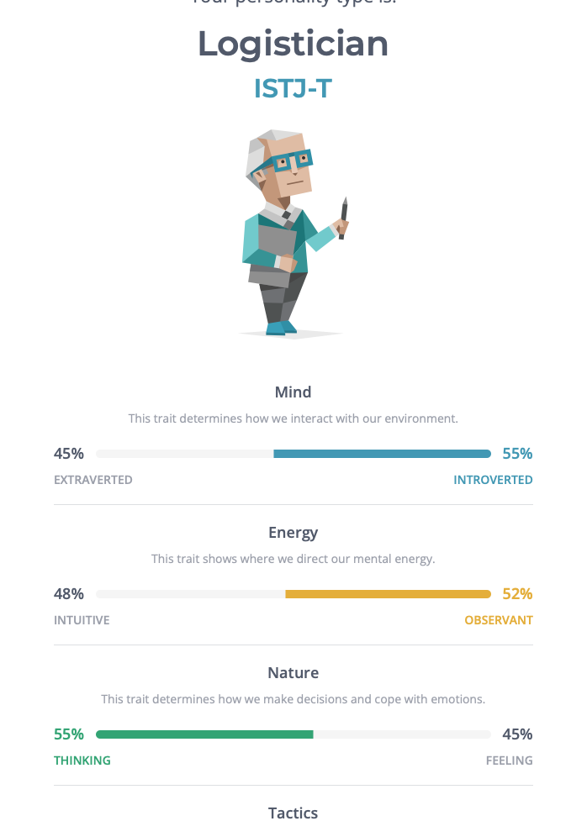

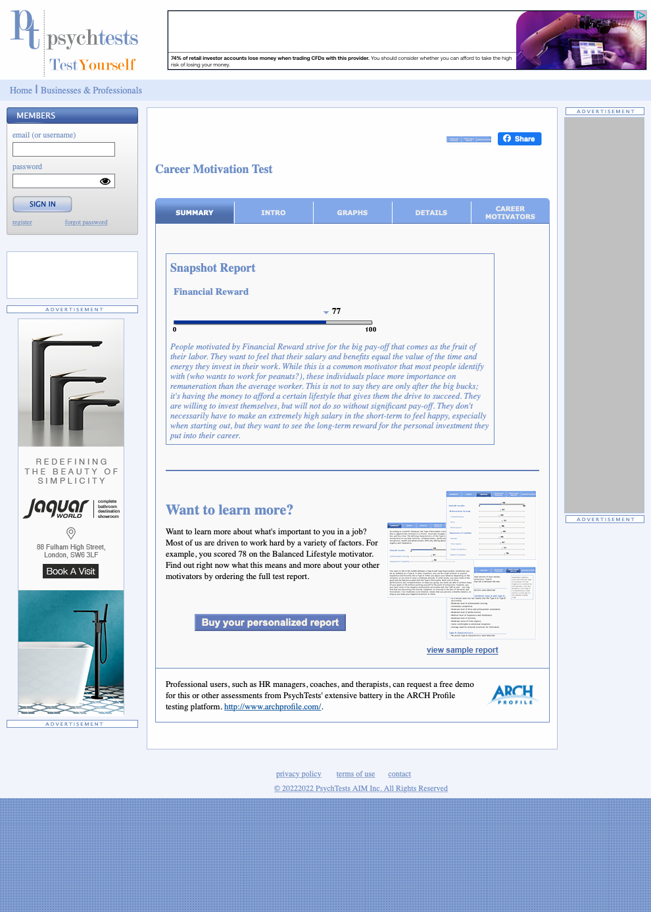

Johari window was developed by Joseph Luff and Harry Ingham in 1955. It helps you understand their relationship with themselves and others. To increase the open area without given too much information about yourself.

Open  area | Blind  area
Hidden  area | Unknown  area

And some of the tools used developed my self- awareness was personality test in which I am logistic according to the test I made. And in Activity9.2 I took the knowledge on legal aspect which My grade was 7.00 out of 10.00. I think I should score more. So, needs to go back and study more.

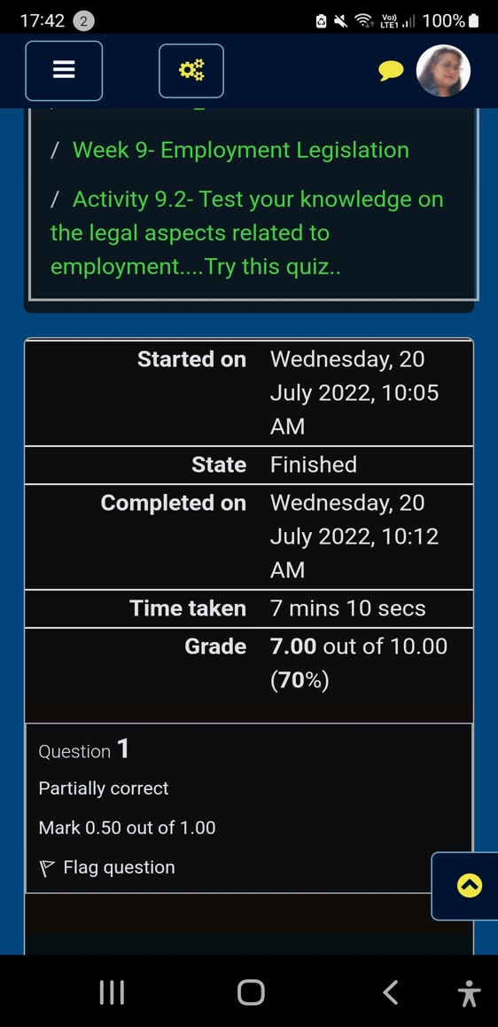

Career option
1, Deputy Manager Care Home
2, Care Home Manager
3, Run my own Care home
4, Social Worker

I made a list of career options for myself. My main goal is to run my own care home, and to be able to succeed , I need to finish level six (6) in health and social care. To acquire my personal goal, I need to identify any development needed, and check any opportunities available. I always use “Indeed” for job search and opportunities available. I have been a member in Indeed job search as far as I can remember. I have the application downloaded in my phone. And I always visit the apps whenever I can to see any interesting jobs that I may be interested. Sometimes I visit others job search company like Reed, The NHS career jobs.

EMERGING TRENDS

“ Technology is changing and for those who wanted to be on Trends has to adapt”. ( Watters. A 2021). Digital transformation is the best solution for consumers and business needs. For personal trends new release Mobile phone with 5g. social media, TikTok, Facebook, Instagram. You can even sell anything using livestream.

In educational trends , my first experience is how to use power point. Copy and paste. Word documents, excel, Forms, share points. This one of too many Technologies which is very useful in studying. By taking the liberty to learn all this modern technology , my chances to level up in personal growth is very useful. And if I want to run my own care home , all this innovation is something that I need to learn . During pandemic, student has been able to continue their studies online.
How can you leverage the emerging opportunities that fits your abilities? Leveraging your abilities means using more of what you are good at. How you’re going to use them is how much you wanted this to happen. How far will you go to attain your main goal. Get recognition from paper. Like evidence that you achieve something.

ASSESSING WHAT I HAVE LEARNED

“ Attitude is everything: If you want to succeed above and beyond” ( Mayer.P.J. 2003). (“Attitude Is Everything : If You Want to Succeed Above and Beyond”)

Setting a SMART goal means focusing on your ideas, efforts, and use them wisely.
SMART is an acronym that guide for goal settings.

S= Be specific on your goal, make it simple and make sense.
M= Measurable, meaningful to you and good motivation.
A= It must be achievable and attainable.
R= Realistic
T= Time bound.

UK EMPLOYMENT LAW AND CAREER DEVELOPMENT

Understanding employment law in UK is essential to any organisation, Big or small. This will be my priority specially if my goal is to run my own care home. Uk employment law is to make sure that employee and employer are protected. This law was to protect workers right and safeguard employers’ interests. Keeping the relationship between the employer and employee fair.
Employment law covers age discrimination, disability, discrimination based on race religion or gender, equal pay, holiday pay, working hours, redundancy, parental leave. Data protection 2018 is about safeguarding important information and making it sure its use properly and legally. When an employee got pregnant, they entitle for leave with pay. Under the maternity and parental leave regulations 1999. And under Health and safety at work act 1974 employers have legal responsibility to make sure that they provide a safe working environment. Risk assessment must be assessed and making sure that employee has the proper training and adequate safety equipment.

LEARNING THEORIES

“ Just as no two people are same, no two students learn in the exact same way or at the same rate” ( Roggeman.P. 2021).
Everyone is different. On the way they act, and the way how they learn things. I took the opportunity 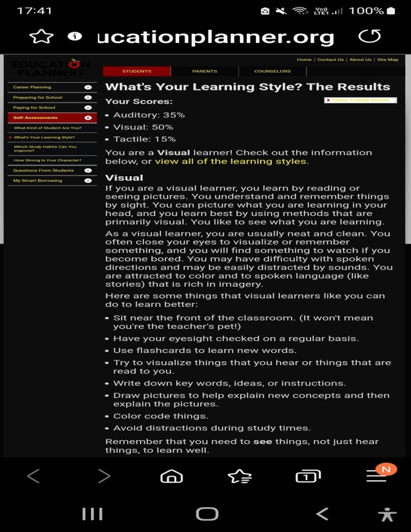
To take the learning style and the results was, I am a visual learner. I learn by reading and seeing pictures. I remember and understand things by sights. I like to see what I am learning. And according to the result, I can picture what I am learning in my head and learn best by using methods that are primarily visual.
“ Learning is defined as a process that brings together personal and environmental experience and influences for acquiring, enriching, or modifying one’s knowledge, skills, values, attitude, behaviour, and worldviews”( the international bureau of education). (“5 educational learning theories and how to apply them”)

SELF-AWARENESS

“ Self- awareness is the ability to focus on yourself and how your action, thoughts, or emotion do or don’t align with your internal standards” ( Duval. (“What Is Self-Awareness, and Why Is It Important? - BetterUp”) S., Wicklund. R).

To be an effective leader and a decision maker, self- awareness is important to develop, to get the best version of myself, and be able to change the course of action when necessary.
This concept is important and makes me realise that however my health has been affecting my concentration in my studies. I have tried alternative option to submit my due assignment later and ask for extra time in my university under extenuating circumstances due for positive test results in Covid. But as soon as I feel better, I decided to finish this report, so I can submit it on time. Being aware that assignment is due, with health concern I still try my best to submit this on time.

OPEN BOOK ASSESSMENT

During the open book assessment, we were given a case study to read one week before that day. The case study is about self-harm. And as soon as I got home, I began researching about self-harm. And on the day of the assessment, we were given two (2) Questioner about the topic given. We are only allowed to choose one questioner. We are given two (2) hours to complete and submit it to Turnitin.
I start to feel nervous, anxious, and at the same time excited. Excited for me because it’s a challenge with time limit. I feel like I’m going for skydiving and waiting how will I landed in the ground. On this occasion, I was happy with the results, I landed 7 out of 10. I think it’s a good result.

MOCK INTERVIEW

Mock interview is also known as practice interview. For this mock interview I have choose to apply as a Healthcare assistant in primary care Phlebotomy/ wounds. The job description was to assists the practice nurse team in delivering nursing services like venepuncture, wound dressing, and ECG’s. To carry-out observations, like pulse, oximeters, blood pressures, and recording accurately. What interest me in this job is they will provide training in Phlebotomy. Which will give opportunities on how to take bloods from patients once I qualified.
On the day of the mock interview, I put on my nice formal top with blazer. I even brought my passport. And during the interview I took off my prescribe eyeglass so I can look at the interviewer eye to eye. It was a good practice. Not forgetting gave me a chance to update my CV. Just receive feedback from my mock interview grading Rubric and the result was 75 out 100. And it means I am hired!!!!
And according to the feedback I have displayed enthusiasm and confidence, arrived on time of the interview, and has explained the behavioural question using the star approach. Although I have some areas that needs to improve like my introduction should have been expanded. I should concentrate more on the areas that needs to improve. I am pleased with these results.

CONCLUSION

I concluded that everything that I have learned during this term has been relevant and helpful for my future growth. Self- awareness is important in everyday life, It can public or personal awareness. It helps you grow and experience what necessary action to be taken. Self- reflection is not only good for personal development but also in professional development in your intended goal.

We should never stop learning or improving ourselves to accomplish our career dreams.

REFERENCE

1, Duval. S., & Wicklund. R. A. (1972). A theory of objective self- awareness. Academic preps

2, Luff. J., Ingham. H. (1955). The Johara window, a graphic model of Interpersonal awareness

3, Meyer. P. J. (2003). Characteristic of SMART goals. Success motivation International.

4, Mobo. F. (2021). The race of emerging trends in Education. International journal of
Multidisciplinary applied business and education research. 2 (10), pp. 909-913.

5, Mondour. P. J. et. Al., (2005); Kramer (2001). SWOT analysis

6, Morgan. E. (2007). Professional Development starts with self- assessment.

7, Plaza. M. C. et. Al., (2007). Use of reflective portfolio in health and science education.

8, Roggeman. P. EdD. (2012). Dean of University of Phoenix’s college of education.

9. Watters. A. (2021). 15 Emerging trends in Information Technology for 2021.

