https://www.theguardian.com/film/2017/sep/10/it-review-enthusiastic-cine-literate-stephen-king-adaptation Accessed 21/10/17

Mark Kermode, Observer film critic

Sunday 10 September 2017 09.00 BST
“It’s summer, we’re supposed to be having fun. This isn’t fun – it’s scary and disgusting!” It, Stephen King’s 1986 novel about a shape-shifting demon that terrorises the town of Derry, Maine, was memorably filmed for TV in 1990. Boasting a mesmerising star turn by Tim Curry as the malevolent dancing clown, Pennywise, Tommy Lee Wallace’s mini-series became every coulrophobe’s worst nightmare, rivalling Tobe Hooper’s Salem’s Lot for the title of best small-screen King adaptation.

'It was wonderfully scary': Tim Curry, Rob Reiner and Kathy Bates on the joy of adapting Stephen King

Read more
Now, the Argentinean director Andy Muschietti, who directed 2013’s creepy Mama, brings a touch of widescreen gloss to King’s enduring horror-adventure. Drawing heavily on such 80s screen favourites as Poltergeist and The Goonies (both of which were co-written/produced by Steven Spielberg), this latest incarnation will resonate with audiences hooked on the nostalgic weirdness of Netflix’s Stranger Things. The chills may be more funhouse than frightful, but Muschietti’s tangible affection for the misfit schoolkids at the centre of this story draws us into their world, lending engaging weight to their (pre)adolescent trials and tribulations.
Tackling only the early years of King’s chunky source, this “Chapter One” (a sequel is due to follow) relocates the coming-of-age section of the novel from the 50s to the late 80s. Here, poor Georgie Denbrough is dragged into a storm drain by the evil Pennywise (Bill Skarsgård, ably filling Curry’s oversize clown shoes). Riddled with guilt and grief, Georgie’s older brother Bill (Jaeden Lieberher, who shone in Midnight Special), becomes obsessed with finding the lost boy. As the summer vacation of ’89 rolls around, and yet more youngsters disappear, a group of variously bullied “Losers” embark upon a Stand By Me-style quest through the woods and into the sewers, in search of a mythical monster.
Advertisement
Significantly, each of our key characters is haunted by nightmarish apparitions that feed upon their individual fears. Mike (Chosen Jacobs) sees visions of fiery tragedy that chime with suppressed memories of childhood trauma; Stanley (Wyatt Oleff) is distracted from his bar mitzvah rehearsals by a chaotic face that leers at him from a painting; hypochondriac Eddie (Jack Dylan Grazer) is pursued by “a walking infection” that seems to embody his mother’s overprotective fantasies. As for Sophia Lillis’s abused but strongly self-sufficient Beverly (“Who invited Molly Ringwald into the group?”), her Carrie-like anxieties manifest in a bloody eruption that owes less to the lift sequence from The Shining than to Johnny Depp’s demise in A Nightmare on Elm Street.
With his gangly arms and marionette gait, Skarsgård’s wall-eyed killer clown resembles a baby-faced relative of Freddy Krueger. No surprise, then, that A Nightmare on Elm Street 5 is seen playing at the local cinema. This is a self-reflexively cine-literate world, in which posters for Gremlins and Beetlejuice hang on children’s walls, and the gateway to the monster’s lair resembles Norman Bates’s home from Psycho. In one bravura sequence, the kids use a slide projector to mount their own movie show, which is promptly hijacked by Pennywise in the manner of the spectral Sadako from Ring.
FacebookTwitterPinterest
Watch a trailer for the film It.
Cinematographer Chung Chung-hoon, who has worked regularly with Park Chan-wook, keeps his cameras gliding elegantly around the action, lending an epic cinematic sweep to the widening horizons of youth. While TV screens burble satirically about having fun with your friends in the sewer, the Losers get involved in outdoor rock fights and bike chases as exuberant as anything from ET. For all its horror trappings, this is still a story in which battles with the supernatural can be abruptly curtailed when your mom turns up unexpectedly. Even the bullies are children at heart. River Phoenix-lookalike Nicholas Hamilton’s Henry may be the knife-wielding scourge of our antiheroes, but a scene in which he is humiliated by his boorish father (“nothing like a little fear to make a paper man crumble”) reminds us that his anger has been passed down through generations, a recurrent King theme.
Flitting between crooked nursery crime chimes and lush orchestral themes, composer Benjamin Wallfisch creates an emotionally resonant score to accompany Muschietti’s blend of scares and sentimentality. The result is an energetic romp with crowd-pleasing appeal that isn’t afraid to bare its gory teeth. While it may not be as frightening as some hardened horror fans desire, the archetypal terrors and fundamental friendships of King’s source are slickly transferred to the screen with a ghoulish enthusiasm that proves hard to resist.

https://www.empireonline.com/movies/stephen-king-2017/review/ Accessed 21/10/17

It (2017) Review
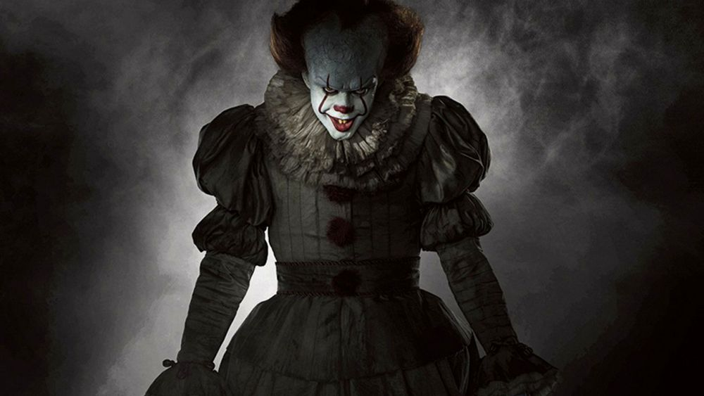
- 
- 
- 
John Nugent
6 Sep 2017 07:21Last updated: 6 Sep 2017 09:47
- Release date
8 Sep 2017
- Certificate
15
- Running time
135 minutes
- Movie
It (2017)

The summer of 1989. In the small town of Derry, Maine, children are disappearing at an alarming rate, and the mysterious culprit appears to be an immortal shapeshifting clown. It falls to seven young misfits, the self-styled Losers’ Club, to investigate.
★★★★★
Back in 1986, when Stephen King first wrote It, his seminal 1,138-page horror epic about a clown-demon terrorising a small New England town, he probably wasn't thinking about search engine optimisation. Pity, then, the poor studio marketers hoping to gain Google ranking traction on a widely used third person singular pronoun. But, as it turns out, the Warner Bros. marketing team needn’t have worried: as that record-breaking trailer attests, Pennywise The Dancing Clown holds a deep-seated cultural cachet, and this latest adaptation from Mama director Andy Muschietti meets that huge expectation like a perma-grinning demon meeting an unsuspecting victim.

It ranks among the better Stephen King adaptations — no small praise indeed.

This is emphatically not the Tim Curry-starring made-for-TV adaptation from 1990. There are deferential little nods here and there — a likeness of Curry’s costume can be glimpsed in one scene, and the iconic opening sequence, with the paper boat of doom, seems nearly identical — but Muschietti’s version feels distinct, discarding the back-and-forth timelines for a straightforwardly linear story (the grown-up portion of the story reserved for a potential sequel), wisely dispensing with the book’s bizarre pre-teen orgy, and shifting things along by 30 years or so, from the original ’50s setting to the more Amblin-esque ’80s.
The result: a coming-of-age yarn not unlike a horror-inflected jumble of The Goonies and E.T. (plus, inevitably, Stand By Me — another King adaptation). Which means the kids are important, and Muschietti is patient enough to devote precious screentime establishing each member of the Losers’ Club and their respective dysfunctional lives. There’s a lot of exposition to get through, but each of the seven losers gets their due, and the result is a truly well-rounded ensemble, as awkward and romantic as they are foul-mouthed and funny. Credit must go to the young cast, among whom there is no single weak link; it’s as authentic a portrayal of children staring down the barrel of adolescence as you’re ever likely to see.
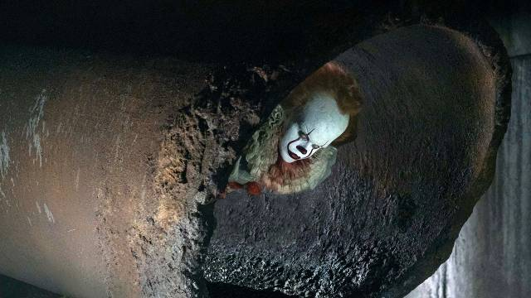
Crucially, the personal strifes that each of the Losers face, from hypochondriac mothers to sexually abusive fathers, are filmed with just as much menace and horror as the supernatural scenes, and are arguably more disturbing. This is It’s great strength: it wants you to care about these loser kids, invites you to share in their deep angst, and bolsters the facing-your-fears allegory by being, fundamentally, a human drama first and a supernatural horror second.
Which is not to say It disregards It. Just as Tim Curry’s larger-than-life performance anchored the 1990 version, so Bill Skarsgård proves the centrepiece of the 2017 vintage. Like the dinosaurs in Jurassic Park, Pennywise is generally used carefully and sparingly, and is all the more powerful for it. With his cracked porcelain forehead, mucky Victorian scruff and giant protruding bottom lip, this Pennywise is a triumph of make-up and design as much as anything else – but despite his minimal screen time shared with prosthetic artists and CGI compositors, Skarsgård leaves a hell of an impression. His performance is full of strange nuance and wit, with subtle touches — like a fine trickle of drool hanging forebodingly from his mouth — making this interpretation more fascinatingly entertaining than truly disturbing.
How scary is It? That depends on your horror threshold. Seemingly oblivious to any recent trends in the genre, Muschietti seems content to go with the most straightforward horror tropes, opting for jump scares, whip pans and Psycho strings from composer Benjamin Wallfisch. There’s nothing wrong with a cliché if it’s executed well, and some of the practical effects are executed astonishingly well — most notably, a nuclear-level explosion of blood, acting as a brilliantly unsubtle puberty metaphor. Only occasionally does the film struggle to escape the sort of easily-avoidable peril that Scream mocked — as when the gang merrily wander into a haunted house, and are surprised to find it haunted.
If the horror sequences sometimes feel obvious, it’s perhaps because King deliberately leaned on those tropes. It’s power to scare, ultimately, is not as strong as its power to evoke the joys, confusions and fears of childhood, or its power to leave you wanting more. In a cinematic landscape weighed down by increasingly unnecessary franchises, you’ll leave It desperate for a sequel — something of which a marketing department charged with promoting a two-lettered film could only have dreamed.
More successful as a coming-of-age movie than a horror, It still ranks among the better Stephen King adaptations — no small praise indeed.

M S Douglas 21/10/ 2017

