Destination Management: Small New Zealand Town

Module code: BMIH5006
Student: Gina Filoftea Bostan
Lecturer: Huw Thomas

Table of contents
Introduction 3
Economic, Socio-cultural, and Environmental aspects 4
The current stage of Small New Zealand Town 5
Regulations and organizations for implementation 9
Recommendation to keep sustainability 10
Conclusion 11
Reference 12

Introduction
Destination management can play a significant role in helping to activate the many benefits related to tourism and ensuring that one's destination continues to offer tourists something unique (Almeida & Garrod, 2018). When it comes to boosting economic growth, enabling the success of already established businesses, and luring in outside financing, the tourist industry can be hugely advantageous for a region or location (Reinhold et al., 2018). The parties concerned and legislators of destination management companies, which are traditionally participation organizations, may include authorities, local politicians, local business owners, non-profit organizations, authorities, and many others involved in travel and tourism. Tourism destinations require shrewd planning and financial soundness. At least at the national and regional levels, the tourism sector is undoubtedly solely accountable for the most obvious and significant implications, the majority of which are critical. Though not all these innovative aspects of tourism are founded on the ideas of sustainable development, a large percentage of them are. A difficult and hotly debated idea on a global scale is sustainable development (Reinhold et al., 2018). The notion of implementing the concept of sustainability in the tourism sector first surfaced in the early 1990s, which led to the formation of sustainability, a field that rapidly gained considerable attention in both academics as well as in tourist industry practitioners, occurrence, and related industries (Almeida & Garrod, 2018). When using thoroughly validated destination choice models, conformity among adjustments in services provided and variations in demand can be guaranteed. Additionally, due to the location selection provider's fully functioning form's high degree of flexibility, it is feasible to account for discontinuities inside the trip density variation in simple ways (Sonuç, 2020).

Economic, Socio-cultural, and Environmental aspects
As a fundamental principle, sustainable tourism separates itself from mass tourism and collaborates with innovative, modern (post-mass) tourism forms. So, in essence, sustainable tourism is the antithesis of over-tourism. According to Butler (2020), tourism and services are operated that, both currently and in the coming years: work within the limitations of the transition of environmental assets and their profitability. Sustainable destination management considers more than just an organization's or corporation's overall quality (Almeida & Garrod, 2018). Even though it is frequently used and interpreted differently, the occurrence of the tourist spot has been the subject of much scientific discipline (Reinhold et al., 2018). The zone is an area that a tourist visits and are known as their desired location. But there are different regional interval scales at which a destination can be interpreted. Successful coordination and collaboration of companies’ resource management, goods, and assistance are essential for both personal stakeholders' accomplishment as well as the performance of the overall departure point (Graci, 2020). There must be a higher level of management in place to transition to a kind of tourism made following sustainable tourism (Subadra, 2021). Over the years, various terms have been used to describe the governance of the desired location that promotes sustainable tourism, such as moving destinations toward tourism development, sustainable tourist satisfaction strategic planning, and ecotourism strategic planning (Reinhold et al., 2018). However, managing a tourist destination sustainably may present several difficulties (Butler, 2020). Departure point planning is essential, but the number of people who can influence a terminal's destiny can sometimes make it challenging. For instance, Ireland has consistently recognized the value of product innovation, and throughout the National Development Strategy time frame, the state has invested thousands of euros in this area (Graci, 2020). The likelihood of an architecture failing decreases with its simplicity. Additionally, this simply spelt-out framework for destination management can offer interested parties and marketing practitioners a forum to discuss how to manage the destination sustainably (Almeida & Garrod, 2018). An integrated and global philosophy is now the primary priority of management. Therefore, it is crucial for each area of the sustainable management of a tourist attraction that staff from both the government and industry receive the necessary training (Sonuç, 2020).

The current stage of Small New Zealand Town
Locals in a developing tourism destination frequently welcome these newcomers with arms wide open, and many confiscate the wealth of entrepreneurs that is currently obtainable (Farmaki, 2020). As a result, inhabitants' perceptions can change drastically, which could endanger the long-term practicability of a place's appellate court to tourists. Consequently, it is essential to reduce factors that might increase locals' discontent to vigilantly manage a destination region (Graci, 2020). As a result, managers can determine resident discontent and make precise predictions by analyzing destinations using tools like Doxey's Index of Resident Irritation and Butler's Tourism Area Life Cycle (Reinhold et al., 2018).

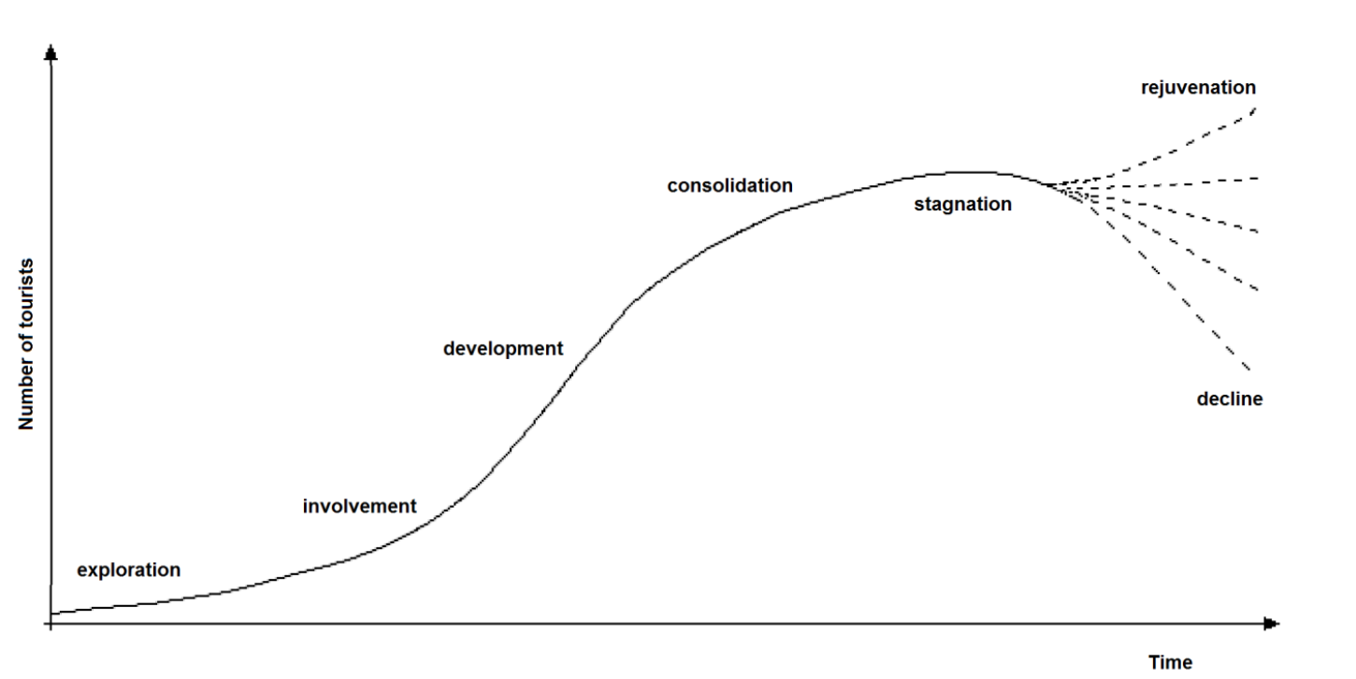
Figure 1: Butler’s life cycle
Source: (Graci, 2020)
Given that it clearly illustrates the majority, if not all, portions, Kaikoura, New Zealand, is the ideal location to examine the ramifications of each model in greater detail (Almeida & Garrod, 2018). But first, a closer examination of Butler's Cycle and Doxey's Irridex. Both frameworks can track the destination territory from perception to decay by placing a destination along this segmentation timeframe (Butler, 2020). This enables a quick, qualitative approach to all different kinds of locations (Volgger et al., 2021). Butler's Cycle claims that these visitors are almost entirely explorers who do not anticipate having access to the following tourist attractions like tourist spots, money exchange offices, or even conventional hotels (Farmaki, 2020). On the other hand, According to Butler's Cycle, the majority of these tourists are adventurers who do not expect to have access to any of these tourist sites, such as tourist destinations, currency exchange office buildings, and even traditional guesthouses (Farmaki, 2020). Tourists rarely left Kaikoura in the middle of the 1970s; when they did, it was usually to take a short respite before actually moving on (Graci, 2020). In response, Kaikoura Tours Limited was founded in the town's harbour in 1987 by Te Runanga O Kaikoura, the Maori Council of Kaikoura (Farmaki, 2020).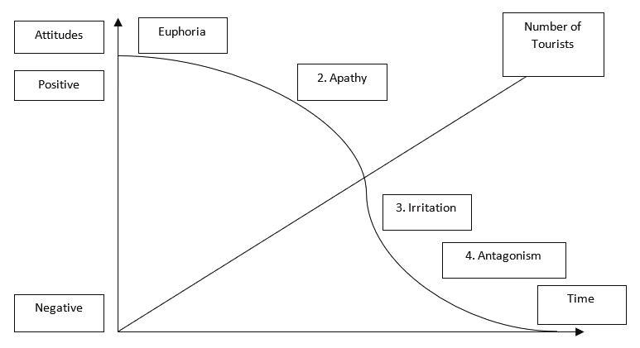
Figure 2: Doxey’s irridex model
Source: (Farmaki, 2020)
This was the first-time locals had worked in the tourism business. Inhabitants were in a state of bliss as tourists began to pour into the small town, even though there were only ten chairs just on the ship, and the company was still serving adrenaline rush excursion commuters (Almeida & Garrod, 2018). Domestic tourists who had previously used Kaikoura as a comfortable fuel stop inching closer to another location were now ended up joining by foreign visitors who would be staying at the hotel and sharing the tiny community with residents (Graci, 2020). Any departure point region can be examined in a correspondingly thorough manner using Doxey's Irridex and Butler's Cycle (Butler, 2020). The location can be given a portion of the great life span after closely examining the perceptions of host inhabitants toward tourism as well as the status of manufacturing participation, effectively assisting those who rely on and enforce the tourism sector (Butler, 2020). Therefore, it is to the greatest advantage of all tourist industry performers to be knowledgeable about Doxey's Irridex and Butler's Tourism Area Life Cycle; prepared to implement policy or change position as needed (Saarinen, 2020).

Figure 3: Statistics of the visitors
Source: Camper Champ
Tourism marketers' top priority is luring travellers to their destinations. Innumerable authors have written about the factors that affect tourists' choice of destination, specifically how the perception of the tourist industry affects that decision (Reinhold et al., 2018). Countries compete with one another by highlighting their differences in the cultural, institutional, and interpersonal facets of tourism (Almeida & Garrod, 2018). The institutional and inter-organizational arrangements for destination management, as well as the methods and degree to which different aspects of destination management are carried out, vary significantly across New Zealand (Farmaki, 2020). In addition to examining the benefits and drawbacks of structural features, this article attempts to clarify why these institutional disparities exist (Graci, 2020). These problems are analysed using a systems approach, which sees operations as the foundation of tourism destinations, deems a variety of related capabilities, and considers the different organizational constructions by which these are produced (Almeida & Garrod, 2018). To discuss more general concerns about the essence of tourism planning and how it's structured, we will move further than the New Zealand particular instance (Wang et al., 2018).

Regulations and organizations for implementation
One of the most crucial duties in destination management is the execution of sustainable programs and initiatives. Environmental and sustainability objectives frequently promote friendly rivalry among organizations, leading to creative solutions and fresh perspectives that broaden the scope of sustainability (Graci, 2020). To ensure the economical, efficient, and effective sustainability of resources that are utilized every day to advance business goals, an agency can also encourage or mandate the application of quality standards at its numerous assets (Reinhold et al., 2018). Guidelines range from simple activities such as composting electronic equipment to the development of complex systems for renewable sources, wind, and solar energy development, the reduction of toxic contaminants in materials, and the reduction of petroleum use, including the use of new types of fuels, as part of a process of reducing the energy consumption while moving ahead environmental targets (Butler, 2020).

Recommendation to keep sustainability
To provide for the needs of both current visitors and the native communities while helping to preserve, culturally significant, and different stimuli for future generations. Although there are many advantages, the drawbacks may discourage people from using sustainable tourism as a source of income. Visitors should think about the many advantages of sustainable tourism. The advantages of sustainable tourism are given below:

- Allows wildlife to stay wild: Knowing about wildlife places to visit and preventing them if they don't have the animals' best interests in thought are two advantages of engaging in sustainable tourism. Those certain locations will eventually disappear if there is less consumption of such types of amusement. Nature can remain untamed.
- Lower ecological impact: Eating traditional cuisine and buying it from regional suppliers is a component of sustainable travel. Food imports are extremely expensive both financially and ecologically, whether they are made across the country or the seafloor. Additionally, sampling local cuisine is a big part of the enjoyment of visiting different areas.
- Keeps the environment clean: Having to spend one's weekend getaway in a prettier destination will also be consistent with sustainable lodging. Individuals won't need to worry that the hydrosphere they intend to jump into the water in is being contaminated by one venue's sewage.

Conclusion
To demonstrate that the tourism industry is not without flaws, these adverse effects were shared. And as travellers, we should be conscious of the harm that our journey can cause. And as travellers, people should be conscious of the harm that our travel can cause. However, Ecological, commercial, and social effects resulting from tourism. The goal of sustainable tourism is to reduce adverse effects while enhancing positive aspects. It appears that the social implications are a combination of both positive and undesirable environmental and economic implications. The most effective means of ensuring and enforcing the principles of sustainable development in the tourist trade is a positive perspective, a hard stance, and particularly regulatory frameworks. As a result, despite being a highly philosophical construct and being somewhat disputed because of the challenges it faces in being put into effect, sustainable development has at least proven useful in making plans for tourism-related operations.

Reference
Almeida, A. and Garrod, B. (2018) “A CATREG model of destination choice for a mature island destination,” Journal of Destination Marketing &amp; Management, 8, pp. 32–40. Available at: https://doi.org/10.1016/j.jdmm.2016.11.005.
Blogger, M., Erschbamer, G. and Pechlaner, H. (2021) “Destination design: New perspectives for tourism destination development,” Journal of Destination Marketing &amp; Management, 19, p. 100561. Available at: https://doi.org/10.1016/j.jdmm.2021.100561.
Butler, R.W. (2020) “Overtourism, education, and the Tourism Area Life Cycle Model,” Overtourism and Tourism Education, pp. 7–23. Available at: https://doi.org/10.4324/9781003031765-3.
Farmaki, A. (2020) “Regional Network Governance and Sustainable Tourism,” Tourism and Sustainable Development Goals, pp. 192–214. Available at: https://doi.org/10.1201/9780429324253-12.
Graci, S. (2020) “Collaboration and Partnership Development for Sustainable Tourism,” Tourism and Sustainable Development Goals, pp. 232–249. Available at: https://doi.org/10.1201/9780429324253-14.
Reinhold, S., Laesser, C. and Beritelli, P. (2018) “The 2016 St. Gallen consensus on advances in Destination Management,” Journal of Destination Marketing &amp; Management, 8, pp. 426–431. Available at: https://doi.org/10.1016/j.jdmm.2017.03.001.
Saarinen, J. (2020) “Tourism and Sustainable Development Goals: Research on Sustainable tourism geographies,” Tourism and Sustainable Development Goals, pp. 1–10. Available at: https://doi.org/10.1201/9780429324253-1.
Sonuç, N. (2020) “Sustainable Tourism (Sustainable Development of Tourism, Sustainable Tourism Management),” Encyclopedia of Sustainable Management, pp. 1–8. Available at: https://doi.org/10.1007/978-3-030-02006-4_454-1.
Subadra, I.N. (2021) “Destination Management Solution Post covid-19: Best practice from Bali – a world cultural tourism destination,” Tourism Destination Management in a Post-Pandemic Context, pp. 25–36. Available at: https://doi.org/10.1108/978-1-80071-511-020211024.
Wang, T. et al. (2018) “A meta-model based automatic conceptual model-to-model transformation methodology,” Proceedings of the 6th International Conference on Model-Driven Engineering and Software Development [Preprint]. Available at: https://doi.org/10.5220/0006718105860593.

