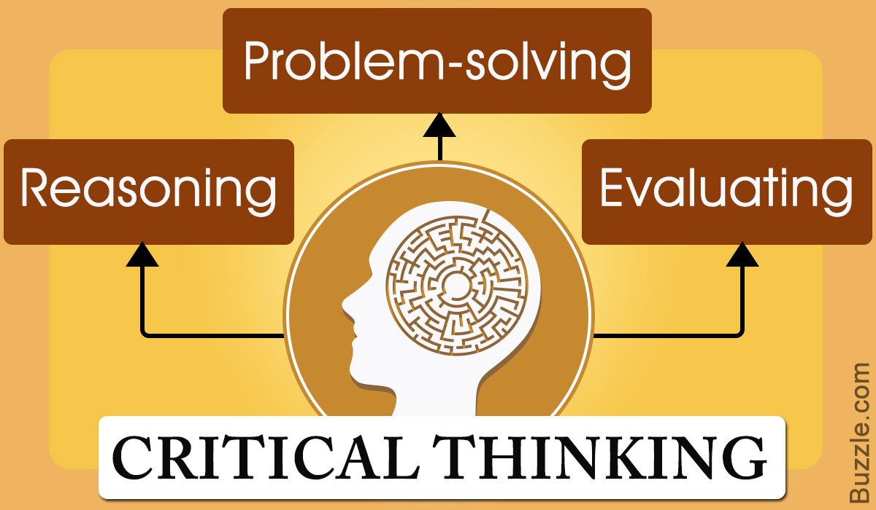
https://www.bing.com/images/search

Student Name | Aneesah Zubair
Student Number | 1809520
Module Name | Developing workplace critical thinking
Module Code | BMSK5001
Lecture Name | Chijioke Uba
Submission Date | 26/03/2020

Table of Contents……………………………………………………………………………...Page 1
Introduction…………………………………………………………………………………… Page 2.
My beliefs and values ……………………………………………………………………….. Page 3
Tesco core values and beliefs……………………………………………………………………….…………...… Page 4.-5.
Tesco case study …………………………………………………………………………….Page 5.
Fredrick Herzberg’s theory and the Two factor, theory’s relevance in the modern day…………………………………………………………………………....................... Page 6-7
Study case for / against the nation and a chosen method. …………………………..………………………………………………………………….. Page 8-9.
Conclusion…………………………………………………………………………………...Page 10
References…………………………………………………………………………………..Page 11.
Appendix…………………………………………………………………………………….. Page 12
Introduction

The aim of this report will consist upon me critically dissecting and analysing the difference between beliefs, attitudes and values within a workplace context. I will then be elaborating upon how I critically asses my own beliefs, attitudes and value systems. As knowing and understanding my own beliefs, values and attitudes which will allow me to have a better understanding within the way how I reflect upon my professional character in the workplace. It has been stated by (Ajzen, I. and Cote, N.G., 2008.) an attitude is a willingness to react favourably or unfavourably to an entity an institution of a person or event. It has also been stated by Anderson (2009) that a value is a worth of measure of the importance an individual attaches to often reflect upon how we life our lives such as how we value our freedom of speech or even family morals. (Greco, J., 2003.) Similarly, argues that it is better in having a virtues belief rather than having a belief that is not virtues.
Furthermore, I will be critically assessing an appropriate management theory to evaluate an individual with different beliefs, attitudes and values which how they may differ in how they interpreted the given management theory. Moving forward I will also be using a well-known organisation as a case study where I will discuss the core values on workplace behaviour. Upon explaining these sectors further in an in-depth manner, the aim of this report will be to critically assess the appropriate management theory to accommodate to the relevant topics linked with the chosen organisation using relevant critical thinking models, I will be evaluating the modern day relevance’s and weaknesses of the management theory. The final task will be to use an appropriate critical thinking model which will allow to develop an argument for or against the notion that an economic environment of a nation can affect a resident’s business. This report has been split in to five sections which are the following;
Task 1] My believes and values – 1) define these concepts, 2) outline my own values, 3)
Task 2] Tesco’s values and core beliefs – 1) organisational values definition, how it became Tesco.
Task 3] examination of the Fredrick Herzberg theory. - And the two-factor theory.
Task4] Relevance of Fredrick Herzberg theory in the modern-day beliefs .and how it has implicated toward vales of today’s society.
Task 5] case study for/against the nation using a relevant method

Task one

[My own beliefs and values]
I have many believes and values. One of them that has a major impact on my character is my religion which is Islam, this is due to me living accordingly by the rules of my religion. Islam is very beneficial for me as it humbles me in the sense of keeping true to myself. In Islam it teaches a person to have self-respect. I also follow the rules / concepts in the holy book which is the Quran and the Hadith. According to the Hadith it narrates Allah is self-Respecting and a believer is also self-respecting, and the respect of Allah is injured if a believer does what he has forbidden him to do. (Sahih. M book 50, Hadith 41)
Another value that I hold within myself is being loyal/committed which is a vital value to have in a personal character as this is also part of Islam According to the teachings of Islam, the definition and true meaning of ‘loyalty’ is the unequivocal fulfilment of one’s pledges and covenants at every level and under all circumstances, regardless of the difficulty] Mind I (.2019.) I also believe in being loyal, to yourself automatically this will change the atmosphere within, everything else surrounding me will develop loyalty as in a vice, versa approach. This method will help assist me to acknowledge and identify my potential values that i will possess using this technique, will also allow me to capture and understand my weakness that I will experience in my career. Moving forward i strongly value this belief in regard to help assist me to achieve my goals throughout my career journey. This belief will also allow me to accomplish my career aspiration’s allowing me to have a better understanding with my attitude toward the workplace. Moving forward, another value I possess is having a positive attitude in regards of what I do in my everyday life, this allows me to be more open and honest with a task I may be carrying out. A positive attitude can lead to many different accomplishments in your career as every business management and companies acknowledges, a person’s attitude within the first meet. Based on upon a person’s attitude they judge you accordingly. Positive attitude is the most important quality that employers look for in candidates and team members] (Gill.N 2009)

Task two

Where did Tesco’ begin from? According to (Dawson, J., Larke, R. and Choi, S.C., 2006) it has been stated that the founder of Tesco was jack Cohen In the year 1919 he was the owner of an market stall selling groceries based in London since then Tesco has expanded throughout providing its services in many nations and cities and also all around the globe . The former name Tesco had first appeared in 1942 after Cohen had purchased a shipment of tea. The first Tesco retail shop was opened in 1931 based in burnt oak Barnet.

[Tesco core values and belief’s]
In this section I will be elaborating upon Tesco’s beliefs and core values and how important their beliefs are as a company. Also, will be elaborating upon how Tesco value’s meet their customers’ needs and satisfaction. Moving forward I will be critically analysing the beliefs and core values of Tesco’s workplace behaviour and how beneficial their beliefs and core values can have a major impact upon Tesco’s customer satisfaction. Tesco have stated the following.; Tesco is built with a simple mission which is to serve and satisfy customer to the best of the business ability this will allow an easier way of communicating all around as the customer’s will be satisfied and also Tesco’s reputation will be kept prospered throughout. Furthermore Tesco. 2020. has also stated the following serving customer’s is at heart of everything we do from the employees in the stores, to those of them who are supporting individual roles.
[No one tries harder for customers]
Evidence from the literature highlighted that Tesco’s have stated the following, these core values which are stated by (Kelly, J., 2000) that their core value is to earn costumer’s loyalty and respect within the business. Tesco have also stated in the following that their business conduct is at the very heart of how they run their business and how it is designed to satisfy their customers in every aspect as possible. Tesco also have stated the following that it is very crucial that they fully understand that the rules that they follow at all times for them to protect their company in order to keep their reputation. they also have outmost respect for costumers as providing them lifetime loyalty is the companies aim Tesco have stated, when you earn lifetime loyalty through a whole set of values underpinned by our, no one tries harder’ for customers’ philosophy’. Tesco’s, according to (Humby, C., Hunt, T. and Phillips, T., 2004.) outlines the following the following core values and their beliefs; the need to understand customers and to be first to meet their needs. In addition, they value acting responsibly toward their communities, teamwork, trust and respect for each other, listening, supporting and “saying thank you”
Tesco’s is known to put their customer’s first, However, this may have its negative side, e.g., customers may take advantage of this business approach where the “customer is always” right. This may lead to a range of issues, such as some customer’s trying to take advantage of that fact that the firm would always want to look after their interests, thereby making it difficult for Tesco to realistically align organisational behaviour to belief. For instance, customer’s believing that they are always right can lead to many different conflicts as in the case of pleasing every customer can be almost impossible and complicated. This ties-in with the view of that one of the most challenging aspect in a business is to encounter a challenging and unsatisfied customer who may never be satisfied no matter how much the business sympathises with their concerns. Moving forward, it has been documented and stated by the following (Rogers, H., Ghauri, P.N. and George, K.L., 2005.) Tesco’s online shopping website had broken down which meant there was no access to online shopping, leaving many customers unsatisfied. Customers had left many negative feedback regarding that matter where left with many complaints regarding this matter which was also led Tesco’s to suffer a financial loss just within a couple of hours been offline. It had also consumed a lot of time for the employees who were carrying out the shopping instore for the customers that’ were supposed to be delivered after making the transaction’s online. Which may have led the employees feeling frustrated and also devastated as all the products they had collected had to be put back therefore a lot have time might have been consumed within this event. Therefore, I believe Tesco’s need to be prepared for upcoming scenario that have been previously afflicted upon them as a company and just have an alternative way to simplify this mater in the near upcoming events. According to (Woods, M., 2008.) selecting a reliable online provider which meets its criteria is essential. True entrepreneurs are prepared for quickly recovering from any downfalls. However, being prepared requires in having a fully equipped plan which will cover all possible aspects in the business and workplace in the near future.

The case study that I will be discussing in a more in-depth detailed manor is Tesco, as it is one of the U.K largest shopping retail organisation. And upon how a cultural difference can become a barrier within the work context.

Task three

Tesco’s management have also stated that since they first introduced Tesco’s value’s they have become a vital part of the organisation’s culture and something responsible for driving growth and success. It has been stated by (Benstead. 2019) multicultural differences, is something that is being highlighted therefore if not taken the correct approach it may lead the business to suffer a very expensive mistake. However, Tesco still have room for improvement due to the fact of Tesco’s not being very successful in china due to not fully understanding the cultural differences.
(Hopkins K 2015) discussed how, in 2013 it was announced that Tesco’s was pulling a solo brand out of china and would merge its 131 stores on mainland with 2,986 outlets of china resources enterprise [CRE] under the vanguard brand, leaving Tesco at 20 percent stake. This was done to align their strategy to Chinese consumer demands and expectations. This was because, according to (Pendrouse (2013), Tesco failed to understand the Chinese consumer’s values (Tesco did not understand how pricing affected consumer purchase intentions0, and this led to the businesses not doing well in the Chinese market. Here, we see a good example of how the failure to link organisational culture and behaviour to consumer vales can impact on sales and performance. This resonates with (Wang (2014) views that Tesco should have looked into the cultural differences in China before investing in the second biggest economy in the world.
Therefore, I believe Tesco’s can still improve on fully understanding the country’s cultural values and how they negotiate liaising terms with other foreign countries like china. It has also stated by (Hopkins (2015) that the painful lesson UK retailer Tesco has learnt is that china is a large, complicated in the sense of cultural differences and a very capital-intensive market to understand. Furthermore, after the major loss Tesco had faced, Tesco’s had announced plans to combine its Chinese operations with consumer goods company, allowing them to multi format in china’s multi-cultural companies’ .Moving forward the overall china and Tesco’s scenario had ended with Tesco’s critically analysing the financial way of solving the problem leaving them with an option to communicate as a team as they have always promised. If this happens, then the firm would have done better in terms of linking their values with those of the Chinese consumers.
Moving forward over all in this case study I have argued a strong point which is that the cultural difference can lead a company to suffer major loss due to not fully understanding different cultural values. Therefore, before a company or business invests over sea / abroad they should fully and critically understand their own values and how these may impact on those of their target consumer’s.

Task four

The theory that I will be discussing and Elaborating upon in this sector is Frederick Herzberg Two-Factor theory.
Fredrick Herzberg was born an American, He had studied at the city college where he was offered a fellowship to attend a graduate school of public and health, at the university of Pittsburgh where he continued further studies in clinical and abnormal psychologist. That is where he become one of the biggest influences of all time and also one of the most influential names in the business management sector.
In 1959 Herzberg wrote the following which can help explain this fundamental part of his theory. [we can expand. By stating that job, whereas the job dissatisfiers deal with the factors which define the job context. (Ewen, R.B., Smith, P.C. and Hulin, C.L., 1966)
The two-factor theory is based upon job satisfaction and job dissatisfaction. According to Herzberg, there are two sets of factors that determine workers’ jobs Dissatisfaction and job satisfaction. The first factor which he has stated is job Dissatisfaction. Fredrick has evaluated in the sense of the hygiene, factors he has analysed the factors between different aspects such as the working conditions, co-workers relations and also the base wage salary upon how all this can, have an effect upon a business and an employees in the workplace. The second part to Herzberg’s theory is based upon job Satisfaction on how it delivers the achievements, recognition and also responsibility of Work within itself, advancement and also personal growth. Moving forward this factor has proved that in today's society it is much needed, as majority of businesses have used this method in order to reach their goals. it has been documented and studied by (Lindsay, C.A., Marks, E. and Gorlow, L., 1967.) Herzberg had identified job enrichment as part of his research to motivate the growth factors in a company this received attention from scholars in 1980,The outcome of this process was achieved by promotion and recognition have increasingly motivated companies to look for ways which enrich the team work.

Diagram

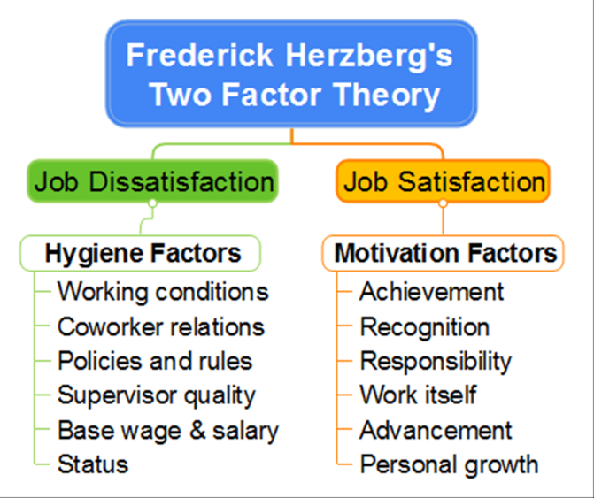
Frederick-Herzberg-(1971)

Limitation of the theory and is the theory relevant in the modern-day relevance?
However, the theory within itself is very limited as it’s only focuses upon satisfaction, and dissatisfaction, based in the business and workplace environment. it doesn’t fully elaborate on what particular work environment, such as different circumstances which could depend on different job roles. Where else for example, when it comes to working in a factory the hygiene level is very limited in the state based upon their given job roles, they may not have cleaners, or even the correct hygiene products which can have an effect upon the employees to be infected with many kind of illnesses according to (Al Kadi, A. and Salati, S.A., 2012) Hygiene measures a person’s way of life an individually by allowing them to feel comfortable in their own bodies, it also allows everyone around at the workplace to feel as if they’re in a more positive atmosphere. There are many other theories which indicate different approaches whilst in the business field such as, the theories of others like Fredrick Taylor provide a different dimensions of management that Herzberg did not consider clearly and in enough detail. Tayler’s theory had centred the idea of that it was mostly affected by employees to work harder as they improve the way their work was done. Tayler had published this principle of science management in 1990 in that which he indicated that efficiency can improve by maximising and simplifying in the workplace. As in Herzberg method was only job satisfaction and dissatisfaction he hadn’t really fully analysed how the coasts will affect throughout his method as in today’s modern day relevance companies like Tesco have upgraded in many aspect as in Tesco are highly trained into management, they not only consider reaching and meeting their given monthly targets at work but they They also consider and respect individual employee’s needs. Therefore, I believe that at the end result of Fredrick Herzberg theory still has its relevance in the modern day however it may have its negative aspects in the theory but I have acknowledged majority of this theory also does have an positive approach as well . As even in the modern-day Herzberg’s theory is still known and also even applied. As a conclusion I have acknowledged and identified that this theory has still got an effect upon todays relevance it’s just portrayed in a different wording manor.

Task five

In this section, I have used the systems thinking and a relevant model to examine the notion that environment of a nation affects residents’ business. My task in this section will be to develop an argument for or against the notion that the economic construct upon. The method that I have chosen to elaborate upon is the eight-cage distance frame this will allow me to explain the task in a more simplified manor.
The eight-cage distance framework systems thinking model assumes, that by defining certain locations that identify and provide low costs of raw materials, market or customer access or other key criteria allows for better decision making.
This means that a business is operating within a nation’s economic system. From this point of views, one can safely conclude that the business operating within the system will necessarily be impacted upon every business internally and externally in the sense of if the business was to be effected by an hygiene cause it can have an major effect and impact upon the overall aspect of an business association this will thereby effect every possible link including the nation and notion
However, According to (Ghemawat 2012). Has stated the following; In every nation there are economic factors that impact upon all the business according to the system or according to the systems point of view a business is a system within itself it will therefore be affected within the economic system as a sub system. however from this country’s point of view it doesn’t impact upon what company’s it is based upon it will still effect every business individually, due to contexts being key in the sense that different economic business turn to differ for example the further, or away from close distance. many a time countries can also be culturally close or further apart, the closer they are, the more it will be similar within the administration of that country. Down below I have shown a diagram developed by (Ghemawat 2012). It allows a better understanding on how it impacts the nation that is connected to the notion it narrates and breaks it down into sections.

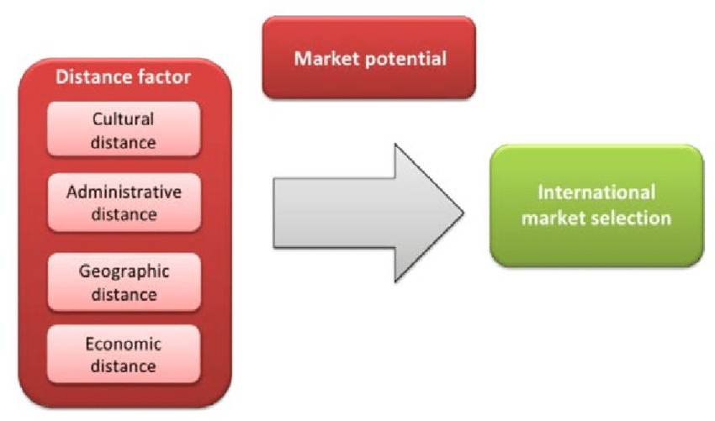
https://www.bing.com/images/search?view=detailV2&ccid=TxGpixD4&id=A09C6F92F8

. Another major impact that has had a negative impact towards the global business industries, is the coronavirus due to many business abroad globally not being able to make sales due to the hygiene risk levels being overseas. this has affected the business economy’s very largely it has been documented by (Ho, B. and Tsai, T., 2004.) The coronavirus outbreak has led towards damaging economical business it has affected Tourism and also to the supply parts of the automotive, Technology industries. this also has had an effect upon major companies such as Toyota, and also general motors and also Volkswagen. These are some of the business effected due to this virus. As now even in the local community many major business such as companies like MacDonald’s, costa and many other restaurants have closed down due to health and safety reasons hygiene was the most major impact upon these closures.

CONCLUSION

By completing this report, I have concluded that by possessing certain beliefs and values I have acknowledged the impact it has toward the attitude in the workplace including that of an organisation. It has helped me to acknowledge and develop the direction of the company or organisation I work for as well as my personal aspirations or goals in which I aim to achieve in the future.
It has also allowed me to better my understanding in the sense of acknowledging the core values and beliefs of the company I had chosen which was Tesco, it has shown me the importance of the (BVA) beliefs, values and attitudes in the workplace. these values are the guiding principles that matter most to us on how we work. We use these strongly held values to distinguish the difference between the right and wrong ways of working and how they elaborate in an understanding format that guides an individual to help assist whilst making a crucial, critical career choice and decision.
In task four, as explained by Fredrick Herzberg in his theory, it does not only take motivational factors to inspire workers nor does it take hygiene factors to eliminate dissatisfaction. In order to inspire and attract workers, managers need to balance the factors appropriately to match their employees’ unique needs. (Dartey-Baah, K. and Amoako, G.K., 2011.)
Task five was very beneficial for me as it allowed me to have a better understanding regarding, upon how the nation has an effect upon the notion as in economically, internally and externally, it has expanded my knowledge and my way of thinking in a more, overall prospective. It has opened a wider horizon for myself which I hadn’t consider thinking in this approach. As in before I had a very limited way of thinking. I had only considered a very little amount of understanding regarding the community and how the economic has an impact globally. Over all after completing this assignment, I have started to critically asses and analyse a given task in a more critical manor.

REFERENCES

Al Kadi, A. and Salati, S.A., 2012. Hand hygiene practices among medical students. Interdisciplinary perspectives on infectious diseases, 2012.

Ajzen, I. and Cote, N.G., 2008. Attitudes and the prediction of behavior. Attitudes and attitude change, pp.289-311.

Dawson, J., Larke, R. and Choi, S.C., 2006. Tesco: transferring marketing success factors internationally. In Strategic Issues in International Retailing (pp. 182-207). Routledge

Dartey-Baah, K. and Amoako, G.K., 2011. Application of Frederick Herzberg’s Two-Factor theory in assessing and understanding employee motivation at work: a Ghanaian Perspective. European Journal of Business and Management, 3(9), pp.1-8.

Ewen, R.B., Smith, P.C. and Hulin, C.L., 1966. An empirical test of the Herzberg two-factor theory. Journal of applied psychology, 50(6), p.544.

Ghemawat, P., 2001. Distance still matters. Harvard business review, 79(8), pp.137-147.
Greco, J., 2003. `Knowledge as Credit for True Belief
Gill, N., 2009. Governmental mobility: The power effects of the movement of detained asylum seekers around Britain's detention estate. Political Geography, 28(3), pp.186-196
Humby, C., Hunt, T. and Phillips, T., 2004. Scoring points: How Tesco is winning customer loyalty. Kogan Page Publishers.
Ho, B. and Tsai, T., 2004. The Chairman and the Coronavirus. Harvard International Review, 25(4), p.28.
Herzberg, F., 1971. The motivation-hygiene theory. Work and the nature of man, 4.
Kelly, J., 2000. Every little helps: an interview with Terry Leahy, CEO, Tesco. Long Range Planning, 33(3), pp.430-439
Lindsay, C.A., Marks, E. and Gorlow, L., 1967. The Herzberg Theory: a critique and reformulation.

Rogers, H., Ghauri, P.N. and George, K.L., 2005. The impact of market orientation on the internationalization of retailing firms: Tesco in Eastern Europe. The International Review of Retail, Distribution and Consumer Research, 15(1), pp.53-74.
Sunnah.com. 2020. Hadith - The Book Of Repentance - Sahih Muslim - Sunnah.Com - Sayings And Teachings Of Prophet Muhammad. [online]
Woods, M., 2008. Linking risk management to strategic controls: a case study of Tesco plc. International Journal of Risk Assessment and Management, 7(8), pp.1074-1088.
.

Appendix



