Rhys David Whatty
1900045
Card Matching Game
ACCA6021

Contents
Project Description 2
Project Design 3
Interface 3
Test Schedule 4
Screenshots 5
Evaluation 8
User Guide 9
Appendices 10
Appendix A: Source Code 10
Bibliography 20

Project Description

The objective of this project was to develop a simple matching card game. Using Visual Studio, alongside the GLM Graphics Library, the game was created in the C++ language with a GLFW window display to show the game. In order to draw the shapes required in the display, the code makes ample use of vector transformations, including translations and rotations, in order to draw the triangles to visually represent the cards. [1]

Project Design

In order to develop the code, the GLM Graphics Library was used, alongside use of OpenGL to use a lighting system within the code. In order to display the cards, textures are mapped onto the shapes. There are 4 textures in use; one to depict the back face of the card, and then 3 additional textures to display colour on the opposing side of the card, one each of the colours Red, Green and Blue. [2]
Once a card is selected on the board, the code will check if the selected card has been flipped. If it has been (although this will not happen on the first card selection), the game will prompt the player to choose another card. If it isn’t, a second rectangle is drawn over the original rectangle that was selected, which will display one of the three coloured textures.

Interface

Upon boot up, the code will generate a canvas with a camera object looking in a fixed direction at 6 rectangles that are drawn up, emulating cards that are face down in order to not be identifiable. The selection of a card is done by pressing any of the number button 1-6. Once 2 cards have been turned over, they will be compared. If the two cards are the same colour, from using the same texture, the code will register that these two cards have been successfully flipped and continue on to allow for 2 more cards to be selected by the player. If they are not the same colour, the 2 coloured rectangles will be discontinue being rendered, and the player can pick again.

Test Schedule

Test No. | Test Description | Expected Outcome | Outcome Success?
1 | Generating 6 cards face-down | Upon initiating the code, it will generate 6 evenly spaced cards with a texture applied to indicate they are face down. | Successful
2 | Selecting a first card | Upon pressing a button 1-6, the respective card should be flipped on the screen, revealing either the red, blue, or green face underneath it | Successful
3 | Selecting a second card | Once the first card has been selected, using the same method, a second card should be chosen by pressing the buttons 1-6 | Successful
4 | Unable to re-select a flipped card | If the player selects a card that has already been flipped, it will not allow the player to select that card and have them select another card instead | Successful
5 | Game flips cards back over if no match | Should the 2 cards selected not having matching face colours, they should both be flipped back to their original orientation before letting the player take another turn | Successful
6 | Game keeps cards flips if a match | Should the 2 cards selected be a match, the game will keep the cards face up when moving on to the next turn | Successful

Screenshots
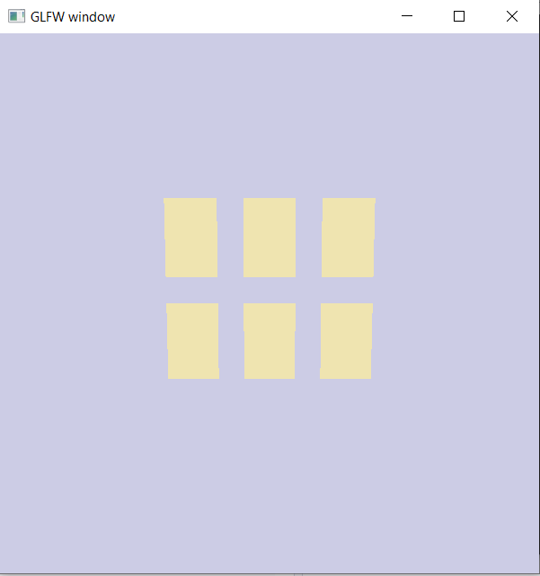
Project on bootup

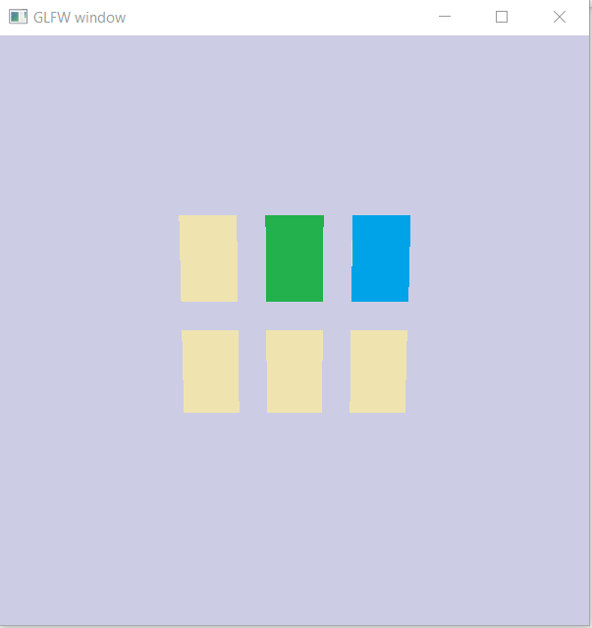
Two non-matching cards

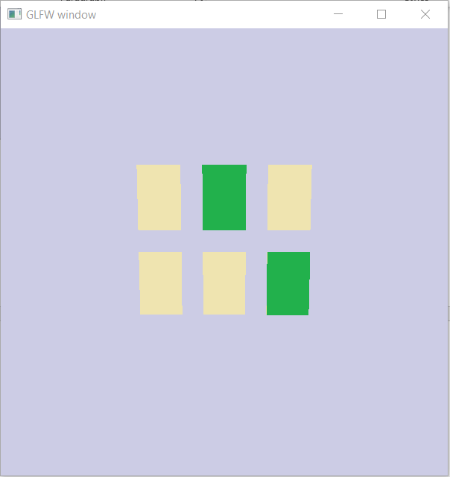
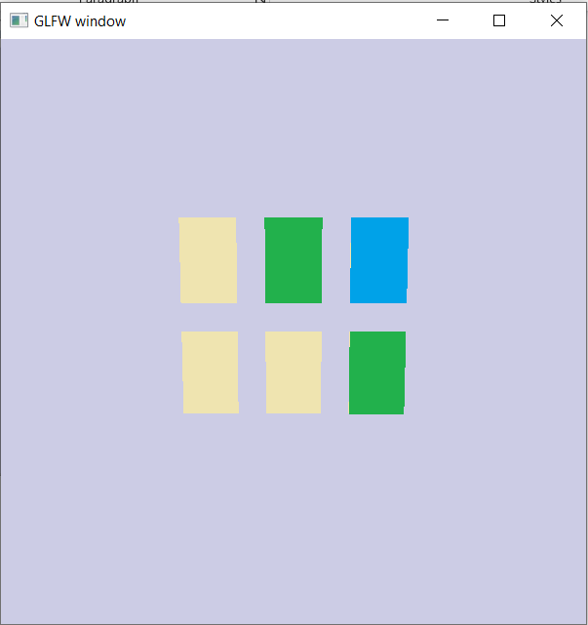
Matching pair, followed by next selection

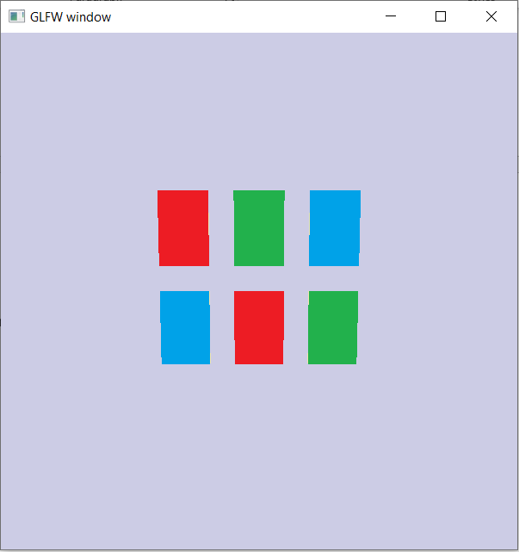
Completed board

Evaluation

The code used in the project is likely not as concise as it could be, meaning that on a future run through, the code could be compressed to be less line heavy, however it is functional in its current state. A more concise code would also allow for less testing time as repeat testing for different scenarios could be reduced if working of the same exact code. Arrays were used to store the flipped state of each card as it was the most effective method of doing so, allowing for their state to be registered in one array in a binary method. Use of textures for the cards over RGB colouring means the textures can be changed to something more complex in future, making the game look more streamlined.

User Guide

The screen will display a series of cards, face down in front of you. Use the number buttons (1-6) to select a card. When a card is selected, it will be flipped, revealing one of three colours underneath. After choosing a second card, should they be a matching pair, the cards will remain flipped, allowing you to select 2 more cards. If not, the cards will be flipped back over, and you will have to guess again. Flip all 6 cards over to win the game.

Appendices

Appendix A: Source Code

#include "GL/glew.h"
#include "GLFW/glfw3.h"
#include "glm/glm.hpp"
#include "./glm/ext.hpp"
#include <iostream>
#include "utils.h"
#include "stb_imageloader.h"
#include <chrono>
#include <thread>
using namespace std;
float cameraX, cameraY, cameraZ;
float cubeLocX, cubeLocY, cubeLocZ;
int direction = 0;
GLuint tex[4];
#define numVAOs 2
#define numVBOs 4
GLuint mvLoc, projLoc;
int width, height;
float aspect;
glm::mat4 pMat, vMat, mMat, mvMat;
void setupVertices(void);
GLuint renderingProgram;
GLuint vao[numVAOs];
GLuint vbo[numVBOs];
bool card1Flipped, card2Flipped = false;
int cardFlipped[6] = { 0, 0, 0, 0, 0, 0 };
int cardLocked[6] = { 0, 0, 0, 0, 0, 0 };

//------------------------------------------------------------------------------------------------------------------------------------------------

//RENDERING TEXTURES
void init(GLFWwindow* window) {
int x, y, n;
int force_channels = 4; //RGB and A
char filename[] = "card.png";
char filename2[] = "red.png";
char filename3[] = "green.png";
char filename4[] = "blue.png";
unsigned char* image_data = stbi_load(filename, &x, &y, &n, force_channels); //x = x dimemsions, y= ydims,
if (!image_data)
{
cout << "error: could not load " << filename << endl;
}
// copy image into ogl buffer
glGenTextures(4, tex);
glActiveTexture(GL_TEXTURE0);
glBindTexture(GL_TEXTURE_2D, tex[0]);
glTexImage2D(GL_TEXTURE_2D, 0, GL_RGBA, x, y, 0, GL_RGBA, GL_UNSIGNED_BYTE, image_data);
glTexParameteri(GL_TEXTURE_2D, GL_TEXTURE_WRAP_S, GL_CLAMP_TO_EDGE);
glTexParameteri(GL_TEXTURE_2D, GL_TEXTURE_WRAP_T, GL_CLAMP_TO_EDGE);
glTexParameterf(GL_TEXTURE_2D, GL_TEXTURE_MAG_FILTER, GL_LINEAR);
glTexParameterf(GL_TEXTURE_2D, GL_TEXTURE_MIN_FILTER, GL_LINEAR);

image_data = stbi_load(filename2, &x, &y, &n, force_channels); //x = x dimemsions, y= ydims,
if (!image_data)
{
cout << "error: could not load " << filename << endl;
}
glBindTexture(GL_TEXTURE_2D, tex[1]);
glTexImage2D(GL_TEXTURE_2D, 0, GL_RGBA, x, y, 0, GL_RGBA, GL_UNSIGNED_BYTE, image_data);
glTexParameteri(GL_TEXTURE_2D, GL_TEXTURE_WRAP_S, GL_CLAMP_TO_EDGE);
glTexParameteri(GL_TEXTURE_2D, GL_TEXTURE_WRAP_T, GL_CLAMP_TO_EDGE);
glTexParameterf(GL_TEXTURE_2D, GL_TEXTURE_MAG_FILTER, GL_LINEAR);
glTexParameterf(GL_TEXTURE_2D, GL_TEXTURE_MIN_FILTER, GL_LINEAR);

image_data = stbi_load(filename3, &x, &y, &n, force_channels); //x = x dimemsions, y= ydims,
if (!image_data)
{
cout << "error: could not load " << filename << endl;
}
glBindTexture(GL_TEXTURE_2D, tex[2]);
glTexImage2D(GL_TEXTURE_2D, 0, GL_RGBA, x, y, 0, GL_RGBA, GL_UNSIGNED_BYTE, image_data);
glTexParameteri(GL_TEXTURE_2D, GL_TEXTURE_WRAP_S, GL_CLAMP_TO_EDGE);
glTexParameteri(GL_TEXTURE_2D, GL_TEXTURE_WRAP_T, GL_CLAMP_TO_EDGE);
glTexParameterf(GL_TEXTURE_2D, GL_TEXTURE_MAG_FILTER, GL_LINEAR);
glTexParameterf(GL_TEXTURE_2D, GL_TEXTURE_MIN_FILTER, GL_LINEAR);

image_data = stbi_load(filename4, &x, &y, &n, force_channels); //x = x dimemsions, y= ydims,
if (!image_data)
{
cout << "error: could not load " << filename << endl;
}
glBindTexture(GL_TEXTURE_2D, tex[3]);
glTexImage2D(GL_TEXTURE_2D, 0, GL_RGBA, x, y, 0, GL_RGBA, GL_UNSIGNED_BYTE, image_data);
glTexParameteri(GL_TEXTURE_2D, GL_TEXTURE_WRAP_S, GL_CLAMP_TO_EDGE);
glTexParameteri(GL_TEXTURE_2D, GL_TEXTURE_WRAP_T, GL_CLAMP_TO_EDGE);
glTexParameterf(GL_TEXTURE_2D, GL_TEXTURE_MAG_FILTER, GL_LINEAR);
glTexParameterf(GL_TEXTURE_2D, GL_TEXTURE_MIN_FILTER, GL_LINEAR);

renderingProgram = createShaderProgram(); //load, compile, create, attach and link shader programmes done here
cameraX = 0.0f; cameraY = 0.0f; cameraZ = 18.0f; //camera position
cubeLocX = 0.0f; cubeLocY = -2.0f; cubeLocZ = 0.0f; // shift cube down Y to reveal perspective
vMat = glm::lookAt(glm::vec3(cameraX, cameraY, cameraZ), glm::vec3(cubeLocX, cubeLocY, cubeLocZ), glm::vec3(0.0f, 1.01f, 0.0f));
// build perspective matrix
glfwGetFramebufferSize(window, &width, &height); //need these to fit clip space to window
aspect = (float)width / (float)height;
pMat = glm::perspective(1.0472f, aspect, 0.05f, 100.0f); // 1.0472 radians = 60 degrees
setupVertices(); //initial vertices x,y,z values
glEnable(GL_DEPTH_TEST);
}

//------------------------------------------------------------------------------------------------------------------------------------------------

//RENDERING CONTENT ON WINDOW
void display(GLFWwindow* window, double currentTime)
//runs 60 times a second by default in glfw - see main loop
{
glClear(GL_DEPTH_BUFFER_BIT);
glClearColor(0.8, 0.8, 0.9, 1.0);
glClear(GL_COLOR_BUFFER_BIT);
glUseProgram(renderingProgram); //specify linked program to use

//get a reference to the shader variable Vcol
//GLuint VcolLoc = glGetUniformLocation(renderingProgram, "Vcol");
mvLoc = glGetUniformLocation(renderingProgram, "mv_matrix");
projLoc = glGetUniformLocation(renderingProgram, "proj_matrix");

// copy perspective and MV matrices to corresponding uniform variables
glUniformMatrix4fv(mvLoc, 1, GL_FALSE, glm::value_ptr(mvMat));
glUniformMatrix4fv(projLoc, 1, GL_FALSE, glm::value_ptr(pMat));
// adjust OpenGL settings
glBindVertexArray(vao[0]);
glBindBuffer(GL_ARRAY_BUFFER, vbo[0]); //house mesh bound to VBO
glVertexAttribPointer(0, 3, GL_FLOAT, GL_FALSE, 0, 0);
glEnableVertexAttribArray(0);
glBindBuffer(GL_ARRAY_BUFFER, vbo[1]); //house mesh bound to VBO
glVertexAttribPointer(1, 2, GL_FLOAT, GL_FALSE, 0, 0);
glEnableVertexAttribArray(1);
glPolygonMode(GL_FRONT_AND_BACK, GL_FILL);
int xOffset = 0, yOffset = 0;
int colNum = 3;
int rowNum = 2;

//Draw Card Faces
for (int i = 0; i < rowNum; i++)
{
for (int j = 0; j < colNum; j++)
{
xOffset = j * 3;
yOffset = i * 4;
glBindTexture(GL_TEXTURE_2D, tex[0]);
//Create new model matrix and then mv matrix (no change to camera position/orientation so view matrix not touched)
mMat = glm::translate(glm::mat4(1.0f), glm::vec3(cubeLocX - 4.0 + xOffset, cubeLocY + +yOffset, cubeLocZ));
mMat = glm::rotate(mMat, glm::radians(0.0f), glm::vec3(0.0f, 0.01f, 0.0f));
mvMat = vMat * mMat;
//copy new mv matrix to shader
glUniformMatrix4fv(mvLoc, 1, GL_FALSE, glm::value_ptr(mvMat));
glUniformMatrix4fv(projLoc, 1, GL_FALSE, glm::value_ptr(pMat));
glDrawArrays(GL_TRIANGLES, 0, 6); //draw a card

}
}
//Drawing flipped over cards
if (cardFlipped[0] == 1)
{
glBindTexture(GL_TEXTURE_2D, tex[1]);
mMat = glm::translate(glm::mat4(1.0f), glm::vec3(cubeLocX - 4.0, cubeLocY + 4, cubeLocZ + 0.1));
mMat = glm::rotate(mMat, glm::radians(0.0f), glm::vec3(0.0f, 0.01f, 0.0f));
mvMat = vMat * mMat;
glUniformMatrix4fv(mvLoc, 1, GL_FALSE, glm::value_ptr(mvMat));
glUniformMatrix4fv(projLoc, 1, GL_FALSE, glm::value_ptr(pMat));
glDrawArrays(GL_TRIANGLES, 0, 6);
}

if (cardFlipped[1] == 1)
{
glBindTexture(GL_TEXTURE_2D, tex[2]);
mMat = glm::translate(glm::mat4(1.0f), glm::vec3(cubeLocX - 1.0, cubeLocY + 4, cubeLocZ + 0.1));
mMat = glm::rotate(mMat, glm::radians(0.0f), glm::vec3(0.0f, 0.01f, 0.0f));
mvMat = vMat * mMat;
glUniformMatrix4fv(mvLoc, 1, GL_FALSE, glm::value_ptr(mvMat));
glUniformMatrix4fv(projLoc, 1, GL_FALSE, glm::value_ptr(pMat));
glDrawArrays(GL_TRIANGLES, 0, 6);
}

if (cardFlipped[2] == 1)
{
glBindTexture(GL_TEXTURE_2D, tex[3]);
mMat = glm::translate(glm::mat4(1.0f), glm::vec3(cubeLocX + 2.0, cubeLocY + 4, cubeLocZ + 0.1));
mMat = glm::rotate(mMat, glm::radians(0.0f), glm::vec3(0.0f, 0.01f, 0.0f));
mvMat = vMat * mMat;
glUniformMatrix4fv(mvLoc, 1, GL_FALSE, glm::value_ptr(mvMat));
glUniformMatrix4fv(projLoc, 1, GL_FALSE, glm::value_ptr(pMat));
glDrawArrays(GL_TRIANGLES, 0, 6);
}

if (cardFlipped[3] == 1)
{
glBindTexture(GL_TEXTURE_2D, tex[3]);
mMat = glm::translate(glm::mat4(1.0f), glm::vec3(cubeLocX - 4.0, cubeLocY, cubeLocZ + 0.1));
mMat = glm::rotate(mMat, glm::radians(0.0f), glm::vec3(0.0f, 0.01f, 0.0f));
mvMat = vMat * mMat;
glUniformMatrix4fv(mvLoc, 1, GL_FALSE, glm::value_ptr(mvMat));
glUniformMatrix4fv(projLoc, 1, GL_FALSE, glm::value_ptr(pMat));
glDrawArrays(GL_TRIANGLES, 0, 6);
}

if (cardFlipped[4] == 1)
{
glBindTexture(GL_TEXTURE_2D, tex[1]);
mMat = glm::translate(glm::mat4(1.0f), glm::vec3(cubeLocX - 1.0, cubeLocY, cubeLocZ + 0.1));
mMat = glm::rotate(mMat, glm::radians(0.0f), glm::vec3(0.0f, 0.01f, 0.0f));
mvMat = vMat * mMat;
glUniformMatrix4fv(mvLoc, 1, GL_FALSE, glm::value_ptr(mvMat));
glUniformMatrix4fv(projLoc, 1, GL_FALSE, glm::value_ptr(pMat));
glDrawArrays(GL_TRIANGLES, 0, 6);
}

if (cardFlipped[5] == 1)
{
glBindTexture(GL_TEXTURE_2D, tex[2]);
mMat = glm::translate(glm::mat4(1.0f), glm::vec3(cubeLocX + 2.0, cubeLocY, cubeLocZ + 0.1));
mMat = glm::rotate(mMat, glm::radians(0.0f), glm::vec3(0.0f, 0.01f, 0.0f));
mvMat = vMat * mMat;
glUniformMatrix4fv(mvLoc, 1, GL_FALSE, glm::value_ptr(mvMat));
glUniformMatrix4fv(projLoc, 1, GL_FALSE, glm::value_ptr(pMat));
glDrawArrays(GL_TRIANGLES, 0, 6);
}

using namespace std::this_thread;
using namespace std::chrono_literals;
sleep_for(1s);
if (card2Flipped == true)
{
if (cardFlipped[0] == 1 && cardFlipped[4] == 1)
{
card1Flipped = false;
card2Flipped = false;
cardLocked[0] = 1;
cardLocked[4] = 1;
}
else
{
card1Flipped = false;
card2Flipped = false;
cardFlipped[0] = 0;
cardFlipped[4] = 0;
}

if (cardFlipped[1] == 1 && cardFlipped[5] == 1)
{
card1Flipped = false;
card2Flipped = false;
cardLocked[1] = 1;
cardLocked[5] = 1;
}
else
{
card1Flipped = false;
card2Flipped = false;
cardFlipped[1] = 0;
cardFlipped[5] = 0;
}

if (cardFlipped[2] == 1 && cardFlipped[3] == 1)
{
card1Flipped = false;
card2Flipped = false;
cardLocked[2] = 1;
cardLocked[3] = 1;
}
else
{
card1Flipped = false;
card2Flipped = false;
cardFlipped[2] = 0;
cardFlipped[3] = 0;
}
}

if (cardLocked[0] == 1 && cardLocked[1] == 1 && cardLocked[2] == 1 && cardLocked[3] == 1 && cardLocked[4] == 1 && cardLocked[5] == 1)
{
sleep_for(1s);
}

//Draw card solutions
float cardCols[18] = {
1.0,0.0,0.0,
1.0,1.0,0.0,
255.0 / 255.0, 0.0 / 255.0, 0.0 / 255.0,
0.0,1.0,0.0,
0.0,0.0,1.0,
233.0 / 255.0,66.0 / 255.0,17.0 / 255.0
};
}

//------------------------------------------------------------------------------------------------------------------------------------------------

//CARD BLUEPRINT
void setupVertices(void) {
float cardVertexPos[18] = {
//Card Vertex Co-ordinates
0.0, 0.0, 0.0,
0.0, -3.0, 0.0,
2.0, 0.0, 0.0,
0.0, -3.0, 0.0,
2.0, -3.0, 0.0,
2.0, 0.0, 0.0
};
//initialse VAO and VBOs
glGenVertexArrays(numVAOs, vao);
glBindVertexArray(vao[0]);
glGenBuffers(numVBOs, vbo);
glBindBuffer(GL_ARRAY_BUFFER, vbo[0]);
glBufferData(GL_ARRAY_BUFFER, sizeof(cardVertexPos), cardVertexPos, GL_STATIC_DRAW);
}

//------------------------------------------------------------------------------------------------------------------------------------------------

//SELECTING THE CARD
static void key_callback(GLFWwindow* window, int key, int scancode, int action, int mods)
{
switch (key) {
case GLFW_KEY_1:
//Select Card 1
if (cardLocked[0] == 1)
{
cout << "Card already flipped, choose another card" << endl;
}
if (cardFlipped[0] == 1)
{
cout << "Card already flipped, choose another card" << endl;
}
else if (card1Flipped == true)
{
card2Flipped = true;
cardFlipped[0] = 1;
}
else
{
card1Flipped = true;
cardFlipped[0] = 1;
}
break;
case GLFW_KEY_2:
//Select Card 2
if (cardLocked[1] == 1)
{
cout << "Card already flipped, choose another card" << endl;
}
if (cardFlipped[1] == 1)
{
cout << "Card already flipped, choose another card" << endl;
}
else if (card1Flipped == true)
{
card2Flipped = true;
cardFlipped[1] = 1;
}
else
{
card1Flipped = true;
cardFlipped[1] = 1;
}
break;
case GLFW_KEY_3:
//Select Card 3
if (cardLocked[2] == 1)
{
cout << "Card already flipped, choose another card" << endl;
}
if (cardFlipped[2] == 1)
{
cout << "Card already flipped, choose another card" << endl;
}
else if (card1Flipped == true)
{
card2Flipped = true;
cardFlipped[2] = 1;
}
else
{
card1Flipped = true;
cardFlipped[2] = 1;
}
break;
case GLFW_KEY_4:
//Select Card 4
if (cardLocked[3] == 1)
{
cout << "Card already flipped, choose another card" << endl;
}
if (cardFlipped[3] == 1)
{
cout << "Card already flipped, choose another card" << endl;
}
else if (card1Flipped == true)
{
card2Flipped = true;
cardFlipped[3] = 1;
}
else
{
card1Flipped = true;
cardFlipped[3] = 1;
}
break;
case GLFW_KEY_5:
//Select Card 5
if (cardLocked[4] == 1)
{
cout << "Card already flipped, choose another card" << endl;
}
if (cardFlipped[4] == 1)
{
cout << "Card already flipped, choose another card" << endl;
}
else if (card1Flipped == true)
{
card2Flipped = true;
cardFlipped[4] = 1;
}
else
{
card1Flipped = true;
cardFlipped[4] = 1;
}
break;
case GLFW_KEY_6:
//Select Card 6
if (cardLocked[5] == 1)
{
cout << "Card already flipped, choose another card" << endl;
}
if (cardFlipped[5] == 1)
{
cout << "Card already flipped, choose another card" << endl;
}
else if (card1Flipped == true)
{
card2Flipped = true;
cardFlipped[5] = 1;
}
else
{
card1Flipped = true;
cardFlipped[5] = 1;
}
break;
default:
break;
}
}

//------------------------------------------------------------------------------------------------------------------------------------------------

//GENERATE WINDOW
int main(void)
{
if (!glfwInit()) { exit(EXIT_FAILURE); }
glfwWindowHint(GLFW_CONTEXT_VERSION_MAJOR, 4);
glfwWindowHint(GLFW_CONTEXT_VERSION_MINOR, 3);
GLFWwindow* window = glfwCreateWindow(600, 600, "GLFW window", NULL, NULL);

cardFlipped[0] = 0;
cardFlipped[1] = 0;
cardFlipped[2] = 0;
cardFlipped[3] = 0;
cardFlipped[4] = 0;
cardFlipped[5] = 0;

glfwSetKeyCallback(window, key_callback);
glfwMakeContextCurrent(window);
if (glewInit() != GLEW_OK) { exit(EXIT_FAILURE); }
glfwSwapInterval(1);
init(window);
while (!glfwWindowShouldClose(window)) {
display(window, glfwGetTime());
glfwSwapBuffers(window);
glfwPollEvents();
}
glfwDestroyWindow(window);
glfwTerminate();
exit(EXIT_SUCCESS);
}

Bibliography

[1] | S. Gordon, Computer Graphics Programming in OpenGL with C++ Second Edition, Mercury Learning and Information, 2020.
[2] | D. &. B. P. Hearn, Computer Graphics with Open GL, Pearson, 2014.

