Computer architecture (ACCC4003_Lon)
Renuga Jayakumar
Vladimir Blagoev (1908772)
1908772@student.uwtsd.ac.uk

UNIVERSITY OF WALES TRINITY SAINT DAVID
BSc CLOUD COMPUTING

Table of Contents
Scenario 1: 2
Scenario 2: 4
Additional Storage 6
References 7

Table 1. Component List, Scenario 1.. 2
Table 2. Component List, Scenario 2. 4
Table 3. Storage Option A. 6
Table 4. Storage Option B. 6

Scenario 1:
In this scenario we are going to prioritize price and stability over performance with a simple, cheap, long lasting and easy to use build.

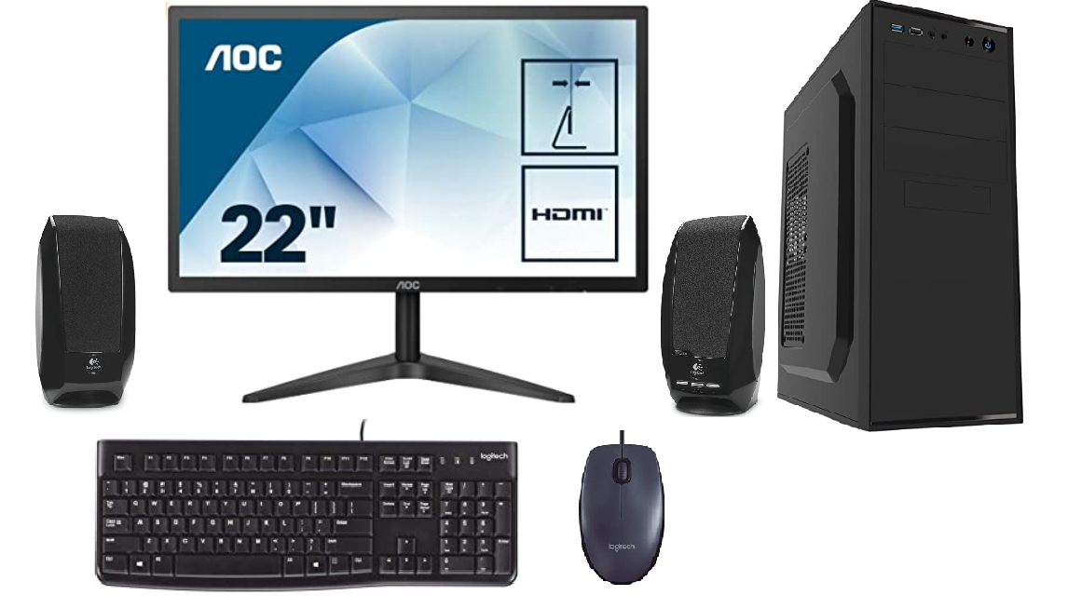

Part | Product | Price
Case | CiT Jet Stream Midi Case with Silver Stripe and 500 W Power Supply | £34.99
Processor (CPU) | Intel® Pentium® Dual Core G5400 (3.70GHz) 4MB Cache | £53.97
Motherboard | ASUS® H310M-A R2.0: Micro-ATX, DDR4, LGA1151, USB 3.1, SATA 6GBs | £56.99
Memory (RAM) | 8GB Corsair VENGEANCE DDR4 2400MHz (1 x 8GB) | £35.49
Graphics Card | INTEGRATED GRAPHICS ACCELERATOR (GPU) | £0.00
Storage Drive | Kingston SSDNow A400 240GB SATA 3 Solid State Drive (SA400S37/240G) | £39.88
Power Supply | 500 W Power Supply | £0.00
Power Cable | PXT101UK3M 3m UK Computer Power Cord | £5.56
Sound Card | ONBOARD 6 CHANNEL (5.1) HIGH DEF AUDIO (AS STANDARD) | £0.00
Wi-Fi | TP-Link TL-WN881ND 300 | £11.99
USB Options | MIN. 2 x USB 3.0 & 2 x USB 2.0 PORTS @ BACK PANEL + MIN. 2 FRONT PORTS | £0.00
Monitor | AOC 22B1H 21.5" LED Full HD monitor | £79.99
Monitor Cables | HDMI 2.0 Cable - 1.8m | £5.99
Keyboard | LOGITECH® K120 USB KEYBOARD | £8.98
Mouse | LOGITECH® B100 Wired USB Mouse | £6.36
Headset | LOGITECH® H340 Headset | £29.08
Speakers | LOGITECH® OEM S150 2.0 Speaker System | £12.12
 | Total Price | £381.39
Table 1. Component List, Scenario 1. All prices and links from (Amazon.co.uk, 2020).

CPU – Intel® Pentium® Dual Core G5400 – Intel CPUs have a very good longevity, but a slightly higher price than their AMD counterparts. This particular CPU also comes with an Intel® UHD Graphics 610 Graphics Card which eliminates the need to buy a dedicated graphics card.
Motherboard - ASUS® H310M-A R2.0 – Here we go for a cheap motherboard that has the right socket for our CPU and the correct slots for our RAM. Asus make very long-lasting good quality motherboards, that’s why we chose them.
RAM – Windows 10 can run on as low as 2gb of memory (Windows 10 system requirements, 2020) however Google Chrome uses a lot of RAM and with a difference of only £11 between 4gb and 8gb of RAM we can go for the safer 8gb option.
Graphics Card – Integrated in the CPU
Storage Drive - 256GB PCS 2.5" SSD– currently on the market the smallest HDD is around 1TB which is way too much in our case this is why we can go for the similarly priced 256 SSD which will greatly improve our loading time.
Case – Cheapest case we can find on the market with at least some I/O ports on back and front and an integrated power supply.
Power Supply – 500W integrated power supply is completely fine for our build.
I/O – Here we can get the cheapest speakers, mouse, keyboard and headset with mic. Logitech are a very good option because both mouse and keyboard and very comfortable to use and their products have very good build quality.
Monitor – Cheapest 21.5” monitor that we can find. AOC makes good and sturdy monitors.

Scenario 2:
In this scenario we will prioritize performance and price to performance ratio while considering future upgradeability.
Part | Product | Price
Case | Corsair CC-9011098-WW 3 x 120 mm Crystal Series 570X RGB Mid Tower Computer Chassis - Black | £160.00
Processor (CPU) | AMD Ryzen 9 3900X Processor (12C/24T, 70MB Cache, 4.6 GHz Max Boost) | £420.00
Motherboard | ASUS TUF Gaming X570-Plus (Wi-Fi) ATX Motherboard, AMD Socket AM4, AM4, Ryzen 3000, 12+2 Dr. MOS, PCIe 4.0, M.2, DDR4, LAN, HDMI, DP, USB 3.2, Aura Sync RGB | £229.95
Memory (RAM) | CORSAIR VENGEANCE LPX 64GB (2 x 32GB) DDR4 3200 (PC4-25600) C16 1.35V Desktop Memory - Black | £289.99
Graphics Card | Gigabyte GeForce RTX 2060 OC | £309.99
1st Storage Drive | Samsung 860 QVO 2 TB SATA 2.5 Inch Internal Solid State Drive (SSD) | £194.81
2nd Storage Drive | Seagate ST8000DM004 Barracuda - 8 TB internal hard drive - Silver | £169.47
Power Supply | Seasonic Focus GX 750W Power Supply, Full Modular, 80 Plus Gold, 90% Efficiency, Cable-Free Connection, Hybrid Silent Fan Control | £113.58
Power Cable | PXT101UK3M 3m UK Computer Power Cord | £5.56
Memory Card Reader | USB 3.0 Card Reader,Beikell High-speed SD/Micro SD Card Reader Memory Card Adapter-Supports SD/Micro SD/TF/SDHC/SDXC/MMC | £6.59
Sound Card | 7.1 Channel Sound Card - PCI Express - 24-bit - 192KHz - SPDIF Digital Optical and 3.5mm Analog Audio (PEXSOUND7CH) | 46.99
Monitor | AOC U3277PWQU 31.5-inch LED Monitor - 3840 x 2160 Resolution, HDMI | £509.20
Monitor Cables | High-Speed 4K, Ultra HD, HDMI 2.0 Cable - 1.8m Supports 3D, Audio Return | £5.99
Keyboard | Redragon S101-UK Gaming Keyboard and Mouse, Plus Mouse Pad and Gaming Headset Combo Silent Quiet Wired RGB Rainbow Backlit Keyboard | £41.99
Mouse |  | £41.99
Headset |  | £41.99
Thermal Paste | ARCTIC MX-4 Edition 2019 Thermal Paste;Heatsink Paste;Thermal Conductivity:>8.5 W/m-k Carbon Based High Performance, Heatsink Paste, | 6.99
 | Total Price: | £2,511.10
Table 2. Component List, Scenario 2. All prices and links from (Amazon.co.uk, 2020).
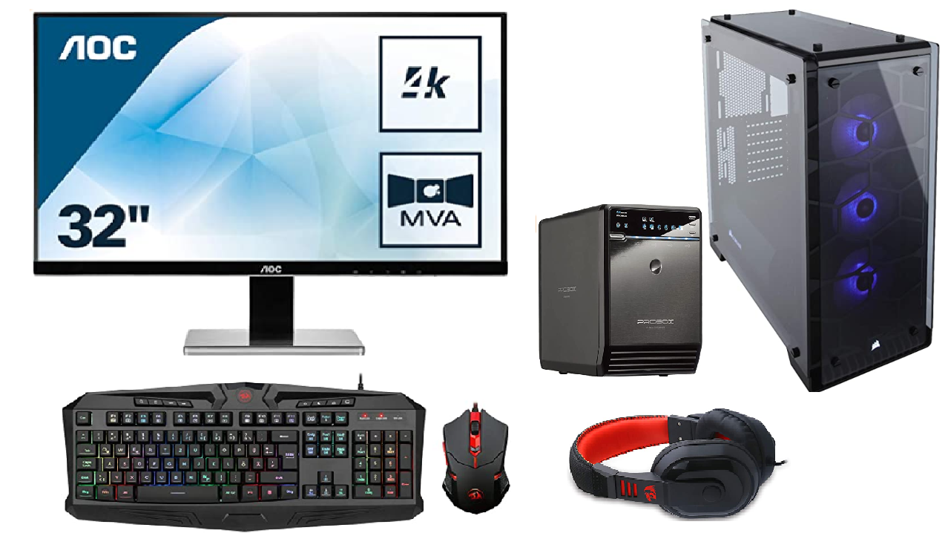

CPU – AMD Ryzen 9 – With 12 cores at 3.8GHz base speed and 70mb cache the AMD Ryzen 9 3900X is an absolute beast of CPU. We get only 4% less performance when compared to the Intel’s i9-9900k but for a 13% lower cost the Ryzen 9 is the clear winner. (Intel-Core-i9-9900K-vs-AMD-Ryzen-9-3900X, 2020)
Motherboard – Asus has proven that they can make good motherboards and they didn’t disappoint with the ASUS TUF Gaming X570-Plus with plenty of features and a robust design this is a great choice for any modern high-end PC.
GPU – The graphics card of this system is debatable, but the Nvidia RTX 2060 has a very good price/performance ratio and it is a solid choice. With more budget this can be replaced with RTX 2070 or RTX 2080 but due to diminishing returns in price/performance ratio it’s not worth the upgrade unless for hardcore gaming.
RAM – 64GB (2x32Gb) of high-speed RAM working in dual channel will be more than enough for the next 4-5 years. The manufacturer doesn’t matter all that much here but the long-time fan favourite Corsair is a solid choice. 2x32 has the performance benefits of dual-channel technology while leaving 2 empty ram slots for future upgrades.
RTX 2060 vs RTX 2070 at 4k resolution we get 21% increase in performance and 34% increase in price. (RTX 2060 vs RTX 2070, 2020)
RTX 2070 vs RTX 2080 at 4k resolution we get 14% increase in performance and 48% increase in price. (RTX 2070 vs RTX 2080, 2020)
Storage – 2TB of SSD is enough for all the software and games a regular user is going to want on their PC. Samsung QVO and EVO series of SSD are the most popular option in this category. 8TB of HDD is plenty for all the raw and edited video footage currently in use. Seagate’s Barracuda hdd’s are a good option in our case.
Power Supply – 750W will be sufficient for our system. The fully modular feature of our chosen power supply will help us with the cable management which will in turn help us with the air flow and the thermals of our build.
Case – A nice big mid-tower computer case will help with cable management and provide enough space for future upgrades.
Sound Card – A cheap sound card with S/DPIF I/O for future equipment upgrades.
Monitor – the AOC 32” LED Monitor has high resolution and amazing colour accuracy which is mandatory for image and video editing. It also comes with built-in speakers which will save us some space on the desk without losing functionality.
Keyboard, Mouse, Headset – We can get a nice, cheap bundle from REDRAGON which are the best option in terms of build quality vs price.
Thermal Paste – ARCTIC MX-4 is the best non-conductive thermal paste on the market. There are better performing pastes in terms of thermal conductivity but they are all liquid metal and are electrically conductive and can damage our PC if not used properly. Liquid metal is used when overclocking the CPU and GPU which is not needed in our case.

Additional Storage

Working with raw 4k footage requires a lot of storage, that’s why we will need an array of external hard drives with at least 56TB of storage. Here are 2 options:
Part | Quantity | Product | Price per unit | Total Price
RAID Enclosure | 1 | Mediasonic ProBox HF2-SU3S2 4 Bay 3.5” SATA HDD Enclosure – USB 3.0 & eSATA Support SATA 3 6.0Gbps HDD transfer speed | £109.99 | £109.99
Hard Disc Drive | 4 | Seagate 14 TB IronWolf Pro 3.5 Inch Internal Hard Drive for 1-24 Bay NAS Systems (7200 RPM, 256 MB Cache, up to 210 MB/s, 300 TB/Year Workload Rate) | £435.49 | £1,741.96
 |  | Total Price: | £1,851.95
Table 3. Storage Option A.
First option is to use a single raid enclosure with 4x14TB expensive hard drives which gives us 56TB of storage with a price of £33 per 1TB. These 7200rpm industrial level hard drives are perfect for heavy load work.

Part | Quantity | Product | Price per unit | Total Price
RAID Enclosure | 2 | Mediasonic ProBox HF2-SU3S2 4 Bay 3.5” SATA HDD Enclosure – USB 3.0 & eSATA Support SATA 3 6.0Gbps HDD transfer speed | £109.99 | £219.98
Hard Disc Drive | 7 | Seagate ST8000DM004 Barracuda - 8 TB internal hard drive - Silver | £169.47 | £1,186.29
 |  | Total Price: | £1,406.27
Table 4. Storage Option B.
Second option is to use 2 different raid enclosures and 7x8TB cheaper hard drives which gives us £25.11 per 1TB. These 5400rpm hard drives are a cheaper alternative that can do the job.

There are a few things to consider when comparing the two options:
Option A is 20% faster than Option B. (Barracuda vs Ironwolf, 2020)
Option A is 30% more expensive than the alternative.
In Option A everything is one place which makes all the data easily accessible. However, in case of HDD failure they are more expensive to replace and the user will lose more data in the process. There is no right or wrong choice here and it all comes down to user preference. Price vs speed is the main difference that we have to consider here.

References
Amazon.co.uk. (2020, April 5). Retrieved from Amazon: https://www.amazon.co.uk/
Barracuda vs Ironwolf. (2020, April 13). Retrieved from UserBenchmark: https://hdd.userbenchmark.com/Compare/Seagate-IronWolf-12TB-2017-vs-Seagate-Barracuda-8TB-2017/m408715vsm323996
Intel-Core-i9-9900K-vs-AMD-Ryzen-9-3900X. (2020, April 5). Retrieved from UserBenchmark: https://cpu.userbenchmark.com/Compare/Intel-Core-i9-9900K-vs-AMD-Ryzen-9-3900X/4028vs4044
RTX 2060 vs RTX 2070. (2020, April 5). Retrieved from GPUCheck: https://www.gpucheck.com/en-usd/compare/nvidia-geforce-rtx-2060-vs-nvidia-geforce-rtx-2070/amd-ryzen-9-3900x-vs-amd-ryzen-9-3900x/
RTX 2070 vs RTX 2080. (2020, April 5). Retrieved from GPUCheck: https://www.gpucheck.com/en-usd/compare/nvidia-geforce-rtx-2070-vs-nvidia-geforce-rtx-2080/amd-ryzen-9-3900x-vs-amd-ryzen-9-3900x/
Windows 10 system requirements. (2020, April 5). Retrieved from Microsoft: https://support.microsoft.com/en-us/help/4028142/windows-10-system-requirements

