COMMUNITY ENGAGEMENT
LCBB4002
Student Name: Dumitru Butuc
Student number: 1909680
Lecture’s name: Tanja Nathan

Reflective practice is '' learning through and from experience in order to gain knowledge about oneself and practice '' Finlay 2008.
This practice is a method by which we evaluate our own thoughts and actions in order to further develop ourselves. When we reach the conclusion we see what he did right and what he did wrong and in the future we will be more careful not to make the same mistakes. There is also an important way to bring theory and practice together through reflection.
Among the first people who wrote about reflective practice through its exploration of interaction and reflection experience was John Dewey at the beginning of the 20th century, then several relevant theories were developed by Kurt Lewin and Jean Piaget.
David Band and his fellow teachers explained the reflection as an important human activity in which people regain their experience and think about it and thank it. When we experiment we learn and when we reanalyse the steps and thoughts we put everything on the right shelves and thus put into action the critical reflection which is of great help to us.
The appearance in recent years of blogging is just as seen as a form of reflection only that it is otherwise printed.
The day also came when I had to write the report on the topic of a company I chose, I chose Toyota Motor corporation so I plunged into the multitude of information you need to study to write something about the given company. I studied different sources of information and started writing the report, I was excited at first but then I arranged my thoughts and went on. I was greatly helped by the previous experience of writing a report.
The steps I took were the following:
I thoroughly analysed the history of this company that killed me to be shocked but I liked the ones found.
This company had many leaders just as they were all descendants of the same family. I was excited because I had business with a company rich in history, economy and has under its wing a multitude of sports car subcompanies.
I made mistakes in terms of spelling and coherence of thoughts but in the future I will work to stop making such mistakes.
Mistakes are made due to lack of experience and study, but over time we solve them all, so we become more careful in what we do.
What is the experience?
The experience is a totality of the knowledge that people acquire from the world around them, in the work process but also in the family life.
But what about the relevant theory?
This theory also called the relevant practice is the principle of communication which involves not only the encoding, decoding and transfer of messages but also other elements that help us to express our thoughts philosophically!
What is the connection between these two?
Both need time to learn and both help us get a well-deserved job and respect from the people next door! Like any object both have differences such as:
The theory of the relevant arena takes less time to finally learn while the experience you gain throughout your life, that is to say, has an unlimited time.
The way of working and the behaviour is shown by the experience but the way you communicate with someone, in which you write something beautiful demonstrates the knowledge of the theory of relevance as well and they have different environments of use as the artistic or literary environment is the theory of relevance and the experience is acquired in different environments in life. Our.
These components are necessary for all of us to learn since not long ago at UWTSD London Campus I had to play a role-playing game where I needed the experience as well as the principles of the theory of relevance because in this game I had to expose a the problem within the work, I activate as a bricklayer and the problem had to be solved but due to the lack of theory I had some problems in the way of expressing and clarifying the problem because I lack more philosophical words in my dictionary what to preface in the future!
Finally, as a conclusion I can say that a reflection is very necessary because it helps us to analyse the Mistakes but also the good things we have done and we are perfecting to become better than we are now, as well as the experience and the way of communication is very necessary. for each of us to be people with culture and understanding!

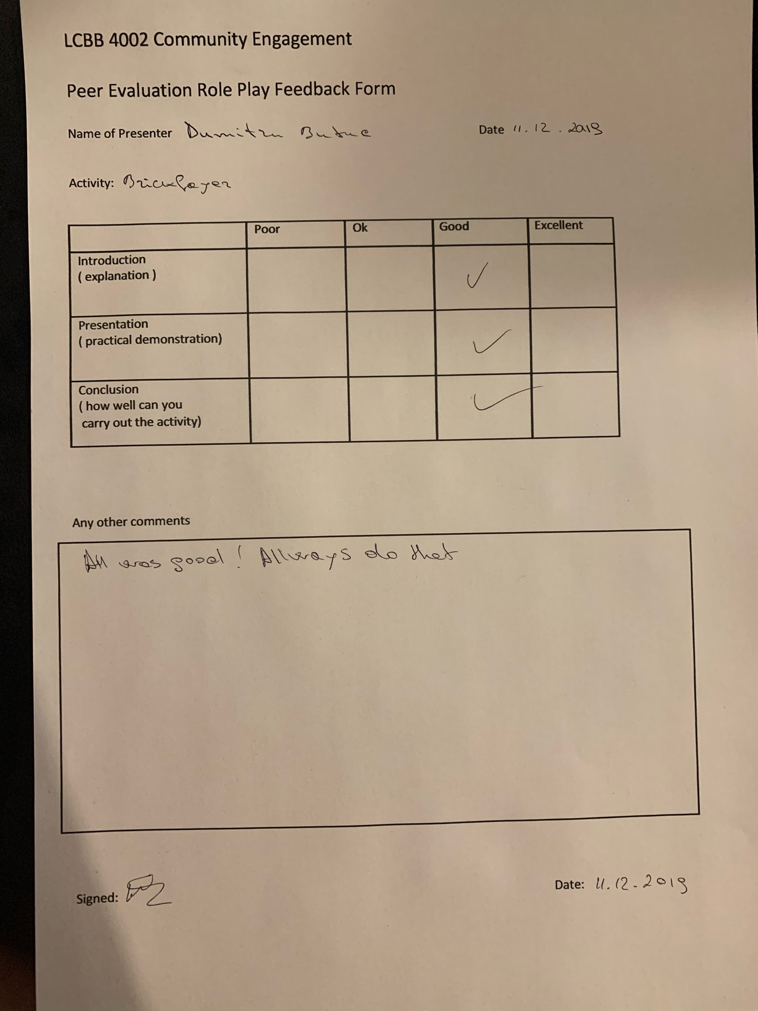

References

- https://www.cambridge-community.org.uk/professional-development/gswrp/index.html Cambridge International Education Teaching and Learning Team
- his paper outlines the main assumptions of relevance theory (Sperber & Wilson 1985, 1995, 1998, 2002, Wilson & Sperber 2002) https://www.phon.ucl.ac.uk/publications/WPL/02papers/wilson_sperber.pdf
- https://www.collinsdictionary.com/dictionary/english/experience

