BMLW5009
Contract Law

Table of Contents
Introduction 3
Formation of a contract 3
What is consideration? 4
Types of Consideration 6
Validation 8
Consideration issues. 9
Reform suggestions 9
Conclusion 10
References 11

Introduction
Contract law is a set of rules that oversee agreements between individuals or substances. It makes a difference to guarantee that guarantees made in these assertions are legitimately authoritative and enforceable. In "Issues in Contract Law: Cases and Materials" by Knapp et al. (2023), real-life cases are utilized to illustrate issues and challenges inside the field. In "Theories of Contract, or How Contract Law Stopped Worrying and Learned to Cherish Chance" by Kreitner (2021), the focus is on the progressing nature of contract law, highlighting its alteration to grasp hazard. This reflects the energetic nature of contracts in response to changing circumstances. "Anson's Law of Contract" by FBA and Cartwright (2020) gives comprehensive direct-to-contract law standards. Anson's Law is broadly utilized to understand the foundational concepts and benchmarks in this field.
Contracts incorporate an offer, affirmation, and thought something of esteem traded between the parties. Breaching a contract may lead to true blue coming about, and courts may give harm to compensate the harmed party. In outline, contract law is about making and implementing agreements decently. It draws from veritable cases and advances to address present-day challenges, giving a framework for parties to engage in agreements with certainty and legal security.

Formation of a contract
Contract arrangement is the most important component of contract law, which is based on central principles and contentions. Knapp et al. (2023) in "Issues in Contract Law" analyze cases and materials, and make more understanding. As the negotiations continue, they code the complexities that will lead to legally binding debate among partners stressing the difficulty in reaching contract legitimacy. Ansos Law of Contraband Contract by FBA, Q.H.B., and Cartwright (2020) gives an in-depth point-of-view on the processes of contract arrangement. This legal definitive source gives a distant better; a much better; a higher; a stronger; an improved" higher understanding of angles of legalities and the basic components of a valid contract but lays the basis for a clearer understanding.
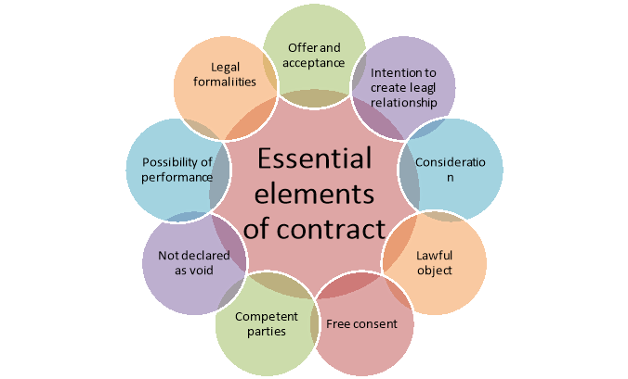
Figure-1 Essentials of Contract Laws
(Sources: Cartwright,2020)
In their research, Kostruba and Hyliaia (2020) propose planning a legitimate instrument for finishing legitimate connections. They not only focus on contracting arrangements but also its end hence pushing for a foundational legitimate system improvement is foremost. In the work titled "The Social Cost of Contract" Hoffman and Hwang (2021) analyze the consequential impact that contract-making has on the wider society. On the other hand, they keep up that any contracts are not simply exchanges between people. Such contracts have social costs as well, which means that debate inside contract law may be easier to get. Contract formation is a complex, multi-faceted process that is inevitably guided by legal interpretation and social norms and regulations. The timing and nature of an offer and acceptance have been a center of focus in numerous scholarly works that argued that the intricacies and difficulties of contract formation are worth close inspection and analysis in the constantly changing landscape of contract law.

What is consideration?
In contract law, equity is a key factor that delivers fairness and a common advantage for the parties that are engaging in the agreement. In "Problems in Contract Law" by Knapp et al. (2023), the editors note that the case and the material lead to a better understanding of the problems of the law. Thinking reminds me of something that is of value which is being supposed to be traded between two parties and it could be the goods, the services, or a guarantee. This, on the whole, has enabled people to look into the vast perspective where intellect is not seen as a specific expression of money-making but as a diversified form of value transmission.
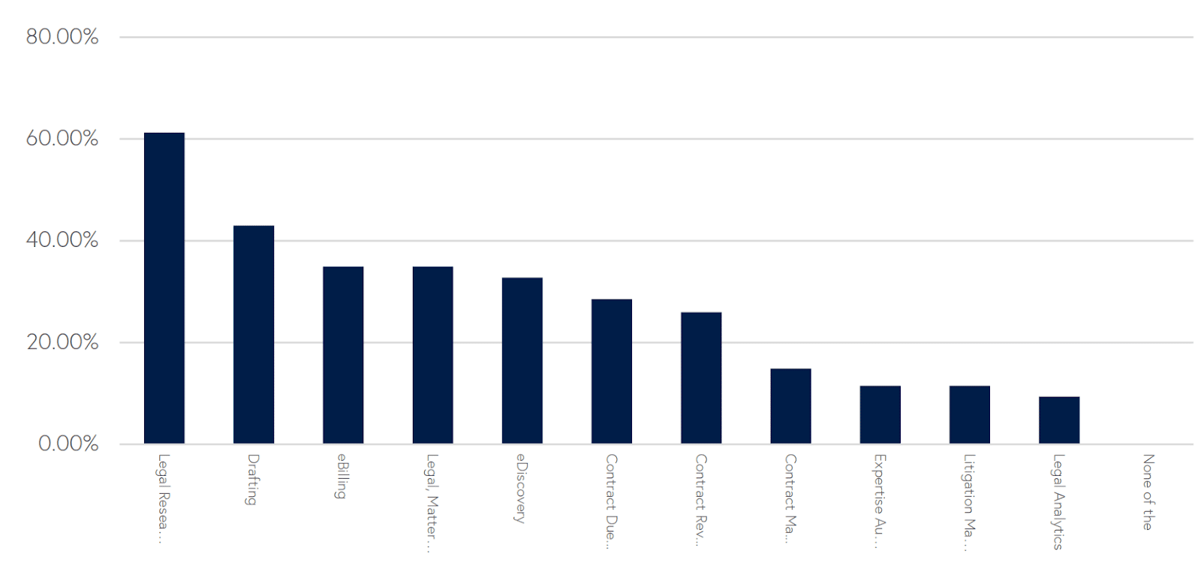
Figure-2 Law Firm Success in 2024
(Sources: Knapp, 2022)
According to Smith (2024), "as thought is advanced" is a highlight that points to this thinking feature. The writer possibly lays down the grounds and puts conjectures and controversies into the picture on the complexities, subtleties, and other related issues in business connections. Anson’s Law of Contract according to FBA and Cartwright (2020) which is an Oxford University Press publication may develop a comprehensive approach to reviewing from a historical and legal standpoint. This book could help develop the knowledge on the history of the idea and it would possibly break the myths about the obsoleteness of this concept. In summary, ethical responsibility is the driving force besides the vital role of thought in designing a contract, maintaining civility, and valuing between two parties. The law is equally important as a legal formality that determines the legality of the contract and ultimately reinforces the soundness and enforcement of legally binding relations within the state.

Figure-3 Global Legal technology Market, 2022-2032
(Sources: Cartwright, 2020)

Types of consideration
In contract law, the doctrine of consideration is considered, and this pertains to a bargain or transaction wherein something of value is exchanged between parties to make the contract legally binding. In "Problems in Contract Law: In the case study and resource material "Ethics in Law" (Knapp et al., 2023), the authors listed different types of considerations.

Figure-4 Types of Consideration
(Sources: Created by Learner)
- Bargained-for Exchange (Quid Pro Quo): This implies one of the most remarkable characteristic features of democracy: all people are equal, and nobody is considered better than the other, in this sense, the interests of the majority of the people prevail (Knapp et al., 2023).
- Legal Detriment: The ability of parties to enter instead of what they owe, or abstain from what they have the right to do is also given by the law (Knapp et al., 2023).
- Pre-existing Duty Rule: Any effort to convince someone who's already obligated to perform certain functions will be futile if we propose to do again that very same thing without providing an additional thing in exchange (Knapp et al., 2023).
- Unforeseen Difficulty: At times, it can be necessary to adjust a contract to a new situation if both parties have reached an understanding, and the consideration is valid (Knapp et al., 2023). The consideration would guarantee that both parties in a contract would get a fair and mutual benefit, which has been highlighted in "Problems in Contract Law" (Knapp et al., 2023). The analysis of these forms of agreement is vital for both counterparts, to the compilation of unbreakable and dispensable contracts.

Validation
Validation in contract law is related to making sure that a contract is legally enforcement and has a two-way influence. It involves making sure that certain requirements are fulfilled so that the set of conditions under which the agreement is legally valid becomes known.
First, everybody who has to sign the contract must be of age and have the mental capacity to enter into legal obligations. This entails that individuals must be mentally stable and of the appropriate legal age.
Secondly, there is a principle of mutual agreement or living on the terms accepted by both parties. This offers everyone the same kind of security that the rest of the contractual parties cannot force them into the contract under duress or coercion.
Thirdly, the contract ascribed with a legal purpose should be a principle. As a result, the pact cannot either prescribe or proscribe anything immoral or in violation of public policy.
Finally, a contract needs to have provisions stipulated clearly and specifically enough so that the parties comprehend the responsibilities they are undertaking. On the other hand, in a few instances, contracts have to be in writing and signed by the parties involved to be valid. However, real estate transactions and agreements that cannot be completed within a year usually require a written agreement and a signature to be considered valid. It can be summarized therefore that approval in contract law means that the agreement has to be fair, lawful, and agreed upon consensual by all the involved parties.


Figure-5 Legal technology Market Size, 2019-2030
(Sources: Kreitner, 2021)

Consideration issues
The validity of a contract is directly dependent on the consideration of contract law. After all, it is the key element of the contract's validity. Parties of a contract should contribute if the loss or giveaway has to be divided. Consideration itself could be demonstrated in this example. Hence, promises to mow the lawn for $20 could be a consideration.
When someone is going to mow the lawn, it is their consideration. The opposite, is when they are going to pay them money, their consideration. One does not have to write a check to feel like they have contributed to society. It may take the form of products or services of any kind. However, the title should not relate to something not equated with law with the value (law, 2024).
If one person makes a promise and the other one just doesn't keep any of the promises, there's nothing that makes it a legitimate contract. The seats occupied by one or the other, positions need to be beneficial to the person that holds the position. Having the contemplation in place makes it ensures that contractual relations stipulate equal treatment (law, 2024).
It will result in making one believe that the party has the intention to fulfill all that was stated in the manifesto. It would be simple to ignore or ruin the relevant contract if it lacks any considerations. Contracts can be compared to engines, and considerations are like the glue that binds them together. It's what makes the public official duty-bound.

Reform suggestions
Reform suggestions in contract law point to form rules superior. They need to settle issues and make things clear. One thought is to disentangle lawful terms. This implies using simple words so everyone understands. Another proposal is to make contracts fairer. This implies both parties are treated similarly. They moreover need to guarantee contracts are simple to discover and examine. This makes a difference in maintaining a strategic distance from misunderstandings. A few individuals think there ought to be limits on punishments for breaking contracts. They accept punishments that ought to be sensible. Another thought is to make it simpler to cancel unjustifiable contracts. This helps protect individuals from terrible bargains.
Reformers too need to improve how contracts are made. They think there should be more transparency. This means being open about what the contract says. In general, the objective of these recommendations is to make contract law easier and more attractive for everybody.

Conclusion
Contract law administers agreements between parties, ensuring their guarantees are legally official. "Issues in Contract Law" by Knapp and "Theories of Contract" by Kreitner stated that in real-life cases and the advancing nature of contract law. "Anson's Law of Contract" by FBA and Cartwright gives foundational principles. The arrangement of a contract includes complexities analyzed by Knapp and Anson law. Thought, investigated by Knapp and Smith, is crucial for fairness and legality. Validation guarantees contracts meet legal prerequisites, while consideration issues decide contract validity. Reform suggestions point to simplifying contracts, ensuring decency, and improving transparency. Overall, contract law points to fairness, legality, and clarity in agreements.

References
Bossu, W., Itatani, M., Margulis, C., Rossi, A., Weenink, H. and Yoshinaga, A., 2020. Legal aspects of central bank digital currency: Central bank and monetary law considerations.
FBA, Q.H.B. and Cartwright, J., 2020. Anson's law of contract. Oxford University Press.
Hoffman, D.A. and Hwang, C., 2021. The Social Cost of Contract. Columbia Law Review, 121(3), pp.979-1016.
Knapp, C.L., Crystal, N.M., Prince, H.G., Hart, D.K. and Silverstein, J.M., 2023. Problems in Contract Law: cases and materials.
Knapp, C.L., Crystal, N.M., Prince, H.G., Hart, D.K. and Silverstein, J.M., 2023. Problems in Contract Law: cases and materials. Aspen Publishing.
Kostruba, A. and Hyliaka, O., 2020. Designing of the legal model of legal relations cessations. Anatoliy V. KOSTRUBA, Oleh S. HYLIAKA Designing of the legal model of legal relations cessations. Astra Slavensis. Supplement, (1), pp.69-86.
Kreitner, R., 2021. Speculations of contract, or how contract law stopped worrying and learned to love risk. In Governing Risks (pp. 439-481). Routledge.
Smith, J.W., 2024. The law of contracts. BoD–Books on Demand.
Law,2024. Consideration. Available at: https://www.law.cornell.edu/wex/consideration#:~:text=Consideration%20is%20the%20main%20element,money%20is%20the%20person's%20consideration. Accessed on 13th March 2024.
Di Angelo, M. and Salzer, G., 2020, August. Tokens, types, and standards: identification and utilization in Ethereum. In 2020 IEEE International Conference on Decentralized Applications and Infrastructures (DAPPS) (pp. 1-10). IEEE.

