Playwriting: Mansplain it to Me
An exploration into how history and society have crafted and developed the presence of women in the theatre industry with a particular focus on the development of female playwrighting.

Contents
Introduction 2
Feminism 2
Playwrighting 5
Athenian Women: Societal expectations and gender roles within Ancient Greece 7
The role of women within the Elizabethan Era 10
The rise in pseudonyms and the Victorian era 12
Women in the early 20th century and suffrage theatre 13
The introduction of Feminist theatre in the 1970s 17
Female playwrights in the 21st century 19

Introduction
Playwrighting, I believe is at the heart of theatre. It is what creates the stories we see displayed in theatre, so I believe this is where we need to start to be able to inspire change. But what change needs to happen and how can theatre help. For my project I aim to explore the presence of women within theatre and society throughout history. Looking at societal expectations of women as well as the restrictions they faced and then comparing it to today’s society. To see if the world is still living in the past when it comes to gender equality. This project will explore the topic of feminism within my local community and how the messages of feminism have been used within the creation of theatre. As an aspiring playwright myself, this project is an opportunity to delve into the world of playwrighting. Investigating what it means to be a playwright and looking at the historical landscape of female playwrighting.

Feminism
Feminism is often a misunderstood term. I think the word and its meaning is often distorted and commonly misinterpreted. Some people believe it means that women want to be superior to men and feminism is about taking power away from the male gender, or that all feminists are man haters. For example, within a Quora discussion on feminists hating men, Quora being an online platform for people to share opinions on a multitude of topics, a user called Shimmergirltalks (2021) expressed ‘I think deep down a lot of them, obviously not all want to be men, or they hate men because they can’t get one’. This referring to feminists. Although this is just one quote from one social media platform, its negative view on feminism can impact a reader’s perspective. In modern society we are constantly exposed to stories and opinions through social media, and it has become our main source of information. Therefore, all it takes is one post to change someone’s view on a topic like feminism. However, there isn’t just one post. Even on this one Quora discussion page there are hundreds of responses, mainly expressing negative views on feminists. Personally, I feel indifferent about whether people want to be a feminist or not, but the misinformation on what we stand for and what feminism means is a real and alive problem today and it needs to be addressed. To further understand this misinterpretation of feminism the University of Surrey (2023) created and conducted a survey which tested the ‘accuracy of the stereotype that feminists harbour negative attitudes towards men’. The investigation was led by Dr Aífe Hopkins-Doyle, a lecturer of Social Psychology at the University of Surrey, and it included over 9,000 participants across nine global countries. As expected, the overall results found that there was no difference in attitude towards men between feminists and non-feminists. However, the study revealed that ‘feminists are wrongly stereotyped as having negative attitudes towards men’ (University of Surrey, 2023). Even feminists themselves, within this survey, ‘underestimated how positive feminists feel towards men’ (University of Surrey, 2023). This survey’s results prove that our perspective on the relationship between men and women have been distorted. As a result of history placing a societal divide between the genders and letting the cycle of sexism repeat itself. However, to grow as a society we need to learn how to let go of these preconceptions and allow ourselves to become more aware of them in order to change. For example, were you like me and heard the title Dr and immediately thought Dr Aífe Hopkins-Doyle was a man?
To gain knowledge on what people around me thought of the topic and in particular the word feminism, I created a mixed-method survey that asked questions regarding the topic of feminism and sexism within our society (see Appendix 1). A total of 54 people completed the survey, the age ranged between 18 to 64 and over (Figure 2 & 6). When reviewing the results it stated that 43 of the participants were women, 8 were men, 2 non-binary and 1 other (Figure 1 & Figure 5). My survey was shared throughout my local community, giving me an accurate representation of what the people around me thought on the topic of feminism. The first question of the survey asked whether they knew what feminism meant, the options were yes, no or maybe. 67% answered with yes, 31% with maybe and 2% with no (Figure 3 & Figure 7). This implied immediately that there is an uncertainty around the topic in my local area. The question that followed asked the participants to describe the meaning of feminism. I received 47 responses on this question and many of the answers included the word equality, which I was pleased with (Figure 3 & Figure 8). However, most responses I received seemed to be in favour of women. For example, some described feminism as the ‘empowerment of women’, or ‘a women’s advocate’ and that feminism is about ‘equal rights for women’. Although these responses are describing what feminism stands for, for me they imply that feminism is made and used only for women. It is interesting for me to see that even in my local community feminism is being limited and that could be adding to the reason why people often see it as a negative against men. A response that I resonated with described feminism as ‘A movement based around uplifting women and pushing for equality between the sexes/genders.’ This response captures why feminism is important and how it strives for equality but is rooted and built on women’s suffering and that still must be acknowledged.
The next question asked whether people believed sexism still exists today. Through my own view of the world, I was expecting many people to answer with yes therefore I was not surprised that 87% of the participants answered yes (Figure 3 & Figure 9). Sexism is forever going to be a topic of conversation as it affects so many people in all walks of life. From this survey I wanted to gauge people’s thoughts and opinions on how sexism affects society today. I had an array of responses back that covered topics such as the gender pay gap, abortion laws, violence against women, gender stereotyping within job roles, sport inequality and many more (Figure 4 & Figure 10). For this question I did not want to give options for participants to choose from because I wanted them to realise and think about how sexism plays a part in their lives. This also reduced the bias in my results. The way sexism exists within parental roles was a topic I was not expecting to be brought up. A participant stated that ‘women are valued largely on their ability to produce and care for children’. Another participant mentioned how women are ‘still expected to look after the children and arrange childcare’ instead of it being an equal role between the parents. These responses made me stop and reevaluate the concept of sexism and how it is much bigger than just boys being stronger than girls. The question I ask myself is how do we change this system we have created? We talk about sexism today in the same way we have talked about the history of women’s suffering. Therefore, what can I do? Personally, I think theatre can be an impactful tool to use. To educate people, to give space for voices to be heard and to help open conversations about topics that are often considered taboo or difficult. In addition, I think looking to the past and exploring how history treated women will help me to recognise how things have progressed. Exploring various time periods and comparing them to the modern day will help me answer the question: Has anything changed?

Playwrighting
Developing stories and characters that people can recognise and see themselves in, can be facilitated by using plays. Plays can explore topics that connect to our society and reflect the lives of everyone. Theatre and plays can have a massive impact if it is used in the correct way, and if it is seen by the right audience. For this project I wanted to explore what it meant to be the one writing the plays that spark conversations, as it is a potential career route I would love to explore. With that being said, what is a playwright? A ‘playwright’ (2025) is a noun, according to Oxford Learner’s Dictionaries, it means: ‘a person who writes plays for the theatre, television or radio’ (Oxford University Press, 2025). This definition is quite generic, and I feel does not encapsulate what it means to be a playwright. When looking to redefine the term ‘playwright’ I discovered Professor Sue-Ellen Case, an American writer and academic. According to Case (1998) ‘Wright does not denote writing, but means someone who is a maker of plays, not necessarily a writer of plays’. I agree with this concept, and it feels more suitable. A playwright does not just write words on a page for someone to perform, they create worlds and characters that have lives just as complex as their own. They make stories come alive.
So, where do playwrights start? How does the process of becoming one begin? It begins with a lot of trial and error and experimenting. A lot of creating and gaining feedback. Playwright Henry Hwang states: ‘I essentially saw as many plays and read as many plays as I could over the next few years and that became my education’ (cited in American Theatre Wing, 2017). This was how Hwang gained knowledge around theatre and playwrighting when he first wanted to explore it as a career. To develop his career, he found techniques and exercises that helped him to find inspiration and to channel certain ideas. For example, within a masterclass he takes students through this writing exercise he learnt. Firstly, you set the scene, finding two characters. Hwang explains how you could flip over a magazine and just take inspiration from two people you see on the page. Next, you write for 10 minutes. Writing whatever comes to mind in the moment. To further the development of this piece of writing he has 3 steps: Step 1 is posing a question that he wants to answer through the writing. Step 2 is having a beginning and an end to structure the writing. Step 3 is taking another person’s play as a model and using that to structure your writing. Hwang would then take random words and phrases to add into the dialogue to further inspire the writing. I tried this exercise out myself and I found it fun and effective, as it took away the need for perfection and it was easy to follow.
As an aspiring playwright I wanted to know what the responsibilities of being one are. The main responsibility is ‘to be able to tell a story through the written word for the theatre’ (Get into Theatre, 2024). In my opinion, the main responsibility of a playwright is to present the stories of real people for an audience to see and understand. Throughout school I always believed that you needed to be the best at English to be able to write and create plays. Always being shown the work of Shakespeare and not being exposed to anything else. It was only when I went to college and University that my eyes were opened to the endless library of plays and playwrights there are in the world, even just in Wales. I believe everyone should have access to plays just as much as fiction books. It could be so beneficial within education. It would have been beneficial to me. With playwrighting I think the literacy part is important, but it should not stop people from being creative and expressing themselves through writing. In addition, I believe writing should be enjoyed by everyone regardless of ability. All you need is a story to tell and a wantingness to share that story.
In addition, playwrighting has been going on for centuries even before people wrote them down. Case (1998) expresses those performances that used ‘the language of the body’ could also be considered plays. Which extends the search for the first female playwright because plays could include female mimes performed in the street and marketplaces; the text being performed through their bodies instead of words. Within Case’s book this research is based around Ancient Greece and Rome and their society. However, I think the universal problem of women being denied access to theatre proves that these performances could have been taking place all over the world as a substitute for playwrighting. Women throughout history had stories to tell but it is whether they were allowed to. The section below will explore this further through the lives of Athenian women.

Athenian Women: Societal expectations and gender roles within Ancient Greece

For this project I wanted to explore the past treatment of women within different time periods and eras, to gauge a better understanding of the struggles women have faced throughout history; focusing on women’s roles within society and within the theatre. Firstly, I investigated the lives of Athenian women in Ancient Greece. Athenian refers to people born and residing in Athens, Greece. Much like other societies girls were seen as the weaker sex even from birth, they were ‘at a higher risk of infanticide’ (Iacob, 2023). This was because families needed to ensure they had at least one healthy boy to inherit their land. Women were seen as inferior to men therefore, ‘Athenian women did not receive any formal education because it was focussed exclusively on boys’ (Iacob, 2023). This was due to the fact boys were destined to work in the military and politics, while women were not expected to work in those fields, therefore their education proved useless to society. In the same manner as other societies, Athenian women were given a more household-based education, following the sentiment that women belong in the home. Learning to run and manage a household, sew clothes and care for children. Which are things considered a female responsibility even now. Furthermore, Athenian society valued marriage very highly and the marrying age for girls was just fourteen. The research (Iacob, 2023) also revealed that if girls were to pass away before they reached maturity, their bodies would often be dressed as brides. This practice suggests that the role of women just included marriage and childbearing. This societal expectation still exists today, as there is still a stigma around women not wanting to be mothers or not wanting to get married. And often that makes women feel out of place or not normal. Caroline Mitchell admits ‘I felt like a freak because I didn’t want children’ (cited in Jenkins, 2024). Even though society may seem to be progressing, the silent social pressures still exist. Moreover, during Ancient Greece within the law system women were only allowed to be represented by men. According to Iacob (2023), ‘women were required to be under the guardianship’ of a man. This was either her husband or a male relative. Treating women like property. Fortunately, this isn’t in place today however this ideology still exists. For example, social media personality Andrew Tate who is known for his misogynistic views, claims that women belong to men within a marriage. When asked by Piers Morgan in an interview about whether a woman is a man’s property Tate stated, ‘I believe she belongs to the man in marriage’ (Piers Morgan Uncensored, 2022). This statement is just his opinion, but the following of young boys and men he has on social media who cling to his every word concerns me, because he is feeding them these views and values that are outdated and harmful, especially to women.
Furthermore, for my project I wanted to delve into the presence of women within Greek theatre and how it compares to today. There were three main tragedian playwrights, they included: Aeschylus, Sophocles and Euripides. The one main comedic playwright was called Aristophanes. Even if you don’t recognise these names, they all have one thing in common; they were male. In such an unequal society it does not surprise me that women were not allowed to occupy creative spaces such as writing, but they were also not allowed to perform. According to Cartwright (2016) ‘women were banished from the stage and their parts taken by men’ because it was considered too dangerous to allow women to perform in public. Even though the playwrights Sophocles and Euripides created female characters that went against societal norms. For example, ‘Medea in Medea by Euripides fights the patriarchal society for her right to control her own life’ (Kapoor, 2022). Even though at this time theatre wasn’t supposed to engage in any political way it challenged the way female characters were portrayed yet women couldn’t enjoy this new representation of them due to society not allowing them. The banishment of women on the stage was only made stronger by the ‘Christian insistence on female chastity’ (Gewertz, 2003) and it remained in place until the 17th century.

The Role of Women within the Elizabethan Era
Following the pattern of Athenian women, I wanted to explore the lives of women in Britain during the Elizabethan era. Looking at societal norms and rules they had to endure. Commonly known as the golden age the period began from 1558 when Elizabeth I became Queen, and it ended in 1603 when she died. This era was considered to have been full of artistic and literacy culture; this was also the time of William Shakespeare. The Elizabethan era has been documented as being ‘a fiercely patriarchal society’ (SparkNotes, no date). Due to the treatment of women and the restrictions they faced. Similarly to Ancient Greece, women in Elizabethan England ‘were not allowed to attend school or university’ (SparkNotes, no date). However, women from wealthy households often had private tutors and were taught at home. Women were also not allowed to take up professions that were deemed masculine like carpenters or goldsmiths. Instead, their trades were confined to those in which could be mastered at home such as brewing or hat making. They couldn’t buy property, and they were encouraged by books written at the time ‘to be silent and obedient to male authority’ (SparkNotes, no date) Implying that women still belong to their husband or father and that they couldn’t be independent. Furthermore, girls were still seen as an object to marry because ‘it was legal for girls to marry at the age of 12’ (Elizabethan England life.com, no date). This is 2 years lower than that of Athenian women. However, the legal marrying age for boys was 14. According to Elizabethan England Life.com (no date) ‘it was believed that women always needed someone to look after them’. This in my opinion was because women were manipulated into thinking they couldn’t do what could as they were never given the opportunity or the rights. For example, if I were to be living in the Elizabethan times, I would not be seen capable of writing this project and frankly I wouldn’t have been allowed to go this university to complete this course. Despite it being an era full of theatre and artistry according to Shanette (2025) ‘women were not allowed to act on the public stage or write for the public stage. Acting was considered dishonourable for women.’ Instead, their parts would have been played by men. It is quite interesting to me that this research specifically states women were not allowed to be playwrights. However, they were ‘allowed to write works of literature, providing the subject was suitable for women’ (Shanette, 2025). For example, they would be allowed to write about love and their children, anything deemed ladylike. I’m thankful as a society that we have moved past this senseless creative restriction. Unlike women, men had the ability and respect to write. For example, Shakespeare explored many different themes, comical, tragedian and historical. In addition, his plays usually contained strong female characters that didn’t reflect the women of society at the time. Such as Lady Macbeth and Tamora from Titus Andronicus. It is a shame that women couldn’t enjoy performing as these characters during that time. There is a myth that Shakespeare wrote and created strong female characters so that men would not be embarrassed to perform as them, but this claim has no evidence. According to Dr Chris Laoutaris (2016) ‘Shakespeare’s female characters often challenged the patriarchal ideal of silent and subservient womanhood’. Therefore, instead of them being made for men they were created to show women their potential strength and the men of society may have just saw it as a production, as entertainment instead of a political agenda.
However, near the end of the Elizabethan era and afterwards there was a slight shift in playwrighting when in 1613 The Tragedy of Mariam was written by Elizabeth Carey ‘the first English woman to compose and publish an original five-act play’ (Bennet, 2001) Carey was a Tudor noblewoman and writer. Her play explored themes of divorce, betrayal, sex and murder. Unlike Shakespeare her play was never performed during her lifetime, but it was speculated that this play might have been read within small groups in private, implying that it wasn’t suitable for a woman to be known for writing such as play. According to Super summary (no date) there has been a resurgence of interest in this play since 1970 due to its ‘reflections on feminist issues, misogyny, and class struggle’. Although this was a great development for female playwrighting, learning to write and education was still only received by women who were from privileged backgrounds which prevented a lot of women from even exploring writing as a pass time.

The Rise of Pseudonyms
As a result of years of societal norms and laws preventing women from writing and publishing; pseudonyms became a common way to conceal their identities and avoid gender bias. Both male and female authors use pseudonyms for many different reasons. But firstly, what is a pseudonym? A pseudonym according to The Speaker Lab (2024) is simply ‘a fictitious name used by an author to conceal their true identity’. They are also more commonly known as pen names or aliases. Also, actors and performers may use them, but it more known as their stage name. There are many reasons why writers choose to use pseudonyms. An example being that it provides privacy for that person as it can help create a separation between work life and personal life. Also, authors may want to use a more whimsical or creative name to associate with their work as it creates a brand for their books and style of writing. The word itself has Greek roots and ‘literal translation meaning “bearing a false name”’ (The Speaker Lab, 2024). Throughout history many playwrights and authors have used pseudonyms. Including, Samuel Clemens more commonly known as Mark Twain, Charles Dodgson who it known as Lewis Caroll. Also, the playwright Tennessee Williams is a pseudonym for Thomas Lanier Williams III. In addition, some pseudonyms consist of just initials and then the last name of a writer. For example, J.K Rowling and C.S Lewis. Charles Dodgson, known most famously for writing Alice in Wonderland, first used his pen name in 1856 and he used them to separate his career as a mathematics lecturer and a children’s book author. Whereas author Mary Shelley wrote under the pen name Percy when writing her book Frankenstein to conceal the fact she was a woman. Even when it was revealed that she, Mary, wrote the book herself. There were doubts and debates discussing whether she, a woman, was capable of writing such a book. She published this book in 1818 and from then on pseudonyms became a more common tool to use amongst female writers. For example, according to The Gothic Library (2018) ‘all three Brontë sisters used pseudonyms to hide their gender and true identities’ and their identities ‘were not revealed until after the deaths of Emily and Anne’. It’s surprising to me that many of the female writers we celebrate and study today, once had to disguise themselves for their work to escape gender bias. Can you imagine if they wrote under their real names and never got their work published? How many more female writers were out there, and their work just dismissed because they were the inferior sex? Pseudonyms continued to be used through the Victorian era as well with author Mary Ann Evans writing under the name George Eliot. In addition, during the Victorian era in 1870 the Education Act was passed in the UK which finally ‘granted girls access to elementary education, which had previously been denied to them’ (Grove, 2025).

Women in the early 20th century and Suffrage Theatre
‘The years between the turn of the century and the First World War were ones of rapid social change.’ (Bruley, 1999). Much like the other time periods I wanted to investigate what life was like for women, especially in Britian. I wanted to gain knowledge on what was expected of them and if they had progressed since the previous time periods. Firstly, I already knew that the role of women during this time was less restrictive than previous eras however there were still obstacles in their way. For example, their role in government. As of 1917 women were still not allowed to vote but through years of protesting and petitions, a selected class of women won the right to vote in 1918. However, it wasn’t until 1928 that all women over the age of 21 were given the same voting rights as men. Similarly, women were not allowed to be elected to parliament but in 1918 Nancy Astor became the first female member of parliament. However, she was never treated like an equal, she endured sexist comments, heckling and even some MPs refused to talk to her. Although these spaces were starting to allow women, they were still not accepted. During this time men were seen the protectors and the stronger gender therefore until 1914 women were not allowed to be employed in the police sector. In addition, in the same year a new law was passed that allowed women to take up certain professions. According to Local Histories (2021) that law allowed women to become ‘solicitors, barristers, vets and chartered accountants’ and ‘they are also allowed to be magistrates and members of juries.’ This research implies that the 20th century was the beginning of Britian seeing women as valued members of society. However, within the topic of jobs and professions it was not until 1970 when the Equal Pay Act was introduced allowing employers 5 years to equal the pay between men and women doing the same job (Local Histories, 2021). However, there is still a gap today.
It would be difficult for me to write this project and not mention the suffragettes. The progression of women in society didn’t just happen overnight. It was years of protests and various actions completed in hope to gain equal rights. As I mentioned previously women did not have the same voting rights as men until 1928. When referring to the right to vote, the term suffrage is often used and means the ability to vote in elections. But how did the fight for suffrage begin?
According to BBC (no date) Mary Wollstonecraft was ‘Britain’s first feminist’. She was born in 1759 and dedicated her life to better the lives of the women around her. When she was 25, she opened a small girl’s school at a time when girls were not given access to education. Also, within her life she became an author and her book A Vindication of The rights of Women made her name recognisable as it ‘outlined a vision of equality between the sexes. If women were afforded the same opportunities and education, she wrote, they could contribute as much to society as men.’ (BBC, no date) Her book is considered to be one of the first in Great Britain to advocate for women’s suffrage. She is also the mother of Frankenstein author Mary Shelley.
From her book the suffrage movement only grew. In 1865 the first UK suffrage committee was formed in Manchester. Within two years they presented a petition for women’s right to work with 1,550 signatures. This was rejected by the government. However, it only prompted more women to get involved and new societies and suffrage committees were being formed all around the UK. The next petition that was brought to the government had almost 3 million signatures. The rejections continued and every petition denied due to the leading politicians at the time not wanting to oppose Queen’s Victoria’s opinion on the women’s movement (Encyclopædia Britannica, Inc, 2025). In the next stage of female suffrage, many societies and committees joined forces in 1897 and made the National Union of Women’s Suffrage Society. Making the mission more cohesive and therefore stronger against the government. Even though this did not immediately make the impact they all expected, the women and men behind this movement did not give up. This leads me to talk about the next development in the fight for women’s suffrage. Emmeline Pankhurst. According to BBC (2014) ‘Pankhurst was a leading British women’s right activist’. She was born in Manchester, 1858, and she shared her family’s interest of ‘radical politics’ (BBC, 2014). Within my research I discovered that her husband Richard Pankhurst was a politician who wrote the Married Women’s Property Acts of 1870 and 1882 which allowed women to keep their earnings and or property they had before and after marriage. In addition, this act would have had a major impact on the way society viewed women in the context of money and property. Within her lifetime Pankhurst also founded the Women’s Franchise league, WFL, who were an organisation created to help fight for the right to vote. This committee was the one that helped to secure the right to vote in small local elections for certain women. As the movement progressed so did Pankhurst. In 1903 she founded another organisation called WSPU, the Woman’s Social and Political Union, who had a more militant style to their choice of protest. The members of this union were the first of many to be known as the Suffragettes. The word ‘Suffragette’ (2025) is used to define ‘a woman who advocates suffrage for women'. You may have also heard the term Suffragist. According to Good (2024) ‘a key difference between suffragists and suffragettes is that while suffragists used largely peaceful methods such as lobbying, the suffragettes weren’t afraid to employ militant tactics. These militant tactics included window smashing; hunger strikes as well as arson.’ The most famous act of a WSPU member was in 1913 when Emily Davison threw herself under the King’s horse at the derby in protest to the government not giving women the vote. Davison sadly died during this act of protest but yet it still was not enough for parliament to allow the vote. Therefore, the suffragettes continued fighting. I have learnt through this project that theatre was used during this time as a way to help the suffrage movement. This is known as suffrage theatre, theatre created and performed for the sole purpose of trying to win the vote for women. According to Paxton (2013) ‘there were over 400 female playwrights in Britain between the years 1900 and 1920’ due to many female writers being ‘inspired by their political beliefs’ (Paxton, 2013). During the suffrage movement, an organisation called the Actress’s Franchise league, AFL, was founded. They performed plays, also known as suffrage plays, held meetings and organised lectures around women suffrage. Paxton (2013) states the plays are often described as ‘unapologetic propaganda pieces written with passion and inspired by frustration.’ They often used comedy and had a satirical style that helped audience enjoy the play while receiving the messages the AFL were trying to spread. For example, How the Vote Was Won by Cicely Hamiliton told the story of how the government told women that their nearest male relative could look after them, so they didn’t need the right to vote. Therefore, in the story the suffragettes stop striking and protesting and return to their closest male relative. It follows the character of this man Horace and that day they stopped striking, each of his female relatives showed up at his door one by one and expected to be looked after. He realises it is unsustainable and rushes to parliament, with many other men in the same position and demands votes for women. This ensemble piece combines comedy and stereotypes of women and uses them to persuade audience to agree with the message. They are clever and use stereotypes and gender expectations to their advantage. This was also known as ‘conversion narratives’ (University of Essex, no date). According to Professor Katharine Cockin as cited in (University of Essex, no date) suffrage plays communicated the arguments of suffragettes ‘to a wider audience and brought in vital funds’ for the cause. The funds would go towards fines and prison sentences that the suffragettes would get due to their protesting. A female theatre director at the time was Edith Craig, she began being involved in the suffrage movement by ‘organising street processions, selling newspapers on the street, and directing plays with the Actresses’ Franchise League’ (University of Essex, no date). Edith Craig is known for saying the statement ‘one play is worth a hundred speeches’, and she truly believed in the ‘power of theatre’ (University of Essex, no date). She believed that theatre could be used for political change, and I think suffrage plays are evidence of that. I would like to imagine that plays can still be used as a way to promote change, regardless of the topic.

The introduction of Feminist theatre in the 1970s
Since the women’s suffrage movement, the development of women and their presence in society only grew stronger. The 1960s and 1970s are often referred to as the second wave of feminism, the first wave being the suffrage movement. According to Huberty (no date) this era ‘challenged what women’s role in society should be’ and ‘traditional gender and family roles were questioned.’ The years leading up to the 1970s saw many historic changes for women. In 1955, ‘Barbara Mandell becomes the first woman newsreader on British TV’ (Local Histories, 2021). In 1965, ‘Elizabeth Lane is the first woman in Britian to become a high court judge’ (Local Histories, 2021). It seemed within this time that women were starting to take up spaces that were previously dominated by men. The involvement of women within the theatre industry also evolved rapidly through the 20th century. This change saw women become actors, writers, directors and many more roles. However, they still faced sexism in their daily lives. Whether that being sexist comments, harassment or just the societal expectations of females compared to men. During this second wave of feminism the woman’s liberation movement was happening which was a movement aimed to gain equal rights and opportunities for women. This is where feminist theatre became a more developed tool, using theatre and performance as a way of protesting. According to Kennedy (2010) ‘Feminist theatre had two main objectives: to raise consciousness of the social and political issues which concerned women and to improve the conditions of women working in the theatre’. In my opinion, the main objectives of this style of theatre are still valid today. As well as educating audiences on social and political issues, feminist theatre aims to encourage positive and diverse representations of women on stage. Throughout history women and female characters have been depicted and viewed through the male gaze, feminist theatre challenges assumptions often attached to women and dismantles them. Creatives involved in feminist theatre can explore the style through writing plays, creating characters and roles that are inspired by real women, and to create work that reflects the struggles and triumphs of women. As example of feminist theatre being used in the modern era is from playwright Lucy Kirkwood. Kirkwood’s play Maryland written in 2021 can be described as an angry feminist play and was written in just 2 days. Akbar (2021) explains that Kirkwood was ‘compelled’ to write this play in response to the rise in violence against women. To give context this play was triggered by the violent deaths of Sabina Nessa and Sarah Everard, who were both victims of male violence. According to Kirkwood the play ‘deliberately sets out to provoke’ (Akbar, 2021). Which reiterates to me that theatre can be used to send messages about topics that are not usually discussed. Notable female playwrights during the period between the 70s and the new century included Caryl Churchill ‘whose work frequently deals with feminist issues’ (Encyclopædia Britannica, Inc, 2024), Sarah Kane and Clare Mcintyre. McIntyre was an actress before she was a British feminist playwright. With her knowledge of acting, she admits that as she writes ‘I act everything as I’m going along’ (Stephenson and Langridge, 1997). She admits that ‘the things I’ve written about are the things that concern me’ (Stephenson and Langridge, 1997). This explains how she only wrote when she had things to say. Her plays include Low Level Panic, My Heart’s a Suitcase and The Thickness of Skin. Known for her unconventional writing Sarah Kane was another notable female playwright before the turn of the century. According to Sierz (2016) ‘her style was so raw, so provocative’. Her work is studied now as her style of writing is brutal and quite controversial. Kane tackled uncomfortable topics and used playwrighting as a way to reach audiences. According to (Stephenson and Langridge, 1997) when Kane was asked about her responsibility as a female writer she responded, ‘I have no responsibility as a woman writer because I don’t believe there’s such a thing.’ She expressed that when people talk about her as a writer, she wants the quality of her work to be judged not her gender. From looking into these playwrights and readings some of their plays I feel inspired and hopeful.

Female playwrights in the 21st century
Continuing into the 21st century life began to get more equal for women in Britain and they were seen as human beings. However, the rise of social media has had a big part to play in the way women are portrayed and still stereotyped. Beauty expectations became more severe due to online platforms such as Instagram and snapchat. The pressure of fitting these beauty standards became the focus of many little girls growing up and it was developed further by the portrayal of women in tv and films. Therefore, the world of women went from fighting for their rights to battling the unrealistic beauty standards set by men. As well as this the 2000s were a period in which violence against women was prominent in society. In 2012 the Protection of Freedoms Act was introduced which meant that ‘stalking was, for the first time ever, explicitly criminalised’ (Gowland, 2013). This could imply that the government did not taken the violence against women seriously until this point in the century. Furthermore, traditional views of women still exist within our society. Not long ago in 2016 Nicola Thorp, an English columnist and activist was ‘sent home without pay on her first day at work for not wearing high heels’ (Middlemiss, 2018) Outraged by this she started an online survey, which received over 130,000 signatures. It’s perplexing to me that even in 2016 women were still being restricted by the type of clothing they wore.
Despite the struggles women still continue to face, the world of female playwrighting was substantially improving. Alongside Lucy Kirkwood, notable female playwrights of the 21st century include Winsome Pinnock and Alice Birch. Pinnock is known for writing A Hero’s welcome, Leave Taking and Mules. She is active in writing plays that allow female voices to take centre stage. Within her plays she also explores topics such as poverty and crime. Pinnock revealed she did not set out to be a feminist dramatist, but she did state ‘I was going to write what I wanted to write’ (Stephenson and Langridge, 1997). However, when writing Masterpieces Pinnock admits ‘I did very much set out to write a play about violence against women and the issue of pornography from a feminist point of view’ (Stephenson and Langridge, 1997). Birch is another playwright who tackles uncomfortable topics and uses plays as a way to communicate those topics to an audience. Her play Blank, written in 2019 was a non-linear play which ‘looks at the experience of women in prison as well as the impact incarceration has on their families’ (Willaims, 2019). The characters included in the play are unnamed and the scenes can be performed in any order therefore, every production will have a different meaning and a different story. For this play she worked with a company called Clean Break (2025), who ‘use theatre to transform the lives of women who have experienced the criminal justice system’ by working with female playwrights and create stories with women at the centre. As an aspiring playwright I look to Birch as a role model as she explores a variety of genres and characters while keeping her focus on making the world a bit more aware of certain topics. When asked by Rogers (2023) what advice she would give to hopeful playwrights trying to find their voice, Birch responded with ‘give yourself permission to write’. Throughout my life I’ve struggled with confidence And I am always worried about taking up space therefore the word ‘permission’ it a bit more meaningful . Through my research it is clear to see that women haven’t been given permission but now that society has progressed, its earned that we as women need to give ourselves permission, to write, to take up space and let our stories be heard.
From researching UK based playwrights I wanted to explore the landscape of female playwrighting within South Wales and where I live. This project gave me the opportunity to reach out to them. From my survey I was introduced to Sue Bevan, she is the Co-founder of W.I.T theatre company and Seren Theatre. Bevan is an award-winning writer, director, producer and performer. I also had the opportunity to speak to Holly Carpenter a playwright, and actor from Port Talbot when I attended a writing workshop of theirs during an event put on by San Portable Arts, a company based in Port Talbot. Their workshop explored freewriting exercises and was an opportunity to meet likeminded people. Carpenter also showed a copy of her play, Dumpy Biscuit. Which was the first play to be performed in Port Talbot’s plaza. I was lucky enough to see the play in the summer of last year and I think that’s what inspired me to write this project. I have never seen a play that captured the essence of Port Talbot before which was exciting and fresh. And it made me think why couldn’t I do that? I proceeded to reach out to Carpenter and sent questions which she kindly answered (see Appendix 3). Asking questions that helped me discover more about them and how their career has developed. In regard to gender equality within playwrighting Carpenter exclaims ‘It’s not an equal playing field by any means. I feel like we’re finding our voices, but the change is still taking an age to happen’ (see Appendix 3). I agree with Carpenter and feel the way forward is by creating new work that helps to bring voices out. Following in the footsteps of women like Edith Craig, Lucy Kirkwood and playwrights who use theatre as a way to change society and the world. Even if it’s just a small corner of it, like Port Talbot.

Collaboration Project
From the research I collected throughout this project I was inspired to run a workshop. Taking inspiration from the workshop I attended with Holly Carpenter and the exercise described by Hwang earlier in this project. I structured the workshop around the practice of freewriting and made the workshop an introduction into feminist theatre (see Appendix 2). For the free writing section I explained what it was and how it can benefit anybody when writing. I used songs and prompts to get the creativity flowing. From this workshop I gathered feedback, their feedback was anonymous to avoid pressure and to gain an accurate opinion of how the participants felt (see Appendix 3). One participant expressed that they realised ‘writing can be fun if you don’t have to think too much about it.’ Another participant wrote that the exercise of free writing helps to also eliminate the need for perfection which is something I resonated with. The aim of this workshop was to create an atmosphere where people felt they could write freely and be truthful in what they wrote. The people who attended my workshop were my fellow actors therefore I wondered what it would be like to take this type of work outside of my theatre community. Taking inspiration from plays such as Constellation Street by Mathew Bulgo and In the Pipeline by Gary Owen I was drawn to the use of monologues.
I wondered if I could tell different stories through monologues and telling the perspectives of different people and bring their stories to life. As my project has a focus on feminism and creating female work, I worked with women close to me in my life. For example, I did a few writing sessions with my friend Dionne to build a monologue around grief and memories. I was also inspired by my hometown of Port Talbot and wanted to add a personal touch to my project. Therefore, I collaborated with my Mam and Nan and guided them to create their own monologues. I asked my mam questions about what the role of a mother is like and helped develop a monologue around that. I asked my nan about my bampa and the memories she has of him. I wanted the monologues to be from real people and wanted this collaboration to help bring stories to life and I think I achieved just that. I have documented these monologues in a collection called ‘Blood and Steel’ (see appendix 4). The 3 monologues are titles, Kettle, Taxi and Jam.

Conclusion
From the beginning of the project, I was unsure of what I wanted to it be, what I really wanted to achieve with the project. Through my research and learning more about playwrighting my project became more than just exploring the presence of women within theatre. It became about dismantling the notion that only ‘creative’ people can write. I don’t come from a creative background. My family don’t have experience of a creative industry apart from being connected by me. Therefore, they don’t believe they can write or even create stories. Therefore, I used this project as a way to break that barrier. It doesn’t matter whether you’re on an acting course, work in a school or a factory. Everyone should feel like they can be creative, and that they are allowed to learn and freely express themselves through writing. Especially women, our voices have been silenced before but should never be again.

Bibliography

- ‘Playwright’ (2025) Oxford Learner’s Dictionaries. Available at: https://www.oxfordlearnersdictionaries.com/definition/english/playwright?q=playwright (Accessed: 23 October 2024).
- ‘Suffragette’ (2025) Merriam-Webster. Available at: https://www.merriam-webster.com/dictionary/suffragette (Accessed: 15 January 2025).
- Akbar, A. (2021) ‘‘This had to happen now’: Lucy Kirkwood on Maryland, her 30-minute ‘howl’ of a play’, The Guardian, 10 October. Available at: https://www.theguardian.com/stage/2021/oct/10/this-had-to-happen-now-lucy-kirkwood-maryland-play-sabina-nessa-sarah-everard (Accessed: 19 March 2025).
- American Theatre Wing. (2017) Working in the Theatre: Playwrighting. 2 August. Available at: https://youtu.be/x1-zTLbegDA?si=NhJJiCcH7wc5rSc7 (Accessed: 1 April 2025).
- BBC (2014) Emmeline Pankhurst (1858 – 1928). Available at: https://www.bbc.co.uk/history/historic_figures/pankhurst_emmeline.shtml (Accessed: 13 January 2025).
- BBC (2025) Mary Wollstonecraft: 'Britain's first feminist'. Available at: https://www.bbc.co.uk/teach/articles/zkpk382 (Accessed: 10 February 2025).
- Bennet, L. (2001) ‘”Written on my tainted brow”: Woman and the Exegetical Tradition in The Tragedy of Mariam’. Christianity and Literature, 51(1),5-28. Available at:https://journals.sagepub.com/doi/abs/10.1177/014833310105100102 (Accessed: 17 January 2025).
- Braganza, V.M. (2022) 10 Women Writing in the Time of Shakespeare. Available at: https://www.mentalfloss.com/posts/women-writers-contemporary-with-shakespeare (Accessed: 14 January 2025).
- Bruley, S., 1999. Women in Britain since 1900 (PAGE!). Basingstoke: Macmillan.
- Burkett, E. (2025) Women’s Suffrage – Great Britain. Available at: https://www.britannica.com/event/womens-movement (Accessed: 13 January 2025).
- Cartwright, M. (2016) Ancient Greek Theatre. Available at: https://www.worldhistory.org/Greek_Theatre/. (Accessed: 11 November 2024).
- Case, S. (1998) Feminism and Theatre. Houndmills: The Macmillan Press LTD.
- Clean Break. (2025) About us. Available at: https://www.cleanbreak.org.uk/about/ (Accessed: 29 October 2024).
- Elizabethan England life.com. (no date) Women Children in Elizabethan Society. Available at: https://elizabethanenglandlife.com/women-children-in-elizabethan-society.html (Accessed: 14 January 2025).
- Encyclopædia Britannica, Inc. (2024) Caryl Churchill – British Playwright. Available at: https://www.britannica.com/topic/list-of-playwrights-2030379 (Accessed: 5 April 2025).
- Encyclopædia Britannica, Inc. (2025) Women’s Suffrage. Available at: https://www.britannica.com/explore/100women/about-suffragist-movement/woman-suffrage (Accessed: 10 February 2025).
- Get into Theatre (2024) ‘What does a Playwright do?’, Get Into Theatre, 16 May. Available at: https://getintotheatre.org/blog/what-does-a-playwright-theatre-writer-do/ (Accessed: 23 October 2024).
- Gewertz, K. (2003) Campus and Community – When men were men (and women, too): Available at: https://news.harvard.edu/gazette/story/2003/07/when-men-were-men-and-women-too/#:~:text=But%20when%20these%20rites%20evolved,portray%20them%20neutralized%20the%20danger. (Accessed: 12 January 2025).
- Good, L. (2024) What was the difference between the suffragists and the suffragettes? Available at: https://www.historyextra.com/period/20th-century/suffragists-suffragettes-difference/ (Accessed: 15 January 2025).
- Gowland, J. (2013). ‘Protection from Harassment Act 1997: The ‘New’ Stalking Offences’, The Journal of Criminal Law, 77(5), 387-398. Available at :https://journals.sagepub.com/doi/10.1350/jcla.2013.77.5.865 (Accessed: 4 April 2025).
- Grech, A. (2019) ‘Painting A Picture About Feminist Theatre’, Intermission, 28 November. Available at: https://www.intermissionmagazine.ca/features/painting-a-picture-about-feminist-theatre/ (Accessed: 21 March 2025).
- Grove, S. (2025) Breaking Barriers: Women’s Education in 19th Century UK. Available at: https://19thcentury.us/womens-education-in-the-19th-century-uk/#:~:text=In%201870%2C%20the%20Education%20Act%20granted%20girls%20access,education%2C%20which%20had%20previously%20been%20denied%20to%20them. (Accessed: 2 December 2024).
- Iacob, A. (2023) The Life of Athenian Women in Ancient Greece: A Comprehensive List. Available at: https://www.thecollector.com/athenian-women-in-ancient-greece/ (Accessed: 11 November 2024).
- Illustrate to Educate (2024) What is Feminism? What is a feminist? Feminism Explained | Feminist Initiatives Movements Explained. [video] Available at: https://www.youtube.com/watch?v=JXz-cMMynuQ (Accessed: 14 October 2024).
- Jenkins, S. (2024) ‘I felt like a freak because I didn’t want children.’ Available at:https://www.bbc.co.uk/news/articles/c72pnllv8nko (Accessed: 12 March 2025).
- Kapoor, J. (2022) ‘The struggle for identity of women in theatre from Greek theatre to contemporary theatre in English.’ Research Journal of English Language and Literature, 10(2),2321-3108. Available at: http://www.rjelal.com/10.2.22/1-7%20Dr.%20JAYA%20KAPOOR.pdf (Accessed: 3 December 2024).
- Kennedy, D. (2010) The Companion to Theatre and Performance. Available at: https://www.oxfordreference.com/display/10.1093/acref/9780199574193.001.0001/acref-9780199574193-e-1310#:~:text=Feminist%20theatre%20had%20two%20main%20objectives%3A%20to%20raise,as%20central%2C%20it%20aimed%20to%20educate%20...%20 (Accessed: 19 March 2025).
- Laoutaris, C. (2016) Shakespeare’s strong-willed women. Available at: https://www.bbc.co.uk/programmes/articles/QWC2DfFD5zWcR0dRGdmj3g/shakespeares-strong-willed-women (Accessed: 17 January 2025).
- Local Histories (2021) A Timeline of Women’s Rights UK. Available at: https://localhistories.org/a-timeline-of-womens-rights-uk/. (Accessed: 19 December 2024).
- Middlemiss, S. 2018. Not what to wear? Employers' liability for dress codes? International journal of discrimination and the law, 18(1),s 40-51. Available at: https://rgu-repository.worktribe.com/output/247088 (Accessed: 4 April 2025).
- National Theatre (2013) An Introduction to Greek Tragedy. 11 January. Available at: https://youtu.be/dSr6mP-zxUc?si=cOw4IemFeqMbUAW1. (Accessed: 11 November 2024).
- Ogletree, K. (2024) Women’s Health Research Has a Long, Quiet History of Exclusion, and it’s Still Affecting Our Well-Being. Available at: https://www.wellandgood.com/lifestyle/women-clinical-trials (Accessed: 22 October 2024).
- Oxford University Press (2025) Playwright. Available at: https://www.oxfordlearnersdictionaries.com/definition/english/playwright?q=playwright (Accessed: 23 October 2024).
- Paxton, N. (2013) The Methuen Drama Book of Suffrage Plays. London: Bloomsbury
- Piers Morgan Uncensored. (2022) Andrew Tate: "Women Belong To Men In Marriage!" On Women Being 'Property'. 8 October. Available at: https://www.youtube.com/watch?v=Scpd0AVkRVo (Accessed: 12 March 2025).
- Pugh, M. (1992) Women and the Women's Movement in Britain, 1914-1959 (Vol. 288). London: Macmillan.
- Ridgway, C. (no date) Elizabeth Carey, Lady Hunsdon. Available at: https://www.tudorsociety.com/elizabeth-carey-lady-hunsdon/. (Accessed: 14 January 2025).
- Rogers, J. (2023) ‘Alice Birch, ‘When I’m writing, the banalities of motherhood such as head lice disappear’’, The Guardian, 22 October. Available: https://www.theguardian.com/stage/2023/oct/22/alice-birch-succession-normal-people-dead-ringers-the-house-of-bernarda-alba-national-theatre (Accessed: 5 April 2024).
- Shanette, H. (2025) Elizabeth R: The Life and Times of Queen Elizabeth I. Available at: https://www.elizabethi.org/contents/women/#:~:text=Women%2C%20regardless%20of%20social%20position,brother%2C%20depending%20on%20the%20circumstances. (Accessed: 17 January 2025).
- Shimmergirltalks (2021) ‘Feminists who hate men, why?’ [Quora] 9 September. Available at: https://www.quora.com/Why-do-the-majority-of-feminists-hate-men-not-all-feminists (Accessed: 15 October 2024).
- Sierz, A. (2016) Sarah Kane: An Interview. Available at: https://www.sierz.co.uk/writings/sarah-kane-an-interview/ (Accessed: 5 April 2025).
- Soken-Huberty, E (no date) Types of Feminism: The Four Waves. Available at: https://www.humanrightscareers.com/issues/types-of-feminism-the-four-waves/ (Accessed: 16 March 2025).
- SparkNotes. (no date) Women in Shakespeare’s England. Available at: https://www.sparknotes.com/shakespeare/life-and-times/social-context/women-in-shakespeares-england/ (Accessed: 15 January 2025)
- Stephenson, H. and Langridge, N. (1997). Rage And Reason Women Playwrights on Playwriting. London: Bloomsbury Methuen Drama.
- Strickland, P. (2017) The Protection from Harassment Act 1997. (House of Commons Library Research Briefing). Available at: https://commonslibrary.parliament.uk/research-briefings/sn06648/ (Accessed: 3 April 2025).
- SuperSummary. (no date) The Tragedy of Mariam Summary and Study Guide. Available at: https://www.supersummary.com/the-tragedy-of-mariam/summary/ (Accessed: 14 January 2025).
- The Gothic Library. (2018) Anonymity and Pseudonyms in Gothic Literature – The Gothic Library. Available at: https://www.thegothiclibrary.com/anonymity-and-pseudonyms-in-gothic-literature/ (Accessed: 2 December 2024).
- The Speaker Lab. (2024) What is a pseudonym? Definition, Origins, and Synonyms. Available at: https://thespeakerlab.com/blog/what-is-a-pseudonym/ (Accessed: 2 December 2024).
- Topping, A., Nwachi, M., Abdul, G., Hall, R. (2024) ‘Killed women count - 80 women allegedly killed by men in UK in 2024’, The Guardian, 31 December. Available at: https://www.theguardian.com/uk-news/ng-interactive/2024/dec/31/killed-women-count-a-project-highlighting-the-toll-and-tragedy-of-violence-against-women-in-the-uk (Accessed: 3 April 2025).
- University of Essex (no date) Research Case Study - Insight: “One play is worth a hundred speeches”. Available at: https://www.essex.ac.uk/research/showcase/one-play-is-worth-a-hundred-speeches (Accessed: 17 January 2025).
- University of Surrey (2023) ‘New study debunks myth that feminists hate men’ 17 November. [Press release]. Available at: https://www.surrey.ac.uk/news/new-study-debunks-myth-feminists-hate-men (Accessed: 15 October 2024).
- Williams, H. (2019) ‘Alice Birch: “How society treat its most vulnerable says everything.”’ Clean Break, September. Available at: https://www.cleanbreak.org.uk/hub/alice-birch-how-society-treats-its-most-vulnerable/ (Accessed: 5 April 2024).
- Zafar, J. (2024) Dismantling the Misconceptions: Feminism is NOT About Hating Men. Available at: (13) Dismantling the Misconception: Feminism is NOT About Hating Men | LinkedIn. (Accessed: 20 October 2024).

Appendices
Appendix
- What is Feminism survey - https://forms.office.com/Pages/DesignPageV2.aspx?prevorigin=shell&origin=NeoPortalPage&subpage=design&id=-REPTm4EBUWcuNshUjEeIQK6IfRoxUJKl3oEqXVNnWZUN1VQQkFOR0NNWE0wRzRBMlE1RllKVlpLNC4u
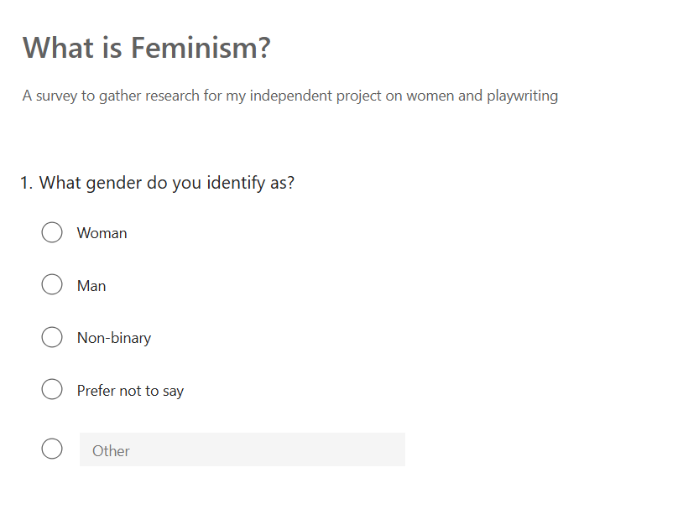

Figure1- Question 1 of What is Feminism survey, created using Microsoft forms



Figure 2- Question 2 of What is Feminism survey, created using Microsoft forms
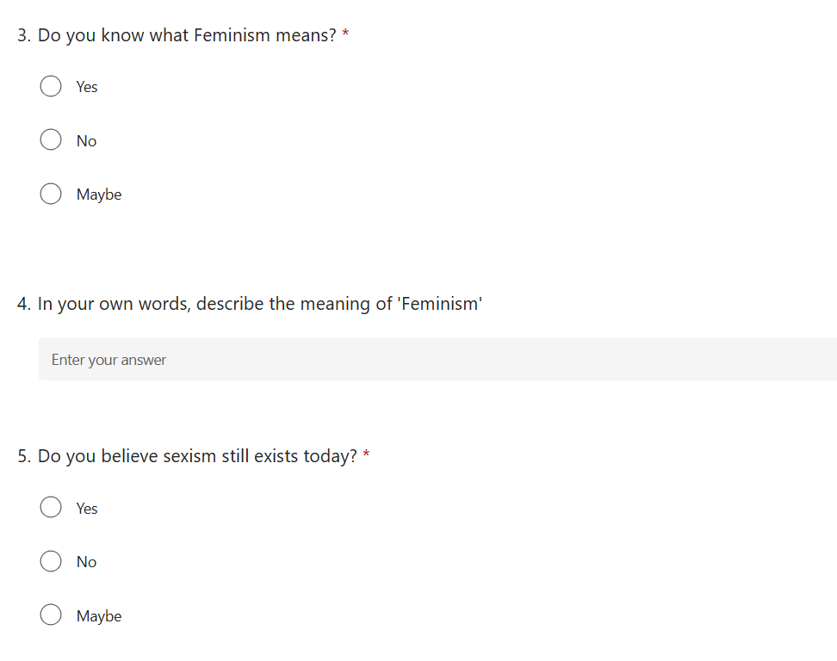

Figure 3- Question 3,4,5 of What is Feminism survey, created using Microsoft forms


Figure 4- Question 6 of What is Feminism survey, created using Microsoft forms

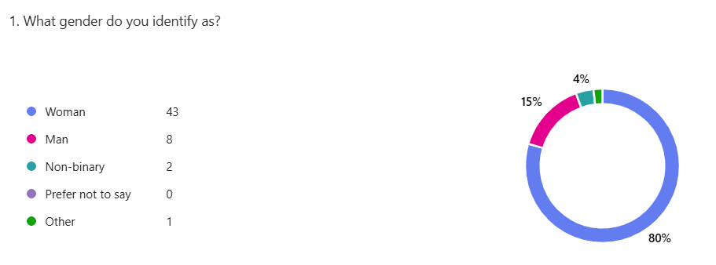
Figure 5- Results from Question 1 of What is Feminism survey
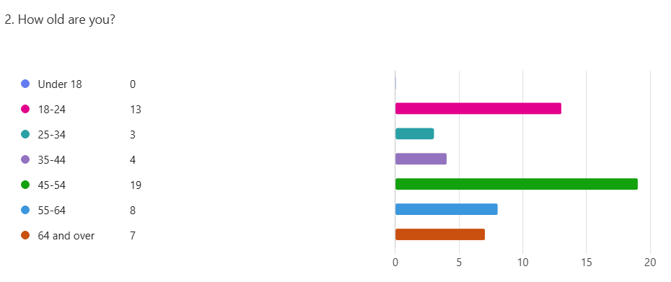

Figure 6- Results From Question 2 of What is Feminism survey

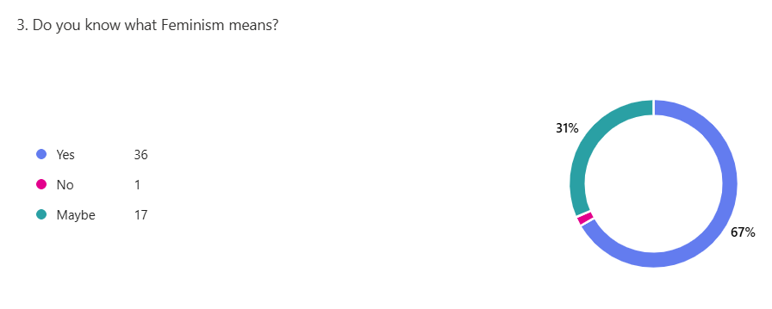
Figure 7- Results from Question 3 of What is Feminism survey

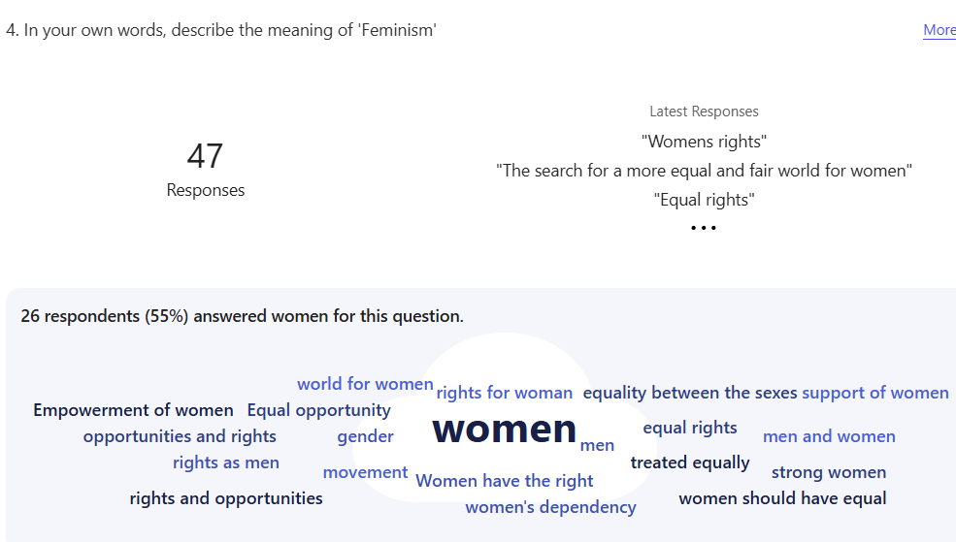

Figure 8- Results from Question 4 of What is Feminism survey

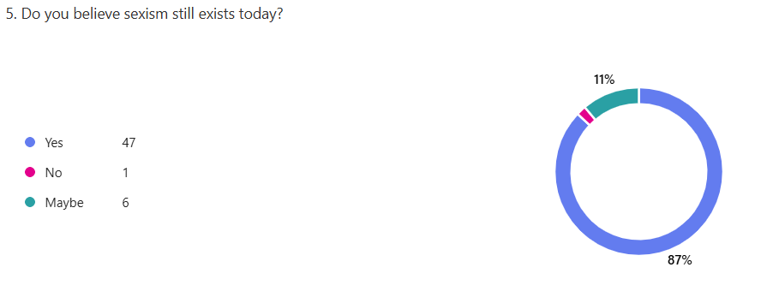
Figure 9- Results from Question 5 of What is Feminism survey
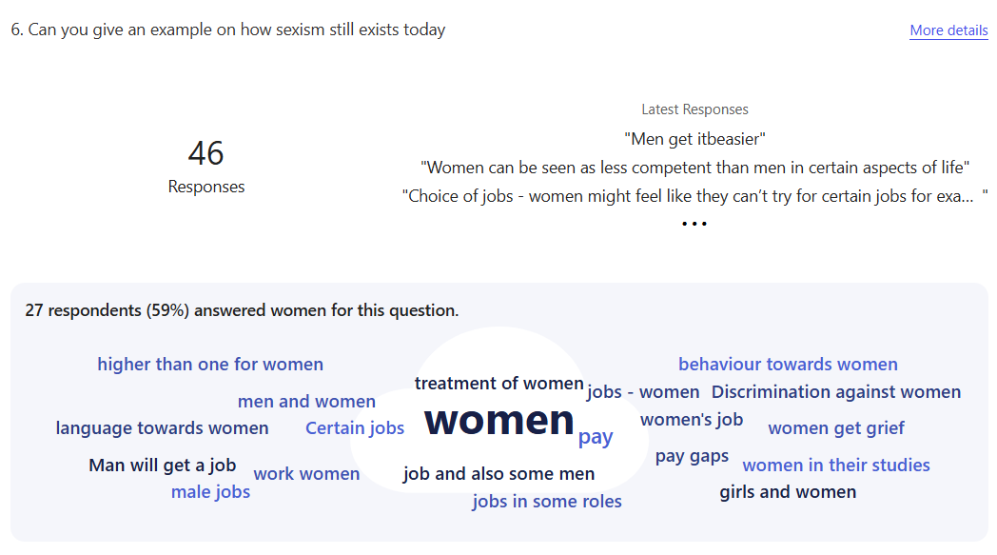

Figure 10- Results from Question 6 of What is Feminism survey

- Freewriting Workshop Presentation - https://www.canva.com/design/DAGb6gJAOLs/uMUMAg4hf2Ep2ZQP7O8_pQ/edit?utm_content=DAGb6gJAOLs&utm_campaign=designshare&utm_medium=link2&utm_source=sharebutton
3.Feedback from Survey

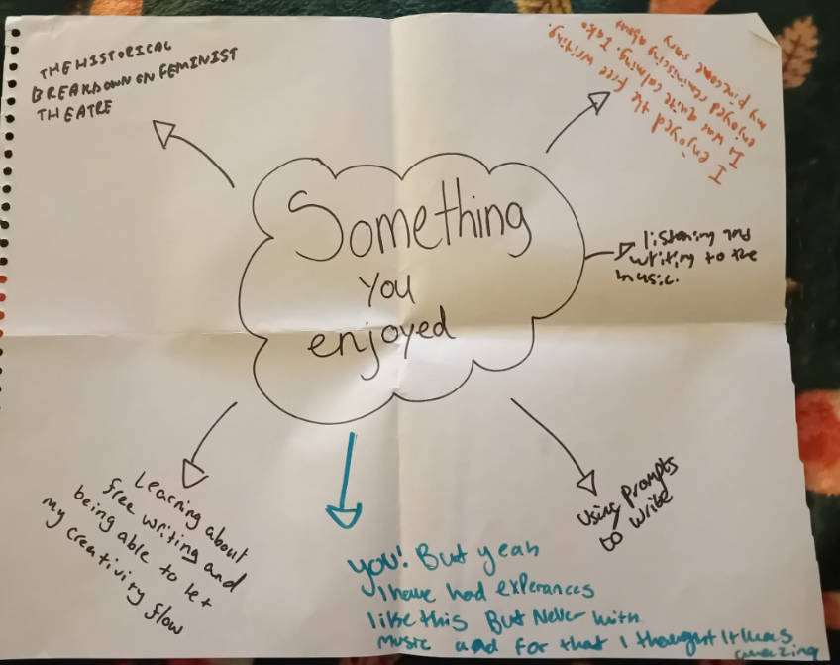

Figure 11- Something you enjoyed – Workshop Feedback
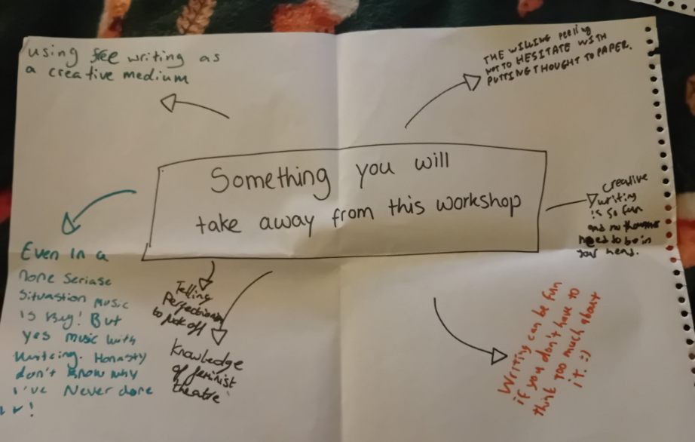

Figure 12 – Something you will take away – Workshop Feedback

4.Project Questions and Answers from Holly Carpenter.
Project Questions

5. Blood and Steel – Collaboration Project
Blood and Steel.docx

