BMOE6003
Landscape and Sustainable Recreation
Tutor name: Anthony Burns
Report title: A Sustainable Management Plan for Llys-y-Fran Reservoir
Ben Lyden
1700632

Executive summary:
Llys y Fran is a reservoir managed by Welsh Water supplying water to south Pembrokeshire. Historically it has been developed as a country park offering walks, fishing, a playground and visitor centre. Recent investment by the Welsh Government and European Fund has led to the establishment of an much improved facility extending the use of the site for water sports, mountain biking, leisure use (a cafe, archery, a climbing wall etc.) and as a camp site. The investment in the site as a tourist destination will result in increased visitor numbers. This report details the management strategy for the site which aims to enhance the visitor experience, control the environmental impact on the site and surrounding area whilst supporting the economic objectives of sustainably supporting and encouraging tourism in Wales.

Introduction:
Outdoor recreation is popular around the world, now especially after the COVID-19 pandemic taught us all to value the freedom to be outdoors. During the pandemic people were forced to explore more local areas and found how enjoyable outdoor spaces in their local areas could be. Whilst this popularity should be celebrated for creating interest in the outdoors and outdoor spaces and all the health and well-being benefits that come with it: it also presents a challenging and increasingly urgent issue of how to manage outdoor spaces for recreation in a way that protects the resources an outdoor space can provide, as well as creating the best quality experience for visitors. The significance of this issue is doubly important as, with the current climate crisis, it is important to maintain and preserve what we already have and ensure that our outdoor spaces are around for future generations to fully enjoy.
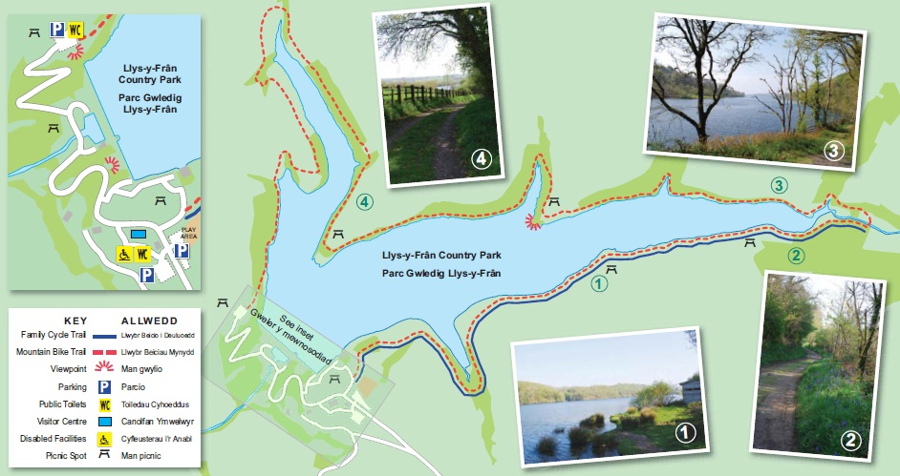
The subject matter of this report will be the production of a management strategy for Llys-y-Fran reservoir to ensure that it is an outdoor space that not only provides environmentally and economically sustainable outdoor recreation of the highest quality but is a space that will flourish and be available in the future.
Figure 1: Map of Llys-y-Fran
Welsh Water (2023) state Llys-y-Fran is a reservoir that has been supplying water to most of south Pembrokeshire since 1972. The reservoir is managed by Welsh Water a ‘not-for-profit’ water company that aims to reinvest all profits into keeping water bills affordable, looking after the quality of Welsh water and maintaining Wales ‘beautiful’ environment. Latterly the lake has been the site of significant Welsh Government and European Funding to develop the Visitor Centre and facilities of Llys-y-Fran as part of the Tourism Attractor Destination Programme led by Visit Wales. The aim is to create a economically and environmentally sustainable resource that promotes outdoor adventure, and tourism “all year round”.
Currently Llys-y-fran offers the following activities:
- Cycling
- Mountain biking (only mountain biking centre in West Wales)
- Mountain biking skills area
- SUP
- Kayak/Canoe
- Open water swimming
- Learn-To-Paddle Courses
- Walking
- Fishing
- Adventure Playground
- Axe-Throwing
- Crazi Bugz (an electric off-road driving experience)
- Climbing Wall
- Archery

And is supported by the following facilities:
- Visitor Centre (Café, Gift shop)
- Activity Centre
- Bike Hub
- Meeting and Function Rooms
- Electric Car Charger Points (8)
- Parking
- Work is currently underway to complete a campsite with a range of pitches from hard standing to grass pitches with electrical hook-ups available for most. Heated showers, toilets and washing areas will be provided as will waste disposal points.
The site is gated and opens at 6.00am with last entry at 7.00pm. Opening times of attractions and facilities are seasonal ranging from 10.00am to 4.00pm in winter to 9.00am to 5.00pm in summer. Currently access is chiefly by bike and car although Clarbeston Road railway station is only 3.2miles (just over an hour on foot).

Definition of the problem:

Tourism and Visitor Economy
Tourism is important to the economy of Pembrokeshire with it being stated “Pembrokeshire's economy relies heavily on tourism” (Pembrokeshire County Council, n.d.). Furthermore, in Pembrokeshire “Tourism supports over 10,000 jobs and the county attracts over 4 million tourists each year, who spend over £550 million per annum” (Pembrokeshire County Council, n.d.).
However, the tourism industry can have a devastating impact on a site: this was highlighted during the COVID-19 pandemic. Due to various lockdowns people, unable go abroad for holidays, fell back on local national parks and outdoor spaces as highlighted by many reports which:
“highlighted some" key findings" which revealed how nature reacted to an increase in visitor numbers at popular sites. "A reduced abundance and diversity of birdlife" was a running theme …..through many sites including the uplands, woodlands and coastal areas.”
(Spridgeon, 2022).
In addition:
“The number of breeding birds and species recorded were lower in all of the sites for a variety of reasons. These included, an increase in visitor numbers in the uplands, and disturbance from recreational motor crafts and paddleboards in coastal areas.”
(Spridgeon, 2022).
The main impacts of the increase of visitors during the COVID-19 pandemic were increase amounts of litter, erosion to the site and the effect of visitors on the local wildlife (Davies, 2022., Pidd, 2021., Spridgeon, 2022.), as such proper management of sites now is even more important as, within easy reach of Llys-y-Fran, is the Pembrokeshire Coast National Park, heritage sites like Pembroke Castle, St Davids Bishop’s Palace, Pentre Ifan and the Preselli hills which are visible from the site. As Williams (2019) states the Preselli Hills are
“special because they represent a key place for human interaction with the upland landscape of west Wales reaching back thousands of years to the early Bronze Age (4000 – 2200 yrs B.C.)”
(Williams, 2019).
As is the case with many coastal areas’ tourism can be seasonal and it makes sound economic sense to try and access and exploit tourism infrastructure year round. Llys-y-Fran has developed itself as a “year-round” attraction featuring the only mountain biking centre in West Wales. The provision of a camping ground opens up the site as both a holiday destination in itself but, also as a base from which to explore not only Llys-y-fran but also other aspects of Pembrokeshire (beaches, culture, heritage etc.) however, extending the season also extends the impact that visitors have at various points in the life cycle of the area.

The Context for Management and Development
The investment in Llys-y-Fran occurs as part of the Welsh Government’s plan to build Wales’ tourism economy as laid out in the government paper by the Welsh Government (2020) the ambitions and goals of this paper are summarised as: economic growth, environmental sustainability, social and cultural enrichment and health benefits all contributing to provide visitor and local satisfaction with tourism and business confidence. The overarching aim is to improve well-being in Wales in line with the 2015 Well-being of Future Generations (Wales) Act developing a Wales that supports its residents to develop their economic, physical and mental wellbeing whilst protecting their unique cultural and physical environment. Any management plan for Llys-y-Fran should support these the objectives.

The Welsh Government (2020) identifies seasonality, spend and spread as key issues in developing sustainable tourism in Wales. Seasonality addresses the problem of attractions only being available at peak times. Spend refers to the time and money spent in Wales by visitors: the aim being to develop the quality rather than quantity of experiences without creating exclusivity or elitism. Spread refers to a widening of visitors perception of Wales so that they are encouraged to look alongside and beyond well-known tourist attractions. Llys-y-Fran is the embodiment of these objectives, its offer is year-round and it opens up access to areas of Pembrokeshire that might be overlooked when compared to places like Tenby, Pembroke and St Davids. The additional development of a campsite at Llys-y-Fran will enable visitors to access the facility but also use it as a base to visit other parts of the County.

- Long term Llys-y-Fran needs to monitor visitor numbers and impact at its site. It is easy to imagine that the Mountain Biking opportunities for children will be a big draw, especially when weather does not really support a day at the beach. In time this might mean that existing routes might need to be developed and extended having further impact on the ecology of the site. At this point research into the impact of such expansion on any special areas of flora and fauna will need to be assessed to gauge whether such expansion is desirable. In addition, areas of the site unsuitable for biking should be cordoned off to encourage biodiversity to mitigate the effects of future expansion.
- With increased numbers of visitors will come increased car use and it might be prudent to look at ways that local bus routes and rail facilities might be exploited to reduce the impact of increased traffic on the local area. In keeping with the idea of ‘spread’, thought might be given to the development of bus services which link attractions in much the same way that the “Puffin Shuttle” has done for the Pembrokeshire coastline.
- Further development might see the lake being twinned with other attractions e.g. sea and freshwater fishing or the use of the lake as a teaching facility for kayaking or SUP and subsequently linked to a suitable coastal site to develop further skills, for example.
- The Welsh Government (2020) highlights the culture of Wales as a key feature in any offer to visitors. Efforts could be made to link the Visitor Centre facilities to other aspects of life in Pembrokeshire. The county has a thriving Arts culture and use of the Visitor centre as an exhibition space or as a teaching space for demonstrating and teaching traditional crafts would have minimal environmental impact on the site at large.

Management Plan:
In managing the Llys-y-Fran site four management practices will be used highlighted by Manning and Anderson (2012) being: limiting use, increasing supply, reducing the impact of use and hardening resources and the visitor experience. For each management practice the conceptual framework of limits of acceptable change will be used strategies will be implemented to ensure visitors can use the site as much as possible and have high quality outdoor recreational experiences whilst minimizing the impacts the outdoor recreational activities have. It also will show how limiting uses can lessen the negative impacts of overusing a site.
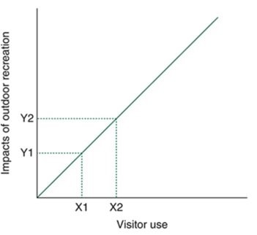
Limiting Use:
Figure 2: Limits of acceptable change
The methods employed to limit use can be used at peak times in the season to ensure that the carrying capacity isn’t strained and visitors will have a limited impact on the site but can still have high quality outdoor recreation.
Using Management Matrices shown in the work of Manning and Anderson (2012) the following strategies will be implemented to ensure that the activities are enjoyable but low impact are: 1a., 2a., 5a., 7c. and 17b.
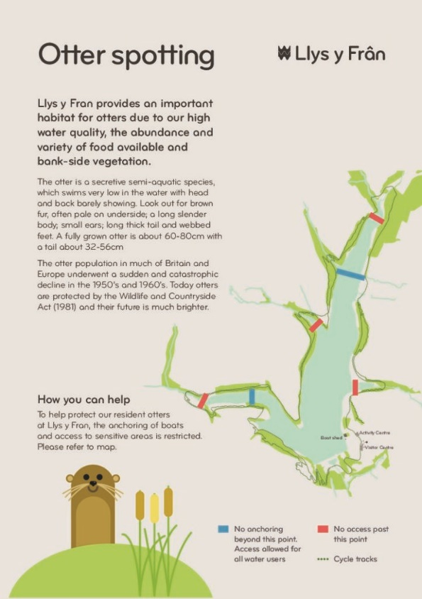
1a.) The reasoning behind selecting this strategy for the site is because Llys-y-Fran is close to being in the centre of all of Pembrokeshire and if visitors found that the site on the day was too crowded or would turned away beacuse the carrying capacity had been met they don't need to go to Clarbeston Road train station to how access to the majority of sites in Pembrokeshire furthermore Llys-y-Fran also is very close to Brecon Beacons an attractive site so a shuttle service could be run to lower the carrying capacity of Llys-y-Fran on a busy day lowering the impact to the site.
Figure 3: Llys-y-Fran Otter spotting map
2a.) Activities that must be paid for are available for pre-determined time periods ranging from an hour or two to half a day for some fishing activities. This rationing of activities allows many people to access the facilities without being overwhelmed, reducing the impact of visitors overall.
5a. and 17b.) This strategy was chosen as there are certain areas of the site that need to be protected for example parts of the reservoir are home to otters and no access or limited access will be put in place to protect the wildlife. The reservoir on the site is also a Site of Special Scientific Interest (SSSI) as “The SSSI covers the river channel, reservoir waterbody and much of the surrounding habitats around the reservoir including woodlands and some of the grasslands and scrub areas” (Welsh Water, 2023).
7c.) This strategy will be implemented because as mentioned before the site is SSSI as such it needs to be protected but also it can control where visitors go and if one area of the site has been used more than another it can protect the area that is being used more and allow it time to regrow.

Increasing Supply:
For this management practice again using Management Matrices in the work of Manning and Anderson (2012) the following strategies will be implemented: 1a., 1b., 31c., and 31d.
1a., 31c., 31d.) Facilities at Llys-y-Fran will be developed to allow for increased use without a corresponding increase in site impact. The site itself is available all year round from 6.00am to 7.00pm daily, although paid activities are only available at certain hours. Users who wish to cycle or walk in relative peace and tranquility can access the site outside peak times. As the site is open all year visitors are under no pressure to visit at set times which may negatively impact the seclusion and natural feel of the attraction.
1a., 1b., 31c., 31d.) Bike and walkways will be developed to offer a half lake family track on the eastern side of the lake and a half lake challenging track on the west of the lake uniting into a demanding circular track around the whole lake. The development of multiple tracks, in addition to the provision of blue and red mountain bike trails which can only be accessed from main trails has the effect of increasing the supply of tracks and diversifying the routes that individuals can take. Allied to the use of a one-way system for biking, more visitors can cycle without undermining other visitors experience of the resource.

Reducing Impact of Use:
Again, using the work of Manning and Anderson (2012) the strategies that will be implemented for this management practice are: 12c., 19b., 21a., 21b., 24b., 31d., 31e., 31f. and 33c.
19b., 21a., 21b., 24b.)The strategies that will be employed to manage the impact of Llys-y-Fran on the environment and neighboring communities. The closure of the site overnight protects nocturnal wildlife unused to people but also ensures that nuisance is avoided for those living in the area.
31d., 31e., 31f., 33c.) The activities provided have a low carbon and noise footprint to aid sustainability and the expansion of the range of activities available ensures that crowds are effectively managed.
12c.) The provision of properly constructed and signposted access ways concentrates visitors into predetermined areas to manage their impact overall. Shared use of accessways by walkers and cyclists further concentrates visitors and reduces the overall impact on the site.

Hardening Resources and the Visitor Experience:
There will be a focus on increasing the durability of the site and experience at Llys-y-Fran using the strategies defined by Manning and Anderson (2012) for management practice and they are: 1, 6a., 6f., 12a., 18a., 18f., 24a., 24b., 52a., 53., 57. and 59.
1, 6a., 6f.) The route around the lake has been developed to enhance visitor experience but also to reduce the seasonality of the offer. Routes are available and accessible year-round; this obvious investment speaks to the value of the site and encourages users to appreciate what is offered.
6a., 12a., 18a., 18f., 24a., 24b.) The development of a range of activities and the provision of a camp site emphasises the site as a valued “destination” promoting use but encouraging uses to look after the resource.
52a., 53., 57., 59.) Frequent information boards reinforce rules and conventions but also educate users about their responsibilities using the site.
Conclusion:
It would be tempting to look at sites like Llys y Fran from a single perspective. Conservationists might place the environmental and ecological needs of the site above those of the economic or leisure implications where business might choose to do the opposite. Bodies like the Welsh Government and Welsh Water do not have the luxury of such a focused view. Public bodies have to consider both the implications for the population financially and environmentally. The strategies proposed allow for the continued economic contribution of Llys-y-Fran to Pembrokeshire’s tourist economy. As aspects of the site are free to the public (e.g. walking), Llys-y-Fran also makes a contribution to the health economy of the area offering a venue for outdoor enjoyment that can be accessed year round. The proposed strategies should allow for high quality outdoor recreation whilst also protecting the site from identified issues such as litter, erosion and effects on the local wildlife. In addition promoting a range of sites in Pembrokeshire a well as Llys-y-Fran will mitigate the impact of visitors but continue to boost the local economy leading to greater funding to maintain facilities and allowing for sites to be preserved and enhanced for longer.
WORD COUNT: 2811
Reference list:
Davies, C. (2022) ‘Post lockdown surge in Snowdonia tourists leaving the national park in 'crisis'’, 5th February. Available at: https://www.dailypost.co.uk/news/local-news/post-lockdown-surge-snowdonia-tourists-22831717 (Accessed 4th May 2023)

Pembrokeshire County Council. (n.d.). About Pembrokeshire. [online] Available at: https://join-pembrokeshire.com/about-pembrokeshire (Accessed 6th May 2023).

Pidd, H. (2021) ‘'The litter was a shock': 2020's Covid-driven rush on UK national parks’, The
Guardian, 1st January. Available at: https://www.theguardian.com/environment/2021/jan/01/the-litter-was-a-shock-2020-covid-rush-on-uk-national-parks (Accessed 6th May 2023).

Spridgeon, D. (2022) ‘Impact of visitors on Snowdonia wildlife during and after 'exceptional' Covid years revealed’, NorthWalesLive, 28th October. Available at: https://www.dailypost.co.uk/news/north-wales-news/impact-visitors-snowdonia-wildlife-during-25382231 (Accessed 6th May 2023).

Welsh Government (2020). Welcome to Wales: Priorities for the Visitor Economy 2020-2025. [online] Available at: https://businesswales.gov.wales/tourism/welcome-wales-priorities-visitor-economy-2020-2025 (Accessed 3rd May 2023).

Welsh Government (2015) Well-being of Future Generations (Wales) Act 2015 Available at: https://www.futuregenerations.wales/about-us/future-generations-act/ (Accessed: 2nd May 2023).

Welsh Water. (2023). Welcome to Llys-y-frân Lake | Discover your Welsh Water Adventure. [online] Available at: https://llys-y-fran.co.uk/ (Accessed 1st May 2023).

Williams, A. (2019) ‘Place is special when we do a bit of homework’, Horizons No. 82. Available at: https://www.outdoor-learning research.org/Portals/0/Research%20Documents/Horizons%20Archive/H82%20Andy%20Williams%20Place%20is%20Specail%20when%20we%20do%20a%20bit%20of%20homework.pdf?ver=2019-10-15-152121-520 (Accessed: 10th May 2023)

