11/20/2017
Vivian Presgrave (P151998)
University of Wales Trinity Saint David
A REPORT INTO BUSINESS ETHICAL ISSUES
Management Ethics

Table of Contents
1. Table of figures 2
2. Executive Summary 3
3. Introduction 4
4. Main Findings 6
4.1 What is sustainability in business? 6
4.2 What is Corporate Social Responsibility (CSR)? 6
4.3 Arguments against sustainability and CSR 8
4.4 Stakeholder versus shareholder theory 10
5. Conclusion 14
6. Reflection on the assignment and interaction with other students 15
7. Bibliography 18
8. Appendices 21
8.1 Appendix A Poster 21

Table of figures

Figure 1:Carroll’s CSR Pyramid 7
Figure 2-Stakeholders of Monsanto 10
Figure 3:Stakeholder Mapping 12
Figure 4:(Gibbs,Learning by Doing,1988) 15
Figure 5:Berol’s Model of Communication: 16

Executive Summary

The report applies the concept of Corporate Social Responsibility (CSR) and other relevant theories such as the Stakeholder verses Shareholder theory to Monsanto specifically. It addresses the unsustainable and unethical practices, that occur during the production of Monsanto’s GMO’s and seeks for potential solutions to the ethical and environmental impacts.

Introduction
This report will broaden knowledge and understanding from the poster produced for the Organic Consumers Association. This will be included in the appendices.
(Association, 2017) Refers to Monsanto as a “Bio-tech bully” and have been campaigning against them since the mid 1990’s. (Association, 2017) States they try to “fight back against Monsanto and the other Biotech Bullies who are responsible for creating Agent Orange, PCBs, Roundup (glyphosate) and other toxins that threaten human health and the environment”. “For over two decades, Monsanto and corporate agribusiness have exercised near-dictatorial control over American agriculture. Finally, public opinion around the biotech industry's contamination of our food supply and destruction of our environment has reached the tipping point. We're fighting back”.
The topic undertaken was should businesses, for example Monsanto be responsible for more sustainable practices and the consequences that are derived from unsustainable and unethical practices. Arguments for and against implementing rules and regulations for sustainability and Corporate Social Responsibilities will be addressed during the report.
“There is one and only one social responsibility of business – to use its resources and engage in activities designed to increase its profits, so long as it stays within the rules of the game which is to say, engage in open and free competition without deception or fraud” (Friedman M. , 1970)
Friedman’s view implies that the only social responsibility of a business is to maximise its profits, as long as it adheres to the laws and regulations set by the locality, without considering any ethical or philanthropic responsibilities.
“The ability to distribute funds effectively for social purposes, and perhaps also some experience in doing so, could become highly desired traits on a corporate executive’s resume.” (Schaefer, 2008, p. 302)
Another view, by (Schaefer, 2008) opposes Friedman’s opinion and suggests that businesses, could solve the custodian argument by pursuing and hiring qualified executives that are experts in social responsibility.
These two opposing statements show the division on the opinions in regards to a business’s corporate social responsibility.
Within the report theories which will be used are Corporate Social Responsibility (CSR), Carroll’s CSR pyramid (Carroll, A Three-Dimensional Conceptual Model of Corporate Performance, 1979) and Stakeholder mapping. Friedman’s theory verses Freeman’s theory will be used, as contrasting discussions.
To reflect on the assignment and discuss the effectiveness of communication during the assignment two models, will be applied. These are, David Berlo’s (1960) model of communication and Gibbs Model of Reflection (1988).

Main Findings

4.1 What is sustainability in business?
“Sustainable development that meets the needs of the present, without compromising the ability of future generations to meet their own needs” (Bruntland, 1987)
As discussed in the poster defence, (Bruntland, 1987) describes the needs for large corporations, such as Monsanto to comply with needs of the population now and in the future. The concept suggests, that natural resources like fossil fuels and water are finite and therefore as scarcity increases, cost also increases. (Reyna, 2012) “At some point the resources with which we depend upon will be more expensive or we won’t be able to get it. So, companies need to be prepared to protect those resources, so they will be plentiful or find alternate resources for their products and services. The winning companies will do both”. This suggests, that it is essential for Monsanto to develop and engage in more sustainable practices to ensure it can continue to grow and prosper as resources becomes scarcer.

4.2 What is Corporate Social Responsibility (CSR)?
During the last century, CSR has been defined in a multitude of ways (Dahlsrud, 2016, p. 361).
The definitions are vastly ranged, from performing ethical practices to enhancing the welfare of society. However, some do believe that the concept of CSR is becoming void it’s meaning. Whereas, others claim that the variety of definitions of CSR are consistent, with each definition relating to the impacts of business on its stakeholders. (Carroll, A Three-Dimensional Conceptual Model of Corporate Performance, 1979, p. 500) states “The social responsibility of business encompasses the economic, legal, ethical, and discretionary expectations that society has of organizations at a given point in time”
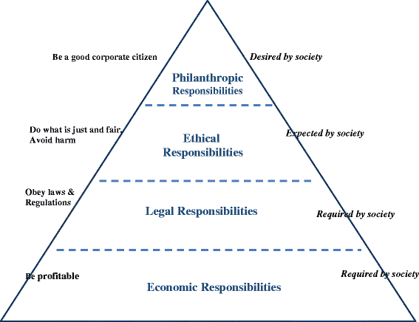
Figure 1:Carroll’s CSR Pyramid

Source: (Carroll, 2016)

Carroll’s CSR pyramid is a diagram, that illustrates how and why organisations should meet their social responsibilities. The main element of Carroll’s CSR Pyramid is that CSR is built on the foundation of profit and that profits must come before, any of the other responsibilities, agreeing with (Friedman M. , 1970). “Just as the footings of a building must be strong to support the entire edifice, sustained profitability must be strong to support society’s other expectations of enterprises. The point here is that the infrastructure of CSR is built upon the premise of an economically sound and sustainable business” (Carroll, 2016)

Though Carroll’s definition is popular it is considered too broad. A more relevant definition was suggested by (Communties, 2006, p. 2), that affirms “(CR) is a concept whereby companies integrate social and environmental concerns in their business operations and in their interaction with their stakeholders on a voluntary basis. It is about enterprises deciding to go beyond minimum legal requirements and obligations stemming from collective agreements in order to address societal needs”. (Horrigan, 2010) continues to add to this definition by stating “As corporations engaging in voluntary social efforts that transcend legal regulations”). The voluntary social efforts (Horrigan, 2010) refers to include philanthropic work, such as charitable giving, environmental activism and community service.

4.3 Arguments against sustainability and CSR
As described by (Friedman M. , 1970), the primary responsibility of business is to make a profit for its owners, albeit while complying with the law. (Dina Frutos Bencze, 2015, p. 145) supports Friedman’s view, by stating “the self-interested actions of millions of participants in free markets will, form utilitarian perspective, lead to positive outcomes for society. If the operation of the free market cannot solve a social problem, it becomes the responsibility of government, not business, to address the issue”.
Another, argument against sustainability and CSR is the fact that addressing social issues will come at a cost for Monsanto. This was the case in 2015, when Monsanto was fined $600,000 by the EPA (Environmental Protection Agency) (More, RT Question More, 2015) for uncontrolled releases of toxic gases.
This suggests, that if Monsanto does choose to internalise the costs of responsible actions, it puts its self at risk of losing its competitive position and therefore being less competitive against other businesses. According to (Dina Frutos Bencze, 2015, p. 145) “In a global competitive environment if businesses in one country expand assets to address social issues, but those in another country do not”, this will therefore put Monsanto in a weaker position potenitally. According to Carroll and Buchholtz, “since CSR is increasingly becoming a global concern, the differences in societal expectations around the world can be expected to lessen in the coming years.” (Maria Aluchna, 2017, p. 159).
Another argument against CSR, is the fact that Monsanto already “has enough power-economic, environmental, political and technological, and so why place in its hands the opportunity to wield additional power?” (Archie B. Carroll, 2017). This statement is supported by the Monsanto Protection and Act, which was signed in 2013 and states ““if future research shows that GMO’s or GE seeds cause significant health problems, such as cancer etc, that the federal courts no longer have any power to stop their spread, use or sales”. (News, 2013). This has therefore granted Monsanto and unlimited source of power, to continually experiment with hazardous chemicals in its products without worrying about the underlying consequences it could have on the environment or consumers.

4.4 Stakeholder versus shareholder theory

NGOs (Non-governmental organisations)

Academia
Farmer customers

Research institutions
Monsanto
Community neighbours

Consumers
Public health organizations

Government, the food industry

Figure 2-Stakeholders of Monsanto
Stakeholder theory implies that the main goal of a business is to create as much value as possible for stakeholders. In order for a business to be successful and sustainable overtime, executives of the business much continuously engage the interests of its customers, employees, suppliers, communities and shareholders aligned and going in the same direction. (Freeman, 1984, p. 46) states “As the recent global finical crisis has taught us. The 21st Century is one of “Managing for Stakeholders”. The task of executives is to create as much value as possible for stakeholders without resorting to trade-offs. Great companies endure because they manage to get stakeholder interests aligned in the same direction”.
According to stakeholder theory, increased CSR will make firms more attractive to customers. CSR was considered and undertaken by Monsanto. The Monsanto Sustainable Report 2016, states “We are focused on how Monsanto can contribute to the 2030 Development Agenda of the United Nations and advancement of the Sustainable Development Goals. Driving sustainable agriculture requires a wide range of systematic approaches and an understanding of how to optimally use resources. At Monsanto, we employ modern agriculture techniques and technologies to help farmers feed the world’s growing population in a sustainable manner” (Monsanto, 2016). However, although this is true Monsanto still fails in the development of sustainable agriculture and continues to do so through promoting its pesticides. According to, (Scientists, 2017) “Monsanto’s Roundup Ready and Bt technologies lead to resistant weeds and insects that can make farming harder and reduce sustainability”

Stakeholder mapping for Monsanto
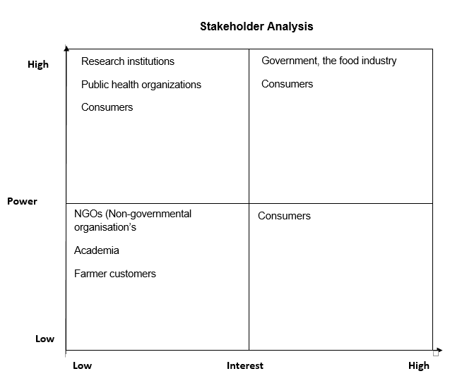
Figure 3:Stakeholder Mapping

(Friedman M. , 1970) outlines the concept of shareholder wealth maximisation. Friedman believed it was inadequate for businesses to concentrate on external social investments and that the main objective of a corporation is to provide a return to shareholders. By investing and concentrating on external social responsibilities, the corporation could lose sight of its main objectives. Friedman argued that corporations, do not know how to properly invest in social causes. Therefore, such decisions should be in the hands of individuals and not the corporation.

Conclusion
In conclusion, both CSR and the United Nations Sustainable Development Goals (SDGs) are starting to influence Monsanto’s ethical policies and GMO production. However, this will still not be influential enough prevent Monsanto to forfeit large profit margins for better environmental issues. The Monsanto Protection Act is another element that will continue to drive unethical and unsustainable practices. This was discussed earlier in the report. A potential solution to solve the issues from the GMO’s is to influence a change in consumers buying behaviour. This, could be done by labelling GMO products, so customers are more aware of what the purchasing and consuming.

Reflection on the assignment and interaction with other students
For this section of the report I will be using (Gibbs, 1988) model of reflection
Figure 4:(Gibbs, Learning by Doing,1988)


Source: (Gibbs, 1988)
For this assignment, I was tasked as an individual identify antagonistic organisations that have contrasting views on Corporate Social Responsibility (CSR). For example, Monsanto and the Organic Consumers Association and their respective opinions on each other’s policies. The poster had to define the key debating issues, which were CSR and sustainable business practices and I constructed a promotional poster against Monsanto’s unethical and unsustainable business practices. The poster, was then followed up by a defence which consisted of answering ten questions in regards to ethical concerns.
I used two models of communication, in order to explore the options I could use to depict my message of Monsanto’s unethical and unsustainable practices through my poster more efficiently. The model I used was David Berlo’s (1960) model. I used the model to grasp a better understanding on how the viewers will interpret the message.

Figure 5:Berol’s Model of Communication:

Source: (Berlo, 1960)
The model helped improve my communication skills, as I had to interact with several students in order to see how they portrayed the message I was depicting in the poster. My attitude towards learning and knowledge on the subject of GMO’s has expanded greatly and I am now more confident in educating people on the repercussions GMO’s can have on the ecosystem and other human beings. I am also, more aware of the unsustainable and unethical practices that occur, when producing and selling GMO’s globally.
On completion of the poster I asked students inside and outside the university to critique the poster and analyse the message it was trying to depict, linking back to the new skills I learnt from the model of communication. The results are shown in the poster defence.
A recommendation, that I would apply to improve the understanding of the assignment would be a more structured assignment brief. Initially, some students were confused about the deadline date for each assignment to be submitted. However, this issue was dealt with promptly, through the corrected assignment brief and solved any confusions.

Bibliography
Archie B. Carroll, J. B. ( 2017). Business & Society: Ethics, Sustainability & Stakeholder Management. Cengage Learning.
Association, O. C. (2017, November 14). Millions Against Monsanto. Retrieved from Organic Consumers Association : https://www.organicconsumers.org/campaigns/millions-against-monsanto
Berlo, D. K. (1960). Process of Communication: An Introduction to Theory and Practice . Thomson Learning.
Bruntland. (1987). Our Common Future:World Commission on Environment and Development. Oxford ; New York: Oxford University Press.
Carroll, A. B. (1979). A Three-Dimensional Conceptual Model of Corporate Performance. The Academy of Management Review.
Carroll, A. B. (2016). Carroll’s pyramid of CSR: taking another. International Journal of Corporate Social Responsibility, 8.
Communties, C. o. (2006). A European Strategy for Sustainable, Competitive and Secure Energy . Brussels: Comission of the European Communties.
Dahlsrud. (2016). Value Creation in International Business: Volume 2: An SME Perspective. Springer.
Dean, D. A. (2009, May 19). American Academy of Environmental Medicine. Retrieved from aaemonline: https://www.aaemonline.org/gmo-pressrelease.php
Development, W. C. (1987). World Commission on Environment and Development. Oxford University Press.
Dina Frutos Bencze, N. H. (2015). Foundations of Global Business: A Systems Approach. IAP.
Eisenstein, C. (2014, January 8). Guardian sustainable business. Retrieved from The Guardian: https://www.theguardian.com/sustainable-business/blog/sustainability-business-sense-profit-purpose
Freeman, E. (1984). Strategic Management: A Stakeholder Approach. Boston: MA: Pitman.
Friedman, M. (1970). The Social Responsibility of Business is to Increase its Profits. New York: The New York Times Magazine.
Friedman, M. a. (1970, September 13). Monetary Statistics of the United States: Estimates, Sources, Methods. Columbia Univ Pr. Retrieved from colorado.edu: https://www.colorado.edu/studentgroups/libertarians/issues/friedman-soc-resp-business.html
Gibbs. (1988). Learning by Doing: A guide to teaching and learning methods. Oxford: FEU.
Grant, H. (2016). Monsanto 2016 Sustainabilty Report. N. Lindbergh Boulevard : Monsanto .
Hopkins, M. (2012). Corporate Social Responsibility and International Development: Is Business the Solution? Middlesex : Earthscan.
Horrigan, B. ( 2010). Corporate Social Responsibility in the 21st Century: Debates, Models and Practices Across Government, Law and Business. Edward Elgar Publishing.
Jamieson, A. ( 2015, March 26 ). Monsanto Fined for Not Reporting Toxic Chemical Releases. Retrieved from NBC News: https://www.nbcnews.com/storyline/harvey-weinstein-scandal/london-s-old-vic-finds-20-claims-inappropriate-behavior-against-n821311
Krimsky, S. (2014, November 22). Rising suicide rate for Indian farmers blamed on GMO seeds. Retrieved from RT Question More: https://www.rt.com/news/206787-monsanto-india-farmers-suicides/
Maria Aluchna, S. O. (2017). Responsible Corporate Governance: Towards Sustainable and Effective Governance Structures. Springer.
Monsanto. (2016). Monsanto 2016 Sustainabilty Report. Monsanto.
More, R. Q. (2014, November 22). Rising suicide rate for Indian farmers blamed on GMO seeds. Retrieved from RT Question More: https://www.rt.com/news/206787-monsanto-india-farmers-suicides/
More, R. Q. (2015, March 27). RT Question More. Retrieved from Monsanto fined $600k by EPA for uncontrolled releases of toxic chemicals: https://www.rt.com/usa/244761-monsanto-fined-toxic-chemical-releases/
Nations, U. (2015). The Millennium Development Goals Report. New York: United Nations.
News, G. R. (2013, May 25). Monsanto Protection Act Signed By Obama, GMO Bill “Written By Monsanto” Signed Into Law. Retrieved from Global Research: https://www.globalresearch.ca/monsanto-protection-act-signed-by-obama-gmo-bill-written-by-monsanto-signed-into-law/5329388
Organic Farming Reserach Foundation. (2013, September 29). Retrieved from ofrf: http://ofrf.org/resources/organicfaqs.html
Reyna, E. (2012, March 1). 10 More Reasons Companies Should Care About Sustainability. Retrieved from Business Insider: http://www.businessinsider.com/the-top-10-benefits-of-convincing-your-company-to-care-about-sustainability-2012-3?IR=T
Schaefer, B. (2008). Journal of Business Ethics. Journal of Business Ethics.
Scientists, U. o. (2017, November 19). Eight Ways Monsanto Fails at Sustainable Agriculture. Retrieved from Union of Concerned Scientists : http://www.ucsusa.org/food_and_agriculture/our-failing-food-system/genetic-engineering/eight-ways-monsanto-fails.html#.WhIv3Upl-Uk
Shahla Wunderlich, K. A. (2015). Consumer Perception of Genetically Modified Organisms and Sources of Information. Consumer Perception of Genetically Modified Organisms and Sources of Information, American Society for Nutrition.
Shiva, D. V. (2014, November 22). Rising suicide rate for Indian farmers blamed on GMO seeds. Retrieved from RT Question Mode: https://www.rt.com/news/206787-monsanto-india-farmers-suicides/
Sputnik. (2015, March 27). Monsanto to Pay for Uncontrolled Releases of Toxic Chemicals in Idaho. Retrieved from Sputnik: https://sputniknews.com/environment/201503271020107715/
White, G. (2016 , April 19, ). Not safe to eat: Rats fed lifetime of GMO corn grow horrifying tumors, die very early. Retrieved from gmo.news: http://www.gmo.news/2016-04-19-not-safe-to-eat-rats-fed-lifetime-of-gmo-corn-grow-horrifying-tumors-die-very-early.html
Who is Monsanto? (2017, November 17). Retrieved from Word Press: http://whoismonsanto.com/

Appendices

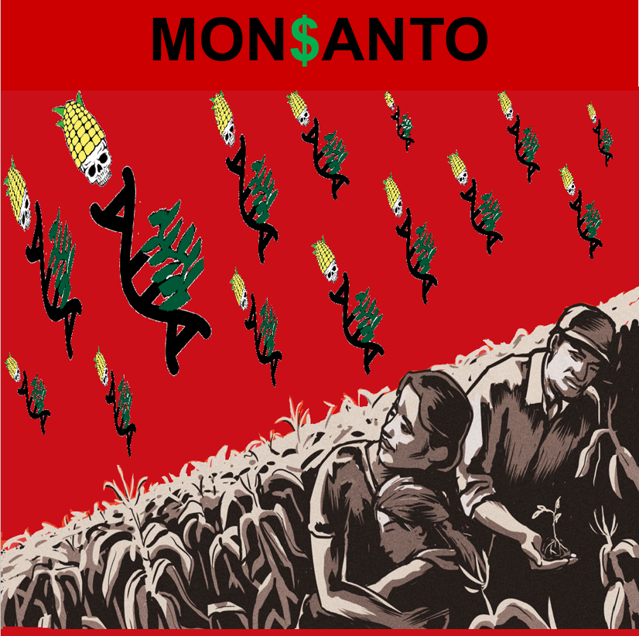
8.1 Appendix A Poster

