
APPENDIX GA36b

LEVEL 5 ASSESSMENT SPECIFICATION

Student name: |  | Student ID number:
Programme:
Module: | Operational Policing Practice 2
Module code: | BMPP5002D | Contribution to Overall Module Assessment (%): | 50%
Lecturer: | Mark Jordan | Internal Verifier:
Assignment Title: | Assignment 2 | Word count (or equivalent): | 4000 Words
Submission deadline: | 12th July 2021 | Return date of provisional marks & written feedback:
Submission method: | All written assessments, where practical and possible, must be submitted via Turnitin unless otherwise instructed by the Lecturer. (Please DO NOT put this assessment specification into Turnitin or it will match many similarities with other students’ submissions.)  Late submission of the assessment will result in a late penalty mark. Penalties for late submission: Up to one week late, maximum mark of 40%. Over one week late, 0%. Only the Extenuating Circumstances Panel may approve a change to submission dates.
Academic honesty / referencing: | Academic honesty is required. In the main body of your submission you must give credit to authors on whose research and ideas your work is based. Append to your submission a reference list that indicates the books, articles, etc. that you have used, cited or quoted in order to complete this assessment.
Module Learning Outcomes
(from module syllabus)
Criminology
- Critically review the constitutional role of the police in contemporary society and the wider criminal justice system
- Assess the strengths and weakness of different policing models in relation to crime/victimisation and the public and explore crime prevention theories initiates and strategies
- Evaluate the benefits that a greater understanding of sociology and criminology can have on operational policing and decision making
Counter Terrorism
- Explain the organisational structures and inter-relationships that exist in counter-terrorism policing and the current threats faced by the UK CT network
- Analyse the potential links between terrorism and other forms of criminality
Response Policing
- Illustrate how theories and principles of psychology and human behaviour can be applied in various response contexts
- Critically review key issues relating to the complexity and challenges of operational policing
- Undertake the role and responsibilities of a first responder to a critical incident
- Review examples of high-profile critical and major incidents and analyse the role of the police within a joint emergency services operation to establish ‘best practice’

Policing Communities
- Analyse why key incidents/events have had a damaging effect on the willingness of communities to engage with the police
- Engage with the community to examine/critique how current policing practice can impact upon the community
- Evaluate the role of community policing in fostering and maintaining community cohesion and understand and apply key principles of effective community engagement
Policing the Roads
- Apply police powers in relation to commercial vehicle enforcement
- Explain how to police the strategic road network effectively and safely
- Explain roles and responsibilities of personnel involved in police pursuits, and the types of vehicle
Information & Intel
- Explain and employ analytical products provided by intelligence specialists during the course of an investigation
Conducting Investigations
- Understand the difference between 'volume and priority' crime
- Understand the importance of the concept of memory upon interview methods and process

TASK DESCRIPTION

- Students are required to complete a 1000-word essay under the following title:

Analyse why key incidents/events have had a damaging effect on the willingness of communities to engage with the police
Evaluate the role of community policing in fostering and maintaining community cohesion and understand and apply key principles of effective community engagement

This essay will look at what a critical incident is and analyse the impacts it has on community engagement. It will also explore the effects of community policing and how it can be implemented to help foster and maintain community cohesion and improve trust and community engagement.
A critical incident is defined as, any incident where the effectiveness of the police response is likely to have a significant impact on the confidence of the victim, their family and/or the community (College of Policing, 2013).
Any incident has the capacity to become a critical incident, including anti-social behaviour, domestics or hate crimes. The way in which police deal with everyday incidents like these can play a vital role in public perception, community engagement and legitimacy.
Public legitimacy and community engagement are fundamental building blocks of UK policing today. When Sir Robert Peel founded the police in 1829, he pledged that he wanted a society whereby the police ‘policed by consent’. Policing by Consent is the concept that the power of the police derives from the public’s co-operation and consent opposed to the power of the state or individual (Home Office, 2012). For this to be successful, he acknowledged that police officers and forces needed to treat the public with fairness, integrity and respect, as this helps to foster positive legitimacy (Lentz and Chaires, 2007). Legitimacy from the public is vitally important when fighting crime, as it has a positive effect on public engagement, reporting crime and reduction in crime (Bryan & Bryant, 2019). Without co-operation from the public the police service would not function well.
When police officers deal with the public it is important that they adhere to the code of ethics (College of Policing, 2021). This can help improve public satisfaction, public perceptions and confidence (Myhill and Bradford, 2012). Likewise, if members of the community do not believe that the police have treated them fairly, the police may lose legitimacy and the public are less likely to engage and report crime (Jackson et al., 2013).
Events having a damaging effect on willingness for communities to engage with police
In 1967, the Home office recommended that forces reduce the number of ‘Bobbies’ on foot patrol in favour of more mobile patrols. It was thought that this model of policing would allow officers to respond to more calls from the public, thereby reducing crime levels and improving community relations. In fact, this had the opposite effect as the relationship between the public and police weakened, resulting in poor intelligence gathering, poor rapport and lack of trust. These components are vital in fighting crime. Newburn (2012), argued that this ‘professional’ model of policing weakened ties between the public and police and made it a more reactive style of policing.
However, in a study done in 2005, Braga (2005) argued that foot patrols were causing issues amongst certain communities, especially ethnic minority groups and non-affluent areas. These communities viewed foot patrols as ‘threatening’ and ‘over policed’ where they had a ‘us’ verses ‘them’ mentality and they felt like they were targeted.
In addition to these challenging events there have also been several incidences where some police forces have been found guilty of corruption, racism and unethical behaviour. For example, the Brixton riots, the investigation into the Stephen Lawrence murder and more recently the death of George Floyd in America. These incidences have led to an increased divide between the black and ethnic minority community and police, with tensions still visible to this day. This could be due to older generations influencing younger generations through their unconscious bias (Marcelin et al, 2019)
When certain groups in society lose trust in the police due to corruption or perceived wrongdoing it can erode legitimacy and they are less likely to engage and be law abiding. The figure below shows offences committed by ethnicity.

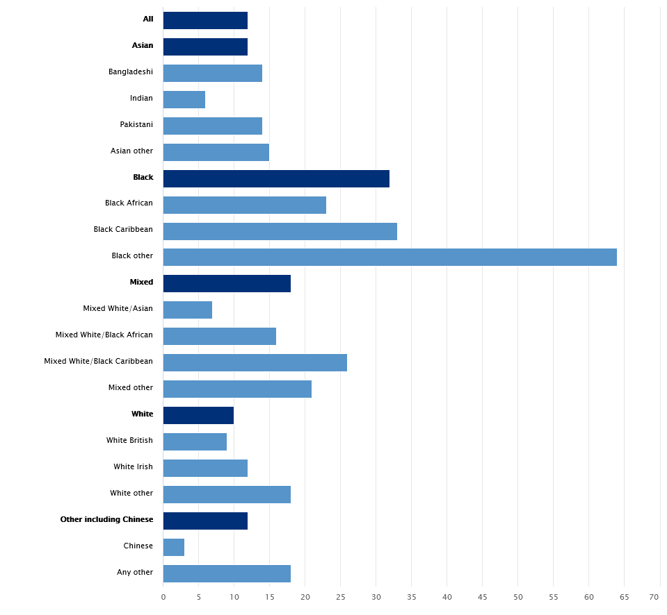
Fig.1 - Arrest rate per 1,000 people by ethnicity (Gov.uk, 2020)
Figure 1 above shows arrest rates per 1,000 people by ethnicity. The figure indicates that black or ethnic minority groups have less legitimacy for police, which could be a result of perceived unfair treatment or wrongdoing by police.

Community Policing
Morash et al (2002), defines community policing as, the delivery of police services through a customer-focused approach, utilising partnerships to maximise community resources in a problem-solving format to prevent crime, reduce the fear of crime, apprehend those involved in criminal activity, and improve a community’s quality of life.
Community policing has been in existence for many years, it is the concept of police and communities working together to make sure that their neighbourhoods are a safer and better environment to live in. This collaborative way of working will help improve community engagement and allow communities an opportunity to have their say on policing strategies and enable them to give feedback on what works best.

Fig 2. Benefits of effective community policing. Adapted from (Segrave, M. & Ratcliffe, J., 2004)

Tilley (2003) argues that community policing is one of three models of policing competing for prominence, the other two being Problem-orientated policing (POP) and Intelligence-led policing (Bryant & Bryant, 2019).
Community Cohesion
Community cohesion describes the ability of all communities to grow and work in harmony rather than in opposition. It aims to build a community where people feel confident that they belong, and are comfortable mixing and interacting with others, particularly with people from ethnic backgrounds. When there is a sense of inclusion, harmony and belonging communities are more likely to pull together to achieve a common goal (Ratcliffe et al, 2012).

Community engagement
Community engagement increases the visibility and understanding of issues and empowers communities to have their say over decisions that affect their lives, communities and neighbourhoods. Community engagement allows for a deeper, stronger and more trusting relationship between public organisations and communities.
To emphasise the importance of how community engagement can effectively increase public confidence, the college of policing, (2014) has implemented a ‘confidence cycle’ which demonstrates that by solving community issues leads to increases in public confidence, trust and reporting through community engagement.

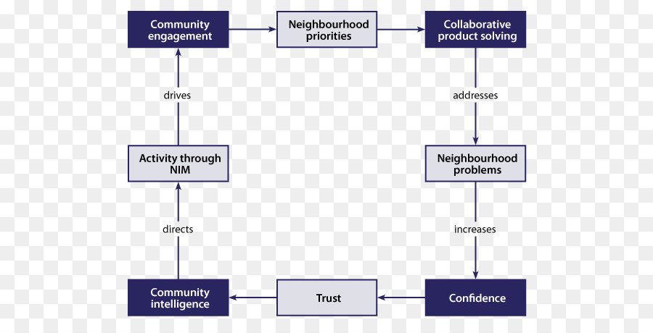

Fig 3. The Confidence Cycle (College of Policing 2014).

According to Bassler et al (2008) there are five basic principles for successful community engagement, these include;

Fig 4. Five principles of community engagement. Adapted from (Bassler et al 2008)

Conclusion
In conclusion, it is paramount for Police officers to deal with all incidents with honesty, integrity and professionalism and to recognise that any incident has the potential to become a critical incident. Police officers need to be aware that their actions can have a positive or negative impact on the public‘s perception and legitimacy which has a big bearing on community cohesion and engagement.
Finding the right balance in relation to mobile and foot patrols within community policing gives police the ‘best’ of both worlds in responding to and preventing crime. In order for police to police by consent, they need the co-operation of the public as they are the ‘eyes and ears’ of the community. Good community engagement will mean that both groups can understand and act on the needs or issues of community experiences helping to reduce crime and disorder and achieve positive change.

1077 Words

- Students are required to complete a 1000-word essay under the following title:

Assess the strengths and weakness of different policing models in relation to crime/victimisation and the public and explore crime prevention theories initiates and strategies

Explain and employ analytical products provided by intelligence specialists during the course of an investigation

This essay will explore and evaluate the strengths and weaknesses of different policing models in relation to crime, victimisation and the public. It will also look at how effective crime prevention theories are in preventing crime.
Modern policing plays an integral part in society. The basic mission for which the police exist is to prevent crime and disorder. Traditionally, policing in the UK began as a reactive service but due to economic and political pressures to increase efficiency, improve performance and reduce costs it has led to more proactive strategic approach of policing (Karn, 2013). To achieve this, forces across the UK have implemented a number of policing models to combat crime, such as intelligence-led policing and problem-orientated policing (Bryant & Bryant, 2019).
Policing models were born as a result of criminology. Criminology is the sociology of crime. It tries to explain crime and criminal behaviour. It also tries to answer questions, in order to understand why certain people commit crime and why some people are repeatedly victimised. It also looks at why certain places or locations attract crime. Modern criminology has evolved into several schools of thought, classical, positivist and post positivist (Taylor, 1974).
Statistically crime figures are down but crime is changing. This means thinking about crime prevention needs to evolve (Home Office, 2016). Forces need to build on past successes and use new research techniques and tools to better reduce crime and protect people and property. The contemporary issues we must face additional to the traditional forms of crime include preventing serious harm to victims inside their own homes, and to address cyber criminality.

Fig 1. Six key drivers of crime prevention. Adapted from (Home office, 2016)
Policing models
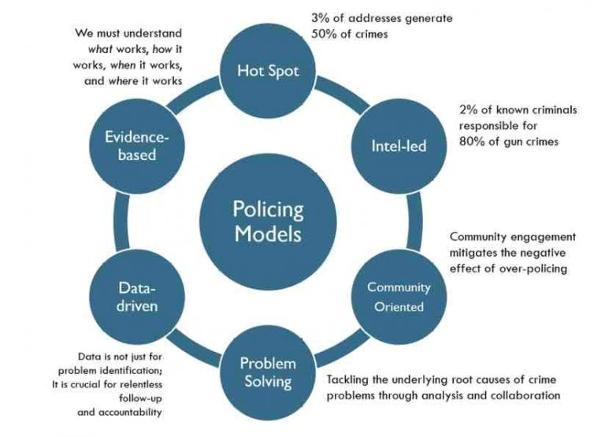
Fig 2. Some of the different modern policing models (Beck, 2019).
Figure 2, shows some of the many different policing models used by police forces to combat crime. These theories are interchangeable and all try to explain the causes of crime from their own perspective. They all have strengths and weakness and there is no definitive right or wrong in criminology and different theories and criminal acts rarely have single causes. Theory exists to help work things out, they inform practice but do not always provide the answers.
Below, are policing models which are more widely used today. This section will try and explain what they are whilst also looking at their strengths and weaknesses.
Hot Spot Policing
Hot spot policing is a strategy that involves targeting individuals or areas where crime is most concentrated. As Beck (2019), states around 3% of addresses is responsible for around 50% of the crimes. It is thought that by targeting those addresses/individuals then criminality will be significantly reduced. Hot spot policing has proved effective in tackling drug offences and violent crime (College of policing, 2017). The negative aspects of this model is that over policing in those areas can be perceived by the public as overly enforced and affect legitimacy (Rosenbaum, 2006) and cause Spatial Displacement (Braga et al, 2012). This is evident by the operations of organised crime groups.
Crime Prevention through Environment Design (CRTED)
CPTED is a crime prevention theory which focuses on reducing crime and disorder through the design and planning of the built environment. The main objective is to reduce/remove the opportunity for crime to occur in an environment which is vulnerable due to high numbers of people, shops or businesses. CPTED is a preventative, pro-active model and not a reactive one.
However, as a result of Terrorist attacks at Westminster Bridge and Houses of Parliament where extremists used vehicles to mow down innocent pedestrians in a killing spree (BBC News, 2017). Concrete bollards have now been strategically placed at those locations to prevent similar events like this from happening again in the future. This is known as target hardening (West Yorkshire Police, 2021).
CPTED is effective but is by no means conclusive. It reduces crime in areas where it is used but does not prevent crime from happening elsewhere. Criminals will simply move to other locations which are less protected to carryout similar attacks. CPTED is a good deterrent and protects property but is only effective when used alongside other models or traditional style of policing. CPTED consists of 5 principles;

Fig 3. Five Principles of CPTED. Adapted from (Greater Manchester Police, 2021)

The Problem Analysis Triangle (PAT)
One of the most widely used theories in today’s world is the Problem Analysis Triangle (PAT). PAT is derived from the Routine Activity theory (RAT). Cohen and Felson (1979), state that in order for a crime to be committed, three specific elements need to be involved. There needs to be a motivated offender, a suitable target and a suitable place. Without all of these present a crime cannot be committed.

Fig. 2 Problem Analysis Triangle (College of Policing, 2019)

This theory allows police forces and officers to understand how and why an offence has taken place. It is a simplistic model and is good at identifying repeat victims. By removing one of the elements above it acts as a deterrent for offenders when committing crime. Offenders often make dynamic risk assessment in relation to risk and reward, by reducing targets/rewards it becomes unappealing. It could be as simple as placing CCTV (Guardian) outside a victim’s home to protect their property or placing a curfew (Manager) on a known offender who has been released from prison to prevent them from committing crime during ‘peak criminal hours’.
Like other models, it does have limitations too. It does not address the root cause of problems and does not account for the offender’s emotional, psychological or social and development factors, which is mentioned in figure 1.
Analysis is vital in fighting crime. It can be used to understand what drives crime and provide insight, clarity and context to decision making. It provides tactical deployment of resources to prevent, reduce and detect crime and disorder. It allows lessons to be learnt through a review of tactical and strategic activity whilst also identifying what practices are effective (College of Policing, 2013).

Conclusion
In conclusion, policing models and theories do have a positive impact on the public, crime and victimisation. Not only is it orientated towards crime prevention but also towards community interaction to achieve common goals. Crime prevention strategies leads to “fewer victims, fewer offences, and less demand on policing achieved by addressing the causes of crime, utilising sophisticated partnership orientated problem solving. Not only do policing strategies prevent crime but it also saves money as a reduction of crime equates to less prisoners in the criminal justice system, which can be costly.
It also allows police to be more efficient, making them more readily available to answer calls from the public. As a result, neighbourhoods and communities feel safer which improves legitimacy. Each model does have limitations but are interchangeable with others. When used in conjunction with each other, they can be very effective in reducing crime and victims. Criminality is always evolving and is becoming more sophisticated, it is important that police forces keep adapting their policing strategies by developing new models in conjunction with the traditional models to combat crime.

1100 Words

- Students are required to complete a 1000-word essay under the following title:

Critically review key issues relating to the complexity and challenges of operational policing, review examples of critical and major incidents and analyse the role of the police within a joint emergency services operation to establish ‘best practice’.

This essay will examine the key issues relating to the complexities and challenges that operational policing face, both in today’s world. It will also analyse the role of police in a joint emergency response when dealing with critical and major incident’s and establish what is ‘best practice’.
Challenges and Complexities of Operational Policing
The police service are the only generalist 24/7 emergency service that deal with a wide variety of issues, which in itself is very challenging. Crime is changing and police need to evolve. Traditional crimes such as burglary, vehicle theft and street violence have more than halved over the last 20 years. Other forms of violent crime such as rape, domestic abuse, sexual exploitation of children as well as cybercrime and mental health calls have all risen (Home office, 2016).
These issues pose a considerable challenge for police. In addition to this around 80% of calls made to the police in England and Wales are not crime related (Webster 2016). This demonstrates the everyday demands on police as they have to deal with more complex issues such as mental health, which is becoming more prevalent in today’s society. The college of policing (2015), estimate that between 15% and 20% of police incidents are mental health related.
This coupled with other challenges, such as austerity and the difficulty in managing expectations of how much longer police forces can prop up other failing public services, like mental health, as well as supplementing the Ambulance service (Webster, 2016).

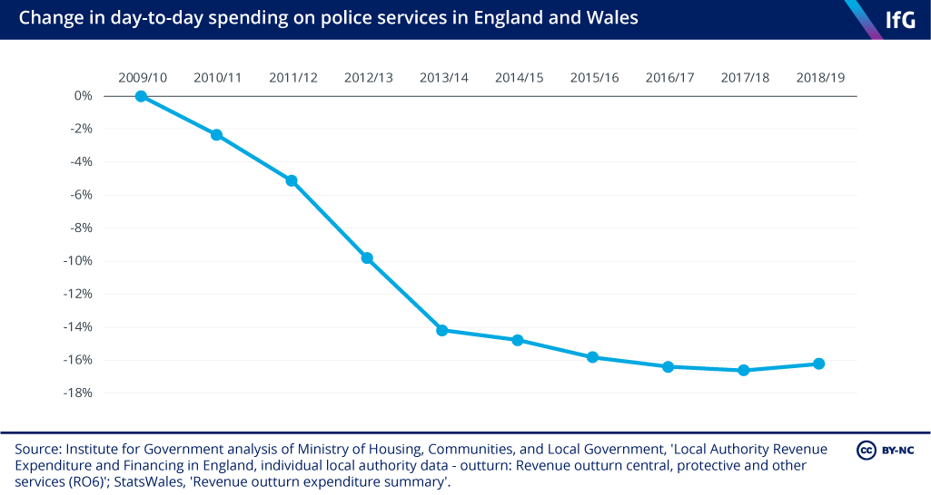
Fig 1. Change to day to day spending on police services in England and Wales (Institute for Government, 2019)

Fig 2. Complexities and Challenges to Operational. Adapted from (IPCC, 2012; Dixon, 2002; ONS, 2017; College of Policing, 2021).
Figure 2 shows other challenges and complexities that police officers face when carrying out their duties. Corruption can really undermine the legitimacy from the public which would make the British model of ‘policing by consent’ impossible (Jackson et al, 2012). Different cultures can cause communication barriers which restricts intelligence gathering from these communities (Dixon, 2002). Public perceptions can also have a detrimental effect on the good work of police forces. The Office for National Statistics (2017), conducted a crime survey for England and Wales between 2015 and 2016 and found that 60% of adults thought crime had increased when in fact it had decreased. This can have a negative impact on public satisfaction, public perceptions and confidence (Myhill and Bradford, 2012). Diversity is also important when trying to break down barriers, when police forces reflect the community they serve it helps to foster good relations and good community engagement (College of Policing, 2021).
Major Incident
The Joint Emergency Services Interoperability Programme (JESIP) (2021), defines a major incident as, an event or situation with a range of serious consequences which requires special arrangements to be implemented by one or more emergency responder agency.
Major incidents can happen anywhere and at any time. Response officers are usually first on scene to most emergencies, it is vitally important that officers recognise when a serious incident becomes a major incident. The purpose of this is to have a multi-agency response. The first responder must make an initial assessment of the nature of the incident and communicate all findings to control room so that Gold, Silver and Bronze command can risk assess and develop a working strategy.

To ensure information is recorded properly, the mnemonic ‘METHANE’ should be used. The ‘METHANE’ model is an established reporting framework which provides a common structure for first responders to share information with control room so that situational awareness can be established quickly.
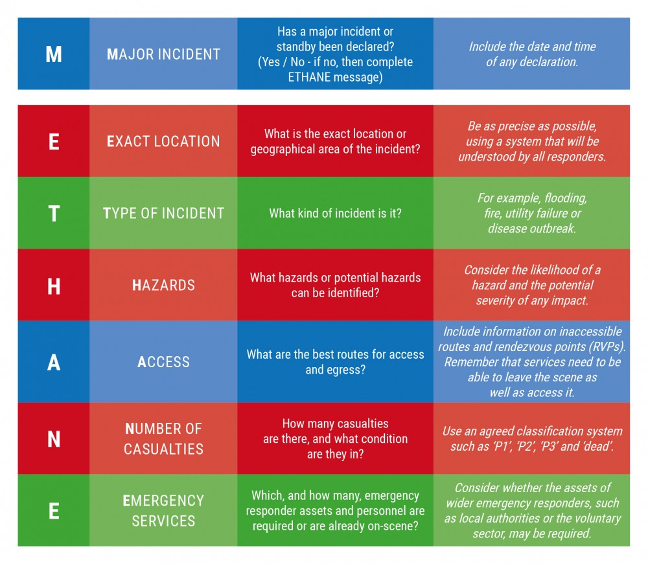
Fig 3. Methane model (JESIP, 2021).
At major incidents, police will oversee and co-ordinate the emergency response phase of the incident. This will enable other emergency agencies to carry out their duties effectively. Examples of major incidents where a multi-agency approach has been used in the UK are; the 2005 7/7 London bombings (BBC News, 2015) and the 2017 Manchester Arena bombing (BBC News, 2018).
JESIP
While ‘METHANE’ is used for the first responder to a major incident, (JESIP) was developed for higher management to ensure that the response of multi-agency services to major incidents are more organised, structured and practised. Thankfully, major incidents are not an everyday occurrence so when they do happen it is vital that responding emergency services understand, not only what they should do but what others can do. The JESIP development framework provides that structure and allows for a better collaborative partnership.
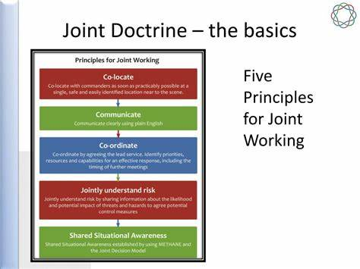
Fig 5. The Five Principles of JESIP (JESIP, 2021)

Fig 5. Benefits of JESIP. Adapted from (JESIP, 2021).
Critical Incident
A critical incident is defined as, any incident where the effectiveness of the police response is likely to have a significant impact on the confidence of the victim, their family and/or the community (College of Policing, 2013).
A critical incident was developed as a result of the Macpherson report back in February 1999. The Macpherson report investigated the Metropolitan Polices handling of the Stephen Lawrence murder. Lord Macpherson, found that Stephen’s murder was ‘marred by a combination of professional incompetence, institutional racism and a failure of leadership by senior officers’ (House of Commons, 2009). A critical incident has a real damaging effect on the legitimacy from the public (Lentz and Chaires, 2007), without co-operation from the public the British police model would not function well.
To prevent a critical incident from occurring it is important to take positive steps to prevent an incident from becoming one. The golden hour principle is important to ensure that best evidence is gathered (Deane, 2019). By acting promptly and effectively it will ensure positive outcomes and restore the confidence of the public. Examples of past critical incidents in the UK are; The Shipman inquiry and the Victoria Climbie inquiry (College of Policing, 2007).
Conclusion
In conclusion, modern policing as changed a considerable amount over the years. It is important that Government and forces in the UK try to understand what drives crime and look at current demands placed on police. By reviewing statistics, challenges and complexities that police face, it will enable the Government and forces to develop a future working strategy to ensure the safety of police officers and public.
In relation to the Manchester Arena and 7/7 London Bombings, it was vitally important that police dealt with them effectively. An inquiry found that there were a number of failings of the partnership approach at these incidents, such as arriving too slowly and poor communication. By not following basic functions of JESIP in the early stages of the incident, contributed to a poor working partnership which impacted on the public’s welfare, confidence and legitimacy. By following the ‘Best Practice’ model, multi-agencies are aware of what they need to do as well as what others can do to achieve best outcomes. When major incidents are dealt with effectively it helps to save lives, restore confidence and legitimacy. This is essential for the British policing model which reduces demand on an already stretched service.
1097 Words

- Students are required to complete a 1000-word essay under the following title:

Analyse the potential links between terrorism and other forms of criminality and discuss how policing the roads assist in counter terrorism investigation

This essay will highlight the links between terrorism and other forms of crime and discuss how effective policing of the roads can disrupt criminality and terrorist activities.
The Terrorism Act (2006) defines Terrorism as the use or threat of action where:
- The action falls within subsection (2)
- The use or threat is designed to influence the government or an international governmental organisation or to intimidate the public or a section of the public
- The use or threat is made for the purpose of advancing a political, religious or ideological cause.
(2) Action falls within this subsection if it:
- Involves serious violence against a person
- Involves serious damage to property
- Endangers a person’s life, other than that of the person committing the action
- Creates a serious risk to the health or safety of the public or a section of the public
- Is designed seriously to interfere with or seriously to disrupt an electronic system
Terrorism is a major threat to everybody, not just businesses. Terrorists seek to cause harm to the economy by attacking business premises or specific targets for their political or religious agendas. (Morrison, 2018). The threat is not confined to just the UK but is a global issue. The most serious threat comes from international terrorism with high-impact ambitions designed to cause mass casualties and mass panic (CPNI, 2021). The current threat level for the UK for Terrorism is ‘Substantial’, meaning an attack is likely (MI5 Secret Service, 2021).
Terrorism in modern times has resulted in the instilment of fear, loss of life and destruction at a global level. To achieve this fear terrorists groups have deployed a tactic known as the ‘Insider Threat’. Einwechter (2002), defines an ‘insider’ as someone who is trusted with authorised access and uses that access to manipulate the system to exploit it. An example of an ‘inside threat’ is highlighted by the actions of a British Airways employee by the name of Rajib Karim. Back in 2011, Karim was found guilty for conspiring to blow up an aircraft and offering sensitive company information leaving it vulnerable to financial and disruptive attacks (Loffi & Wallace, 2014).

Terrorists can use many different methodologies in their attacks, these include:

Fig 1. Terrorist methods. Adapted from (CPNI, 2021)
There are different types of terrorist organisations, these include Islamist Terrorists, Right-wing Terrorists and Northern Ireland-related Terrorists. This makes it even harder to police as there are so many groups to keep under surveillance. Not all terrorism activity is direct attack planning. UK-based extremists are supporting terrorism by:

Fig 2. Extremists supporting Terrorism (CPNI, 2021).

To combat terrorism here in the UK, the government has implemented the ‘CONTEST’ strategy in 2011. This strategy consists of four key elements known as the four P’s, ‘Prevent, Pursue, Protect and Prepare’. The aim of this strategy is to reduce terrorism on all levels through: preventing people from becoming radicalised; pursuing suspects; protecting the public, and preparing to manage the response to mitigate the impact of an inevitable attack (HM Government, 2018).
In order for Terrorist groups to operate effectively they require funding. This is facilitated through criminal activities such as drug trafficking, human trafficking, arms smuggling, money laundering, fraud, robberies, extortion and kidnap for ransom (Dandurand & Chin, 2004). Bjorgo (2006) describes money as ‘the lifeblood’ of terrorist organisations. Due to state sponsorship decreasing in recent years, terrorist groups have turned to crime to finance themselves (Bantekas, 2003). Bantekas argues that crime has become a necessity for groups without other sufficient sources of finance.
Criminals use the road network to commit crime. The majority of crime cannot be carried out without the use of transport as criminals need to get from A to B. To keep our roads safe and combat crime, the National Police Chiefs Council (NPCC) published a three year policing strategy for 2018-2021. This strategy set out three main objectives for roads policing;
- Safe roads, free from harm
- Secure roads free from the threat of serious crime and terrorism
- Efficient roads that promote public confidence and satisfaction (College of Policing, 2018)
The NPCC strategy (2020) states that forces and multiply agencies must work more closely together. It is expected that this collaborative way of working will have a positive impact on road safety and the disruption of criminality on our roads.
It is also found that criminals have a disregard for traffic regulations, such as using mobile phones or speeding (Brace et al, 2010). Proactive policing to target these offences is a very useful disruption tactic. Being visible and proactive and utilising powers such as section 163 of the road traffic act (RTA) for minor offences can often lead to the detection of more serious crimes (Davies, 2012). Section 163 of the RTA is a very important tool which provides officers with a gateway into vehicles and allows them the opportunity to disrupt criminality (Miller et al, 2000).

Fig 3. Other Powers to Stop Vehicles. Adapted from (Bryan & Bryant, 2019)

Another effective policing tool in disrupting crime on UK roads is the use of Automatic Number Plate Recognition (ANPR). Criminals and Terrorists have become more sophisticated in their illegal activities, therefore the police need to update their crime-fighting capabilities. By using ANPR technology it provides police with a tool which is capable of combating crime and bringing criminals to justice. The use of this technology is effective in the detection and prevention of crimes, such as Terrorism and OCG at local, regional and national level. ANPR also provides lines of enquiries and evidence when investigating crime (NPCC, 2020).

Fig 4. Benefits of ANPR. Adapted from (College of Policing, 2020)

In conclusion, policing terrorism can be extremely difficult for a number of reasons. From ambiguous laws, ever changing threats and laws like stop search can increase tensions between certain ethnic minority groups. All of these factors make policing terrorism more difficult which can have a serve impact on the police’s ability to prevent crime and keep communities safe. The current UK threat level is graded as ‘Substantial’, meaning that it is important that terrorism is monitored and policed effectively. Being proactive and using effective policing of the roads to detect and disrupt criminality on UK roads can help police forces/officers to uncover active terrorists. This essay has shown that terrorists are linked with other aspects of criminality which are undertaken to help fund their operations.
Furthermore, conducting high visibility patrols and using powers under the RTA can help the detection of crime by identifying road traffic offences which in turn can lead to uncovering bigger offences. Being visible to the public also provides reassurance and strengthens Police legitimacy whilst also deterring criminals from using the roads to commit crime. The use of ANPR cameras in modern day policing is an excellent resource when detecting, disrupting and investigating crime.
1088 words

Bibliography
Bassler, A., Brasier, K., Fogel, N. and Taverno, R., (2008). Developing effective citizen engagement: a how-to guide for community leaders. Center for Rural Pennsylvania.

BBC News, (2015).
Available at: https://www.bbc.co.uk/newsround/33401669 (Accessed 1st July, 2021)

BBC News, (2018)
Available at: https://www.bbc.co.uk/news/uk-england-43555145 (Accessed 1st July, 2018)

Beck, J., (2019)
Available at: https://www.esri.com/about/newsroom/blog/philadelphia-police-collaborate-crime/ (Accessed 12th June, 2021)
Bjorgo, T., 2006. Root causes of terrorism. London: Routledge, p.28.

Brace, C, Scully, M, Clark, B, Oxley, J, (2010) “The Relationship Between Crime and Road Safety”
Braga, A. (2005). “Hot spots policing and crime prevention: A systematic review of randomised controlled trials”. Journal of Experimental Criminology, 1(3), 317-342.

Braga, A., Papachristos, A. and Hureau, D., 2012. Hot spots policing effects on crime. Campbell Systematic Reviews, 8(1), pp.1-96.

Brantingham, P.L., 1981. Notes on the Geometry of Crime (From Environmental Criminology, P 27-54, 1981, Paul J Brantingham and Patricia L Brantingham, ed.-See NCJ-87681).

Bryant, R & Bryant, S. (2019). Blackstone’s Handbook for Policing Students 2020. Oxford University, USA.

Cohen, L.E. and Felson, M., 1979. Social change and crime rate trends: A routine activity approach. American sociological review, pp.588-608.

College of Policing (2018)
Available at:https://library.college.police.uk/docs/appref/Policing-our-Roads-Together-partners-copy.pdf (Accessed 21st June, 2021)

College of Policing, (2013)
Available at: https://www.app.college.police.uk/app-content/intelligence-management/analysis/delivering-effective-analysis/ (Accessed 12th June, 2021)

College of Policing, (2014)
Available at: https://www.app.college.police.uk/app-content/engagement-and-communication/engaging-with-communities (Accessed 4th June 2020)

College of Policing, (2015)
Available at: https://college-of-policing-demand-on-policing-report.pdf (Accessed 1st July, 2021)

College of Policing, (2017)
Available at: https://library.college.police.uk/docs/APPref/Extract-Critical-Incident-Management-2007.pdf(Accessed 2nd July, 2021)

College of Policing, (2017)
Available at:https://whatworks.college.police.uk/toolkit/Pages/Intervention.aspx (Accessed 12th June, 2017)

College of Policing, (2019)
Available at:https://d17wy4t6ps30xx.cloudfront.net/production/uploads/2019/07/Problem-Solving-Practice-Advice-v1.0.pdf#:~:text=Routine (Accessed 12th June, 2021)

College of Policing, (2020)
Available at: http://www.app.college.police.uk/app-content/investigations/investigative-strategies/investigative-strategiesanpr/ (Accessed 21st June, 2021)
College of Policing, (2021)
Available at: https://www.college.police.uk/support-forces/diversity-and-inclusion (Accessed 1st July, 2021)

College of Policing, (2013)
Available at: https://www.app.college.police.uk/app-content/critical-incident-management/types-of-critical-incident/?highlight=schedule%201%20human%20rights%20act (Accessed 4th June 2021)

College of Policing, (2013)
Available at: https://www.app.college.police.uk/app-content/critical-incident-management/types-of-critical-incident/?highlight=schedule%201%20human%20rights%20act (Accessed 1st July 2021)

College of Policing, (2021)
Available at: https://www.college.police.uk/ethics/code-of-ethics (Accessed 4th June, 2021)

Dandurand, Y., & Chin, V. (2004)
Available at: https://icclr.org/wpcontent/uploads/2019/06/LinksBetweenTerrorismLatest_updated.pdf?x48887 Accessed 21st June 2021)
Davies, (2021)
Available at: https://www.theguardian.com/uk/2012/jul/06/seven-terror-raids-weapons-car (Accessed 21st June, 2021)
Deane, (2019)
Available at: https://harpershaw.co.uk/back-to-basics-golden-hour-principles-in-serious-collision-investigation/ (Accessed 1st July, 2021)

Dixon, L., (2002) Crime. Policing Ethnic Minorities. Probation Journal 49(1), pp. 44-45.

Einwechter, N., 2002. Preventing and detecting insider attacks using ids. SecurityFocus, March.

Gov.uk, (2020)
Available at: https://www.ethnicity-facts-figures.service.gov.uk/crime-justice-and-the-law/policing/number-of-arrests/latest (Accessed 4th June, 2021)

Greater Manchester Police, (2021)
Available at: https://designforsecurity.org/crime-prevention-through-environmental-design/ (Accessed 12th June, 2021)

HM Government, (2018)
Available at:https://assets.publishing.service.gov.uk/government/uploads/system/uploads/attachment_data/file (Accessed 21st June, 2021)
Home Office (2006)
Available at: https://www.gov.uk/government/publications/the-terrorism-act-2006 (Accessed 21st June 2021)
Home Office, (2012)
Available at: https://www.gov.uk/government/publications/policing-by-consent/definition-of-policing-by-consent (Accessed: 4th June, 2021)

Home Office, (2016)
Available at https://assets.publishing.service.gov.uk/government/uploads/system/uploads/attachment_data/file/509831/6.1770_Modern_Crime_Prevention_Strategy_final_WEB_version.pdf (Accessed 1st July, 2021)

Home Office, (2016)
Available at: https://assets.publishing.service.gov.uk/government/uploads/system/uploads/attachment_data/file/509831/6.1770_Modern_Crime_Prevention_Strategy_final_WEB_version.pdf(Accessed 12th June, 2021)

House of Commons, (2009)
Available at: https://publications.parliament.uk/pa/cm200809/cmselect/cmhaff/427/427.pdf (Accessed 1st July, 2021)

Institute for Government, (2019)
Available at: https://www.instituteforgovernment.org.uk/publication/performance-tracker-2019/police(Accessed 1st July, 2021)

IPCC, (2021)
Available at:https://assets.publishing.service.gov.uk/government/uploads/system/uploads/attachment_data/file/243479/9780108511622.pdf (Accessed 1st July, 2021)

Jackson J, Bradford B, Stanko E and Hohl K (2013) Just Authority? Trust in the Police in England and Wales, Routledge: Abingdon.

Jackson, J., Bradford, B., Hough, M. and Murray, K., 2012. Compliance with the law and policing by consent: notes on police and legal legitimacy. In Legitimacy and compliance in criminal justice (pp. 38-58). Routledge.

JESIP, (2021)
Available at: https://jesip.org.uk/why-do-we-need-jesip (Accessed 2nd July, 2021)

JESIP, (2021)
Available at: https://www.jesip.org.uk/early-stages-methane (Accessed 1st July, 2021)

Lentz, S and Chaires, R. (2007). The invention of peel’s principles: A study of policing ‘textbook’ history. Journal of Criminal Justice, 35 (1), pp.69-79.

Loffi, J.M. and Wallace, R.J., 2014. The unmitigated insider threat to aviation (Part 1): a qualitative analysis of risks. Journal of Transportation Security, 7(4), pp.289-305.

Marcelin, J.R., Siraj, D.S., Victor, R., Kotadia, S. and Maldonado, Y.A., 2019. The impact of unconscious bias in healthcare: how to recognise and mitigate it. The journal of infectious diseases, 220 (Supplement_2), pp.S62-S73.

MI5 Secret Service, (2021)

Available at: https://www.mi5.gov.uk/threat-levels (Accessed 21st June, 2021)

Miller, Joel, Bland, Nick & Quinton Paul, (2000). The impact of stops and searches on crime and the Community.
Morash, M. and Ford, J.K. eds., 2002. The move to community policing: Making change happen. Sage Publications

Morrison, (2018)
Available at: https://www.independent.co.uk/news/business/news/terror-attacks-uk-economy-cost-manchester-arena-westminster-london-bridge-a8385661.html(Accessed 21st June, 2021)
Myhill, A. and Bradford, B., 2012. Can police enhance public confidence by improving quality of service? Results from two surveys in England and Wales. Policing and society, 22(4), pp.397-425

Newburn, T. ed., 2021. Handbook of Policing. Routledge

NPCC, (2020)
Available at: https://www.npcc.police.uk/ANPR%20Strategy%202020%20Final.pdf (Accessed 21st June, 2021)

Office for National Statistics, (2017)
Available at: https://www.ons.gov.uk/peoplepopulationandcommunity/crimeandjustice/articles/publicperceptionsofcrimeinenglandandwales/yearendingmarch2016 (Accessed 1st July, 2021)

Ratcliffe, P., 2012. ‘Community cohesion’: reflections on a flawed paradigm. Critical Social Policy, 32(2), pp.262-281.

Rosenbaum, D.P., 2006. The limits of hot spots policing. Police innovation: Contrasting perspectives, pp.245-263.

Segrave, M. and Ratcliffe, J. (2004) Community Policing: A Descriptive Overview Australian Institute of Criminology/Australian Government

Taylor, I., 1974. Pioneers in Criminology.

Tilley, N., 2003. Community policing, problem-oriented policing and intelligence-led policing.

Webster, (2016)
Available at: https://www.russellwebster.com/seven-challenges-for-policing/ (Accessed 1st July, 2021)

West Yorkshire Police, (2021)
Available at: https://www.westyorkshire.police.uk/advice/10-principles-crime-prevention/10-principles-crime-prevention/10-principles-crime-prevention(Accessed 12th June, 2021)

GUIDANCE FOR Students IN THE COMPLETION OF TASKS

NOTE: The guidance offered below is linked to the five generic assessment criteria overleaf.

- Engagement with Literature Skills

Your work must be informed and supported by scholarly material that is relevant to and focused on the task(s) set. You should provide evidence that you have accessed an appropriate range of sources, which may be academic, governmental and industrial; these sources may include academic journal articles, textbooks, current news articles, organisational documents, and websites. You should consider the credibility of your sources; academic journals are normally highly credible sources while websites require careful consideration/selection and should be used sparingly. Any sources you use should be current and up-to-date, mostly published within the last five years or so, though seminal/important works in the field may be older. You must provide evidence of your research/own reading throughout your work, using a suitable referencing system, including in-text citations in the main body of your work and a reference list at the end of your work.

Guidance specific to this assessment:

Refer to reading list to help you find relevant sources. Do not use Wikipedia or ‘red top’ newspapers’ these sources are not reliable, try to use governmental sources and reliable journal articles and books.

- Knowledge and Understanding Skills

At level 5, you should be able to demonstrate: sound knowledge and critical understanding of the well-established concepts and principles of the subject area and the way in which those principles have developed; knowledge of the main methods of enquiry in the discipline. Knowledge relates to the facts, information and skills you have acquired through your learning. You demonstrate your understanding by interpreting the meaning of the facts and information (knowledge). This means that you need to select and include in your work the concepts, techniques, models, theories, etc. appropriate to the task(s) set. You should be able to explain the theories, concepts, etc. meaningfully to show your understanding. Your mark/grade will also depend upon the extent to which you demonstrate your knowledge and understanding.

Guidance specific to this assessment: You should demonstrate that you have understood what we have discussed in lectures and tutorials. Do not simply reproduce power point slides, show understanding and expand your knowledge by reading.

- Cognitive and Intellectual Skills

You should be able to critically analyse information, and propose solutions to problems arising from that analysis, including the critical evaluation of the appropriateness of different approaches to solving problems. Your work must contain evidence of logical, analytical thinking, evaluation and synthesis. For example, to examine and break information down into parts, make inferences, compile, compare and contrast information. This means not just describing what! But also justifying: Why? How? When? Who? Where? At what cost? At all times, you must provide justification/evidence for your arguments and judgements. Evidence that you have reflected upon the ideas of others within the subject area is crucial to you providing a reasoned and informed debate within your work. Furthermore, you should provide evidence that you are able to make sound judgements and convincing arguments using data and concepts, with an understanding of the limits of knowledge, and how this influences analyses and interpretations. Sound, valid conclusions are necessary and must be derived from the content of your work. Where relevant, alternative solutions and recommendations may be proposed.

Guidance specific to this assessment:
Do not show bias in your assignment you should present a balanced argument putting forward different perspectives on the topic for example can states commit ;’terrorism’? some would argue that they can whilst others would disagree.

- Practical Skills

At level 5, you should be able to use/deploy a range of established techniques within the discipline, and apply underlying concepts and principles outside the context in which they were first studied, including, where appropriate, the application of those principles in an employment context. You should be able to demonstrate how the subject-related concepts and ideas relate to real world situations and/or a particular context. How do they work in practice? You will deploy models, methods, techniques, and/or theories, in that context, to assess current situations, perhaps to formulate plans or solutions to solve problems, or to create artefacts, some of which may be creative. This is likely to involve, for instance, the use of real world artefacts, examples and cases, the application of a model within an organisation and/or benchmarking one theory or organisation against others based on stated criteria. You should show awareness of the limitations of concepts and theories when applied in particular contexts.

Guidance specific to this assessment: You might use ‘real world’ examples to highlight your arguments, for example why might one group be labelled ‘terrorist’ whilst another is not, is it the intended target? Or the ideology?

- Transferable Skills for Life and Professional Practice

Your work must provide evidence of the qualities and transferable skills necessary for employment requiring the exercise of personal responsibility and decision-making. This includes demonstrating: professional development to advance existing skills and acquire new competences that will enable you to assume significant responsibility within organisations; that you can initiate and complete tasks and procedures, whether individually and/or collaboratively; that you can use appropriate media to effectively communicate information, arguments and analysis in a variety of forms to specialist and non-specialist audiences; fluency of expression; clarity and effectiveness in presentation and organisation. Work should be coherent and well-structured in presentation and organisation.

Guidance specific to this assessment: Put into practice what you have learned in Academic skills to structure your work so that it flows from one logical argument to the next using ‘linking’ words and sentences. Demonstrate you effective referencing skills.

Student FEEDBACK FORM

This section details the extent to which the assessment criteria are demonstrated by you, which in turn determines your mark. The marks available for each category of skill are shown. Lecturers will use the space provided to comment on the achievement of the task(s), including those areas in which you have performed well and areas that would benefit from development/improvement.

Generic Assessment Criteria | Marks available | Marks  awarded
1. Engagement with Literature Skills  . | 15
2. Knowledge and Understanding Skills | 25
3. Cognitive and Intellectual Skills | 25
4. Practical Application Skills | 25
5. Transferable Skills for Life and Professional Practice | 10

Assessment Mark (Assessment marks are subject to ratification at the Exam Board. These comments and marks are to give feedback on module work and are for guidance only until they are confirmed. ) | Late Submission Penalties (tick if appropriate) |  | %
 | Up to 1 week late (40% Max) |  | %
 | Over 1 week late (0%) |  | %

GENERIC ASSESSMENT CRITERIA

Level 5
In accordance with the Framework for Higher Education Qualifications, at the end of Level 5 students will be expected to have developed sound knowledge and critical understanding of the well-established concepts and principles in their field of study, and of the way in which those principles have developed. They will have learned to apply those concepts and principles more widely outside the context in which they were first studied, including, where appropriate, the application of those principles in an employment context. They will have knowledge of the main methods of enquiry in the subject area, and ability to evaluate critically different approaches to problem solving. They will possess an understanding of the limits of their knowledge, and how this influences their analyses and interpretations. They will be able to use a range of established techniques to initiate and undertake critical analysis of information, and to propose solutions to problems arising from that analysis. They will be able to effectively communicate information, arguments and analysis in a variety of forms to specialist and non-specialist audiences, and deploy key techniques of the discipline effectively. They will be able to undertake further training, develop existing skills and acquire new competences that will enable them to assume significant responsibility within organisations. They will have the qualities and transferable skills necessary for employment requiring the exercise of personal responsibility and decision-making.

Level 5 | FAIL | MARGINAL FAIL | SATISFACTORY  (3rd / Pass) | GOOD  (2.2 / Pass) | VERY GOOD  (2.1 / Merit) | EXCELLENT  (1st / Distinction) | EXCEPTIONAL  (1st / Distinction)
Category | 0-29% | 30-39% | 40-49% | 50-59% | 60-69% | 70-84% | 85-100%
Engagement with literature (including reading, referencing,  academic conventions and  academic honesty) | Little or no evidence of reading and/or reliance on inappropriate sources.  Views and findings mostly unsupported and non-authoritative.  Referencing conventions used incoherently or largely absent. | Poor engagement with essential reading. No evidence of wider reading. Reliance on inappropriate sources, and/or indiscriminate use of sources. Heavily reliant on information gained through class contact. Inconsistent and weak use of referencing. | Engagement with a limited range of mostly relevant and credible sources. Some omissions and minor errors.  Referencing conventions evident though not always applied accurately or consistently. | Engagement with an appropriate range of literature, including sources retrieved independently. Some over-reliance on texts. Referencing may show minor inaccuracies or inconsistencies. | Engagement with a wide range of literature, including sources retrieved independently.  Selection of relevant and credible sources. Very good use of referencing, with no/very few inaccuracies or inconsistencies. | Engagement with an extensive range of relevant and credible literature. Consistently accurate application of referencing. | Exceptional engagement with an extensive range of relevant and credible literature. High-level referencing skills consistently applied.
Knowledge and understanding (Sound knowledge and critical understanding of the well-established concepts and principles in their field of study; knowledge of the main methods of enquiry in the discipline.) | Major gaps in knowledge with unsatisfactory, uncritical understanding of the subject matter. Much irrelevant material. Substantial inaccuracies. Significantly flawed understanding of the main methods of enquiry in the discipline. | Fragmentary knowledge, with only superficial critical understanding. Some significant inaccuracies and/or irrelevant material. Incomplete or partially flawed understanding of the main methods of enquiry in the discipline. | Limited but adequate knowledge and critical understanding of the well-established concepts and principles within the subject area, with a few gaps in the selection of material. A narrow critical understanding of the main methods of enquiry. | Knowledge is reasonably detailed and accurate. A good critical understanding of the well-established concepts and principles and the main methods of enquiry, with minor gaps in the selection of material. | Knowledge is reasonably extensive. Exhibits very competent critical understanding of the well-established concepts and principles of the subject and the main methods of enquiry. Breadth and depth of knowledge. | Excellent, detailed knowledge and highly critical understanding of the well-established concepts and principles of the subject and the main methods of enquiry. | Exceptionally detailed knowledge and outstanding critical understanding of the well-established concepts and principles of the subject and the main methods of enquiry. May go beyond established theories.
Cognitive and intellectual skills  (Critical evaluation and analysis of concepts and principles; argument and judgement; the limits of their knowledge, and how this influences their analyses and interpretations.) | Wholly or almost wholly descriptive work. Little or no critical evaluation and analysis of concepts and principles.  Failure to develop arguments, leading to illogical or invalid judgements. Unsubstantiated generalisations or opinion, made without use of any credible evidence. | Largely descriptive work, with superficial use of critical evaluation and analysis of concepts and principles. Weak development of arguments and judgements. Information accepted uncritically, uses generalised statements made with scant evidence and unsubstantiated opinions. Ideas sometimes illogical and contradictory. | Limited attempt at critical evaluation and analysis of concepts and principles, tending towards description.  Some evidence to support arguments and judgements but these may be underdeveloped, with a little inconsistency / mis-interpretation or failure to fully recognise limits of knowledge. | Some critical evaluation and analysis of concepts and principles, though descriptive in parts.  An emerging awareness the limits of their knowledge and ability to use evidence to support the argument though with some tendency to assert/state opinion rather than argue on the basis of reason and evidence.  Mostly valid arguments and logical judgements. | Sound critical evaluation and analysis of concepts. Is selective in the range of evidence used and synthesises rather than describes. Ability to devise arguments that show awareness of different stances, and use evidence convincingly, to support appropriate and valid judgements. | Excellent critical evaluation and analysis of concepts and principles leading to logical, evidence-based, reasoned arguments and judgements. Explicit recognition of other stances and a strong awareness of the limits of their knowledge.  A capacity for independent thought and ability to ‘see beyond the question’, suggesting some grasp of the broader field and wider concepts. | Outstanding critical evaluation and analysis of concepts and principles. Uses evidence exceptionally well to connect ideas, and support highly logical and persuasive, arguments and judgements. Evidence of independent thought and ability to ‘see beyond the question’, suggesting a clear grasp of the broader field and wider concepts. Perceptive recognition of the limits of their knowledge, and how this influences their analyses and interpretations.
Practical skills  (Apply underlying concepts and principles more widely outside the context in which they were first studied; use a range of established techniques; propose solutions to problems arising from analysis.) | Limited or no use of established methods, materials, tools and/or techniques.  Little or no appreciation of the context of the application.  Limited understanding of the application of theory to practice or making appropriate links between the two.  Very weak problem-solving skills outside the context in which they were first studied. | Rudimentary application of established methods, materials, tools and/or techniques but without consideration and competence. Flawed appreciation of the context of the application.  Weak understanding of the application of theory to practice, with only occasional evidence of making appropriate links between the two. Weak problem-solving skills outside the context in which they were first studied. | An adequate awareness and mostly appropriate application of established methods, materials, tools and/or techniques.  Basic appreciation of the context of the application. Theoretical knowledge and understanding applied in practice, but not always making logical links between the two.  Can identify problems and propose basic solutions outside the context in which they were first studied. | A good and appropriate application of established methods, materials, tools and/or techniques.  Clear appreciation of the context of the application. Mainly consistent, accurate and logical application of theory to practice, making appropriate links between the two.  Can identify problems and propose mostly appropriate solutions outside the context in which they were first studied. | A very good application of a range of established methods, materials, tools and/or techniques.  Very good consideration of the context of the application, with perceptive insights. Consistent, accurate and logical application of theory to practice, making appropriate links between the two. Can identify problems and propose appropriate solutions outside the context in which they were first studied.  Evidence of some creativity. | An advanced application of a range of established methods, materials, tools and/or techniques.  The context of the application is well considered, and insightful.  Consistent, accurate and logical application of theory to practice, making well-developed links between the two. Can identify problems and propose excellent, creative solutions outside the context in which they were first studied. | Exceptional levels of application and deployment skills using established methods, materials, tools and/or techniques. Consistent, accurate and logical application of theory to practice, making highly developed links between the two. Can identify routine and non-routine problems and propose quite sophisticated, creative solutions outside the context in which they were first studied.
Transferable skills for life and professional practice  (Effectively communicate in a variety of forms  to specialist and non-specialist audiences; the qualities and transferable skills necessary for employment requiring the exercise of personal responsibility and decision-making.) | Communication medium is inappropriate or misapplied.  Work is poorly structured, disorganised and/or confusingly expressed. Very weak use of language and/or very inappropriate style. Failure to work effectively as part of a group. Little or no evidence of the skills for employment requiring the exercise of personal responsibility and decision-making. | Communication medium is poorly designed and/or not suitable for the audience.  Work is poorly presented in a disjointed manner. It is loosely, and at times incoherently, structured, with information and ideas often poorly expressed. Weak use of language and/or inappropriate style. Flawed approach to group work, meeting only partial obligations to others. Limited evidence of the skills for employment requiring the exercise of personal responsibility and decision-making. | Can communicate in a suitable medium for the audience but with some room for improvement.  Mostly ordered presentation and structure in which relevant ideas / concepts are reasonably expressed. Work may lack coherence in places. Can work as part of a group, meeting most obligations to others but perhaps with limited involvement in group activities.  Demonstrates the basic skills for employment requiring the exercise of personal responsibility and decision-making, with some areas of minor weakness. | Can communicate effectively in a suitable medium for the audience, but may have minor errors.  Mostly coherent, organised work, in a suitable structure and is for the most part clearly expressed. Can work effectively independently and/or as part of a team, with clear contribution to group activities.  Demonstrates the skills for employment requiring the exercise of personal responsibility and decision-making, with some areas of strength and some of minor weakness. | Can communicate well, confidently and consistently in a suitable medium for the audience.  Work is coherent, fluent, well-structured and organised. Can work very well autonomously and/or as part of a team, with very good contribution to group activities.  Demonstrates very good skills for employment requiring the exercise of personal responsibility and decision-making, with just occasional minor weakness. | Can communicate professionally confidently and consistently in a suitable medium for the audience.  Work is coherent, very fluent and is presented proficiently. Can work autonomously with initiative. Where relevant can work professionally within a team, showing leadership skills as appropriate, and meeting obligations. Demonstrates excellent skills for employment requiring the exercise of personal responsibility and decision-making and an appetite for further development. | Can communicate with an exceptionally high level of professionalism, highly suitable for the audience.  Work is exceptionally coherent, very fluent and is presented professionally. Can work exceptionally well within a team, showing leadership skills. Demonstrates exceptional skills for employment requiring the exercise of personal responsibility and decision-making and an appetite for further development.

THIS DOCUMENT IS ALSO AVAILABLE IN WELSH

