

Postgraduate/Distance Learning
Assignment coversheet & feedback form

THIS SHEET MUST BE THE FIRST PAGE OF THE ASSIGNMENT YOU ARE SUBMITTING (DO NOT SEND AS A SEPARATE FILE)

For completion by the student:
Student Name:
Kathy Vinton
Module code: HPCA7014  Module title: Sacred Geography | Student ID number:  2212888 |  |  | Educational support needs:  No
Module tutor: Dr. Bernadette Brady

Assignment due date: 12 January 2023
If your module has multiple submissions please indicate which piece of work this is.

1st 2nd 3rd 4th 5th 6th
I confirm that this is my original work and that I have adhered to the University policy on plagiarism.
Signed ……………………………………………………………
Email submission: if you are submitting this form via email, please tick this box □x
(as a substitute for your signature) to confirm that you agree to the above declaration.
Assignment Mark
Final Mark | WILL BE GIVEN ON TURNITIN

NB. All marks are provisional until confirmed by the Final Examination Board.

PLEASE NOTE: ALL COMMENTS WILL BE POSTED ON TURNITIN

For completion by Marker 1 :
Comments:

Marker’s signature: |  |  | Date:
For completion by Marker 2/Moderator:

Comments:

Marker’s Signature: |  | Date:
AGREED INTERNAL MARK (where necessary):
Comment on process of arriving at agreed mark:

External Examiner’s comments (if relevant)

External Examiner’s Signature: |  | Date:

Is Sacred Space a Human Construct or a Natural Phenomenon? Discuss this question through a research project with reference to the work of at least three theorists

Can the Canadian War Memorial in Burley, The New Forest, be thought of as 'Sacred Space' and, if so, is it a human construct or a natural phenomenon?
Word Count 5251

Introduction

The aim of this research is to investigate whether the Canadian War Memorial, located near Burley, in The New Forest National Park, can be thought of as sacred space and, if so, whether this is a human construct or a natural phenomenon.

The New Forest National Park is a low-populated, mainly unfenced area, with a mixture of forest and heathland, attracting campers, walkers and cyclists. However, seemingly randomly located in an isolated location, is a Canadian War Memorial. Unlike war memorials whose sites may have been chosen by planners, or erected on the site of battle, this memorial is unusual in that it is located precisely where outdoor, religious services had been held for Canadian servicemen billeted in the area for the three months leading up to their dispatch to Juno Beach, Normandy, on D-Day, in June, 1944. Figure 1 shows the dedication stone. Although very peaceful now, thousands of British, Canadian and American troops had been billeted in different parts of The New Forest due to its location on the south coast, close to the coast of France. The memorial commemorates the Canadian lives lost, which include those who had taken part in the services only days before D-Day.

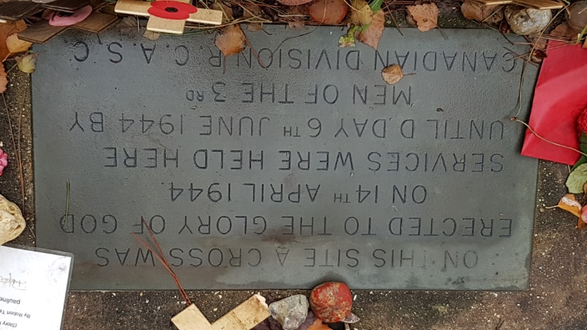
Figure 1 Canadian War Memorial Dedication Stone
For this project, the question of sacredness with regard to this site has been considered with respect to its location, its previous use as a site for services and its current use as a war memorial, incorporating the views of major theorists, including Emile Durkheim (1858-1917), Mircea Eliade (1907-86) and Belden Lane.

Having carried out a literature review, a phenomenological approach was taken on a reflective basis, following a programme of visits for 14 consecutive days, maintaining a daily journal recording thoughts and feelings. With a qualitative observational approach, people's behaviour visiting the site or in the vicinity during this time was also recorded. Additionally, some photographs were taken. The notes of the journal were then related back to the views of the theorists.

In the discussion, consideration was first given as to whether the site, prior to being chosen for the outdoor services, could have been considered sacred in terms of Eliade's concept of hierophany or Lane's understanding of 'landscapes of the sacred' dismissed 'because we have not learned to recognize them; secondly, with all three theorists in agreement to some extent that ritual action created sacredness, the effect of the services held before D-Day was considered and, thirdly, the possibility of sacredness having been retained either through natural phenomenon or through its current use as a commemorative site was discussed. Conclusions were drawn as to, if the Canadian War Memorial site could be deemed to be sacred space, was this as a human construct or a natural phenomenon.

Academic Rationale

Scholars still draw on the views of two of the earlier theorists on sacred space, Durkheim and Eliade. Linked through their use of the words sacred and profane, (Durkheim fifty years before Eliade), their views, whilst ostensibly containing similarities, are contrasted by Durkheim's stance that the sensation of certain natural phenomena could not give us 'the idea of something whose defining trait is to be outside the world of ordinary experience', whereas Eliade's concept of sacred had co-opted Rudolf Otto's idea of the numinous, a quality 'felt as objective and outside the self', and 'something beyond the concept of 'holy'', although widening it to cover 'sacred in its entirety'.

These polarised views, acclaimed and critiqued to different degrees, have generally been more positive to Durkheim's structuralist approach, as William Pickering has described, with one group claiming that Durkheim's view gave weight 'to an approach to the scientific study of religion which persists to this day' which was 'more valuable than to define [sacredness] in terms of relationship to god spirit or some transcendental force or existence' with the problem, as illustrated in William Paden's description, of perception being that the sacred refers to an 'a priori religious reality . . . wholly other, unknowable' which 'therefore is not ultimately an object for analysis' and additionally implying some 'religious privilege' for the sacred, contrasted with 'those who would like to abandon the term and its overtones'.

Other scholars have more recently suggested alternative theories on sacred space although, as with Durkheim and Eliade, this has often focused on the sacred space of indigenous societies, as described in Catherine Allerton's work in Southeast Asia, and by Anthony Gorley and Celia Gunn whose work has spread from the Colombian rainforest to other continents who claimed that 'We are trying here to develop a definition which will encompass both modern ideas of a focussed sacred site such as a cathedral or the temple of an ancient culture, with more complex ideas subsumed under sacred as expressed by indigenous and traditional peoples'. Denis Byrne highlighted this division by describing numinous sites in Europe, 'to guard against any assumption that such places are confined to the non-western world' and continuing 'Rather than being a peculiarity of religion in certain regions, what these places (or what ‘the numinous’) represents is a characteristic way in which humans everywhere at different times have engaged spiritually with their topographic surroundings '.

Currently, however, it is apparent that, as Christopher Tilley and Kate Cameron-Daum have highlighted 'Notions of sacredness are fine to take seriously in relation to traditional indigenous societies but not amongst ourselves in the west'.

It is therefore evident that the subject of sacred space presents an on-going challenge and it is hoped that all investigations into sacred space, wherever or however carried out, are accepted as valid contributions to the body of research.

Methodology

The three processes employed to carry out this research project were, firstly, as suggested by Judith Bell and Stephen Waters, to review relevant literature to create a framework, and this was carried out with respect to sacredness and sacred spaces, together with the significance of war memorials.

Secondly, phenomenological fieldwork on an auto-ethnographic basis was undertaken, being described by Elaine Campbell as 'a method which allowed research to be done on one’s self', and with the advantages, according to Bell and Waters, of allowing 'emotions, beliefs and personality characteristics' to be recorded. To allow a suitable time for perceptions to adjust and change, a programme of visits to the site for fourteen consecutive days was followed, incorporating observations and prayer, with notes being recorded at the time and some photos taken.

The involvement of prayer was designed to simulate the prayer experience of the servicemen. A minimum of seven minutes was maintained and included set prayers (from memory) and contemplative prayer as described by Amber Griffioen as not only seeking to increase understanding of the divine but also to 'arrive at important truths about one’s own self and what one is . . . . Although in this instance very limited in scope, José-Manuel González-González, Jesús-Gerardo Franco-Calvo and Darío Español-Solana have described the value of re-enactment in research, despite the acknowledgement that 'Feeling safe . . . prevent[s] us from thinking and acting as they did in the past, which distorts our reactions'.

As suggested by Bell and Waters, an initial pilot visit was carried out to ascertain any potential issues related to the process. Additionally, reflexivity was regularly focused on during the process in an attempt to carry out the task in an impartial manner. Finally, an analysis of my observations, was made with reference to the theorists.

Reflexive consideration

I am from a white, working-class, Roman Catholic family, although I have questioned the existence of God in the form of Christianity since my late teens. I completed a BSc (Hons) degree in Applied Biology in my forties in order to gain a scientific perspective of the world and briefly taught science in secondary schools before returning to office work. I am married with two daughters and am now retired.

Literature Review
Sacred and Sacred Space

Among the early theorists on sacred space, Durkheim and Eliade are prominent, having each presented detailed views regarding the creation and maintenance of the sacred in religion, including sacred space, albeit maintaining opposing views on its causality.

Both views concurred that the perception of sacredness is an objective experience, however excluded experiences of awe and wonder as sacred if, as stated by Durkheim, it is not specific to religious feeling and, as stated by Eliade, that sacred space cannot be chosen by non-religious man even if the experience of it is similar to a hierophany.

With the above limitation, Durkheim's sociological view was that anything sacred had to be constructed by a group of similar-minded people with one 'collective consciousness'. He described how anything can become sacred if it is deemed so by 'collective feeling' and that the energy acquired by an object can be transferred to the space around it by 'psychic contagion'.

In contrast, Eliade claimed that sacred space, which was only applicable to 'religious man', resulted from the fact that some space was not homogenous allowing for sacred space to manifest itself in a 'hierophany', which he described as usually taking the form of an eruption 'that results in detaching a territory from the surrounding cosmic milieu and making it qualitatively different'.

However, Lane, a more recent theorist, has expressed his discomfort with what he described as too simple a dichotomy between the religious aspect and the cultural aspect, describing that, for him, the cultural approach was taken from the 'outside' compared to his own approach to the same phenomenon from the 'inside'. He expressed his concern regarding the difficulty of steering between ' the Scylla [monster] of the constructivists and the Charybdis [whirlpool] of the essentialists', claiming that each side missed some of the value of the other's stance.

His ideas have attempted to resolve this, evident in his theories regarding the creation and maintenance of sacred space wherein, together with his presentation of four axioms as a guidance to understanding its character, he appeared to combine both Durkheim's and Eliade's views. His first axiom, that 'sacred space is not chosen, it chooses' is comparable to Eliade's concept of hierophany, although Lane subsequently seems to downplay the reality of the numinous through his second axiom, that sacred place is ordinary place, ritually made extraordinary. This axiom concurred with Durkheim's view that religious ritual (by a group) created sacredness although for Durkheim this meant that when rites and rituals cease, 'any concept of sacredness disappears', whereas, for Lane, the first axiom implied that sacredness would remain. Eliade also allowed that ritual was important, although not in the creation of the sacred, but as a 'return to the sources of the sacred' so that 'human existence appears to be saved from nothingness and death.

Lane also acknowledged the special experience of a sacred space, describing 'A curious transformation of consciousness' occurring when '“an ordinary place” . . . becomes . . . a place of extraordinary significance', following the perception of earth and sky being joined by 'an otherworldly mystery'. However, having invoked words such as 'otherwordly', he proceeded to describe these experiences as being 'exercised on the human imagination', which again detracts from the concept of numinous. His statement that 'Sacred place, therefore is a construction of the imagination that affirms the independence of the holy. God chooses to reveal himself only where he wills', appears partially contradictory in that it has fused the concept of human construction with the designation of sacred space by God.

However, this is consistent with the idea that sacred space appears to have developed from being divided between religious and secular ideas to include non-religious sacredness. Writing in 2011, Veronica della Dora, described, '. . . for the past fifty years sacred space has received the attention of scholars from a variety of disciplines. Its conceptual boundaries have contracted and expanded as [scholars] theorized sacred space in different and often contrasting ways'.

MEMORIALS

An example of the mixed public views on sacred space in the west has emerged from research carried out by Erika Svendsen and Lindsay Campbell with respect to nationwide local memorials created following the 9/11 event in New York, which found that 75% of the sites' stewards viewed them as sacred, with half of these asserting that a main reason was their longevity, together with memorial acts at the sites. They also found that the definition of sacred ranged from formally consecrated space to a broader 'setting aside' including the leaving of relics (debris from the crash site, personal mementos) as well as through spiritual rituals, including prayer and the inscription of victims' names. Patriotic symbols, such as flags, were also felt by some to create sacredness.

Svendsen and Campbell also reported however that those stewards (25%) who did not feel their sites were sacred, nevertheless felt they were special or important, but reserved 'the use of the word sacred for actual religious sites or the crash sites'. Specifically, they noted that family members of September 11 victims did not believe that these memorials were sacred sites.

Regarding war memorials specifically, James Mayo has claimed that the sentiments and the utilitarian purposes imposed on them give them meaning, with memorials that perform public services contributing to sacredness. However, contrasting memorials to shrines, he described that 'Shrines and commemorative rituals are war memorials that emphasize sacredness but not utility' and that 'these spaces and artifacts become hallowed ground . . .'.

However, a different experience of commemorative ritual has been described by Edward Casey when, during the ritual of a remembrance parade, he recognised that he was not remembering the deceased or even really thinking of them at all and he suspected that most of the people there were in the same position.

This is similar to Lane's description of his initial experience at the Vietnam Veterans Memorial in Washington, D.C. Although being touched by the mementos, he contrasted this feeling with his 'transformative experience' of being drawn to the books listing the names of the dead, an old school friend's name randomly coming to mind, and finding his name listed among the dead. He described that this caused him to experience a burst of deep emotion and that the place 'became sacred for me in a way I had never expected' which he did not know how to explain.

Comparing Lane's experience with Casey's, it is apparent that his personal connection had revealed or created the sense of sacredness, without the need for ritual or setting aside. This, together with the views above, highlights that sacred space can be a deeply personal thing, or perceived as part of a group, with differing ideas as to how this is influenced. The results of the fieldwork, as recorded in the journal, can be compared to these ideas and an evaluation made as to whether they fit with these ideas or add something new.

Field work and discussion -

Following the pilot (trial) day, the fourteen day programme of visits commenced on Tuesday, 22nd November, 2022. Although conflicting ideas were evident from the literature review, key points were considered significant with which to interpret the perception of sacredness during the fieldwork on both a spiritual and secular basis, as highlighted by della Dora above and categorized below.

Sacredness inherent through nature

The Canadian War Memorial (Fig. 2) is situated close to the top of a hill, accessed by a three-mile, low gradient, cycle path through forest from Burley or, alternatively, a single-track road runs along the ridge of the hill at right-angles to the cycle path, passing approximately 20 metres away from the site.

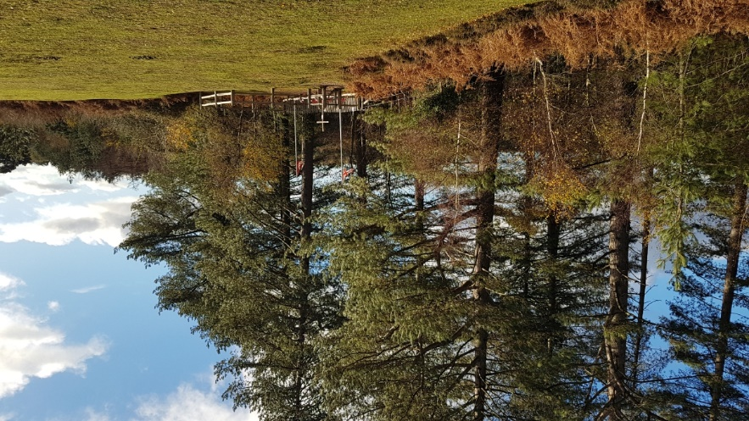
Figure 2 Canadian War Memorial

The view from the ridge is instantly spectacular and had been noted on previous trips but the area had not been considered in terms of sacred. (Fig. 3).

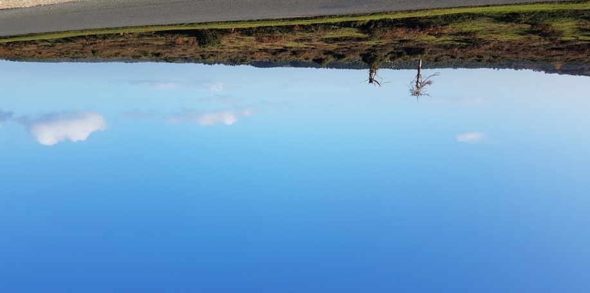
Figure 3 View from the ridge of the hill opposite the Memorial

During the fieldwork, however, I observed a deepening awareness and appreciation of the surrounding landscape as being sacred, noting a growing sense of commune with the trees, squirrels, ferns, sun, wind and rain, which conformed with Lane's description, ' . . .sacred places also participate in the entire array of sensory exchanges that play across the land' describing the motion of the wind and the shifting of rock contributing to an ambient character, and declaring that 'A sacred place is necessarily more than a construction of the human imagination alone'.

I soon noted in my journal that this would indeed have been a possible location for an Eliadian hierophany at some time in the past as well as Lane's first axiom, and may have guided the choice of location for the outdoor religious services in 1944. In addition to the magnetism of the location, however, the practicalities of the site were also evident in that it had the form of a small, natural amphitheatre, was protected from westerly wind and with the tree line providing cover from the view of German planes. A possible consideration may also have been given to the distant west-facing view, towards Canada and home, as shown in Figure 4. All these, however, could possibly have been interpreted as signs, in accordance with Eliade's idea that a 'sign' could be shown to indicate sacred space.

For these reasons, together with my own experience, I deduced that the site constituted a natural sacred space, of itself containing sacredness.

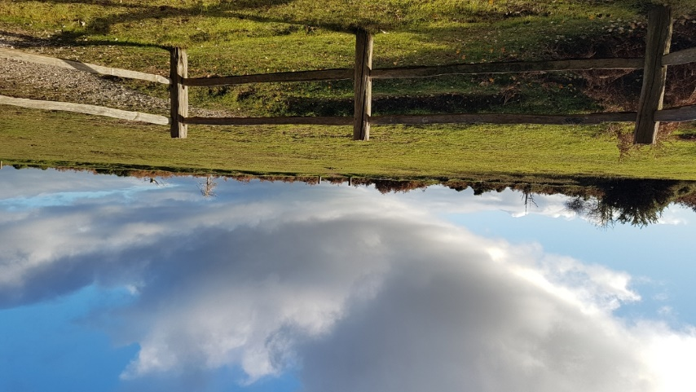
Figure 4 View West from the Memorial

Sacredness acquired through design of the site

Surprisingly, rather late on in the fieldwork, I noted that the memorial itself was very understated and almost odd-looking with two tall white flag posts (one Canadian, one British) towering either side of a much lower (two metres) plain wooden cross, which can be seen in Figure 5. The flags contributed to a sense of Lane's fourth axiom, concerning centrifugal force, driving thoughts away to Canada although, at the same time, echoing Svendsen's findings of the importance of patriotic signs. The flag poles are also reminiscent of Eliade's 'axis mundi', connecting the site with the 'three cosmic levels - earth, heaven, underworld'. Additionally, during its use as a site for services, the cross itself may have simulated the axis mundi, as described by Eliade and, as a religious symbol, would definitely have connected the servicemen's prayers with the concept of sacred.

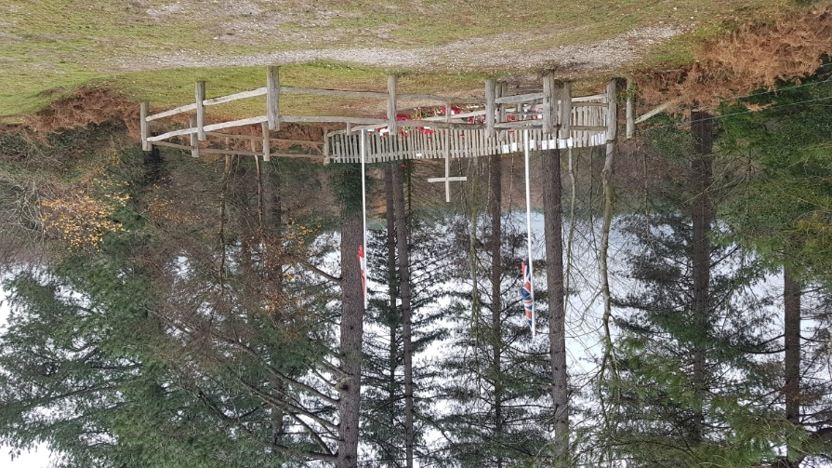
Figure 5 The Cross with Flag Poles either side
From Figure 2, it could be seen that there is no path to the memorial and the memorial is 'set apart', a criterion for sacred space described by both Durkheim? and Eliad? by a picket fence which now creates a small enclosure with space restricted to perhaps ten people, entered through a 'kissing gate' allowing access to one person at a time. Interestingly, however, instead of communicating a sense of sacred space which pulled me in, for the first few days, my own experience was not centripetal, but of a sense that a commitment needed to be made which caused some hesitation. From my observations, this was also common to other people observed during the fourteen days. Out of eight sets of visitors counting 21 people in all, only six went through the gate with others, including other members of the same group, remaining at what perhaps they may have considered a 'respectful' distance, although carrying on chatting. However, personally, after the first few days, I looked forward to the protection the fence seemed to supply, sensing the concept of entrance described by Eliade.

The fencing off and the fact that the bolt from the original wooden cross made by the men had been purposely re-used in the making of a replacement cross, created more of a shrine-like effect, which has been described above by Mayo as increasing the sense of sacredness.

The part played by rituals

The services held for the servicemen at the site for the three months before D-Day constituted ritual action, described almost universally as designating the status of 'sacred' as described above.

In addition, the subsequent small memorial services which have been held on 11th November each year may also be said to preserve the sacredness with longevity found to be an important criterion for sacredness by Svendsen. The fact that, during the year, a small number of people attend independently, either in terms of having made a pilgrimage there, ritually placing flowers or artefacts adds to this.

The ritual aspect of visiting also appeared to be a key to my perception of the sacredness of the site and, as it was undertaken alone with no group support as described by Durkheim, it could be said that this was more in line with Lane's and Eliade's views.

I also perceived that my ritual of prayer became significant in directing my thoughts back to the possible thoughts of the young men, wondering if the ritual of prayer allowed them to sense or perceive more deeply the sacredness of the site, as described by Griffioen that prayer ' aims at placing the human being in relation to that which is viewed as sacred. I recorded that I hoped that their prayer had given them reassurance and comfort, strengthening them in the face of battle, as pertinently described by Jason McMartin, 'prayer links terrestrial life with participation in God’s purposes in our post-mortem existence'.

Do changing perceptions of the sacredness of a site confirm or invalidate its authenticity?

Lane asserted that sacred space is intimately related to consciousness and, from my personal stance, it is the case that my raised awareness of the site altered my consciousness, enabling my perception of sacredness to be experienced.

My initial lack of awareness of sacredness changed once within the enclosure, and similar to Lane, although moved by mementos, typical of many war memorials, I was significantly struck by three black and white photos supported on sticks in the ground of young men in uniform, on which their names and Canadian regiment had been written (Figs 6, 7 and 8). I could sense, as described in Lane's third axiom, my state of consciousness changing and the sense of sacredness growing.

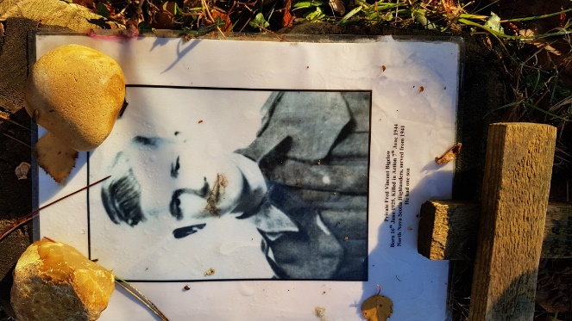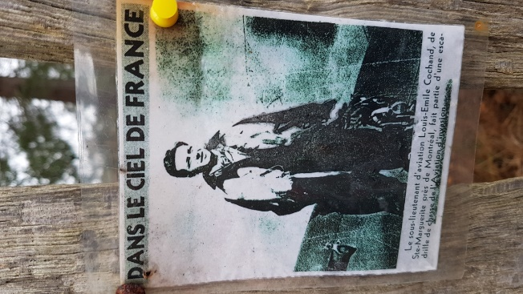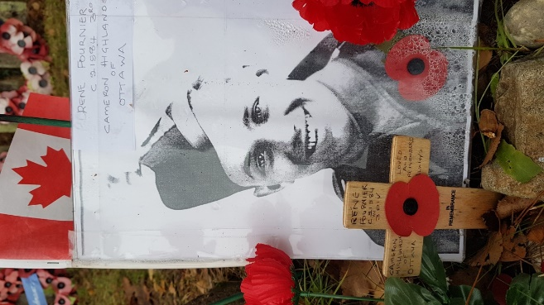
Figure 6 Canadian Serviceman Figure 7 Canadian Serviceman Figure 8 Canadian Serviceman
Through my engagement with the landscape and the site itself, by the end of the 14 days, I noted that I had become very aware of the sacredness of the site. The possibility of an original hierophany, the design of the site and the ritual action, together concurred with many of the descriptions of sacred space described in the literature although, from Durkheim's viewpoint, the criteria were more limited to include ritual action during the three months when the services were taking place. Since the lack of ritual action would cause the site to lose its sacredness, according to Durkheim, the fact that I, at least, could still perceive its sacredness, would imply that his view was not accurate.
Final thoughts

As discussed, the concept of sacred space has raised many issues and polarizes thoughts. Theorists' views differ at many levels and, della Dora has summarised the problem with sacred space, claiming that 'It problematizes traditional binary distinctions, such as those between the spiritual and the material, the invisible and the visible . . .'. Lane has attempted to find an acceptable way forward and stated that 'What fascinated me most was the messiness, ambiguity, and the mystery of people's deeply personal experience of place'.

As an illustration of this, on the pilot day, before officially commencing the fieldwork, having arbitrarily driven to the War Memorial, I got out of the car and checked the time on my phone to start the seven minute prayer. It showed 11.11, significant as being instantly recognisable as Armistice Day or Memorial Sunday. My final visit to the War Memorial was on the way home following an overnight stay at a hotel. As usual, I checked my phone before the prayer and it showed 10.25. Having prayed, I then became lost in thought reflecting on the 14-day experience. Finally, on returning to the car and taking off my jacket, the engine was switched on and the car radio lit up with the time - 11.11. I quickly double-checked my phone which also still showed 11.11.

Each of these incidences of synchronicity, as described by Jung, one right at the commencement of the fieldwork and the other right at the end, for me were powerful experiences of Otto's numinous. They were the most significant development of the project, being neither perception nor imagination. However, for the purposes of the project, and with respect to reflexivity, I isolated (as far as possible) the initial experience during the 14 days, and both experiences in the writing up of this discussion.

Together with my religious history, despite being in the past, it is easy to see how criticisms can be made of phenomenological auto-ethnographic work, querying the representativeness and validity on the basis of bias, making it unlikely that someone else would experience the same results as descibed by Bell and Waters. The fact that I have edited that extract from my own diary (as it contained a reference to field notes that I felt did not fit within this section on subjectivity) shows that experiences can be altered or reinterpreted by the teller to suit the purpose of the story
However, In their paper, Wilma Koopman, Christopher Watling and Kori LaDonna Koopman have suggested that an improvement would be achieved if more effort could be made with regard to reflexivity, beyond 'traditional approaches sitting down writing a reflexive paragraph or two'.

Although there are valid criticisms, however, as long as all possible influences are declared, according to Jo Pearson, it could be considered that certain backgrounds have an advantage in research, for example as prayer was included in the project as an attempt to re-enact the prayer time of the servicemen, my own familiarity with prayer could have helped me identify with the servicemen more than someone who dismissed the idea of prayer.
There remained, however, the difficulty in distinguishing between my perception (involving belief or knowledge) and my imagination with regard to the increase in sacredness. Lane described the recognition of sacredness as existentially, not ontologically discerned. However this should not mean that sacredness does not ontologically exist. The recent concept of the ontological turn has been described by Paolo Heywood as continuing 'a long tradition in anthropology of aiming to take difference seriously and understand it as best we can on its own terms'. He continued 'your interlocutor may ‘believe’ the tree to be a spirit, and you may ‘respect’ this belief as much as you wish, but your own belief is probably not what you would consider to be a belief at all; it is what you would think of as ‘knowledge’. You do not think of yourself as ‘believing’ it to be a tree, you know it to be so. ‘Respect’, in such a situation, becomes a synonym for mere toleration' and finally positing 'It may be that our perception which is different is not tuned in correctly'.

The apparent reluctance of modernism to acknowledge the possibility of an objective spirituality, which is hopefully lessening in the post-modern world, has appeared to affect analysis of sacred space, which will hopefully change coupled with increased use of phenomenological, auto-reflexive accounts.

Conclusion

The aim of this research project was to discover whether the Canadian War Memorial, which had been formerly used as an outdoor worship site, could be described as sacred space.

From Durkheim's era, the concept of sacred space has been constantly changing but has not lost any importance. In comparing the fieldwork results with the views of various theorists on sacred space and several papers on memorials, this project aimed to further that discussion.

Having been chosen and used as an outdoor place of worship for the three-month period before D-Day, 6th June 1944, by men whose lives would later be commemorated there, it was thought appropriate to consider sacredness at three levels, the first being whether this particular area in the landscape originally was in itself sacred, secondly whether sacredness had been established through the ritual of services and prayer by the servicemen, and thirdly whether, as a memorial, it could now be counted as sacred space.

A literature review was carried out ascertaining different scholars' interpretations of sacred space, and to what degree War Memorials are generally deemed to be sacred.

Having decided upon a phenomenological approach, field research in the form of a programme of visits on 14 consecutive days was carried out during which, following a brief period of prayer undertaken as a re-enactment of the activity at the site prior to D-Day, thoughts and feelings were recorded in a diary. These notes were subsequently discussed and compared with other scholars' accounts and opinions from the literature.

The initial discussion focused on the possibility of the site having already been sacred, referencing concepts described by Eliade and Lane. Had this been the case, the site could then be said to have attracted the servicemen who may also have appreciated the distant views towards the west and their homes in Canada. It was acknowledged that the site would also have offered protection from wind and been hidden from German planes although these advantages may have been incidental. My own perception of the landscape's sacredness at the location increased during the 14 days.

The ritual of outdoor prayers and services for the servicemen over the three month period, with the wooden cross as a focus, was thought to concur with many theorists' ideas of what makes a place sacred, therefore, if not already, it became sacred during that three month period.

Currently, there is less ritual, mainly once a year on Memorial Sunday, however taken together with the location, its 'set apartness' by a small fence, the re-use of the bolt from the original wooden cross in its replacement and the cross's current position between the two national flag poles, it was concluded that the site did warrant the status of sacred.

The fieldwork, based on phenomenological auto-ethnographic experiences, exposed my changing perceptions of the site from an outsider viewpoint, as described by Lane, with no personal sense of the sacred, to an insider viewpoint, eventually perceiving the landscape itself to be sacred. The site's sacredness was added to due to its design and the ritual activity which had taken place, as well as as a result of my own ritual activity.

Although from Durkheim's secular view, there could have been no sacredness inherent in the site, the ritual during the time when it was used for worship would have created sacredness and, currently, the setting aside of the area together with group, annual ritual may possibly have maintained some sacredness on his terms.

However my final conclusion was that the area itself was sacred due to natural phenomenon, in accordance with Lane's axioms and descriptions, with Eliade's hierophany having possibly drawn the men to the site in April, 1944.

Newforestknowledge.org. https://nfknowledge.org/contributions/history-of-the-memorial-at-mogshade-hill/#map=10/-1.66/50.88/0/24:0:0.6|39:1:1|40:1:1.
Mircea Eliade, The Sacred And The Profane The Nature Of Religion, (W.R. Trask, Trans.) (San Diego:Harcourt Brace Jovanovich, 1987), p. 11.
Belden C. Lane, Landscapes Of The Sacred, Geography And Narrative In American Spirituality, (Baltimore: The John Hopkins University Press, 2002), p. 254.
Emile Durkheim, The Elementary Forms Of Religious Life, (K. E. Fields, Trans.) (New York: The Free Press, (1995) 1912), p. 84..
Rudolf Otto, The Idea Of The Holy An Enquiry Into The Non-Rational Factor In The Idea Of The Divine And Its Relation To The Rational, (John W. Harvey, Trans.) (London: Oxford University Press), p. 11.
Otto, The Idea Of The Holy, p. 7.
Eliade, The Sacred And The Profane, p. 10.
William S. F. Pickering, 'The Eternality Of The Sacred : Durkheim’s Error?', Archives De sciences Sociales Des Religions 35, no. 69 (1990), pp. 91–108, p. 91. http://www.jstor.org/stable/30114718.
Paden, William E. Paden, 'Before 'The Sacred' Became Theological: Rereading The Durkheimian Legacy', Method & Theory in the Study of Religion 3, no. 1 (1991), pp. 10–23, p.10. http://www.jstor.org/stable/23549544.
Catherine Allerton, 'Introduction: Spiritual Landscapes Of Southeast Asia', Anthropological Forum, 19 (3) (2009), pp. 235-251. DOI: 10.1080/00664670903278387
Anthony Thorley and Celia M. Gunn, Sacred Sites: An Overview. A Report For The Gaia Foundation (Abridged Version), 2008, (London: Calverts, 2008), p. 2.
Thorley & Gunn, Report for Gaia Foundation p. 11
Denis Byrne Spirit Scapes p 55
Christopher Tilley and Kate Cameron-Daum, An Anthropology Of Landscape, The Extraordinary In The Ordinary, (London: UCL Press, 2017), p. 12.
Judith Bell and Stephen Waters, Doing Your Research Project, A Guide For First-Time Researchers, 7th Ed., (London: Open University Press, 2018), p. 127.
Elaine Campbell, 'Exploring Autoethnography as a Method and Methodology In Legal Education Research', Asian Journal of Legal Education, Volume 3, Issue 1, January 2016, pp. 95-105, p. 96.
Bell and Waters, Doing Your Research Project, p. 26.
Amber L. Griffioen, 'Are You There, God? It's Me, The Theist, On The Viability And Virtue Of Non-Doxastic Prayer', Analyzing prayer : Theological And Philosophical Essays, 1st ed., ed. by Oliver Crisp, James Arcadi and Jordan Wessling, (Oxford: Oxford University Press, 2022), pp. 38-58, p. 43. https://doi.org/10.1093/oso/9780192859044.001.0001, accessed 13 Nov. 2022.
José-Manuel González-González, Jesús-Gerardo Franco-Calvo and Darío Español-Solana, 'Educating in History: Thinking Historically through Historical Reenactment', Social Sciences, 11: 256, (2022), p. 13. https:// doi.org/10.3390/socsci11060256.
Bell and Waters, Doing Your Research Project, p. 254.
Durkheim, Forms, p. 81.
Eliade, The Sacred And The Profane, p. 24.
Durkheim, Forms, p. 426.
Durkheim, Forms, p. 416.
Durkheim, Forms, p. 281.
Eliade, The Sacred And The Profane, p. 20.
Eliade, The Sacred And The Profane, p. 11.
Eliade, The Sacred And The Profane, p. 28.
Lane, Landscapes Of The Sacred, p. 6.
Lane, Landscapes Of The Sacred, p. 5.
Lane, Landscapes Of The Sacred, p. 19.
Durkheim, Forms, p. 9
Karen E. Fields, 'Translator's Introduction', E. Durkheim, The Elementary Forms of Religious Life, (K.E. Fields, Trans., (New York: The Free Press, 1995 [1912]), p. xliv.
Eliade, The Sacred And The Profane, p. 107.
Belden C. Lane, 'Giving Voice to Place: Three Models For Understanding American Sacred Space', Religion And American Culture: A Journal Of Interpretation, Vol. 11, No. 1 (Winter 2001), pp. 53-81, p. 53. https://www.jstor.org/stable/10.1525/rac.2001.11.1.53.
Veronica della Dora, 'Engaging Sacred Space: Experiments In The Field, Journal Of Geography in Higher Education, (2011) 35:2, pp. 163-184, p. 165. DOI: 10.1080/03098265.2010.523682,
Erika S. Svendsen and Lindsay K. Campbell, 'Living Memorials: Understanding The Social Meanings Of Community-Based Memorials To September 11, 2001', Environment And Behavior, 2010, Vol.42 (3), pp.318-334, p. 326, 327
Svendsen and Campbell, 'Living Memorials', p. 326.
Svendsen and Campbell, 'Living Memorials', p. 327.
Svendsen and Campbell, 'Living Memorials', p. 330.
James M. Mayo, 'War Memorials As Political Memory, Geographical Review, (1988), Vol. 78, No. 1, pp. 62-75, p. 64.
Mayo,'War Memorials', p. 63.
Edward S. Casey, Remembering, A Phenomenological Study, 2nd edn. (Bloomington: Indiana University Press, 2000), p.216. https://www.jstor.org/stable/j.ctt16gzfjf.19.
Lane, Landscapes Of The Sacred, p. 54
Lane, Landscapes Of The Sacred, p. 55.
della Dora, 'Engaging Sacred Space', p. 165.
Lane, Landscapes Of The Sacred, p.4.
Lane, Landscapes Of The Sacred, p.4.
Eliade, The Sacred And The Profane, p. 27.
Lane, Landscapes Of The Sacred, p. 19.
Eliade, The Sacred And The Profane, p. 36.
Eliade, The Sacred And The Profane, p. 32.
Eliade, The Sacred And The Profane, p. 25.
Mayo,'War Memorials', p. 63.
Griffioen, 'Are You There, God?', p. 39.
Jason McMartin, 'Prayer And The Meaning Of Life', Analyzing prayer : Theological And Philosophical Essays, 1st ed., ed. by Oliver Crisp, James Arcadi and Jordan Wessling, (Oxford: Oxford University Press, 2022), pp. 202-219, p. 216.
Lane, Landscapes Of The Sacred, p. 19.
Karen Fields, 'Translator's Introduction', The Elementary Forms of Religious Life, trans. Karen E. Fields, (New York: The Free Press, 1995 [1912]), p. xliv.
della Dora, 'Engaging Sacred Space', p. 165.Veronica della Dora, 'Engaging Sacred Space: Experiments In The Field, Journal Of Geography in Higher Education, (2011) 35:2, pp. 163-184, . DOI: 10.1080/03098265.2010.523682
Lane, Landscapes Of The Sacred, p. 6.
C.G. Jung and Roderick Main, 'Synchronicity', Jung On Synchronicity And The Paranormal, (Princeton: Princeton University Press, 1997), pp. 93-102, p. 97. https://doi.org/10.2307/j.ctvzsmf3b.9.
Bell and Waters, Doing Your Research Project, p. 244.
Cambell, 'Exploring Autoethnography', p. 100.
Wilma J. Koopman, Christopher J. Watling and Kori A. LaDonna Koopman, 'Autoethnography as a Strategy for Engaging in Reflexivity', Global Qualitative Nursing Research, (2020) Vol. 7: 1–9, p. 7. DOI:10.1177/2333393620970508
Pearson, 'Going Native', p. 58.
Lane, Landscapes Of The Sacred, p. 19.
Paolo Heywood, 'The Ontological Turn', The Cambridge Encyclopedia of Anthropology, ed. by Felix Stein. 2017. p. 9. Online: http://doi.org/10.29164/17ontology

