  Component One:  What are the key skills required when working in the housekeeping team? 750 words (+/- 10%)  Contribution to Overall Module Assessment: 25% | Student No: | 2018162
 | Module Title: | Hotel Placement – Operating Hotel Facilities
 | Module Code: | BMIH4006
 | Lecturer: | Lola Villard
Housekeeping it is an operational department very important in each hotel because cleanliness means respect for guests and they are all looking for a clean and nice environment to stay.
“ Hospitality, leisure, travel and tourism sector employs more than two million people: 1 in 14 of UK jobs. Of these, 58 per cent are female and 42 per cent male.” ( Mullins, 2013, p. 3 )
My second experience during my student placement at Delta Hotel by Marriott in Swansea it was at housekeeping department. There were 3 demanding weeks in which I met other wonderful people, who made my adaptation easier and who showed me how to organize my work in this department in order to be as efficient as possible and to make my work as easy as possible with optimal results.
I discovered a number of skills that an employee must have that I did not know before actually working in a hotel. Following I will give some examples from my placement period.
In the first week I was assigned to the public areas where I cleaned the elevator, the stairs, the reception area and the lobby, the restaurant and bar, the spaces for the employees such as toilets and changing rooms, the employees' offices as well as at the entrance in the hotel.
Together with my colleague from the housekeeping department, I learned how often these areas should be cleaned, what kind of substances are used and how to interact with the clients from the housekeeper position.
I discovered that you have to be very attentive to details because customers have high expectations and some may be disturbed by small imperfections such as a surface that doesn’t shine perfectly, a cable that passes through the hall, a crumb of bread on the chair and others.
The next 2 weeks I was part of the hotel room cleaning team. Here I learned other things and discovered how hard it is, both physically and mentally, to be responsible for handing over the rooms to the clients. I received advice and discovered what a hard work is behind a hotel room arranged sophisticatedly and ready to welcome guests. During this period, no complaints were received from the clients, even some guests stopped to thank and specify that they were very pleased with their rooms.
You have to be a hardworking person because working in the housekeeping department is not easy. You need to have physical strength to move the beds, change the sheets and use vacuum cleaner. Also cleaning the bathroom requires effort, the cleaning standards being very high. ( Hotelowner, 2018)
“ One of the responsibilities for executive housekeeper is to administer and maintain all assets allocated to the rooms division of lodging properties. ( Casado,2012, p.85). Responsibilities increase with function so that employees with executive function have a wide range of responsibilities.

In order to be efficient and to deliver quality at the highest standards, as a housekeeping person working in a hotel like Delta you must have a series of soft skills such as hardworking, physical flexibility and strength, attention to detail, perseverance, a good organization, smiling with customers, customer service, trustworthiness, communication, time management, punctuality, personal hygiene, cooperation, honesty and others.

“ The housekeeping department in a hotel may easily have the largest workforce.” ( G. Raghubalan, 2015, p.34) No matter how big importance have other departments, definitely housekeeping has the biggest number of employees as cleaning is a daily job, I will say a non-stop one in a hotel as the guest is paying to have his room and he needs all the comfort and a clean room.

Customer service is an essential skill housekeepers use to succeed in the field. It's essential to communicate with clients, colleagues, and managers regularly to ensure the expectations of each job. (Bridger, 2018, p.167)

Also important are hard skills such as certifications of window cleaning, carpets, laundry, sweeping, mopping or vacuum. It is very important to have qualified employees as they can do their tasks properly, to save time and to have better results of their work.
At the end I would like to add the fact that I enjoyed my placement experience, that I will appreciate more a clen room from now on and I definitely will see faster each aspect that is not in order when I will open the door of my hotel room.

Word Count | 731

Component Two:
Contribution to Overall Module Assessment: 25%
In this scenario – You have just been promoted to team leader for a floor within the hotel. A guest complains that on their arrival, their room had not been properly cleaned. Create an action plan and answer the following questions.

Problem | Why did it happen? | What are you going to do? | How will you prevent this from happening in the future? | What measures would you introduce to improve team effectiveness?
Dust under the bed | Because the housekeepers don’t move the beds and don’t vacuum well every time under the beds. | I am going to ask the housekeepers at least one time per week to vacuum all the room properly. | The housekeepers will have a new task to vacuum all the room each Monday of the week. | I will propose the purchase of new vacuum cleaners that allow a better suction in a shorter time, with a better result and without producing dust in the room.
TV screen with stains | The wipes are not changed after each use and the cleaning products are not a good quality. | We are going to clean the TV screen daily and use better products to protect better the screen and offer better quality of the image. | We are going to clean the TV with special and soft wipes and cleaning products. | Weekly a member of the team will clean carefully all the screens.
Mold at the corners of the bathtub | Because the applied silicone is old and is a moist environment that favours the appearance of mold. | I am going to achieve some special products to try to keep mold away as much as possible. I will propose to apply new silicone around the corners in order to have new and clean surface. | It is very heavy to prevent this, but the housekeepers will have to use the special products and clean better the affected surface. | The team members will be more effective using better products and keep a log about each room status.
Dirty windows | Because they are hard to clean on the exterior. | Use specific products and wipes for each surface. | A company will come monthly to clean the windows on the exterior. | We are going to buy wipes in different colours, so each surface will be cleaned with the right wipe.
Unpleasant smell in the wardrobes | Because the cabinets are old and are located in an area where ventilation is more difficult. | I will ask the housekeeping persons to open the cabinets doors and leave them open while they are cleaning the room so they can ventilate. Also I will achieve a spray to get rid of the unpleasant smell. | All the unoccupied rooms will stay with the closet doors open for better ventilation. I also will propose to fit some paper inside the closet for a fresh aspect and easy to clean as well. | Each to clean surfaces will save time and the housekeeper will be more effective with less effort.
Small traces of dirt on towels and unpleasant smell of towels. | This can happen because of the transport, they can touch the trolley or because the housekeeping person is not wearing gloves and can be dirty on hands. | I am going to ask the laundry, that after washing to pack the hand towels and the bath towels separately in sets of 2 pieces. | The housekeepers will put the new and clean towels at the bathroom by the end of all the cleaning and open the bags only in that moment. | Smaller packages of towels that are easier to handle, to transport and thus avoid touching other surfaces after unfolding.

Component Three:
Contribution to Overall Module Assessment: 50%
Your task is to create and prepare a presentation following the detailed scenario provided below.

As the floor housekeeping manager and given the recent guest complaints you need to put together a basic training presentation for your colleagues within the housekeeping team to get the best out of them, ensure that brand standard is being achieved and that Health and Safety procedures are also being followed.

Training Notes:
Hello and thank you for participating in this presentation. My name is Catalina and I am floor housekeeping manager. The purpose of this meeting is to understand what are the problems we are dealing with, what solutions we propose and how we want to achieve training for employees, as well as which are the most handy solutions to offer high standards to our guests.

Training Notes:
At last week's meeting with the members of the management, the main complaints from our guests were presented and I would like to let you know what they are. You can see the attached table.

Training Notes:
In the following I will talk about brand standards regarding cleaning in our hotel. We have a strong reputation for high standards of cleanliness with well-established cleaning processes. We have always taken standards for hygiene and cleanliness very seriously to ensure that our hotels remains a clean and comfortable environment for our guests and our associates.
Maintaining brand standards in housekeeping contributes to the hotel's overall reputation and positioning in the market. Our hotel is known for its high cleanliness standards and attention to detail stands out from competitors.

Training Notes:
Talking about health and safety, it is really important for us to keep all our employees safe at work and that’s way we are asking you to respect our health and safety procedures. I would like to remind you some of them : Safe lifting procedures , how to use cleaning equipment, proper handling and storage of chemical: Store chemicals in safe places, have a comprehensive fire safety plan in place, using of caution signs like WET FLOORS, to avoid cross contamination, mops, buckets and cleaning equipment have to be cleaned and replaced when is necessary, using of PPE like rubber gloves when handling cleaning products and slip-resistant safety shoes.

Training Notes:

Next we will approach the actual training methods proposed as follows: hands-on training: This method involves hands-on training where new hires or existing staff members learn by observing and performing housekeeping tasks under the guidance of experienced employees. It allows trainees to learn practical skills in a real-world setting. The second one it is called role- paying and simulations: Role-playing exercises and simulations allow staff members to practice their skills in simulated scenarios. This method helps them develop problem-solving abilities, customer service skills, and decision-making capabilities.

Training Notes:
The thirth method it is called classroom training: Classroom training sessions provide a structured learning environment where housekeeping staff can receive theoretical knowledge, understand standard operating procedures, and gain a deeper understanding of industry-specific topics. It may involve: presentations, lectures, discussions, training videos. Then we look on cross-training, which Cross-training involves rotating housekeeping staff across different areas of the department, such as rooms, public areas, laundry, and maintenance. This method broadens their skill set, improves flexibility, and enables them to handle multiple tasks efficiently.

Training Notes:
New techniques, professional development training: specialized window cleaners, professional carpet cleaner, moping and vacuum cleaner .

Training Notes:
For better results in our housekeeping department, a new series of task will be included. Daily tasks will be: Dust all surfaces: furniture, lamps, electrical appliances, clear mirrors, wipe TV screen, remove dirty towels and linen, make the beds, clean and sanitize bathrooms, empty bins, clean the floor, weekly tasks will be: dust blinds, clean the wardrobe, vacuum underbed, clean armchairs/sofas, dust and clean air ventilations, check the signs, then the monthly ones are change bed cover and pillow covers, clean the exterior of the windows, professional cleaning of carpets, sanitize remotes, phones, switches.

Training Notes:
We are planning to improve hotel cleanliness standards by procuring improved cleaning products in order to make housekeeping easier and generate better results. Also, we are planning to change the trolleys so they can be easier to move, better organized and in this way our employees be more efficient and save time. New cleaning equipments will be achieved for each floor in our hotel and a member of our team will learn how to use each product in order to have better results in a faster way.

Training Notes:

By the end I would like to thank you all for your attendance and your attention, for all your hard work and involvement and for being part of our nice and friendly housekeeping team. I would like to assure you that all the steps presented today have as main purpose the improvement of the services delivered to our customers, but especially we want to progress and make your work easier through the new products and equipment available. That's why I ask you to get involved in the new training program!

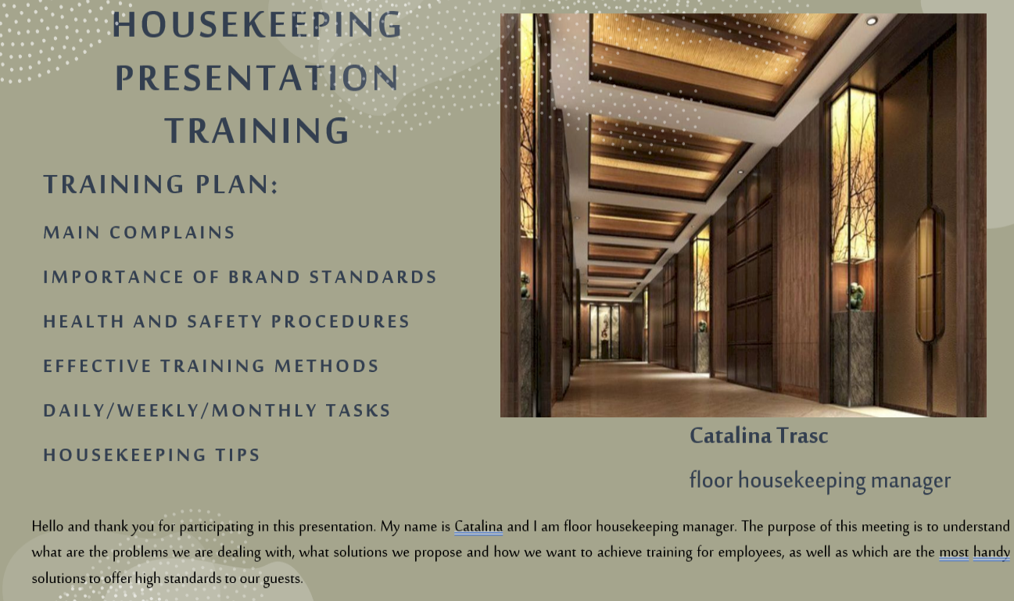
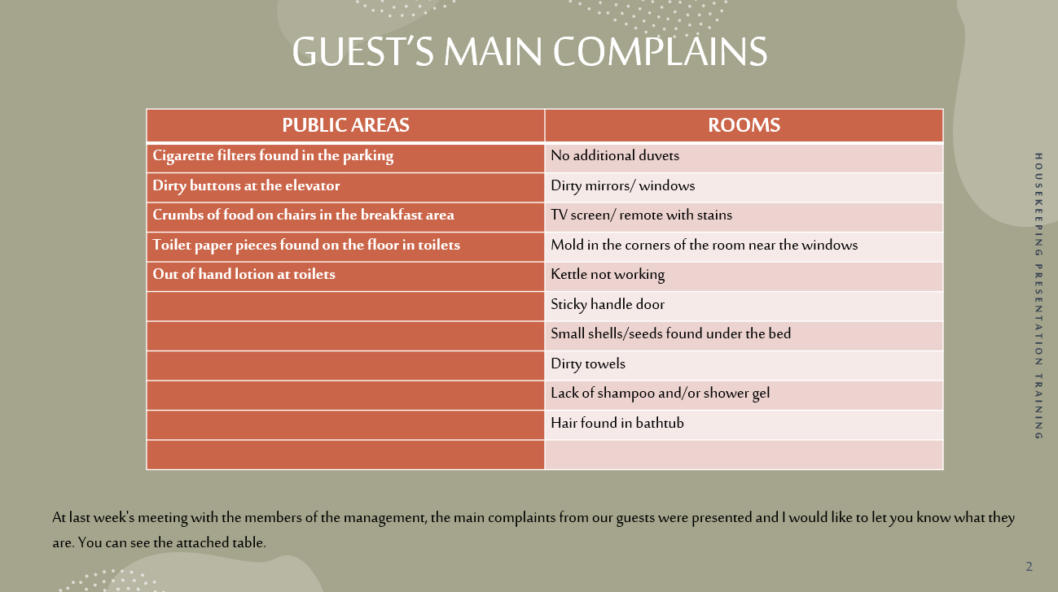
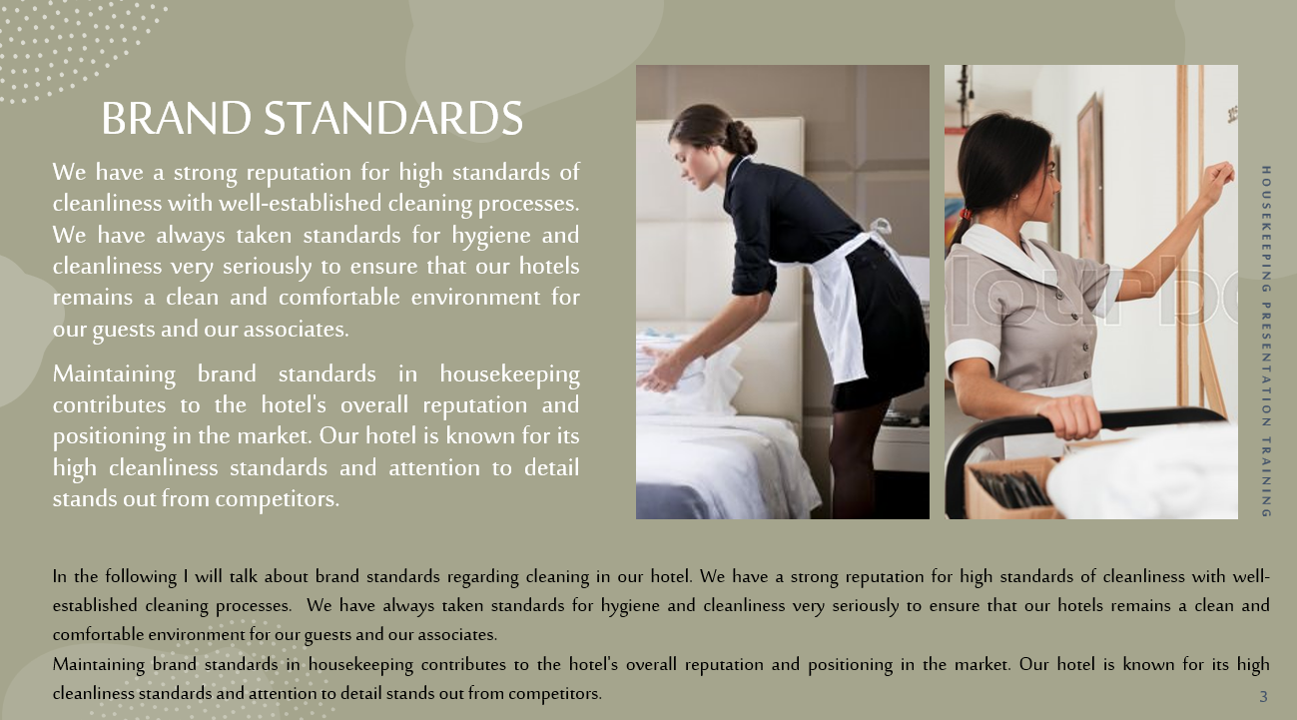
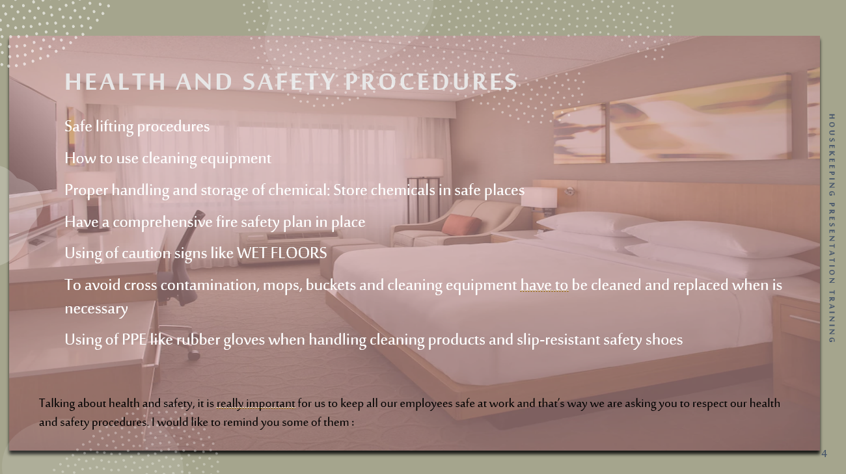
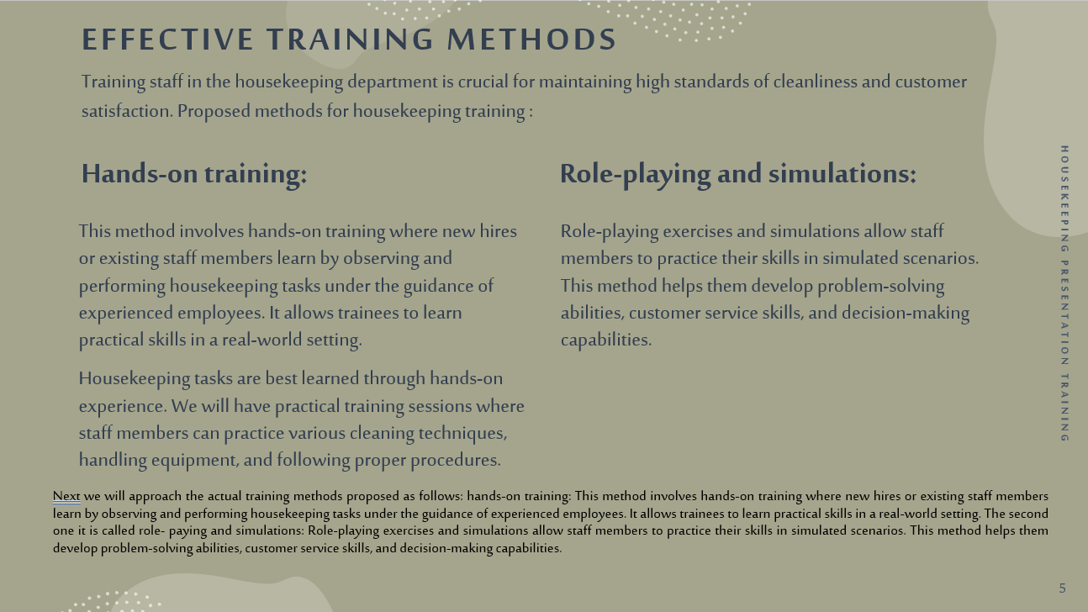
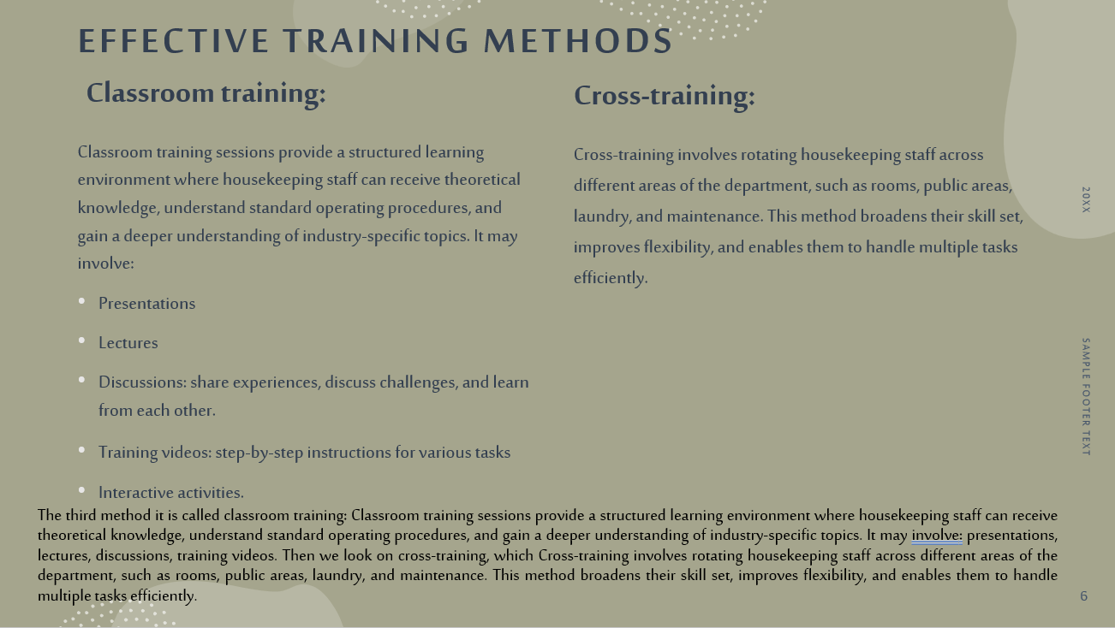
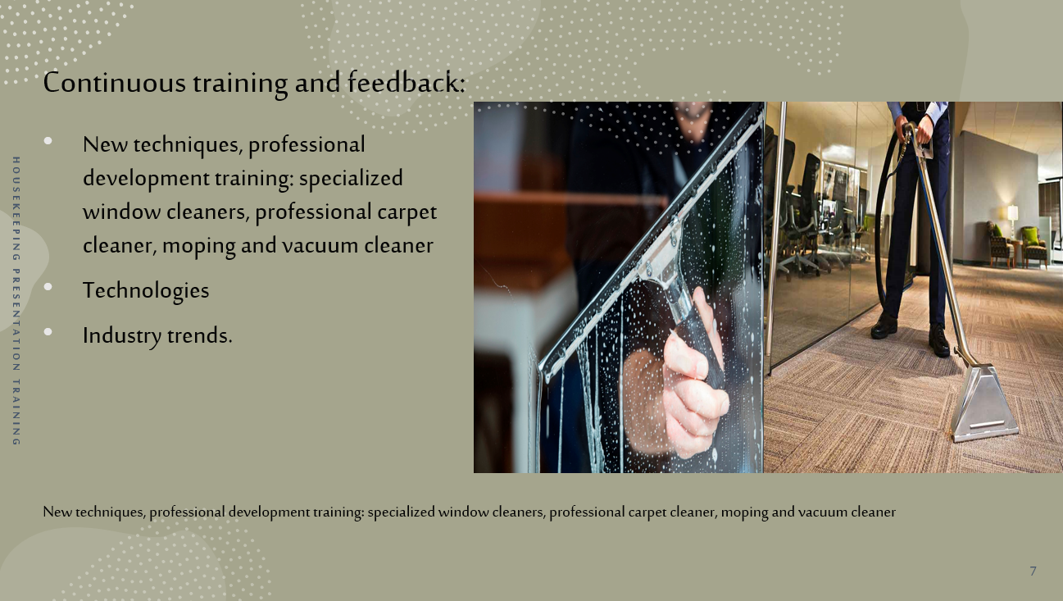
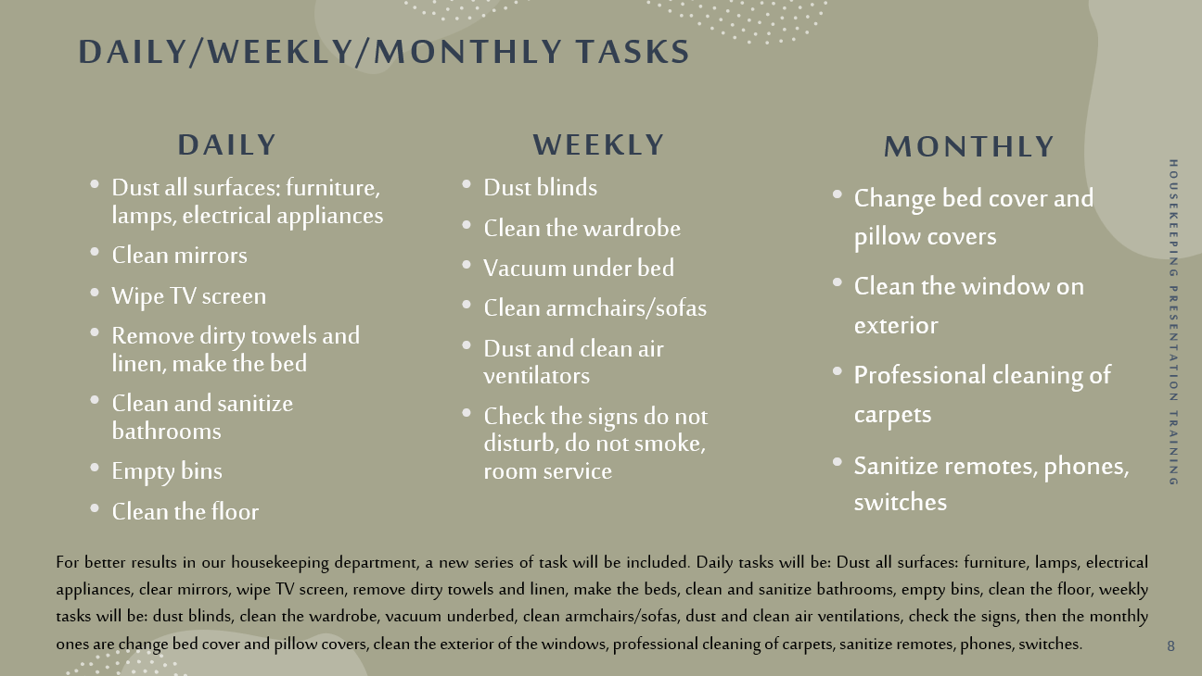
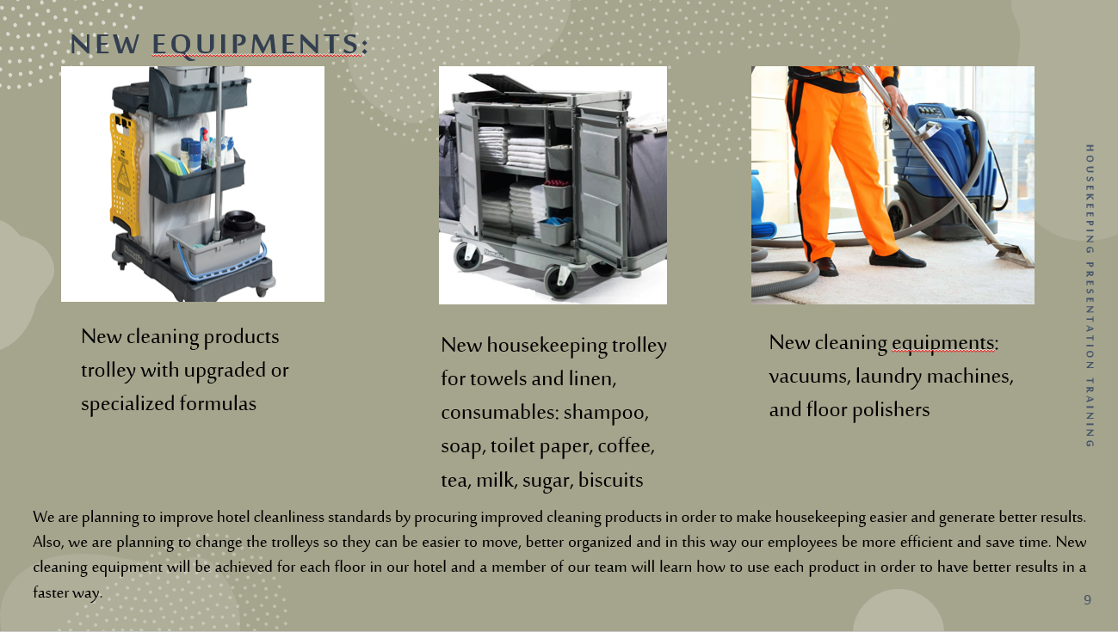
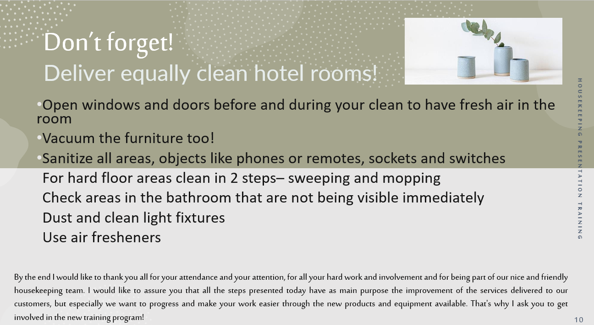

References

Component one:
Bridger, E. (2018) Employee engagement: a practical introduction. 2nd ed. HR Fundamentals. London: CIPD and Kogan Page.
Casado, M. (2012) Housekeeping Management. London: Wiley
Hotelowner (2018) The importance of a good housekeeping. Available at: The importance of good housekeeping | Article | Hotel Owner ( Accessed on 29th of May 2023)
Mullins, L. and Dossor, P. (2013) Hospitality Management and Organisational Behaviour. 5th ed. Harlow: Pearson
Raghubalan, G. and Raghubalan, S. (2016) Hotel Housekeeping - Operations And Management. 3rd ed. India: Oxford University Press.

Component three:
Bridger, E. (2018) Employee engagement: a practical introduction. 2nd ed. HR Fundamentals. London: CIPD and Kogan Page.
Casado, M. (2012) Housekeeping Management. London: Wiley
G., & Vallen, J. (2014) Check-in check-out. Harlow: Pearson
Hospitalitynet (2020) Hoteliers share their opinion on whether the post-COVID era require a different skillset from housekeepers? Available at: Hoteliers Share Their Opinion On Whether The Post-COVID Era Require A Different Skillset From Housekeepers? (hospitalitynet.org) ( Accessed on 28th of May 2023)
Hotelowner (2019) Tackling the skills shortage in the hospitality industry. Available at: Tackling the skills shortage in the hospitality industry | Article | Hotel Owner ( Accessed on 6th of June 2023)
Jones, T. (2010) Professional Management of Housekeeping Operations. London: Wiley.
Mullins, L. and Dossor, P. (2013) Hospitality Management and Organisational Behaviour. 5th ed. Harlow: Pearson
Premier Inn (2023) Premier Inn CleanProtect. Available at: CleanProtect - our enhanced cleanliness commitment | Premier Inn ( Accessed on 8th of June 2023)
Raghubalan, G. and Raghubalan, S. (2016) Hotel Housekeeping - Operations And Management. 3rd ed. India: Oxford University Press.
Tesone, D. (2010) Principles Of Management For The Hospitality Industry. 1st ed. London: Routledge.

