Craig Y Nos Country Park

Management summary

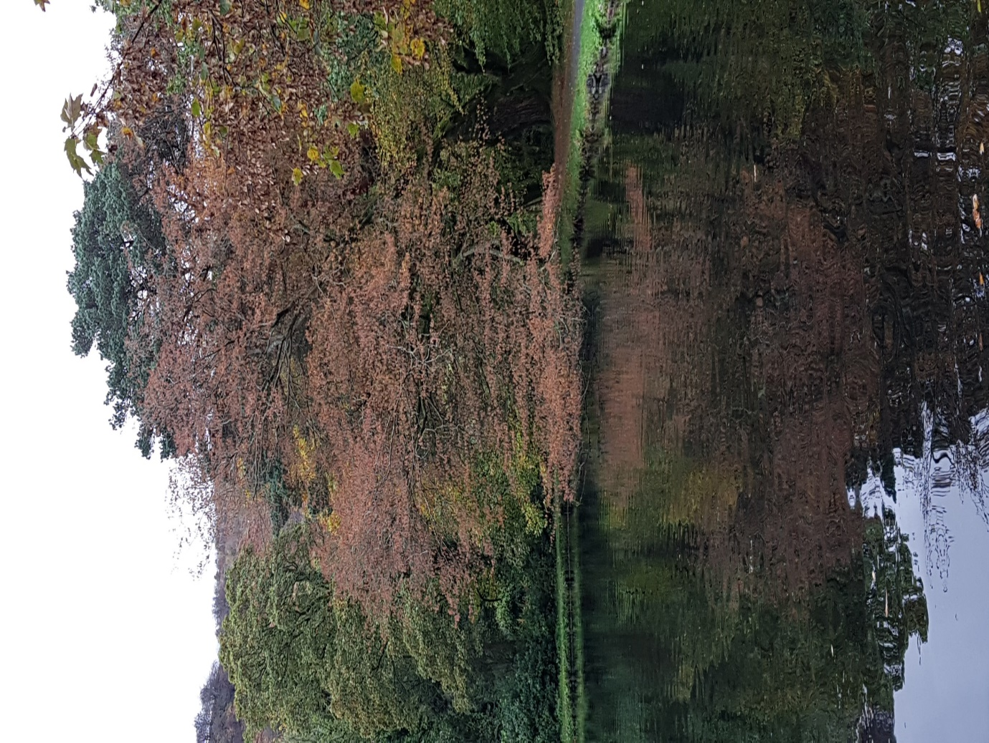

Simon Richards 1809846 12th December 2019

BSc Environmental Conservation UWTSD

Contents
Description 2
Map 1. OS map of the area from the Brecon Beacons to Swansea bay with Craig y nos marked with pin. 3
Map 2. OS map of the upper Tawe valley 4
Legal obligations 5
Designations 5
Infrastructure and other support services 5
Fig 3. Disabled parking bay 6
Fig 4. Pedestrian gate in boundary hedge leading onto A4067 6
Fig 5. Old entrance sign 7
Fig 6. Fishpond with Sequoiadendron 8
Fig 7. Cotoneaster lacteus in berry 9
Fig 8. Grey Squirrel damage to bark on beech 10
Fig 9. Regeneration of native understorey of hazel and holly under black pine 11
Conclusion 13
References 14

Description
Craig Y Nos is a 40-acre country park, uniquely situated in the Glyn Tawe valley within the Brecon Beacons National Park. It sits beside the Brecon road A 4067 20 miles north of Swansea and 20 miles south of Brecon. (See map 1) It nestles in the U-shaped upper Tawe valley with pasture in the lower slopes, in the upland’s heath and acid grassland with limited woodland areas. (See Map 2) This area forms the catchment for the river Tawe and smaller tributary river Llynfell which converge above the middle bridge (Craig y Nos has three bridges) and run south through the length of the park. During heavy rainfall the rivers can rise approximately 1m over a 24-hour period and flooding occurs on average 10 times a year.
The river Tawe is an important natural resource and is used by spawning brown trout and bullheads, and salmon have been recorded. It is highly regarded by local fishing groups and is also popular with canoeists.
Once the home of famous opera singer Adelina Patti who lived in the Victorian gothic castle from 1878 to 1919, this park used to be her garden and much of its exotic planting and landscaping dates from this period. She named it Craig Y Nos ‘the rock of night’ and performed regularly to wealthy patrons in the opera house she had built.
Since 1976 the castle has been managed as a private hotel and the remaining grounds managed as a Country Park within the Brecon Beacons National Park. The country park has four shared boundaries with two family run farms Pentre Cribarth and Rhongur Uchaf, Craig-y-Nos castle and the popular tourist attraction Dan yr Ogof National show caves.
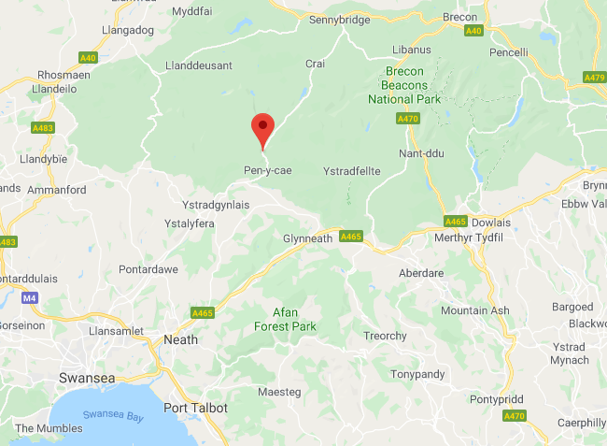

Map 1. OS map of the area from the Brecon Beacons to Swansea bay with Craig y nos marked with pin.

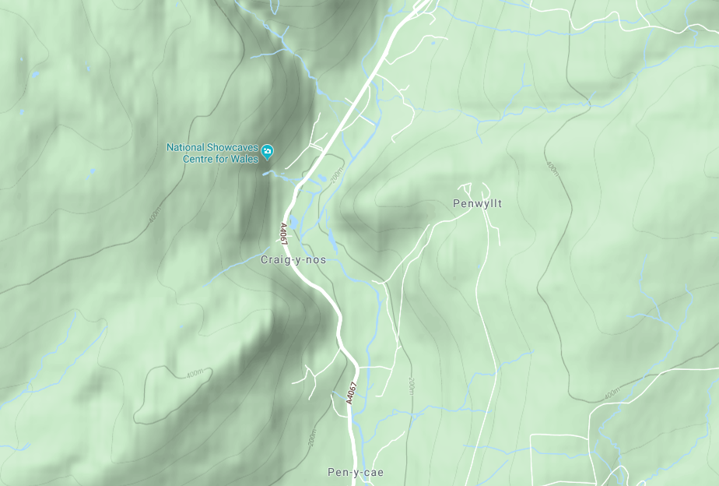

Map 2. OS map of the upper Tawe valley

Legal obligations
The Environment Act 1995 sets out two statutory purposes for National Parks in Wales:
Conserve and enhance the natural beauty, wildlife and cultural heritage.
Promote opportunities for the understanding and enjoyment of the special qualities of national parks by the public.
The park management has the duty to seek to foster the economic and social well-being of local communities within the national parks.
https://nationalparks.uk/students/whatisanationalpark/aimsandpurposesofnationalparks
Additionally, a country park is required to promote sustainable use of the natural resources of the area and encourage enjoyment in the form of recreation.
https://data.gov.uk/dataset/14aae4d3-e8aa-4b6a-a571-ef36d9348e53/country-parks

Designations
It is on a CADW/ICOMOS Register of Historic Parks and Gardens and the site is a Grade II* Garden in the list. This needs to be considered in all future planning for the park and the importance of historic, cultural, built and natural features including a mix of exotic and natural plantings must be recognized.
It has a site of scientific interest (SSSI) in the park at Craig y Rhiwarth designated because of its limestone plant communities. The SSSI extends into adjoining land where the important species are found. Careful management of this conservation area is necessary and the woodland pocket which is also within the SSSI must also be considered. As the rare plant communities listed are outside the park boundary no important plant species are within the park designation.

Infrastructure and other support services
The total staff is one full time warden and one part time administrator who doubles up as the volunteer’s coordinator, support from four National Park wardens who all hold climbing arboriculture qualifications, eleven regular volunteers two days/week and a separate group of Princes Trust volunteers one day/week. Maintenance work and projects involve volunteers so risk assessments and health and safety regulations need to be addressed.
Stakeholders need to be recognized and considered in all day to day activities and future plans to ensure that the running of the country park does not adversely impact on their livelihoods or wellbeing.
There is a firm gravelled car park with spaces for 82, some of these can be used as coach parking. 4% of these spaces need to be allocated and clearly marked for disabled use. There are 6 spaces provided which is enough to satisfy minimum requirements. https://www.nidirect.gov.uk/articles/access-to-everyday-services
Two spaces for disabled parking nearest to the main building are unsuitable due to the serious sloping ground so need reallocating. (Fig 3.)
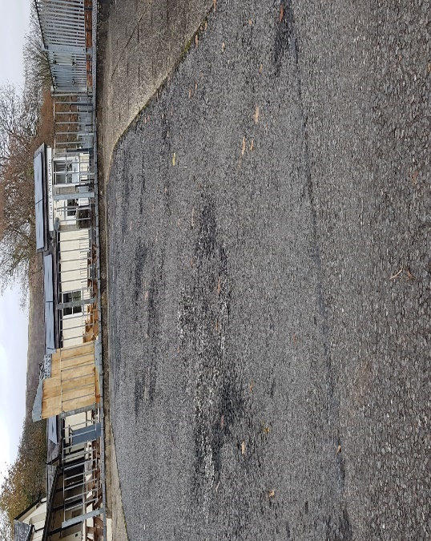

Fig 3. Disabled parking bay
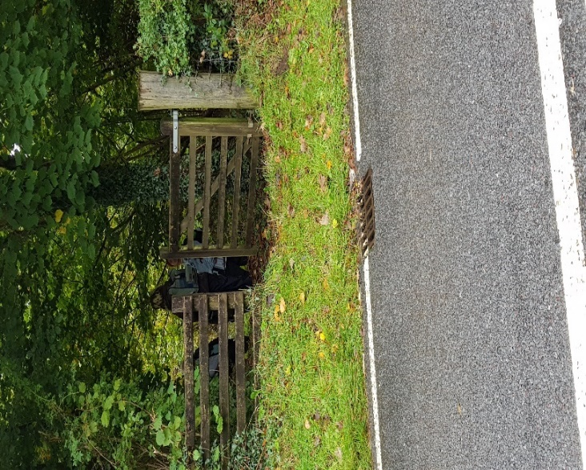

Fig 4. Pedestrian gate in boundary hedge leading onto A4067

The boundary hedge line runs north and south from the visitor centre alongside the busy A 4067. For safety where the pedestrian gate opens onto the main road the gate should be removed or fitted with a lock and chain. (Fig 4.)
The hedgerow is narrow and underdeveloped. To reduce traffic noise and enhance biodiversity a further addition of mixed planting of native hedgerow species would improve it.
The main building houses a café, a small gift shop, toilets including disabled provision, a classroom doubling up as a meeting room with heating, power and projector and screen provision. A separate retail space in the bottom of the car park provides a photographic service. The café, shop and photographic service are leased and managed by others.

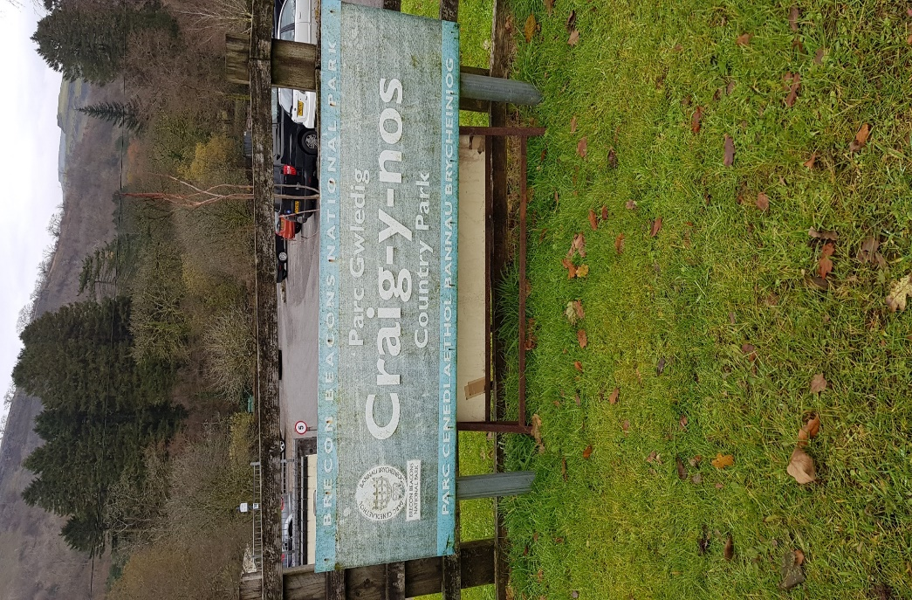

Fig 5. Old entrance sign

Anthropogenic issues, with so many visitors can cause damage to infrastructure with steps, fences and paths needing maintenance. Litter, graffiti and dog faeces require daily monitoring and management. Only 2 dog poo bins are provided near the top of the site so installation of more bins at both the north end and the south end would help prevent users dropping used bags elsewhere.
Health and safety require a good maintenance of infrastructure with clear signage for toilets, first aid points, car parking and directional info boards around the site.
Access points for the Brecon Beacons way need to be clearly marked and provided with information boards about Craig Y Nos too.
Zoning of badly worn paths have been successfully carried out to allow regeneration of grass.
New scree paths have replaced timber stepping stones as they were a potential slip hazard in wet weather.
Better main road signage has been installed on one side of the main gate but the other side still has a weather worn sign that needs replacing. (Fig 5.)
Many of the paths follow the river and through the woodlands with open access into the meadows and are fairly level and firm proving all abilities access.
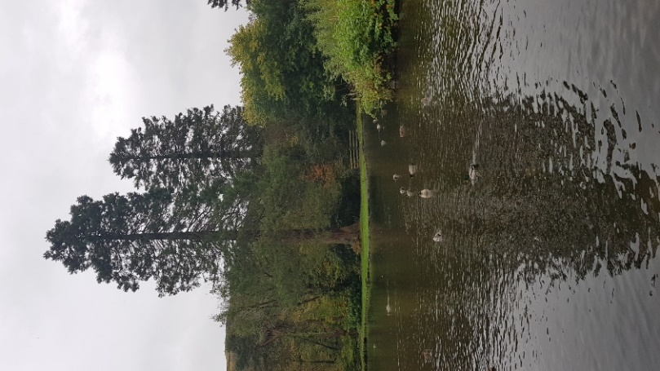

Fig 6. Fishpond with Sequoiadendron
An attractive fishpond with exotic trees is circled by a level footpath suitable for all abilities just north of the car park. (Fig 6.)
A large wildflower meadow is located at the southern end of the site. Archive maps indicate the hay meadow area has been permanent grassland since 1840, initially as pasture and since 1985 as hay meadow. In 1997 the National Park Ecologist described the sward as a mix of NVC MG5 unimproved hay meadow and pasture and MG6 improved permanent grassland. MG5 is uncommon as much lowland pasture has been fertilized, with herbicides used which have reduced the wild flora and degraded the lands biodiversity. This meadow is regularly flooded by the river and provides a useful flood management but this carries sediment that enriches the soil and thereby reduces the likelihood of many flora developing as most prefer poor soil. The grass is cut at the end of summer and removed. 80% of park visitors are dog walkers (Jenkins, 2019) with dogs currently only allowed on leads. The sheep ae no longer grazing the hay meadow in the winter and I recommend that this area becomes an exercise meadow for dogs off the lead. Most dogs need to be able to run free to exercise fully and owners enjoy throwing a ball and getting involved. It is far enough away from the main paths and is fenced so should not cause upset to other users of the park. This also makes policing the rule of dogs on leads much easier as owners can be encouraged to use this area if they want to let them off. This should not affect the flora that is currently growing as they are species that are able to withstand trampling by farm animals.
The far lake is shallow and silts up. Issues with the water pressure causing a breach of the fragile retaining wall have resulted in the water level being artificially lowered. Current management has used puddled clay to prevent seepage of water through the wall which is a low-cost option. It appears to have worked and is a natural and unobtrusive technique. 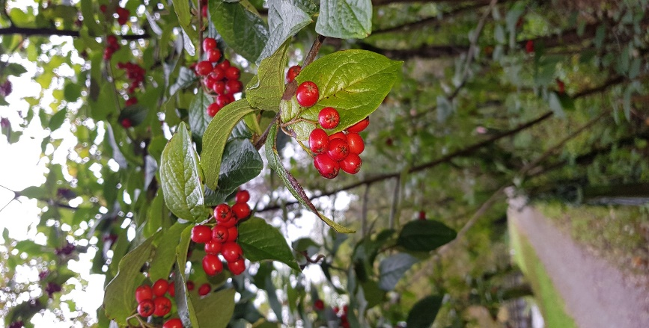

Fig 7. Cotoneaster lacteus in berry
Common species of flora and fauna are plentiful although it is many years since a full survey has been carried out. A county notifiable species, Arabis hirsuta has been recorded as present 1994 – 1999 but not recorded since. Based on this survey and observations of the present ranger and my own observations of two site visits September and November 2019, other rare or endangered species are not recorded or evident on site. A request to get an up to date report from Aderyn at the Local Environmental Record Centre (LERC) Wales is still outstanding at the time of this report.
In the last management plan in 2004, 14% of the park was woodland, this area is largely unchanged although storm damage since has resulted in pockets of woodland being cleared with a recent one in 2018 resulting in the loss of many large mature beech. Woodland forms a vital part of the overall amenity and wildlife value of the park but at Craig y nos, has a poor age structure with little replanting over the past decades providing with limited continuity.
A significant established area of beech monoculture (Fagus sylvatica) 65 to 115 years old (Management plan 2001-2014) are growing in low lying often waterlogged ground which has not affected their growth as I would have expected. This is borne out by studies on four mature stands of beech in high water saturation conditions. (Scharnweber, T.,) Large drainage ditches dug throughout the wood take flood water back into the river watercourse which aids soil drainage after flood periods. Good levels of regeneration of beech is developing in the better lit areas following storm clearance of mature trees which should be encouraged.
However, control of the grey squirrel (Sciurus carolinensis) which is an introduced species from the United States and Canada in the period 1876 to 1929, is essential at Craig Y Nos as there is extensive damage to numerous trees including Sycamore (Acer pseudoplatanus), Oak (Quercus spp), Beech (Fagus sylvatica) and Ash (Fraxinus excelsior) causing mutilation and death of branches or even whole trees. Studies show that the damage is most extensive following a good breeding year when high numbers of juveniles enter the population.( Mayle, B.A. and Broome, A.C., 2013) The squirrels strip the bark for food and have no natural predators so numbers can grow unchecked if a constant supply of food and habitat is provided. Humane trapping, shooting or perhaps consideration of a rewilding introduction of the once resident pine marten (Martes martes) could provide a solution to this destructive forest pest, one that could provide great interest to the human visitors too. (Sheehy, E. and Lawton, C., 2014.)
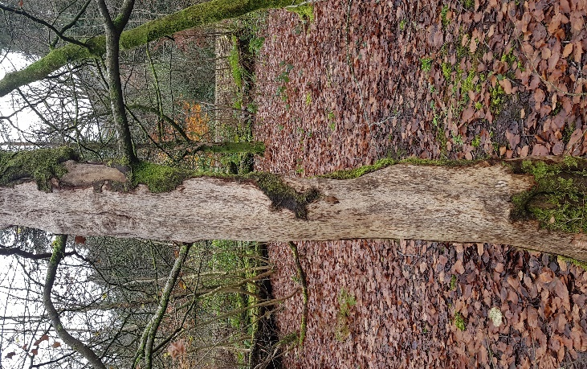

Fig 8. Grey Squirrel damage to bark on beech

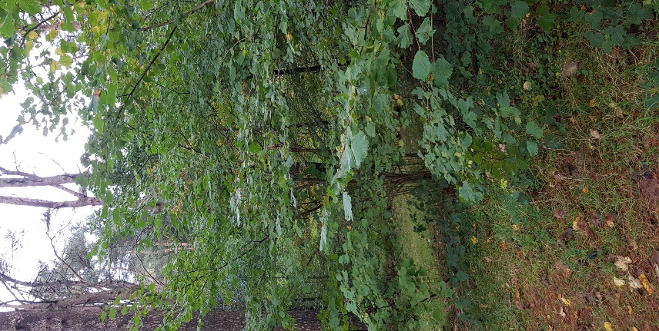

Fig 9. Regeneration of native understorey of hazel and holly under black pine

A Black Pine (Pinus nigra) glade planted as a grid plantation lies to the north of the site alongside a calm stretch of the Tawe River and is a single age structure over 120 years old. They are long lived up to 500 years but should have continuity plans built into the management of the woods. It is an important historical place as Adelina Patti found the pine infused air beneficial for her singing voice and used to stroll often through the trees. Individuals and small groups of mature pine have blown over leaving clear areas without canopy within the wood which are allowing a valuable understorey of hazel and holly to establish providing valuable habitat for a wide variety of birds. This should be encouraged to continue with thinning of the understory as necessary as it develops.
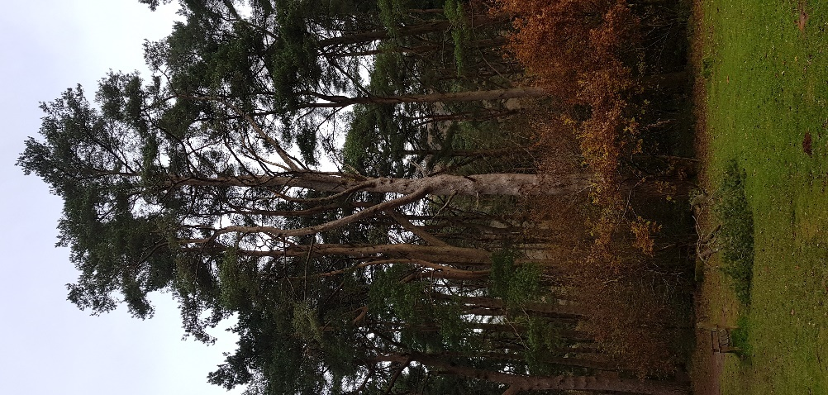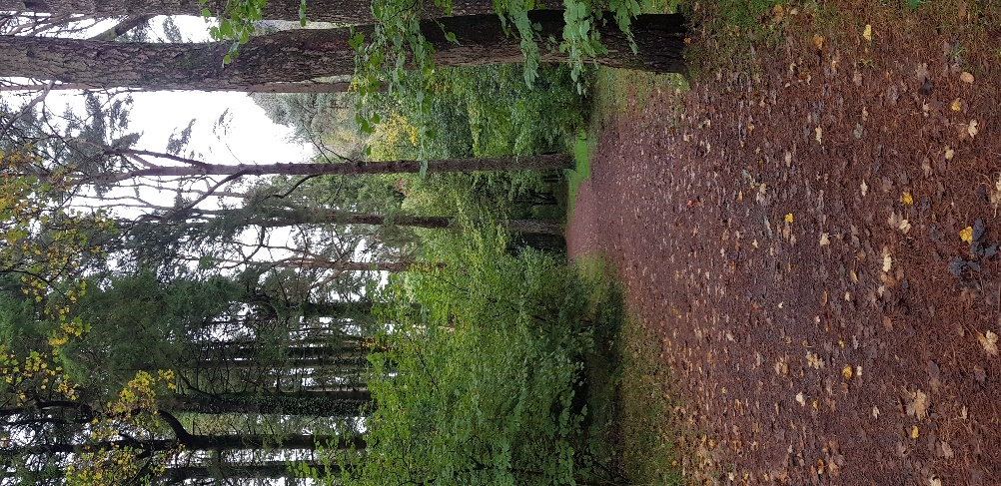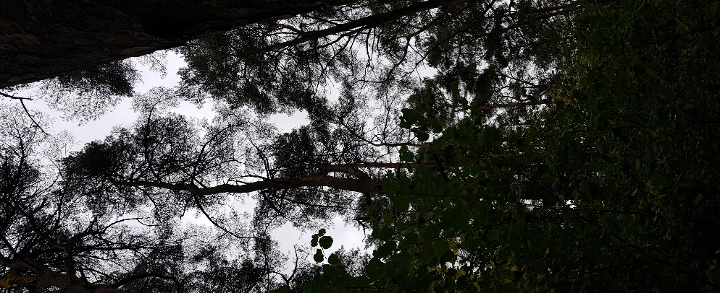
Fig 10. A collection of images showing the black pine woods
A pine tree planting programme should be instigated in 2020 with a planting of 100 trees with option of naming it Centenary Woodland celebrating one hundred years since Adelina Patti’s death in 1919. This planting should be repeated every fifty years to help with the age structure balance in the future.
The continued control of Rhododendron ponticum is essential by cutting top growth and either winching the stumps out of the ground or treating with ammonium sulphamate or Glyphosate to prevent regrowth. This is an invasive species that will continue to spread throughout the park if left unchecked to the detriment of most of the flora and fauna. (Evans & Becker, 1988)
The importance of dead wood to woodland processes is increasingly being recognised. Fortunately, neglected woodlands are slow to decline and can tolerate limited maintenance for a decade or more without serious problem. Planning for woodland should be for the long term, at least a century. For good habitat for wildlife and for timber products, woodlands need to be managed to maintain some open clearings and to ensure a wide range of tree species of various age stands to provide mixed habitats and continuity of the woodland. Mature trees and dead wood are valuable for epiphytic fungi including lichens, ferns, bryophytes and fungi, particularly in sites with high humidity and rainfall with relatively clean air such as Craig Y Nos. Good host trees include oak (Quercus spp), Ash (Fraxinus excelsior), Beech (Fagus sylvatica) and elm (Ulmus spp). (Harding & Rose, 1986)
Any grassy clearings are valued as much as the woods themselves for biodiversity providing essential habitat for many species of flowering plants, invertebrates such as butterfly, moth, beetle and spider and other animals including bank voles (Myodes glareolus), common shrew(Sorex araneus), red fox (Vulpes vulpes) and birds such as tawny owls (Strix aluco) and barn owls (Tyto alba).(Peterkin, 1993)
Visitor numbers are very consistent with 176,000 in 2017 and 176,000 in 2018 with similar numbers to date in 2019. The importance to people’s mental and physical health is becoming more recognized in the 21st century and The Wellbeing of Future Generations Act (Wales) 2015 has made it mandatory that public bodies in Wales plan and deliver services that help maintain and enhance all visitors, staff and volunteers wellbeing.

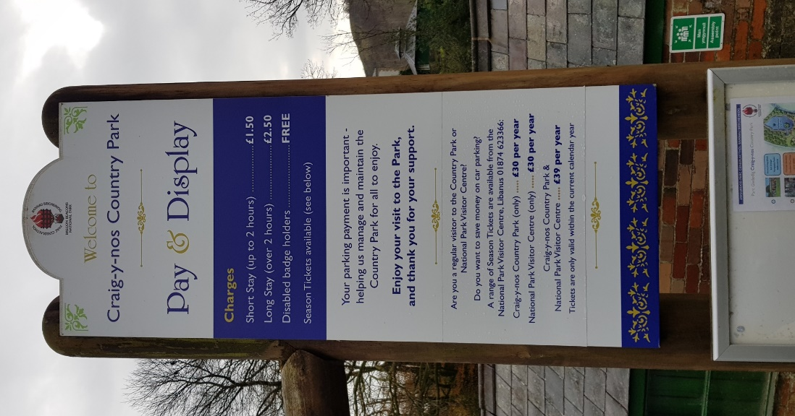
Fig 11. Car parking sign
Car park income has increased from £19,000 2017 to £22,000 in 2018 with similar pattern to date in 2019. However, there are only 21 season ticket holders in 2019. This should be encouraged to increase with a target of 300, this figure based on a similar 60-acre venue in Pembrokeshire, Scolton Manor Country Park which has over 300 season ticket holders with only 100,000 visitors/p.a. (Mark Thomas)
This would generate an additional £9,000 income for the park and Friends of Craig Y Nos could be galvanized to lead this promotion and create a database for future marketing of Craig y Nos. The website is informative but needs updating. www.breconbeacons.org/craig-y-nos-country-park

Conclusion
Craig y Nos is a valuable asset for Brecon Beacons National Park providing semi wild space where people can spend time walking freely in clean air, amongst impressive natural features including rivers, woodland, meadows and flora and fauna. This benefits the local community and the wider population of south Wales as these public spaces provide essential space for individual’s wellbeing, improving physical and mental health and social opportunities to take part in volunteering or on organised outdoor activities. It is beneficial in helping to meet our net zero carbon targets to slow down global warming with carbon sequestration from all the flora on site. It also provides an important attraction for tourism from at home and abroad benefiting the local economy.
The recommendations in this summary are relatively low cost and can be delivered with the small workforce that is available. They help provide continuity of the historic garden and parkland well into the twenty first century.

References
Evans, C.E. and Becker, D., 1988. Rhododendron control on RSPB reserves. RSPB Conservation Review, 2, pp.54-56.
Harding, P.T. and Rose, F., 1986. Pasture-woodlands in lowland Britain: a review of their importance for wildlife conservation. Institute of Terrestrial Ecology.
Jenkins, R., 2019
Manthey, M. and Wilmking, M., 2013. Differential radial growth patterns between beech (Fagus sylvatica L.) and oak (Quercus robur L.) on periodically waterlogged soils. Tree physiology, 33(4), pp.425-437.
Mayle, B.A. and Broome, A.C., 2013. Changes in the impact and control of an invasive alien: the grey squirrel (Sciurus carolinensis) in Great Britain, as determined from regional surveys. Pest management science, 69(3), pp.323-333.
Peterken, G.F., 1993. Woodland conservation and management. Springer Science & Business Media.
Sheehy, E. and Lawton, C., 2014. Population crash in an invasive species following the recovery of a native predator: the case of the American grey squirrel and the European pine marten in Ireland. Biodiversity and conservation, 23(3), pp.753-774.
Thomas, M., 2019. Scolton Manor Country Park
www.breconbeacons.org/craig-y-nos-country-park
https://www.nidirect.gov.uk/articles/access-to-everyday-services

