Programme: BA Business Management
Module: Management Economics
Module code: LCBB5008

Component-1 Essay
Submitted By: Cristian Pintilei
Student ID: 2126371

Contents
Recent Challenges and Opportunities for UK Haulage Industry 4
Challenges faced by Haulage Industry UK 4
Brexit 4
Shortage of Drivers 5
Fuel Prices 5
Regulatory Restrictions 5
Infrastructure Development 6
Opportunities for Haulage Industry UK 6
An E-Commerce Shift 6
Outsourcing Trend 6
Boost in International Trade 6
Technological Up gradation 7
Sustainability Awareness 7
Profit Maximization Theory in light of the UK Road Haulage 7
Demand and Supply Analysis 8
Pricing policy 8
Optimum Utilization of Resource 9
Cost Management 9
Risk Management 9
Capital Expansion 9
Economic Theories Application on UK Haulage Industry 10
Demand and Supply Theory 10
If Supply Increases 10
If Demand Increases 11
If Demand and Supply are Equal 11
Business Environment and Market Structure for UK Haulage Industry 11
Business Objectives 12
Stakeholders Issues 12
Conclusion and Recommendations 12
Bibliography 13

UK ROAD HAULAGE SERVICES-An Economic Analysis
A haulage service is a transportation service between two cities, states, or countries for the transport of goods of any type. This is normally for long distance transportation by road that carries goods. In UK, various haulage services are operating with a difference of work magnitude (Robert Mason, 2007). Some transport the goods within city while some are operating internationally. Cost incurred, efficiency of transportation and reliability are the factors on which any haulage service is analyzed (Bouyes, 2004). Haulage service is mandatory for businesses that need to transport its goods from one location to another and with emergence of E-commerce, need for such services have been increasing (Lalwani, 2004). Globalization and E-commerce has made the haulage industry to grow, attracting more investments and demanding for innovations for the industry to grow. Innovations in the industry involve ROS (Route optimization software), GPS, telemetric (Julian, 2018). These have been used for efficient haulage operations.

Recent Challenges and Opportunities for UK Haulage Industry
Haulage industry of UK has been under various economical and technological changes since a few years such as emergence of e-commerce, emerging concept of outsourcing and most importantly Brexit (Paraskevadakis, 2022). Some of these events have made the Haulage industry operation challenging but at the same time, business has been open to new opportunities to grow (Markus, 2016). Following done is some research into challenges faced and opportunities discovered by Haulage industry of UK.

Challenges faced by Haulage Industry UK
In recent dew years, Haulage industry of UK has been under various economical, technological and regulatory changes putting industrial operations in a challenging situation (Robert Mason, 2007). Following analyzed are some challenges;

Brexit
Brexit is the event when UK decided to leave European Union and have its own separate identity in terms of trade and decision formulation (Arnorsson, 2018). Although this might be a good decision for country’s global position, but for businesses it came up with taxes and duties for trade. When UK was a part of EU, it was duty free to move in country that was a part of EU (Sampson, 2022). This Brexist has been impacting specially for Haulage business, as this business deals with transportation and moving across the borders. The increased duties and taxes have made haulage services to increase their charges (Tarrant, 2018). So since 2020, when Brexit happened, businesses have been facing a new challenge of managing the new costs of duties and taxes along with the business profit (Bouyes, 2004).

Shortage of Drivers
A very big issue being faced by haulage industry of UK is the shortage of drivers (Ji-Hyland, 2022). This is somehow related to Brexit. Many of haulage companies of UK had been working with EU nationals as drivers but with Brexit, they have lost their employee pool (Marchington, 2003). Haulage industry is facing aging workforce issues, as their employee bank has been reduced to UK nationals only. This shortage of drivers has made companies to retain trained drivers making the drivers retention cost increase (Beresford, 2003). This issue has also been a cause for delays in orders placed with haulage companies.

Fuel Prices
Haulage industry is highly dependent upon the fuel prices. A fluctuation in fuel prices puts profit margins of haulage companies in question (Beresford, 2003). Increasing fuel prices with changes global dynamics adversely impact the operating expenses of the business ultimately reducing the net profit for the company. Global political situation have put more duties and taxes to fuel import and export (Whiteing, 2017). Ongoing wars in Ukraine and Palestine and previous wars in Iraq, Syria and Afghanistan has badly impacted the global fuel market. Such unpredictable political situations have made fuel industry volatile, making a rise in fuel prices anytime (Rietveld, 2005).

Regulatory Restrictions
Brexit has placed various regulatory restrictions in haulage business of UK that it needs extra tax and duty to move across the EU, it was not the situation before (Arnorsson, 2018). Apart from these restrictions and situations, UK has its own very strict regulations regarding transportation business (Bayliss, 1986). These regulations include pollution emission standards, the workplace environment for work hours for drivers, the payment regulations and safety protocols such as insurance. Complying with these regulations is a challenge in itself (Button, 1983). A safety and health protocol for the drivers needs to be followed strictly as they are the key person in the Haulage business.

Infrastructure Development
There is a need for infrastructural development in UK for a better haulage operation. The industry should work with government to upgrade the infrastructure so that haulage services could be improved (Bayliss, 1986). These infrastructural issues are causing delays in deliveries, more oil and fuel consumptions, and an increase in operating expenses (Mackie, 2005). This is a challenge for haulage industry to overcome these infrastructural issues as it needs a huge development that cannot be carried out without the help of government and all the stakeholders involved (Marchington, 2003).

Opportunities for Haulage Industry UK
There are certain opportunities that have been created with passing time for haulage industry of UK. Following given are some identified opportunities;

An E-Commerce Shift
With changing global dynamics, online buying is overcoming the offline buying pattern and this has made world shift to e-commerce (Julian, 2018). With this online buying shift, an opportunity has been created for haulage service providers as these online buying needs their bought good to be transported to them by some trusted transportation company (Markus, 2016). Producers need reliable, efficient and cost effective solution for their business. The goods producers then send these articles bought online through these haulage companies.

Outsourcing Trend
A new concept in the business world is outsourcing that is making contract with some outside specialized organization instead of developing this new service with the business (Rafiq., 2005). Contracting with haulage companies is an example, instead of developing own delivery service, business contract with these transportation companies for the delivery of their goods (Button, 1983). This saves with incurring cost in developing a whole new department and generate business for outside haulage industry. Haulage companies needs to identify and exploit these outsourcing opportunities (Kakabadse, 2005).

Boost in International Trade
With increase in e-commerce activities, whole world is just a click away from customers. One can buy goods from Australia while sitting in UK. This international buying has given a boost in haulage service usage (Julian, 2018). Apart from that a boost in international trades in recent times has identified the importance and need of haulage industry of the country, creating an opportunity for the business to grow (Lalwani, 2004).
To avail such opportunities, haulage industry needs to comply the international trade regulations. Although Brexit has impacted such trade opportunities from EU for UK adversely, but increase in international trade present various such opportunities for haulage service providers of UK (Arnorsson, 2018).

Technological Up gradation
Things are getting advance with passage of time, similarly there has been various technological developments in Haulage industry as it is creating a growth opportunity for business increasing the trust of customers. Innovations in the industry involve ROS (Route optimization software), GPS, telemetric (Sindi, 2021). These have been used for efficient haulage operations as customers can easily track their order in transit (Evangelista, 2014). These technological up gradation has helped the business increase its efficiency, improvement in customer support services and reducing the costs being incurred in keeping the track of order by company (Mackie, 2005).

Sustainability Awareness
World has been shifting to sustainable future, making things work in coordination with environment. Haulage industry showing an environment sensitive side of it can gain more customers trust (Beresford A. K., 2003). It will make more potential customers to opt using the haulage service instead of other available options.
Haulage Company should plan to shift to hybrid or electric transport system that would least impact the environment (Teixeira, 2021). It will serve a dual purpose, one is the environment sustainability and other is gaining trust in eyes of customers as socially responsible organization (Pöllänen, 2021).

Profit Maximization Theory in light of the UK Road Haulage
Profit Maximization theory describes that the basic motive of any business is to achieve the highest profit margins and to minimize the costs being incurred (Jafar, 2010). The level of sales where marginal revenue equalizes the marginal cost is the point of profit maximization (Brueckner, 2013).
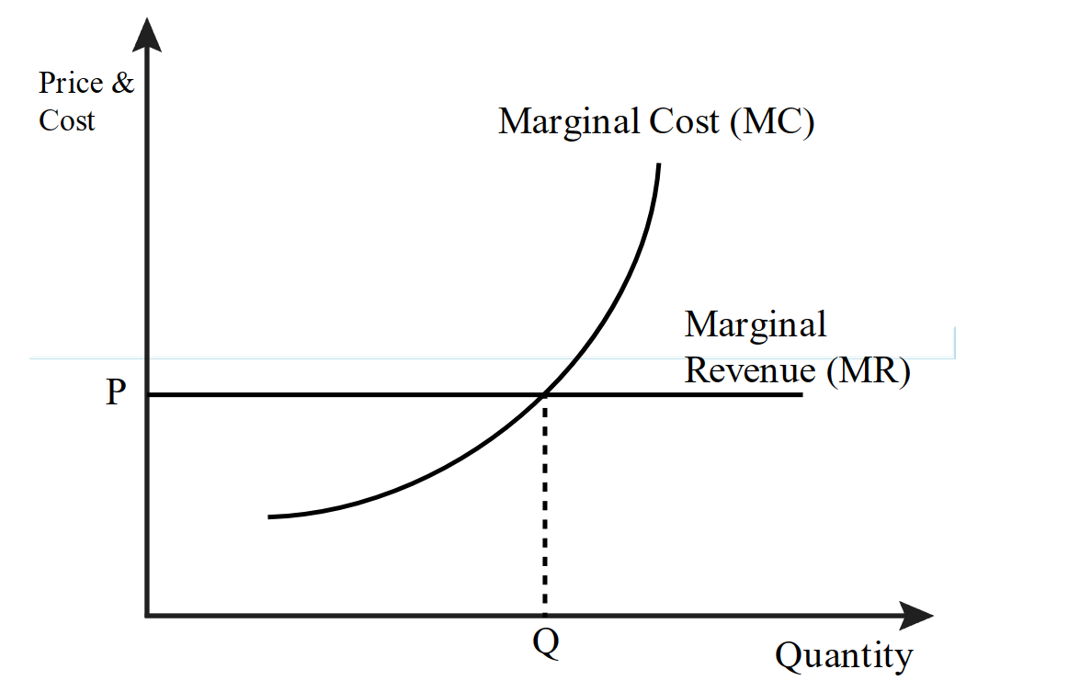

Like

any other business, there is a motive of profit maximization in Haulage service industry. Application of profit maximization theory in the light of UK haulage industry needs to focus on following factors that can give a boost to profit maximization and controlling the costs being incurred.

Demand and Supply Analysis
Like any other company, haulage companies need to understand the demand and supply rule for the business and market dynamics. More demand means more sales and a boost in profit at the same time it needs more supply (Cook, 2017). In Haulage business, companies need understand the amount and nature of goods ordered to be transported. Nature of goods is attributed by the fact that perishable goods need some extra arrangement while being transported such as refrigerators etc that needs an extra cost to be incurred (Lillo, 2005). Customer preferences and the volume of demand in certain periods of time such as Christmas should be analyzed based on previous market data available. This would make the business tackle all the increasing demand and maximize its profits (Farmer, 2008).

Pricing policy
Price of anything includes the cost incurred in a product and a margin of profit in it. Based on the demand in the market and availability of other market players, business should set the price of haulage service provided (Potter, 2007). Setting the optimal price should serve the dual purpose, it should generate a good profit margin for business at the same time it should be balanced enough, so that it could attract new customers. While pricing a product, haulage companies should consider the fact of price fluctuation.
Prices should be flexible to offer discounts at events and for bulk shipments. Such discounts can connect customers with company and it can also attract more business to the company increasing the net profit for the business.

Optimum Utilization of Resource
Optimum use of available resources either its financial resources or human resource is crucial to profit margins of business. Resources used at their optimum level can generate maximum possible profit for business (Beresford A. K., 2003). In case of Haulage industry, companies need to ensure that vehicles being used are fully utilized, delivering maximum of deliveries of the same route. It also needs to optimize the use of human resource to efficiently delivering the goods on time (Ji-Hyland, 2022). It would spread the fixed costs on a large number of goods being transported. That would ultimately increase the profit margins for business.

Cost Management
Most important factor in maximizing the profit is minimizing the costs. This is characterized by an efficient cost management (Mackie, 2005). In case of Haulage industry, cost management means controlling expenses such as fuel prices, insurance costs, administrative costs, human resource costs. Strategies should be formulated to use fuel efficient vehicles that would reduce cost of fuel, and fixed assets depreciation (Farmer, 2008). Companies should also make negotiations with suppliers about spreading the transportation costs or insurance costs.

Risk Management
For the purpose of risk management there is a need for risk management strategies to be formulated. In case of Haulage industry, risk is all about the fluctuation in prices and another factor is fluctuation in currency rates especially when international goods transportation is involved (Bayliss, 1986). Risk management strategies for natural disasters should also be formulated and should be communicated to all the stakeholders including customers and suppliers. If not formulated, these risk factors can impact profit margins of business adversely (Marchington, 2003).

Capital Expansion
In order to match the pace of dynamic global business activities, haulage industry needs to invest in many areas such as technology, fixed assets and route optimization (Bayliss, 1986). All of these factors as k for a capital expansion that would ultimately add up in the profit of business. Investing in technologies like route optimizing software, tracking system etc would increase the company worth in the eyes of customers making it a priority in the eyes of customers and suppliers (Beresford A. K., 2003). Similarly investing in fixed assets such as transport fleets would increase business for industry that is an ultimate add up in net profit of business. Investing in fleets’ expansion can explore various new opportunities in new markets for the business (Beresford A. K., 2003).

Economic Theories Application on UK Haulage Industry
Demand and Supply theory along with other environmental analysis has been done for UK haulage industry.

Demand and Supply Theory
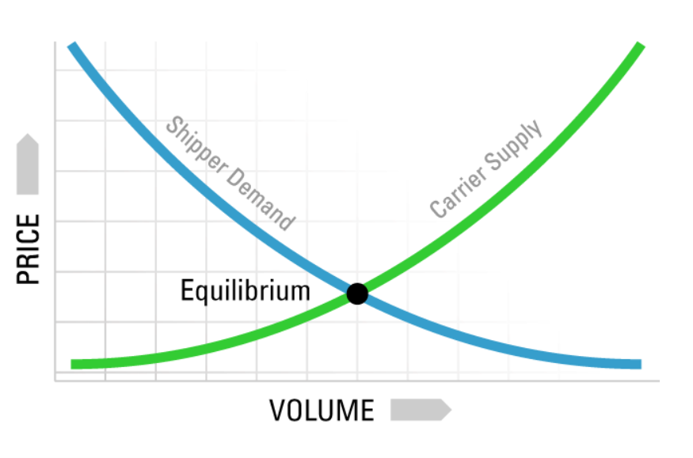
In Haulage industry of UK, Demand and supply forces correlated with the economic conditions of the country and globally (Farmer, 2008).

If Supply Increases
If the Haulage industry has more players than the shippers available in market, this would be considered as loose market. Shippers would decide the price in this scenario.

If Demand Increases
When there are more shippers in the market and a few haulage companies, the price setting power goes in the hands of transport companies. This situation is known as tight market.

If Demand and Supply are Equal
When both the parties, shipper and Transporters are equal and both decide price with mutual consent, such situation is known as market equilibrium.

Business Environment and Market Structure for UK Haulage Industry
In UK, Haulage industry has a huge market, earning about £13.5 billion to country. It has a huge workforce employed there (Stats, 2021). Business environment for Haulage industry is very favorable as emergence of E-commerce has given a boost to industry generating various growth opportunities for the business (Evangelista, 2014).
UK Haulage market is an example of perfect competition, where there are various shippers and haulage companies as well (Monios, 2018). Both the parties decide the price of service to be delivered by Haulage Company.
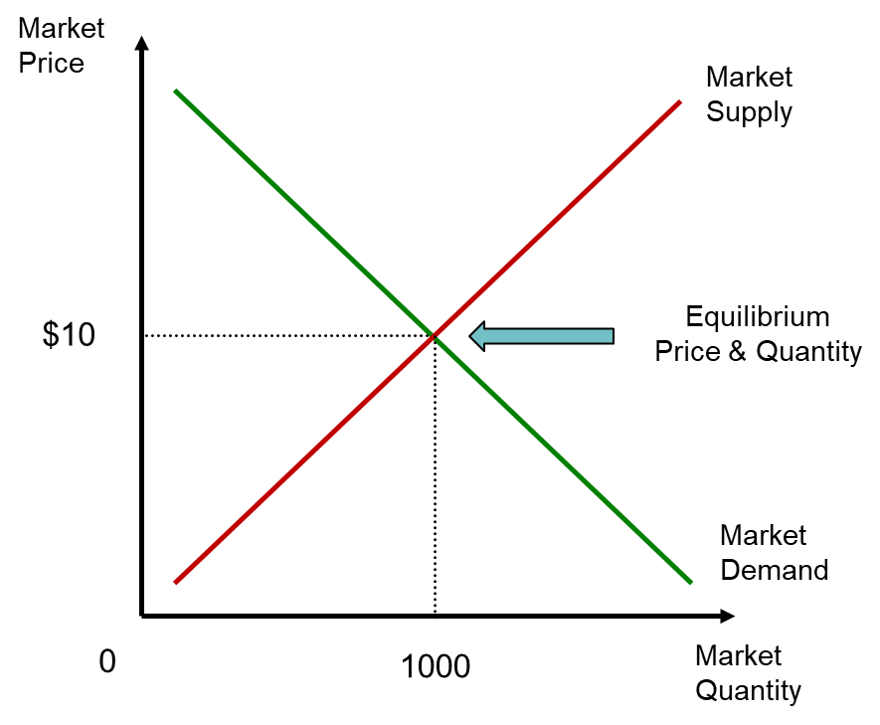

The graph above shows a equilibrium position where supply is meeting demand, same is the situation in UK haulage industry, the service providers are equal to number of shippers and it is giving a true picture of perfect competition (Laroche, 2017). With globalization and increasing trend of online shopping is creating an opportunity for business and turning this perfect competition situation to oligopoly were haulage industry would be the price setter with so many shippers in the market (Bayliss, 1986). It will create opportunity for new buyers to enter the market.

Business Objectives
The basic motive of any company is profit maximization, apart from that, following designed are certain business objectives for Haulage industry, to meet future demands and to groom in its space;
- Cost reduction in long run
- Fleet development
- Improving the customer services
- Exploiting the Haulage Industry Opportunity
- Deep Market analysis
These objectives are need of time and haulage companies should have a strategy for implementing and achieving these objectives.

Stakeholders Issues
Stakeholders for a haulage industry are the customers, shippers, society and planet. There are certain issues that are encountered by stakeholders’;
- Late deliveries
- Driver and employees’ health and safety
- Interdependency of suppliers and haulage companies
- Increased pollution emission from the transport vehicles putting environment on stake
All these issues are to be managed well by the haulage companies otherwise these can be a hurdle on the way of profit maximization.

Conclusion and Recommendations
The report discusses a complete analysis of challenges and opportunities of Haulage industry of UK. They have many opportunities to be exploited, and still are facing many challenges. Demand and supply theory is applied in light of haulage industry of UK, keeping in view the stakeholders issues and market structure. Following are certain suggestion on the base of this report for haulage industry of UK;
- Industry should consider the carbon footprints of the transport business that is putting environment on stake, the solution for it is to shift towards the hybrid transportation.
- Haulage industry must make provisions for covering the same route in one visit, this can be managed using software giving insight of all the parcels of same area. It would reduce the cost of fuel consumption and ultimately business costs.
- Currently the market is experiencing perfect competition but is going towards oligopoly as the whole is shifting towards online buying and selling. Companies need to make provisions for it.
- Haulage companies should offer driver training programs, that would ultimately cope with driver shortage business is facing.

Bibliography
Arnorsson, A. a. (2018). On the causes of Brexit. European Journal of Political Economy , 301-323.
Bayliss, B. T. (1986). The structure of the road haulage industry in the United Kingdom, and optimum scale. Journal of transport economics and policy , 153-172.
Beresford, A. K. (2003). "Use of alternative fuels in the UK road haulage industry. In Proceedings of the Institution of Civil Engineers-Municipal Engineer , 11-17.
Beresford, A. K. (2003). Use of alternative fuels in the UK road haulage industry. In Proceedings of the Institution of Civil Engineers-Municipal Engineer , 11-17.
Bouyes, G. (2004). The British Road Haulage Industry since 1954. JOURNAL-RAILWAY AND CANAL HISTORICAL SOCIETY , 514-524.
Brueckner, M. (2013). Profit maximization. Encyclopedia of Corporate Social Responsibility .
Button, K. a. (1983). Road haulage regulation: a comparison of the Canadian, British and American approaches. Transport Reviews , 237-264.
Cook, P. J. (2017). The demand and supply of criminal opportunities. Crime Opportunity Theories .
Evangelista, P. a. (2014). "Information and communication technology adoption in the Italian road freight haulage industry. International journal of logistics systems and management , 261-282.
Farmer, R. E. (2008). Aggregate demand and supply. International Journal of Economic Theory , 77-93.
Jafar, H. I. (2010). Profit maximization theory, survival-based theory and contingency theory: a review on several underlying research theories of corporate turnaround. Jurnal Ekonom .
Ji-Hyland, C. a. (2022). What do professional drivers think about their profession? An examination of factors contributing to the driver shortage. International Journal of Logistics Research and Applications , 231-246.
Julian, M. P. (2018). Understanding the impact of e-commerce on last-mile light goods vehicle activity in urban areas: The case of London. Transportation Research Part D: Transport and Environment , 325-338.
Kakabadse, A. a. (2005). Outsourcing: current and future trends. Thunderbird international business review , 183-204.
Lalwani, C. (2004). Internet use by UK general haulage companies. In Proceedings of the 9th International Symposium on Logistics , 385-391.
Laroche, F. C. (2017). Imperfect competition in a network industry: The case of the European rail freight market. Transport Policy , 53-61.
Lillo, F. S. (2005). Theory for long memory in supply and demand. Physical review .
Mackie, P. J. (2005). Sources of Operating Costs.
Marchington, M. M. (2003). Labour scarcity and the survival of small firms: a resource‐based view of the road haulage industry. Human Resource Management Journal , 5-22.
Markus, G. B. (2016). Opportunities and Challenges of Rail Haulage Systems in Current Mining Operations. Engineering and Mining Journal , 42.
Monios, J. a. (2018). The Economics of intermodal freight transport. ResearchGate .
Paraskevadakis, D. a. (2022). An industry-level analysis of the post-Brexit and post-Covid 19 Ro-Ro ferry market and critical maritime freight transport links between the UK and the EU. Journal of Shipping and Trade , 1-33.
Pöllänen, M. T. (2021). Is there progress towards environmental sustainability among road haulage companies?. Sustainability , 5845.
Potter, A. R. (2007). Analysis of factory gate pricing in the UK grocery supply chain. International Journal of Retail & Distribution Management , 821-834.
Rafiq., M. (2005). Logistics outsourcing practices in the UK: a survey. International Journal of Logistics: Research and Applications , 299-312.
Rietveld, P. a. (2005). Why fuel prices differ. Energy Economics , 79-92.
Robert Mason, a. C. (2007). Assessing the impact of ICT on UK general haulage companies. International Journal of Production Economics , 12-27.
Sampson, T. (2022). Expecting brexit. Annual Review of Economics , 495-519.
Sindi, S. a. (2021). Implementing commercial autonomous road haulage in freight operations: An industry perspective. Transportation Research Part A: Policy and Practice , 235-253.
Stats, R. H. (2021). Road Haulage Facts and Stats. Retrieved Feb 29, 2024, from www.rha.uk.com: https://www.rha.uk.net/News/Road-Haulage-Facts-and-Stats#:~:text=57%20million%20people%20work%20in,freight%20businesses%20in%20the%20UK.
Tarrant, A. N. (2018). "Brexit and the UK’s services trade.
Teixeira, A. C. (2021). Alternative fuel technologies emissions for road heavy-duty trucks: a review. Environmental Science and Pollution Research , 20954-20969.
Whiteing, T. M. (2017). Effective fuel management in road transport fleets. Transport lessons from the fuel tax protests of 2000 , 205-219.

