  Component One:  What are the key skills required when working in the housekeeping team? 750 words (+/- 10%)  Contribution to Overall Module Assessment: 25% | Student No: | 2129006
 | Module Title: | Operating Hotel Facilities
 | Module Code: | BMIH4006
 | Lecturer: | Lisa Bassler, BA (Hons)
Housekeeping is part of the Operational Department of a hotel and it is responsible for one of the most important pillars of the lodging business, which is maintaining cleanliness and hygiene in all areas of the property. These areas are: guest rooms/ floors, public areas, back-of-the-house areas, linen and uniforms rooms laundry (if it is on-premises), pools, etc. Working in this department is an appealing way to start a career in hospitality, because it offers the chance to work with people having various backgrounds, it’s flexible and it gives the opportunity to grow. However, working in housekeeping involves plenty of hard and soft skills and even if it doesn’t require a strong educational background, it still demands professional training and personal abilities.
The purpose of my student log is to maintain a record of my academic performance in the Operating Hotel Facilities module and, more precisely, to reflect on the essential skills required in order to successfully perform in the housekeeping team.
In order to establish the set of needed skills, this journal will first establish the duties that a housekeeper must complete and the departments with which he/ she interacts. Based on these two important factors, this paper will determine the necessary abilities which will help an employee to thrive in the housekeeping job.
A room attendant's duties involve: cleaning the rooms before and after check-out, arranging the beds, changing unclean sheets and blankets, refilling the cosmetics, taking out the trash, informing the maintenance staff about any broken equipment, or destruction, respecting the "do not disturb" messages, etc. The daily responsibilities of a public area attendant are: clearing waste bins in public areas, cleaning communal areas like entrances, restaurants and conference halls, cleaning back-of-house spaces, cleaning corridors and lifts, and informing the service department about the damaged object. Grouping, washing, drying, ironing, and arranging the laundry, clearing bedsheets with stains or fissures, operating washing and drying devices, blending and weighing soaps and handling dry cleaning within the specified timeline are among the basic duties of laundry personnel. Daily responsibilities for a housekeeping manager include organizing arrivals and departures reports, timetabling employees for the upcoming week or two, coordinating with the reception desk, attending management meetings, holding pre-shift staff meetings, answering guests' demands, addressing client service matters concerning housekeeping, utilizing technology, recording goal achievement, managing staff, and more.
The cleaning division collaborates closely with all other hotel departments, more frequently with the front desk, the food and beverage sector and the engineering department. Above all, the housekeeping staff is meeting directly with the guests, which involves customer service skills, since the client's consent is a prerequisite for their work.
The second important skill is punctuality and time management, as housekeepers frequently work alone and are required to perform a certain volume of cleanings per day. Attention to detail is a crucial skill also because a housekeeper's performance will improve as they are more meticulous in their task completion. Communication skills are also a must, as housekeepers must speak frequently with guests, colleagues, and managers. In the same time, interpersonal skills are also required, as Thomas J.A. Jones states in his book, Professional Management of Housekeeping Operations (2007, p. 38), that “rather than scheduling housekeepers on an individual basis, housekeeping teams may be formed“. Flexibility is also a skill that should be considered, as the work of a housekeeper depends on the occupancy rate, so the worker might be called for a shift on short notice time. A significant role in this job is played by the physical abilities of the housekeeper because sometimes it is required to drag large items of equipment from one place to another or reposition furniture while cleaning a room. Other housekeeping tasks may require a lot of bending and pulling, so being in reasonably decent shape may be very helpful. (Employment Development Department, 2023).
Other abilities that should be considered for a role in the housekeeping team are organization and self-discipline, trustworthiness, careful listening, trash management understanding and equipment know-how.
While some of these skills can be acquired during training and practice, other abilities are native and difficult to gain, like physical strength, for example. That is why it is very important that before deciding to embark on a housekeeping role, to accurately analyse your strengths and weaknesses, so that you choose the best professional path.
Taking into consideration the critical role of self-reflection in the process of learning, this log illustrates my comprehension of the duties of a housekeeping employee and the critical skills required in order to thrive in this department.

Word Count | 758

References

Bridger, E. (2018), Employee Engagement : A Practical Introduction, Kogan Page, 2nd Ed., available at https://web-s-ebscohost-com.ezproxy.uwtsd.ac.uk/ehost/ebookviewer/ebook/bmxlYmtfXzE4NTcwNzhfX0FO0?sid=d2e20fe0-c0b2-4e81-8691-9e4917a5b663@redis&vid=0&format=EB&rid=1, (Accessed 26 February 2023);
Employment Development Department (2023), California Occupational Guides, available at https://labormarketinfo.edd.ca.gov/Occupational-Guides.html (Accessed 1 March 2023);
Indeed (2022), Guide to Housekeeping Skills (With Tips and Examples), available at https://www.indeed.com/career-advice/career-development/housekeeping-skills, (Accessed 27 February 2023;
Thomas J.A. Jones, (2007), Professional Management of Housekeeping Operations, John Wiley & Sons, Inc., available at https://ebookcentral.proquest.com/lib/trinity/reader.action?docID=315165, (Accessed 28 February 2023;

Component Two:
Contribution to Overall Module Assessment: 25%
In this scenario – You have just been promoted to team leader for a floor within the hotel. A guest complains that on their arrival, their room had not been properly cleaned. Create an action plan and answer the following questions.

Problem | Why did it happen? | What are you going to do? | How will you prevent this from happening in the future? | What measures would you introduce to improve team effectiveness?
Ana, a loyal guest of the hotel, checks in and finds her room poorly cleaned, with dust on the furniture and an unpleasant smell in the air. | The responsible housekeeper was overloaded, being asked to make 19 rooms that day; so she didn’t have enough time to properly clean the rooms. | There are 2 layers of measures that should be taken: one in relation to the guest, and other in the relation to my colleagues (the managers and team members);  So first I will acknowledge that the problem has occurred;  I will show my empathy, because it is a known fact that “hospitality is moving from a pure service to emotion economy“ (Hospitality Insights, 2023), so empathy is a must in resolving a complain;  I will apologise and assume full and clear ownership of the problem (Johnston, 2012, p. 348); | I will report the incident to my direct manager and I will ask for one extra housekeeper on my floor; | I will introduce incentives for “perfect rooms“;
 | The housekeeping supervisor trusted the housekeeper and didn’t check the room by herself, according to the procedures. That is why that day the air freshner was not used and the dust was not noticed; | I will try to fix the problem, either alone or involving other colleagues;  I will offer compensation within the limits of my position (change the room, free taxi ride, fruit basket, etc.) | I will randomly check the rooms by myself; | I will suggest organizing weekly reviews with housekeeping managers and the team;
 |  | I will involve my direct manager | I will suggest to the management to introduce the opening of the window as mandatory procedure at the beginning of the cleaning (before entering toilets); | I will create a target for the entire team, in terms of the numbers of complains and offer incentives accordingly.
In relation with my team:
I will investigate the causes of the incident, I may apply some coercion measures if necessary, I will identify the factors that will prevent this from happening in the future and I will introduce some measures that will improve team effectiveness.

References:

Bridger, E. (2018), Employee Engagement: A Practical Introduction, Kogan Page, 2nd Ed., available at https://web-s-ebscohost-com.ezproxy.uwtsd.ac.uk/ehost/ebookviewer/ebook/bmxlYmtfXzE4NTcwNzhfX0FO0?sid=d2e20fe0-c0b2-4e81-8691-9e4917a5b663@redis&vid=0&format=EB&rid=1, (Accessed 26 February 2023);
Hospitality Insights, 2023, How to Improve Communication Skills in Hospitality Industry, available at https://hospitalityinsights.ehl.edu/communication-skills-hospitality-industry, (Accessed 26 February 2023);
Johnston, R., (2012), Service Operations Management: Improving Service Delivery, 4th Ed, Pearson Education, available at https://r1.vlereader.com/Reader?ean=9780273740490, Accessed 28 February 2023;
Vallen, G. and J., Check-In Check-Out: Managing Hotel Operations: Pearson New International Edition, Pearson Education, Limited, 2013, ProQuest Ebook Central, http://ebookcentral.proquest.com/lib/trinity/detail.action?docID=5173949 Accessed 28 February 2023;
Whitbread Online Academy (2023) available at https://academy.whitbread.co.uk/totara/dashboard/index.php?id=68, (Accessed 27 February 2023);

Component Three:
Contribution to Overall Module Assessment: 50%
Your task is to create and prepare a presentation following the detailed scenario provided below.

As the floor housekeeping manager and given the recent guest complaints you need to put together a basic training presentation for your colleagues within the housekeeping team to get the best out of them, ensure that brand standard is being achieved and that Health and Safety procedures are also being followed.

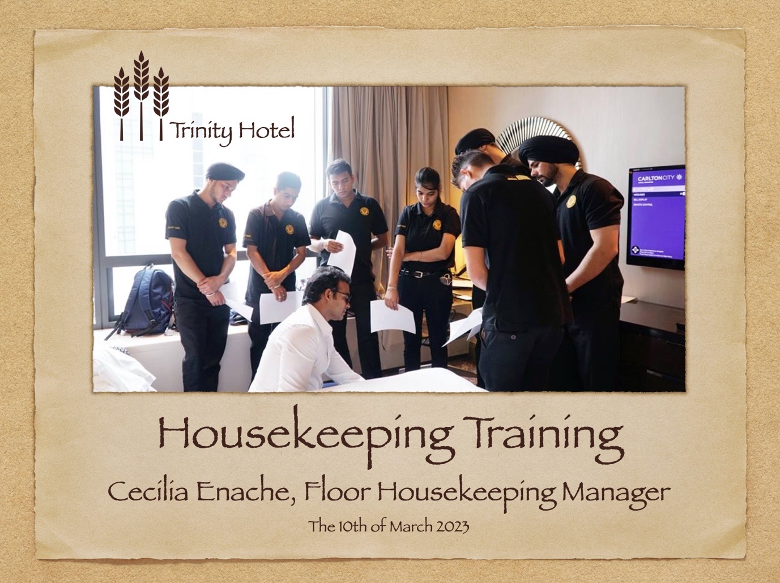

Training Notes:
Today’s training will address some existing and potential issues within the housekeeping department that are leading to guests’ complaints, it will identify the causes and it will provide solutions for better customer satisfaction;
At the end of this session, you will be able to create more value for your work, you will demonstrate a higher engagement and you will get the chance of receiving more incentives at the end of the month;
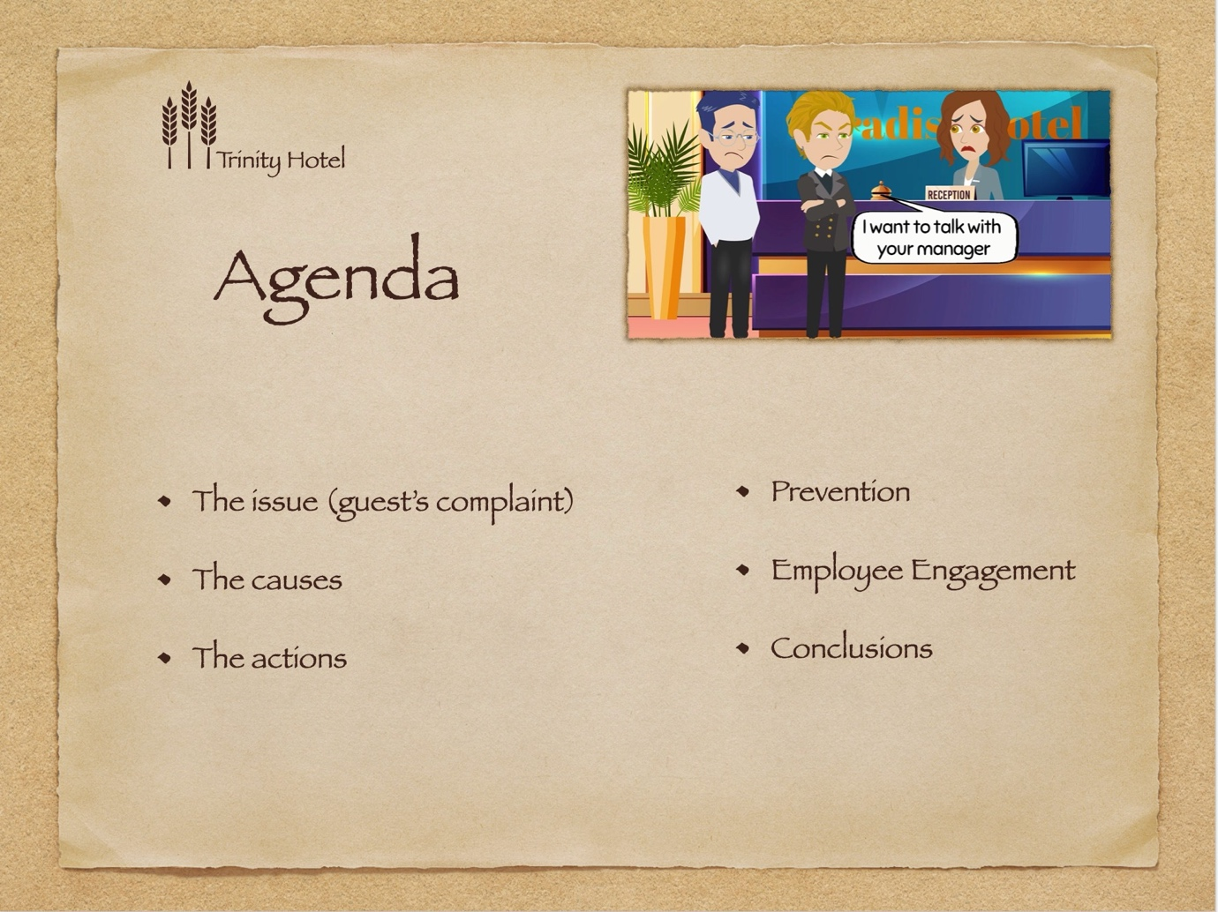

Training Notes:
For the next 20 minutes we will dive into the guest’s complaint regarding his dirty room, we will identify together the causes which actually lead to this issue, but also other potential causes that may occur in the future and we will reiterate the actions that we, as housekeepers, we must take in such situations. We will continue our learning journey finding the ways to prevent future complaints and in the last part of the training we will talk about what is motivating us in our work and how we can be better engaged in our job.
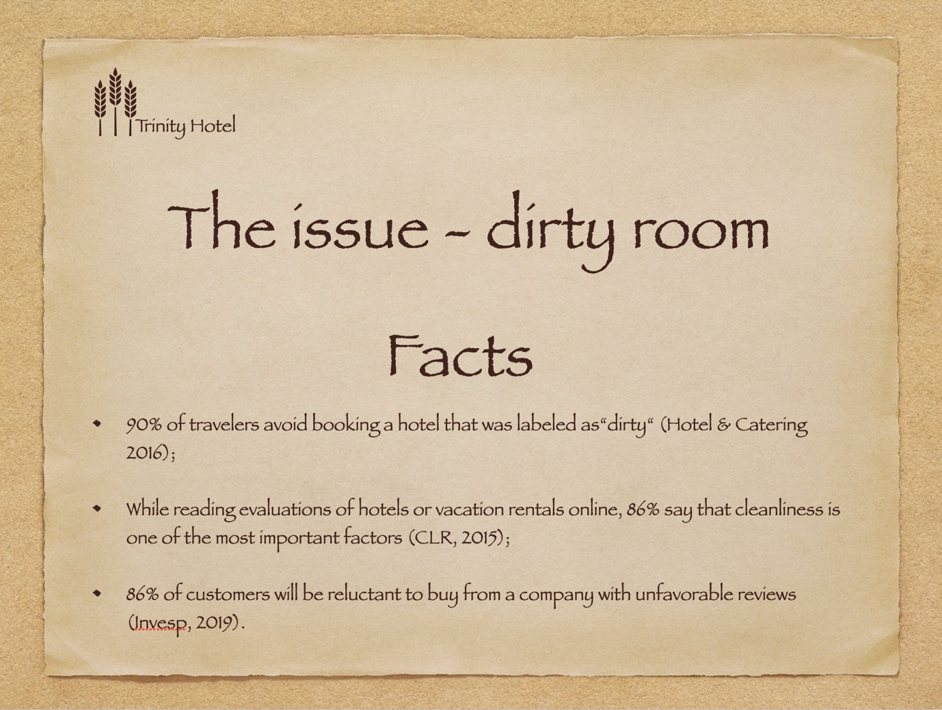

Training Notes:
One of our main priorities is cleanliness. We must always ensure that the work is done correctly.

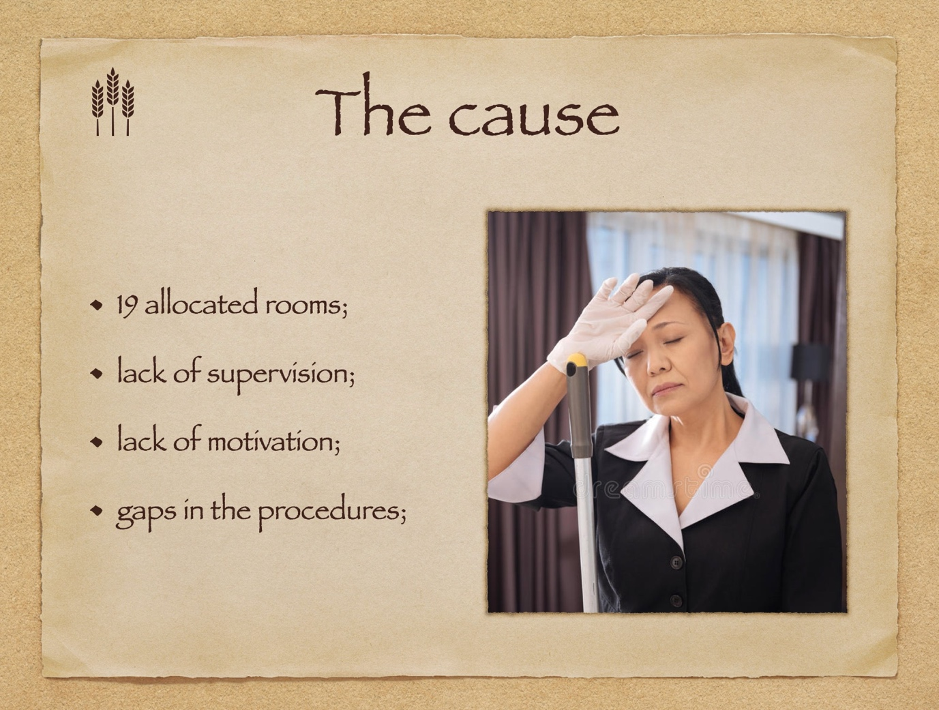

Training Notes:
Dear colleagues, let’s name together all the causes that might lead to a dirty room (the team will enumerate plenty of causes and the trainer will write those who made the present incident happen). This is how we will separate the real causes from the potential ones and approach them accordingly;

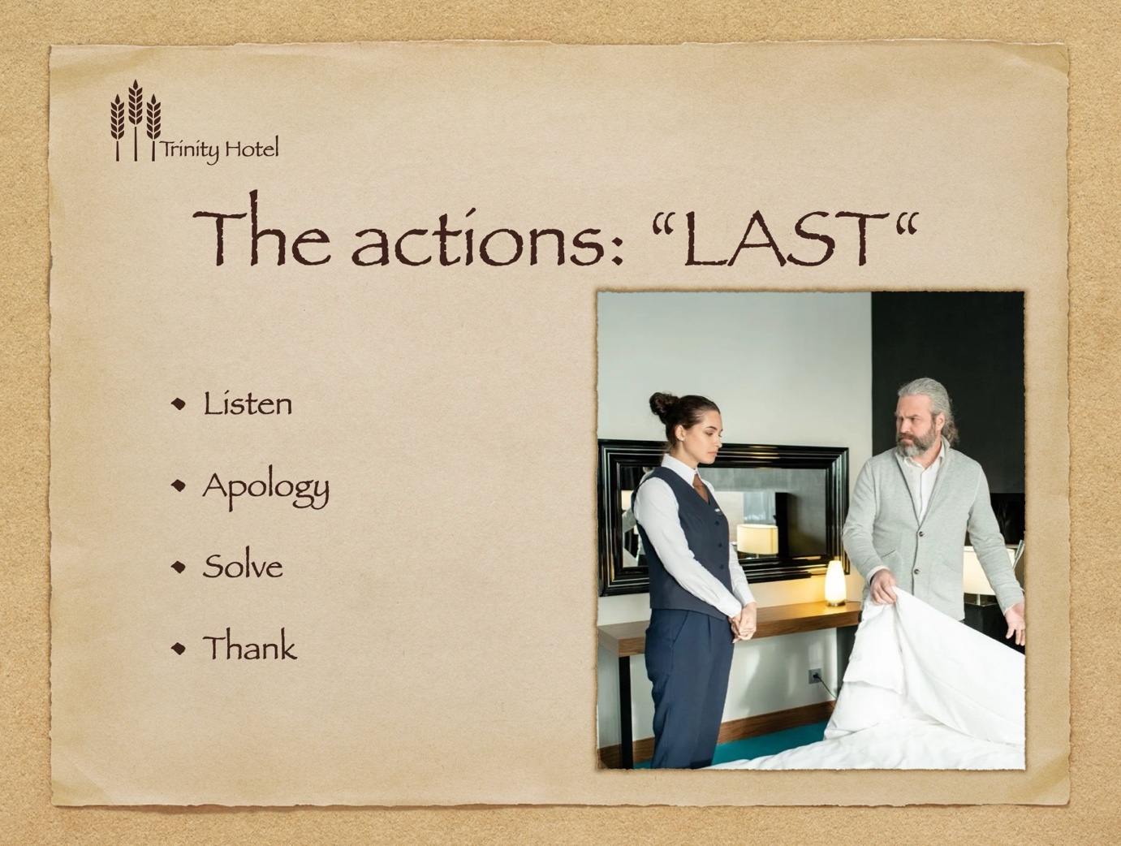

Training Notes:

Which are the steps in dealing with a complaint?
- Listen – ask the right questions, put yourself in the client’s shoes;
- Apology – take ownership of the issue;
- Solve – either by yourself or with the support of the team;
- Thank – the customer for understanding, compensate if possible, etc;
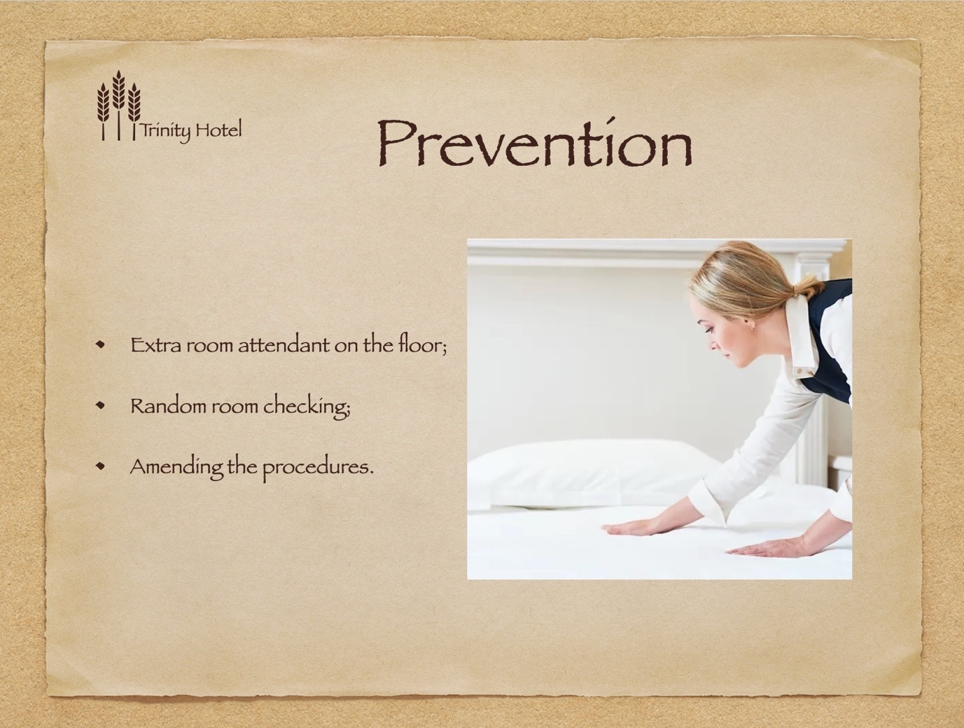

Training Notes:
The aim of this slide is to demonstrate that if we, as a team, follow the new guidelines, starting with next month the complaints in our department will decrease with 15%; (SMART Objective);
To avoid being overloaded, an extra room attendant will be soon part of our team;
The floor supervisor will plan for random checkings, to ensure that all rooms are properly made;
The odor issue made our management amend the housekeeping procedures, by introducing the opening of the window as mandatory task at the beginning of the cleaning (before entering toilets);

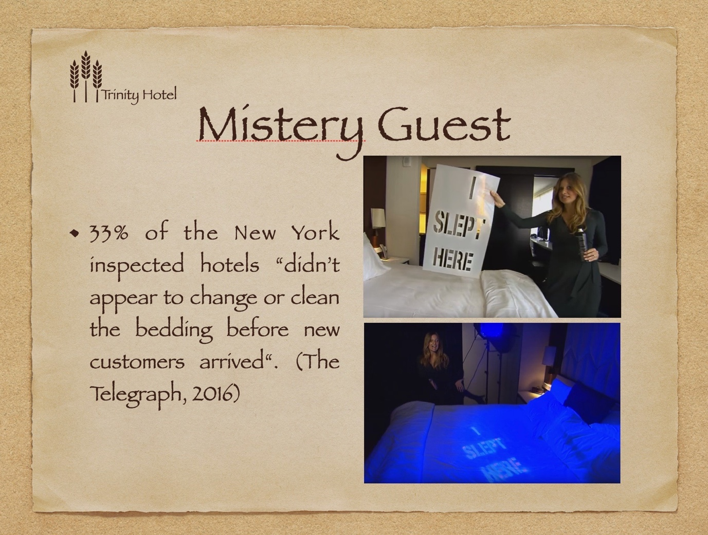

Training Notes:
If time allows, we can watch the investigation here: https://www.youtube.com/watch?v=HdbRx-Oz9mg&t=118s

When remaining at a hotel, the bedsheets might not always be clean, according to an Inside Edition investigation. The journalists went to various hotels on New York and sprayed notes on the linens with washable color that could only be seen under UV light. The following day, they made reservations for the same accommodations after checking out. The painted words remained when they turned on the UV light.
Why is it relevant to us? Imagine the impact of such reviews on Booking.com or TrivAdvisor for Trinity Hotel!

Hotel guests read 6-12 reviews before booking, according to a new TripAdvisor survey;

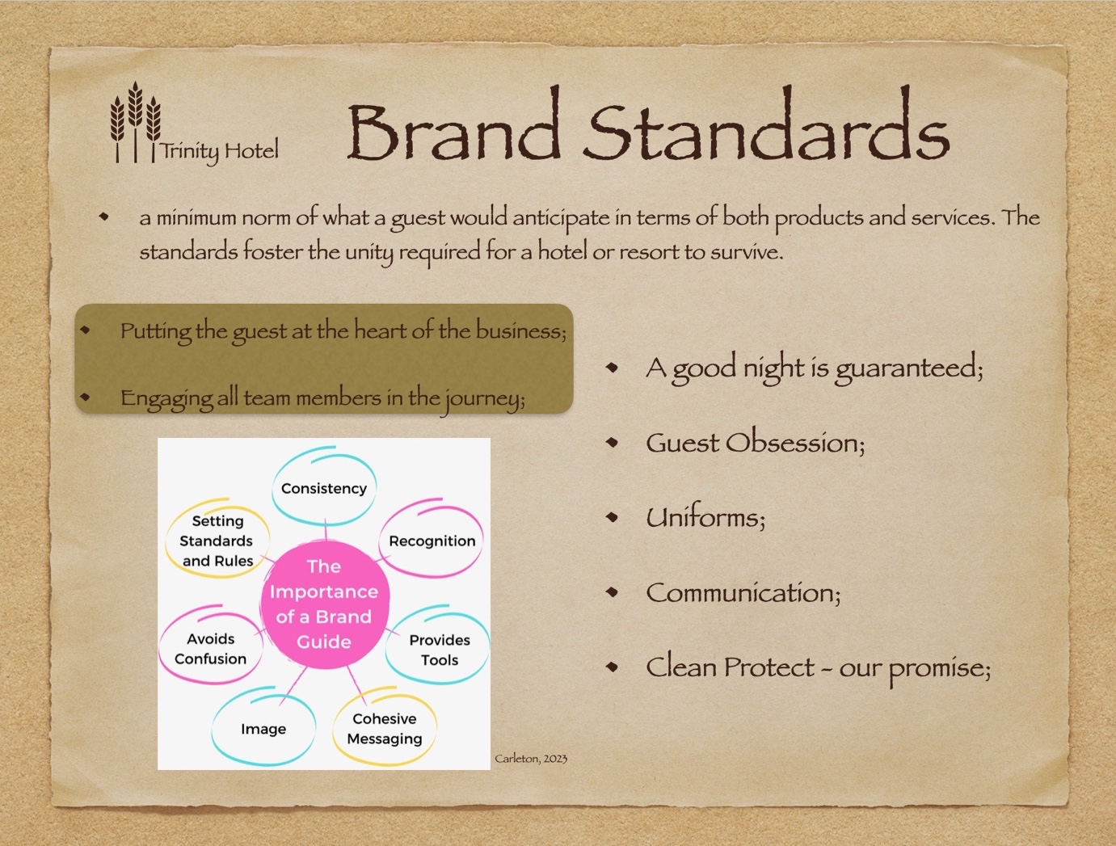

Training Notes:
This slide is just to remind us about Trinity Hotel Brand Standards, to ensure that we review them on a regular basis and that we all respect them.
Any questions related to our hotel brand standards?

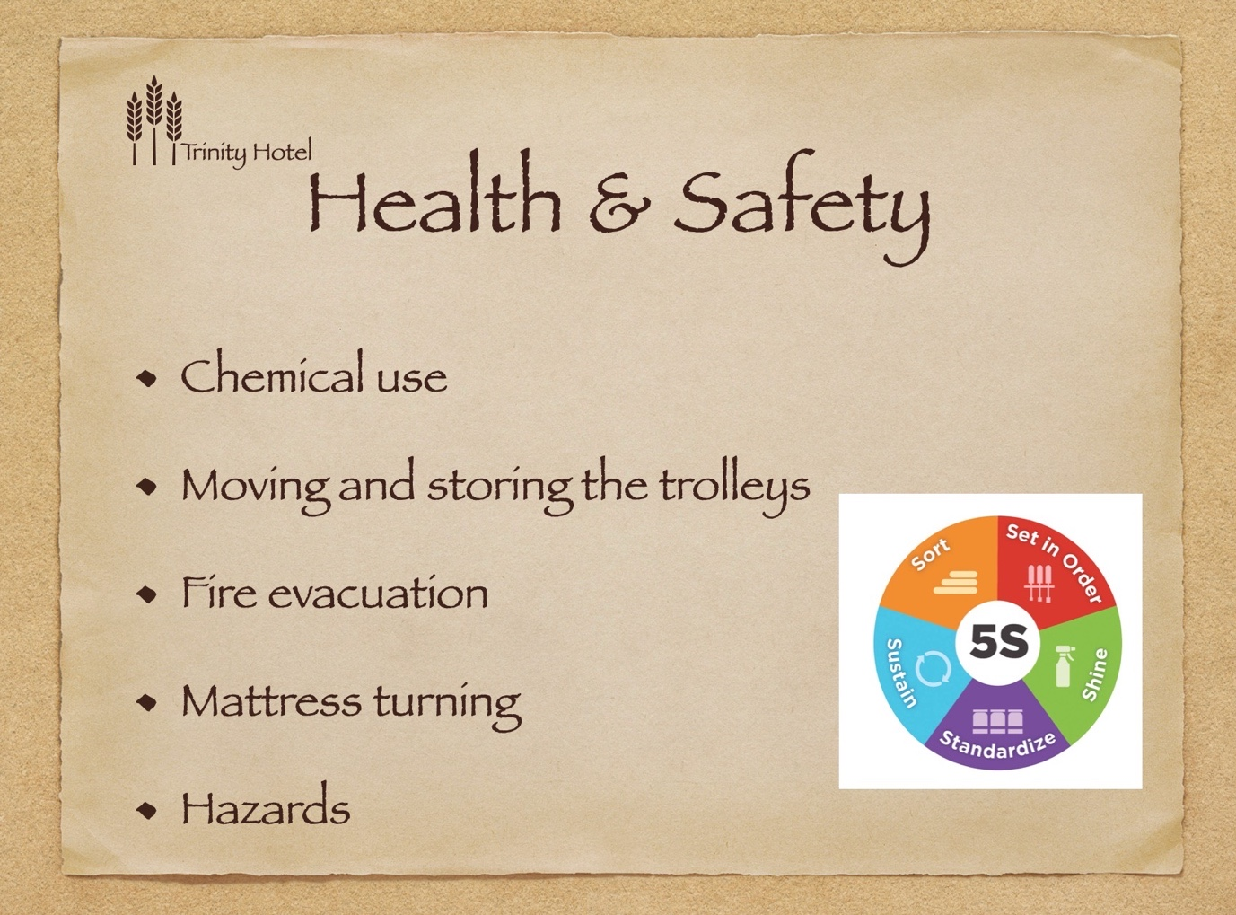

Training Notes:
5S is a system for setting up workplaces so that work can be done successfully, carefully, and efficiently. This method emphasizes putting everything in its proper place and maintaining a tidy workspace, which makes it simpler for people to do their jobs without wasting time or running the risk of getting hurt.
5S: 1. Sort; 2. Set in order; 3. Shine; 4. Standardise; 5. Sustain (5S Today, 2023).

Benefits:
lower expenses
better quality
a rise in output
higher levels of employee happiness
a more secure job setting
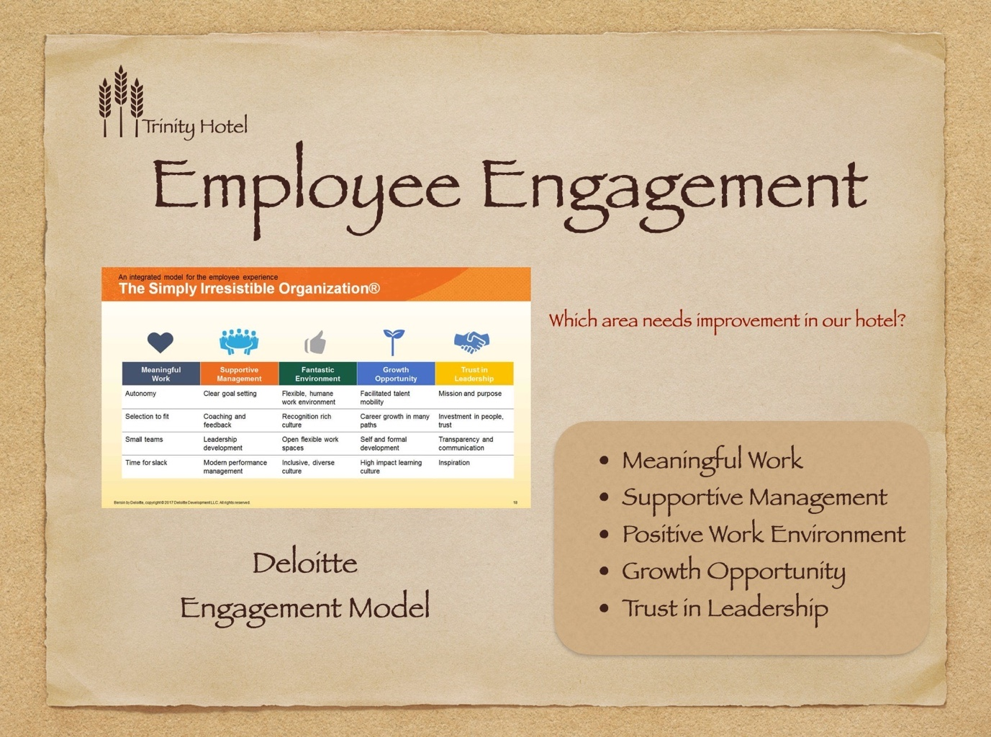

Training Notes:

- Meaningful work: Feel assured that you were hired for the right job, that you were given the freedom and resources to do your best work as a member of a positive team, and that your efforts were valued.
- Supportive management: When provided specific, attainable goals as well as regular coaching, our team must flourish. Our business makes investments in management training to make sure that managers have the abilities to keep their personnel motivated.
- Positive Work Environment: Employees who work in welcoming and varied environments feel appreciated because of the flexibility and perks that support their work-life balance.
- Growth Opportunity: Employees who work well need room to develop. In order to lower turnover, the company must provide opportunities for career growth and progress.
- Trust in Leadership: For employers to motivate staff and boost engagement, they must practice honesty, transparency, and powerful leadership.

So we as a team must feel that our work has a great meaning, we have all the support from our managers, we are having a good work-life balance, plenty of opportunities to progress and visionary leaders to push us forward in our career.

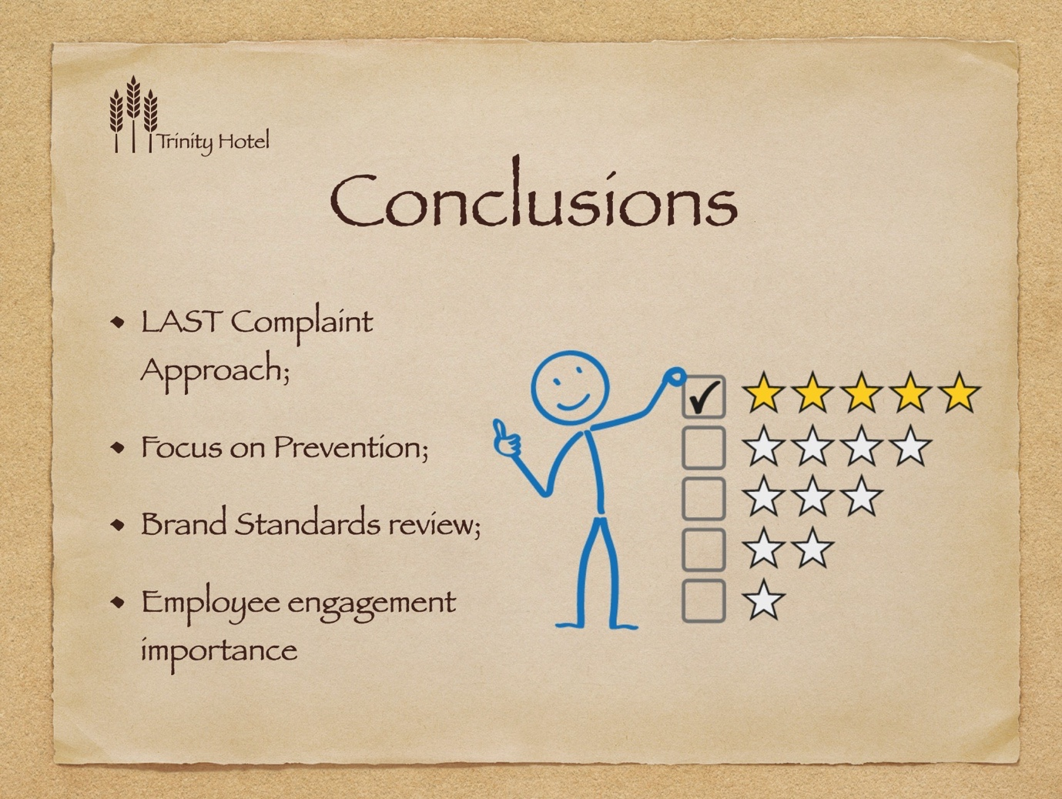

References

5S Today (2023), What is 5S?, Available at https://www.5stoday.com/what-is-5s/ (Accessed 8 March 2023).
Carleton University, (2023), The Importance of a Brand Guide, available at https://carleton.ca/theprintshop/story/the-importance-of-a-brand-guide/, (Accessed 8 March 2023).

Deloitte Insights (2015), Becoming irresistible: A new model for employee engagement, available at
https://www2.deloitte.com/us/en/insights/deloitte-review/issue-16/employee-engagement-strategies.html (Accessed 7 March 2023),
EDAPP, 2023, Hotel Housekeeping Inspection, available at https://www.edapp.com/course/hotel-housekeeping-inspection/ (Accessed 7 March 2023);

Hotel & Catering (2016), 90% of travelers avoid booking a hotel if labeled “dirty” online says FCS, available at https://www.hotelnewsme.com/news/90-travellers-avoid-booking-hotel-labelled-dirty-says-fcs/ (Accessed 6 March 2023);

Invesp, (2019), The Importance Of Online Customer Reviews [Infographic], available at https://www.invespcro.com/blog/the-importance-of-online-customer-reviews-infographic/ (Accessed 8 March 2023);

Litmos Heroes, (na), Customer Complaints Handling, available at https://training.nottingham.ac.uk/Public/Complaint-Handling-Workbook.pdf, Accessed 7 March 2023;
Premier Inn, (2023), Premier Inn Clean Protect, available at https://www.premierinn.com/gb/en/why/cleanliness.html, (Accessed 6 March 2023);
Renderforest, 2023, 55 Branding Statistics for 2023 [Inforgraphic], available at https://www.renderforest.com/blog/brand-statistics, Accessed 8 March 2023;

The Telegraph, (2016), How clean are your hotel bed sheets? Undercover investigation has disgusting results, available at https://www.telegraph.co.uk/travel/destinations/north-america/united-states/new-york/articles/how-clean-are-your-hotel-bedsheets-inside-edition-disgusting-investigation/ (Accessed 6 March 2023) and at
https://www.youtube.com/watch?v=HdbRx-Oz9mg&t=118s (Accessed 6 March);
West Edge Collective, (2023), The Importance of Brand Standards, available at https://westedge.us/branding/the-importance-of-brand-standards/, (Accessed 8 March 2023).
Whitbread Online Academy (2023) available at https://academy.whitbread.co.uk/totara/dashboard/index.php?id=68, (Accessed 7 March 2023);

