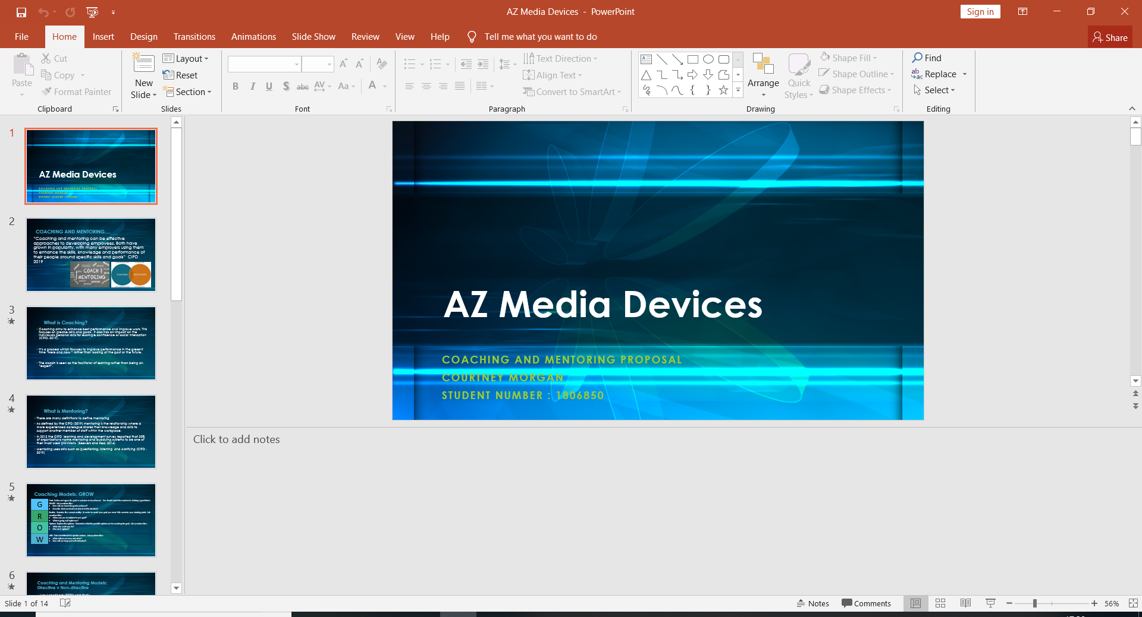

Briefing Paper
By Courtney Morgan

Module - Coaching and Mentoring
Student number – 1806850
Membership number- 5343295X
Word Count –3,039
Submission Date –7th May 2019
Contents Page:

Introduction Page 3
Coaching and mentoring roles at AZ Media Devices Page 4
The role of the HR and Learning function aligned with the role of line managers Page 5
AZ Media Devices policies and support systems Page 6
How coaches and mentors will be selected Page 8
Potential barriers that could be faced while implementing coaching and mentoring to AZ Media Devices Page 9
My contribution to the implementation as a qualified coach and mentor Page 11
References Page 12

- Introduction:
This briefing paper is to support and justify the implementation and feasibility of introducing coaching and mentoring into AZ media devices. This paper sets out the role of Courtney Morgan L+D team leader two fellow colleagues of the HR team which are also qualified coaches and mentors and also the line managers. This briefing paper covers the learning and development strategy of how this will be implemented, supported and any potential barriers within AZ media devices that maybe faced as set out by L+D manager and two-line managers within the business. This is in order to support the planned changes taking place at AZ Media devices in the next two years, as stated by Downey (2003) that by adopting a coaching strategy has various benefits as change within the business can have side effects such as fear, uncertainty, or cultural and there are many questions to be asked by the employees. It has also been noted that AZ Media Devices have a lack of understanding and also a stagnant learning and development process within the organisation.
By having this coaching strategy in place Downey (2003) says that this can prevent anxiety and can also help eliminate possibilities and options and the best can be chosen and also gives some relief to the higher management teams.
According to Enterprise Study (2019) by inputting coaching and mentoring strategy within the workplace this will improve an individual’s performance and a way to enhance current skills and obtain new skills. It has also been noticed that individuals and groups perform better with coaching which also develops into better business performance. By implementing coaching and mentoring Enterprise Study also states that when coaching and mentoring is done well this can:
- Increase productivity
- Improve communications
- Increase staff commitment and loyalty
- Decrease stress and tension within the workplace
Enterprise Study (2019) also states by having a coaching and mentoring culture and leadership styles this will become a norm within the organisation with daily communication and conversations. Coaching becomes a day to day activity in communications.

- Coaching and Mentoring roles at AZ Media Devices
Currently, at AZ Media Devices there are three qualified coaches and mentors, which are all based within the HR and Learning and Development team. Being a large company and having over 300 members of staff, AZ Media Devices has a number of line managers. After a meeting to discuss the implementation of coaching and mentoring to the business with the L+D Manager and two-line managers, it has come to a decision that the coaching and mentoring will be facilitated internally within the organisation. This is due to a number of reasons such as costs, learning and development within the organisation, having an internal view on the organisation and the benefits that come with it such as retention. This is also an advantage to the organisation as due to the changes taking place within the next two years the management within the organisation will have a clear view on this. Talent for Growth (2019) states that for organisations to develop internal coaches with enables businesses to progress people through coaching in a cost-effective away and using internal coaching training delivers growth for the coaches also. This is also a great asset to the organisation to develop coaching as part of their L+D strategy which AZ Media Devices are wishing to do as this is pretty stagnant at present.
The proposed coaching strategy will be supported and implemented by the L+D team and 2 other qualified coaches and mentors. As part of the line managers role, it will be their job to coach their teams and will be supported by the L+D team. Training will be undertaken by the line managers in order to complete this role and will also part of their learning and development portfolios. This way also line managers are able to keep a close monitor on staff to see if this is having an overall improvement on their performance as a team member.
Bright HR (2019) states that “Observing your employees as they grow over a long period can help you make crucial business decisions, such as aligning the career path of an employee with their strongest skills for your business. For the line managers, this will also contribute to their learning and development by developing their leadership skills and also supports the organisations coaching culture which is going to be vital in this strategy. This is always not natural to managers but will give them an outlook on the different styles of coaching to use in different situations (Talent for Growth, 2019). The following roles are outlined in table 1.0:
Table 1.0- AZ Media Devices coaching and mentoring roles:
- L+D Manager (Trained coach and mentor)- Coaching Manager (To support the Learning and development function)

- Trainer (Trained Coach and Mentor)- Coaching supervisor who is going to implement to coaching and mentoring to line managers

- HR team member (Trained Coach and Mentor)- Coaching administrator who is going to create policies, contracts, handbooks and itineraries.

- 5 x Line Managers- Who will be the Coaches and Mentors within the organisation

In order for the line managers to complete their roles as successful coaches and mentors, they will undertake a series of coaching and mentoring workshops held by L+D manager and fellow trained coach and mentors. These workshops will give the line managers a full understanding of their role and the different aspects of coaching and mentoring with regards to the requirements and the needs of the business.

- The role of the HR and Learning function aligned with the role of line managers
The HR team and the Learning function will work closely with the line managers, these are the qualified coaches and mentors within the organisation. The HR and learning functions role are to support, coordinate and oversee the coaching and mentoring strategy, They will do this by carrying out their designated roles assigned to them and holding the employees to account of their roles. It is also up to the HR and learning function to support and coach the coaching supervisors within their roles as they develop and train to be aspiring coaches and mentors. Brockbank and McGill (2006) state that the suggestion of any training for is virtually always taken up by aspiring coaches and mentors and the support that comes with this comes with the training as for example being part of a group of coaches and mentors can be found as supportive and give support and reassurance.
It is down to the HR and learning function to produce policies and procedures to align with the business plan to produce a coaching/mentoring contract for coachee’s and mentees to agree too. It is seen that the HR is seen as vertical and the L+D team as horizontal and the management team support the strategy.
This is an important document and acts as a legal binding contract which sets out the rules for the coaching relationship for both members. This gives both members clarity of their roles, peace of mind and also protection if ever they had the event, they were unhappy. Having this coaching contract in place also offers the professional security to ensure the confidentiality is in place at all place as many times it can become an intimate conversation (Coaching Network, 2013). This also relays back to the keeping in line with the GDPR policy which was updated in May, which has been expanded from the Data Protection Act. This underpins that everyone is accountable for everyone’s personal data and has to be followed by a strict set of guidelines to ensure the data is kept safe and for a specific reason. It also gives the person the right to know what information is being kept on them by the organisation and also be able to access this at any time (GOV UK, 2019).
The role of HR and the L+D function is to manage the training programmes and to also ensure these are delivering the results needed. This is also to ensure that the employees have the skills and knowledge to complete their job meeting the businesses needs and objectives effectively. This can then proceed with the planning and evaluating any additional training for development goals and identifying any learning gaps. This way HR and the L+D function can closely monitor and keep costs aligned with the budget (Chron, 2019). With regards to any development goals it is also the role of HR and the L+D function to manage and build in house capability and record any training, coaching or courses completed as this may count towards the individuals personal career development plan which then may lead to future pay increases or more job opportunities and face any obesities that may arise during this period (The Open University, 2019

- AZ Media Devices policies and support systems
There are many policies that will be needed to underpin the coaching and mentoring strategy at AZ Media Devices to ensure that it is carried out effectively and, in the right way. These include policies such as:
Coaching/Mentoring Contract-
As explained as above all individuals undergoing coaching and mentoring will need to complete a coaching/mentoring contract. This will simply set out the guidelines and expectations required from the main focus of the coaching strategy. As stated on David Clutterbuck Partnership (2015) they need to be contracted to:
- Have active support and guidance
- Have a good understanding of the issues and end goal and what is needed to form the end goal
- An agreement on how they will identify positive change when it takes place
The overall point of the contract is to have the roles of the various parties involved to know their roles and the expectations/responsibilities. This also links to the phycological contract with relays back to the relationship and the motivation of all parties.
GDPR Policy (General Data Protection Regulation)-
GDPR came into effect in May 2018. This replaced the Data protection directive and is a law that protects EU citizens personal data. The GDPR update brought in force new requirements that organisations should comply to and if they fail to do so before the deadline, they could be subject to penalties and fines (Digital Gaurdian, 2019).
When collecting data form the candidates it is vital that AZ media devices to be clear what data they are keeping and why they are keeping data and also how this was processed. AZ also needs to have a legitimate reason for what this is going to be used for. It will be suggested that AZ media devices include a copy of their organisations GDPR policy with the proposed contract as this will inform the candidate the reasoning to why and how their data is being kept and how this complies with the UK Data protection regulations (GOV UK, 2019)
Confidentiality Policy-
“Confidentiality in the workplace is the rule number one in the book of business etiquette” according to Hiscox (2018). This is showing the employees that as an organisation AZ Media device are protecting their data and are also protecting any sensitive information. Breaches of any confidential data could endure the organisation serious consequences. Confidential data could arise during the coaching and mentoring strategy which is going to be implemented on many occasions, e.g, many conversations may end up being sensitive as coachee may feel that they are able to confide in their coach which could be the reason their performance is down in work. This will also help employees have trust in AZ Media Devices that they can confide in someone and this information will be kept confidentially.
Coaching/mentoring policy – this will answer any questions the candidates may have and is useful to have. Clutterbuck et al (2016) say that is answers questions such as the following shown in Table 2.0 below as an example contents page:
Table 2.0 - AZ Media Devices Coaching and Mentoring policy guidelines
- AZ Media coaching and mentoring philosophy
- AZ media vision for coaching and mentoring
- Coaching and mentoring options
- Are you eligible for coaching and mentoring?
- The role of the coach/mentor
- The role of coachee/mentee
- Confidentiality policy
- Coaching and mentoring engagement standard duration
- Extensions policy
- Coaching and mentoring approval policy
- Communications
- Any other activities to support coaching and mentoring
(Clutterbuck et al, 2016)

Coaching Handbook-
Evaluation Survey- This evaluation survey will be completed at the end of each coaching or mentoring session where this can then be evaluated. There will also be a survey completed at the end of the process to evaluate if the coaching and mentoring strategy has been beneficial to the organisation and the candidate’s overall performance. This will be also reflected in AZ Media Devices KPI’S.

- How coaches and mentors will be selected
Building the coaching culture within the organisation needs to be aligned with a strong vision and a significant amount of effort and determination required from those who are selected to contribute to the strategy in order for it to be successful as stated by Clutterbuck et al (2016).
In order for the implementation of the coaching and mentoring strategy to be successful, it is vital that the right coaches and mentors are allocated to the selected coachee’s and mentees. In order to do this fair, employers need to take The Equality Act into consideration. This came into force in 2010 and replaced the Race Relations Act 1796 and the Disability Discrimination Act 1995. This act ensures that organisations and their employees have consistency and fair with the law ACAS (2019). When selecting coaches/mentors with coaches/mentees it is vital that AZ Media Devices are not discriminatory against anyone and are in line with the Equality Act. This provides good and fair practice for AZ Media Devices and matching them up to who is best suited by avoiding any unconscious bias or discrimination. (ACAS, 2019). It is also vital that AZ Media also select the following coaches and mentors in conjunction with their policies and trade union regulations.
There are various ways in which matching coaches and mentors can be arranged one being by compatibility. As stated by Clutterbuck et al (2016) “compatibility refers to the ability of coach and coaching client to establish rapport and trust and is often based on similarities in temperament and personality”. It has been suggested that at AZ Media devices that we would also use compatibility as a way to match both together as their similarities can help build rapport between both and develop and good relationship. All coaches/mentors and coachee’s/mentees will undergo a personality test to configure who they will be best matched with. The Myers-Briggs personality test will be used as it is understood there are many people within the organisation who do not know each other. The 16 personality types test was made by Briggs and Myers in the 1960s which was based on the findings of phycologists. Both Briggs and Myers made personality types as a way to identify peoples favoured ways of thinking and behaving (Truity, 2019). All members of staff that sit under the line managers who are going to become the coaches and mentors will be undergoing personality testing. It has been identified that the changes happening within the organisation will be affecting all members of staff and will be vital they all feel supported through this change as this is part of the organisation's ethos. Due to the timescale of two years, this will be feasible and it is also vital that the trade unions are on board with the strategy as well as if there is any employee representation groups with AZ Media Devices to be on board.

- Potential barriers that could be faced while implementing coaching and mentoring to AZ Media Devices

Clutterbuck et al (2016) stated that as well as finding the starting point it is beneficial to identify the barriers. By identifying these it is valuable prep for the coaching and mentoring strategy. In order for the planning and implementation of the coaching and mentoring strategy to be successful and in order to highlight any barriers Clutterbuck (2016) outlined a process as shown below in Figure 1.0:
Figure 1.0 – The ABC-DE of coaching culture and planning and interpretation:
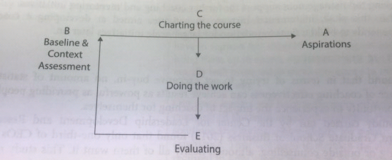

Clutterbuck et al (2016)
Table 3.0 Below explains the points of ABCDE –
Table 3.0- The ABC-DE of coaching culture and planning and interpretation explained
A – Aspirations – what is the purpose? What is the mission and key objectives of AZ Media Devices?

B- Baseline and context assessment - where are AZ Media Devices now in terms of culture and are they flexible to change? Is there a fixed or a growth mindset in the organisation?

C- Charting the course – what is the plan for AZ Media devices? Does this fit with AZ Media Devices organisational strategy and goals? Who will do what? How will it be done what training is needed? How will it be implemented?

D- Doing the work/Delivery - the implementation of the strategy. Has it worked or failed? Has the strategy been adopted? what has gone well and what doesn’t go well?

E- Evaluation – the important point! Has the AZ media devices strategy been successful? Has it been effective? Have there been any barriers or key drivers in the process? Is there anything that needs to be adjusted?
Clutterbuck et al (2016)
This model may highlight any issues such as uncertainty, time, resistance, costs and the coaching culture within the organisation. Resistance is a potential barrier with AZ Media Devices from within the organisation, this could be from the line managers or the potential coachees or mentees. Downey (2003) stated that "the first rule is that if someone does not want to be coached then attempting to coach will get you nowhere". If someone within AZ is getting along fine with their work e.g. meeting their goals and does not want to be coached then he suggests is to leave them alone. If this is someone who is not meeting their goals and still refusing then this becomes more of a management issue and it is the role of HR to explain that it's in their best interest to participate.
The cost can be seen as a large barrier to AZ Media devices. This can be seen as costs for the candidates to be released from their desks or stations to meet with the coaches and mentors as well as for the line managers who take time form their position also. As an organisation due to costs it's in AZ Medias best interest as decided to complete the coaching mentoring within the organisation to save on these costs for external courses. With regards to the line managers completing an external cost course, this can be high in cost and can cost £651.60 each to complete the ILM Level 3 Certificate in Coaching and Mentoring (Coaching Pathway) (Learning Direct, 2018). This is a chartered course which is known as ideal for managers to gain the confidence and skills to be able to coach and mentor within their role. To enrol all line managers this will in total cost the AZ Media Devices £3.909.60 in addition to the hours out of work.
Having a coaching culture can benefit the organisation and can also be seen as a barrier if not in place. Clutterbuck et al (2018) stated that there have been recent research findings that having a coaching and organisational culture can have a significant impact on the organisations business performance and can help boost this. Having this coaching culture within AZ Media devices can also help boost employee engagement , financial performance which also relates back to AZ media devices showing their employees that have a steady focus on their culture and are dedicated to their employee development programmes which according to Clutterbuck et al (2016) these factors have also been revealed as the drivers to the 2014 great place to work survey. A case study from Coaching and mentoring national (2019) shows that in a recent coaching strategy with The City and Guilds Group they had regular group supervision sessions to give guidance on their coaching culture as this was vital to the organisations as they focus on developing leaders.

- My contribution to the implementation as a qualified coach and mentor

My implementing the coaching and mentoring strategy at AZ media devices this is going to improve my skills and learning, by doing this It will also contribute to my own personal development to add to my CPD evidence folder also. As an HR professional it is vital that we keep up to date with updating and keeping on top of our knowledge and gaining more skills. By keeping on top of my development and learning, I would do this by attending regular CIPD events such as the Learning and Development show coming up in June and other event or seminars on employment law.
As the learning and development manager within AZ media my contribution to the team is that I am able to identify any skills gaps as a result of the coaching and mentoring strategy and be able to facilitate this.

- References
ACAS (2019) Recruiting Staff Guidance. Available at: http://www.acas.org.uk/media/pdf/n/m/Recruiting_staff_guide.pdf (Accessed 2.4.19)
Bright HR (2019) Benefits of coaching and mentoring in the workplace , Available from: https://www.brighthr.com/articles/training/coaching-mentoring/benefits-of-coaching-and-mentoring-in-the-workplace (Accessed 30.4.19)
Brockbank, A and McGill (2006) Facilitating Reflective Learning through mentoring and coaching, Kogan Page:London
Chron (2019) Job Description for an HR Training & Development Officer, Available from: https://work.chron.com/job-description-hr-training-development-officer-17508.html (Accessed 30.4.19)
Clutterbuck, D (2016) Everyone needs a mentor, 4Th Edn, CIPD:London
Clutterbuck, D, Megginson, D and Bajer, A (2016) Building and Sustaining a Coaching Culture, CIPD: London
Coaching and Mentoring International (2019) Coaching, Available from: https://coachingandmentoringinternational.org/coaching/ (Accessed 7.5.9)
David Clutterbuck Partnership (2015) Managing the three way contract in executive coaching and mentoring, Available from: https://www.davidclutterbuckpartnership.com/managing-the-three-way-contract-in-executive-coaching-and-mentoring/ (Accessed 30.4.19)
Digital Guardian (2019) What is the General Data Protection Regulation? Understanding & Complying with GDPR Requirements in 2019, Available from: https://digitalguardian.com/blog/what-gdpr-general-data-protection-regulation-understanding-and-complying-gdpr-data-protection (Accessed 30.4.19)
Downey, M(2003) Effective Coaching: Lessons from the coach’s coach , 3rd Edn, Cengage Learning: America
Enterprise Study (2019) Coaching within the workplace : 4 Reasons to implement a coaching scheme, Available from: https://enterprisestudy.com/Blog/Coaching-within-the-workplace (Accessed 30.4.19)
Free Management Books (2019) Internal and External Coaches - Advantages and Disadvantages , Available from: http://www.free-management-ebooks.com/faqch/principles-05.htm (Accessed 30.4.19)

Gov UK (2019) Data Protection. Available at : https://www.gov.uk/data-protection ( Accessed 30.4.19)
Hiscox (2018) The importance of confidentiality in the workplace, Available from: https://www.hiscox.co.uk/business-blog/the-importance-of-confidentiality-in-the-workplace/ (Accessed 30.4.19)
Learning Direct (2019) ILM Level 3 Certificate in Coaching and Mentoring (Coaching Pathway) , Available form: https://www.learndirectpd.com/courses/ilm-level-3-certificate-coaching-mentoring-coaching-pathway (Accessed 7.5.19)
Talent for Growth (2019) Performance Coaching , Available from :https://www.talentforgrowth.com/performance-coaching/ (Accessed 30.4.19)
The Coaching and Mentoring Network (2019) Why have a coaching contract? , Available from: http://www.coachingnetwork.org.uk/information-portal/Articles/ViewArticle.asp?artId=34 (Accessed 30.4.19)
The Open University (2019) Workplace learning with coaching and mentoring, Available from:https://www.open.edu/openlearn/money-management/workplace-learning-coaching-and-mentoring/content-section-1.1 (Accessed 6.5.19)
Truity (2019) The 16 Personality Type Profiles, Available from: https://www.truity.com/view/types (Accessed 1.5.19)

