Radio Frequency Systems

ACDA5019

Analysis of Simulated Radio Frequency Systems with a Focus on Modulation

Contents
Abstract 2
Introduction 2
Amplitude Modulation 2
Theory 2
Simulation 3
Analysis 3
Dual Sideband Single Carrier 6
Theory 6
Simulation 7
Analysis 7
Frequency Modulation 9
Theory 9
Simulation 10
Analysis 11
Conclusion 13
References 14
Appendix 14

Abstract
Herein the report investigates the relationship between a modulated and demodulated signal, be that in an amplitude modulated signal or frequency modulated one. Two systems of Amplitude modulation are investigated while only one system is investigated in detail with frequency modulation. Each of these are simulated with both multimedia and base sine samples, with the goal of replicating the same systems with an optimised multimedia file that almost exactly resembles a sinewave in practice. These are then evaluated against a noise addition in-system and analysed for further consideration and research.

Introduction
This report will seek to investigate the various responses of signals when under various modulation influences. The primary methods of interest herein are as follows: Amplitude modulation and Frequency modulation, while having a secondary focus on Dual Sideband Supressed Carrier (DSB-SC), despite this being a form of Amplitude Modulation. These investigations will first try to analyse various components of the aforementioned methods and compare them with the original, noise, modulated and demodulated forms of the same signal, as well as demonstrating a theoretical basis for these observed patterns.

Background Research
Initial research showed the general basis for expected results. Outlining the expected theoretical and simulated environment settings. While some insights into expected outcomes have come to light that was not previously expected, research was primarily conducted into investigating application into simulated software and expected results therein[1].

Amplitude Modulation

Theory
Amplitude Modulation is a method of rendering a signal viable for transmission, in particular this seeks to adjust the amplitude levels of a signal in line with the values that exist locally to the signal[2]. For instance, a binary signal of 1011 would, at a basic level, require a sequence of High-Low-High-High amplitude be produced.
This particular example would endeavour to use a modulation index of 0.7 initially, with further investigations into over and critical modulation. As a modulation index (MI) value of 0.7 already fulfils the criteria of under modulation[3], utilisation of the value of and MI equalling 1 and MI greater than 1 must be used. Though largely arbitrary, this instance shall examine the effects of and MI of 1.3, to maintain a level of similarity with the under modulated value.

Simulation
The simulation diagram was designed as follows in figure 1.
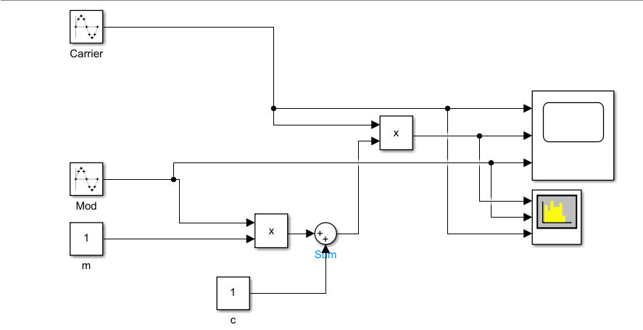
This is written with the specifications of Carrier having a frequency of 10KHz, Mod having a frequency of 1KHz. These two values representing the equation values of $ω_{c}$ and ωₘ respectively, while m represents the MI and c represents the constant.
Figure 1, Above, Simulink Block Diagram of amplitude modulation

Analysis
This setup produced a largely expected result, with figures 2 and 3 demonstrating the expected result for a critically modulated signal along amplitude modulation protocols. Featuring a sequency in spectrogram section 2 that reflects a perfectly modulated sine wave when summed with the carrier. With the spectrum analyser largely providing information on the strength of the signal, with no real observation of the amplitude shift, however, it does provide evidence as to the existence of the sidebands expected with modulation[4], as can be witnessed close to the 24dbm mark.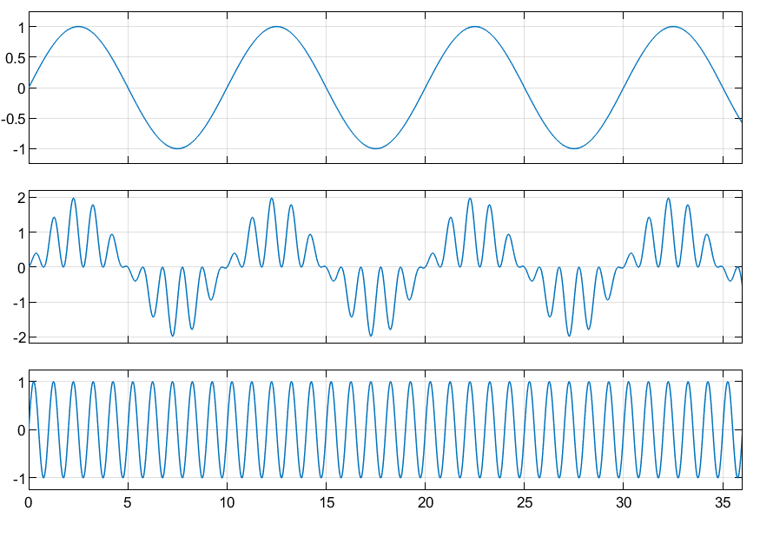
Figure 2, Above, Oscilloscope reading of a noiseless AM Signal modulation
Figure 3, Above, Spectrum capture of an AM modulated signal
When further implementing the variance of value the MI to under modulate, we witness a spectrum analysis with minorly shifted sidebands but a markedly different oscilloscope reading. In Figure 4, we can observe the modulated signal having a shift away from the central 0 amplitude on the troughs, while maintaining a similar form. This is also as expected due to the alteration of the MI creating a distortion of the central regions of the signal, creating an offset, with the sidebands being attributed to the same variance and scale of alteration as observed in figure 5.
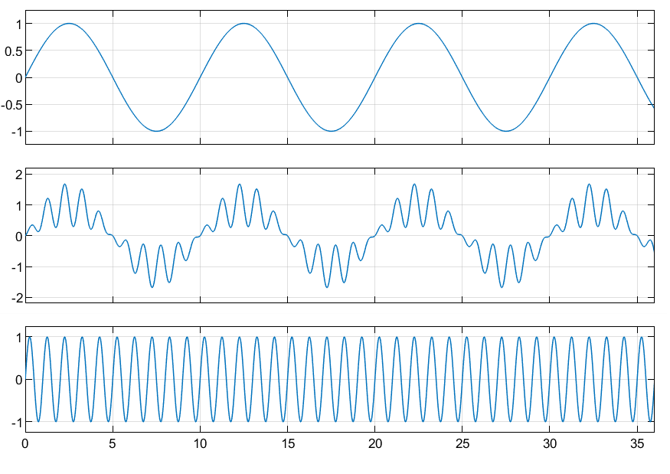
Figure 4, Above, Oscilloscope capture of a MI shifted AM signal modulation
Figure 5, Above, Spectrum capture of a MI shifted AM signal modulation
When analysing the overmodulation, a similar observation can be made as with under modulation, except in the inverse. The minor offsets witnessed there translate to the same scale of offset in the inverse in this particular case, due to their identical variance from 1, except in differing directions. As such, it is possible to observe a shift of the sidebands towards the central frequency peak in figure 7, while also observing the same scale of offset past 0, except instead of reducing the troughs as previously observed, they are magnified, as can be seen in figure 6.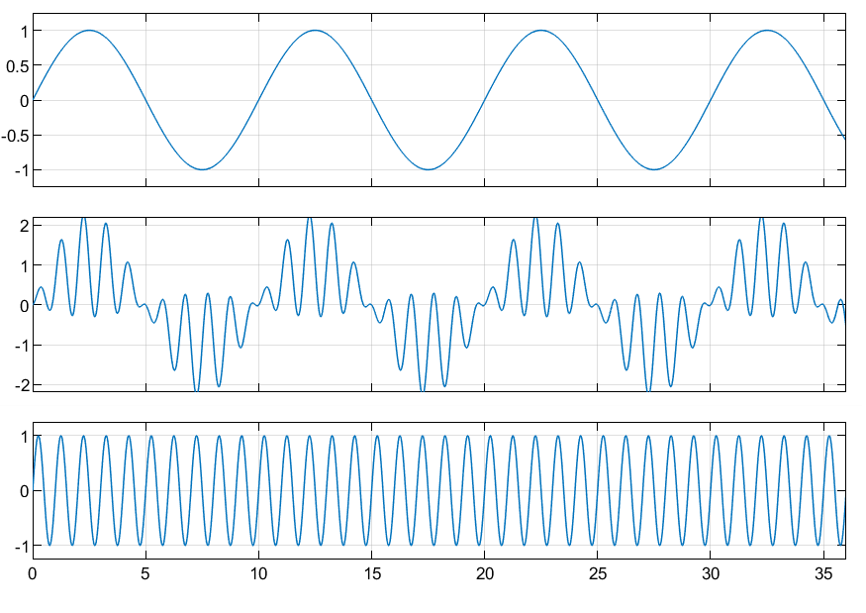
Figure 6, Above, Oscilloscope capture of a positive MI shifted AM signal modulation

Figure 7, Above, Spectrum capture of a positive MI shifted AM signal modulation
In order to further compare the demodulated to the original and modulated signal, the design of the system must be edited to incorporate a demodulator, as seen in figure 8. This produces an oscilloscope reading that allows for the comparison of the various signals, observed in figure 9. This figure demonstrates that the original and demodulated signal are identical and that they are both logically produced from the modulated signal. While this would likely be imperfect in practice, due to the lack of simulated noise, it is undeniable that the demodulation sequence has successfully been applied to a modulated signal in line with expected norms[2].
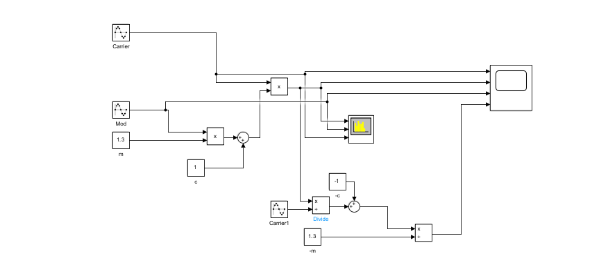
Figure 8, Above, Demodulation block diagram of an amplitude modulation method.
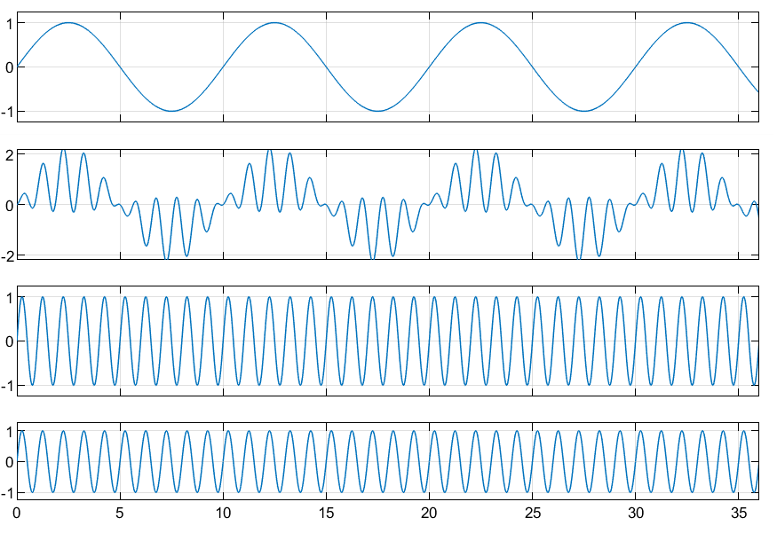
Figure 9, Above, Oscilloscope capture of demodulation with a positive MI reading.

Dual Sideband Supressed Carrier

Theory
Dual Sideband Supressed carrier is a method of data transmission in the Amplitude modulation category of techniques. This seeks to supress the central carrier frequency in the name of conserving power, this attempts to do so by enabling the sidebands to act as a transmission signal[3], which can then be demodulated out to obtain the original message signal. This modulated signal, due to the locations of sidebands, tends to be around 2 times the frequency of the original or AM modulated signal, due to the sidebands existing in both a positive and negative position relative to the central message/ carrier frequency, thus magnifying the sidebands while supressing the central carrier with equivalent magnitude.
This case will use an MI of 0.5, demonstrating first that the signal transmitted is the same as the received, then demonstrating the use of the transmission method to transmit a distinct signal. These will also be analysed with the inclusion of an Average White Gaussian Noise block. This will demonstrate the noise resilience required to act as a viable transmission method.

Simulation
The simulation consists of two main sections, that being the blocks prior to noise, generally regarded as the modulation phase and the phase after the AWGN, generally referred to as the demodulation phase. This system utilizes a 2*pi*15 message frequency and a 2*pi*60 carrier frequency, while using an increased amplitude of 2 for the carrier. In the case of the secondary task, utilising a multimedia file – this multimedia file is generated along the exact same specifications as the original sine wave in Figure 10.
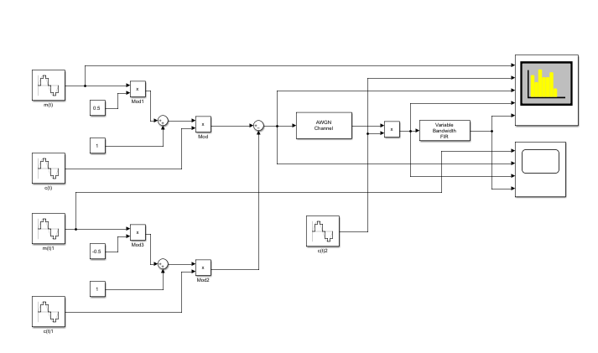
Figure 10, above, Simulink block diagram of a DSB-SC method
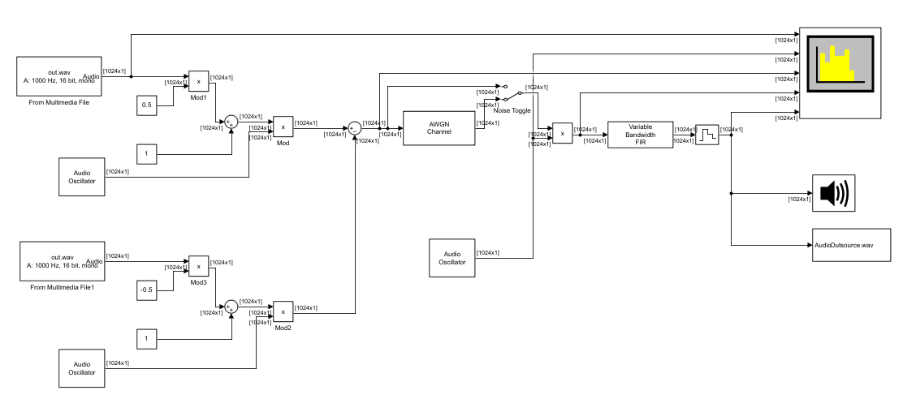
Figure 11, above, Simulink block diagram of a DSB-SC method utilizing multimedia outputs and inputs.

Analysis
As is observable in Figure 12, there are four distinct signals taken by the oscilloscope, of particular note are those classified in the first and final sections, as these are the initial and final signals respectively. Each of these signals retains the same amplitude and frequency as the other, serving as a statement to the efficacy of the system as a modulation and demodulation method. We can also witness that, within figure 12 we can observe the carrier sum and carrier subtracted from the total signal in slots 2 and 3 respectively. Following in Figure 13, we can witness the two points of the sidebands that are utilized for carrying the message signal, as expected following the theory[5].
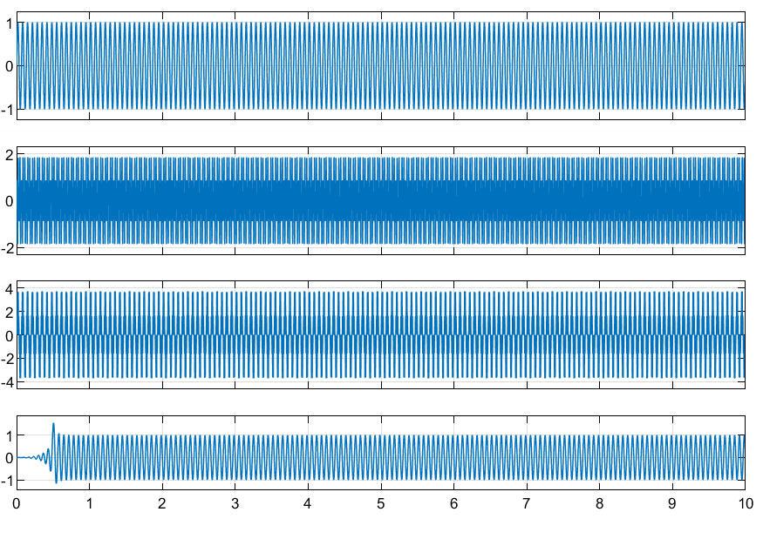
Figure 12, Above, Oscilloscope capture of DSB-SC Modulation and Demodulation
Figure 13, Above, Spectrum capture of DSB-SC signal
When the design specified in figure 11 is used, it has both an in and output multimedia file, with accompanying oscillators to simulate sine waves. Due to that fact that, in this particular instance, the multimedia file is a system generated sinewave matching the exact parameters as previously observed, it is possible to examine how their frequencies stay identical. In figure 14, it can be seen that both M(t) and the final filtered product match in both amplitude and frequency. When comparing the frequency in the oscilloscope reading, the frequencies throughout, be that in the demodulation or modulation all through to the final product, stay identical, while the frequency domains occupied at a given time may shift, the frequency stays constant.

Figure 14, Above, Spectrum capture of DSB-SC filtered demodulated signal
Finally, in figure 15 the impact of noise is observable, this impact is particularly audible when comparing the two audio files to each other by ear. However, this can also be easily observed in the third and forth section of figure 16. The forth section is visibly distorted as a result of the fluctuations in demodulation caused by filtering, creating a recognisable output but one that does not bear as strong of a similarity coefficient as might be desired[6]. This is a downside of any wireless protocol, and is not specific to DSB-SC, as increasing amounts of noise cause inevitable distortion, in this case, mostly impacting the fluidity of the data as week as the various troughs and peaks, mostly due to limitations with the aforementioned filtering process.
Figure 15, Above, a noisy spectrum capture of the product and filtered demodulated signal
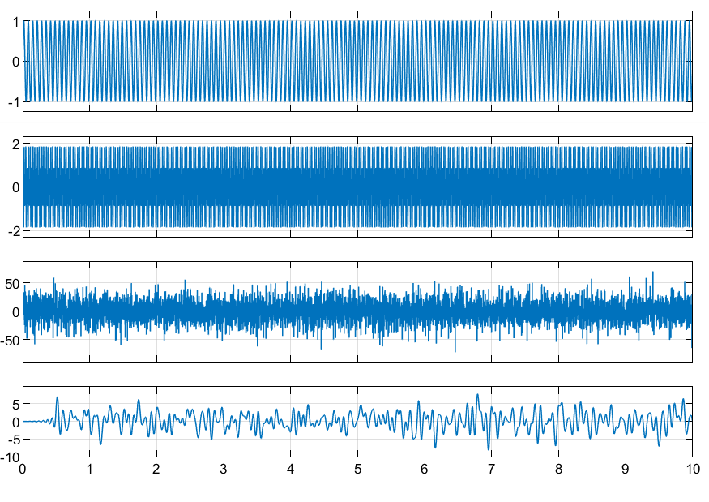
Figure 16, Above, a noisy oscilloscope capture of modulation and demodulation

Frequency Modulation

Theory
Frequency modulation is a method of modulation that alters the frequency of a signal to represent the peaks and troughs of the original signal. Generally, this is represented by a higher frequency in the higher components and the lower frequency wherever there is a lower power level. Methods of modulation and demodulation can vary depending on application[7], [8], in this case, the demodulation method shall be that of phase discrimination, this is a method that uses a Phase Locked Loop (PLL) to create an expected output by filtering out substandard waveform components.
The following shall seek to demonstrate a phase discriminated modulation-demodulation system, proving the validity of this system. Then following by testing the efficacy of the algorithm with the same multimedia input as was used in the AM modulation tests, that being an edited wav and MIDI file, allowing it to replicate the sinewave Simulink block in property.

Simulation
Including the basic PLL system, figure 17 is comprised of an arbitrary sinewave, taken at a single Hertz. Which is then integrated and passed through a cosine function, creating a modulated frequency signal. The demodulation is passed through a matrix multiplier, filter and Voltage Controlled Oscillator (VCO).
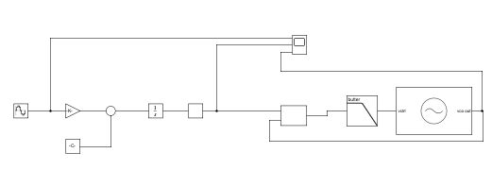
Figure 17, Above, Simulink block diagram of a phase discriminated frequency shifted architecture.
Figure 18 and figure 19 are both based off the architecture of a frequency modulator and demodulator in-line with the MathWorks example architecture. After enabling the wav file to operate with a high degree of compatibility previously in the AM section, this enabled it to function with the FM modulator and demodulator blocks. These blocks are herein used to demonstrate the effect of noise and effectiveness against an optimised multimedia file.
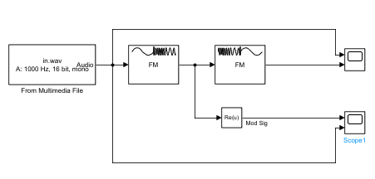
Figure 18, Above, Multimedia processed modulation and demodulation block diagram.
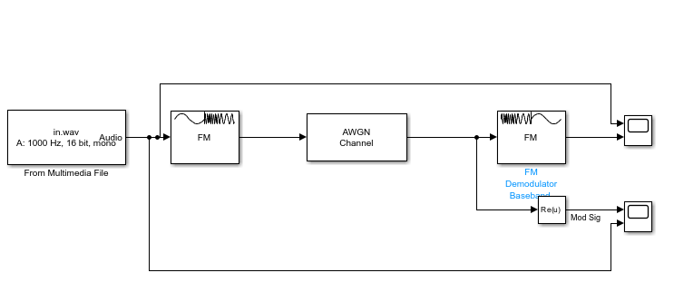
Figure 19, Above, Multimedia processed modulation and demodulation block diagram with additional noise.

Analysis
Figure 20 demonstrates the original and frequency modulated signal, this signal is among PLL system architecture products, with figure 21 demonstrating a demodulated signal on the output side of the system. Here it is possible to observe the fluctuation in frequency holding a high correlation between the low frequency at low points and high at high points, as was specified to be expected in theory. It is also observable that the demodulated signal matches perfectly to the original signal, largely due to the lack of any added noise at this point.

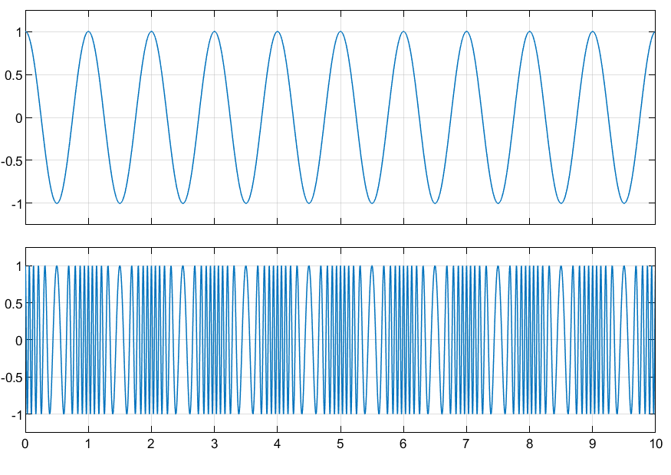
Figure 20, Above, frequency modulation reading on oscilloscope for modulation phase.
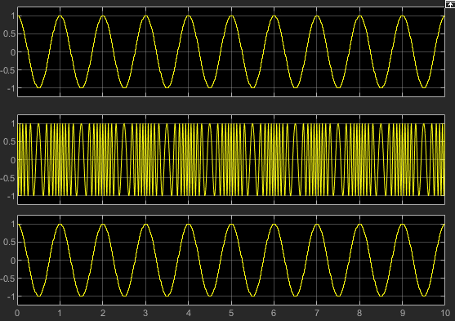
Figure 21, Above, Frequency modulated signal with demodulation reading.
In figure 22, the properties of the optimised audio input are noted as being identical, with the input data and demodulated data being identical. With the further observations in figure 23, the modulated data resembles the input data to a high degree.
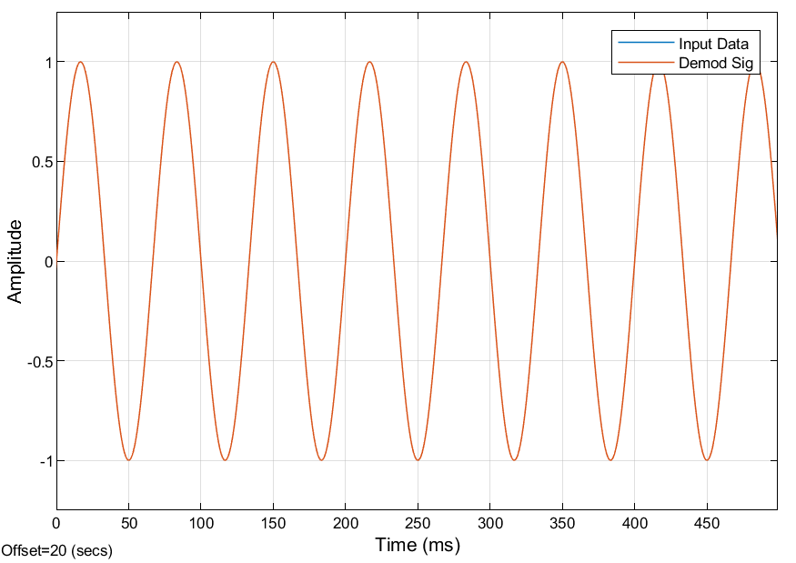
Figure 22, Above, demodulated signal and initial signal overlayed in oscilloscope reading.
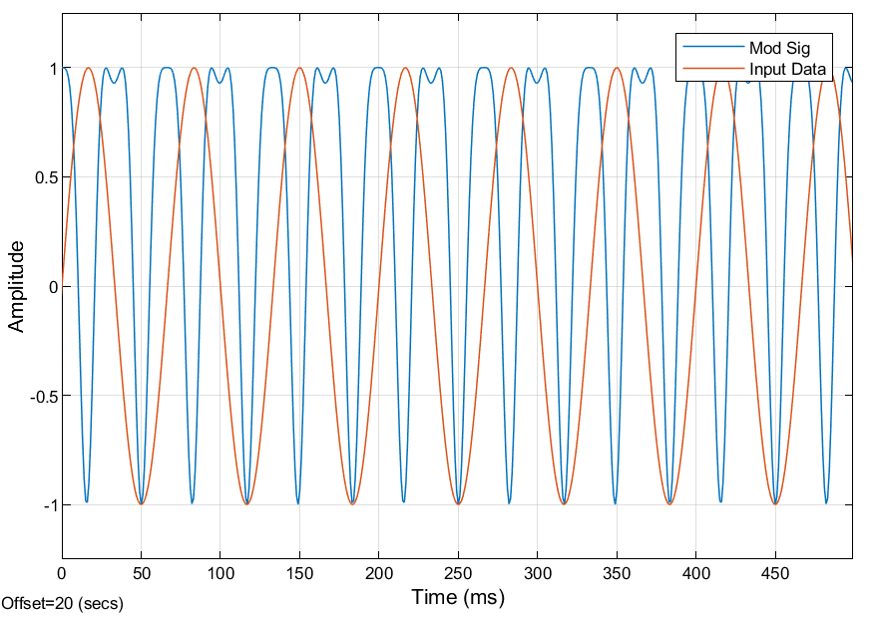
Figure 23, Above, modulated signal and initial signal overlayed in oscilloscope reading.
When regarding the noise influence, comparing the noisy (figure 24) and noiseless modulated and input data gives a clear alteration of data values being impacted by noise, thought still notably resembling the modulated signal. As such, we can determine that a relatively low level of noise is present. Looking further into the demodulated signal, figure 25, a notable degree of fluctuation outside of expected bounds is obviously present, as such we can summarise the impact of noise being highly evident in causing amplitude fluctuations in the demodulated signal, greatly distorting the received signal.
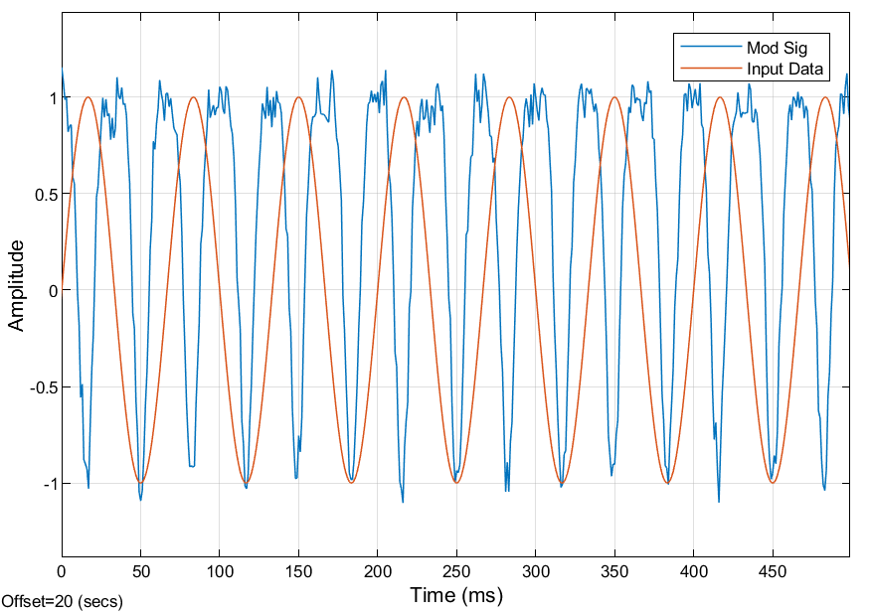
Figure 24, Above, noisy modulated signal and initial signal overlayed in oscilloscope reading
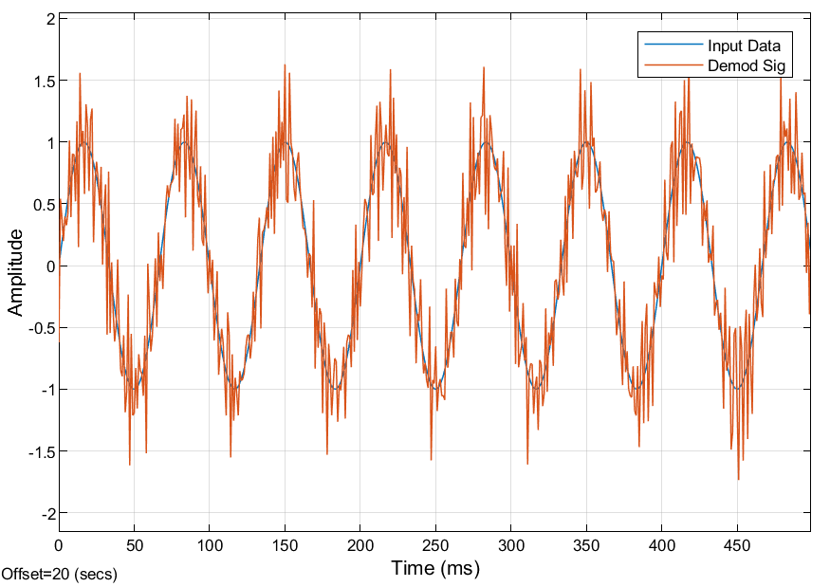
Figure 25, Above, noisy demodulated signal and initial signal overlayed in oscilloscope reading.

Conclusion
To conclude, it is possible to evaluate errors and shortfalls of all modulation methods, particularly when regarding higher levels of noise causing erroneous data to be interpreted. However, we can draw from this that amplitude and frequency modulation can be used with multimedia formats of data and fixed data. It is equally worth noting that the effectiveness of these systems in practical application would vary somewhat dramatically without perfect theoretical parameters and environments, as can be observed in the software.

Recommendations
Recommendations for further investigation would most notably include some form of application in a real, physical, environment. As is inevitable with theoretical designs, variables and miscalculations that are mostly observed in practical application due to logical or system errors. Further investigation should, in particular, investigate alternative frequency modulation methods that may not create such a heavy hardware simulation burden. Alternatively, some other multimedia files that are not optimised would make for interesting real world insights that a perfectly optimised sinewave media item would not raise.

References
[1] G.N Kareem, G.A Gbotoso, and S.O Omogoye, ‘MATLAB analysis and simulink model for amplitude modulation technique’, World Journal of Advanced Engineering Technology and Sciences, vol. 2, no. 2, pp. 021–028, May 2021, doi: 10.30574/wjaets.2021.2.2.0035.
[2] S. Faruque, ‘Amplitude Modulation (AM)’, 2017, pp. 17–32. doi: 10.1007/978-3-319-41202-3_2.
[3] S. Yaakob, R. M. Mahmood, Z. Zan, C. B. M. Rashidi, A. Mahmud, and S. B. A. Anas, ‘Modulation index and phase imbalance of dual-sideband optical carrier suppression (DSB-OCS) in optical Millimeter-wave system’, Photonics, vol. 8, no. 5, 2021, doi: 10.3390/photonics8050153.
[4] M. H. Weik, ‘sideband’, in Computer Science and Communications Dictionary, Boston, MA: Springer US, 2000, pp. 1574–1574. doi: 10.1007/1-4020-0613-6_17305.
[5] A. Al Amin, ‘Implementation and Investigation of VDSL2 Signal Modulation/Demodulation Functions for FDM Solution via POF Channel’, Nov. 2023.
[6] T. Nikas, A. Bogris, and D. Syvridis, ‘Double sideband suppressed carrier modulation for stable fiber delivery of radio frequency standards’, Opt Commun, vol. 382, pp. 182–185, Jan. 2017, doi: 10.1016/j.optcom.2016.07.071.
[7] I. B. Obot and I. B. Onyeachu, ‘Electrochemical frequency modulation (EFM) technique: Theory and recent practical applications in corrosion research’, J Mol Liq, vol. 249, pp. 83–96, Jan. 2018, doi: 10.1016/j.molliq.2017.11.006.
[8] R. Holtzman, ‘Wideband frequency modulation applications and techniques’, Microw J (Int Ed), vol. 2015, 2015.

Appendix
NOTE: input file requires optimisation in Matlab or a MIDI file optimiser or manual optimisation to function as a single data stream for a sine wave. Additionally, bass equalized audio systems are recommended for hearing the sinewave, particularly without noise, running it through a MIDI simplifier will also generally raise the level to be audible to less bass optimised audio systems.
Figure 26, Above, unoptimized wav format input multimedia
Figure 27, Above, output multimedia without noise after demodulation
Figure 28, Above, noisy output multimedia without noise after demodulation

