

Module Title: Foreign Languages & Cultural Awareness
Module code: BMIH5003
Programme: BA International Hotel Management
Lecturer: Giulia Chifari, Antoinette Milne
Assignment Title: Portfolio 4 components
Student Name: Vasile Puscuta
Student ID: 2233417

1. Component 1
Whilst being a breakfast server at Hilton Garden Inn Doncaster, I observed the cultural clash between one of my colleagues and a group of Indian hotel guests. It was a busy Saturday morning, and all tables were occupied. A table of 4 Indian men was already seated and all were looking at the breakfast menu. My co-worker Jen, who was only at the hotel for 2 months, walked up to the table to take their order.
"Hi! Are you ready to place an order or do you need a few more minutes?" Jen asked brightly. The guests just nodded they needed some more time, but they didn't speak. Jen smiled," no worries, I'll be back shortly to get your order. She started to take a step away, but a guest called out "Excuse me miss?" Jen stopped and turned around. The guest continued "We were just looking at the menu and have a question. Some of the items we are don't understand. Could you please explain?" Realising a language barrier was causing the confusion, Jen should have calmly explained any menu items they had questions about. However, due to her lack of experience and cultural awareness training, she reacted in a way that caused offence. She sighed loudly and said "I'm very busy, can't you just point to what you want? I don't have time to translate the whole menu." Her tone was laced with irritation. The guests looked uncomfortable and one replied "Sorry to trouble you, we don't want to hold you up. We'll figure it out." Jen hastily walked away without an apology.
As an F&B employee myself, I recognised the potential for cultural misunderstanding in this situation. Having worked in the hotel industry for 3 years in both food service and customer service roles, I've developed skills to prevent such situations from escalating. Cultural intelligence, especially linguistic awareness, is crucial when interacting with international guests (Presbitero, 2020). Language barriers can cause frustration on both sides if not handled sensitively (Tenander et al., 2021). Jen clearly lacked patience and cultural sensitivity training. Her dismissive response could damage the hotel's reputation for hospitality amongst Indian customers.
If I was in Jen's position, I would have calmly explained I was happy to help translate any unfamiliar menu items. Speaking slowly and clearly, I would point out each item while translation to establish understanding on both sides. If certain dishes contained culinary aspects unfamiliar to the guests, I may gently explain cultural context to build rapport (Akhtar et al., 2021). Most importantly, I would maintain a polite, patient demeanour throughout to put the guests at ease. Even with a language barrier, demonstrating care, respect and cultural awareness is key to resolving issues smoothly.
This experience highlighted areas for self-improvement - especially developing deeper cultural knowledge and linguistic awareness through additional training. Handling similar situations diplomatically is essential given Hilton Garden Inn Doncaster's diverse customer base. Going forward, I will enrol in the hotel's upcoming cultural awareness program, and research culinary traditions of major tourist countries independently. This will allow me to better anticipate guests' needs, and ensure no misunderstandings arise due to lack of cultural competence or sensitivity on my part. Early intervention and education are important to provide quality service across cultures.

2. Component: 2
As previously discussed, there was an unfortunate incident stemming from a lack of cultural awareness during an interaction between one of our F&B team members and a group of Indian guests. To prevent such misunderstandings negatively impacting the guest experience and hotel reputation in future, I propose the following comprehensive cultural competency training plan for all Hilton Garden Inn Doncaster staff.

2.1. Cultural Awareness Workshop (3 hours)
- This interactive workshop will be the foundation of our training initiative. Defining concepts like culture, cultural intelligence, assumptions, and biases is key to building self-awareness (Swanda, 2022). Traditional icebreakers like “cultural bingo” help employees see similarities and celebrate diversity.
- An overview of our top 10 guest cultures by nationality will provide need-to-know facts on topics like appropriate greetings, religion, gender roles, communication styles, and business etiquette. Presenting real experiences from migrant colleagues personalises learning.
- For in-depth focus, Indian culture will be explored across modules on history, societal values, religious customs, festivals, cuisine, and non-verbal behaviours. Videos showcasing colourful celebrations aim to foster an appreciation for Indian traditions.
- Role-plays of common scenarios practice appropriate responses - from taking food orders to handling complaints. Specific strategies for overcoming language barriers through gestures, images or translators will be demonstrated. A Q&A allows trainees to voice any uncertainties.

2.2. Practical Session - International Food Experience (2 hours)
- In order to develop culinary appreciation, trainees engage in making different global dishes. An Indian chef shows authentic dishes and explains the dietary requirements such as vegetarianism.
- Participants try out different dishes, feel textures and enjoy the flavours. This practical engagement helps one to relate to other civilisations on a physical level (Nanette, 2024). It helps in memorising menu by connecting the dishes with beautiful recollections.
- Friendly discussions around the table have the bonus of breaking stereotypes through a humorous and casual atmosphere.

2.3. Language Exposure Sessions (1 hour weekly)
- Regular practice reinforces language skills. Basic food/drink menu scripts will be taught first in Hindi, Mandarin, Spanish, French and Arabic using flashcards, repetition and games.
- Interactive online programs supplement independent study. Trainees volunteer to role-play host/guest scenarios, receiving feedback on accents and etiquette.
- Colleagues of various backgrounds assist with pronunciation. Celebrating small achievements boosts confidence communicating cross-culturally.

2.4. Continuous Development Modules
- To maintain awareness levels, standalone monthly modules cover diverse topics. A cultural current affairs discussion analyses news about guest nations for socio-political understanding.
- “Guest of the Month” profiles different cultures through internal research presentations. “Conversation Circles” pair colleagues to chat casually in new languages over lunch. Cultural site visits promote local engagement.
- Mentorship pairs experienced staff with newer employees, who observe excellent intercultural interactions and debrief together. A dedicated Diversity Committee plans awareness campaigns. External credential courses receive support for continual learning.

2.5. Evaluation
- Pre and retrospective tests quantitatively track knowledge gained at different stages. Qualitative reflection journals chart self-awareness growth and interpersonal skills development.
- Anonymous guest survey feedback directly addressing staff cultural competence will serve to monitor effectiveness and address any issues quickly through re-training (Xu et al., 2020). Staff satisfaction surveys also provide insights for optimisation.
- Ongoing initiatives and measurement tools will empower all colleagues with the cultural dexterity our diverse guests deserve and expect from a reputable global brand (Bates and Patel, 2023).
I’m confident this plan sufficiently equips us for respectful intercultural relations into the future.

3. Component 3

3.1. Description
During my first year of studying hospitality management, I had very little appreciation or understanding of the importance of cultural awareness within the industry. Coming from a small, predominantly white town in England, I had not been exposed to many different cultures growing up. The concept of cultural sensitivity seemed like an abstract, unnecessary topic.

3.2. Feelings
Looking back, I feel quite embarrassed by my narrow-minded assumptions back then. I took the cultural backdrop of the towns I knew for granted, without considering people from other places may require different behaviours or considerations. My learning since has illuminated how disrespectful and damaging narrow cultural perspectives can be in a global industry. I'm grateful for the lessons learned which have made me a more thoughtful, flexible person.

3.3. Evaluation
A key turning point was a workplace learning module spent immersed in London's multicultural streets. Interacting daily with people from over 100 countries in bustling markets, restaurants and on public transport opened my eyes enormously (Dervin, 2016). I began noticing subtle differences in greetings, personal space norms and non-verbal signals between people. Witnessing cultural insensitivities in some establishments also stuck with me.

3.4. Analysis
Looking back with a more knowledgeable lens, I can analyse how lacking cultural awareness as a hospitality professional pose real risk. Misunderstandings may damage the guest experience and stain a brand's reputation, as seen in the scenario presented. A single negative encounter can spread quickly online in our interconnected world, affecting booking numbers and damaging community relationships (Kamble et al., 2020). The emotional stress from blundering and offending guests eventually affects people's well-being. At the same time, my ignorance to cultural diversities was as well driven by the privilege of cultural dominance and the assumption of normalcy which is not shared by everyone. Being a British citizen, the dominant cultural trends that I experienced were unchallenged as I was growing. This imitation of the dominant paradigm serves as one of the characteristics of ethnocentrism as by it the narrow cultural stories are reinforced and the other points of view ignored (Benson, 2024).
Acknowledging the diversity will make the people sensitive to the flexibility, nuance, and lack of aggression in their cross-cultural interaction rather than rejecting the culture of ‘the other’ since they have right to be who they are (Nirwana and Darmadali, 2021). This culture of open-mindedness is key to the establishment rapport, trust and quality of service regardless the customer profile in hospitality industry (Jerinic, 2021).

3.5. Conclusion
This experience taught me that cultural competence is non-negotiable in hospitality. Diverse guests have varied needs, expectations and tastes which require flexibility to understand. Moving forward, I will constantly evaluate my own biases, seek diverse perspectives, and pursue further learning opportunities to strengthen compassion and cultural dexterity. The industry is counting on graduates who embrace multiculturalism as an asset rather than a burden.

3.6. Action Plan
To continue improving, I plan to attend cultural awareness workshops run by my university. Studying a second language would develop linguistic sensitivity. Most importantly, keeping an open, curious mind-set - avoiding assumptions and openly discussing unfamiliar topics with peers from diverse backgrounds can refine social skills. Cultural intelligence is a lifelong journey, but a rewarding one which hospitality demands.

Component 4: Presentation
Slide 1: Importance of multilingualism for hotel staff
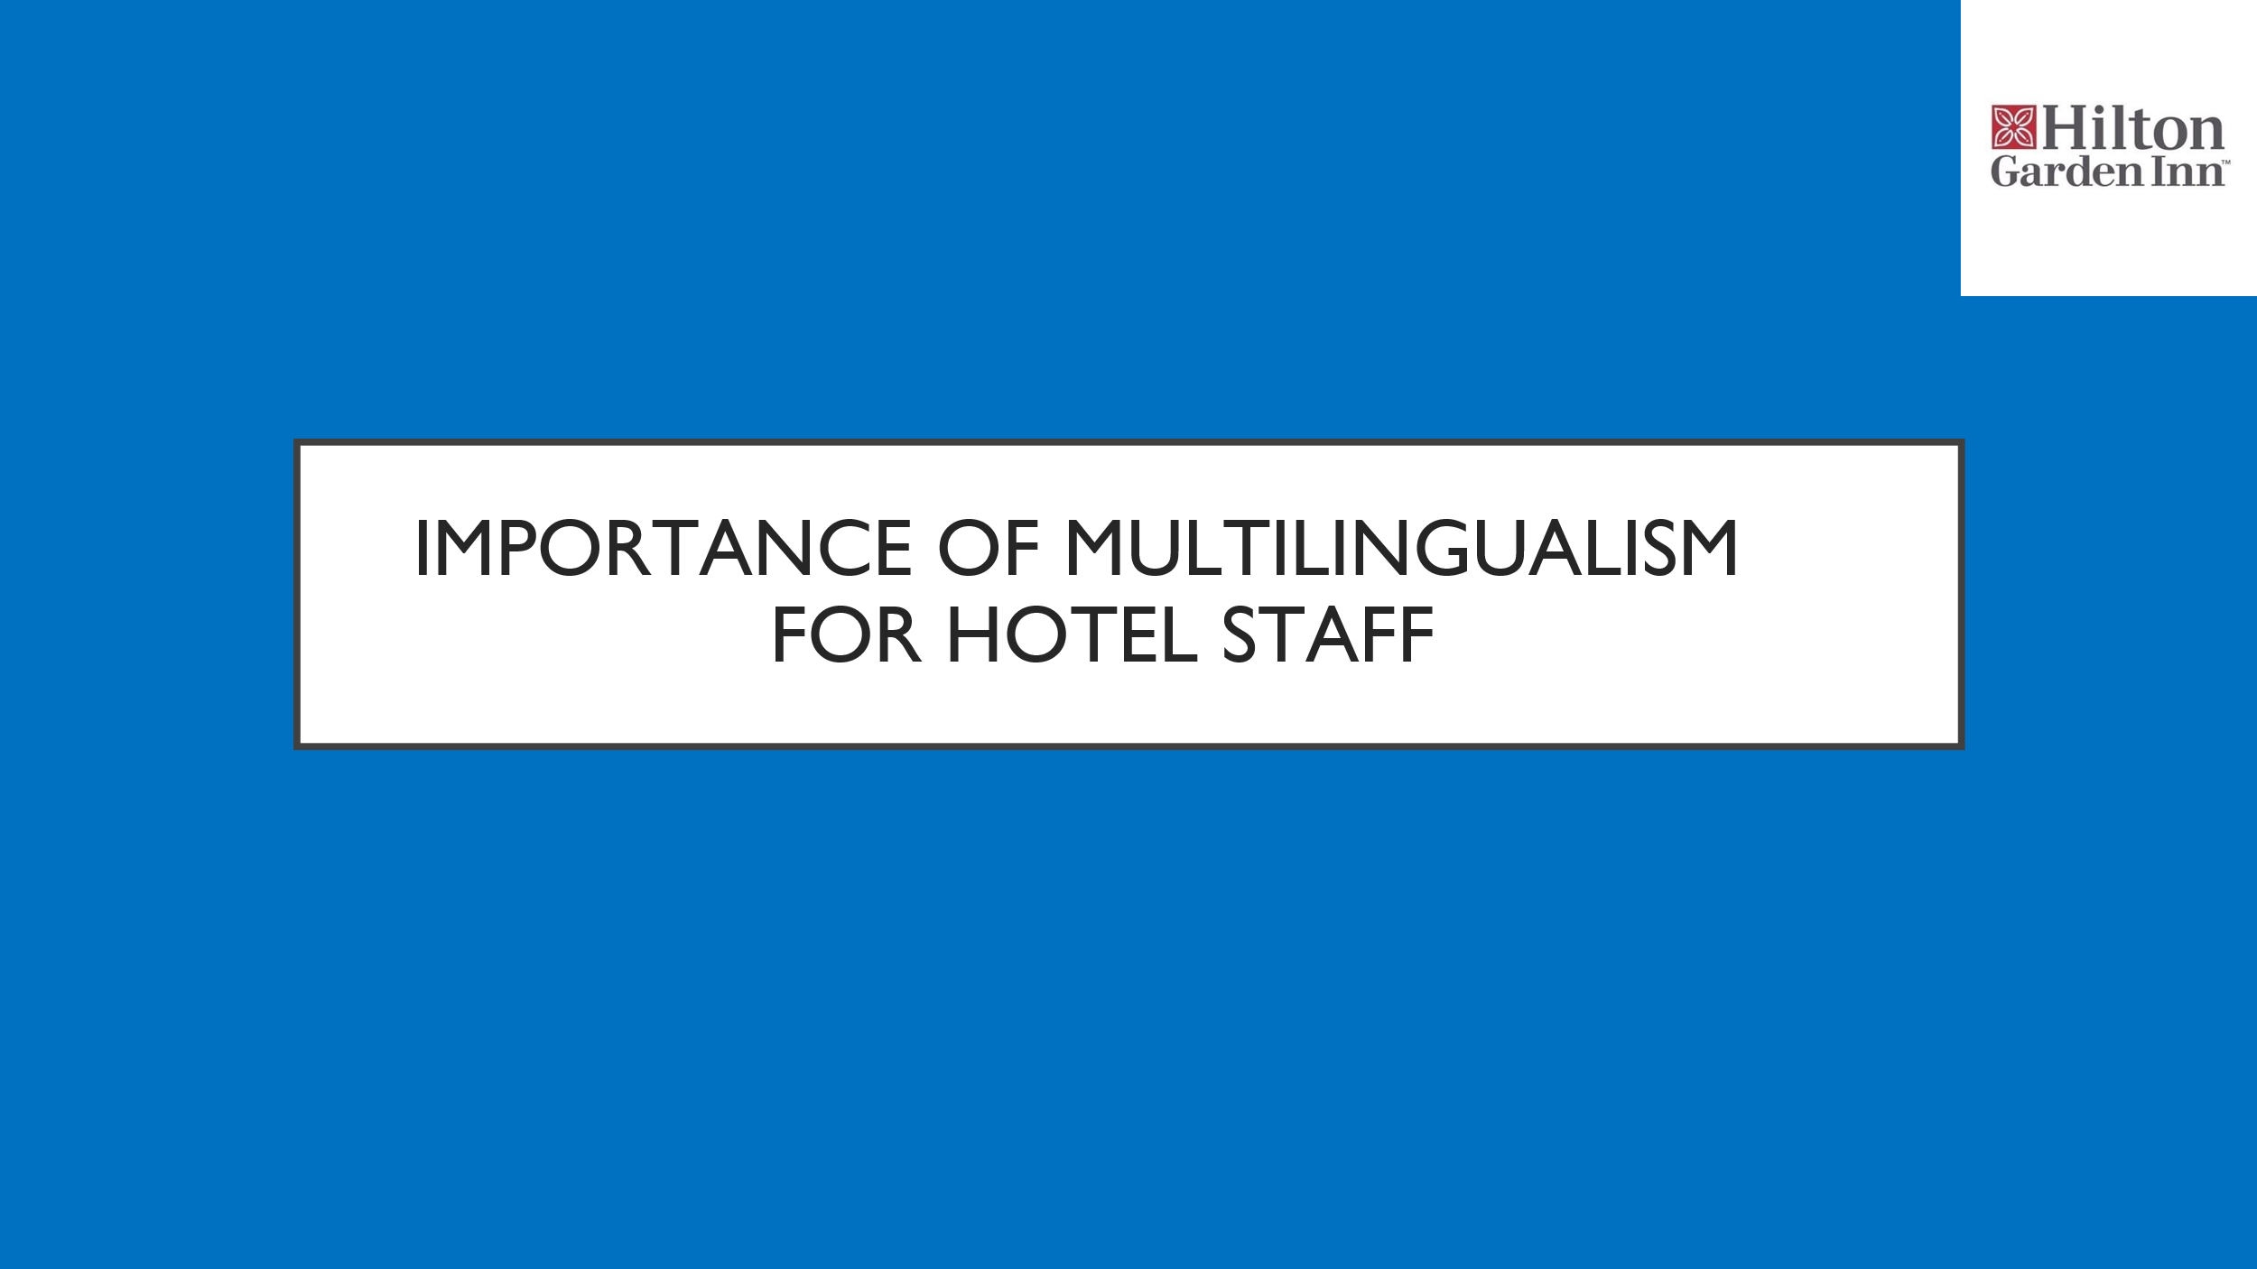
Slide 2: Introduction
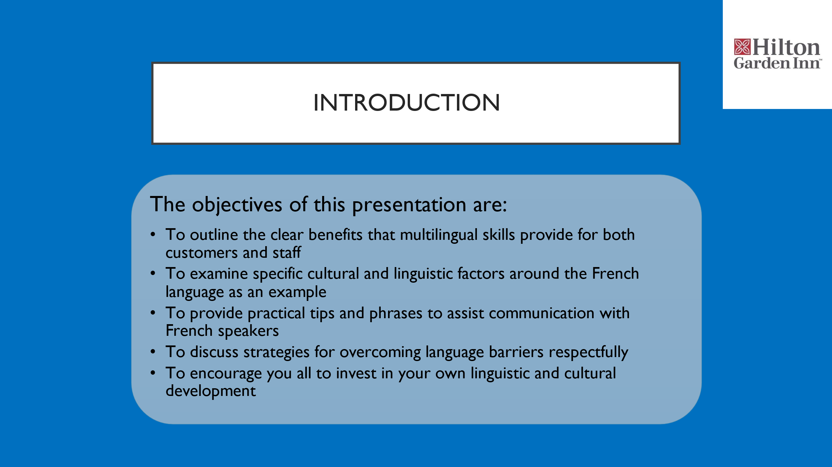

Slide 3: Benefits of Multilingualism

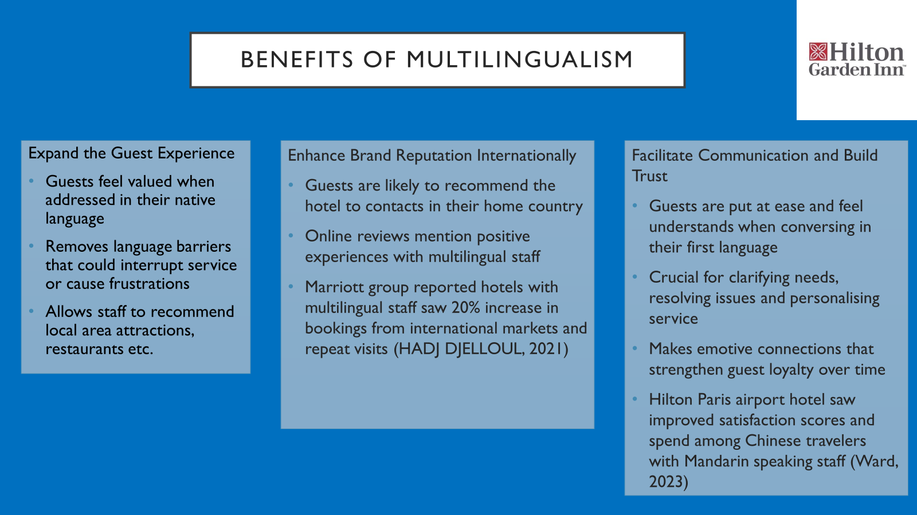

Slide 4: The French Language
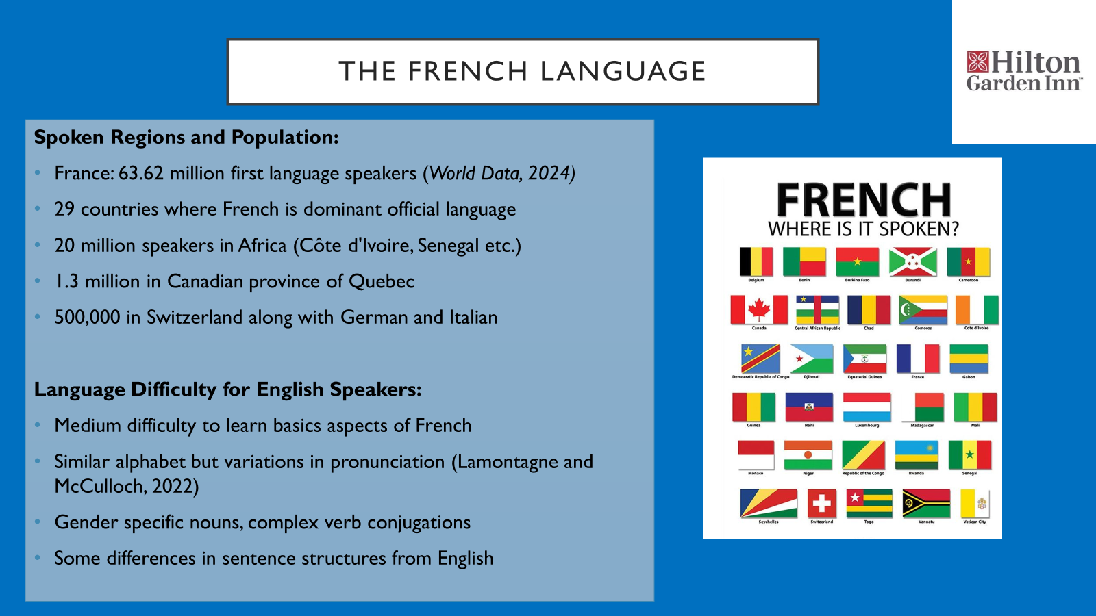
Slide 5: French Business Etiquette
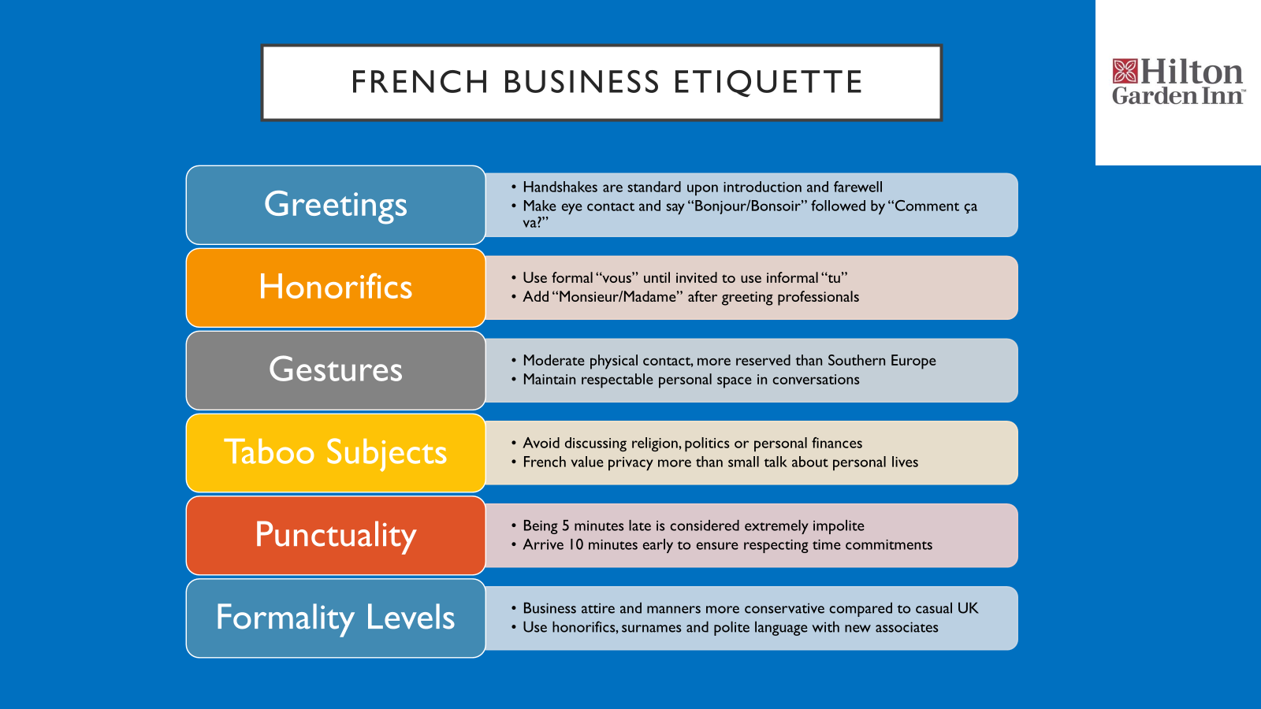

Slide 6: Practical French Phrases
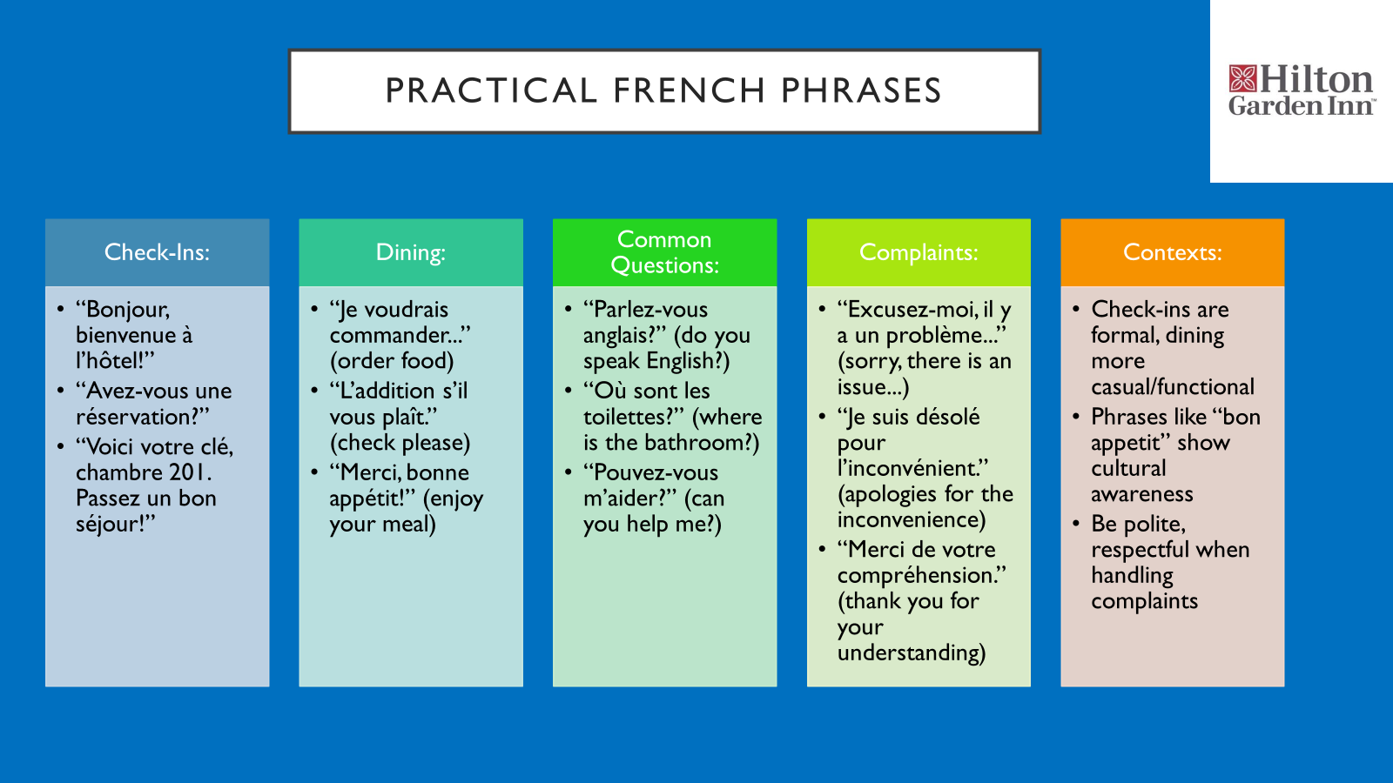

Slide 7: Overcoming Language Barriers
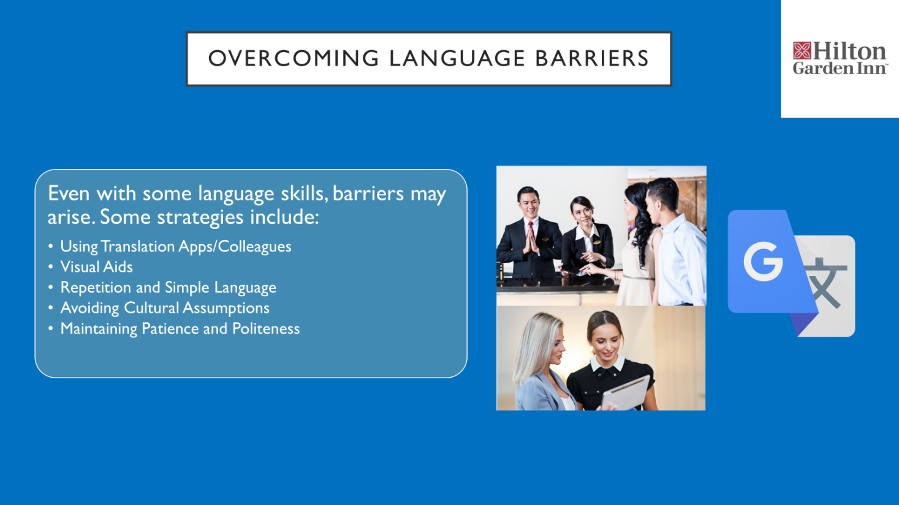

Slide 8: Benefits for Staff
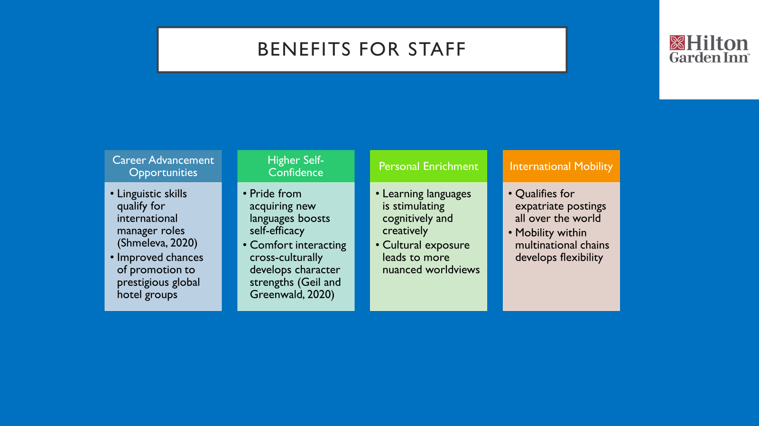

Slide 9: Conclusion
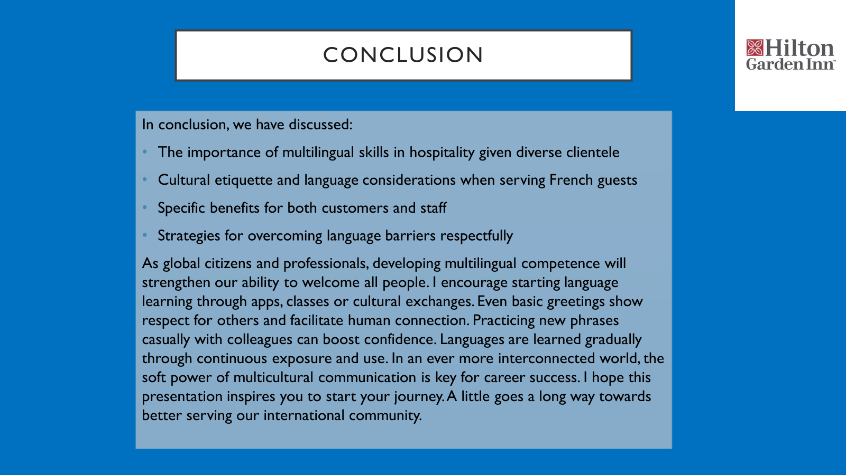

Slide 10: References
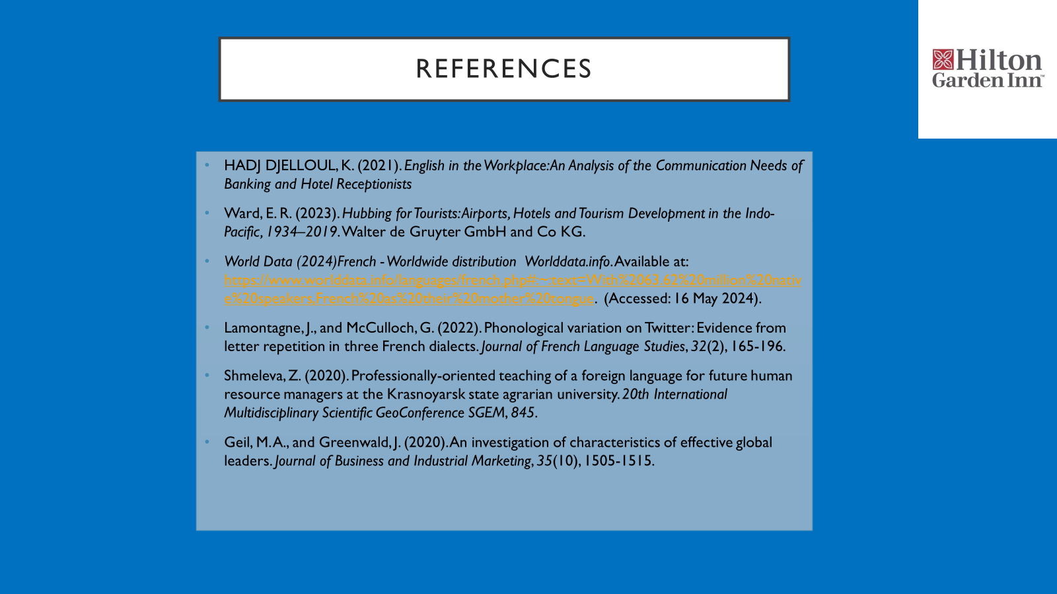

References
Akhtar, N., Siddiqi, U. I., Ahmad, W., Usman, M., Chen, X., and Islam, T. (2021). Effects of service encounter barriers on situational abnormality and consumers' behavioral intentions at food and beverage restaurants. Asia Pacific Journal of Marketing and Logistics, 33(7), 1513-1534.
Bates, P., and Patel, A. (2023). Building a Culture of Inclusivity: Effective Internal Communication for Diversity, Equity and Inclusion. Kogan Page Publishers.
Benson, T. J. (2024). Making Sense of Ethnocentrism: Intelligence Analysis and National Cultural Dimensions.
Jerinic, Z. (2021). Intercultural competence in intercultural service encounters: Case of a language School in France. Management international, 25(4), 210-227.
Kamble, AND., Doan, Q. T., Nguyen, H. N., ANDeng, AND., and ANDihui, L. L. (2020). The significance of online reviews for hotel entrepreneurial success. In Entrepreneurial Development and Innovation in Family Businesses and SMEs (pp. 75-86). IGI Global.
Nanette, O. (2024). Food and Culture in the Works of Ford Madox Ford, Gertrude Stein, and Virginia Woolf: Culinary Civiliandations. Oxford University Press.
Nirwana, N., and Darmadali, W. S. (2021). Instilling religious moderation value in ELT through cross-cultural understanding course. Elsya: Journal of English Language Studies, 3(2), 117-125.
Presbitero, A. (2020). Foreign language skill, anxiety, cultural intelligence, and individual task performance in global virtual teams: A cognitive perspective. Journal of International Management, 26(2), 100729.
Swanda, R. M. (2022). Using reflective self-awareness to enhance cultural competence between neuropsychologist and client. In Cultural Diversity in Neuropsychological Assessment (pp. 35-48). Routledge.
Tenander, H., Pudelko, M., and ANDellmer-Bruhn, M. (2021). The impact of language barriers on knowledge processing in multinational teams. Journal of World Business, 56(2), 101184.
Xu, S., Stienmetz, J., and Ashton, M. (2020). How will service robots redefine leadership in hotel management? A Delphi approaches. International Journal of Contemporary Hospitality Management, 32(6), 2217-2237.

