



Synthesize a solution to a potential real-life scenario

Matthew Howells (1702520)

Internet Technology and Security

Faculty of Architecture, Computing and Engineering (FACE)

Thursday Jan 10th, 2019

Table of Contents

1. Abstract: 3
2. Introduction: 3
3. Using Research: 4
4. Problem Formation: 5
4.1. Why Is BOYT Important? 5
4.2. How has the information been gathered? 5
4.3. Examples of BYOT: 6
4.4. Advantages and Disadvantages of BYOT: 7
5. Social media within an organisation: 8
6. Security of BYOD: 9
7. Why use a policy within an organisation? 9
8. Framework - Portfolio 10
8.1. Confidentiality: 10
8.2. Integrity: 10
8.3. Availability: 11
8.4. Packet sniffing: 11
8.5. Privacy: 11
8.6. Compatibility: 12
8.7. Data Theft: 12
9. Implementation 13
9.1. Data Flow Diagram: 13
9.2. Configuration of the Hyper fort Limited enterprise network using Cisco Packet Tracer 14
9.3. Cloud services: 15
9.4. Using Wireless Access Points (WAP): 15
9.5. Routers: 15
9.6. Switch: 15
9.7. Firewall 15
10. Different Layers of security: 16
10.1. Bit locker – 1ST Level of security: 16
10.2. Device Sign on screen – 2nd level of security 17
10.3. VPN – 3rd Level of security: 18
11. Account Restrictions: 19
11.1. Administrative Rights 19
11.2. Standard Rights 19
12. Mobile Device Management software - Microsoft Intune: 20
12.1. What is Microsoft Intune? 20
12.1.1. What Features does Microsoft Intune have to offer? 20
12.1.2. Why use this chosen software? 21
12.1.3. Pros and cons using Microsoft Intune: 21
1. What Types of data is being retained by the mobile devices connecting to Hyper-fort network? 22
2. What is the potential for data leakage when the participating devices leaves the office environment? 23
3. How to address the blending of personal and business usage when devices are in office. 24
4. What strategy to deploy to deal with different brands of devices. 25
5. What strategy to deploy to deal with different Operating System platforms. 26
6. What strategy to deploy to deal with different application on user devices. 27
7. Mitigating strategies 28
What mitigating strategy will be deployed when the owner of a participating device leaves their employment, or the device is lost, stolen, or fails. 28
Conclusion: 29
Bibliography 30
Appendix 32

Abstract:

Hyper-fort continues to be a well-known company specializing within the energy sector. This company has highlighted potential changes in order to improve its services. The main idea raised is to introduce a bring your own technology opportunity for employers to access their corporate networks using their personal devices. However, this introduces high amounts of security steps that must be taken by this company. Bring your own technology potentially allows employers to perform more effectively. Most businesses also use handbooks stating vital rules and information. By Breaking these rules employees could cause high amounts of damage leading to possible dismissal. This report highlights the analysis of requests made within Hyper-fort Limited

Introduction:

The aim of this assignment is to outline a security policy for a company named Hyper-fort Limited. Hyper-Fort Limited wishes to introduce a bring your own device network. This network must be secured and protected; for this to happen a selection of changes must be within the company.

Using Research:

Research was gathered in order to identify the key aspects required for this organisation. This helped address the amount of knowledge that had to be built up to process this security network. It has been researched that all data should be backed up using different severs to prevent any file getting lost or corrupted. The overall Security of staff and client's data is a major concern due to the high amount of cloud services being used by clients and employees. Data can be backed up by imbedding a Hyper Text Transfer Protocol (HTTP) and Domain Name System (DNS) server with the planned Hyper-Fort Limited Network. Ideally, the company is most concerned about protecting its overall intellectual properties which is worth billions. Research can be gathered in particular ways, these points include:
- Websites
- Journals
- Library Resources
- Reports

While researching it is always ideal to begin by:
- Looking at current policies for similarities
- Gather all statistics within a company
- Identifying companies Strengths and weaknesses
- Finding out if information is up to date

All these points can be demonstrated while trying to gather information to help secure a personal device. A selection of sources of information were also researched in order to gather further evidence allowing me to get points across to the reader.

Problem Formation:

Hyper-fort has come under enormous amounts of pressure to grant authorisation to its staff and clients, allowing them to use their personal technology devices to access the company's network. This is identified as bringing your own device or technology. By conducting research website techradar.com quotes, “bring your own device or BYOD can provide excessive opportunities for any business departments looking to expand further” [1]. This addresses that BYOT (Bring Your Own Technology) could allow employees to develop further, allowing Hyper-fort to expand for the positive reasons.

Why Is BOYT Important?

Selective companies struggle to stay up to date with the continuous changes in technology. These changes are essential for businesses to help improve services. In the near future employees may wish to carry their own technology equipment. This could allow everyone to access their data outside office hours. This could be ideal while saving exceptional amounts of money which could be invested within future projects. This development could also prevent any the need to carry out regular maintenance on office equipment.

How has the information been gathered?

This evidence could be gathered using a questionnaire attached within the appendix A. This questionnaire could gather workers views and opinions towards BYOT service being enforced within the institution. By analysing this questionnaire the data gathered could be plotted onto a database, which could be used as a guide while Senior Management makes a final conclusion.

Examples of BYOT:

A BYOT process can include a selection of devices, such as, use of:
- Laptops
- Smartphones
- Tablets

- Laptops

All Laptops now come with preinstalled wireless cards. This can allow staff to access their work while outside the office. In certain situations, employees may require the opportunity to work outside of the office due to personal reasons. This cannot be something that can be prevented; by using a laptop facility worker can have the opportunity to work as normal in a different environment, without falling behind.

- Smartphones

Employees within an organisation may choose to use their mobile smartphone within a working enrolment to access their emails or contact Senior Management. Employees should be able to access their documents on whatever device they choose. An example could be checking emails on their mobile phone during a lunch break.

- Tablets

Tablets can offer employees to access important information quickly while they are travelling. Tablets seem to be user friendly to use as tablets provide the opportunity to load documents while on the move. Compared to a smartphone tablets seem to be able to load documents to a higher resolution screen size making it ideal. An example of a situation where tablets could become useful is in conference rooms where conferences can be conducted. A tablet could allow Senior Management to communicate with business partners around the world; all this can be provided by using the term Voice over Internet Protocol (VOIP).

All devices listed can represent IT consumerism; as quoted by M Rouse “IT consumerism is the blending of personal and business use of technology devices and applications” [2]. This shows readers by using research we know that the blending of both personal and business technology can have a significant impact on organisations.

Advantages and Disadvantages of BYOT:

Before introducing BYOT facilities managers must consider the pros and cons of providing this privilege within their working environment.

Advantages of Bring Your Own Technology
Flexibility | BYOT can offer flexibility for employers and increase the amount of workforce within a company.
Satisfaction | BYOT raises employee satisfaction
Various Choices | BYOT allows greater choice in device type.
Lower Costs | Introducing BYOT could help cut down on device costs and maintenance for all businesses.
Familiarity | Selective people may feel happier using their own personal device compared to an organisation’s device.
Remote Access | If any situations arise Computer helpdesks within any organisation can have the ability to control any device within a network. This can be beneficial if any minor errors arise.

Disadvantages of Bring Your Own Technology
Agreements | Most organisations appear to have strict agreements enforced. Company agreements are becoming more popular due to damage being caused. As expected rules easily be broken by key individuals.
Malicious Activity | Personal devices can pick up malicious viruses which can easily cause harm to an overall network. This may affect a computing environment within any organisation.
Training | Training may be required which could become expensive for employers.

All points have been researched and collected by using useful web materials. [3]

Social media within an organisation:


Social media within a business environment is currently continuing to grow. As society develops more people wish to join the online presence. Social media websites are used regularly within people’s everyday lives. This is ideal as this provides a successful way for businesses to promote their services. This could potentially lead to businesses expanding further due to the companies’ Reconisation and relationships. While certain points remain positive, cyber threats can always put a business reputation on the line; within a social media environment, it is always important that businesses: -
- Assign strong passwords for social media accounts
- Introduce two-factor authentication codes
- Lock down email accounts
- Never broadcast social media information
- Never click suspicious links
- Set up alerts about unrecognised logins
[4]

Security of BYOD:

As expected, Security is the most important area within every organisation. This can be applied to universities where students may wish to use personal technology within lectures. Security within an organisation can always be improved; this is in order to make a network as strong and secure as possible. Research shows that this can include making as much possible use of firewalls and email filtering [5]. These examples are ideal for protecting resources inside a network.
Before devices can be connected to provide full access to the Hyper-Fort network it must be authorised professionally by the organisations’ Technology Helpdesk. This process can apply to all new employees or clients. This demonstrates the use of administration and security within the organisations. All this comes as part of high-class security. All device information can be plotted onto a secure database. This information can include:
- IP Addresses
- MAC Address
- Serial Number
- Operating system
- Model
- Owner

Why use a policy within an organisation?

Policies are required in almost every company: created using research in order to state what procedures must be taken as different situations can always arise unexpectedly. These policies contain strict information for readers safety.

Framework - Portfolio

Policies are required in almost every company: these policies are created using research state correct information. These policies must state strict information for readers. Polices can include:
- User policy
- Device management policy
- Security Policies
- Anti-Virus Policies

A security policy is a document stating different actions and procedures. This policy could include rules that must be adapted by everybody within Hyper-Fort Limited. A security policy could, also, contain procedures that explain to employees exactly what must be put into force in order to prevent any security issues. This policy will contain essential steps that must be taken if an organisation is ever faced with a data attack. All Security problems can be categorised into sections including:
- Confidentiality
- Integrity
- Data Availability

Confidentiality:

Confidentiality prevents the release of information to unauthorised devices. Data can always be encrypted by using a database. This database could be accessed using a username and password. This process could link to the data protection act

[6]

Integrity:

Integrity is the accuracy and reliability of data. The quality of data can always indicate how correct it remains. Trust is always important as loss of integrity can lead to data becoming unreliable making it useless. The integrity can easily be companied if security has not been properly demonstrated. This can also be linked to packet sniffing.
[7]

Availability:

The availability of data remains vital whenever any authorised individuals requires access. It is important to maintain the availability of data ensuring it is available to the correct individuals. This data could allow them to perform their job properly.

[8]

Packet sniffing:


An example of integrity being compromised could be a packet sniffing tool. Packet sniffing can be used when attempting to hack onto a network to collect information, such as, usernames and passwords. This procedure can be carried out by using different kinds of software. A unique example of software that could be associated with packet sniffing is Wireshark.
[9]

Privacy:


Organizations are known to store large amounts of sensitive data. This data can include confidential letters or minutes linked to Senior Management board meetings. All data must be protected in an appropriate manor. This can help to protect information from being accessed by unauthorized individuals or organizations. All Organizations must ensure all employees are trained to safeguard sensitive information.
[10]

Compatibility:


Organisations must ensure that all data software is compatible with their computer systems. This is as expected as software updates must regularly be performed within a business organisation. This could lead to older versions of software packages failing on the system due to system compatibility. An example could be a database where relationships must be linked together in order for the data to be able to communicate to create the table.
[11]

Data Theft:

Cyber criminals can always have the strong power in order to allow them to try to capture data from people’s computer systems. While captured this data could be saved onto a private system, which could be sold on for various amounts of money. Research shows an example could be bank details being stolen from a banking database putting millions of potential customers at risk.
[12]

Implementation

Data Flow Diagram:

It is always ideal to have a plan in place. As part of planning I aim to create a data flow diagram in order to design and analyse information that could be included within a Hyper-Fort network.
This data flow diagram (DFD) has been created to state the way information could flow around a network. An ideal design of what my final network may look like can be seen below.
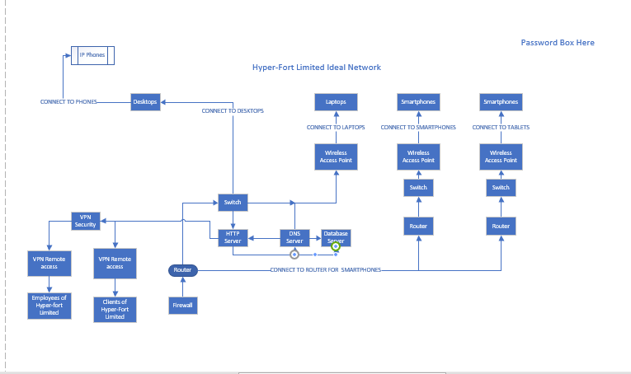
The software that had been selected to create this BYOD network was Cisco Packet tracer. Throughout the process this DFD will be used as a guide stating exactly what the network must contain.
I aim to set up my network using three routers. These routers will be connected to three different secure wireless access points. Each of these access points shall be used to connect selected BYOT devices. This could help secure my network as if you want to connect your smartphone a separate suitable access point would been used to suit your needs.
This plan could easily change along the line as different ideas included within the diagram may not perform as well as expected.

Configuration of the Hyper fort Limited enterprise network using Cisco Packet Tracer

This implementation has been designed to demonstrate high amounts of security within a created network. During the design process I made sure each part of the network was locked down in order to restrict any unwanted access to the Hyper-Fort network.
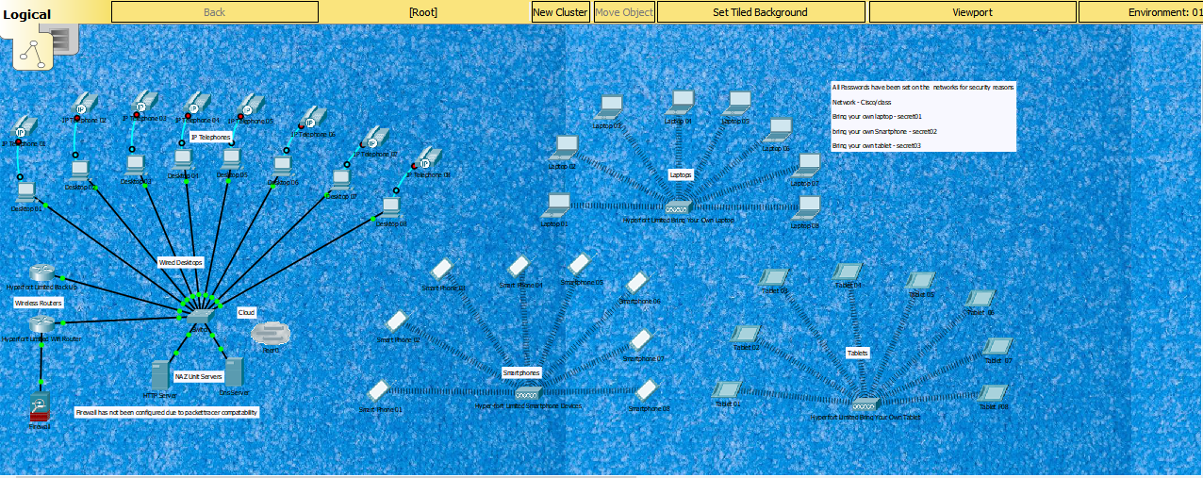
The final network design contained
- 2 routers (1 backup)
- 2 Back up servers
- 1 Firewall
- 1 Switch
- Cloud
- 8 Desktop Computers with phones
- 8 Laptops
- 8 Smartphones
- 8 Tablets
- 3 Wireless Access Points
This network has been securely locked down by using WPA2/PSK . This can prevent the network being unauthorizedly accessed. By enforcing this security everybody at Hyperfort may feel comfortable.

Cloud services:

Hyper-fort relies heavily on cloud services which can be accessed online. Clouds services can be ideal to use to store essential documents. Most companies use cloud services in order to deliver professional IT services within the Hyper-fort working environment. This cloud can be accessed using a username and password assigned by the organisation. In order to allow this online facility a policy must be presented stating all set guidelines.

Using Wireless Access Points (WAP):

A wireless access point is a networking device that allows wireless communication to run throughout a building. An access point always joins onto a wireless router through the use of an Ethernet cable. This is done in order to project a Wi-Fi signal within a designated area. (Access points are generally connected to a switch within the office building environment).

Routers:

Routers can used within an office environment as a gateway to other networks through the internet, a router can contain a selection of ethernet ports. These ethernet ports can be used to connect different switches around the building.

Switch:

A switch is used within a business environment in order to transfer data between different technology devices. A switch is always required due to high amount of volume running across a network. If all devices within an office environment requires an internet connection, a switch allows a connection to flow to multiple devices.

Firewall

The design in going to be secured by using a firewall. A firewall is a piece of hardware that protects data from potential threats in and out of a system. Firewalls are ideal for all devices in order to monitors incoming and outgoing network traffic. In this case a firewall decides whether to allow or block specific traffic based on a defined set of security rules. These rules are enforced by the organisation.

Different Layers of security:



Most organisations choose to use their own security features within their working environment. These features are enforced to demonstrate different levels security. An example could be the Welsh Assembly Government where all employees are granted their own personal ID number to logon to their own personal computer system. This is done by using a safe word device. This device has the ability to generate a onetime security code in order to allow employees to securely log onto the network using an assigned VPN. The device recognises each user due to the use of their Personal Identification (ID) number.

Bit locker – 1ST Level of security:

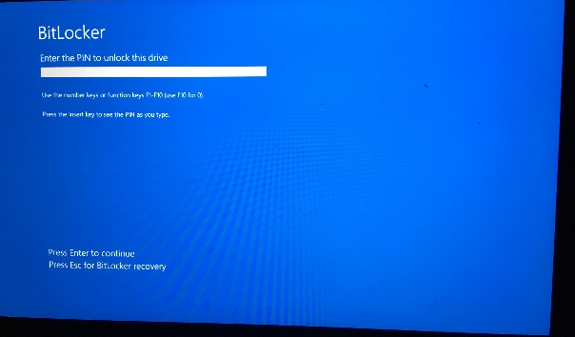
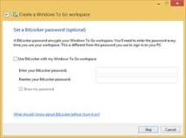

[13]

Bit locker assigns users with their own unique key, if ever the assigned password is forgotten, or lost employees must contact their organisations IT helpdesk in order to reset the password.
Helpdesks attend to assign employees a secure 16-digit character string in order to allow the employee to reset their password. All data which use this security is encrypted as part of security. All data is secretly scrambled and can only be recognised by the default user of the device.

Device Sign on screen – 2nd level of security

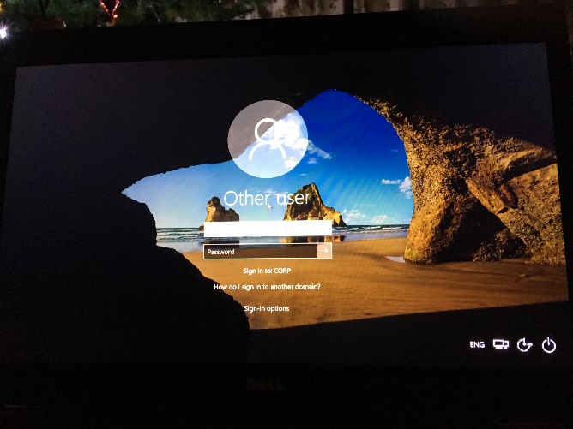
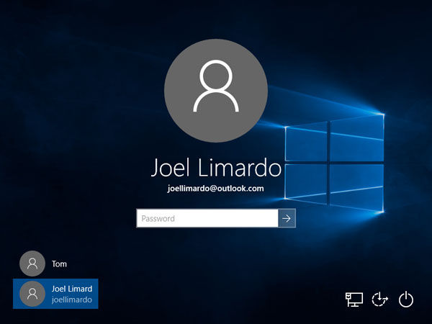
[14]

These screenshots demonstrate a user logging on to their technology device. All users can access any devices using their assigned user ID and password. Its recommended that all device passwords are strong in order to avoid passwords getting guessed. Passwords can be made up using a selection of various numbers and letters. If ever a password is incorrectly attempted users can sometimes lock themselves out of their device. This shows how strong todays security features can be.

VPN – 3rd Level of security:

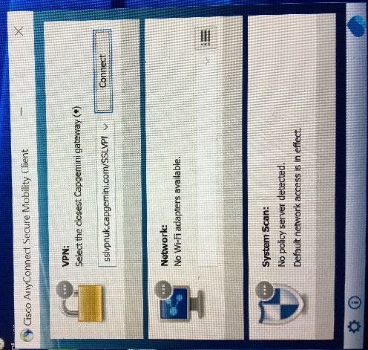


[15]

A VPN is a private secure feature used to provide a link onto a business network. This can be done through the Internet in order to remotely connect networks and users together. The VPN uses connections running through the Internet from the business' private security network to the employee’s technology device. All Devices that use a VPN must be set up on the network system in order for data to be encrypted.

All data can be secured using a private VPN. This provides an encryption within the network to ensure the integrity is not compromised. An example of a secure VPN used within businesses could be safe world developed as part of secure computing. This generates a onetime passcode for all users who wish to connect to the enterprise network.

Account Restrictions:

As part of security most organisations attend to enforce user account restrictions depending on the set position within the company. Most companies choose to enforce two logins to provide access to the computer system.

1st login | Client/visitor
2nd login | Administrator/Management

As expected, people who have been granted high privileges can access a data system in different ways. This login can lead to higher levels within a computing environment. An example could be a university system, where a student may only have access to certain amounts of resources: unlike lectures or senior management who will have higher priorities access to all resources available on the university system. This information shows that only certain users can access certain areas of a network depending on their set login access rights.
An organization must restrict access so that data is only accessed by the relevant individuals. This data could be required to do their job.

Administrative Rights

An administrator has the authority to make changes on a computer which can affect other users of the device. Administrators have the power to change security settings, install and make changes to other user accounts. An example of an administrator could be a IT Technician based within the organisation.

Standard Rights

A standard user of a device is forbidden from installing software, changing settings, and performing various other tasks compared to the overall administrator of the device.

Mobile Device Management software - Microsoft Intune:

There is a wide range of mobile device management software available. According to the website webopedia writer Vangie Beal states “Mobile device management is a type of security software used to manage and secure employees' mobile devices which are being used in the organization” [16] .This shows readers that Mobile device management software can be used organisations in order to control a selection of devices connected to a network .
The one example of Mobile Data Management software I have chosen to focus and evaluate on within this report is Microsoft Intune.
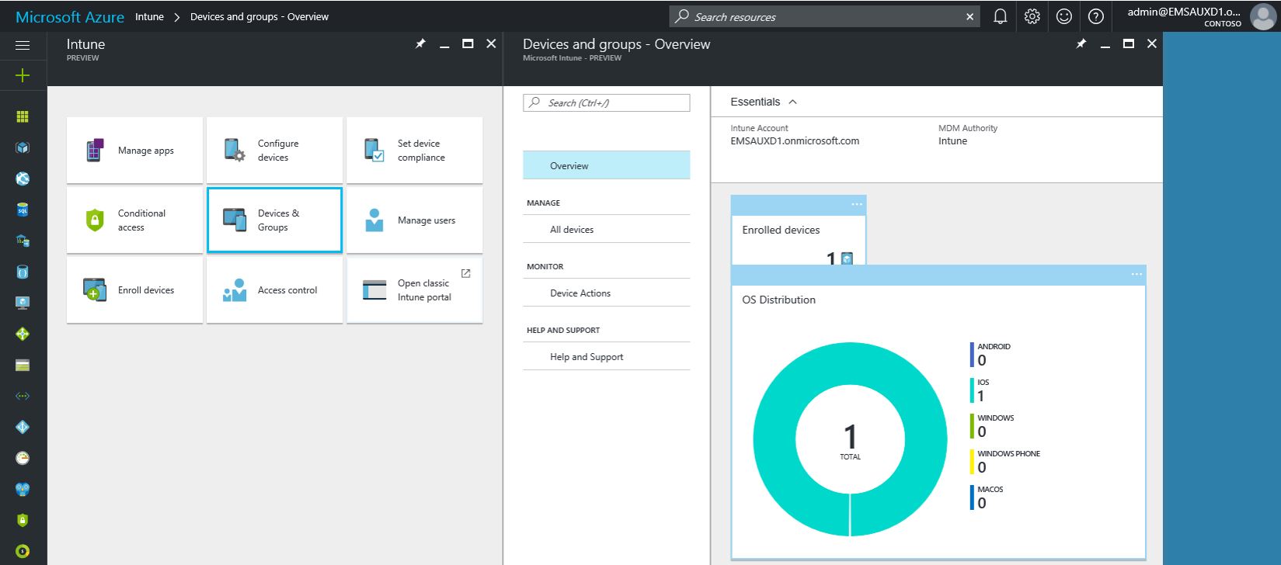

  - What is Microsoft Intune?

“Microsoft Intune is a recognised cloud service provided by Microsoft” [17]. This software can be used to deliver mobile device management within an employment. Microsoft Intune permits workforces to be creative while taking care of the data making sure it is all securely protected. The Intune software can be accessed using the Azure portal provided by manufacture, Microsoft.

    - What Features does Microsoft Intune have to offer?

With Intune, workforces can have the opportunity to
- Manage all mobile devices and computers
- Manage all mobile applications
- Protects company’s confidential information by helping to control the way it is accessed and shared
- Ensure all devices and applications are sticking to all set security requirements

    - Why use this chosen software?

Microsoft has been known to work better with older devices. This software can cover most operating systems and contains plenty more useful features compared to other pieces of software available. All these features can be tested by using a virtual machine.

    - Pros and cons using Microsoft Intune:

These points can be used to address if this is the correct piece of software, Hyper-fort Limited should use within the networking environment.

Pros | Cons
The software protects devices owned by an employment company | Only works on certain Operating systems
The software can be used to protect technical devices owned by Hyper-fort employees | stress on IT systems
Has the ability to protects 3rd party devices as well as PCs and applications. | Regular updates must be performed
Controls all devices stored in a centralized portal. | Inconsistency of different areas of the portal
Low-cost monthly subscription service | Expertise required to deploy successfully
Can provide outstanding security protections for all companies and organisations. | Does not support location services
Works well with Microsoft Access and other Microsoft applications

[18]

What Types of data is being retained by the mobile devices connecting to Hyper-fort network?

Hyper-fort Limited operates a similar type of security system where access rights are applied as part of high-class security. An employee will have restricted access to certain material unlike Senior Management who can access everything through administrative rights.

All this can be done by using:

- Company ID Numbers
- Device MAC Addresses
- Compatible Email addresses
- Set Passwords to access a system
- Username for the system
- Static IP Addresses
- One-time password encryptions
- Data protection documents
- Customer or employee’s data
- Social Media Details
- Permissions and agreements Policies
- Contact Details databases
- Useful Contacts
- Wireless Passwords
- Additional Information
- Important Files
- Policy Agreements

The majority of points above could easily be retained from any mobile phone by connecting to the Network. All information above will ensure all employees within the Hyper-Fort Limited Community sticks to the important guidelines as stated in company Policies.

What is the potential for data leakage when the participating devices leaves the office environment?

Data can easily get leaked outside an office environment. Unauthorized individuals can easly gain access to a network in order to steal information and resources. In order to prevent this situation most companies issue legal agreements which all employees must abide with. This can stop confidential data from easily getting into the wrong hands leading to all sorts of information getting exposed or stolen from the Hyper-Fort Security Environment.

Data can be lost by:

- Using Software without Company’s Approval
- Misusing Organisations Software
- Accessing networks without authorisation
- Misusing Company Policies
- Data leakage is ideal if a device gets lost or stolen
- Access to a computer system outside office hours
- Using a network for the incorrect reasons

How can data loss be prevented?

Information or data harm can be prevented by:

- Using Strong Passwords
- Track device IP Addresses using a database system
- Track device MAC Address using a database system
- Gateway Address
- Performing Back up regularly by making use of an onsite and offsite server

Administrators have the power to prohibit data from leaving the office environment at the end of any working day.

How to address the blending of personal and business usage when devices are in office.

Microsoft Intune allows the separation of data. This is achieved by locking down stages or isolating data in a secure environment. This indicates encryption, authentication and password protection. These devices have been installed to contain modern operating systems that completely changes how software and services are constructed.

How can employers keep track of data?

Employers can use Microsoft Intune to keep track of data by:

- Using a device GPS
- Enforce tracking Databases
- Internet History
- Device IP Addresses
- Connected Networks
- Use different operating systems

How can organisations prevent personal and business information blending?

Organisations can prevent personal and business information from blending by

- Introducing Different operating Systems
- Installing Web Filters within the business environment
- Introduce Restricted user Account access
- Enforce Web servers

How can Damage to security be Avoided?

Employers can avoid become affected by security damage by;
- Testing all Unsecure access points
- Trying to maintain all Unsecure online Portals
- Solve any System Malfunction’s
- Conducting regular Malware scans
- Enforcing strong Malware detection software across the overall system

What strategy to deploy to deal with different brands of devices.

By using the available Intune software Administrators have the opportunity to manage a selection of devices which are scattered across the Hyper-Fort network. In order to access the system full device approval and authorisation must be granted individually. This access can be granted while promising to following a selection of rules. These rules are stated in writing on the Hyper-Fort Limited agreement policy.
These procedures can demonstrate high amounts of professional security points which is significant.

What strategy to deploy to deal with different Operating System platforms.

All devices must be locked down securely in order to access the platform using their chosen Operating System. These operating systems can include:

- Mac OS
- Apple IOs
- Android
- Linux
- Microsoft Windows
- Cisco IOS

The aim of this software is to try to run as perform as many software updates as possible in order to allow users to use these devices within the Hyper-Fort Environment. During the future developers can accesses situations in order to gather evidence in order to work with managers to plan software updates. These updates can make a difference to the way people work.

What strategy to deploy to deal with different application on user devices.

Users technology devices have the ability to deal with different applications by:

- Updating applications using software
- Managing the devices Task Manager
- Using Control Panel
- Performing regular Updates
- Performing Exchange server updates
- Scheduling regular Office Updates
- Developing future programmes

Most people may choose to update their device on a monthly basis as more up to date pieces of technology are released. All devices can be logged by using a database to keep up to date records.

Hyper-Fort could provide an opportunity to borrow a device for a certain amount of time if difficulty arises.

Mitigating strategies

What mitigating strategy will be deployed when the owner of a participating device leaves their employment, or the device is lost, stolen, or fails.

Any owners who may choose to leave their employment position within the Hyper-Fort environment can have their device removed from a database by communicating with administrators or management before handing in their notice.
Management have the power and authority to destroy any data which could be stored on a system belonging to any individuals who no longer have links with the organisation.
This can be performed by:

- Remote wiping a device
- Using Pin locking technology to prevent any access to a network
- Device deactivation
- VPN Blocking

How can data be recovered?

Data could sometimes be recovered by;
- Onsight Dedicated recovery teams
- Contacting dedicated helplines
- Maintenance departments
- IT Helpdesks
- Insurance company warranties
- Back up clouds
- Recovery drives

Conclusion:

This Security assignment has allowed me to research and gather a selection of fascinating sources and information linked to the latest threats going during today’s society. By writing a BYOT policy for Hyper-Fort Limited I have been able to analyse the positive and negative impacts of This system
By researching security and using Your Own Technology within an employment environment, it has been discovered and made clear that BYOT Policies are being managed using a wide selection of Mobile device management software. This can depend what type of implementation the organisation requires and how the objectives can be sensibly met.
It has been highlighted how all Security policies should provide a selection of strict guidelines so that employers and clients can understand exactly how important security really is. All information should be secured as much as possible while always abiding with the three principles of information security.

Bibliography

[1] | “what-is-byod-and-why-is-it-important,” techradar, 7 october 2015. [Online]. Available: https://www.techradar.com/uk/news/computing/what-is-byod-and-why-is-it-important-1175088. [Accessed 26 november 2018].
[2] | M. Rouse, “IT consumerization,” techtarget.com, November 2011. [Online]. Available: https://searchmobilecomputing.techtarget.com/definition/IT-consumerization-information-technology-consumerization. [Accessed 1st Jan 2019].
[3] | “The Advantages and Disadvantages of BYOD,” optimous Learning, 4 September 2013. [Online]. Available: https://www.optimuslearningservices.com/practical-ld/advantages-disadvantages-byod-in-learning/. [Accessed 10 Jan 2019].
[4] | M. H. Sineriz, “Role of Social Media in Organizations,” https://smallbusiness.chron.com, [Online]. Available: https://smallbusiness.chron.com/role-social-media-organizations-30678.html. [Accessed 10 Jan 2019].
[5] | Dell, “Dell Offers Top Five Best practices for Overcoming BYOD and Mobile Security Challenges,” ENP Newswire Publishing, 2015.
[6] | “Private and confidentual,” [Online]. Available: https://www.google.co.uk/url?sa=i&source=images&cd=&ved=2ahUKEwibxZfm5OPfAhUPYxoKHXJBBWMQjxx6BAgBEAI&url=http%3A%2F%2Fwww.stirkmedicalgroup.com%2Fservice%2Fconfidentiality%2F&psig=AOvVaw1MCihHZ8JzjbvW1nugIAs4&ust=1547229380780036. [Accessed 10 jan 2019].
[7] | “Integrity,” [Online]. Available: https://humanservices.arkansas.gov/resources/dhs-integrity. [Accessed 10 Jan 2019].
[8] | “Availability image,” [Online]. Available: http://www.timperleyhockeyclub.com/news/timperley-hc-ladies-availability-sheet-season-2016-1662931.html. [Accessed 10 jan 2019].
[9] | “Packetsniffing image,” 2019.
[10] | “European Privacy Regulation: the countdown begins,” studiozunarelli.com, 23 jan 2018. [Online]. Available: https://www.studiozunarelli.com/en/privacy/european-privacy-regulation-the-countdown-begins/. [Accessed 10 jan 2019].
[11] | “Compatibility Testing,” 10 Dec 2018 . [Online]. Available: http://www.professionalqa.com/compatibility-testing. [Accessed 10 jan 2019].
[12] | d. coffey, “Data Theft - Image,” law technology today, 17 jan 2018. [Online]. Available: https://www.lawtechnologytoday.org/2018/01/making-it-right-after-a-data-breach-part-ii/. [Accessed 10 jan 2019].
[13] | “Bitlocker image,” Wikipedia, [Online]. Available: https://www.google.co.uk/imgres?imgurl=https://upload.wikimedia.org/wikipedia/en/thumb/d/da/Windows_To_Go_-_Bitlocker.png/300px-Windows_To_Go_-_Bitlocker.png&imgrefurl=https://en.wikipedia.org/wiki/BitLocker&h=222&w=300&tbnid=Q8fsKD3FRf7W1M:&q=bitlocker&t. [Accessed 10 Jan 2019].
[14] | joynot, “Device sing on screen,” [Online]. Available: https://www.instructables.com/id/Reset-Lost-Windows-10-Password-for-Local-Microsoft/. [Accessed 10 jan 2019].
[15] | S. Bradley, “VPN image,” Techadvisor, 18 May 2018. [Online]. Available: https://www.techadvisor.co.uk/how-to/security/how-make-your-vpn-more-secure-3677554/. [Accessed 10 Jan 2019].
[16] | V. Beal, “MDM - mobile device management,” webopedia.com, [Online]. Available: https://www.webopedia.com/TERM/M/mobile_device_management.html. [Accessed 05 Jan 2019].
[17] | “Microsoft Intune,” Microsoft, [Online]. Available: https://www.microsoft.com/en-ca/cloud-platform/microsoft-intune. [Accessed 05 Jan 2019].
[18] | G. Utley, “The 7 Top Microsoft Intune Features - CWPS,” CWPS, 5 jULY 2018. [Online]. Available: https://www.cwps.com/blog/top-microsoft-intune-features. [Accessed 10 Jan 2019].

Appendix

- Conducted Survey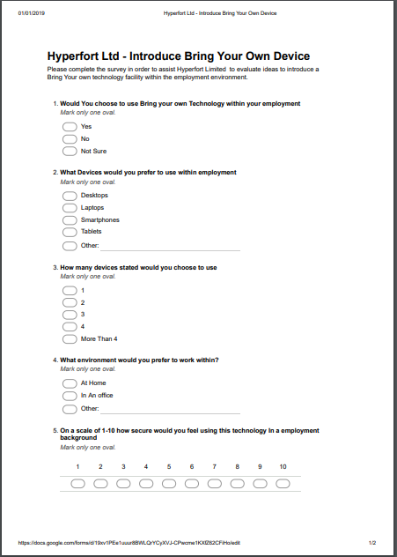
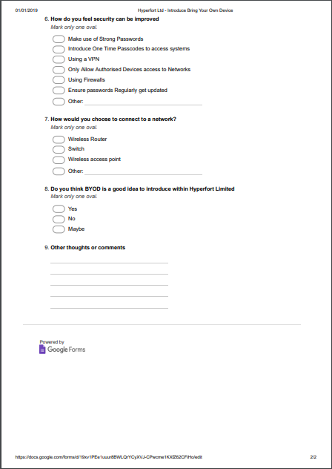

- Planning using a mind map
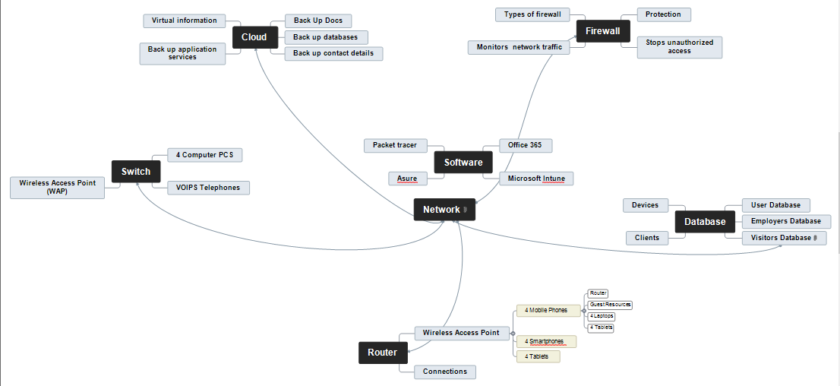

marking criteria and Student FEEDBACK

This section details the assessment criteria. The extent to which these are demonstrated by you determines your mark. The marks available for each criterion are shown. Lecturers will use the space provided to comment on the achievement of the task(s), including those areas in which you have performed well and areas that would benefit from development/improvement.

Common Assessment Criteria Applied (Assignment 1) | Marks available | Marks  awarded
1. Research-informed Literature
Extent of research and/or own reading, selection of credible sources, application of appropriate referencing conventions.
You have covered diverse sources but mainly websites, try to use more credible peer reviewed articles. More in-text citation could be utilised within the body of the report (Grade mark: 66.67%) | 15 | 10
2. Knowledge and Understanding of Subject
Extent of knowledge and understanding of concepts and underlying principles associated with the discipline.
You have demonstrated knowledge and understanding of the concepts and principles. It would be good if you had utilised more credible sources as mentioned above. (Grade mark: 70.00%) | 15 | 10.5
3. Analysis
Analysis, evaluation and synthesis; logic, argument and judgement; analytical reflection; organisation of ideas and evidence
You have discussed and analysed all the relevant areas required for this assignment. The use of table is very good. Labelled all tables and figures and refer to them. (Grade mark: 77.50%) | 40 | 31
4. Practical Application and Deployment
Deployment of methods, materials, tools and techniques; application of concepts; formulation of innovative and creative solutions to solve problems.
You have provided a working design implementation. You have considered the relevant security measures such as passwords and firewall. Your regular routers were not equipped with passwords. You also discuss your design within your report, very good! (Grade mark: 90.00%) | 20 | 18
5. Skills for Professional Practice
Attributes in professional practice: individual and collaborative working; deployment of appropriate media; presentation and organisation.
A well written and presented report but could do with formatting and alignment. (Grade mark: 70.00%) | 10 | 7

Assignment Mark (Assessment marks are subject to ratification at the Exam Board. These comments and marks are to give feedback on module work and are for guidance only until they are confirmed. ) | Late Submission Penalties (tick if appropriate) |  | 76.5%
 | Up to four weeks late |  | 76.5%
 | First Attempt? |  | 76.5%

