University of Wales Trinity Saint David

School of Engineering

Vehicle Handling Optimisation Through Simulation



Wesley Patrick – 1701708

MSc Automotive Engineering

Advanced Vehicle Dynamic Behaviour – ACEA7003

Table of Contents
1.0. Introduction 3
2.0. Methodology 5
2.1. Design of Experiment 5
3.0. Analysis 9
3.1. Slalom Results 9
3.2. Double Lane Change 14
4.0. Conclusion 20
5.0. References 22

Figure 1 - VI-CarRealTime build mode model tree 8
Figure 2 - VI-CarRealTime press manoeuvres window 8
Figure 3 - Completion time Vs Damping Rate (Front) Vs Spring Rate (Front), Slalom 11
Figure 4 - Completion Time Vs Spring Rate (Front) Vs Anti Roll-Rate (Front), Slalom 11
Figure 5 - Lateral Acceleration Vs Spring Rate (Front) Vs Damping Rate (Front), Slalom 12
Figure 6 - Lateral Acceleration Vs Spring Rate (Rear) Vs Damping Rate (Rear), Slalom 13
Figure 7 - Lateral Acceleration Vs Spring Rate (Rear) Vs Anti Roll-Rate (Rear), Slalom 13
Figure 8 - Lateral Acceleration Vs Anti-Roll Rate (Rear) Vs Damping Rate (Rear), Slalom 14
Figure 9 - Lateral Acceleration Vs Damping Force (Front) Vs Spring Rate (Front), DLC 16
Figure 10 - Lateral Acceleration Vs Spring Rate (Front) Vs Anti-Roll Rate (Front), DLC 17
Figure 11 - Lateral Acceleration Vs Damping Rate (Front) Vs Anti-Roll Rate (Front), DLC 17
Figure 12 - Lateral Acceleration Vs Spring Rate (Rear) Vs Damping Rate (Rear), DLC 18
Figure 13 - Lateral Acceleration Vs Anti-Roll Rate (Rear) Vs Spring Rate (Rear), DLC 18
Figure 14 - Lateral Acceleration Vs Anti-Roll Rate (Rear) Vs Damping Rate (Rear), DLC 19

Table 1 - Factor table with variable values 5
Table 2 - Design of Experiment 6
Table 5 – Double Lane Change Manoeuvre Results 15

Introduction
Engineering is an ever-developing industry constantly exceeding what was thought possible. The dynamics sector within this industry is no different with original equipment manufacturers, aftermarket component companies, and race teams all constantly developing components to alter the dynamic response of a vehicle to achieve the required response. Although dynamics covers a wide area of components, this report will focus on suspension components such as springs, dampers, and anti-roll bars. the importance of these components directly influence the movement of the unsprung mass of the vehicle, through spring stiffness, damping rate, and anti-roll bar stiffness. Using a myriad of components through the design and development stage is both costly and time consuming for manufacturers and therefore a more efficient method is required, therefore simulation software has been developed so that engineers can quickly and efficiently evaluate the dynamic response of a vehicle without the cost of a wide range of components for testing purposes (Siemens, 2022).
This project is focused on optimising a vehicles dynamic response to a series of dynamic manoeuvres using simulation software. The software that has been selected for this investigation is VI-CarRealTime, from VIGrade. This simulation software has the capability independently alter vehicle parameters and conduct investigations into the differing response of the vehicle with real time results and animation (VI-GRADE, 2022). the benefits of the real time results and animation are of key importance to this project as the results can be processed and recorded with ease. The simplicity of the software allows quick alterations in set up to be completed and therefore increases productivity, saving time.
As stated above OEM’s, aftermarket manufacturers and race outfits are constantly developing solutions to deliver required dynamic responses. All of these manufacturers require different results when evaluating suspension components, for example an OEM may focus on passenger comfort, an aftermarket manufacturer may focus on results that stiffen the response of the vehicle whilst maintaining a level of passenger comfort, and a race team will focus on results that ensure the fastest lap time whilst maintaining drivability (Nicolae & Todoruţ, 2019).
This project focuses on optimising a passenger sedan car for a series of dynamic manoeuvres to reduce the forces experienced by the passengers and to improve comfort. The sedan car model which is built in to the VI-Grade simulation software provides an ideal platform to conduct this projects investigation upon as it replicates a very common vehicle that is aimed at consumers. The parameters that will be altered with this vehicle are the spring rate, damping rate, and anti-roll rate of the front and rear suspension components in order to reduce lateral and longitudinal forces and improve comfort from a noise vibration and handling perspective. As outlined in the project brief two dynamic manoeuvres have been used to optimise the vehicles suspension components which simulate scenarios that may arise on public roads, these manoeuvres are a double lane change and a slalom.

2.0. Methodology

2.1. Design of Experiment
Due to the vast array of potential suspension components that could be used for this project to optimise the vehicles dynamic response, a design of experiment program was used to create a list of runs that analyse the full potential results using the lower through to the upper limits of the spring, damping, and anti-roll rates. The program that has been used for this element of the project is Design Expert from StatEase, a specialist software for designing two-level factorials, analysing data sets, and creating graphs and contour plots (StatEase, 2022). The DOE software is a powerful tool that is able to create a wide variety of experiments with a range of factors and responses, although for this project the box Behnken experimental methodology was used. The benefit of a box Behnken design is that the number of runs that is required to complete a full investigation (Rao & Kumar, 2012).
The experiment that has been designed for this investigation is comprised of six factors and five responses, the factors are the variables that will be changed throughout the investigation and are listed in table 1 below along with the upper, lower, and mean values.
Table 1 - Factor table with variable values
Factor | Units | Lower Limit | Mean Value | Upper Limit
Front Spring Rate | N/mm | 50 | 75 | 100
Front Damping Rate | N/m | 2000 | 5500 | 9000
Front Anti-Roll Rate | N/mm | 5 | 40 | 75
Rear Spring Rate | N/mm | 10 | 40 | 70
Rear Damping Rate | N/m | 100 | 2550 | 5000
Rear Anti-Roll Rate | N/mm | 5 | 15 | 25

The responses are the characteristics of each run that will be recorded for the analysis, and are listed below along with their units of measure:
- Lateral acceleration, m/s²
- Longitudinal acceleration, m/s²
- Time, s
- Max steering input, rad
- Max velocity, km/h
The responses that have been chosen for this investigation have been selected as strong parameter to deliver an insight into the response of the vehicle. The lateral acceleration will give insight into the roll of the vehicle as the negates the cones laid out in the simulation, whereas the longitudinal acceleration response will give insight into the pitch of the vehicle. With the aim of reducing these responses, theory suggests that the comfort experienced by the passengers will be increased. Similarly by investigating the time and maximum velocity of the simulation a middle ground can be observed as it is expected that the quickest time would also have the highest velocity and potentially the most uncomfortable experience, on the other end of the spectrum, the run with the slowest time and velocity may experience the most pitch and yaw leading to an uncomfortable experience.

Using the data that has been provided above, the DOE program is able to specify a list of runs for the experiment that cover the full range of variables. The DOE program dictated that in order to fully analyse the relationships of the factors then 53 runs were required which were conducted for both dynamic manoeuvres and can be seen in the table below.

Table 2 - Design of Experiment
 | Factor 1 | Factor 2 | Factor 3 | Factor 4 | Factor 5 | Factor 6
Run | Spring Rate (Front) | Damping rate (Front) | Anti Roll spring rate (Front) | Spring Rate (Rear) | Damping Rate (Rear) | Anti Roll spring rate (Rear)
 | N/mm | N/m | N/mm | N/mm | N/m | N/mm
1 | 75 | 9000 | 75 | 40 | 5000 | 15
2 | 75 | 2000 | 40 | 40 | 5000 | 25
3 | 100 | 5500 | 40 | 70 | 100 | 15
4 | 75 | 5500 | 40 | 40 | 2550 | 15
5 | 100 | 5500 | 5 | 40 | 2550 | 25
6 | 75 | 5500 | 75 | 70 | 2550 | 25
7 | 75 | 5500 | 75 | 10 | 2550 | 5
8 | 75 | 2000 | 75 | 40 | 5000 | 15
9 | 100 | 5500 | 40 | 10 | 5000 | 15
10 | 75 | 5500 | 40 | 40 | 2550 | 15
11 | 100 | 9000 | 40 | 10 | 2550 | 15
12 | 50 | 5500 | 75 | 40 | 2550 | 25
13 | 75 | 5500 | 5 | 10 | 2550 | 25
14 | 50 | 5500 | 40 | 10 | 100 | 15
15 | 75 | 2000 | 40 | 40 | 100 | 5
16 | 100 | 5500 | 40 | 70 | 5000 | 15
17 | 50 | 2000 | 40 | 10 | 2550 | 15
18 | 75 | 5500 | 5 | 70 | 2550 | 5
19 | 75 | 2000 | 5 | 40 | 100 | 15
20 | 100 | 5500 | 5 | 40 | 2550 | 5
21 | 50 | 9000 | 40 | 70 | 2550 | 15
22 | 100 | 5500 | 75 | 40 | 2550 | 25
23 | 75 | 5500 | 5 | 70 | 2550 | 25
24 | 50 | 5500 | 75 | 40 | 2550 | 5
25 | 75 | 5500 | 40 | 40 | 2550 | 15
26 | 75 | 9000 | 5 | 40 | 5000 | 15
27 | 75 | 9000 | 40 | 40 | 5000 | 25
28 | 75 | 9000 | 40 | 40 | 5000 | 5
29 | 50 | 2000 | 40 | 70 | 2550 | 15
30 | 50 | 5500 | 5 | 40 | 2550 | 25
31 | 50 | 9000 | 40 | 10 | 2550 | 15
32 | 75 | 9000 | 40 | 40 | 100 | 25
33 | 75 | 2000 | 40 | 40 | 100 | 25
34 | 100 | 2000 | 40 | 70 | 2550 | 15
35 | 75 | 2000 | 75 | 40 | 100 | 15
36 | 75 | 5500 | 40 | 40 | 2550 | 15
37 | 100 | 5500 | 75 | 40 | 2550 | 5
38 | 75 | 5500 | 40 | 40 | 2550 | 15
39 | 100 | 9000 | 40 | 70 | 2550 | 15
40 | 75 | 9000 | 5 | 40 | 100 | 15
41 | 75 | 9000 | 75 | 40 | 100 | 15
42 | 50 | 5500 | 40 | 70 | 100 | 15
43 | 75 | 5500 | 5 | 10 | 2550 | 5
44 | 50 | 5500 | 40 | 70 | 5000 | 15
45 | 75 | 2000 | 5 | 40 | 5000 | 15
46 | 75 | 9000 | 40 | 40 | 100 | 5
47 | 75 | 5500 | 75 | 70 | 2550 | 5
48 | 100 | 5500 | 40 | 10 | 100 | 15
49 | 75 | 5500 | 75 | 10 | 2550 | 25
50 | 100 | 2000 | 40 | 10 | 2550 | 15
51 | 75 | 2000 | 40 | 40 | 5000 | 5
52 | 50 | 5500 | 40 | 10 | 5000 | 15
53 | 50 | 5500 | 5 | 40 | 2550 | 5
the process of changing the parameter variables is carried out by navigating to the model tree in the build tab of VI-CarRealTime as shown in the figure below. From here the necessary components can be selected and adjusted to the required value.
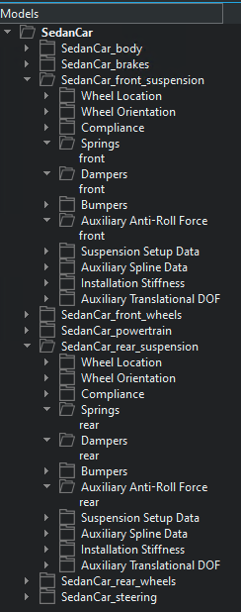
Figure 1 - VI-CarRealTime build mode model tree
Following on from the build mode tab, the test mode tab is then used to create a fingerprint, which forms the basis of the run. Within this tab, press manoeuvres can be selected from the events tree on the left which brings up the figure below in which the simulation program can be selected (Noble, 2022).
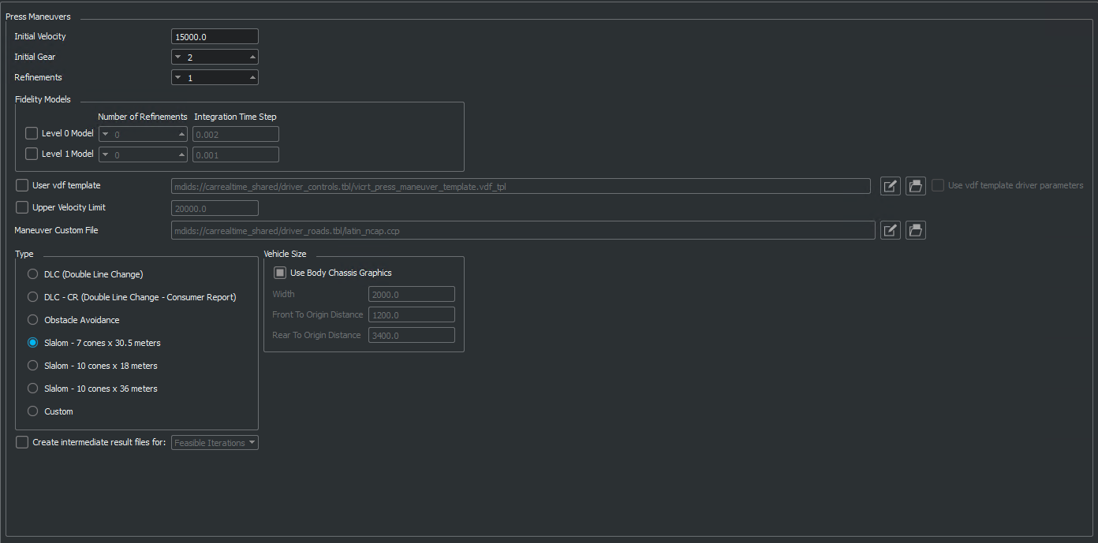
Figure 2 - VI-CarRealTime press manoeuvres window

3.0. Analysis
This section of the report will cover an overview of the base results from the simulation runs, following on from this an analysis of the results has been performed so that an optimised suspension set up can be determined.

3.1. Slalom Results
Although the slalom test is not a standardised test, it does offer a good insight into the dynamic response of a vehicle. The test scenario is comprised of seven cones spread equally over a 30.5m distance. This press manoeuvre is important in the analysis of vehicle dynamic response due to the constant steering input creating an extreme scenario that induces higher than normal forces on the vehicles sprung mass position and forces acting through the vehicles sprung and unsprung masses. The results of this manoeuvre over the 53 runs are detailed in the table below.

Table 3 – Design of Experiment Slalom Results
 | Factor 1 | Factor 2 | Factor 3 | Factor 4 | Factor 5 | Factor 6 | Response 1 | Response 2 | Response 3 | Response 4 | Response 5
Run | Spring Rate (Front) | Damping rate (Front) | Anti Roll spring rate (Front) | Spring Rate (Rear) | Damping Rate (Rear) | Anti Roll spring rate (Rear) | Lateral Acceleration | Longitudinal Acceleration | Completion Time | Max Speed | Max Steering Input
 | N/mm | Ns/m | N/mm | N/mm | Ns/m | N/mm | m/s^2 | m/s^2 | s | km/h | Rad
1 | 75 | 9000 | 75 | 40 | 5000 | 15 | 8.7309 | 1.1772 | 11.29 | 89.47 | 645.9631278
2 | 75 | 2000 | 40 | 40 | 5000 | 25 | 9.2214 | 3.0411 | 11.08 | 92.39 | 644.2466624
3 | 100 | 5500 | 40 | 70 | 100 | 15 | 9.3195 | 2.4525 | 11.1 | 91.49 | 633.9478703
4 | 75 | 5500 | 40 | 40 | 2550 | 15 | 8.829 | 1.2753 | 11.29 | 87.51 | 648.8239034
5 | 100 | 5500 | 5 | 40 | 2550 | 25 | 8.829 | 1.5696 | 11.26 | 89.61 | 633.9478703
6 | 75 | 5500 | 75 | 70 | 2550 | 25 | 9.0252 | 1.3734 | 11.05 | 91.42 | 656.834075
7 | 75 | 5500 | 75 | 10 | 2550 | 5 | 8.3385 | 1.4715 | 11.8 | 85.5 | 648.8239034
8 | 75 | 2000 | 75 | 40 | 5000 | 15 | 8.7309 | 1.1772 | 11.29 | 89.51 | 633.9478703
9 | 100 | 5500 | 40 | 10 | 5000 | 15 | 8.9271 | 1.3734 | 11.26 | 89.61 | 634.5200254
10 | 75 | 5500 | 40 | 40 | 2550 | 15 | 8.829 | 1.2753 | 11.29 | 89.51 | 634.5200254
11 | 100 | 9000 | 40 | 10 | 2550 | 15 | 8.4366 | 1.2753 | 11.53 | 87.52 | 646.5352829
12 | 50 | 5500 | 75 | 40 | 2550 | 25 | 9.0252 | 1.7658 | 11.1 | 91.18 | 645.9631278
13 | 75 | 5500 | 5 | 10 | 2550 | 25 | 8.829 | 1.4715 | 11.26 | 89.65 | 660.2670057
14 | 50 | 5500 | 40 | 10 | 100 | 15 | 8.5347 | 1.2753 | 11.54 | 87.5 | 645.9631278
15 | 75 | 2000 | 40 | 40 | 100 | 5 | 8.9271 | 1.1772 | 11.54 | 87.68 | 634.5200254
16 | 100 | 5500 | 40 | 70 | 5000 | 15 | 9.0252 | 2.4525 | 11.09 | 91.55 | 645.9631278
17 | 50 | 2000 | 40 | 10 | 2550 | 15 | 9.3195 | 3.2373 | 11.08 | 92.54 | 646.5352829
18 | 75 | 5500 | 5 | 70 | 2550 | 5 | 9.0252 | 3.2373 | 11.28 | 90.57 | 633.9478703
19 | 75 | 2000 | 5 | 40 | 100 | 15 | 9.2214 | 1.4715 | 11.5 | 87.79 | 662.5556262
20 | 100 | 5500 | 5 | 40 | 2550 | 5 | 9.4176 | 3.5316 | 11.34 | 90.16 | 633.3757152
21 | 50 | 9000 | 40 | 70 | 2550 | 15 | 9.2214 | 3.2373 | 11.08 | 92.47 | 644.8188175
22 | 100 | 5500 | 75 | 40 | 2550 | 25 | 9.2214 | 1.6677 | 11.1 | 91.13 | 657.4062301
23 | 75 | 5500 | 5 | 70 | 2550 | 25 | 8.9271 | 1.5696 | 11.48 | 87.71 | 632.8035601
24 | 50 | 5500 | 75 | 40 | 2550 | 5 | 8.5347 | 1.2753 | 11.54 | 87.56 | 678.5759695
25 | 75 | 5500 | 40 | 40 | 2550 | 15 | 8.829 | 2.2563 | 12.01 | 89.51 | 665.4164018
26 | 75 | 9000 | 5 | 40 | 5000 | 15 | 8.7309 | 1.5696 | 11.8 | 89.67 | 634.5200254
27 | 75 | 9000 | 40 | 40 | 5000 | 25 | 9.2214 | 2.4525 | 11.82 | 91.56 | 662.5556262
28 | 75 | 9000 | 40 | 40 | 5000 | 5 | 8.9271 | 1.5696 | 12.01 | 89.35 | 667.1328671
29 | 50 | 2000 | 40 | 70 | 2550 | 15 | 9.2214 | 3.3354 | 11.98 | 92.31 | 631.0870947
30 | 50 | 5500 | 5 | 40 | 2550 | 25 | 8.5347 | 1.5696 | 11.77 | 87.78 | 656.834075
31 | 50 | 9000 | 40 | 10 | 2550 | 15 | 8.829 | 1.5696 | 12.52 | 89.34 | 648.8239034
32 | 75 | 9000 | 40 | 40 | 100 | 25 | 9.4176 | 3.1392 | 12.01 | 92.45 | 633.9478703
33 | 75 | 2000 | 40 | 40 | 100 | 25 | 9.4176 | 3.1392 | 11.98 | 92.41 | 634.5200254
34 | 100 | 2000 | 40 | 70 | 2550 | 15 | 9.3195 | 2.5506 | 12.01 | 91.61 | 634.5200254
35 | 75 | 2000 | 75 | 40 | 100 | 15 | 8.7309 | 1.2753 | 12.25 | 89.5 | 646.5352829
36 | 75 | 5500 | 40 | 40 | 2550 | 15 | 8.829 | 1.2753 | 10.76 | 89.51 | 645.9631278
37 | 100 | 5500 | 75 | 40 | 2550 | 5 | 8.5347 | 1.2753 | 10.92 | 87.52 | 660.2670057
38 | 75 | 5500 | 40 | 40 | 2550 | 15 | 8.829 | 1.2753 | 11.2 | 89.5 | 645.9631278
39 | 100 | 9000 | 40 | 70 | 2550 | 15 | 9.2214 | 2.4525 | 11.2 | 91.51 | 634.5200254
40 | 75 | 9000 | 5 | 40 | 100 | 15 | 9.4176 | 3.1392 | 10.75 | 90.58 | 645.9631278
41 | 75 | 9000 | 75 | 40 | 100 | 15 | 8.7309 | 1.2753 | 10.74 | 89.46 | 646.5352829
42 | 50 | 5500 | 40 | 70 | 100 | 15 | 9.4176 | 3.1392 | 10.94 | 92.56 | 633.9478703
43 | 75 | 5500 | 5 | 10 | 2550 | 5 | 8.829 | 1.6677 | 11.16 | 87.66 | 662.5556262
44 | 50 | 5500 | 40 | 70 | 5000 | 15 | 9.2214 | 3.2373 | 11 | 92.44 | 633.3757152
45 | 75 | 2000 | 5 | 40 | 5000 | 15 | 8.9271 | 3.2373 | 10.74 | 90.48 | 644.8188175
46 | 75 | 9000 | 40 | 40 | 100 | 5 | 9.0252 | 1.2753 | 10.76 | 87.59 | 657.4062301
47 | 75 | 5500 | 75 | 70 | 2550 | 5 | 8.7309 | 1.2753 | 11.14 | 89.49 | 632.8035601
48 | 100 | 5500 | 40 | 10 | 100 | 15 | 8.5347 | 1.2753 | 11.2 | 87.46 | 678.5759695
49 | 75 | 5500 | 75 | 10 | 2550 | 25 | 8.6328 | 1.1772 | 11.76 | 89.48 | 665.4164018
50 | 100 | 2000 | 40 | 10 | 2550 | 15 | 8.3385 | 1.2753 | 11.25 | 87.56 | 634.5200254
51 | 75 | 2000 | 40 | 40 | 5000 | 5 | 8.9271 | 1.5696 | 11.78 | 89.43 | 662.5556262
52 | 50 | 5500 | 40 | 10 | 5000 | 15 | 8.7309 | 1.1772 | 11.29 | 89.59 | 667.1328671
53 | 50 | 5500 | 5 | 40 | 2550 | 5 | 8.6328 | 1.5696 | 11.97 | 87.84 | 631.0870947

By colour formatting the results of the slalom manoeuvre a quick analysis of the data can be performed. The green cells indicate the lowest values received in the response column, whilst the red cells indicate the highest values observed. As stated above, for a passenger vehicle the passengers comfort and driving experience is of utmost importance, due to this neither the best or worst run can be selected as giving the most desired response. As the most vivid colours indicate the most extreme values the most ideal set up for a passenger vehicle will include mostly green cells but also considering if those runs include any higher values indicated in red. It is clear from the colour formatting that the run that contains the highest values is run 27 and the run that contains the lowest values is run 47 although a deeper analysis with the aid of graphs will offer a deeper insight.
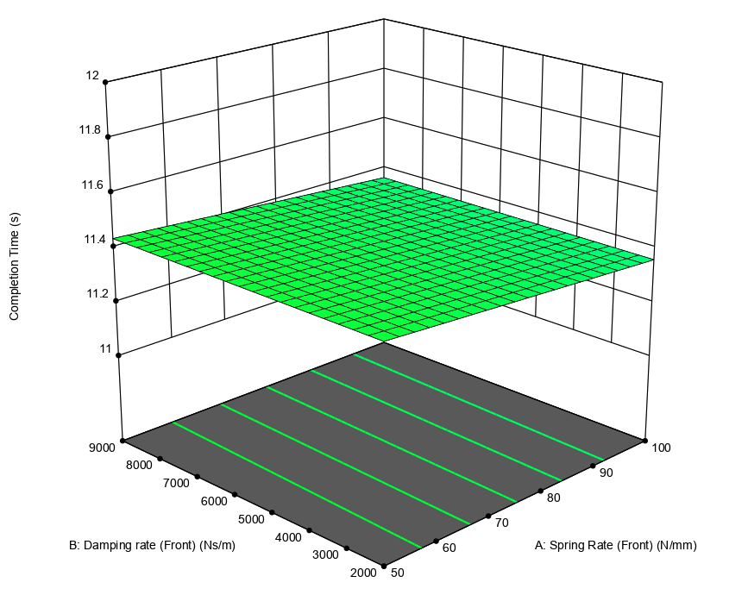
Figure 3 - Completion time Vs Damping Rate (Front) Vs Spring Rate (Front), Slalom
The figure above depicts the 3D contour plot of Completion time Vs Damping rate Vs Spring rate of the front suspension components. It is clear that the highest completion time occurs when the lowest spring rate and that the damping rate has little to no effect to the completion time in this figure. When analysing the effect of the spring rate and anti-roll rate at the front of the vehicle against completion time, in the figure below, it can be observed that there is a clear relationship between the components.
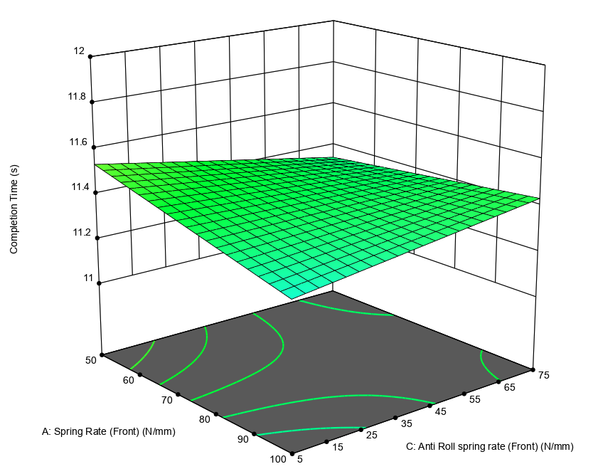
Figure 4 - Completion Time Vs Spring Rate (Front) Vs Anti Roll-Rate (Front), Slalom
With the lowest spring rate and highest anti-roll rate, this gives the highest completion time. As the anti-roll rate is increased the completion time then the completion time reduces although, as the spring rate is increased the completion time begins to rise again. The setup with the lowest completion time occurs with the lowest anti-roll rate with the highest spring rate.
Looking at the effect these components have on the lateral acceleration observed during the simulation the figure below depicts lateral acceleration Vs spring rate Vs damping rate across the front of the vehicle.

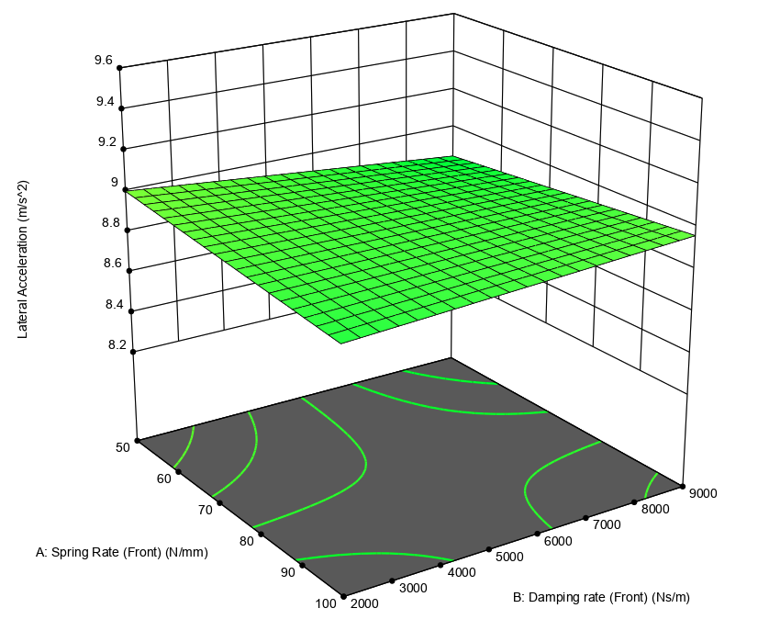
Figure 5 - Lateral Acceleration Vs Spring Rate (Front) Vs Damping Rate (Front), Slalom
It is evident from the above figure that a combination of the highest spring rate and highest damping force deliver the lowest lateral acceleration recordings. The values that create the highest lateral acceleration are when both the spring rate and damping force are set to their lowest value. Both extremes analysed on this figure would not be ideal set ups for this vehicle as they would create either an overdamped or underdamped dynamic response.
From the analysis of the front suspension components during this dynamic manoeuvre and the statements made it is clear that neither an extremely low or high value set up is preferred due to the requirements of the vehicle and that a set up that incorporates mid values would give the most optimal response. Moving to the rear of the vehicle, the figure below depicts the relationship of spring rate and damping rate against lateral acceleration.
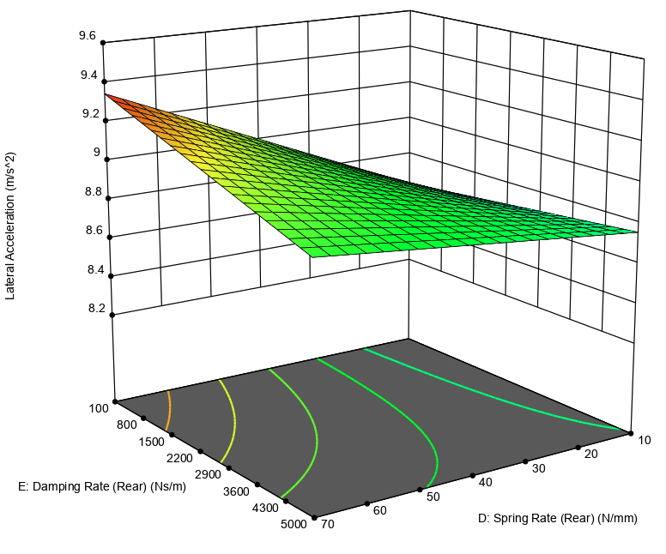
Figure 6 - Lateral Acceleration Vs Spring Rate (Rear) Vs Damping Rate (Rear), Slalom
It is clear from the figure above that the damping rate at the rear of the vehicle has a strong relationship with the lateral acceleration, as this value is increased the lateral acceleration observed is reduced. The effect of the damping rate is reduced however as the spring rate is reduced and has the opposite effect on lateral acceleration as lower forces are observed with a low spring rate and damping force than with a higher damping force. When removing the damping force to analyse the effect of the spring rate and anti-roll rate on the lateral acceleration a very clear graph is presented, in the figure below.
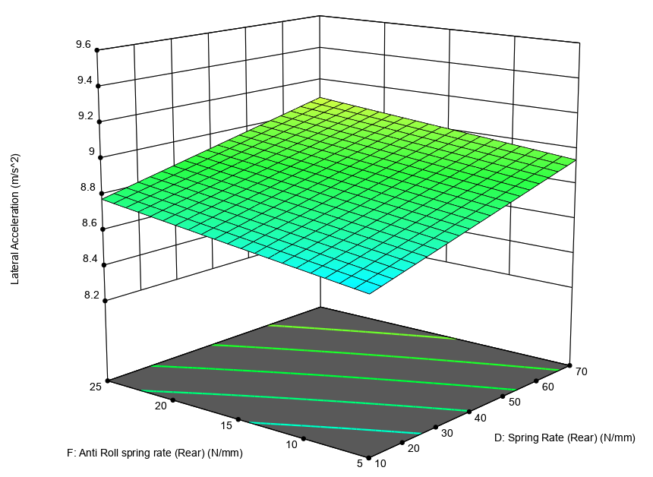
Figure 7 - Lateral Acceleration Vs Spring Rate (Rear) Vs Anti Roll-Rate (Rear), Slalom
The figure above shows a clear relationship between the spring rate and the lateral acceleration as there is a steep decline as the spring rate is decreased. A similar effect can be seen as the anti-roll rate is reduced although not to the same extent. The relationship of the two components is linear and proportional as the spring rate and anti-roll rate are both increased, as does the lateral acceleration. Finally the figure below depicts the relationship of the anti-roll rate and the damping rate at the rear of the vehicle.
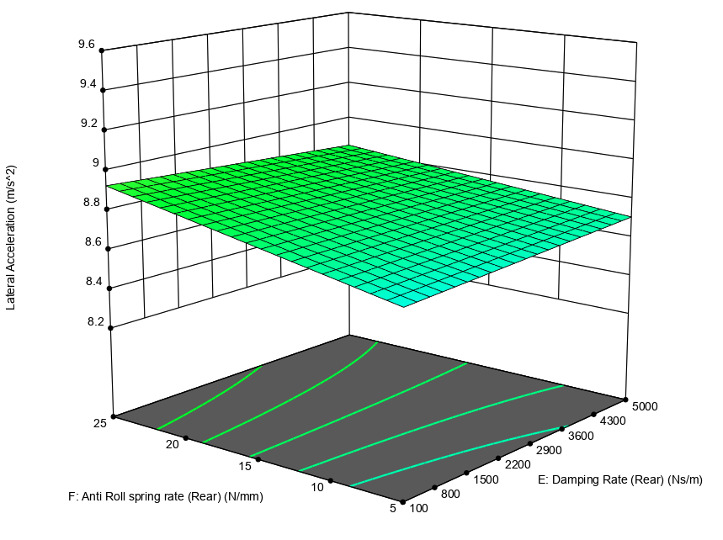
Figure 8 - Lateral Acceleration Vs Anti-Roll Rate (Rear) Vs Damping Rate (Rear), Slalom
The trend of the damping rate remains the same in the figure above, as in Figure 7, although there is a gradual reduction in the lateral acceleration due to the damping rate increasing. As stated previously neither extremes are preferred for the passenger vehicle set up and from the figures analysed for the slalom test at the rear of the vehicle it can be suggested that mid values may offer the best driving experience for passengers and deliver the most optimal dynamic response.

3.2. Double Lane Change
The double lane change manoeuvre consists two lane change manoeuvres within a set distance and width, which is prescribed in ISO 3888-1:2018 (the International Organization for Standardization, 2018). The press manoeuvre that is simulated within VI-CarRealTime conforms to the stated ISO standard and delivers analytical data from the dynamic manoeuvre similarly to the slalom results above. Furthermore similarly to the slalom test above, the project methodology consists of 53 simulation runs that have been carried out in the same format as above and the results are detailed in the table below. It is worth noting at this point that although the test procedure of the two press manoeuvres were carried out in the same manor, limitations in the software meant that the double lane change manoeuvre had to be completed at a start velocity of 1000mm/s as opposed to 15000mm/s.
Table 5 – Double Lane Change Manoeuvre Results
 | Factor 1 | Factor 2 | Factor 3 | Factor 4 | Factor 5 | Factor 6 | Response 1 | Response 2 | Response 3 | Response 4 | Response 5
Run | Spring Rate (Front) | Damping Rate (Front) | Anti Roll Spring Rate (Front) | Spring Rate (Rear) | Damping Rate (Rear) | Anti Roll Spring Rate (Rear) | Lateral Acceleration | Longitudinal Acceleration | Velocity | Steering | Completion Time
 | N/mm | N/m | N/mm | N/mm | N/m | N/mm | m/s^2 | m/s^2 | km/h | rad | sec
1 | 75 | 5500 | 40 | 40 | 2550 | 15 | 0.01808 | 0.027141 | 12.604 | 1.03966 | 48.151
2 | 75 | 9000 | 40 | 40 | 5000 | 5 | 0.018092 | 0.027075 | 12.6054 | 1.0404 | 48.151
3 | 100 | 5500 | 40 | 10 | 5000 | 15 | 0.018089 | 0.027058 | 12.6055 | 1.04296 | 48.151
4 | 50 | 2000 | 40 | 70 | 2550 | 15 | 0.018091 | 0.027075 | 12.6053 | 1.04077 | 48.151
5 | 75 | 5500 | 40 | 40 | 2550 | 15 | 0.018097 | 0.027058 | 12.6054 | 1.03988 | 48.151
6 | 100 | 9000 | 40 | 70 | 2550 | 15 | 0.018112 | 0.027141 | 12.6054 | 1.03975 | 48.151
7 | 100 | 5500 | 40 | 70 | 5000 | 15 | 0.018092 | 0.027145 | 12.604 | 1.04191 | 48.151
8 | 75 | 5500 | 40 | 40 | 2550 | 15 | 0.018082 | 0.027058 | 12.6053 | 1.03954 | 48.151
9 | 50 | 5500 | 5 | 40 | 2550 | 5 | 0.0181 | 0.027075 | 12.6055 | 1.04157 | 48.151
10 | 100 | 5500 | 5 | 40 | 2550 | 5 | 0.018108 | 0.027075 | 12.6053 | 1.04186 | 48.151
11 | 75 | 9000 | 5 | 40 | 100 | 15 | 0.181174 | 0.027075 | 12.6054 | 1.04264 | 48.151
12 | 75 | 9000 | 40 | 40 | 5000 | 25 | 0.018089 | 0.027075 | 12.6054 | 1.04052 | 48.151
13 | 75 | 2000 | 40 | 40 | 5000 | 25 | 0.018089 | 0.027075 | 12.6054 | 1.04044 | 48.151
14 | 75 | 9000 | 75 | 40 | 100 | 15 | 0.018086 | 0.027075 | 12.6053 | 1.03961 | 48.151
15 | 75 | 5500 | 75 | 70 | 2550 | 25 | 0.01808 | 0.027058 | 12.6055 | 1.03933 | 48.151
16 | 50 | 5500 | 75 | 40 | 2550 | 5 | 0.018092 | 0.027075 | 12.6054 | 1.03989 | 48.151
17 | 100 | 2000 | 40 | 70 | 2550 | 15 | 0.018089 | 0.027058 | 12.6055 | 1.03993 | 48.151
18 | 100 | 5500 | 40 | 10 | 100 | 15 | 0.018091 | 0.02715 | 12.6042 | 1.04168 | 48.151
19 | 50 | 9000 | 40 | 10 | 2550 | 15 | 0.018097 | 0.027141 | 12.604 | 1.04255 | 48.151
20 | 50 | 5500 | 5 | 40 | 2550 | 25 | 0.018112 | 0.027075 | 12.6054 | 1.04282 | 48.151
21 | 50 | 5500 | 40 | 70 | 5000 | 15 | 0.018092 | 0.027058 | 12.6055 | 1.04041 | 48.151
22 | 50 | 5500 | 75 | 40 | 2550 | 25 | 0.018082 | 0.027075 | 12.6053 | 1.03966 | 48.151
23 | 75 | 2000 | 40 | 40 | 100 | 5 | 0.018101 | 0.027075 | 12.6054 | 1.0404 | 48.151
24 | 75 | 2000 | 5 | 40 | 5000 | 15 | 0.018116 | 0.027075 | 12.6054 | 1.04296 | 48.151
25 | 75 | 5500 | 75 | 10 | 2550 | 25 | 0.018076 | 0.027141 | 12.604 | 1.04077 | 48.151
26 | 100 | 5500 | 40 | 70 | 100 | 15 | 0.018089 | 0.027058 | 12.6055 | 1.03988 | 48.151
27 | 75 | 2000 | 75 | 40 | 5000 | 15 | 0.018085 | 0.027075 | 12.6053 | 1.03975 | 48.151
28 | 75 | 2000 | 5 | 40 | 100 | 15 | 0.018115 | 0.027075 | 12.6054 | 1.04191 | 48.151
29 | 75 | 2000 | 75 | 40 | 100 | 15 | 0.018086 | 0.027075 | 12.6054 | 1.03954 | 48.151
30 | 100 | 2000 | 40 | 10 | 2550 | 15 | 0.018092 | 0.027141 | 12.6054 | 1.04157 | 48.151
31 | 75 | 9000 | 75 | 40 | 5000 | 15 | 0.018085 | 0.027075 | 12.6053 | 1.04186 | 48.151
32 | 75 | 5500 | 75 | 70 | 2550 | 5 | 0.018087 | 0.027058 | 12.6055 | 1.03946 | 48.151
33 | 100 | 5500 | 75 | 40 | 2550 | 25 | 0.018081 | 0.027075 | 12.6053 | 1.03952 | 48.151
34 | 50 | 9000 | 40 | 70 | 2550 | 15 | 0.018092 | 0.027058 | 12.6055 | 1.04034 | 48.151
35 | 100 | 9000 | 40 | 10 | 2550 | 15 | 0.018092 | 0.027141 | 12.604 | 1.04193 | 48.151
36 | 50 | 5500 | 40 | 10 | 100 | 15 | 0.018097 | 0.027145 | 12.6042 | 1.04224 | 48.151
37 | 50 | 5500 | 40 | 70 | 100 | 15 | 0.018092 | 0.027058 | 12.6056 | 1.04019 | 48.151
38 | 75 | 2000 | 40 | 40 | 100 | 25 | 0.01809 | 0.027075 | 12.6054 | 1.0402 | 48.151
39 | 75 | 9000 | 5 | 40 | 5000 | 15 | 0.018115 | 0.027075 | 12.6062 | 1.0433 | 48.151
40 | 75 | 5500 | 5 | 10 | 2550 | 25 | 0.01811 | 0.027141 | 12.604 | 1.04457 | 48.151
41 | 75 | 5500 | 40 | 40 | 2550 | 15 | 0.018094 | 0.027075 | 12.6041 | 1.04055 | 48.151
42 | 50 | 2000 | 40 | 10 | 2550 | 15 | 0.018098 | 0.027141 | 12.604 | 1.04239 | 48.151
43 | 50 | 5500 | 40 | 10 | 5000 | 15 | 0.018097 | 0.027133 | 12.604 | 1.04267 | 48.151
44 | 75 | 5500 | 75 | 10 | 2550 | 5 | 0.018092 | 0.027141 | 12.604 | 1.04109 | 48.151
45 | 75 | 9000 | 40 | 40 | 100 | 5 | 0.018102 | 0.027075 | 12.6054 | 1.04064 | 48.151
46 | 100 | 5500 | 5 | 40 | 2550 | 25 | 0.018102 | 0.027075 | 12.6054 | 1.04173 | 48.151
47 | 75 | 5500 | 5 | 70 | 2550 | 25 | 0.0181 | 0.027058 | 12.6055 | 1.04149 | 48.151
48 | 75 | 5500 | 5 | 70 | 2550 | 5 | 0.018117 | 0.027058 | 12.6056 | 1.04231 | 48.151
49 | 75 | 2000 | 40 | 40 | 5000 | 5 | 0.018102 | 0.027075 | 12.6054 | 1.04099 | 48.151
50 | 100 | 5500 | 75 | 40 | 2550 | 5 | 0.01809 | 0.027075 | 12.6053 | 1.03968 | 48.151
51 | 75 | 5500 | 5 | 10 | 2550 | 5 | 0.018159 | 0.027141 | 12.6042 | 1.04863 | 48.151
52 | 75 | 5500 | 40 | 40 | 2550 | 15 | 0.018094 | 0.027075 | 12.6054 | 1.04055 | 48.151
53 | 75 | 9000 | 40 | 40 | 100 | 25 | 0.01809 | 0.027075 | 12.6053 | 1.04032 | 48.151

Upon first inspection of the results from the double lane change manoeuvre in the table above it is clear that due to the limitations with the simulation that the completion time is an irrelevant response in this data set therefore it will not factor into the analysis of the results. In addition to this steering input and velocity also do not contain a range of data that will offer a valuable analysis so will also not be included in the analysis.
Following on from the initial analysis, and factoring in previous statements that neither extreme values are optimal for the passenger vehicle set up as to not avoid a harsh or boat like passenger experience. Looking at the front suspension set up of the passenger vehicle in relation to lateral acceleration, the figure below describes the relationship between the spring rate and damping rate against the lateral acceleration.
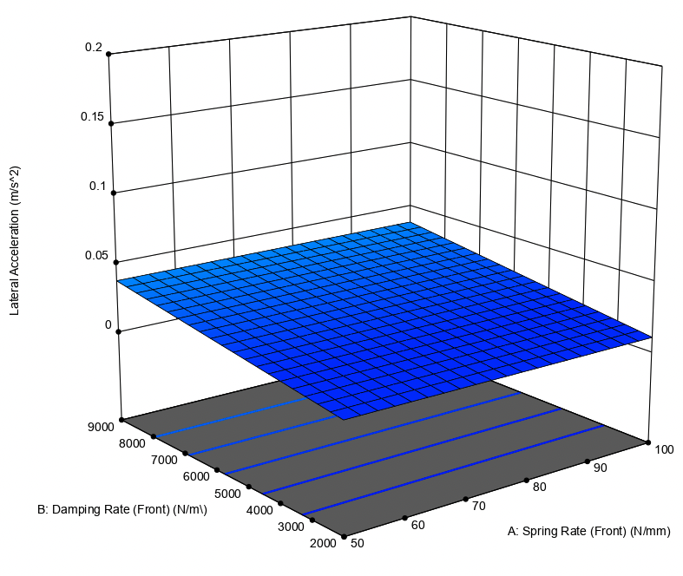
Figure 9 - Lateral Acceleration Vs Damping Force (Front) Vs Spring Rate (Front), DLC
From the figure above it is clear at low velocities that the spring rate does not have an effect on the lateral acceleration of the passenger vehicle although, the damping force does show a positive correlation as the damping rate is increased as does the lateral acceleration.
Looking next at the relationship between the spring rate and anti-roll rate, in the figure below plotted against the lateral acceleration. Similarities can be formed as the spring rate doesn’t show an impactful contribution to the lateral acceleration although a negative correlation is shown as the anti-roll rate is decreased the lateral acceleration is increased.
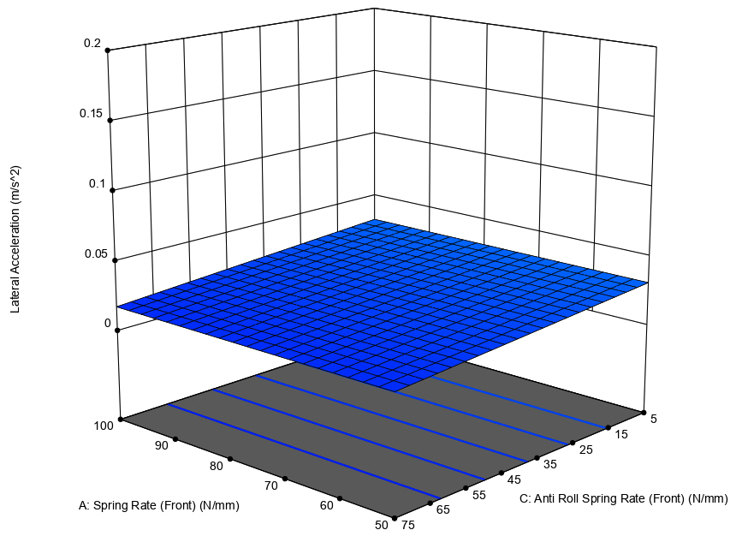
Figure 10 - Lateral Acceleration Vs Spring Rate (Front) Vs Anti-Roll Rate (Front), DLC
From the previous two figures it is clear that the spring rate doesn’t have a direct effect on the lateral acceleration of the vehicle, with this in mind the following figure displays the relationship of the damping rate and anti-roll rate plotted against the lateral acceleration. When looking at the components which have an effect on the system during the DLC, a gradual positive correlation is observed in the damping rate with a high anti-roll rate. When there is a low anti-roll rate this acts as a force multiplier to the damping rate increasing the gradient of the positive correlation of the lateral acceleration.
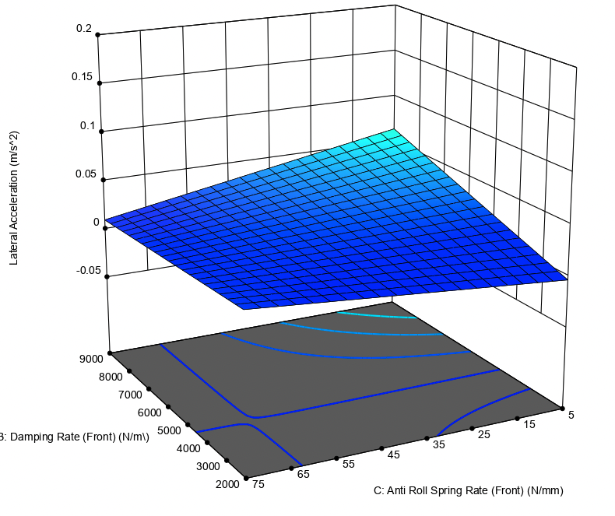
Figure 11 - Lateral Acceleration Vs Damping Rate (Front) Vs Anti-Roll Rate (Front), DLC
Upon analysis of the front suspension components against lateral acceleration it is clear that the spring rate does not factor at this velocity although the damping rate and anti-roll rate do have negligible effects on the lateral acceleration of the vehicle.
Upon analysis of the rear suspension components the same criteria were considered. The figure below shows the relationship between the spring rate and damping rate against the lateral acceleration.
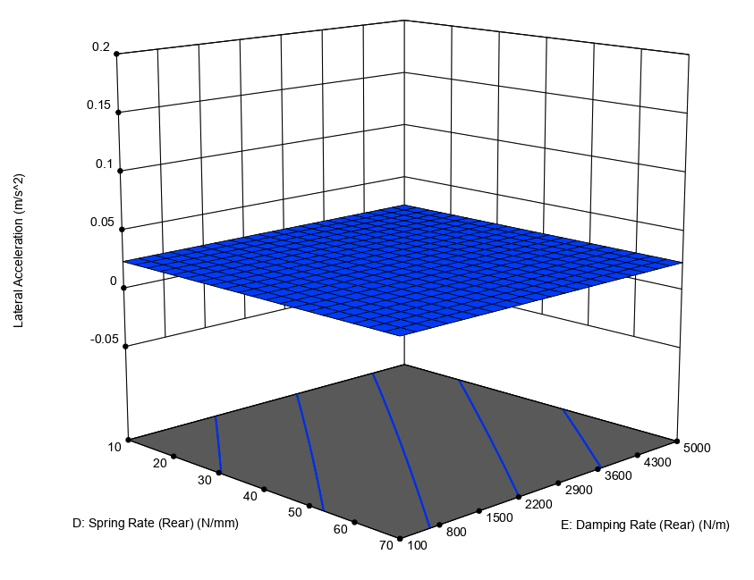
Figure 12 - Lateral Acceleration Vs Spring Rate (Rear) Vs Damping Rate (Rear), DLC
From the figure above neither the spring rate or damping rate have a relationship that effects the lateral acceleration at this velocity as the lateral acceleration remains a constant throughout the range of the data set. The figures below depict the relationship between the spring rate and anti-roll rate, and the damping rate and anti-roll rate against the lateral acceleration, respectfully.
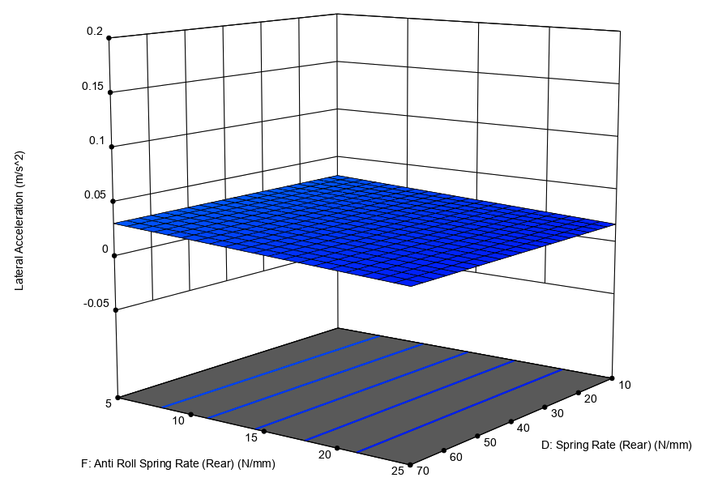
Figure 13 - Lateral Acceleration Vs Anti-Roll Rate (Rear) Vs Spring Rate (Rear), DLC
Firstly, the spring rate continues to have no effect on the lateral acceleration when paired with the anti-roll rate at the rear of the vehicle. The anti-roll rate does show a negative correlation as the lateral acceleration is reduced as the rate is increased. The figure below shows a more interesting plot as the peak lateral acceleration occurs with the lowest anti-roll rate and highest damping rate, a peak also occurs with the lowest damping rate and anti-roll rate. The lowest troughs on the graph occur in the opposite corners of the plot to those just described, although continue to show negligible effects at this velocity.
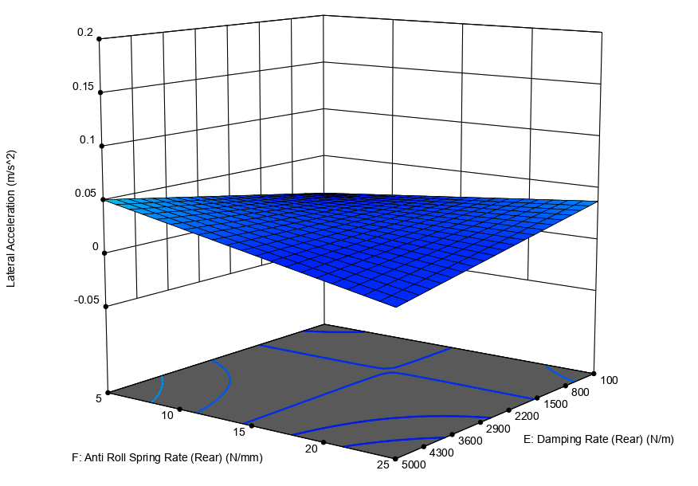
Figure 14 - Lateral Acceleration Vs Anti-Roll Rate (Rear) Vs Damping Rate (Rear), DLC
From the analysis at the rear of the vehicle it is clear that the spring rate has the least effect on the lateral acceleration although the damping rate and anti-roll rate do not show a considerable effect on the lateral acceleration. This lack of effective data can be contributed to the low initial velocity of the simulation, in addition to this the effects at the rear of the vehicle have been observed as having a lesser effect than observed at the front of the vehicle due to the lateral acceleration being initiated at the front of the vehicle (Riddles, 2020).

4.0. Conclusion
The aim of this project was to design an investigation with the intention of optimising a passenger vehicles suspension system. The design of experiment that has been developed for this project has provided a list of simulation runs in order to fully analyse the components of the suspension system. The use of design of experiment software has created a data set that is both more productive and effective as opposed to a manual method of optimisation (SARTORIUS, 2020). The inclusion of contour plot graphs has afforded an ease of interpolation and analysis that was not possible with 2D graphs because the relationship between the components across the full factor range was visible and clear to understand due to the colour coding (VanderPlas, 2022).
VI-CarRealTime has provided an ideal suite with a simplistic approach to vehicle dynamics. The range of output data that has been generated for each simulation run along with the real time animator offer a full insight into the dynamic behaviour of the vehicle. Limitations within the software however meant that the manoeuvres that were selected had to be carried out at different initial velocities, due to this the double lane change manoeuvre results do not show a clear insight into the behaviour of the simulation vehicle.
Only looking at the data generated by the slalom test consisting of seven cones over a distance of 30.5m, a clear insight into the vehicles dynamic behaviour was generated. As stated throughout that an extreme high or low lateral acceleration is not preferred as this will either create an experience that is too harsh or too soft through corners. For this reason it is the opinion of the author that the ideal set up would consist of the following criteria:
- Front spring rate – 75 N/mm
- Front damping rate – 5000 N/m
- Front anti-roll rate – 45 N/mm
- Rear spring rate – 25 N/mm
- Rear damping rate – 4500 N/m
- Rear anti-roll rate – 5 N/mm
To allow for a more in depth insight into the dynamic behaviour of the vehicle tyre load simulations would be carried out to investigate the vertical loading upon each corner of the vehicle, this would allow for a much more refined optimisation of the vehicle set up (Schmid, 2011). In addition to this more press manoeuvres would be simulated so that reliable and comparable data can be produced and validated as the data provided in this report for the double lane change manoeuvre is both limited by the initial velocity and doesn’t provide a comparison or validation to the slalom test.

5.0. References
Nicolae, C. & Todoruţ, A., 2019. Influences of the Suspensions Characteristics on the Vehicle Stability. s.l., International Congress of Automotive and Transport Engineering .
Noble, A., 2022. Lecture [Interview] (2 2022).
Rao, J. S. & Kumar, B., 2012. 3D Blade root shape optimization. London, 10th International Conference on Vibrations in Rotating Machinery .
Riddles, E., 2020. The Importance of Your Car’s Suspension System. [Online]
Available at: https://www.customcompleteautomotive.com/the-importance-of-your-cars-suspension-system/
[Accessed 13 5 2022].
SARTORIUS, 2020. What is DOE? Design of Experiments Basics for Beginners. [Online]
Available at: https://www.sartorius.com/en/knowledge/science-snippets/what-is-doe-design-of-experiments-basics-for-beginners-507170
[Accessed 13 5 2022].
Schmid, M., 2011. Tire Modeling for Multibody Dynamics Applications, Madison: University of Wisconsin-Madison.
Siemens, 2022. Vehicle System Dynamics Simulation. [Online]
Available at: https://www.plm.automation.siemens.com/global/en/products/simulation-test/vehicle-dynamics.html
[Accessed 9 5 2022].
StatEase, 2022. Design of Experiments (DOE) Made Easy. [Online]
Available at: https://www.statease.com/software/design-expert/
[Accessed 9 5 2022].
the International Organization for Standardization, 2018. ISO 3888-1:2018(en) Passenger cars — Test track for a severe lane-change manoeuvre — Part 1: Double lane-change. [Online]
Available at: https://www.iso.org/obp/ui/#iso:std:iso:3888:-1:ed-2:v1:en
[Accessed 13 5 2022].
VanderPlas, J., 2022. Python Data Science Handbook. 1 ed. s.l.:GitHub.
VI-GRADE, 2022. VI-CarRealTime. [Online]
Available at: https://www.vi-grade.com/en/products/vi-carrealtime/
[Accessed 9 5 2022].

