
GOOGLE new HEADQUARTERS PROJECT in LONDON
Essay
MILENA ADZHEMOVA 2129045 | PROJECT MANAGEMENT

[Date]

Contents
Introduction 2
Landscaper crucial point in PMBOK 3
Ten core elements in PMBOK 4
Scope 4
Cost 4
Time 4
Quality 5
Risk 5
Stakeholders 5
Human Resource 7
Communication 7
Procurement 7
Integration 7
The most essential success / failure factors 7
Project Life Cycle 9
Conclusion 10
List of references: 11

Introduction

Project for 1billion pounds – is it a huge mistake or right and well-established entrepreneurs’ decision?!
Google is established in 1998 by Lawrence Page and Sergey Brin, American computer scientists. It is American technology company and global corporation. Google LLC concentrating in search engineering, computer software, online advertising, e-commerce, Artificial Intelligence, quantum computing and electronics for customers. Mentioned as the most powerful company in the world it dominates on the market and develop to tech giant with more than fifty services. Its parent company Alphabet Inc is in the first 5 Tech corporations next to Meta, Apple, Microsoft, and Amazon.
Google new project in UK is King’s Cross Headquarter in London. The Landscaper is situated on King’s Cross Station in London. Longer than Shard and seventy-two meters high, the landscaper will have eleven storeys in his highest part, and occupied 650,000 sq. ft. This will be the first fully designed and owned building of Google, outside US.
With BDP as design architect, construct architects Bjarke Ingles and Heatherwick Studio, main contractor Lendlease, and Gardener and Theobald as a cost management the building is expected to be finished in 2024 with a big delay of 3 years. It has been planed the project to start in 2014, but because of redesign the plan and Google to achieve better results the project was started in 2017 (cityam.com, 2014).
The building made of steel, timber, and glass, is situated alongside railway lines for three hundred meters. It was planned to have a swimming pool, twenty-five meters long, rooftop running trail, two hundred meters long and a sports hall with overview of London.
.

Landscaper crucial point in PMBOK

Project Management Body of Knowledge is essential in project management. It involves best practices, standards, and techniques. It is a guidebook developed by PMI.
According to Project Management Institute (2017) key points in PMBOK are:
- What is Project Management Body of Knowledge? - It is not a methodology by itself, it is a collection of standards, guidelines and best practices and comprises fundamental concepts and principles.
- How does PMBOK help in Project Management?
- Standardization – runs communal framework and language for specialists in separate industries.
- Knowledge Repository – provides a depot of knowledge for project managers, keeping them informed on industry techniques and trends.
- Process Oriented - figures connected processes to guaranteeing reliability in the lifecycle of the project.
- Best Practices – using worldwide best practices the project will be more successful.
- Common terminology – the terminology is standardised between the teams in the project.
Pearson, A (2023) marks key aspects in Google Headquarter, Kings Kross:
- It is the first specialised-built Google’s office in Europe.
- Its designers are Bjarke Ingels Group and Heatherwick Studio
- The office is delivered by BDP.
- Remarkable attributes are 25-meter swimming pool, a running track and roof landscaped terraces.
- The location is Kings Kross in London, and the new Google HQ is known as Platform G.
- It is a 60,000sq.m massive and it extends 330m along the non-vehicular boulevard between Granary Square and Kings Kross Station.
- The offices are two stories above and the first levels are retail spaces.
- The workplace alloy daylight and have flexible workspaces.

Ten core elements in PMBOK
The project success/failure factors are time, budget, scope, quality, risk assessment, Internal and external stakeholders, HR, procurement, communication, integration.
These ten knowledge fields shell all of domains and processes necessary for managing every one stage in a project. They give the managers structured knowledge and made them competently in to boost the probability of presenting projects within budget, on time, and gathering requirements.
Project Management tools and techniques are important for delivering effectiveness in different by nature and size projects. They are used for strategic plan, systematising, execution, supervising, controlling, and reporting the details of the projects. (Landau, 2023)

Scope
Scope contains identifying, restricting scope of the project and decision what have to be included or excluded from it.
The stages included in Scope management are:
- Planning – creating a plan project for scope plan include defining, validating, and controlling.
- Requirements collection – determining, documenting, and managing stakeholders needs and constraints to meet the objectives.
- Defining process - a detailed transcript of the project and product
- Work Breakdown Structure – dividing the work into smaller and more controllable components.
- Validation – form arising acceptance of the completed project deliverables.
The project scope management processes need to be well integrated with other knowledge area processes.

Cost
The cost evaluates budget and control the project costs. It covers every financial based component in the project, budget planning and allocation, also capital and financing recourses.
Predictable cost for the new Google HQ, King’s Cross construction is above six hundred million of pounds – four hundreds for skeleton and core and two hundreds for fit-out. (Waite R, 2017). Now the cost for the project is assessed on 1bilion pounds.

Time
Project time management is essential, and it is focused on constructing and managing the project schedule, guaranteeing completion on time.
After updating changes, the head office scheme was put on hold in 2013. Google request consented scheme of AHMM to be redesigned. Afterwards BIG and Heatherwick Studio were brought in, and they developed new conceptions for the same building. The project was late with more than 3 years, and it was started in 2017 instead of 2014. Now the expectation is in 2024 HQ, King’s Cross Project to be finished.

Quality
It is important the quality standards and the customer expectation to be faced. Every project has to be without defects and with excellent quality.

Risk
The project risk has to be identified, assessed, and mitigated. The project risk can cause failure or delays. It is classified by quality or quantity and can be low, medium, or high. Risk curriculums could be external, when they come outside and internal, which come inside the project.

Stakeholders
In stakeholder management is encompassed identifying, examining, and engaging the stakeholders in the venture. Hiring the right people in the project is main point for its success.
Stakeholders in Google Headquarters, King’s Kross in London are.
- Google as a client, IT giant with managing director for Ireland and UK Ronan Harris

- Lendlease as Main contractor
Lendlease is an Australian company, global leader in designing and building sustainable, vibrant, and innovative environmental places for schemes, communities, governments, and people. Key aspects in their work are construction, investments, commercial, hospitality, living, urbanisation, scientific and health, user experience, retail and mixed used and moreover. The corporation is established expansion and infrastructure projects, communities, and workplaces. (Lendlease, no date)
Choosing Lendlease as a main contractor has been a major step in delivering of King’s Kross HQ project. (proposition, no date)
- AKT II as a structural engineer.
AKT II is a B certified Corporation, founded in 1996, with three hundred awards in United Kingdom and worldwide, and with high impact in environmental and social area. (AKT II, 2023)

- Bjarke Ingles Group (BIG) and Heatherwick Studio as concept architects
The new Google building is designed by BIG and Heatherwick Studio with natural composition and healthful substances through healthy material programme of Google.

- BDP as a design architect
BDP is top design and consulting architects for King’s Cross Landscaper in London. The Company delivers Cat A architectural, lighting, and interior design. In King’s Cross project is absorbed passive and active environmental design, targeted at least Bream Excellent, Lead Gold to achieve Excellent and Platinum. (BDP, 2023)
- Atelier Ten as environmental and building service designer and energy analyst.

- Gardiner & Theobald as cost managers
As an independent construction and consultant company in all building areas their work is focused to minimise the risk and to maximise the progress and property assets. The Company has eighteen offices in US and UK and clients worldwide.
With their and other stakeholders work on King’s Cross Landscaper project, Google will contribute growing knowledge-based economy.
- Camden Council is also stakeholder in the project as it has approved the plan King’s Cross boulevard to be fully pedestrianized and from trade street and main busy transport hub to be included in the masterplan of King’s Cross. (Gillespies, 2020)
- Gillespies as landscape specialist
The planned eliminating of vehicular operate from King’s Cross boulevard has allowed Gillespies to develop it as a pedestrian space, combining connective street and retail destination inspires the pedestrians to spend more time and enjoying there, likewise, to accommodate bicyclists. (Gillespies, 2020)
Gillespies is based in London, Leads, Manchester, Oxford, and Abu Dhabi. It is a free thinking and diverse team of planners and expert planners, architects, and designers. The Company are continuing to develop, widen and adapt and the human is the main focus in their work. Four guiding pillars in Gillespies work are human element, natural networks, living legacy and personal places. The Company is chosen to serve substantial and innovative garden on the roof on the 11-storey building in King’s Cross. The roof space is covered by long 300-meter garden, where is placed 200-meter run trail, wooden decking, grassland, easy for space changing moveable planters and performance areas.

Human Resource
To find and collaborate with right team is one of the most important aspects in the project. Furthermore, the people have to receive roles and responsibilities, which are suited for them. It is essential the employees and the partners to be competitive, experienced, and able to work in a team environment. Training and opportunity for development are necessary in the business.

Communication
The effective communication in the team and between them and the stakeholders have to be guaranteed.

Procurement
Key role in procurement is liable to acquire services and goods from external suppliers.
Contractors and subcontractors have to show a breakdown of their work - needed time and necessary budget and resources.

Integration
Project integration management set up a framework for coordination between resources, tasks, stakeholders, changes, and variables in the project.

The most essential success / failure factors
Time, quality, and cost are the most crucial factors for project success or failure.
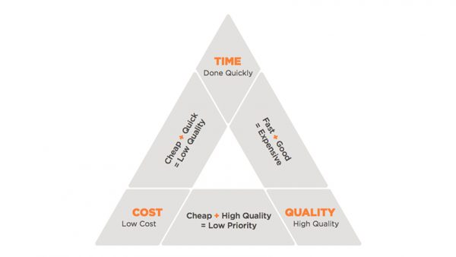
https://77productions.com.au/
Figure 1. Triangle of objectives and trade-offs between Time, Cost and Quality

Time has to match planned progress. If the project is stated late, it is more likely to be finished late. All phases of the project are necessary to finish according to their planned dates. Project delay will have negative effects in overhead costs, like administration, management, service, accommodation, or facilities. The time is also related to the financing – bank interest or stakeholders’ percent could apply if it is used a loan or stakeholder capital. In case the client uses own money, he still can loose the interest if the money are invested somewhere else. Cost penalties is another time delay effect.
In every cost budget it has been guaranteed that expenses allowed in the contract are not surpassed. Failure to complete the project within the budget will low the profit and furthermore it can cause extreme cases and serious financial issues.
Quality characteristics are determined by the features of the project or product. In a huge project like construction, the quality is extremely important, even if this can cause time delay or overspend.
How it can be seen in the figure above the time, the cost and the quality are in strong correlation and depend on what is prioritised it could be received different effect

Project Life Cycle
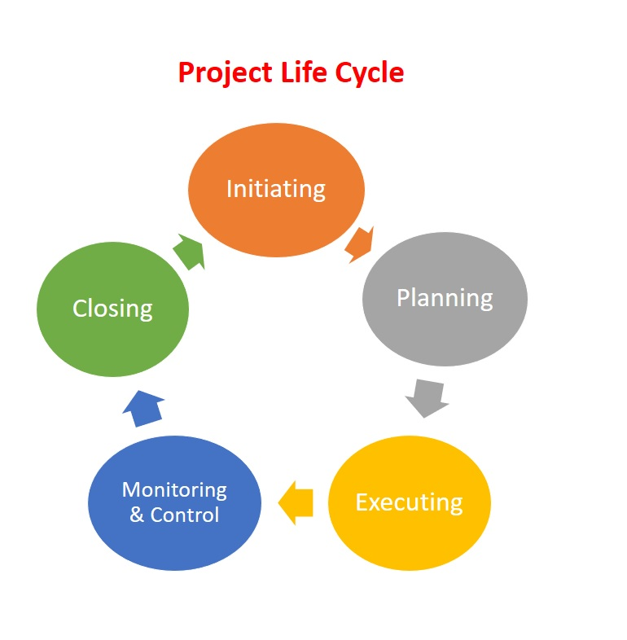 ecampusontario.pressbooks.pub
Figure 2. Project Life Cycle

Accordingly, Project, MI & Project, MI (2012) the project life cycle is formed from sequential phases and their numbers and names depends on the management, control needs, the nature of and area of the project. The phases can be separated by intermediate results, partial or functional outcomes, or finances. They are bounded by time, with a start and an end time, or by control point.
The Life Cycle in the project can be plan-driven or predictive, where the product and deliverables are identified from the start and every change is carefully succeeded. But the cycles also can be change-driven or adaptive, where the product is advanced through several iterations and the scope in everyone is defined as iteration beginning.
The Project Life cycle is differed by size and complexity, but every variety of it can be matched to a generic structure: start, organise and prepare, conducting, and project closure.

Conclusion

How does Google perform with their HQ King’s Cross project? If the company present well in all core elements in the project or this was a huge mistake for one billion pounds, as the critics says.
The project was started with changes, which could be caused from not enough detailed information, faulty planning, or any other wrong steps in the scope. King’s Cross scope is not well done.
With time management the things seem quite bad. Three years delay from the start are two much for a project. Why it is allowed to happen. Google is ambitious and change the plan for better results in the building. Maybe this late was preventing from ineffectiveness in the building or protect from the project fail. Can not be said that Covid cause delay in the project, because it comes two years after the project start, but definitely it gives effect in expenses.
In cost can be seen big differences between the planned budget of 650,000 pounds and real spend of one billion pounds. The cost management was failed in cost predictions. Google as a client made changes in the plan, which made impact in the budget. Covid, Ukraine War and the following big inflation were made significant increase in life costs and give negative budgetary impact in HQ, King’s Cross project.
The quality is on elevated level. Wedge-shaped design, flexible workspace, wellbeing, sustainability and building information modelling are main characteristics. This HQ was built with healthy materials with Google healthy material program and more than thirteen thousand devices will work connected to improve energy efficiency.
The design choice increases the workplace flexibility, furthermore the natural light can get deeper into the building.
According to Prynn, J (2022) four thousand people was planning to work in the new building.
The building at 6 Pancras Square, combined with the new building and one more building is constructed a Campus, where seven thousand people is expected to work.
Landscaper is providing growing expertise-based economy for King’s Cross and Knowledge Headquarter. This is a resource for Googlers, for Londoners, for London’s visitor and UK economics as a whole.

List of references:
Project, MI, & Project, MI (2012) A Guide to the Project Management Body of Knowledge (PMBOK® Guide), Project Management Institute, Newtown Square, PA. Available from: ProQuest Ebook Central. (Accessed:31 March 2024).
(No date). Available at: https://i.ytimg.com/vi/Gq-ra9cwKeY/maxresdefault.jpg.
Project Management Institute, 2017. A Guide to the Project Management Body of Knowledge (PMBOK® guide)
Landau, P. (2023). Available at: https://www.projectmanager.com/blog/10-project-management-knowledge-areas (Accessed: 01 April 2024).
Pearson, A. (2023). Arriving on Platform G: Google’s new Kings Cross office. CIBSE Journal (Accessed: 01 April 2024).
https://ecampusontario.pressbooks.pub/app/uploads/sites/2841/2022/08/Project-Life-Cycle.jpg
Starting Out in Project Management 2018, Association for Project Management, Princes Risborough. Available from: ProQuest Ebook Central. [1 April 2024].
Larson, E and Gray C. (2018) Project Management: Managerial Process 7th Edition, McGraw Hill.
PMI (2006) The Guide to the Project Management Body of Knowledge (PMBOK), 5th Edition: PMI
BDP (2023) Google HQ King’s Cross, BDP. Available at: https://www.bdp.com/en/projects/f-l/google-hq-kings-cross/ (Accessed: 01 April 2024).
Behold London’s ’Landscaper’! Google’s new UK HQ – as long as the shard is tall (2022) The Guardian. Available at: https://www.theguardian.com/business/2022/jul/01/behold-londons-landscraper-googles-new-uk-hq-as-long-as-the-shard-is-tall (Accessed: 01 April 2024).
Prynn, J. (2022) New Pictures of £1bn google HQ featuring pool and Rooftop Running Trail, Evening Standard. Available at: https://www.standard.co.uk/homesandproperty/property-news/google-hq-new-office-kings-cross-london-plans-b994436.html (Accessed: 01 April 2024).
Waite, R. (2017) Council gives go-ahead for Heatherwick and BIG’s £600m Google HQ at King’s Cross [Preprint].
Hayman, A. (2014) Google HQ Faces ‘at least’ three-year delay, Building. Available at: https://www.building.co.uk/news/google-hq-faces-at-least-three-year-delay/5068479.article (Accessed: 02 April 2024).
Adamson, C. (2022) Google’s New London office is a $1bn mistake, Business Age. Available at: https://www.businessage.com/post/googles-new-london-office-is-a-1bn-mistake (Accessed: 02 April 2024).
Google Kings Cross HQ protest over sackings and union busting (2023) Unite the Union. Available at: https://www.unitetheunion.org/news-events/news/2023/april/google-kings-cross-hq-protest-over-sackings-and-union-busting (Accessed: 02 April 2024).
Arriving on platform G: Google’s New King’s Cross Office (2023) CIBSE Journal. Available at: https://www.cibsejournal.com/case-studies/arriving-on-platform-g-googles-new-kings-cross-office/ (Accessed: 03 April 2024).
Homepage (no date) Gardiner & Theobald. Available at: https://www.gardiner.com/us (Accessed: 04 April 2024).
Home (2023) AKT II. Available at: https://www.akt-uk.com/ (Accessed: 04 April 2024).
What we do (No date) Lendlease. Available at: https://www.lendlease.com/au/what-we-do/ (Accessed: 04 April 2024).
Lock, D. (2013). Project Management (10th ed.). Routledge. https://doi.org/10.4324/9781315245911
What we do (No date) Lendlease. Available at: https://www.lendlease.com/au/what-we-do/ (Accessed: 04 April 2024).
Video Production Melbourne (2023) 77 Productions. Available at: https://77productions.com.au/ (Accessed: 05 April 2024).

