
Student Name: | Mushkanbi Multani | Student ID: | 2531718
Programme: | Master of Business Administration
Module: | Human Capital Management
Module Code: | LCMB7023
Assignment Title: | Assessment component 1: Individual report – HR strategy
Lecturer Name: | Nerys Dosseh
Word Count: | 2582(Excluding References, Tables, Appendix) | Submission Date: | 20th March, 2026

Table of Contents
Executive Summary 1
PART 1: Re-Engineering Job design and Performance 2
1. Introduction 2
2. Critical Evaluation of Performance Management in Technology Firms 2
3. Proposed Integrated Performance Management Framework 3
3.1 Objectives and Key Results (OKRs) 3
3.2 360-Degree Feedback 4
4. Strategic Job Design for Leadership Roles 5
4.1 Chief Executive Officer (CEO) 5
4.2 Chief Financial Officer (CFO) 5
4.3 Chief technology officer (CTO) 6
4.4 Chief Innovation Officer (CIO) 6
4.5 HR Director 6
4.6 Head of Research and Development 6
5. Application of the Job Characteristics Model 6
6. Building a Performance-Driven Culture 7
Part 2: Reflective Analysis 8
7.0 Reflection Using Gibbs’ Reflective Cycle 8
8. Staying Relevant in the Age of Artificial Intelligence 9
Conclusion 10
References 10

Executive Summary
Aether Innovations is a technological organisation, which has a rapid expansion with about 300 employees. The organisation is experiencing various strategic issues today such as high employee turnover, diminishing customer satisfaction and stagnant organisational performance despite the initial growth. These problems imply that organisational strategy and the current human capital practices do not match each other.
In the knowledge based industries like technology industry, the human capital is a source of competitive advantage (Delery and Roumpi, 2023). Companies that do not synchronise their human resource management (HRM) systems with their innovation and performance goals have a tendency of becoming less productive with their employees showing a lack of engagement.
By means of this proposal, the report has developed an integrated human capital blue-print model aimed at restoring organisational performance by adopting two main interventions; modern performance management systems and strategic job design. To begin with, the report is a critical evaluation of the existing performance appraisal practices in the technology firms and the limitation linked to the traditional annual review systems. The report then suggests an integrated performance management framework of a combination of Objectives and Key Results (OKRs) and 360-degree feedback as a way of fostering transparency and accountability and continuous development.
Second, the report shows restructured job descriptions of six key top roles such as the CEO, CFO, CTO, CIO, HR Director, and Head of Research and Development. Jobs that are redesigned with the Job Characteristics Model and skills-based job design are aimed at improving autonomy, innovation and collaboration.
The report also uses the Ability-Motivation-Opportunity (AMO) framework to illustrate how combined HR practices enable to reinforce organisational performance. The culture of innovation and continuous improvement can be developed by Aether Innovations by matching performance management with job design and strategic leadership.
The reflective part of the report uses the Reflective Cycle developed by Gibbs to the learning outcome analysis of Human Capital Management module and assesses how the learning outcomes assist in the professional development in the environment of the growing artificial intelligence use.

PART 1: Re-Engineering Job design and Performance

1. Introduction
The management of human capital has emerged as the nexus of strategic concern of organisations in dynamic and knowledge based industries. Innovation, employee engagement, and organisational agility are critical factors in technology industry where competitive edge is maintained (Van den Broek, 2024). This means that organisations should establish human resource management systems which are able to keep in line employee performance against strategic goals (Armstrong and Taylor, 2023).
Aether Innovations is a fast growing technology firm that is currently experiencing various organisational issues such as the increasing staff turnover, falling customer satisfaction, and the growth has slowed. These types of symptoms are often associated with underlying structural issues associated with weak performance management systems and weak job role design.
According to the Strategic Human Resource Management (SHRM) theory, the performance of organisations can be enhanced in case the HR practices are consistent with strategic goals and organisational culture (Boxall and Purcell, 2016). In the event that performance management systems do not promote innovation and engagement of employees, organisations face the risk of losing talent and productivity.
The present report suggests a comprehensive human capital blueprint that would help in solving these issues by implementing two interconnected interventions. First, the report analyzes the existing performance management practice in the technology companies and recommends the implementation of modern models of performance management like Objectives and Key Results (OKRs) and 360-degree feedback. Second, the report reforms the important leadership roles applying the Job Characteristics Model to increase the motivation of employees and their ability to innovate.

2. Critical Evaluation of Performance Management in Technology Firms
The performance management systems are also meant to assess employee performance, develop them and match personal efforts to organisational strategy. Nevertheless, the old systems of annual performance appraisal have been highly criticised to not meet these goals.
The conventional appraisal methods usually entail the yearly performance appraisals by the line managers. These reviews are aimed at the review of the past performance, instead of the advocacy of the constant improvement. Studies indicate that these systems can be very anxiety-inducing to the employee and offer little developmental benefits (Cappelli and Tavis, 2018).
The annual review performance is especially problematic when it comes to the technology industry where innovation and quick adaptation are crucial. They do not offer feedback on time in a setting where the project cycles and organisational priorities evolve at an alarming rate.
Therefore, most technology organisations have adopted continuous performance management instead of the traditional appraisal systems (Thu, 2026). Such companies like Adobe, Microsoft and Google have presented systems on the basis of frequent feedback discussions, alignment of goals and performance evaluation coupled with teamwork.
The other trend is the adoption of digital HR analytics tools which enable organisations to track real time performance indicators. These tools also give managers practical information about the productivity of employees as well as the development of their skills and performance of the organisation (Khatoon, 2025).
In spite of these developments, studies indicate that most organisations are failing to adopt integrated performance management systems to their benefit. The absence of a definite goal set and clear assessment procedures might make employees feel that the performance management system is unfair or inconsistent.
Thus, a performance management system with a strong focus on feedback and observable results, as well as alignment with strategy, should be implemented at Aether Innovations.

3. Proposed Integrated Performance Management Framework
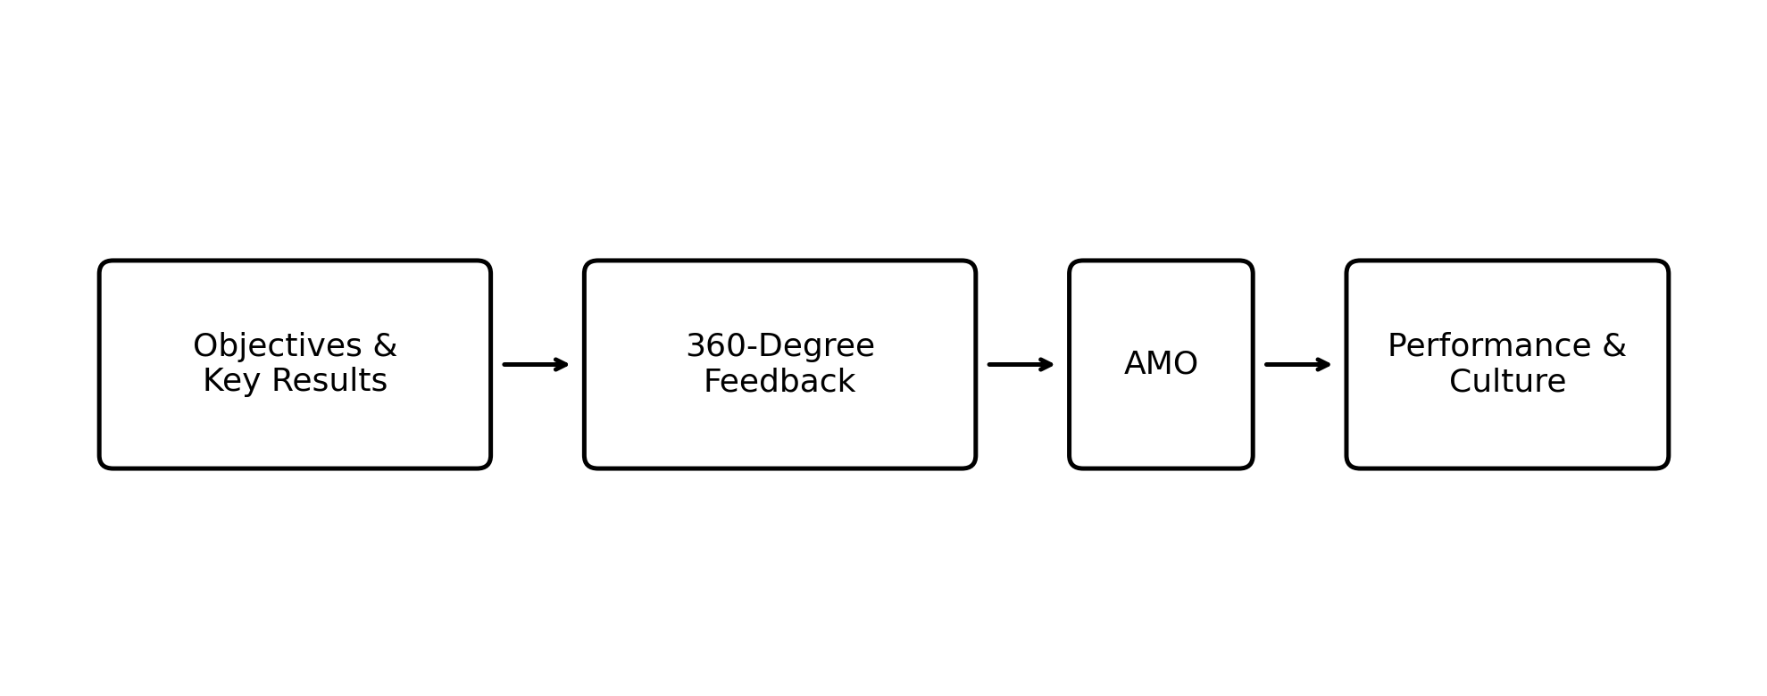
Figure 1: Integrated performance management framework for Aether Innovations
This report suggests introducing an integrated performance management framework that will be based on the Objectives and Key Results (OKRs) and 360-degree feedback approaches to overcome the shortcomings of current HR systems.
This balanced strategy is consistent with the Ability-Motivation-Opportunity (AMO) model, which proposes that the performance of the employees improves when organisations increase the employee abilities, motivation, and possibilities of making contributions (Appelbaum et al., 2000).

3.1 Objectives and Key Results (OKRs)
The Objectives and Key Results (OKRs) are a popular performance management model in the technological world. The framework helps organisations to translate strategic priorities in measurable goals which may be monitored across teams and departments.
Goals are strategic aspirations of the organisation that it desires to accomplish. Key Results are measurable outcomes that are targeted at measuring delivering progress to those goals. However, OKRs may also create excessive performance pressure and short-term focus if not balanced with long-term strategic objectives (Cappelli and Tavis, 2018).
To illustrate, one of the OKRs at Aether Innovations can be determined as follows:
Goal: Enhance customer satisfaction and product reliability.
Key Results:
• Retain a greater number of customers (20 per cent).
• Reduce product defects by 30%
• Reduce by 40 per cent the time it takes to respond to customer inquiries.
OKRs have a number of strategic merits to them. First, the use of OKRs leads to better alignment of the organisation as it makes sure employee activities foster strategic goals. Second, they enhance visibility, performance objectives are made visible in the organisation. Third, the use of OKRs fosters innovation through the setting of high but realistic goals (Dang, 2025).
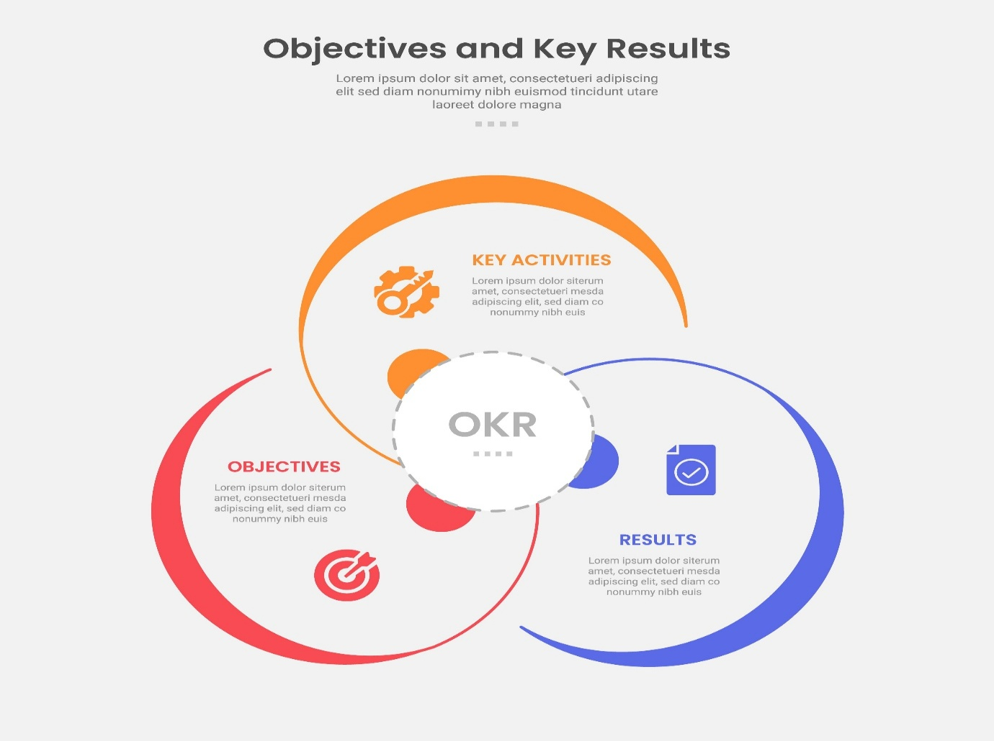
Figure 2: Objectives and Key Results (OKR)

3.2 360-Degree Feedback
On the one hand, unlike OKRs, which are mainly concerned with quantifiable results, on the other hand, 360-degree feedback deals with behavioural and leadership skills. The method gathers performance feedback of various stakeholders such as supervisor, peers, subordinates, and customers.

According to research, the multi-source feedback systems is a more accurate and balanced approach to evaluating employee performance than a traditional top-down appraisal system (London and Smither, 2017). However, 360-degree feedback systems may introduce bias and conflict if organisational trust is low (Armstrong and Taylor, 2023).

There are a number of opportunities that come with the implementation of 360-degree feedback into the OKR framework:
• minimizes discrimination during performance appraisals.
• Leadership development is improved.
• Promotes team work and responsibility.
• Enhances organisational learning.
When used together, the combination of 360-degree feedback and OKRs forms a well-balanced periodontal management approach that measures both behavioural skills and quantifiable results.
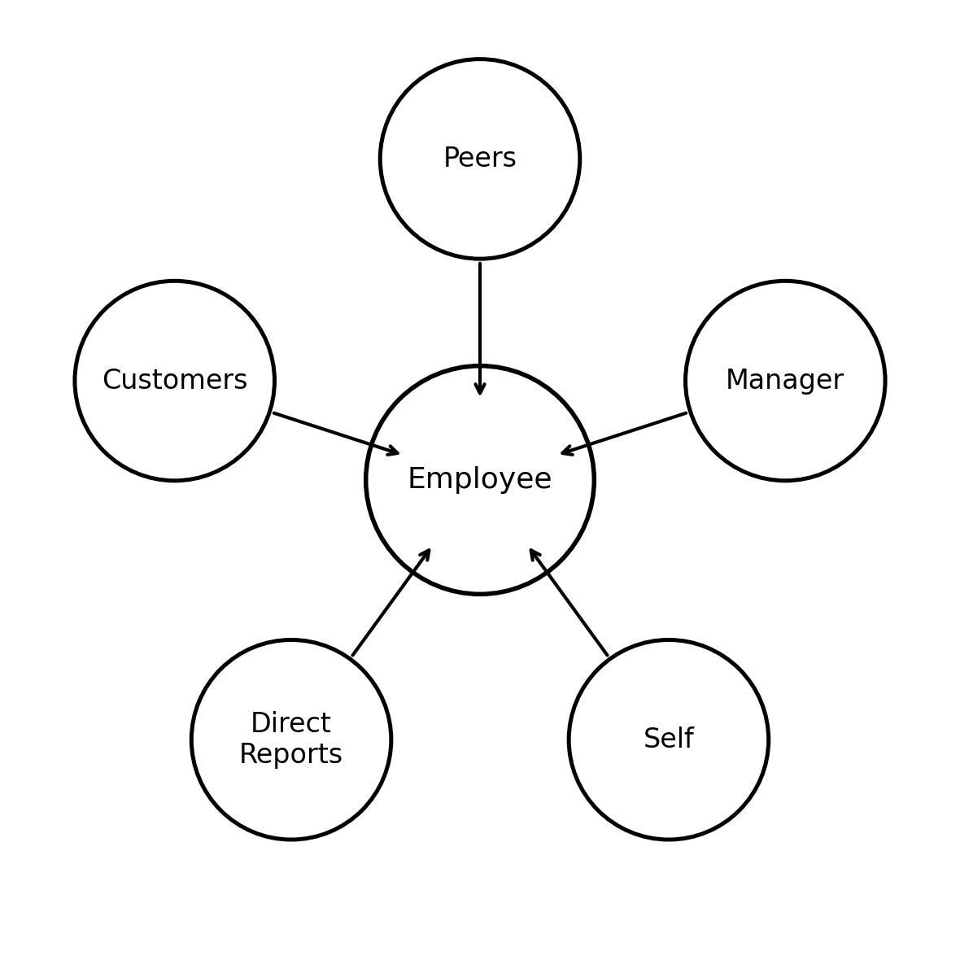
Figure 3:360-degree feedback model used to enrich performance reviews

4. Strategic Job Design for Leadership Roles
Job design is very fundamental in employee motivation, creativity and organisational performance (Cotič, 2025). Unsuitable jobs may decrease the engagement of employees and restrain innovation.

4.1 Chief Executive Officer (CEO)
The CEO has the mandate of establishing the strategic direction of the organisation and strategic business growth. The major roles are to create corporate strategies, executive leadership and relationships with the external stakeholders.
The position is one that needs good leadership skills, tact and decision making skills.

4.2 Chief Financial Officer (CFO)
The CFO manages the financial planning and the risk of the organisation. These involve budgeting, financial reporting, investment planning and cost control.
Among the critical skills that are necessary are financial skills, analytical skills and the capacity to assist in strategic decision making.

4.3 Chief technology officer (CTO)
The CTO is the head of the technology strategy of the organisation and he is the one responsible to develop the digital products and services. The duties involve overseeing technical teams, guaranteeing cybersecurity, and determining the emerging technologies.
It involves high technical skills and innovation prowess.

4.4 Chief Innovation Officer (CIO)
The CIO is concerned with innovation and finding new business opportunities. They are roles such as overseeing research projects and creating new products and fostering intrapreneurship in the organisation.

4.5 HR Director
The HR Director is in charge of human resource policy involving human resource recruitment, employee engagement, performance management and training and development.

4.6 Head of Research and Development
The Head of R&D organizes the work of research and manages to innovate a product. The job demands good technical expertise, project management experience and interdepartmental synergy.

5. Application of the Job Characteristics Model
Hackman and Oldham were able to develop the Job Characteristics Model that recognizes five job dimensions that have an effect on employee motivation (Cotič, 2025):
• Skill variety
• Task identity
• Task significance
• Autonomy
• Feedback
Application of this model to leadership position can greatly contribute to the scope of innovation in organisations.
As an illustration, the autonomy can be improved, and the leaders can be experimenting with new ideas and implementing innovative solutions. On the same note, the importance of work assignments will encourage the employees to appreciate the role played by their work to organisational success.
The skill variety may be increased through the promotion of cross-functional and multidisciplinary project teams. The use of continuous performance discussions with the help of the OKR framework can be used to enhance feedback mechanisms.
Aether Innovations can provide a creative, accountable, and learning organisational environment by reshaping the leadership roles on the basis of these principles.
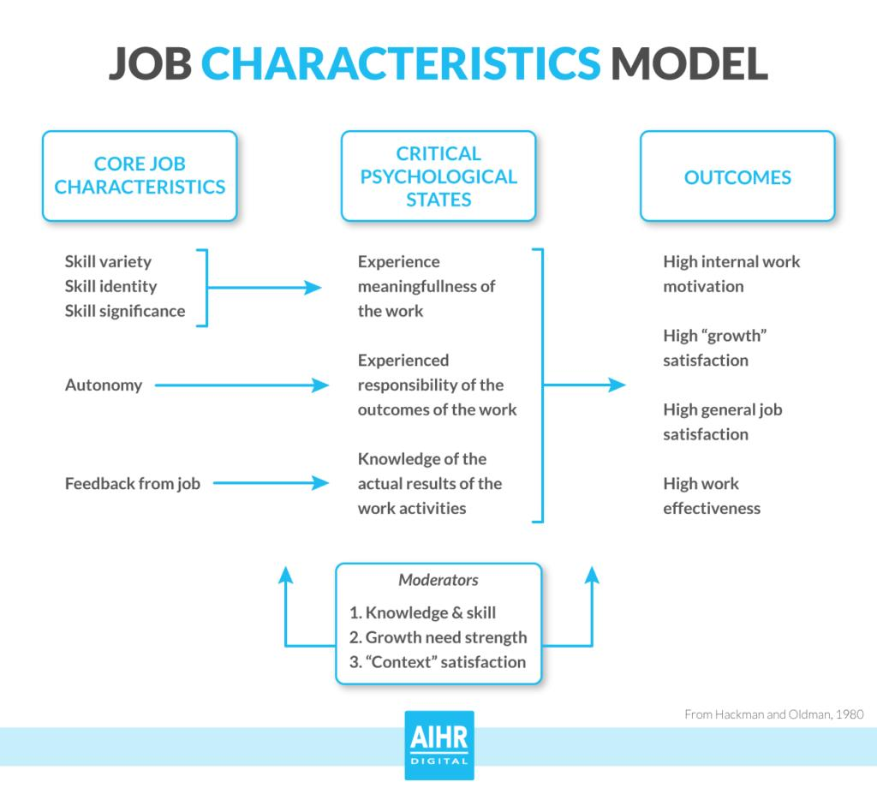
Figure 4: Job Characteristics Model (Hackman & Oldham)

6. Building a Performance-Driven Culture
Job design interventions and performance management systems should eventually lead to a wider organisational culture that facilitates innovation and teamwork.
Performance-based culture lays stress on transparency, accountability and constant improvement. Leaders are very important in governing such a culture by setting the behaviour that is desired and encouraging free flow of communication.
There is a good likelihood that the organisations who integrate performance management systems with strategic leadership practices tend to have increased levels of employee engagement, innovation and customer satisfaction (Al Humairah et al., 2023).
Through the integrated human capital blueprint that has been suggested in this report, Aether Innovations will be able to restore organisational performance and make itself self-sufficient to grow valueably in the future.

Part 2: Reflective Analysis

7.0 Reflection Using Gibbs’ Reflective Cycle
Description
The HRM module offered useful information about the strategic importance of HRM in deciding the performance of the organisation. The module covered some of the key issues such as performance management, job design, organisational culture, and strategic HR alignment.
I learnt more about the role of the human capital practices in creating organisational competitiveness through lectures and academic readings.

Feelings
My initial perception of HRM was that it was an administrative role that entailed employee relations and recruitment. Nevertheless, the module pointed out the fact that HRM has a far more strategic role in contemporary organisations.
The knowledge about strategic HR frameworks like AMO model has greatly altered my views on the influence of HR systems on organisational performance.

Evaluation
The module was rich in theoretical and practical knowledge. The relevance of integrating HR practices with organisational strategy was also one of the most valuable lessons.
The other major lesson was that job design is relevant in motivating and innovating employees. The Job Characteristics Model revealed the potential of the well-designed roles to increase the engagement and productivity of the employees.

Analysis
On the reflection of the learning experience, it is clear that the modern organisations should implement the integrated HR strategies that involve the combination of performance management, job design, and leadership development.
The example of Aether Innovations shows that the ineffective HR practices may have a toll on the organisational performance. Using the theory of HR like the AMO model and Job Characteristics Model, organisations can formulate better mechanisms of managing human capital.

Conclusion
On balance, the Human Capital Management module has become a great boost to my cognitive growth by understanding the strategic HRM and its relevance to the success of an organisation.
The qualifications acquired during this module will be useful in my future career especially within the areas of leadership, organisational development and strategic decision making.

8. Staying Relevant in the Age of Artificial Intelligence
The concept of artificial intelligence is changing the face of labor in most sectors. Machine learning, predictive analytics, and automation are just some of the technologies that are increasingly being adopted to assist in decision-making, enhance efficiency, and productivity in organisations. The use of AI-driven systems to process high amounts of data is becoming common in many organisations to help improve the efficiency of business processes and enable managers to make faster and more informed strategic decisions.

Nevertheless, AI can automatize usual and data-driven duties, but it cannot simply imitate specifically human qualities such as imagination, emotional intelligence, moral judgment, multifaceted and critical problem-solving, and strategic management. The human capabilities are not forgotten in team management, organisational culture building and innovation, which are vital instances and in which interpersonal understanding and judgment is crucial.

In order to keep up with changes in the changing labour market, professionals should thus not compete with technological advancement but rather develop skills that are complementary to them. Critical thinking, adaptability, collaboration, and leadership are some of the skills that will remain greatly sought after as organisations adopt AI in their business processes.

I intend to use AI in my future profession as an aiding tool when analysing data, detecting patterns, and enhancing decision-making. At the same time, I will also consider enhancing such human abilities as leadership, communication, creative problem-solving, which are less likely to be automated.

It will also be necessary to constantly engage in learning in order to adjust to technological change. Through constant knowledge upkeep, the use of new digital tools and awareness of the latest technologies, I will be empowered to remain professionally relevant and make my contributions to organisations that work in a more AI-driven world.

Conclusion
In conclusion, Aether Innovations should implement integrated and strategic human capital strategy that will help overcome the existing organisational challenges such as high employee turnover, declining customer satisfaction, and low growth. This report has presented the argument that conventional performance management systems cannot work with fluid technology environments hence suggested adoption of the new frameworks like Objectives and Key Results (OKRs) and 360-degree feedback. Such systems allow the ongoing performance assessment, enhanced transparency, and enhanced individual and organisational goal alignment.
Also, the redesign of the main leadership positions through the Job Characteristics Model promotes motivation through an increase in the measures of autonomy, skill variety, importance of tasks, and the feedback mechanism. These interventions when coupled with Ability-Motivation-Opportunity (AMO) framework help in developing a high performance work system that fosters innovation and teamwork.
In sum, through the coordination of performance management, job design, and leadership practices in accordance with the strategic objectives, Aether Innovations can enhance the organisational culture, enhance employee engagement, and attain the sustainable competitive advantage in the long term.

References
Armstrong, M. and Taylor, S. (2023) Armstrong’s Handbook of Human Resource Management Practice. 16th ed. London: Kogan Page.
Delery, J. and Roumpi, D. (2023) ‘Flexibility in human resource management: A catalyst for organisational performance’, Journal of Applied Psychology, 108(2), pp. 189–203.
Dang, L.H. (2025) ‘How human resource management practices promote job performance through innovative work behaviour’, Cogent Business & Management, 12(1).
Khatoon, U.T. (2025) ‘Technology-driven change in human resource management and organisational design’, Administrative Sciences, 15(11).
Thu, T.N.T. (2026) ‘The impact of performance management systems on organisational performance’, Journal of Advanced Data Science, 5(2).
Humairah, K.A. et al. (2023) ‘Crafting effective HRM strategies for enhancing organisational performance and employee engagement’, Advances in Human Resource Management Research, 1(3), pp. 126–136.
Hoang Dang, L. (2025) ‘Human resource management practices and innovative work behaviour’, Cogent Business & Management.
Cotič, L.P. (2025) ‘Job characteristics and employee engagement: The role of autonomy and task significance’, Journal of Organizational Effectiveness.
Van den Broek, A. (2024) ‘Human resource management and organisational performance: Balancing optimisation and employee wellbeing’, Human Resource Management Review.
Al Humairah, K. et al. (2023) ‘Strategic HRM practices and organisational performance’, Advances in Human Resource Management Research.

