Student Name: Bianca Anamaria Chirita
Student Number:1815749
Module’s Lecturer’s Name: Molly Jack
Assignment Title: The project management plan
Module Code: LCBB5005

Executive Summary
In this summary, the overview of this project will be portrayed in short. The project has been done on the vehicle service area plan and being a project manager; all the possible criteria have been evaluated. In this plan, the scopes, deliverables and the constraints have been discussed on the basis of the proposed project. The timeframe of this project is six months and the capital that has been given to utilize is £50,000. The project has been completed smoothly and effectively under the given time and the budget. Also, some risk factors have been discussed throughout this project and those factors are also discussed in this plan. In the risk register, all the factors that are related to this project are mentioned already.
Table of Contents
Executive Summary 2
Introduction 3
Project goals and objectives 4
Project scopes and Deliverables 4
Scope 4
Deliverables 4
Constraints 5
Project Schedule 5
Gantt chart 5
Project Resources 6
Work Breakdown Structure 6
Project budget 7
Human Resources 9
Quality Management Plan 9
Communication plan 10
Risk and Issue Management Plan 12
Project Risks 12
Risk Register 12
Conclusion 14
Reference List 15

Introduction
The project management plan is the most important document that is necessary for any planning. In this document, all the overall tasks are included like, planning, observing and execution of a project. You have been assigned as a project manager; with a budget of £50,000 to undertake a project of your choice. The duration of the project will be 6 months. In this study, some topics are going to be discussed, like, how the project is going to be executed, observed and managed by the project team. Also, some other key factors are going to be discussed in this plan and those are the scope of this plan, time and cost of this project. Risk factors are also going to be explained in this project plan.

Project goals and objectives
Based on a comprehensive analysis as per the data from the stakeholders and the project team, it is found that the project goal is the vision of the project. The main goal of this project is to complete the entire project smoothly and effectively within the given time period of 6 months and within the budget of £50,000. The long term goal of this project is:
- To design an effective vehicle service area that includes a sensor fire alarm system that is beneficial for trucks and other lightweight vehicles.

The objectives of the project are:
- To install modern technology in the vehicle service facility zone.
- To construct a proper training are so that the aspects of services can be modified.
- To properly design the vehicle service area for all the light automobiles as well as pickup trucks.
- To install a sensor fire alarm system in that vehicle service area.

Project scopes and Deliverables

Scope
The main scope of any project is to take the first step as a project manager to explain the objectives and goals of the project properly (Di Giorgio et al. 2016). In this project plan, the scope is to design and construct a space or area which will provide all types of vehicle services provisions to the stakeholders. This project consists of some advanced technologies along with the upgraded maintenance and servicing areas for the heavy goods vehicles and other medium and small vehicles. Some of the new inventions or designs like emergency exit gate and user interface will be introduced as a part of the project task. The assigned task will be discussed among the stakeholders as per the structure of project breakdown. Also, a brainstorming session will be held to discuss safety check-ups and audits. One of the main scopes of this project is to ensure that the vehicles service area should have a proper and effective fire alarm system.

Deliverables
The project outcome or deliverables are one of the main aspects of any project management plan (Sun et al. 2018). The most informative and important part of this project will be the fire alarm system with the sensor attached. The development of the vehicles service area is also a very important part of this task. With the help of the developed vehicle service area, the maintenance and servicing time of every vehicle can be reduced (Csonka and Csiszár, 2017). This project also needs to be finished within the limited resources and time that has been mentioned in the task and it will also make the task or project more pleasing to the customers. This project has opted mainly to provide services to heavy goods vehicles and medium and small vehicles. So the main priority needs to be shifted on this side. Also, needs to maintain the sensor fire alarm system for this servicing area so the servicing can be done effectively.

Constraints
Every project management plan consists of some limitations that can hamper the project (Afghah et al. 2019). In this project plan, as the technological part would get included as support for the betterment of the infrastructure, the time management and resource crisis problems can occur. According to Ulmer et al. (2017), to battle against the project uncertainties more effectively, the project plan must be contingent. The project plan must be based on a contingency plan. In this task, with the help of this plan, the analyzing of the value or cost of the injuries that will happen on the job and it will also analyze the accidents that will happen at the worksite. This contingency plan also needs to improve the technological factors as with the help of the technology, it can make an effective system that can fight the security issues and breaches. Making an alternative resource plan is also a task of this contingency project plan.

Project Schedule
Creating a project schedule is an important task in every project management plan (Llorca et al. 2017). In the first month, some particular features relevant to the vehicles service facility will be designed and conveyed among the stakeholders. In this part, the discussion will be on the internal build-out and instruction rooms. In the second month, the main focus will be on the site works like parking lots customization, installing markers and bollards, installation of dustbins, etc. The third month will be consumed to monitor and complete the worksite activities and also for the landscaping of the worksite activities. In the fourth month, the working focus will be on the pavements in the entrance of the vehicle service area. Also, the planning for the interior of the main gate and creating and selecting of the entrance sign will be done within the fourth month. After all the above tasks, the final task setup will be done by the fifth month. The last month, that is the sixth month will be consumed for the final check-ups and clean-ups. In this month, the documentation of occupancy will also be done so the vehicle service and maintenance facilities can run smoothly for the stakeholders.

Gantt chart
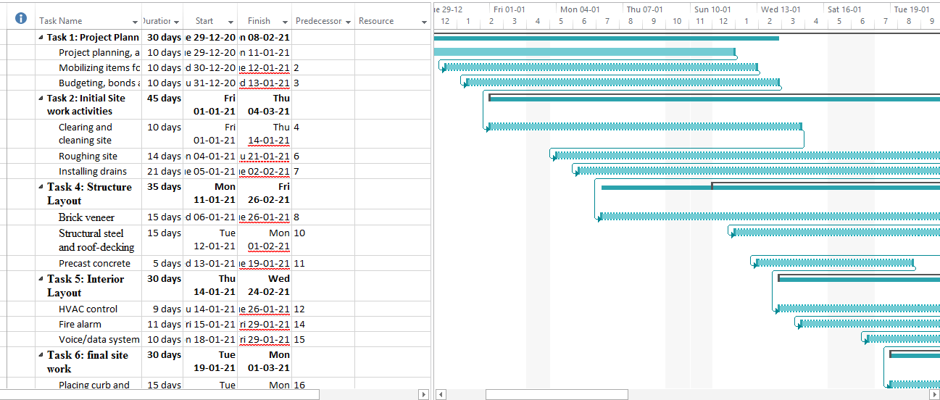
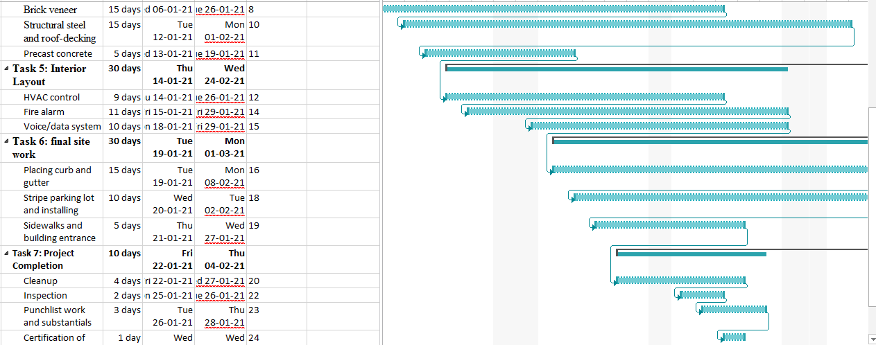
Figure 1: Gantt chart
(Source: MS Project)

Project Resources

Work Breakdown Structure
The work breakdown structure is a type of method that can be used to do or solve complicated and multi-layer projects (Thirunavukkarasu et al. 2017). With the help of WBS, any large or multi-layered project can be divided into parts so the project can be completed easily and within the deadline. Work breakdown structure is a type of tree structure that defines the project and breaks down into small parts and due to that, it can be managed properly. In this project, there are four steps of WBS that have been portrayed below. In the first step, the planning stage is there. Under this step, some important tasks are being done like mobilizing general condition items, finalizing bonds and permits, receiving NTP, etc. The second step of this WBS structure is very important. In this step, the first thing that needs to do is to take the project approval. After that, all the structures, interiors and executions will be done accordingly. In the third step, the documents related to occupancy and final check-ups need to be done. At the last step, after inspecting all the parameters the project needs to mark as closed.

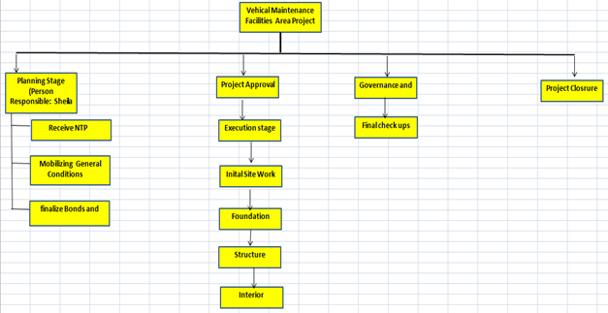
Figure 2: Work Breakdown Structure

Project budget
Name | Cost
Project Management
Bonds and Permits | £5,000
Mobilize General Conditions items | £2,000
Initial Site Work
Clear & grub site | £3,000
Rough grade site | £2,000
Foundation
Excavate for Service Pit | £2,000
Install steel columns in Service Pit | £4,000
Insert Voice AI | £2,000
Structure and Envelope
Finish electrical – Office Area | £5,000
Interiors – Office Area | £10,000
Install registers and grilles in ceiling grid – Office Area | £7,000
Final site related work
Landscaping | £3,000
Fine grade for the related parking lot | £2,000
Project Closeout
Final cleanup | £2,000
Punch List work | £1,000
Total | £50,000

Table 1: Project Budget

Human Resources
In every project, there is an essential role of the human resource. With the help of human resources, any project can get required manpower (Guo and Li, 2020). In this project, all the stakeholders are important as they are the sole member of this project plan. The main project team consists of internal stakeholders. These stakeholders are associated with the planning, implementation, purchase of raw ingredients, observing and evaluating the project. This team includes the members, from the project manager to lower level staff who are involved with the vehicle’s service area project. Such as Project Manager, Industrial Manager, Site Manager, Cost Accountant, Quality Manager, Shop Supervisor, Safety Manager, Suppliers, etc. The stakeholders of the project will also include the people who will be getting the services as an end-user. These stakeholders are segregated into two parts. These are - external and internal. All the people, who are going to use the services and facilities by the vehicle’s service area are called as external stakeholders. Like for example, the owner and drivers of the heavy goods vehicles and medium and small vehicles will be visiting the vehicles service area as external stakeholders.

Quality Management Plan
Creating and implementing a quality management plan is an important part of any project. In this quality section, all the staff of the vehicles service area will be taking crucial roles. Every employee and members need to ensure that the task is completed at a good level of quality so the final project can be done properly. The factors affecting the Quality management plan of the vehicle service area can be stated as
Creating a quality culture

The vehicle service area should carefully carry ahead the maintenance work of the service area of vehicles for avoiding the defects in working efficiency of the motor parts (Sangiuliano and Davies, 2018).

Working with the suppliers

The suppliers play a vital role in time to time delivery of the products that contributes to the overall efficiency of the work. Alongside, improving the availability of raw materials can also improve the quality of work.

Using technology for connecting the supply chain

Sound technologies should be administered that will drive the increased effectiveness and efficiency of the Vehicle service area. Deployment of technologies will also attract the customers as it is known to everyone that technologies generally provide a flawless work.

Demanding more than inspection report

A periodic inspection of the place should be conducted for checking the spills and leakages and to avoid any sport of mishappenings in the near future. Demanding an inspection report will help the owner of the service area to promote a flawless inspecting and maintenance of the vehicles (Schedule, 2019).

Manufacturing Intelligence of the leverage

The manufacturing intelligence of the leverage plays a vital part in smoothly driving the work functionality of the workplace.

After the completion of the task, the sponsor of the project will check the quality standard of the project work. The project manager will be accountable for any type of project quality standards that will be delivered throughout the project time.

Communication plan

Communication Goal | Communication Tool | Audience | Frequency
Installation of censored fire alarm system | Conference | Project Manager | Regular
Conduction of proper training | Meeting | Quality Manager | Regular
Installation of Modern Technology | Business meeting | Site manager | Weekly
Facility for light automobiles | Notice | Safety and security manager | Periodically
Table 1: Communication Plan
Analysis
The above mentioned table is a communication plan that states the various communication goals, audience and the frequency of distributing the message. The table reflects that the frequency of sharing the communication goals will be regular, weekly as well as periodic depending upon the urgency of the job. The goals of communication will be based on the messages of Installation of censored fire alarm system to avoid the happening of any misconduct in the near future. Alongside, the communication table also states the necessity of conduction of proper training for the working employees of the workplace so that the workforce is duly supervised for maintaining a safe and sound vehicle servicing area. Along with that the table also reflects the necessity of installation of modern technology in the vehicle servicing area that will help to attract the customers and alongside it will also help to escalate a flawless process of work. Despite that the table reflects the messenger that says sound facilities for light weight vehicles such as lifting bars, washing gears, refueling gas chambers should be duly installed in the service area for facilitating the work (Schedule, 2019). The communication goals will be shared via various communication tools such as Business meeting, Notice and Conference. The person responsible for smooth handling of the communication goals are Quality manager, project manager, safety and security manager and site manager. The responsible person should also ensure that safety and security will be duly followed in the workplace alongside making the necessary changes that have been mentioned in the list.

Risk and Issue Management Plan

Project Risks
Being a project manager, calculating the project risks are very much an important task to do (Łebkowski, 2017). The risks can only be reduced only after identifying them in the first place. In this project, some risk factors that can impact the project are shown in the risk register. One of the risks that are mentioned in the risk register is the consultant or contractor delays. This risk factor can make a huge impact on the project. There are some points that can help to counter the risk. Like, to ignore this type of delays the project manager can include a late fine in the contract. The project manager can provide the work schedule early so the consultant or the contractor gets to know the actual time of the supply. Another factor of risk that can hamper the project is estimating and scheduling errors. If any estimation error happens in the project then it can hinder the project at its maximum level. According to Obanda (2017), to overcome this issue, there are such steps that can help. Like, break the risk factor into two factors as cost calculation and finding errors. With the help of the cost calculating method, the cost forecast can be analyzed. Also, flagging the errors to the project management team earlier can make the risk factor vanish. Creating a contingency plan can also reduce the risk factor of this project.

Risk Register
Risk Description | Likelihood of the risk | Impact if it occurs | Severity | Responsible Person | Mitigating actions
Consultant or contractor delays | Medium | High | High | Project Manager | Late penalties can be included in the contract.  Make a proper time schedule to protect the lead time.  Provide the work schedule early.  Keep in touch with the suppliers on a daily basis.
No control over staff priorities | Medium | Medium | Low | Project Manager | The sponsor of the project will explain the team managers about the significance and importance of the project. After that, creating and scheduling workshops for the staff will have the best effect.
Estimating or scheduling errors | Medium | High | High | Project Manager | Break this risk into two factors like cost calculating and finding errors.  Use the cost calculating method to analyze the cost forecast.  Create a contingency of 10% on scheduling and cost.  Highlight the forecast of delays and errors to the project board as soon as possible.

Table 2: Risk Register

Conclusion
Therefore, this project will cater to the construction of a vehicle maintenance center. Both the internal and external stakeholders will be involved to fulfill the needs of the projects.The project contains a deep information about the work breakdown structure that is provided in the article. The main objective behind undergoing this project is to install a censored fire alarm system in the vehicle service area and to promote an effective and efficient functionality of work in the vehicle service area. Alongside that, the article also aims to improve the domestic training of the employees that will help to provide sound facilities foe the light weight vehicles that have their needs associated with the servicing and maintenance if the cars.

Reference List
Journals

Afghah, F., Razi, A., Chakareski, J. and Ashdown, J., 2019, April. Wildfire monitoring in remote areas using autonomous unmanned aerial vehicles. In IEEE INFOCOM 2019-IEEE Conference on Computer Communications Workshops (INFOCOM WKSHPS) (pp. 835-840). IEEE.
Csonka, B. and Csiszár, C., 2017. Determination of charging infrastructure location for electric vehicles. Transportation Research Procedia, 27, pp.768-775.
Di Giorgio, A., Liberati, F., Germana, R., Presciuttini, M., Celsi, L.R. and Priscoli, F.D., 2016, June. On the control of energy storage systems for electric vehicles fast charging in service areas. In 2016 24th Mediterranean Conference on Control and Automation (MED) (pp. 955-960). IEEE.
Guo, S. and Li, H., 2020. Design of an Intelligent Broken Window System for Dealing with Bus Fire Accidents. Journal of Scientific Research and Reports, pp.120-126.
Łebkowski, A., 2017. Electric vehicle fire extinguishing system. Przegląd Elektrotechniczny, 93(1), pp.329-332.
Llorca, C., Moreno, A. and Moeckel, R., 2017. Effects of shared autonomous vehicles on the level of service in the greater Munich metropolitan area. In International Conference on Intelligent Transport Systems in Theory and Practice, mobil. TUM (pp. 4-5).
Obanda, Z.S., 2017. Multi-sensor fire detection system using an Arduino Uno microcontroller (Doctoral dissertation, Strathmore University).
Sangiuliano, S.J. and Davies, I.M., 2018. A quality management review of Scotland's sectoral marine plan for tidal energy. Ocean & Coastal Management, 157, pp.217-226.
Schedule, F., 2019. Gwydir Alluvium Water Resource Plan–Water Quality Management Plan.
Schedule, F., 2019. Murrumbidgee Alluvium Water Quality Management Plan.
Sun, Y., Wang, T. and Wang, S., 2018, May. Location optimization for unmanned aerial vehicles assisted mobile networks. In 2018 IEEE International Conference on Communications (ICC) (pp. 1-6). IEEE.
Thirunavukkarasu, M., Vani Manasa, N., Kumar, K.R. and Sundar, S., 2017. Emergency information systems for cars. MS&E, 263(5), p.052044.
Ulmer, M.W., Heilig, L. and Voß, S., 2017. On the value and challenge of real-time information in dynamic dispatching of service vehicles. Business & Information Systems Engineering, 59(3), pp.161-171.

