UWTSD MBA (May/Nov 2019 intakes)
BMMB7006 Global Business Challenges

Assignment Title:
Challenges of BONJOUR Holding to Expand Operations in Indonesia

“I, Jeffery Chan (student no. 1912529), certify this work is the result of my own investigations, except where otherwise stated. All references have been duly cited”

Signed: _____________________

Date: 6th March 2020

Synopsis

This report explores and discusses BONJOUR’s rationale for entering into Indonesia and evaluates the potential challenges and risks that could be faced. This study aims to develop business strategies for BONJOUR to enhance its competitive edge in the world market by using the SWOT model aided by a comprehensive collection of information about the company and the business environment of the Cosmetics and Personal Care industry in Indonesia. Research findings suggest that BONJOUR has a good chance to expand their foot print in Indonesia and will be successful if they can follow the set action plans according to the developed business strategies. BONJOUR is facing the downturn of the economy in the Greater Bay Area due to the social unrest in Hong Kong and the current outbreak of the Wuhan Coronavirus.

Table of Contents

 |  |  |  |  |  | Page
1 | Introduction (About 700 words) |  |  |  |  | 1
2 | Company Background (About 1000 words) |  |  |  |  | 4
 | 2.1 | Company’s product portfolio
 | 2.2 | Domestic and foreign market environment for the development of the cosmetic, beauty and personal care industry |  |  |  | 6
 | 2.3 | The rationale of expanding Operations in Indonesia |  |  |  | 9
3 | Country Background (About 1000 words) |  |  |  |  | 9
 | 3.1 | Economic setting
 | 3.2 | Sociological setting
4 | Analysis and discussion (About 2000 words) |  |  |  |  | 17
 | 4.1 |  | Theoretical background
 |  |  | 4.1.1 |  | The theory/model | 17
 |  |  | 4.1.2 |  | Application | 18
 | 4.2 |  | Challenges
 |  |  | 4.2.1 | Empirical facts
 |  |  | 4.2.2 | Identification of potential challenges
 | 4.3 |  | Responses to work on the challenges
5 | Conclusion and recommendation (About 300 words) |  |  |  |  | 19
References |  |  |  |  |  | 20

1 Introduction

Due to the unstable social situation of Hong Kong since June 2019 and outbreak of the new Wuhan Coronavirus (COVID-19) early January 2020, the retail sectors in Hong Kong are facing a very different situation. But well before this, BONJOUR has already issued a profit warning that it is expected to record a substantial increase of loss for the year ended 31 December 2019 which will be another year with loss of HK$39.6 million in 2018. BONJOUR is expected to record a double-digit year-on-year decline for the year going forward. The average gross profit margin also decreases mainly due to the change of sales mix, consumer’s spending pattern and the increase in promotion to attract customers. With the unexpected coronavirus epidemic started in late December 2019/beginning of January 2020, the retail sales will be even worse than earlier anticipation. After a month for factories shut for the extended Lunar New Year holiday, a patchwork picture of production is emerging in China, with only 30 per cent of small businesses able to reopen due to the ongoing coronavirus epidemic. The visitor from China arrivals in Hong Kong will continue to stay weak, coupled with RMB softness and easing Chinese economic growth which BONJOUR was well depended on and the company has to find a way to turnaround the gross profit margin in 2020. Tapping to another market seems to be the only way for BONJOUR to achieve this utmost important objective. Then the question is which market?
It is observed that emerging markets particularly Indonesia have been growing quickly in recent years, it is be an unique chance for the Cosmetics & Personal Care products industry. According to a report in January 2015, emerging markets are the driving force for the growth of health and wellness sectors and are projected to account for almost half of the total market share by 2019. The beauty business including the Cosmetics & Personal Care products is a rapidly growing small and medium enterprise in Indonesia. The development of beauty industry in Indonesia grew rapidly from 1990 to 2017 and hence Indonesia has a large market for beauty products. Based on 2017 Central Bureau of Statistics data, the population of women aged 15-64 years in 2016 was 33.23% of the total population of Indonesia. These data reflect the great potential for the beauty industry services in Indonesia (Ministry of Industry, 2016). “GlobalData”, a leading data and analytics company, said that increasing population and decreasing in the unemployment figures are anticipated to push the growth of the economy in Indonesia, as peoples are now more concerning of their appearance and start using cosmetics & toiletries products. We have chosen Indonesia as our target in this round of new market after the research finding of the country background and Indonesian Cosmetic Sector’s performance in these years & outlook.
We will then try to identify the opportunities as well as challenges with the research finding on both BONJOUR and the Indonesia markets. We will use the SWOT analysis to derive the top business strategies and action plans for BONJOUR to follow for its market entry to Indonesia. A SWOT analysis is a planning tool used to identify the Strengths, Weaknesses, Opportunities, and Threats associated with a project or business. It builds the objective of the business or project and figuring out the internal and external factors that are favourable or unfavourable to attaining that built objective. (Mike Morrison, 2016).
The report will first look at the background and history of BONJOUR and from there we can understand their successful story in the past and what capability has been developed. We will then do the research findings based on the recent development of Indonesian’s economy including the GDP, PPP (Purchase Power Parity), Economic Structure, Religion, Population, Median Age, Language and Government Investment Policy for foreign direct investment with reliable source of information:- 1) Hong Kong Trade Development Council , 2019) 2) IMF Country Report no, 19/250), & 3)UNTCAD, 2019. Then, we need to have the research finding on the overview of the Indonesian Cosmetic Sector and of course the outlook. With all these findings, we can then apply the SWOT analysis to derive the “can be done” business strategies for BONJOUR to develop business in Indonesia and help out their current non-profitable status.

2 Company background

BONJOUR Holdings Limited (thereafter BONJOUR) is a leader of cosmetics retail chains in Hong Kong. It has been public listed on the Main Board of The Stock Exchange of Hong Kong Limited since 2003.
BONJOUR is running 39 retail stores in Hong Kong, Macau and Guangzhou. BONJOUR is always trying to provide good mix products of exclusive international and private brands. BONJOUR is now selling over 20,000 different products on skincare, cosmetics, fragrance, health food, hair and body care, meeting various needs of customers. “More Mall”, a famous brand famous in providing snacks from Japan, Korea and Taiwan, is also stationed in 7 branches. The Company also operates beauty and health salons in Hong Kong.

2.1 Product profile
BONJOUR always try their best attempt to expand the products mix from time to time to meet customers changing appetites and needs. As beauty products and cosmetics are evolving rapidly, BONJOUR is keeping the latest market trends on the cosmetics and beauty products globally.
Here below are some observations of the capability and business model of BONJOUR:
BONJOUR has the good understanding of the key beauty trends and customer needs on the cosmetic products, BONJOUR constantly doing the research and development for the best up-to-date market moves that are generating new products each and every season globally, including South Korea, Japan, Europe and the United States, etc. BONJOUR is sourcing over 20,000 quality and trendy brands for a broad appeal product mix to ensure there is adequate products in the shop that will attract consumption. The vision ‘We strive for the best and keep a keen eye on the rapid market changes to continue providing a good variety of products and services for the customers.” is another good strategy of BONJOUR. As for the real shopping environment, BONJOUR is to provide unique, comfortable and special shopping experience to ensure customers will visit and purchase their favours in BONJOUR’s shops again.
“Services-oriented, striving for excellence”is another vision statement of BONJOUR. The staff are dedicated to providing sincere service to customers. The customer care or sales staff are continuously undergoing professional training for the improvement of their service skills and product knowledge. The retail stores are in convenient and popular areas that are highly perceptible and easily reachable by traffic conveyance and hence their retail network can easily provide their unique cosmetic, personal -care products for the local peoples as well as the visitors. This earns the popularity among customers.
BONJOUR kicked off their online shopping platform for domestic consumer as well as overseas purchases. This is also to cope with the needs of the Mainland Chinese online customers prefer cross-border shopping platforms hosted by Hong Kong providers. BONJOUR online stores have stationed on multiple e-commerce websites so as to reach more targeted customers and to provide them with trendy update information such as promoting new and upcoming products with pre-ordering discount. BONJOUR understands the online shopping platform is the upcoming trend for shopping particularly for the overseas customer and Generation Z. (Generation Z is referring to the age group that was born between 1996-2010, following millennials. This age group has been raised on the internet and social media networking, with some the oldest finishing college by 2020 and entering the working group. (Advertising Age, 2000))
BONJOUR is treating well for its talents such as providing comfortable working environment for the employees and enhancing their capability by arranging regular training course. As for the customer care and sales staff are all well-trained with professional beauty knowledge and customer service skills. BONJOUR values employees’ feedback and ideas on daily operations and react timely to improve the company’s operating efficiency and to be better performed.

2.2 Domestic and foreign market environment for the development of the cosmetic, beauty and personal care industry
Indonesia’s cosmetic sector has grown rapidly in recent years. With years of experience and abundant skilful human resources and potential large domestic market, Indonesia has successfully sail through the global economic slowdown after 2008/2009.
GlobalData, a leading data and analytics company, said that the cosmetics sector of Indonesian market forecast to be worth Rp105.1 trillion by 2023 and will grow with a compound annual growth rate (CAGR) of 8.4% from Rp70.3 trillion (US$5bn) in 2018 to Rp105.1 trillion (US$7bn) by 2023. ‘Country Profile: Cosmetics & Toiletries in Indonesia’, shows that skincare products, which held the largest value share of 31.1% in 2018, are forecast to record the fastest growth with a value CAGR of 9.6% over 2018-2023. The per capita consumption (PCC) of cosmetics & toiletries in Indonesia, which was low at 9.5 units compared to both APAC and global levels in 2018, is forecast to increase to 11.6 units by 2023. (GlobalData, 2019).
The growing number of peoples and improving unemployment rate are the driving force to push the growth of the economy in Indonesia, as peoples are now more caring about of their appearance and cosmetics & health care products become popular.
The leading players are Unilever, P&G and L`Oreal S.A. in the Indonesia Cosmetic market while Pond`s, Lifebuoy and Sunsilk were the top brands in 2018. The main distribution channels are Hypermarkets and supermarkets, and convenience stores.
Other private label products are still at a very low penetration rate of 0.5% by value in 2018. The consumers in Indonesia are becoming clever and more conscious of the harmful effects of chemicals used in cosmetics and toiletries, the demand for products with ‘natural’ claims are set to rise in the future.” Indonesia’s cosmetics sector performed very strong by 2017 along with the uprising of the rich middle class.
The implementation of halal regulations (major religious concern on the cosmetics in Indonesia) has proven to be the major turnaround factor resulting great demand of halal cosmetics to dominate the cosmetic sales in the country. “Wardah” the country's first halal cosmetic manufacturer, has successfully capitalised on the new trend and has become a leading cosmetics brand in Indonesia.
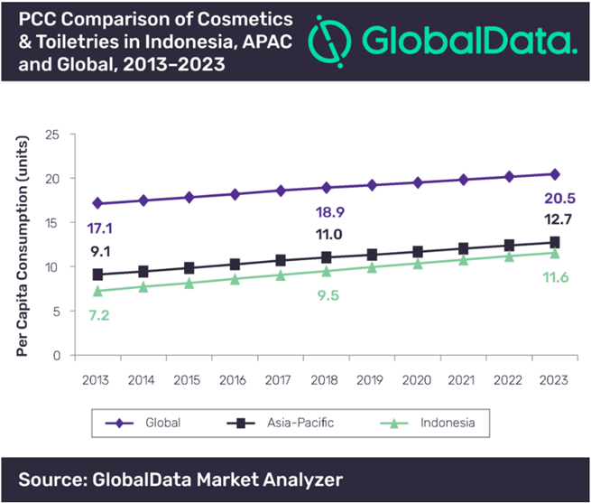
Remarks on the above graph: You can see that Indonesia has a good growing trend on PCC when comparing with the region of Asia-Pacific and the Global.
Challenges are still the keen competition from global brands plus the market being flooded with fake and illegal products. Hence there is room for good quality and genuine products for the growing middle class of Indonesia and this is the opportunity for BONJOUR to utilize their strength in this respect.
Halal cosmetics in Indonesia becomes more popular as mentioned. This is in line with the increased number of rich middle- class Muslim women who are halal conscious as it is the religious duty to use Islamic certified cosmetics and other personal care products. It is understood that from a survey that 58% of Indonesian female whom is Muslim now prefer to use halal cosmetics. They have much more concern on halal certification over other factors such as price, packaging, ingredients and etc.. The carrying out of the Indonesian government regulation on halal product assurance as a derivative regulation of Law No. 34/2014 on Halal Product Assurance in 2017 has further increased demand for halal cosmetics. Halal is an Arabic word means lawful or permitted which stated in the Qur’an (the Muslim scripture). The term halal is particularly associated with Islamic dietary laws, and especially meat processed and prepared in accordance with those requirements.

2.3 The rationale of expanding Operations in Indonesia
The business environment in Hong Kong is always challenging, BONJOUR has confidence that it is well equipped to resolve any challenge as they have a very strong established business stand in Hong Kong. However, given the current and anticipated macroeconomic situation of Hong Kong and Greater Bay Area, BONJOUR will not have a chance to turnaround the deficit deterioration in the coming years. BONJOUR must find and tap on another potential market so that they can replicate their successful story for better profit.
We can see the potential changes and challenges of the Indonesian Market which give the opportunity for BONJOUR to expand its operation in Indonesia. This will be further discussed under the SWOT analysis and if the research findings are applicable to attain the objective of BONJOUR to gain profit in this emerging market with quite some room for it to develop and grow their business. Of course, the process will be very challenges but this what BONJOUR can overcome as in Hong Kong.

3 Country background

Indonesia (officially the Republic of Indonesia) is a country in Southeast Asia, between the Indian and Pacific oceans. It is the world's largest island country, with more than seventeen thousand islands, and at 1,904,569 square kilometers (735,358 square miles), the 14th largest by land area and 7th in the combined sea and land area. With over 267 million people, it is the world's 4th most populous country as well as the most populous Muslim-majority country. Java, the world's most populous island, is home to more than half of the country's population.
Indonesia consists of hundreds of distinct native ethnic and linguistic groups, with the largest—and politically dominant—ethnic group being the Javanese. A shared identity has developed, defined by a national language, ethnic diversity, religious pluralism within a Muslim-majority population, and a history of colonialism and rebellion against it.

3.1 Economic Setting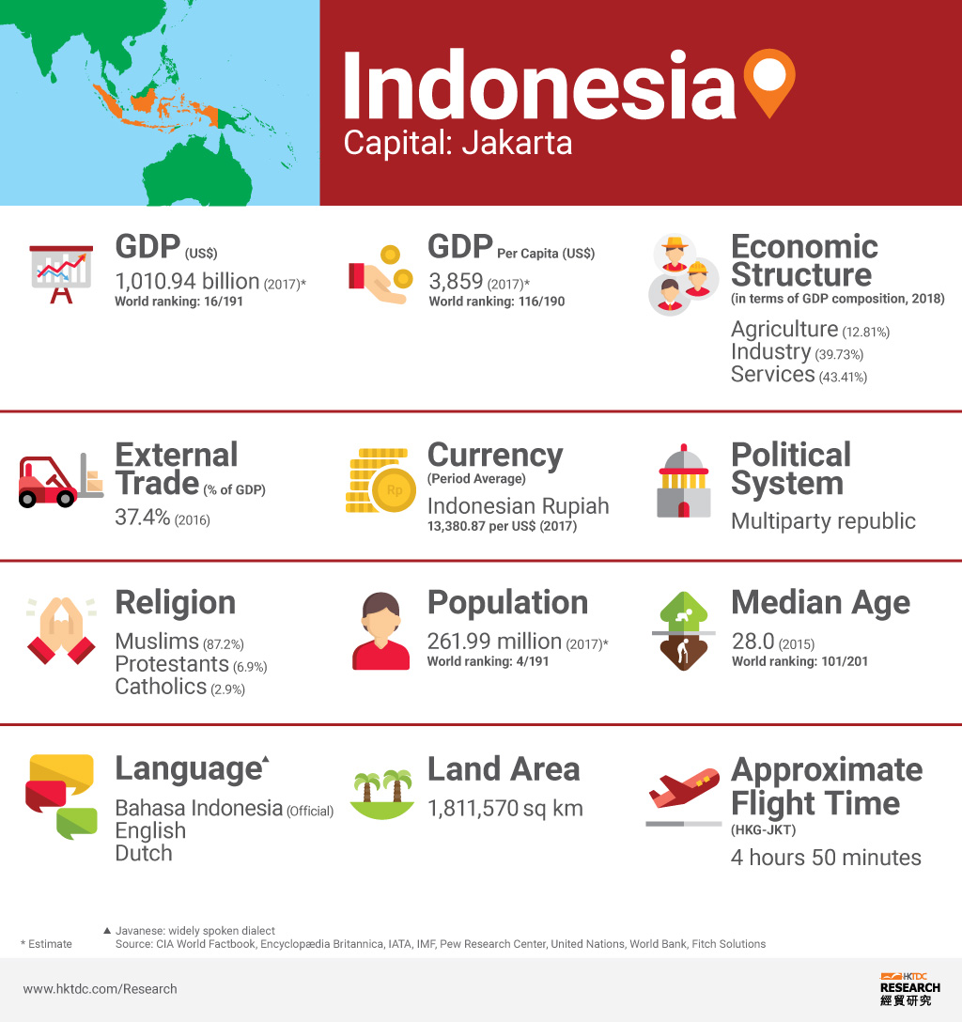
Source: HKDTC, 2018
The economy of Indonesia is the largest in Southeast Asia and is one of the emerging market economies of the world. The country is a member of several international multilateral organisations, including the UN, WTO, IMF, G20, as well as founding member of Non-Aligned Movement, Association of Southeast Asian Nations, Asia-Pacific Economic Cooperation, East Asia Summit, Asian Infrastructure Investment Bank, and Organisation of Islamic Cooperation. It is the 16th largest economy in the world by nominal GDP and the 7th largest in terms of GDP (PPP - Purchasing Power Parity). Faced with unstable global situation, the government policy flexibility supported a positive macroeconomic performance in 2018 - growth stabilized at above 5 percent and inflation was moderate at around 3 percent (IMF Country Report No. 19/250).
Major Economic Indicators of Indonesia: showing the positive trend since 2016 and outlook for 2019.
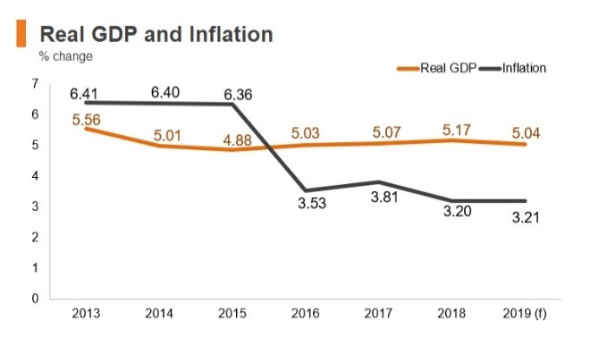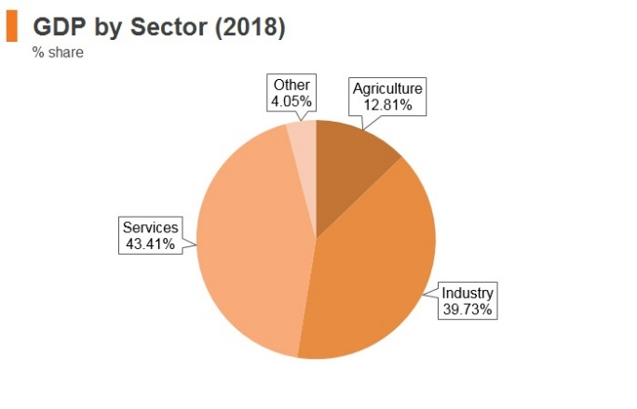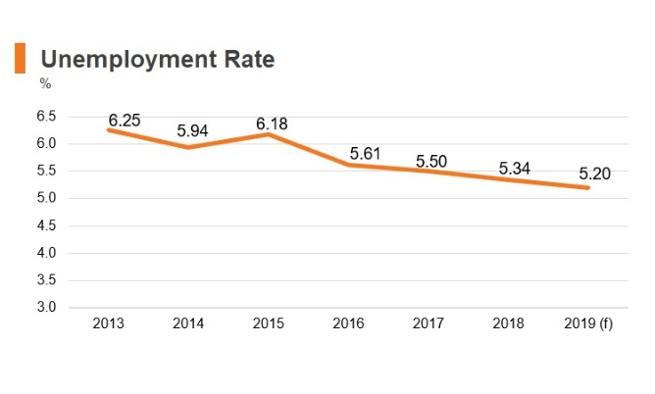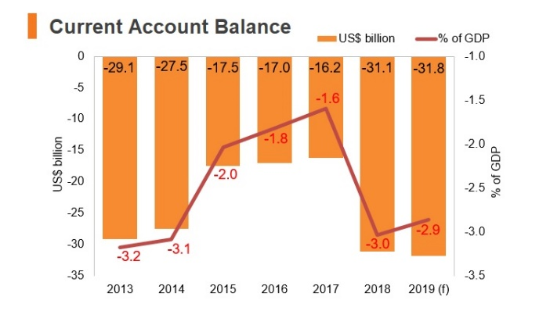
f = forecast
Sources: IMF, World Bank (November, 2019)

Investment Policy- Foreign Direct Investment of Indonesia
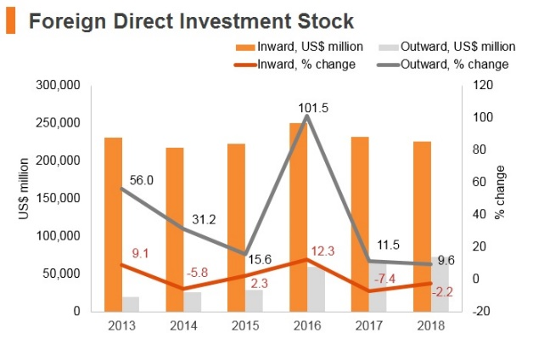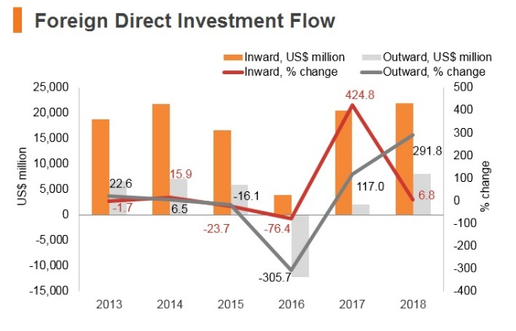
Source: UNTCAD
Date last reviewed: November 6, 2019
Since 2014, the Indonesian government has promoted policies and initiatives to encourage foreign direct investment (FDI), particularly those that can help in developing the country's economy, infrastructure and skill base. The Foreign Investment Law regulates FDI in the country by granting licensing procedures principally controlled by the Indonesia Investment Coordinating Board (BKPM). The government encourages FDI by offering a number of fiscal and non-fiscal incentives, including tax holidays, tax allowances, and the exemption of import duties for capital goods and raw materials required for investment. However, the economy remains significantly closed to foreign investment as a result of the multitude of barriers which exist for foreign investors. In order to conduct business in Indonesia, foreign investors must be incorporated as a foreign-owned limited liability company in Indonesia. Investors are also required to participate in the Workers Social Security Programme. Various incentives are offered to companies which are located in bonded zones throughout the country, the largest of which is based on the island of Batam, south of Singapore. These include acceptance of 100% foreign ownership; exemption from import duties, income tax, VAT and sales tax; and fewer required permits and licences. Indonesia also has several special economic zones and industrial zones although development is sometimes limited. These provide further incentives for foreign investment. (Sources: WTO – Trade Policy Review, ITA, US Department of Commerce, Fitch Solutions)

3.2 Sociological setting
Indonesian (Bahasa) is the official language of Indonesia and is the widely spoken language across the country. Javanese is also spoken throughout Java Island and some provinces in Sumatra and Kalimantan Island. Although it is possible to conduct business in English but some understanding of local languages is better for developing business relationships in Indonesia. Hierarchy in business is respected in Indonesian culture as Chinese culture which is very different as in the United States and Western Europe.
Indonesia has a population of approximately 261 million people. It’s a young country, with 41 percent of the population age 24 or younger, and 42 percent between ages 25 to 54. The population is split fairly evenly, with only 3 million more males than females. Of the total population, 55 percent live in urban areas and 45 percent live in rural environments. The western islands are home to 80 percent of the population; the most populous are Java, Sumatra, Suawesi, and Kalimantan. Java and Sumatra are the main economic hubs for Indonesia, and there’s a significant gap in health, wealth, and employment between these heavily populated islands and rural areas like Papua or Maluka. This ongoing economic inequality affects the economy and social structures of the country.
Indonesia has the fourth-largest education system, with 55 million students and more than 236,000 schools in 500 districts but the quality of the schools is low. Only 25% of the students can meet the minimum international standards in literacy and numeracy. Teacher shortages and repeated cheating scandals are the other problems. Education in Indonesia is mandatory for twelve years, and parents can choose between state-run public schools supervised by Ministry of Education and Culture, or private religious (usually Islamic) schools supervised and financed by the Department of Religious Affairs. In 2014, President Joko Widodo launched an Indonesia Smart Card program that provides for students’ educational needs and guarantees 12 years of free education. The cards also guarantee free higher education for poor students who pass the university entrance exams. It remains to be seen how much of an improvement this effort will have on Indonesia’s educational system.
While the constitution stipulates religious freedom, the government officially recognises only six religions: Islam, Protestantism, Roman Catholicism, Hinduism, Buddhism, and Confucianism; with indigenous religions only partly acknowledged. Indonesia is the world's most populous Muslim-majority country with 227 million adherents in 2017, with the majority being Sunnis (99%). The Shias and Ahmadis respectively constitute 1% (1–3 million) and 0.2% (200,000–400,000) of the Muslim population. Almost 10% of Indonesians are Christians, while the rest are Hindus, Buddhists, and others. Most Hindus are Balinese, and most Buddhists are Chinese Indonesians.
There are rigorous prerequisites in terms of labour force and supply-chain partners in a wide variety of sectors in Indonesia. This makes it much harder and more expensive, and presents higher risks for businesses wishing to hire foreign workers. Given the low levels of skills present in the Indonesian labour market, which makes the hiring of foreign workers for highly and technically skilled positions a necessity in many cases, this is a significantly risk for business operation. A company can hire foreigners only for positions which the government has deemed open to non-Indonesians. Employers must have training programmes aimed at replacing foreign workers with Indonesians. The foreign worker must meet education, work experience and Indonesian language requirements and commit to the transfer of knowledge to an Indonesian counterpart. Staying in Indonesia for work purposes for a long period (more than five weeks) requires the approval of the immigration office in Indonesia. Foreign workers must have the necessary visa and work and stay permits, all of which can be applied for at the immigration office by a sponsor or counterpart in Indonesia. Foreigners can only be issued with limited or temporary resident visas for a maximum period of 12 months, with the possibility of extension; this is again subject to approval from the immigration office. The process of obtaining a visa and work permit for foreigners in Indonesia is lengthy, taking an average of three months. It is also a bureaucratically complex process. The temporary resident visa can only be obtained if the applicant has a sponsor or counterpart in Indonesia to help them obtain the visa by applying to the immigration office. Indonesia has a significant tourism industry, there are many countries (such as those in the EU and those party to the Asia-Pacific Economic Cooperation Agreement) whose citizens can obtain visas on arrival in order to enter Indonesia for a period of 30-60 days. (Sources: Government websites, Fitch Solutions)
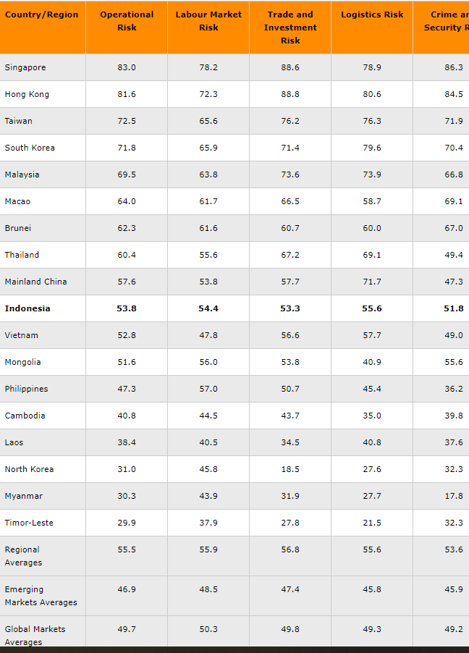
100 = Lowest risk, 0 = Highest risk
Source: Fitch Solutions Operational Risk Index
Date last reviewed: November 7, 2019
Research findings: as per operational risks provided by Fitch, it is easily observed that Indonesian has the best rating amongst the emerging markets as well as the global market averages.
4 Analysis and discussion

SWOT Analysis – introduction and application
STRENGTH  Build | OPPORTUNITIES  Invest
WEAKNESS  Shore Up | THREATS  Monitor / Watch
INTERNAL Factors  - Executive, Board of Directors  - Employees  - Customers  - KPI’s | External Factors  - Mega Trends  - Industry  - Market  - Competitors

We then gather and obtain the information from the research findings regarding the above items and factor into the following tables. (Mike Morrison, 2016)

STRENGTH  - Strong branding in the Hong Kong  - Capability of introduction for famous international brands to the market  - Good client servicing model  - Already demonstrated success business model which makes them one of the business leaders on cosmetic goods in HK -see the accomplishment of the group (company background).  - BONJOUR online stores - E-Trading Platform following the global trends.  - Strong Human Resource Management – all frontline staff are well-trained with professional beauty knowledge and customer service skills. | OPPORTUNITIES  - Strong and growing economics in the recent years  - A consumer market of more than 250 million potential customers, a growing middle class, increasing local income  - Foreign Direct Investment Policy including tax exemption, Free trade zone & etc.  - Most Indonesians prefer imports more than the domestic products  - Hierarchy in business and culture should be respected which is similar to Hong Kong i.e. Chinese society.
WEAKNESS  - No local expertise in Indonesia – need to have an optimal workforce  - Weak annual result, may need to raise additional capital for the expansion  - The capability of the company to run an overseas operation as they have only local HK retail shops and branches in Macau and Guangzhou (China). | THREATS  - Keen competition from already existing market players and fake products.  - Languages barrier  - Can’t produce Halal cosmetics (the Muslim scripture) as this is well protected by the government policy and almost half of the women are Muslim.  - Labour Unrest - cheap labour advantage is fading  - Inequality – the huge gap of rich and poor  - Inflation – high inflation rate brings poverty

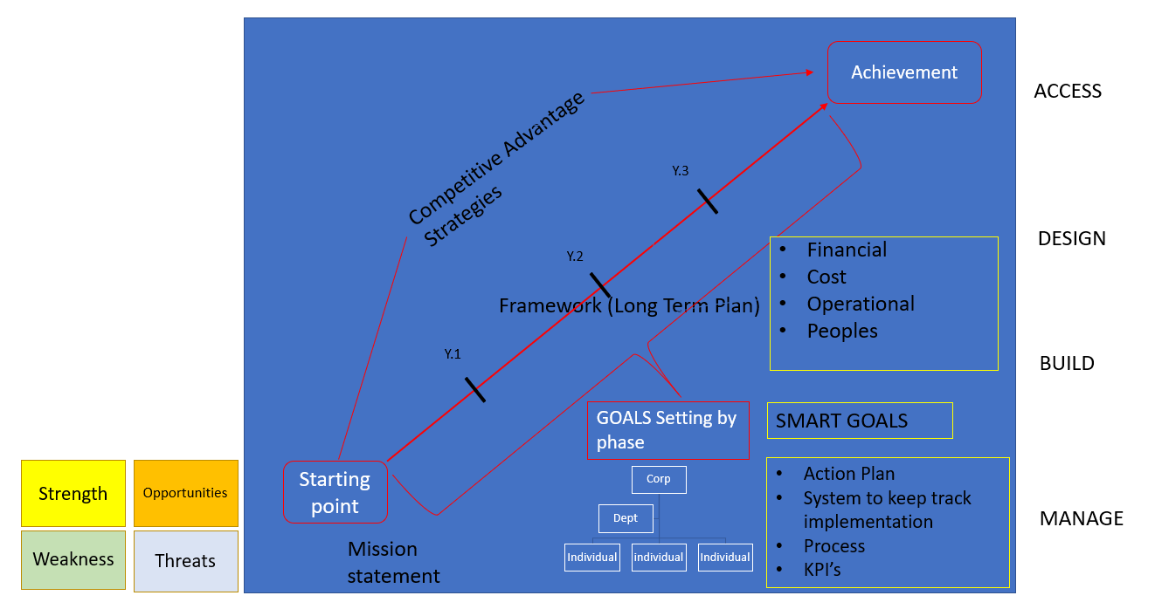
Overview of Strategic Plan Building for BONJOUR to enter into Indonesian Market
The above diagram illustrates the steps process to develop the strategic planning for BONJOUR to enter to Indonesia Market.
From A to B, the Starting point to Achievement after the result drilled from the SWOT Analysis and develop the Competitive Advantages Strategies (how we can success, the guidelines) for the company. The mission statement is to be created in the starting stage say “To have certain market share in the Indonesia markets on Cosmetics & Personal Care products in the next 4 years’ of time span”.
The whole process – Assess, Design, Build and Manage. The first step is to assess the risk by SWOT analysis. The second step is to design the strategy, starting with mission statement according to the SWOT analysis as stated the last session. The third step is casting the future and tells us where we want to go. Building the framework covering Financial, Customer, Operational and People prospective. The fourth step is to building the plan with SMART corporate goals, a great acronym to make sure you have good, quantifiable, outcome-based goals. Specific, Measurable, Attainable, Realistic and Time-Bound i.e. the milestones. The fifth steps is to formulate action Plan and castling to different level, department and then individual with KPIs. The last step is to managing the execution, make sure each and every individual’s action plan – ownership, accountability by when. A system is to develop to track and manage performance.
Strategic Action Plans – according to the SWOT analysis as above and establish the following action plans table
Short term Action Plans | Long term Action Plans
To employ a local consultancy to understand the Foreign Direct Investment Policy for the entry of Indonesian market on the Cosmetics & Personal Care products and most important ascertain the needs of the Indonesian customers. | To train and retain local expertise to run this branch in Indonesia. The head office in Hong Kong supplement, support and monitor the branch.
To raise fund by issuing new share or debenture bond in HK stock market. | To set up shops & beauty salons in Sumatra, Suawesi, and Kalimantan.
Sending experienced operational and frontline staff to Indonesia to kick off the first shop. This is to copy their successful business model in Hong Kong to provide excellence customer services in the shop with good location in Jakarta (Java) to earn the reputation. | To establish a user-friendly online shopping platform to be launched in Indonesia for providing the good mixed and quality products as mentioned above.
To undergo the global research & purchase for good and qualitive products that are not available in the current Indonesia markets. | BONJOUR needs to find local partner to produce Halal certified products.

5 Conclusion and recommendations

Based on the findings of the research on the Company profile, Indonesia’s Cosmetics Industry and the potential of the Indonesia’s growing economy in the forthcoming years.

With the SWOT analysis method and the research findings, the result has been derived and conclusions are drawn. Firstly, BONJOUR can utilize its strength in the following areas: very strategic shop location, quality services and professional advices of the frontline staff, good variety of products not available in Indonesia, online purchase platform and good branding in Hong Kong. Secondly, it must address its weakness in the following areas：lacking of local expertise, additional capital & resources to build the infrastructure, facilities which can be overcome. Thirdly, BONJOUR can explore numerous opportunities, including good market growth, customer loyalty, familiar Chinese culture and government policy on foreign direct investment. Fourthly, the threats include increasingly fierce competition, challenge of the market entry and can’t produce halal cosmetic products.

On the basis of the SWOT analysis, the business strategies and company structure are formulated as shown in the section 4. With the proper implementation to overcome the weakness and threats, BONJOUR should able to apply their experience and expertise to develop profitable business in Indonesia given the potential and opportunities identified.

References

Baye, Michael R. and Prine Jeffrey T. (2017) Managerial Economics and Business Strategy. 9th edition. McGraw-Hill/Irwin.

International Monetary Fund. Asia and Pacific Dept. (2019) Indonesia : 2019 Article IV Consultation-Press Release; Staff Report; and Statement by the Executive Director for Indonesia. IMF Country Report No. 19/250. Available at https://www.imf.org/en/Publications/CR/Issues/2019/07/30/Indonesia-2019-Article-IV-Consultation-Press-Release-Staff-Report-and-Statement-by-the-48535

Xu, M., David, J. M., & Kim, S. H. (2018). The fourth industrial revolution: opportunities and challenges. International journal of financial research, 9(2), 90-95.

Farjartriyani, A.P., Raharja, S.J. and DAI, R.M., 2020. Competitive Strategies of Indonesian Skincare Clinics: Study on Rafa Health and Beauty Lifestyle, Bandung, Indonesia. Review of Integrative Business and Economics Research, 9, pp. 80-87.

Rivani, Raharja, S.J. and Arifianti, R., 2018. SWOT Analysis on the Export-oriented Ceramic Industry Centre in Purwakarta, Indonesia. Review of Integrative Business and Economics Research, 7, pp. 189-199.

Herliana , S., Lawiyah, N. and Aina , Q., 2018. SWOT Analysis Approach on SME'S Entrepreneurial Competency. Academy of Entrepreneurship Journal, 24(2), pp. 1-6.

Maulina, E. and Raharja, S.J., 2018. SWOT Analysis for Business Strategies: A Case of Virage Awi in the Bamboo Craft Industries, Bandung, Indonesia. Review of Integrative Business and Economics Research, 7, pp. 213-224.

Tannoury, M., & Attieh, Z. (2017). The influence of emerging markets on the pharmaceutical industry. Current Therapeutic Research, 86, 19-22.

Hong Kong Trade Development Council, 2019. HKTDC Research on Emerging markets in Asia. Indonesia, 3 Dec. 2019. http://emerging-markets-research.hktdc.com/business-news/article/Asia/Indonesia-Market-Profile/mp/en/1/1X000000/1X00107T.htm (accessed February 2020)

Dewi, F.A., 2019. Indonesia's Regional Foreign Policy After the 2019 Election. Asia Policy, 14(4), pp. 72-78.

Rasiah, R., Latifah, M.C., Cheong, K.C. and Norman, V.L., 2019. Introduction:
Global Business Guide, Overview of Indonesian Cosmetic Sector: Growing Domestic and Export markets, 2016
http://www.gbgindonesia.com/en/manufacturing/article/2016/overview_of_indonesian_cosmetic_sector_growing_domestic_and_export_markets_11593.php

Global Business Guide, Indonesia’s Cosmetic Industry: The Rise of Halal Cosmetics, 2018
http://www.gbgindonesia.com/en/manufacturing/article/2018/indonesia_s_cosmetics_industry_the_rise_of_halal_cosmetics_11842.php

Rangkuti, Freddy. 2000. Analisis SWOT Teknik Membedah Kasus Bisnis. Jakarta: Gramedia Pustaka.

Mike Morrison, 2016. SWOT analysis (TOWS matrix) Made Simple
https://rapidbi.com/swotanalysis/

