Analysis of results

This chapter will analyse data collected via the questionnaire which examined the effects of trauma exposure on police constables. This section will also include sub-sections explaining data preparation, data analysis techniques, results and discussion of findings. A questionnaire was utilised due to its ease and accessibility which allows it to be shared to many people. This method also allows the researcher to collect results promptly and its cost-effective. A questionnaire was produced and published via SmartSurvey (Smart survey, 2020) with the aim of collecting 100 responses. However, the questionnaire generated 66 responses conclusively, a potential discrepancy of the overall study. This section will also include sub-sections explaining data preparation, data analysis techniques, results and discussion of findings.
The results and analysis of these findings will allow for conclusions to be drawn based on the initial aims and objectives. The aim of the study is to identify how many police officers experience mental vulnerabilities due to trauma exposure and how effective alternative therapies can be to improve mental wellbeing.

Data Preparation
To produce clean data, the raw data that is initially collected must be analysed using data preparation. This means the researcher must rectify any errors, refine the data used to ensure comprehensive results and therefore, accurate conclusions. The questionnaire utilised in this research collated some partial responses because of participants not completing the entirety of the survey. A total of 12 participants completed the questionnaire partially and to produce clean and comprehensive findings, these partial responses must be discounted. This will exclude any disparity and confusion about findings. The website used to collect the data also produces graphs to adequately display the data, allowing for the reader to easily understand the results of the study.

Data Analysis
This study consists of quantitative questions and to analyse this data the researcher has utilised both descriptive statistics. This means analysing the data by presenting it in a factual way, often using graphs or charts. This method allows conclusions to be drawn on known data whilst also providing visual aids to readers (Xu, 2021). This method was chosen due to its ability to present findings accurately and simply, using graphs and tables. It also allows the researcher to provide findings and reach conclusions based on the responses. The overall goal of the research is to identify the impact of trauma exposure on police officers and to establish the effectiveness of current trauma therapies. By using descriptive statistics, these aims, objectives and overall goal of the research can be achieved.

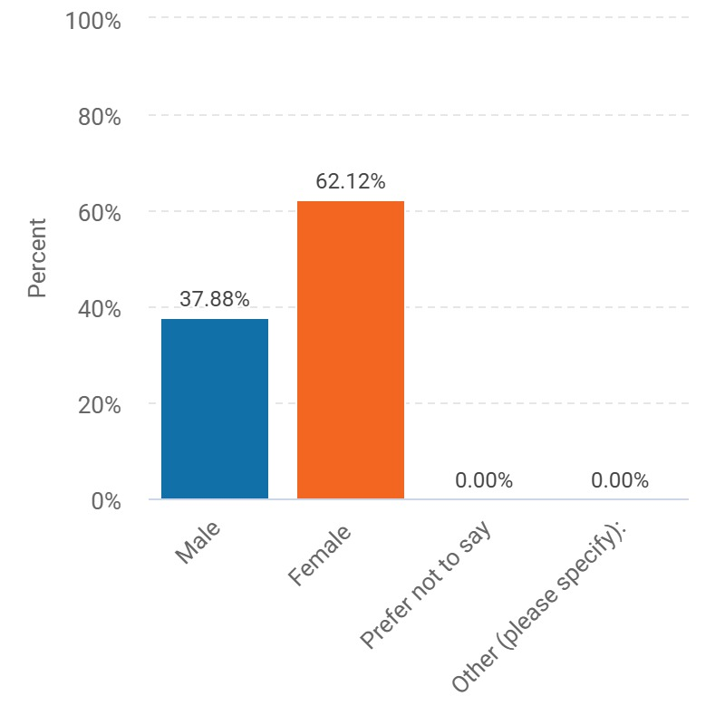
Results

Figure 1. A graphical representation of the gender of police officers who responded to the questionnaire.
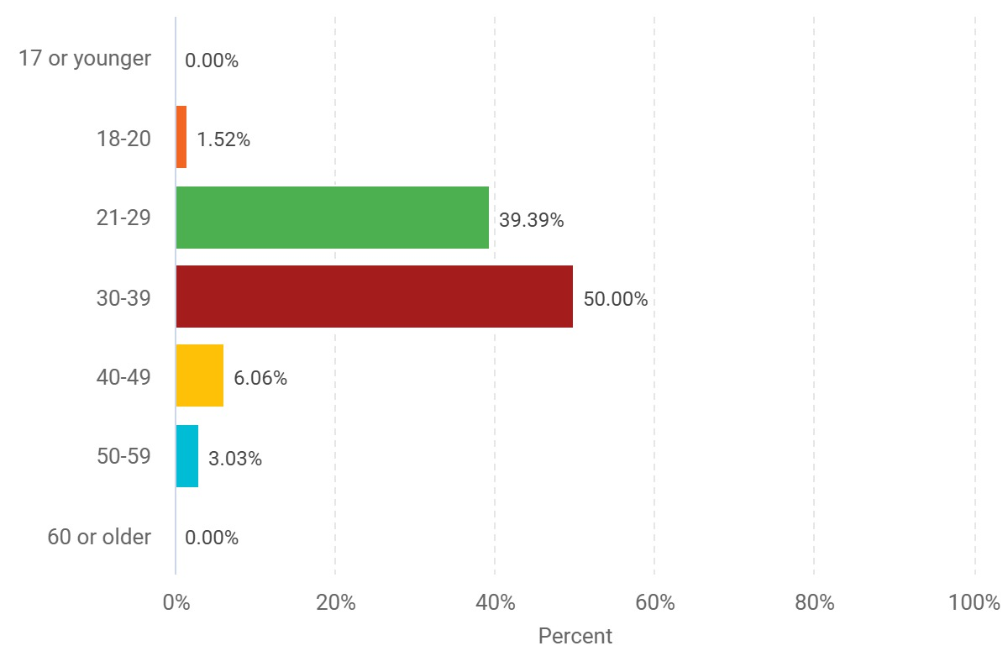

Figure 2. A graphical representation of the age groups of respondents.
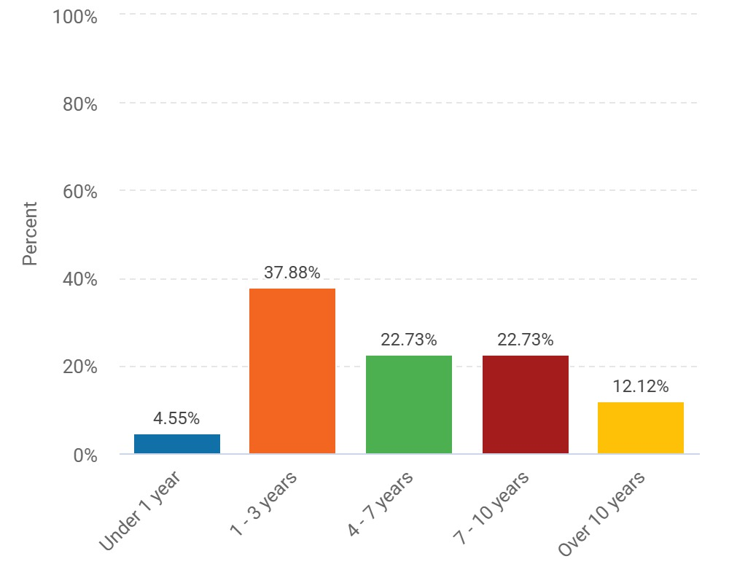

Figure 3. A graphical representation of years of service of respondents.
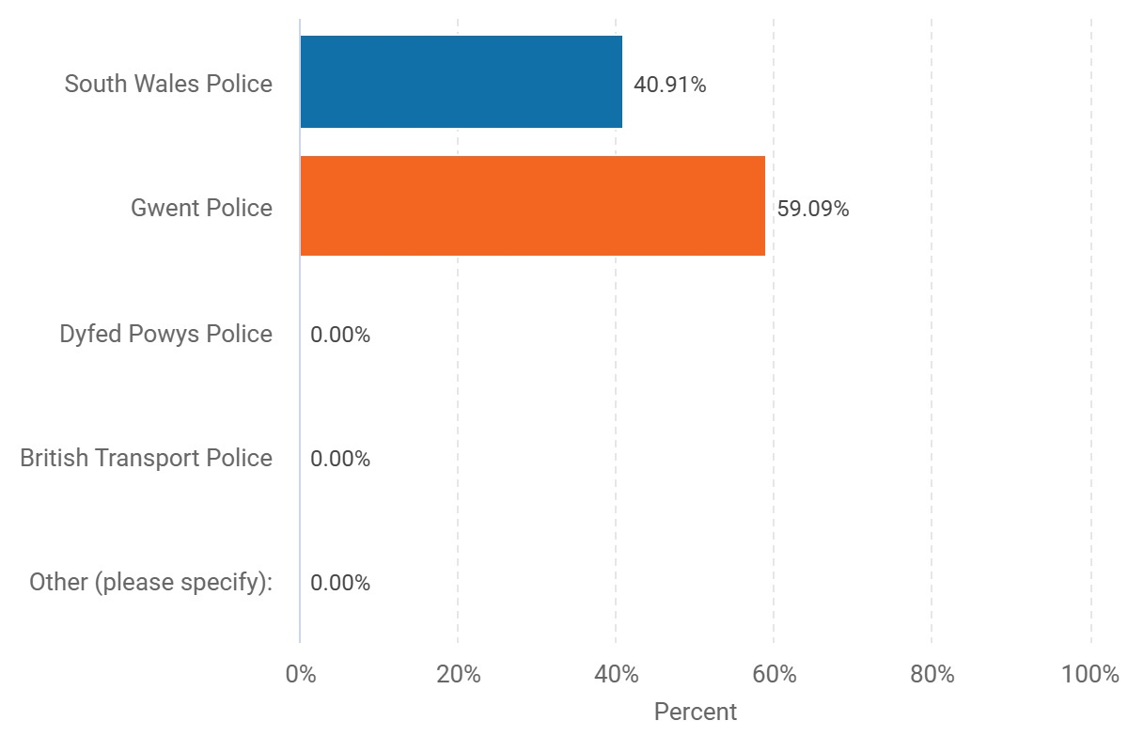

Figure 4. A graphical representation of the different police forces represented by respondents.
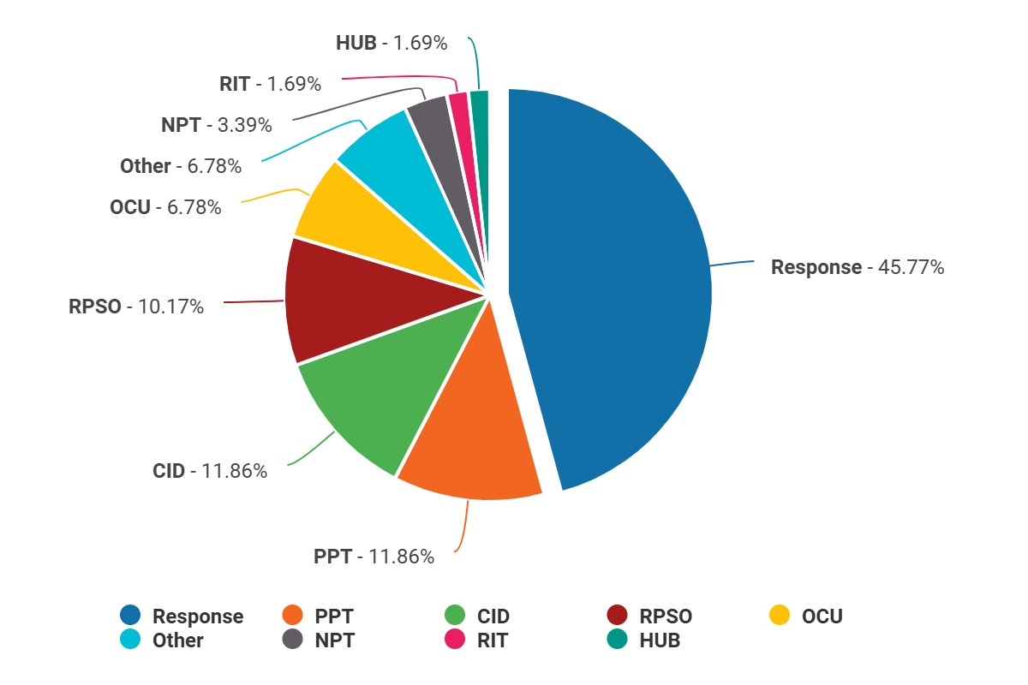

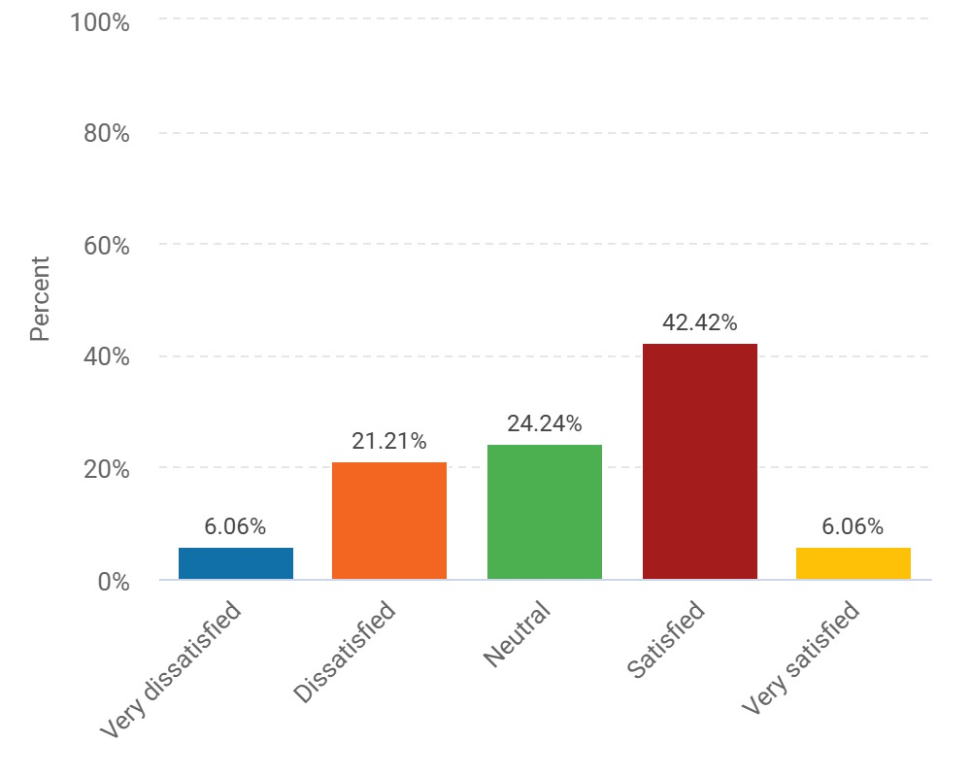
Figure 5. A graphical representation of the variety of departments represented by respondents.

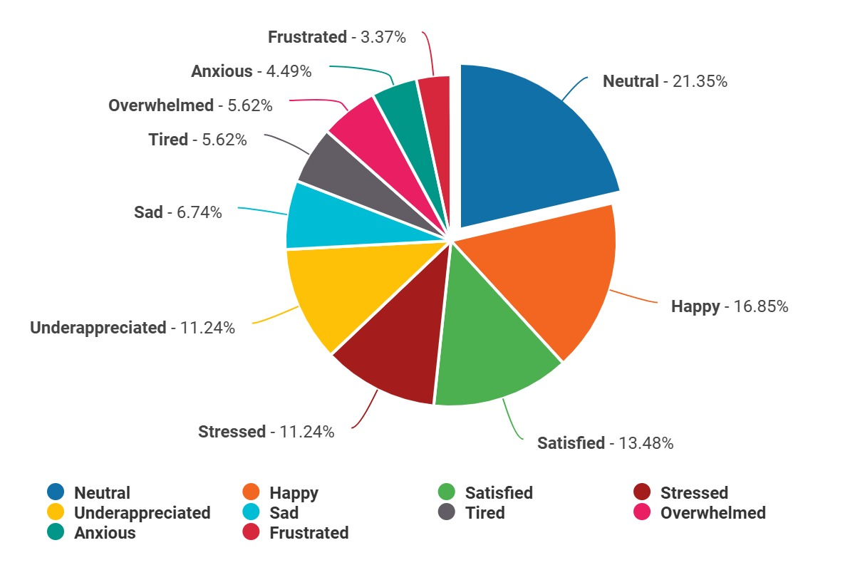
Figure 6. A graphical representation of the satisfaction levels felt by respondents at work.

Figure 7. A graphical representation of the emotions felt by respondents at work.
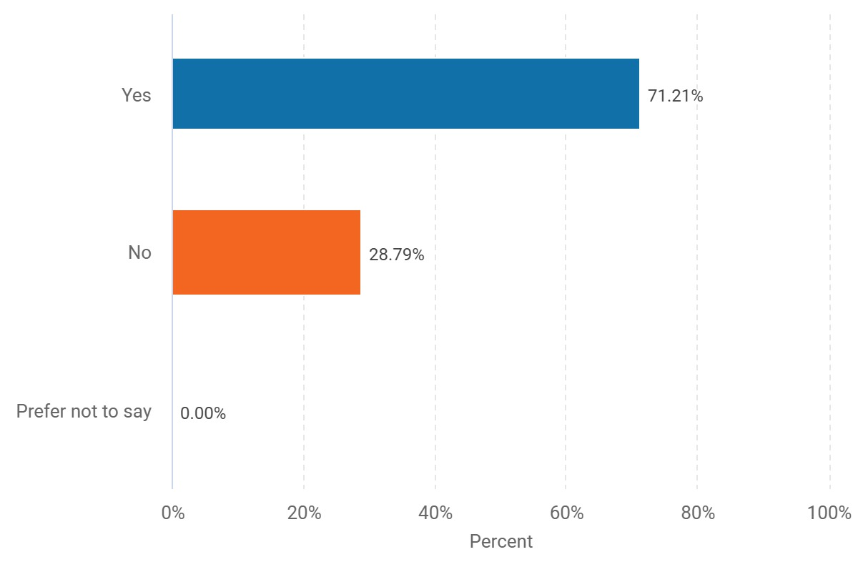

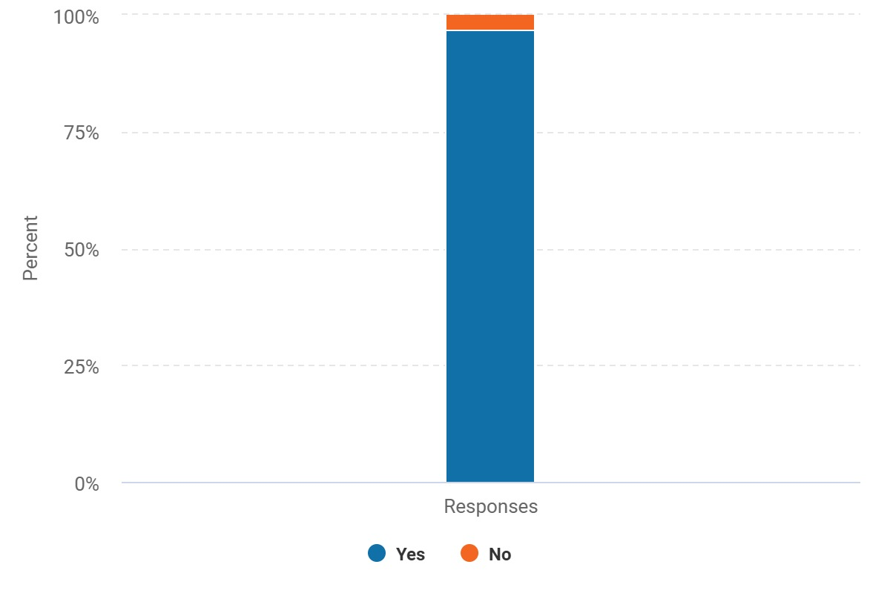
Figure 8. A graphical representation of whether respondents mental health has been affected since being a police officer.

Figure 9. A graphical representation of whether respondents have experienced trauma at work.
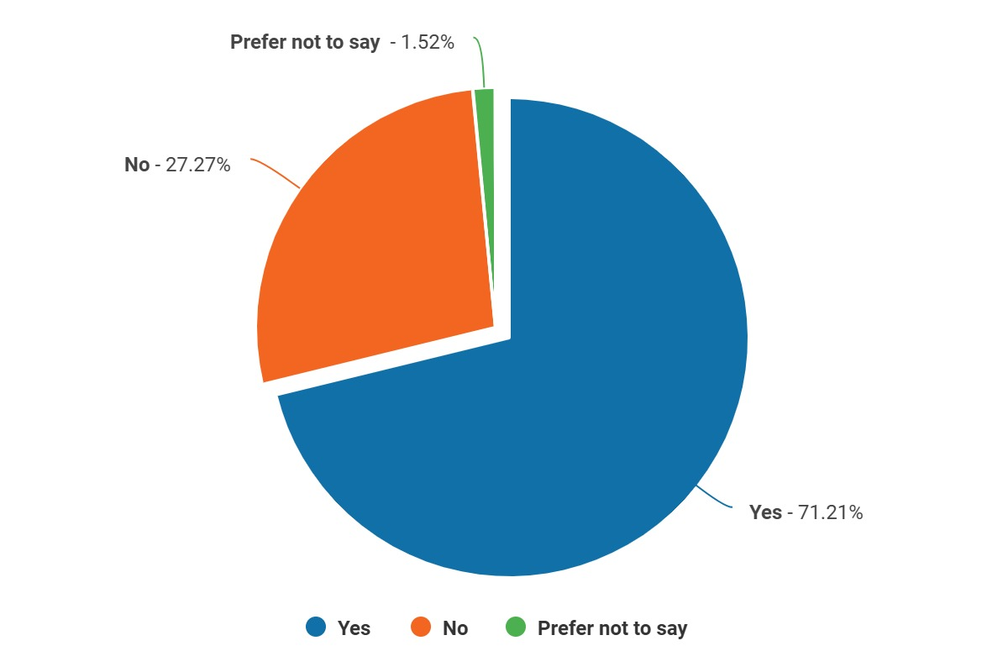

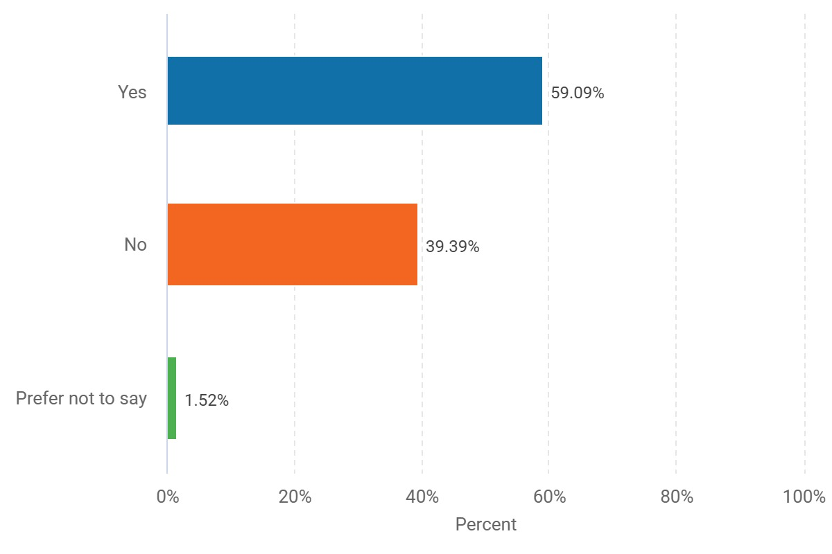
Figure 10. A graphical representation of whether these traumatic experiences have affected respondents.

Figure 11. A graphical representation of whether these traumatic experiences have affected officers outside of work.
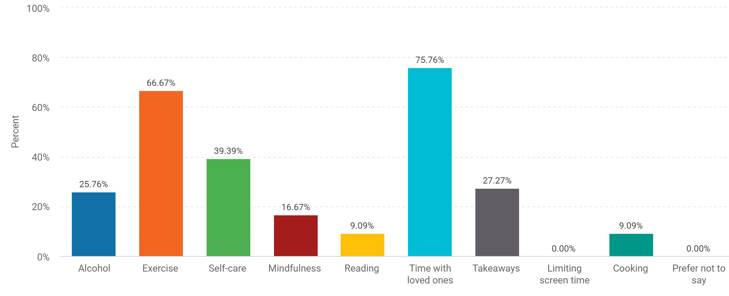

Figure 12. A graphical representation of the different types of coping mechanisms used by respondents.
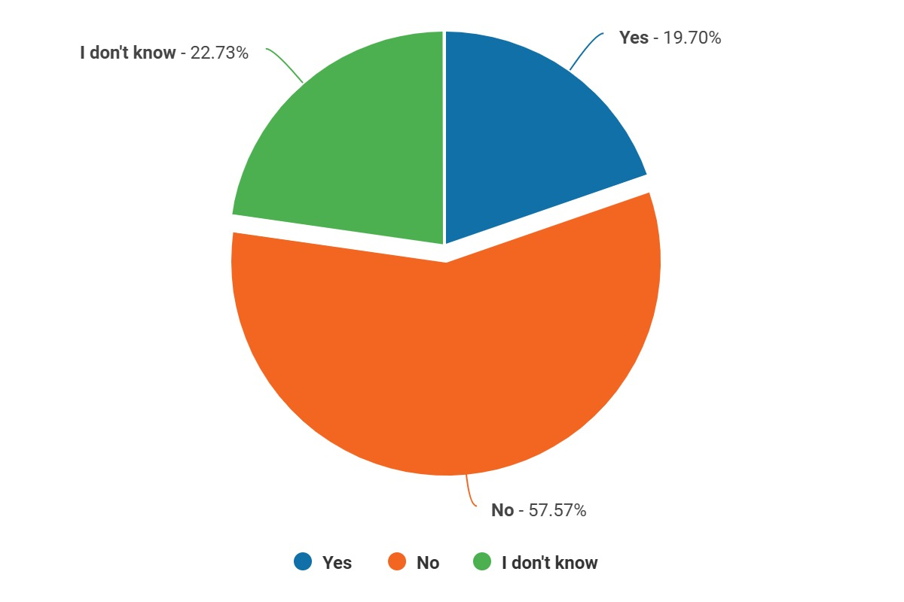

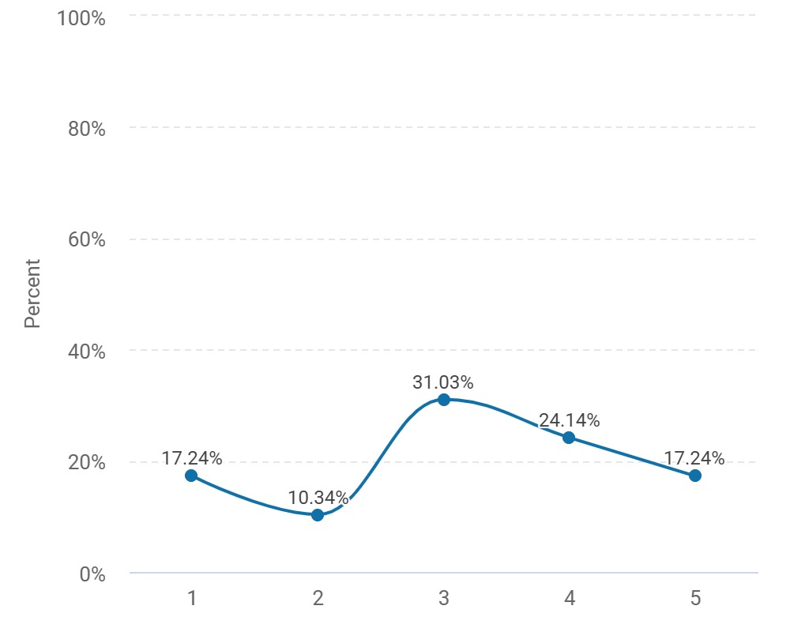
Figure 13. A graphical representation of whether there is adequate support for those suffering from trauma.

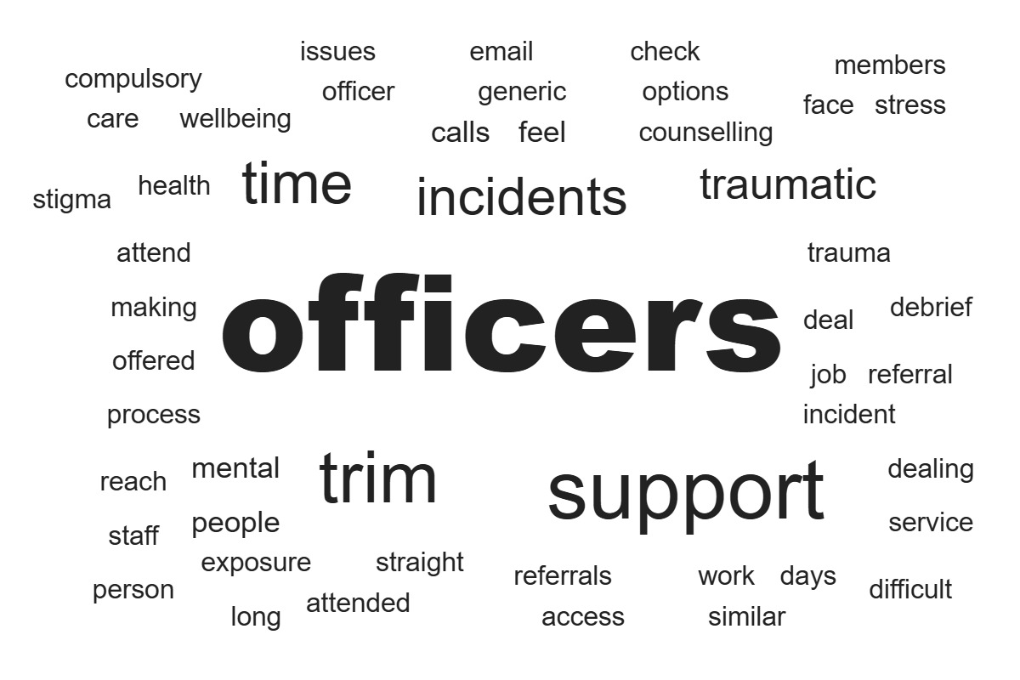
Figure 14. A graphical representation showing how beneficial respondents found the TRiM process (max.5 stars).

Figure 15. A graphical representation of how respondents believe organisations could better support officers suffering from trauma exposure.

Discussion of findings
This section of the chapter will be dedicated to discussing responses received back from the questionnaire. Of the 66 participants, more females (62.12%) answered the survey compared to males (37.88%). Most participants were also between the ages of 30-39 years old (50%) closely followed by 21-29 years old (39.39%). Similarly, most participants had 1 – 3 years’ service as a police officer (37.88%) with only 12.12% having over 10 years’ service. Interestingly, this corroborates the trend relating to a younger workforce within policing and the lack of more senior and experienced constables (Williams and Sondhi, 2022).
Perhaps a downfall in the questionnaire is the lack of responses from more than two police forces, most responses came from Gwent Police officers (59.09%) with South Wales Police officers (40.91%) following closely behind. There were no responses from the other two forces, Dyfed Powys Police or British Transport Police. The lack of variety could potentially hinder conclusions drawn based on this research. Most responses came from officers who are on response (45.76%) followed by officers on CID and PPT (11.86%). Positively, this questionnaire includes responses from officers from nine different departments. This allows a variety of perspectives to be included in the findings.
Participants were asked how satisfied they are in their current roles and interestingly 42.42% of respondents stated they were satisfied. However, this was followed by participants feeling neutral about their role (24.24%). Moreover, only 6.06% of respondents stated they were very satisfied, and the same percentile answered that they were very dissatisfied. According to other literature, this corroborates the trend that police officers often feel overwhelmed and overlooked whilst at work (Edwards and Kotera, 2020). Moreover, most respondents reported that they felt neutral feelings whilst at work (22.83%). Concerningly, 11.96% reported feeling stressed at work and 10.87% feel unappreciated. Sadness (6.52%), anxiety (4.35%) and tiredness (5.43%) were also reported however, these percentages were lower than initially expected. Interestingly, 16.30% reported feeling happy whilst at work.
Participants were asked if they feel their mental health has been affected since becoming a police officer and concerningly, 71.21% answered yes. These statistics are worrying and show a direct link between policing and the decline of mental wellbeing (Regehr et al., 2019). Additionally, participants were also asked if they had ever experienced traumatic experiences in work. An overwhelming statistic of 96.97% answered yes and 71.21% admitted that these traumatic experiences have affected them. This shows a clear correlation between traumatic experiences in policing and its detrimental effects on officers.
Positively, 66.67% of participants stated they use exercise and 39.39% use self-care to deal with trauma at work and time with loved ones was also popular with 75.76%. This emphasises positive coping mechanisms exhibited by many officers (Modula et al., 2024). Other unhealthy coping mechanisms were also selected with 27.27% admitting to eating takeaways and 25.76% using alcohol to cope. Demonstrating a range of coping strategies are used by officers. The unhealthy habits do corroborate previous research surrounding the correlation between stress in policing, unhealthy coping mechanisms and more physical/mental health (Galbraith et al., 2020).
Concerningly, 57.58% of respondents stated they do not feel there is adequate support for those struggling with trauma in work. This corroborates the hypothesis that there is not enough support for officers suffering from traumatic experiences and the psychological effects of trauma exposure on officers is monumental.
Participants were asked to rate the trauma risk management system utilised by police forces to help officers with the effects of trauma. Most respondents rated this system 3 out of 5 stars (31.03%). However, 17.24% persons rated TRiM referrals with 1 out of 5 stars but the same percentile rated the system 5 out of 5 stars. This shows mixed perspectives surrounding TRiM referrals and their effectiveness.
Lastly, respondents were asked how organisations could better support officers with trauma exposure. Most participants stated that de-briefs need to be a compulsory part of the aftermath of trauma exposure (Civilotti et al., 2021). Another common theme was further education and a better understanding from senior management about trauma, its effects and further support for officers (Collazo, 2020). Interestingly, officers also reported that TRiM referrals are not adequate and the ‘generic’ emails that are sent following these experiences are not adequate, and many officers do not feel individually supported (Phung et al., 2022). Moreover, low staffing levels also contributes to the lack of support and officers who are struggling often going over-looked (Cartwright and Roach, 2020). Overall, there was a clear theme to the answers in this question, there needs to be more variety and easier access to mental health services and trauma support.
1405 words.

References
Smart survey (2020). SmartSurvey. [online] Smartsurvey.co.uk. Available at: https://www.smartsurvey.co.uk/.
Xu, M. (2021). Understanding Graph Embedding Methods and Their Applications. SIAM Review, 63(4), pp.825–853. doi:https://doi.org/10.1137/20m1386062.
Williams, E. and Sondhi, A. (2022). A Narrative Review of the Literature on the Recruitment of Younger Police Officers in Age and in Service: What Are the Implications for the Police in England and Wales? Policing: A Journal Of Policy And Practice, 16(4). doi:https://doi.org/10.1093/police/paac001.
Edwards, A.-M. and Kotera, Y. (2020). Mental Health in the UK Police Force: a Qualitative Investigation into the Stigma with Mental Illness. International Journal of Mental Health and Addiction, [online] 19(4). Available at: https://link.springer.com/article/10.1007/s11469-019-00214-x.
Regehr, C., Carey, M.G., Wagner, S., Alden, L.E., Buys, N., Corneil, W., Fyfe, T., Matthews, L., Randall, C., White, M., Fraess-Phillips, A., Krutop, E., White, N. and Fleischmann, M. (2019). A systematic review of mental health symptoms in police officers following extreme traumatic exposures. Police Practice and Research, 22(1), pp.1–15. doi:https://doi.org/10.1080/15614263.2019.1689129.
Modula, M.J., Mathapo-Thobakgale, E.M., Nyoni, C.N. and Jansen, R. (2024). Strategies for Coping with Occupational Trauma: A Scoping Review of the Police Officer Context. International Journal of Environmental Research and Public Health, [online] 21(7), p.921. doi:https://doi.org/10.3390/ijerph21070921.
Galbraith, N., Boyda, D., McFeeters, D. and Galbraith, V. (2020). Patterns of occupational stress in police contact and dispatch personnel: implications for physical and psychological health. International Archives of Occupational and Environmental Health, 94(2), pp.231–241. doi:https://doi.org/10.1007/s00420-020-01562-1.
Civilotti, C., Di Fini, G. and Maran, D.A. (2021). Trauma and Coping Strategies in Police Officers: A Quantitative-Qualitative Pilot Study. International Journal of Environmental Research and Public Health, 18(3), p.982. doi:https://doi.org/10.3390/ijerph18030982.
Collazo, J. (2020). Adapting Trauma-Focused Cognitive Behavioral Therapy to Treat Complex Trauma in Police Officers. Clinical Social Work Journal, 50(2). doi:https://doi.org/10.1007/s10615-020-00770-z.
Phung, V.-H., Sanderson, K., Pritchard, G., Bell, F., Hird, K., Wankhade, P., Asghar, Z. and Siriwardena, N. (2022). The experiences and perceptions of wellbeing provision among English ambulance services staff: a multi-method qualitative study. BMC Health Services Research, [online] 22(1). doi:https://doi.org/10.1186/s12913-022-08729-1.
‌

‌

‌

‌

‌

‌

‌

