0550909 Ty Golding ~ Assessment Component 2

Moving between the Macro and Meso: In what ways do head teachers influence the implementation of Curriculum for Wales, in their schools?

Table of Contents
Chapter 1 | Introduction | 4
1.1 | Introduction to the research | 4
1.2 | Research purpose, questions, aims and objectives | 5
Chapter 2 | Literature Review | 7
2.1 | What is Curriculum for Wales? | 7
2.2 | Curriculum implementation, enactment or realisation? | 7
2.3 | Leading Change | 9
2.4 | Subsidiarity, Autonomy and Agency | 10
2.7 | Conclusion | 12
Chapter 3 | Research Design | 13
3.1 | Research Design | 13
3.2 | Epistemology and Ontology | 13
3.3 | Positionality and Reflexivity | 14
3.4 | Theoretical Framework | 17
Chapter 4 | Methodology | 18
4.1 | Case Study | 18
4.2 | Participants and Sampling | 19
4.3 | Data Collection Methods | 20
4.4 | Semi-Structured Interviews | 21
4.5 | Documentation Analysis | 21
4.6 | Ethical Considerations | 23
Chapter 5 | Data Analysis | 24
5.1 | Using Reflexive Thematic Analysis | 25
5.1.1 | Familiarisation | 25
5.1.2 | Coding | 27
5.1.3 | Generating Initial Themes | 30
5.1.4 | Developing and Reviewing Themes | 31
5.1.5 | Refining, Defining and Naming Themes | 33
5.2 | Analysis of Themes | 33
5.2.1 | Leading Change: all aboard, destination CfW | 33
5.2.2 | The Head Teacher: what do they do all day? | 34
5.2.3 | Professional Learning: from knowing to doing | 35
5.2.4 | Relationships & Networks: looking out, looking in | 36
Chapter 6 | Discussion and Implications for Future Research | 38
Chapter 7 | Limitations | 41
Chapter 8 | Recommendations | 42
 | References | 43
 | Appendices  APPENDIX A - Critical evaluation of research process  APPENDIX B - Participant Information  APPENDIX C - Interview Schedule  APPENDIX D - Research Questions, Interview Questions & Prompts  APPENDIX E - Application for Ethical Approval (Approved)  APPENDIX F - Participant Consent Form  APPENDIX G - Data Management Plan  APPENDIX H - Excerpts of codebook  APPENDIX I - Excerpts of reflexive journal | 52 - 94
List of Figures
Figure 1: | Excerpt from reflexive journal during interviews | 15
Figure 2. | Excerpt from reflective journal during thematic analysis of data | 16
Figure 3. | Sketch note following familiarisation and first pass of coding participant c data | 26
Figure 4. | Sketch note following familiarisation and first pass of coding participant d data | 27
Figure 5. | Questions used throughout the analysis process. | 28
Figure 6. | Example of using code labels to construct codes, during the inductive coding process | 29
Figure 7. | Example of compiling the data and refining the codes, using a codebook | 30
Figure 8. | Example of iterative and recursive development of themes | 31
Figure 9. | The codes and themes following the review process | 32
Figure 10. | Example from my thematic mapping process | 32
Figure 11. | Refined themes, sub themes and definitions | 33
List of Tables
Table 1: | Purposive sampling and interview timings | 20
Table 2: | Documentation analysis | 22

Chapter 1 Introduction

Educators in Wales, currently find themselves in a significantly shifting paradigm. This shift is defined by far reaching reforms that encompass Additional Learning Needs (ALN), assessment, qualifications, accountability and curriculum. Internationally, education reform is nothing new as we know that ‘national curricula are constantly changing’ (Sinnema, 2015, p. 965) and historically, Wales is no different. Whilst curriculum policy reform and the ensuing implications for schools are well studied topics, we could mistakenly assume that ‘the idea of implementation and of the factors affecting actual use seem simple enough, but the concept has proven to be exceedingly elusive’ (Fullan, 2000, p.66). A significant proportion of the knowledge base serves to highlight the challenges and solutions, when it comes to translating education policy into practice, particularly curriculum policy (Ball, Maguire & Braun, 2012; Priestley, Biesta & Robinson, 2012; Handelzalts, Nieveen & Van den Akker, 2019; Hill & Hupe, 2022; Humes, 2023). The traditional research lens focuses upon the mechanisms of and degree to which a top down ‘implemented curriculum’ must meet the ‘intended curriculum’; qualifying success through measuring ‘fidelity’ as both the extent to which curriculum is faithfully implemented and delivered through translation directly into classroom reality (Caroll et al, 2007; Prendergast and Treacy, 2017; Priestley et al, 2021). There is a well documented dissonance between the expectations of policy makers and the realities for practitioners, those in schools charged with rendering policy into practice, particularly in the context of education reform. Policy makers have a tendency to develop new policy direction in order to solve a problem or secure a particular national outcome, whilst practitioners all too often struggle with the implications of any such policy interpretation, enactment and accountability (Hadfield & Ainscow, 2018; Nyhamn & Hopfenbeck, 2014; Priestley, Biesta, Philippou & Robinson, 2015; Wollscheid, Stensaker & Bugge, 2019; Forde et al, 2022).

Fullan (2000), establishes that such tensions are an outcome of ‘critical factors’ which operate between the first and second steps of the ‘three broad phases of the change process’, these being, ‘phase 1 - initiation, phase 2 - implementation and phase 3 - continuation’(p.47). It is alongside this, that Cuban’s, (1993) proposition of the existence of multiple curricula serves well to further illuminate the challenges in moving between curriculum policy and curriculum practice. He argues that there is a difference between the ‘official curriculum’, that being prescribed, and the ‘taught curriculum’, that which is received (p.184), further elaborating that, although overlapping and interrelated, the official and the taught are in fact only two of four curricula within an education system - the official, the taught, the learned and the tested curricula. Therefore, it could be argued that there is great complexity when attempting to navigate not just longitudinally, throughout the phases of a reform change process, but also latitudinally, between the types of curricula that are being socially constructed as they move downward through the tiers of a system, from government to classroom. These complexities only begin ‘to explain what is often referred to as the implementation gap between policy intention and classroom practice’ (Humes and Priestley in Priestley et al, 2021, p.183). Ford et al (2022) compounds the complexity further still, in their assertion that any such implementation gap is due to the hierarchical, bureaucratic governance and accountability of policy implementation, resulting in consequences for the role of head teachers.

Research purpose, questions, aims and objectives
Purpose of the Research

The purpose of this research is to explore the ways in which head teachers influence curriculum implementation, in the context of Curriculum for Wales, in order to contribute to the knowledge base both in Wales and more widely. There is currently a knowledge gap when it comes to the realisation of CfW. As we find ourselves amidst a global pandemic and facing the statutory implementation date of September 2022 (Welsh Government 2019, p.2), there is a need to grow the curriculum knowledge base in Wales, broaden the debate regarding effective means of enacting Curriculum for Wales in the classroom. This research is an inductive exploration of the ways in which a head teacher intends to, and is perceived to, influence the implementation of CfW in their own school settings. It will initially seek to establish whether they perceive themselves, and are perceived by others, as influencing implementation or not. Supplementary to this, I will also be seeking to understand the ways in which that same head teacher makes use of the available national policy and guidance to enable during implementation.

Research Questions
Moving between the Macro and Meso: In what ways do head teachers influence the implementation of Curriculum for Wales, in their schools?
- a. Does the head teacher influence curriculum implementation?
b. In what ways does the head teacher influence curriculum implementation?
- In what ways are head teachers using national policy guidance and resources to support the local curriculum implementation?

Research Aims
This research aims to

- Establish if head teachers influence curriculum implementation
- Explore the ways, and extent to which, head teachers influence curriculum implementation
- Explore how head teachers use national policy guidance and resources roles to support curriculum implementation
- Offer an insight into how head teachers may be supported with curriculum implementation

Research Objectives
The objectives of this research are:
- Define the terms curriculum and implementation, in the context of CfW
- Identify and synthesise the existing body of knowledge regarding curriculum implementation and leadership of curriculum change
- Explore the perceptions of how head teachers influence curriculum change by undertaking qualitative research, through a case study. The case in this instance is CfW, more specifically, its implementation in one primary school.
- Analyse the data through the ontological and epistemological perspectives, contributing to the knowledge base and supporting implementation.
- Contribute to the body of knowledge and influence practice, in terms of curriculum implementation and leadership of curriculum change.

To understand the research area more deeply, the literature review critically examines empirical evidence and descriptive information, regarding curriculum implementation and school leadership. It articulates both the challenges and limitations found, offering background and reasoning for this study.

Chapter 2 Literature Review

What is Curriculum for Wales?
Curriculum for Wales is a purpose led curriculum. It is built upon four nationally prescribed, learner-centric purposes of education and a suite of ‘What Matters’ statements, which themselves determine the essential routes for learning. In combination, the four purposes and what matters determine the national ambition for all educated sixteen year olds in Wales. Through its organising structure, the curriculum aims to retain a breadth of learning for all learners from the age of three up until sixteen, whilst also providing increased flexibility for schools to provide the necessary depth of specialist learning.

This curriculum has been designed to allow schools greater scope for innovation, creativity and professional freedoms.

Consideration of balance between prescription and autonomy is central to the work of designing a national curriculum. Without sufficient prescription, learners’ curriculum entitlement cannot be assured. Without sufficient freedom, teacher agency and opportunities to operate as professionals with autonomy is put at risk.
(Sinnema, 2015, p. 30)

This goes beyond the simple delivery of a fully fledged product. This curriculum will in fact work at two levels:

- a national level framework
- school-level design and planning

(Welsh Government, 2019)

Curriculum: implementation, enactment or realisation
‘We have got to learn that the implementation period for complex social programs is not a brief interlude between a bright idea and opening the door for service’ (Williams, 1975, p. 531). It is important to note that despite the ubiquitous references to policy implementation, throughout the broad existing body of knowledge on curriculum reform (Gouedard, Pont & Huang, 2020; Nyhamn and Hopfenbeck, 2014; Priestley et al 2021; Priestley, Biesta, Philippou & Robinson, 2015; Viennet and Pont, 2017), the infrastructures, process and contexts of education systems vary greatly and there remains an absence of a universal definition. Curriculum reform is complex and it appears that the definition relies upon a number of key factors, most notable of which include: the scope of change; who initiates and who is involved in the change; alignment of practitioner philosophy with the curriculum product and desired outcomes; and the quality of professional learning (PL) available to enable the effective synthesis of policy and practice (Stenhouse, 1978; Elliott, 1994; Caroll et al 2007; Fullan, 2015; Castro Superfine, Marshall and Kelso, 2015; Harris and Jones, 2019; Gatley, 2020). For the purposes of this research, the following definition will provide the basis for establishing a common understanding of implementation:
Implementation consists of the processes of putting into practice an idea, program, or set of activities and structures new to the people attempting or expected to change. The change may be externally imposed or voluntarily sought: explicitly defined in detail in advance or developed and adapted incrementally through use; designed to be used uniformly or deliberately planned so that users can make modifications according to their perceptions of the needs of the situation.
(Fullan, 2016, p.67)

Whilst the majority of the knowledge base refers to implementation and enactment interchangeably. However, when it comes to CfW I prefer the term realisation, which is itself beginning to be used in research eg Aldous et al (2022). It better describes the intent behind the development of the national policy and legislation. It could be argued that the term realisation, is used in Wales’ reforms, to move understanding and behaviours beyond that which has traditionally been perceived as curriculum implementation. Moving away from implementation being seen as a simple enactment of a predetermined and complete policy product (Ball, Maguire and Braun, 2012; Hill & Hupe, 2022). However, it is this traditional perception of implementation that contrasts with the processes through which CfW was not only developed but aims to be embedded in daily classroom practice. Through the deliberate use of the term realisation, Wales’ curriculum reform attempts to articulate both the processes of co-construction in the design of the national framework and the need for practitioners to proactively engage. The intent, when it comes to CfW, is for such engagement to be through increased school level autonomy and localised professional agency. This is supported by Hairon, Chua and Neo, (2018), when they assert that successful curriculum design depends upon teachers’ abilities to innovate and develop a curriculum to meet local needs.

As such, the term implementation refers to the short term stages of local, school level planning, organising and setting up of the new curriculum - the early processes of familiarisation, putting into place and getting started. In the context of this research, if we use implementation to define where the system currently finds itself, in referencing the existing knowledge base and my own research questions. Whereas, I refer to realisation in an attempt to define the future national and local ambitions, the complexity of the necessary ongoing refinement, balancing the tolerances of national policy and necessary heterogeneity - a cyclical and iterative process of negotiating policy meaning and developing contextualised practices. Ball, Maguire and Braun (2012) point out the impossibility of attempting to produce a linear model from policy to implementation practices. Education policy to practice ‘involves negotiation, contestation and struggle between different groups’ (Ozga, 2000, p.2).

Leading Change
Where teachers are genuinely at the forefront of educational reform and co-constructing change, the net result can be both positive and empowering’ (Harris and Jones, 2019, p.123). However, ‘research into the enactment of change over the last decade tells a story of weak leadership and management by policy makers, schools leaders and teachers’. Where the shortcomings in curriculum implementation are due to ‘poor management of change by school leaders, teachers' lack of understanding of the changes, and weak teacher collaboration’. Successful implementation of change is dependent upon the ability of school leaders to create a two way dynamic where the change that is realised across their organisation is both built-upon and built-alongside the improvements made at the classroom level, Fullan (2016). ‘Such capacities and motivations are influenced by the direct experiences organisational members have with those in leadership’ (Leithwood and Jantzi, 2005, p.36).
However, there are a number of interrelated and recurring themes when it comes to the influential behaviours and effective actions of those who are involved in leading any organisational change. It can be strongly argued that effective leaders, in circumstances of change are: highly motivated; are self aware; have a clear vision and strategy; empower teachers through meaningful dialogue, networking and collaborative practices; provide high quality professional learning; have a focus upon developing pedagogy; and establish effective structures to support all learners (Avolio, Bass and Jung, 2019; Hargreaves & Fullan, 2012; Hargreaves & O’Connor, 2018; Leithwood, Harris and Hopkins, 2008; Welsh Government, 2017). If we were to consider these recurring leadership themes, in the context of Curriculum for Wales, school leaders face having to deliver on what could arguably be two wholly new concepts in their repertoire of leadership skills. Those being, the ability to effectively lead large-scale change and become leaders of curriculum design and development. It is this that Bendikson, Robinson and Hattie (2012), identify as instructional leaders and leaders of learning. For curriculum leadership to be successful, it requires sophisticated consideration to be given to content, progression, assessment and pedagogy, themes that are the very essence of learning and teaching. When it comes to leading change in education, of which curriculum implementation is only one element, there is already an exceptionally broad empirical base from which to draw (Elliott, 1994; Thijs and Akker, 2009; Sinnema, 2015; Lamb and Branson, 2015; Gouëdard, Pont and Huang, 2020). However, the crux will be leading curriculum design and development, this is why ‘curriculum leadership matters and why it deserves far greater research attention and prominence in school and system improvement discourse’ (Harris, Jones and Crick, 2020).
There past two decades have been witness to a significant rise in international curricula reform and thus implementation activity, which has set about to challenge the traditional orthodoxies of the top-down policy approaches and provide greater flexibilities for those within the system (Bediako, 2019; Humes, 2023; Nieveen and Kuiper, 2012; Prendergast and Treacy, 2017; Priestley and Drew, 2017; Sahlberg, 2006). Curriculum is increasingly deemed to be not only the concern of policymakers, but also the concern of practitioners based in schools, including school leaders and teachers’ where ‘schools are asked to address the challenges inherent in designing and implementing a local curriculum.’ As such, the efficacy of local curriculum will be determined by the quality of professional learning available and school level design will be ‘strongly impacted by the degree and nature of the autonomy in the national curriculum’ (Sinnema, 2015, p.966).
The design process of Curriculum for Wales was one that was anchored in the concept of co-construction, whereby national policy development involved school leaders, teachers, administrators and policy makers. Both the policy development process and subsequent enactment in schools, relies heavily upon the principle of subsidiarity - a recognition that those closest to the challenges, in our schools, are the ones best positioned to develop solutions (Blyth, 1993; Jover, 2002)

Subsidiarity, Autonomy and Agency
It is through understanding how subsidiarity has been applied, in the context of Curriculum for Wales, that we are then able to better appreciate the expectations placed upon school leaders and their teams, in not only contributing to the national agenda but also in translating that agenda into effective practice in their schools. In this way, subsidiarity and increased school autonomies, recognise that ‘too much steering does not create ownership or professional ownership by teachers’ (Kuiper, Nieveen and Berkvens, 2013, p. 139) and as such, it serves a ‘pivotal role in ensuring a strong ownership of policies and helping to bring about greater policy coherence’ (OECD, 2017, p. 20). Ultimately, ‘studies of the relationship between autonomy and student performance lend support for such autonomy and the flexibility afforded to practitioners for school-based curriculum design’ (Sinnema et al, 2020, p. 3).

Including headteachers and teachers in both the development of national policy and granting greater freedoms at a school level, attempts to address criticisms from the (OECD, 2017, p. 44) that previous failures were in part due to the profession not being ‘sufficiently engaged in the policy-making and implementation process’. It can be argued with good reason that there are three deliberate and interrelated motives for subsidiarity in Wales’ reforms. Individually and in combination, they demonstrate first hand Wales’ willingness to learn from their own previous reform journeys and that of others. Firstly, it works to win the hearts and minds of the workforce through a greater ownership of policies, resulting in greater coherence, (OECD, 2017). Secondly, it provides opportunities for head teachers to take greater ownership when implementing policies, avoiding passive compliance or over reliance on the centre. This is not dissimilar to Scotland’s ‘empowerment agenda’ and the national drive, post-implementation of Curriculum for Excellence (CfE), to enable greater autonomy for headteachers (Forde et al, 2022; Humes, 2023). Finally, and arguably the most important motive, it serves as the basis for empowering the profession through increased curriculum and professional autonomy. Those working in Wales’ schools know only too well that ‘too much steering does not create ownership or professional ownership by teachers’ (Kuiper, Nieveen and Berkvens, 2013, p. 139). Ultimately, any drive for professional autonomy and agency aims to improve the professional and thus the learner experience, as such ‘ studies of the relationship between autonomy and student performance lend support for such autonomy and the flexibility afforded to practitioners for school-based curriculum design’ (Sinnema et al, 2020, p. 3).

Unlike the previous pragmatic definition of subsidiarity, knowing what is meant and expected when there is reference to autonomy and agency, is not as straight-forward. Autonomy and agency have been used synonymously but is there a distinction that the education populace should be aware of and what does this mean for the realisation of the new curriculum? Defining and dividing autonomy and agency is no easy task. Whilst (Wermke and Salokangas, 2015) remind us that ‘the etymology of the concept derives from the Greek autonomos ‘having its own laws’. As such, the debates around the concept circulate around individuals’ or groups’ ability and capacity to self-rule. Priestley, arguably one of the most prolific contemporary voices on agency, still openly admits that the term is a ‘slippery’ one and warns ‘that autonomy does not necessarily equate to agency’ (Priestley, Biesta, Robinson, 2015, p. 19).

If this is the case, appreciation of school level autonomy need look no further than Fleming (1998, p. 20) to understand that ‘teacher autonomy is commonly used to describe the degree to which teachers make independent curriculum decisions, especially in the context of sweeping societal change and government policy initiatives’ and then to (Fullan and Hargreaves, 2016, p. 21) to learn ‘that the profession and those who connect to it should approach the next phase with a critical and appreciative edge... the critical part is about responding intelligently to the barrage.’ Important to note here that there is wider thinking that shows ‘while the discussion of school autonomy is often limited to the decentralisation from ‘central to site level… the impact of autonomy on student performance is still lacking.’ (Hanushek, Link, and Woessmann 2013; Gorard 2009; Grattan Institute Report 2013). In moving from the local to system level responsibilities, there is clarity for practitioners when Sinnema (2015, p.966) sets out that ‘those challenges are strongly impacted by the degree and nature of autonomy in the national curriculum’ and in the main the system responsibilities lie ‘in what a revised curriculum should emphasise: autonomy versus prescription; reduced versus expanded curriculum content; local versus national priorities; and knowledge versus competencies.’

Conclusion
Undoubtedly, the majority of the current body of knowledge and curriculum reform discourse, addresses implementation and leadership of curriculum change in other international or regional contexts. As ‘there are many continuing challenges in successfully implementing educational reform and turning policy into practice’ (Prendergast and Treacy, 2017, p.17), we must be cognizant of potential learning from other systems and open to the possibilities arising from identifying the coherence between implementation in different systems. In this way, we will enable more head teachers to be more effective decision makers in facing their own implementation challenges. As ‘education change is technically simple and socially complex’ (Fullan, 2016, p.67), there is a need for head teachers to become not only more knowledgeable regarding the mechanics of CfW but to also be able to make increasingly informed decisions required for successful implementation.

Chapter 3 Research Design

Research Design
Research design should be based upon a systematic and organised process and is used to service a multitude of purposes which include: solving specific problems; furthering understanding of what works and why; extending the knowledge base where little is currently known about phenomenon; establishing fresh insights into an area where there is already a significant body of knowledge; and providing a basis for improvement (Flick 2014; Gray 2018; Yin, 2018; Cohen, Manion and Morrison, 2018; Basu 2020). Gray (2018), continues to explain that research in the real world, education in the context of this study, presents many challenges, is layered with complexities and must be considered as something more than a simple pragmatic activity. As such, it is important that I clearly articulate how my research design allows for exploring the ways in which head teachers influence curriculum implementation.

Epistemology and Ontology
As the researcher, it is essential to recognise my own positionality and its relationship with my research. ‘For research practice, they inform: what is ideal; what is permissible; and what doesn’t make sense. (Braun and Clarke, 2022, p. 166). The researcher’s ontological assumptions and beliefs are highly likely to directly influence their epistemological positioning, which in turn influence research design, methodology and interpretation of findings (Crotty, 1998; Tight, 2017; Cohen, Manion and Morrison, 2018; Gray, 2018). I do not believe in a singular truth or an objective reality but in the existence of multiple realities. As an outcome of my relativist ontological perspective, this research was designed from an interpretivist epistemological standpoint. As a qualitative study, this research sits within the constructivist paradigm and seeks to specifically explore and interpret the multiple realities of head teacher roles and curriculum implementation.
Multiple realities are played out through social construction - the subjective interpretations of those experiences by the head teacher and each member of the team, where ‘interests shape multiple beliefs and values, as these beliefs and values are socially constructed’ (Cohen, Manion and Morrison 2018, p.33). ‘In fact, researchers continually find that teachers in the same building teach different versions of the same course’ (Cuban, 1993, p.184). We must therefore acknowledge that any reality is ‘always filtered through the lenses of language, gender, social class, race, and ethnicity’ (Denzin & Lincoln, 2005, p. 21). It is in such an acknowledgement that we can begin to see a potential systemic challenge for curriculum implementation. Each head teacher will have a unique combination of these subjective lenses, and doubtless many more, so that at any given time the possible realities of implementation could be as numerous, even more so, as the number of head teachers themselves.
Positionality and Reflexivity
Subjectivity and interpretation are as much of a challenge for the researcher as it is the researched. ‘It guides everything from the choice of topic that one studies, to formulating hypotheses, to selecting methodologies, and interpreting data’, (Ratner, 2002, p.1), and so reflexivity throughout this process was critical, working towards mitigating the innate biases that accompany qualitative research. May & Perry (2013) embrace reflexivity, as a means of reflecting upon positionality and developing and refining future research. For me, embracing reflexivity was largely through reflexive journaling. However, it is equally important to heed warnings that ‘reflexivity is a notoriously slippery concept’ and ‘a double edged sword’, avoiding self indulgence through interminable deconstructions and allowing an over emphasis of the researchers' experiences to drown out the research participants’ experiences (Bryman, 2012; Doyle, 2012). As an inside researcher, I am ‘immersed, embedded and strongly connected with both the setting and those being ‘researched’ (Smith and Holian, 2008, p.34). Being an inside researcher does come with several advantages, including: access to participants and materials; an established understanding of the fundamental issues and culture; less disruption in the social interaction processes; an established relationship with those involved; and an ability to better extract the truth from the data (Bonner and Tolhurst, 2002; Smyth and Holian, 2008; Floyd and Arthur, 2012; Fleming, 2018). Inside researchers are able to develop ‘descriptions’, seeking to accurately describe and interpret observations. It is the process of developing such ‘thick descriptions’ that set the scene for ‘thick interpretation’ and ‘thick meaning’, reporting findings that fully resonates with the reader (Creswell, 1998; Denzin, 1989; Geertz, 1973; Gray, 2018; Point and Baruch, 2023; Ponterotto, 2006; Ryle, 1971). Whilst there are strengths in the researcher being fully immersed, it is equally important to note that being an inside researcher does have its limitations, such as: the lack of objectivity; potential prejudice and bias of the researcher influencing interpretation of the data; preconceived ideas and assumptions; and insider relationships, loyalty and politics (Brannick & Coghlan, 2007; Chavez, 2008; Creswell, 2013, Fleming, 2018).
Despite the widely accepted challenges with insider research, I argue that the shared identity, language, and experiential base between myself and the participants, is a strength (Asselin, 2003). ‘Researchers should consciously and deliberately acknowledge, interrogate and disclose their own selves in the research’ (Cohen, Manion & Morrison, 2018, p.303). As a means of ‘keeping my thoughts, feelings and opinions visible and an acknowledged part of the research process’, I have maintained a reflective journal (see Fig. 1), a tool to critically reflect upon my position within the study and upon the study process itself. The ongoing journaling and analysis helped me to maintain a sense of critical perspective, facilitate reflexivity, consider transparency, ask questions and establish a research trail which allows me to move beyond existing only in my own experiences and influences (Braun & Clarke; 2022; Ortlipp, 2008; Russel & Kelly, 2002).

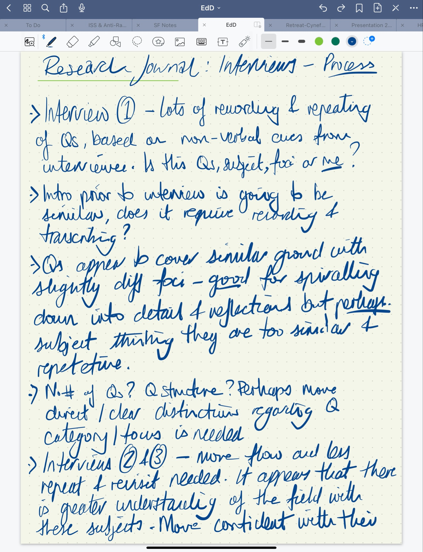
Figure 1: Excerpt from reflexive journal during interviews

Braun and Clarke (2022), establish that maintaining a reflexive journal is one of the most important mechanisms for storing, interrogating and sense-making. This is especially true for myself as a new researcher, attempting to make meaning within a topic in which I am already fully embroiled. For me, it has allowed me to document my personal thoughts, observations and experiences which in turn have helped with my self awareness and my understanding of personal biases and assumptions, which may influence the interpretation of any data (Bashan and Holsblat, 2017; Russel and Kelly, 2002). Using bracketing, as an approach, will also support the maintenance of a reflexive position. As such, it is important for me to revisit my position beyond this research, my assumptions, my place in any power hierarchy and any potential role conflicts I may have with the research participants (Tufford and Newman, 2012). This has been particularly useful as I moved from my reflecting upon the interviews, through transcription, familiarisation and seeking to establish initial themes (see Fig. 2).
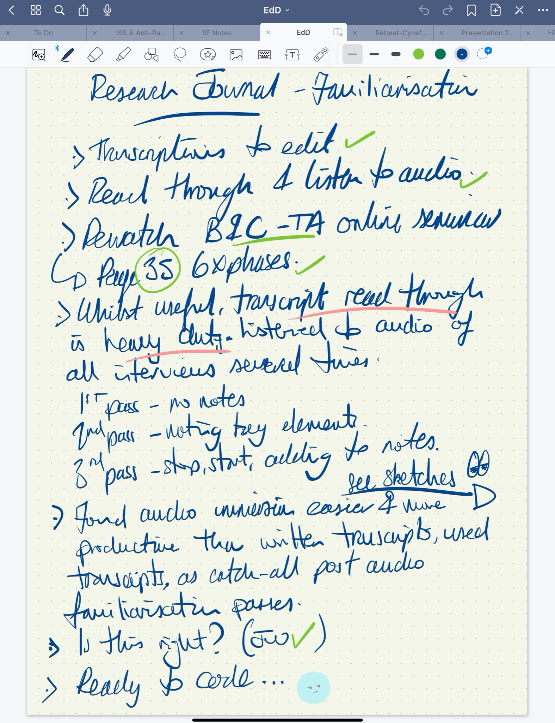
Figure 2. Excerpt from reflective journal during thematic analysis of data

The reality sought by this research is not a fixed entity but rather part of a multiple view of reality, a social and subjective construct which ‘moves beyond facts and descriptions of acts to interpretations and perspectives’ (Cohen, manion and Morrison, 2018, p.716). As such, the interpretivist epistemology perspective provides a setting for the social constructivist theoretical framework.

Theoretical Framework
This study is embedded in the social constructivist paradigm. That being the belief that knowledge is constructed through interaction with others. The key concepts of this research are curriculum as an entity itself, curriculum implementation as a process and leadership approaches to curriculum implementation, in the context of this study we are asking about the roles of headteachers. Billsberry (2014, p.680) expresses leadership through the lens of social constructivism by conceptualising that it is ‘analogous to beauty; it is in the eye of the beholder'. I found the analogy helpful when conceptualising the sheer extent of leadership variability and subjectivity, due in some extent to; individual personalities, energy, resilience, styles and strategies, measures of success and context ( Avolio, Bass and Jung, 2019; Hargreaves and Goodson, 2006; Sethuraman and Suresh, 2014). Billsberry (2014) posits that, it is for this reason, that a universal definition of leadership does not exist and posits that this is why different people hold differing opinions of the same leader and why ‘completely different approaches to leadership’ may work in similar circumstances. If we consider Burns’ (1978) assertion, that ‘leadership is causative. True leadership affects the motives of individuals and groups of peoples and alters the course of the organisational history’ (Xiao-xia & Jing’s 2006, p.9), then we begin to see the critical role of leaders when it comes to not only relationships with their teams but as ‘active actors’ in the organisation’s interpretation and socially constructed implementation of curriculum. Substantiated by Marzano et al. (2005), in that ‘effective leaders demonstrate personal interest in staff and make themselves available to them’.
Whilst we recognise that the participants of this study engage in social construction of school level curriculum, via their own particular set of subjective lenses, we must also acknowledge that I, as the researcher, am an ‘intervening variable and cannot exist in isolation from that which is being researched (Flick, 2018, p.8). Importantly, Yin (2018, p.120), warns of a ‘methodological threat’ arising from the influence of the researcher upon the research responses and equally so, how those same responses in turn influence lines of inquiry. My positionality has been shaped by my lived professional experiences: formerly as one of the architects of the national curriculum policy development; in my current role as a head teacher seeking to implement CfW in my own school; and as someone who works closely alongside the study participants. It is these very experiences that are the foundations of both my knowledge and understanding, my assumptions on the nature of reality and how we can best establish knowledge about any such reality in the context of this research. As such, it is the recognition of my position, influence and interpretation that allows me to open up my self identification to consideration and criticism (Massoud, 2022, p. 64).

Chapter 4 Methodology
This is a qualitative study that will be undertaken in a primary school, not my own but within the same local authority, recognising that I will be working within an organisation and community where I, the researcher, am a member (Fleming, 2018). As such, it is considered as insider research. It is universally recognised that ‘qualitative inquiry is not a neutral activity’ (Cohen, Manion and Morrison 2018, p.33) and as the researcher I will need to negotiate three positionality based challenges as a means of addressing my involvement with the subject matter and participants. These being: my experiences and subject knowledge; participant awareness of my roles and experiences; and the way in which both of these factors influence perspectives, interactions, findings and interpretations i.e both of the knowledge itself and the ways that the knowledge is established. The research questions are qualitative in nature and seek to explore the perceptions of head teacher influence upon curriculum implementation, through a case study.

Case Study
Yin’s, (2018, p.15) provides a comprehensive, ‘twofold definition’ that case studies are ‘an empirical method that investigates a contemporary phenomenon in depth and within its real-world context, especially when the boundaries between phenomenon and context may not be clearly defined.’ It is important to recognise that I am the main instrument of the research, interacting with the participants and their environment, blurring the lines between researcher and participants, between the researcher's subjective interpretation and objective facts. (Cohen, Manion & Morrison, 2018; Hamilton & Corbett-Whittier 2013, Yin, 2018). ‘This does not mean that qualitative research lacks design’ (Maxwell, 2012, p.215). In the context of this particular case study, I as the researcher become ‘the primary instrument or medium through which the research is conducted’ (Lofland et al, 2006, p.3 cited in Xu & Storr, 2012, p.1). Maxwell is not only in agreement, he further advises that qualitative methodology must consider that ‘relationships with the people in your study can be complex and changeable, and these relationships will necessarily affect you as the ‘research instrument’ (Maxwell, 2008, p.234).
Despite Maoz (2002, p.164), claiming that ‘the use of the case study absolves the author from any kind of methodological considerations’, Yin (2018) counters this an assertion that it is not necessarily the case study approach that is the problem. He proposes that it is more so the case study researcher being ‘sloppy’ with procedures or allowing equivocal evidence to influence the outcomes and conclusions. The purpose of this study is an in depth exploration of the challenges involved in implementation of CfW, in schools, as such it is an instrumental case study.
The case in this study is CfW, with the research being conducted in a closed setting, that of a one primary school, where the researcher has an overt approach and as such acknowledges that the ‘most prominent critique of single case study analysis is the issue of external validity or generalisability’ (Willis, 2014, p.5). However, Pring (2017, p.57), parries such concerns by prompting us to ‘remember the uniqueness fallacy’ explaining that whilst there is something distinct in single cases there will also be commonalities. It is through rich narrative and thick descriptions that the researcher seeks to capture the lived experiences and realities, avoiding a need for over interpretation and judgement (Cohen, Manion & Morrison, 2018; Dyer, 1995; Geertz 1973; Hitchcock & Hughes 1995; Marelli, 2007).

Participants and Sampling
This research is driven by a relativist ontological positioning with an interpretivist methodology and as such it was important that I used multiple methods of data collection, in order to fully explore as many interpretations of curriculum implementation as possible. Within this study I used both semi-structured interviews and documentation analysis to enable ‘ convergent and concurrent validity’ (Cohen, Manion and Morrison, 2018, p.387).
The quality of a study rests upon the appropriateness of its methodology and instrumentation, which in turn rely upon a suitable sampling strategy (Cohen, Manion and Morrison, 2018).

Bryman (2012) explains that the ‘discussions of sampling in qualitative research tend to revolve around the notion of purposive sampling’ (p.416), whilst Creswell (2014) goes on to elucidate that the ‘idea behind qualitative research is to purposefully select participants or sites that will best help the researcher understand the problem and the research question’ (p.239). There was limited gain in selecting a sample at random if they will have nothing to contribute to the study. As such participants were hand-picked according to their role in the school studied, consent was sought (See Appendix F) a primary school local to my own and within the same secondary school feeder cluster, in order to meet the specific needs of the study, providing multiple experiences and perspectives (Cohen, Manion and Morrison, 2018). Table 1 shows the purposive sample and interview timings.

Role in School | Criteria for Sample | Interview Time in min
Head teacher | Current Head teacher | 55
Senior leader | Leadership team member with a minimum of three years experience | 58
Teacher A | Class teacher with a minimum of five years experience | 72
Teacher B | Class teacher with less than five years experience | 39
Learning Support Assistant (LSA) | Full time LSA | 44
Table 1: Purposive sampling and interview timings
Where more than one person met the sample criteria for the sample, I had already decided to select the person alphabetically last by surname. Purposive sampling has been used to ensure the inclusion of knowledgeable people but we must accept that it does not represent the wider population, with Bryman (2012) arguing that the because it is ‘non-probability sampling approach, purposive sampling does not allow the researcher to generalise to a population’ (p.418). However, Teddlie and Yu (2007) rationalise that it is a ‘trade-off’. Whilst purposive sampling provides greater depth in the study it provides opportunity for less breadth. I allowed the participants to choose from a number of predetermined interview dates and times, assigning letters alphabetically to participants in the order that the interviews took place.
Data Collection Methods
The data collection methods were chosen in order to fully explore the perspectives of the participants, capturing their realities regarding curriculum implementation. According to Stake (1995, p.56), ‘the researcher should have a connoisseur's appetite for the best persons, places, and occasions’ and the ability to identify good sources of data, test out the veracity of their eyes and the robustness of their interpretations (p.50). Full details of the research study were provided to participants in advance of the interviews.(See Appendix B)

Semi-Structured Interviews
In keeping with the social constructivist paradigm of this research and my own epistemological perspectives, ‘the use of the interview in research marks a move away from seeing human subjects as simply manipulable and data as somehow external to individuals, and towards regarding knowledge as generated between humans, often through conversations’ (Cohen, Manion & Morrison 2018, p. 506). Semi-structured interviews proved to be an opportunity to elicit rich responses, ‘negotiate between researcher and researched’ (Pring, 2017, p.54), and allowed me to respond to any newly emergent findings or hypotheses. In support, Flick, (2009, p.150), reports that ‘the interviewed subjects' viewpoints are more likely to be expressed in an openly designed interview situation'. Although Normore and Brookes (1995), point out that ‘with privilege and power come many temptations or necessities to present information in a particular manner’, with school leaders having a tendency to keep any answers to a high level of abstraction. To mitigate such challenges, the interviews included probing follow-up questions, prompts, and I made a point of asking for examples where appropriate. Whilst also recognising that ‘the interviewer inhabits his or her own unique world of beliefs and understandings’ (Pring, 2017, p.54). Semi-structured interviews will allow the researcher control over the order of questions, the nuances in the way questions are asked and the flexibility to pursue emergent findings.
Interviews:
- Included introductions and explain the purpose and aims of the study
- Included clear explanations of ethical considerations including data protection
- Had check-ins, ensuring participants were comfortable and willing to continue
- Included options to follow up and explore responses
- Followed the interview aide-memoire
The aide-memoire (See Appendix D), whilst not prescribing the course of the interview, include the questions, notes and prompts in relation to participant’s knowledge, understanding, experiences, perceptions and perspectives of key elements which included: CfW and implementation (national and local context); head teacher decisions and actions; their own roles and actions; and perceived strengths, challenges and limitations in implementation.
Whilst I made audio recordings of each interview, storing the data securely (See Appendix G) in order that I may revisit the responses as required, Stake (1995, p.66) argues that ‘getting the exact words of the respondent is usually not very important, it is what they mean that is important.’ To deepen my understanding of the case, I simultaneously undertook a documentation analysis, combining the interview and documentation data into a single dataset for analysis.
Documentation Analysis
Bowen (2009) states that ‘Like other analytical methods in qualitative research, document analysis requires that data be examined and interpreted in order to elicit meaning, gain understanding, and develop empirical knowledge’(cited in Normore and Brookes, 2015, p.801). As advocated by Bowen (2009, p.28), I reviewed some documentation prior to commencing the face-to-face processes in the school. Table 2 shows the documents requested and highlights those that were provided, the rationale and limitation of each document reviewed.

Documentation | Rationale | Limitations
Self evaluation and School Improvement Plans  PROVIDED | Provides details of the school’s ability to reflect, evaluate and plan for prioritising of curriculum implementation  To be analysed prior to commencing study, supporting initial lines of enquiry | Deliberately developed for accountability purposes ie a critical internal and external audience
Relevant school policies:  - Curriculum Policy  - Learning & Teaching Policy  PROVIDED | Provides an overview of school wide procedures, processes, expectations and standards in relation to CfW.  To be analysed prior to commencing study, supporting initial lines of enquiry | Deliberately developed for accountability purposes ie a critical internal and external audience  Confidentiality
Professional learning diaries, plans and resources  NOT PROVIDED | Provides an overview of professional learning related to curriculum implementation | Potential to lack detail and context
Minutes of leadership, planning, staff and staff meetings  NOT PROVIDED | Provides insight into the thinking, dialogue behind decisions and actions | Potential lack of detail and context  Confidentiality
Newsletters and stakeholder communication  NOT PROVIDED | Demonstrates the efficacy of school policies, decisions and plans | Produced for an external audience and may lack sufficient depth of detail
Table 2: Documentation analysis

Given the nature of external accountability surrounding the school self-evaluation, improvement and policy documents, Normore and Brookes (2015, p. 801), advise that the researcher ‘treat them as what they are – intentionally shaped documents created for the purpose of communicating formal organisational dynamics to a critical audience.’ Ergo, whilst these documents are helpful, they were created for the purposes of accountability and to be critiqued against a set of expectations. It is useful to consider if they are representative of the ‘idealised’ or ‘actual’ reality? The interpretation of which was done through Reflexive Thematic Analysis and as part of a combined single dataset, in an attempt to address the research questions.

Ethical Considerations
Research, Hammersley & Traianou (2012) share that it ‘is not uncommon, in planning research or in carrying it out, for the question to arise: Is this ethical?’ This research will both adhere to the BERA Ethical Guidelines for Educational Research (2019) and maintain compliance with the UK General Data Protection Regulations (UK GDPR), under the legislation of the Data Protection Act 2018. Component three of this assessment is an application for ethical approval (See Appendix E), which sits alongside the literature review and research planning. Orb, Eisenhauer & Wynaden (2000), espouse that whilst ‘principles cannot ensure ethical research but they can contribute to an understanding that ethical responsibility in qualitative research is an ongoing process'.

Chapter 5 Data Analysis
‘Qualitative data analysis concerns how we move from the data to understanding, explaining and interpreting the phenomena in question’ (Bryman, 2012, p.643). Creswell (2014) explains that this requires a process for both deconstruction and the reconstruction of the data. There are long established criticisms of qualitative data analysis, disputing the legitimacy of findings due to: researcher subjectivity and bias; a lack of generalizability; difficulties in replicating studies; and its labour intensive nature (Flick, 2018; Miles, Huberman and Saldaña, 2014; Sliverman, 2019). However, it is important to note that whilst the quantitative researcher aims to remain objective and detached from the process (Gray, 2018), it is widely recognised that the qualitative researcher is not only immersed and integral within the process but are themselves the primary instrument of data collection and analysis (Creswell, 2013; Denzin and Lincoln, 2018; Marshall and Rossman, 2016). As such ‘reflexivity and self-awareness enable researchers to recognize their biases and engage in a critical examination of their assumptions and preconceptions’ (Denzin & Lincoln, 2018, p. 35). It is the researcher’s very own experiences, skills and characteristics that will ultimately influence any analysis of data (Patton, 2015; Yin, 2018).
Alongside this widely recognised role of self in qualitative research (Braun and Clarke, 2022; Flick, 2018; Shufutinsky, 2020), Gray (2018) reminds us that there is the requirement for the researcher to demonstrate theoretical sensitivity - an awareness of potential bias and the ability to recognise what is important to the study, what is not. In line with the qualitative research paradigm within which this study sits, I have attempted to embrace my role as the researcher using reflexive thematic analysis (Braun and Clarke, 2022). Reflexive thematic analysis, developed from Braun and Clarke’s prior thematic analysis work (2006), brings the researcher’s influence on the analysis process to the foreground and seeks to establish engagement with the data over a number of levels (Nowell et al, 2017).
The RTA approach will be used ‘to organise and simplify the complexity of the data into meaningful and manageable codes, categories and themes’, (Peel, 2020, p.7). The approach in this study used my research questions to guide the processes of interviewing and analysis. This is contrary to quantitative methods and allows me to act iteratively and respond to emergent lines of enquiry whilst providing potentially rich and detailed accounts of data (Braun & Clarke, 2006; Merriam, 2009; Bryman, 2012; Creswell, 2014; Flick, 2014; Cohen, Manion & Morrison, 2018).
Braun and Clarke (2022), advocate six phases for RTA, see below, yet they liken it more to an ‘adventure map’ with guidelines as opposed to strict rules to follow (p.34). These phases broadly reflect the six stages advocated by Peel, (2020), which themselves build upon the work of Braun and Clarke (2006); Creswell (2013); Merriam, (2009). It is important to note at this juncture that ‘themes do not passively emerge from data but are actively produced by the researcher through systematic engagement with, and all they bring to, the dataset’ (Braun and Clarke, 2022, p.8).

The Six Phases of Reflexive Thematic Analysis

- Familiarisation
- Coding
- Generating initial themes
- Developing and reviewing themes
- Refining, defining and naming themes
- Writing up
(Braun & Clarke, 2022)
Using Reflexive Thematic Analysis
Familiarisation

Arguably, familiarisation with the data began during the semi-structured interviews, when I clarified language, sought definitions from interviewees and recorded notes in my reflexive journal. Each of the interviews was audio recorded using Microsoft Teams, with each of the transcripts being automatically transcribed using Microsoft Word within Office 365. Whilst this automation saves a significant amount of time, I initially had difficulties connecting with the transcripts and so for the purposes of immersing and familiarisation, I listened to each of the audio files a number of times, before making notes and editing the transcripts. The process of listening and re-listening to the audio files alongside the reading and editing of the transcripts, served as an ideal way to become increasingly immersed in the data. It was at this point that I read and re-read the data provided within the documentation. In this way, I was able to move forwards with the RTA and for the purposes of this research, I have considered both sets of data as a single dataset. During the process of listening to the audio files, editing the transcripts and reading the documents, I recorded reflections, insights and questions regarding key concepts, as sketch notes, in my reflective journal (see Figures 3 & 4). I experienced some difficulty reimmersing myself in the written transcripts, once they were fully edited and as such found myself returning again to the audio files, exploring each of them in depth through a cyclical process of listen, pause, reflect and record. The transcripts were used as reference in support of this process. I believe my difficulty, in part, to be an outcome of both the laborious nature and the sense of physical exhaustion I experienced during the initial transcript editing and refining (Azevedo et al, 2017). Whilst this is a valuable lesson, regarding my planning and timelines, for future research I was still able to ‘critically engage with the information as data, rather than simply as information’ (Braun and Clarke, 2022, p.42). At this point I began to become more analytical in my thinking by making connections to my research questions, to existing research, being mindful of both my positionality and theoretical sensitivity (Braun and Clarke, 2022; Gray, 2018; Nowell et al, 2017). The digital nature of my reflexive journal and sketch notes, allowing me to both edit (highlight, group, as my insights developed and have a library of the document as they changed over time. Braun and Clarke (2022), clarify that ‘the different phases of reflexive TA are not always sharply delineated’, as I discovered when I found myself refining the sketch notes beyond familiarisation. Through grouping, highlighting, querying and cross referencing the content, distilled information started to become data and the familiarisation phase moved into the first pass in coding my dataset.
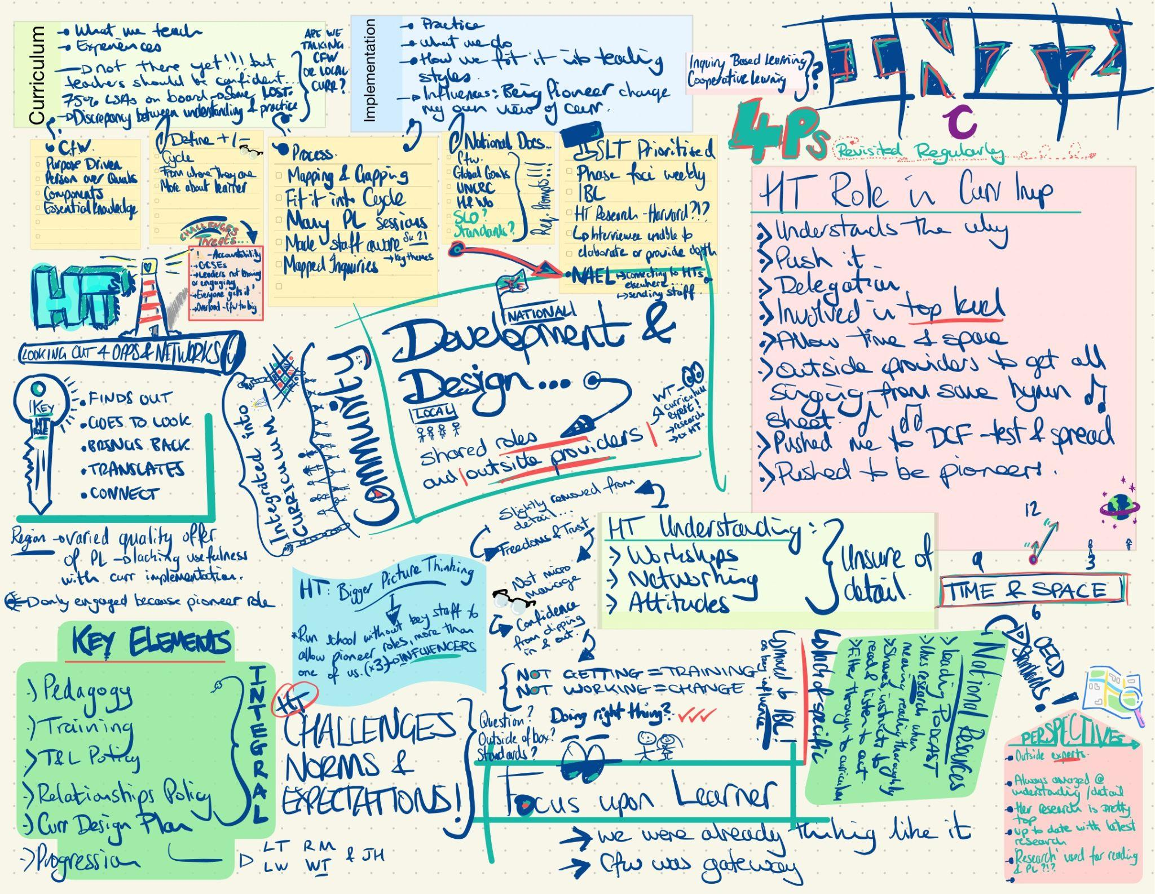
Figure 3. Sketch note following familiarisation and first pass of coding participant c data


Figure 4. Sketch note following familiarisation and first pass of coding participant d data
Coding
My first pass at coding played a critical role when it came to both the organisation and analysis of the dataset. This initial coding provided the basis for the data to be 'assembled, categorized, and thematically sorted, providing an organized platform for the construction of meaning’ (Williams and Moser, 2019, p.45). An inductive approach to coding allowed me to use the data as a starting point to develop rich contextualised meaning, enabling the experiences of the participants to have a voice in the data (Braun and Clarke, 2018; Patton, 2015). The inductive process is in contrast to employing a deductive coding process, whereby codes development is researcher or theory driven, a priori using existing models or concepts. Whilst it could be argued that inductive approaches allow the data to be analysed without overt preconceived notions or theories, Braun and Clarke (2022) posit that there is no such thing as ‘pure induction’ because, as previously discussed, the researcher’s own experiences and skills will influence what is extracted and what is not. Therein, we can once again see the fundamental role of reflexivity, particularly in the analysis phases. There are several common criticisms of inductive coding, serving to highlight that it is time consuming, highly subjective, lacks consistency of process and the potential to put emphasis on minor or idiosyncratic aspects of the data (Fereday & Muir-Cochrane, 2006; Guest, MacQueen, & Namey, 2012; Saldaña, 2016).
In response to these criticisms and as a means of building consistency and transparency through my inductive reasoning, I developed and systematically used a codebook to record codes, code labels, descriptions and examples directly from the dataset (Byrne, 2022). Using a codebook allowed me to make sense of the data, considering ‘meaning making rather than truth seeking or discovery’ (Braun and Clarke, 2022, p.55). Developing the codes, and ultimately themes, is an iterative process and one where I constantly sought to keep reflexivity at the forefront of my analysis. Within my reflexive journal, I used a set of questions that I regularly revisited during each stage of the RTA, as a means of establishing a deeper understanding and thorough analysis (see Figure 6).

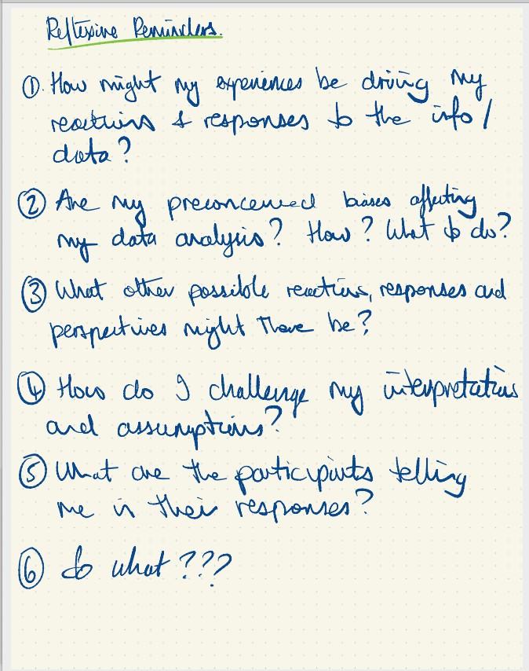
Figure 5. Questions used throughout the analysis process.

Maintaining reflexivity as a researcher, throughout the interpretation and interrogation of the data, against my research questions. The analysis process, being both constructive and recursive, allowed me to draw out the codes through my interpretations of patterns and meaning, those which I deemed to be analytically important and based upon my theoretical understanding (see Figure 6). Whenever I began to question the validity of my own coding process, I found it reassuring to remind myself that codes develop at the intersection of the dataset, my theoretical assumptions of the analysis and my own analytical skills, as the researcher. Good codes articulate the ‘qualitative richness of the data’ (Braun and Clarke, 2019; Nowell, Norris and Moules, 2017).

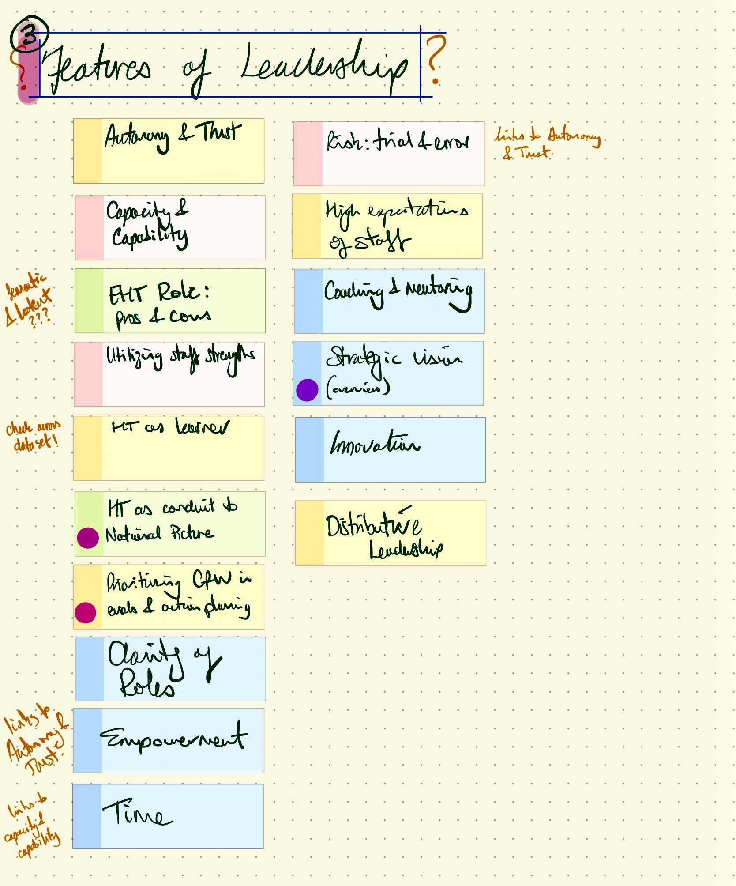
Figure 6. Example of using code labels to construct codes, during the inductive coding process

The next step was to transfer the codes into my codebook, noting that there are both semantic and latent examples (see Figure 7). The semantic codes capturing the explicit meaning extracted from the data whereas the latent ones are an attempt to identify hidden meaning though my own interpretations and processing - these can be more implicit and conceptual in nature, perhaps requiring greater levels of engagement, creativity and activity from the researcher, yet we must be careful not to assume that one is any more sophisticated than the other (Braun & Clarke, 2022; Byrne, 2022).

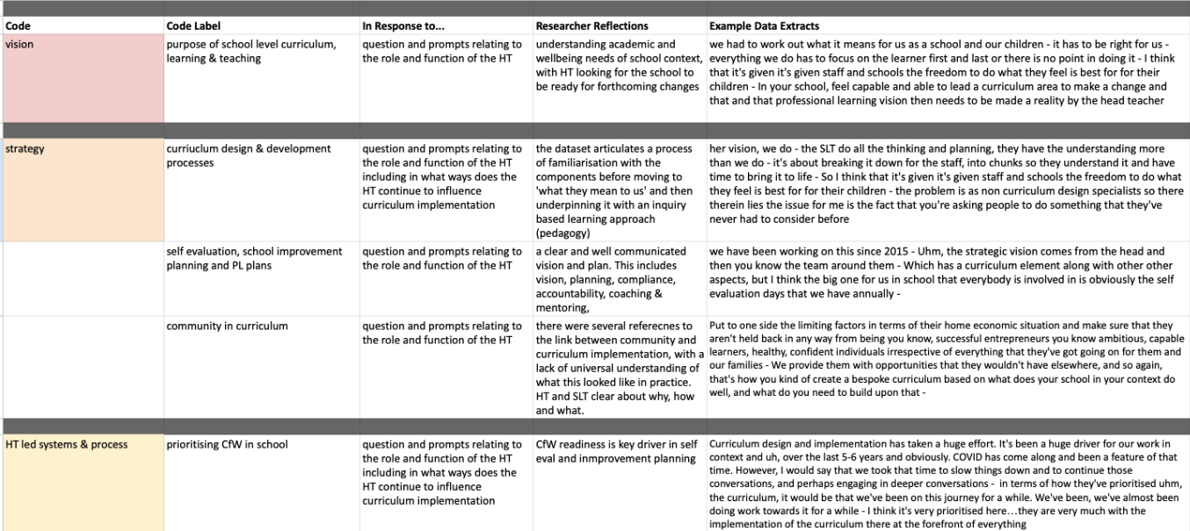

Figure 7. Example of compiling the data and refining the codes, using a codebook

Generating Initial Themes
In thematic analysis, a theme is a pattern or recurring idea that is developed through systematic and iterative analysis. They are concepts that capture the underlying meaning and essence of your data as a means of addressing the research questions (Attride-Stirling, 2001; Braun and Clarke, 2022; Gray 2018; ). It was at this point that I was able to collate the codes into clusters of shared meaning against the foci of my research questions. I was aware that during this iterative process, I needed to keep my research questions at the forefront of my thinking as I worked iteratively through generating my themes, revisiting the codes and dataset alongside recording the development (see Figure 8).
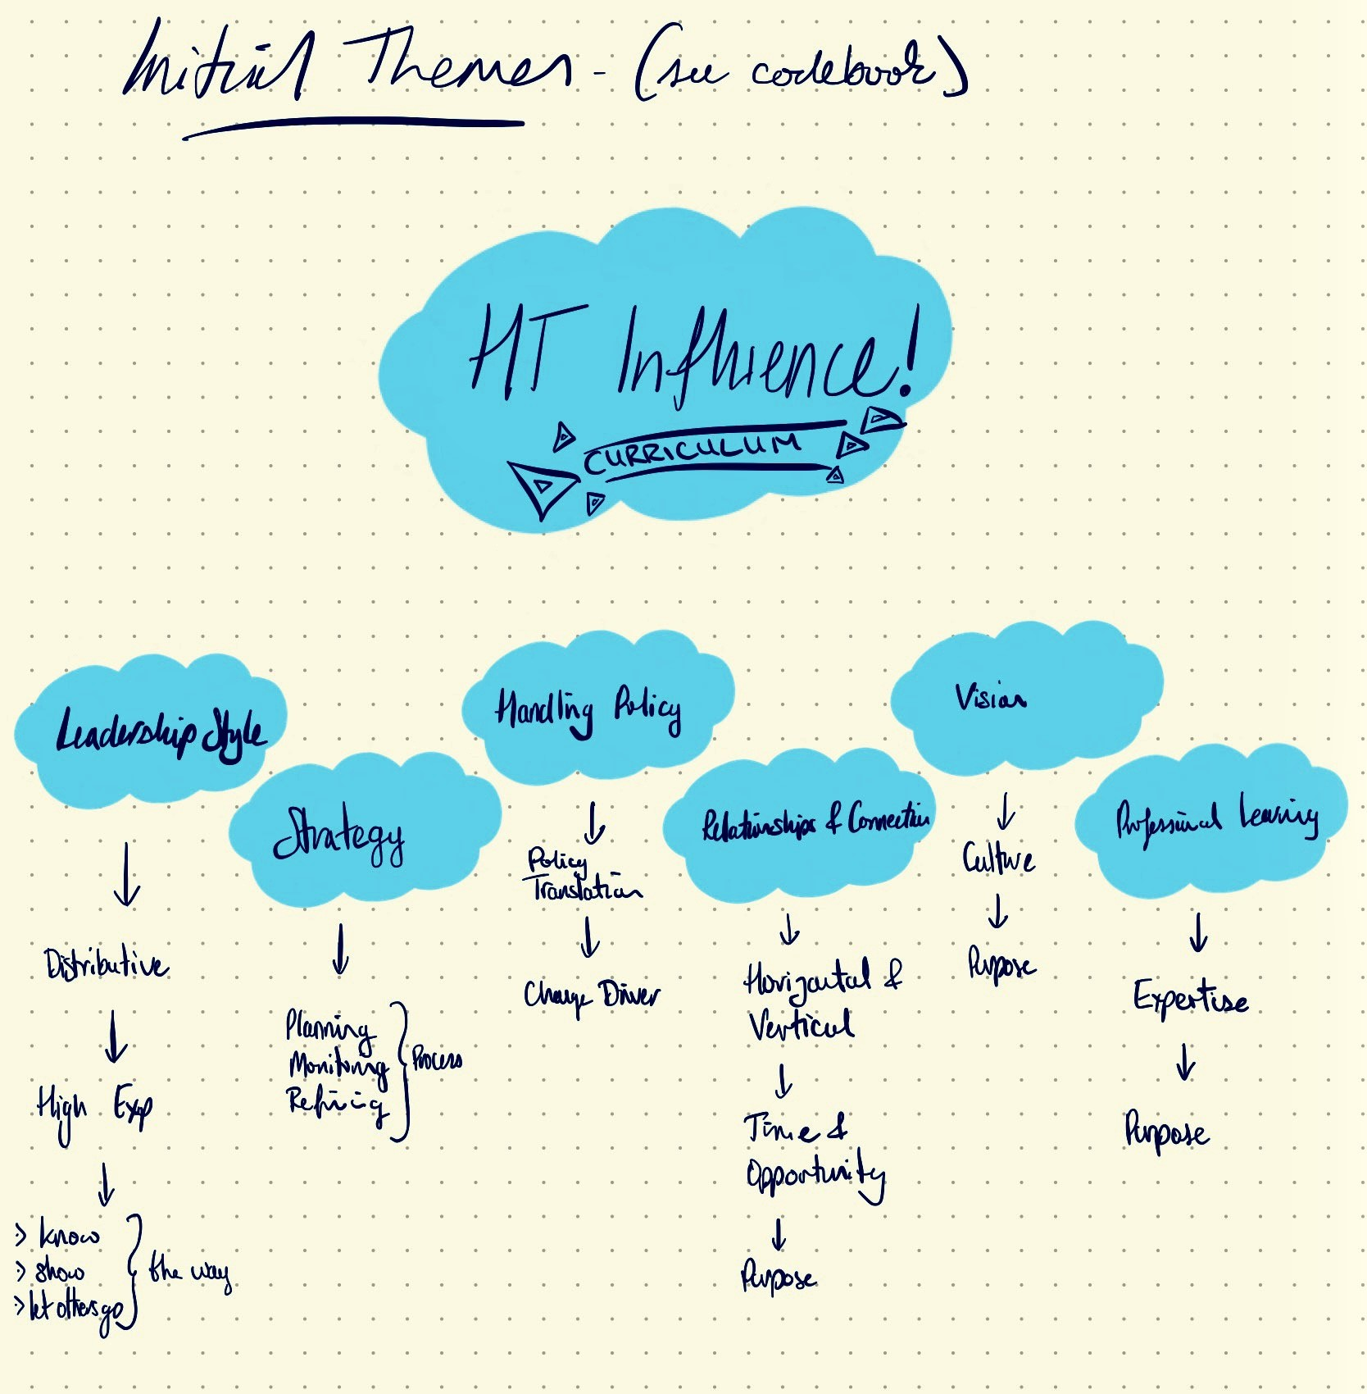
Figure 8. Example of iterative and recursive development of themes
Braun and Clarke, (2022) explain that themes will come to represent both surface-level and deeper meaning in the data, yet, they have previously warned that thematic analysis has the potential to prioritise the surface-level over the deeper meaning (2006). Guest et al (2012), take a similar stance in identifying that whilst ‘condensing the data into themes, there is a risk of oversimplifying or losing the richness, complexity, and context of the participants' experiences’ (p. 61). As an outcome of understanding this, I made certain that I sought to go beyond simply representing all the information provided by the participants but more so identifying and clustering my codes into candidate themes and exploring their meaning, in the context of the research questions.

Developing and Reviewing Themes
I took these candidate themes and used them as a basis to challenge the collective of codes from which they had been developed, the meaning that was conveyed by the theme itself and questioned their relevance to this study. I took the opportunity at this point to ensure the codes within each of the themes were representative of the whole dataset and were not constructed as an outcome of information from narrow sources of individual participant data. The recursive nature of this phase allowed me to scrutinise the codes and refine accordingly, be that combining codes, removing codes and rethinking the themes (see Figure 9). For me, as a researcher, it was this phase that particularly highlighted the value in the iterative process of developing the quality and depth across the themes, triangulating my thinking against the literature and my research questions. In particular, I noted in my reflexive journal, that it was in reviewing the themes that I began to appreciate the value in what I earlier referred to as in moving through thick descriptions to thick interpretation and eventually thick meaning.
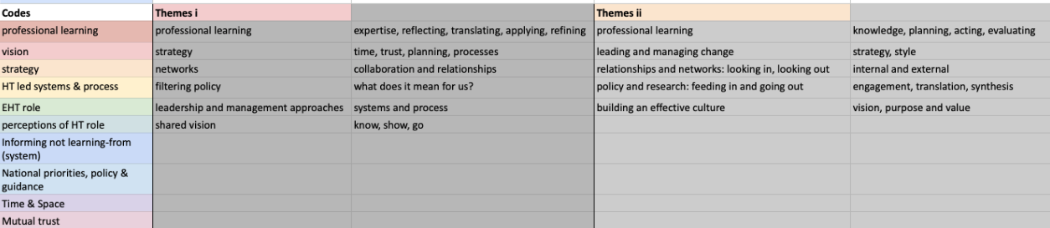
Figure 9. The codes and themes following the review process

Developing a thematic map (see Figure 10) proved helpful in visualising the themes, sub themes and the relationships amongst them, which were not always readily apparent through the journal or codebook. This then allowed me to better understand the dynamic between my themes in readiness for further analytical refinement (Braun & Clark, 2022; Castleberry and Nolan, 2018; Gray 2018).

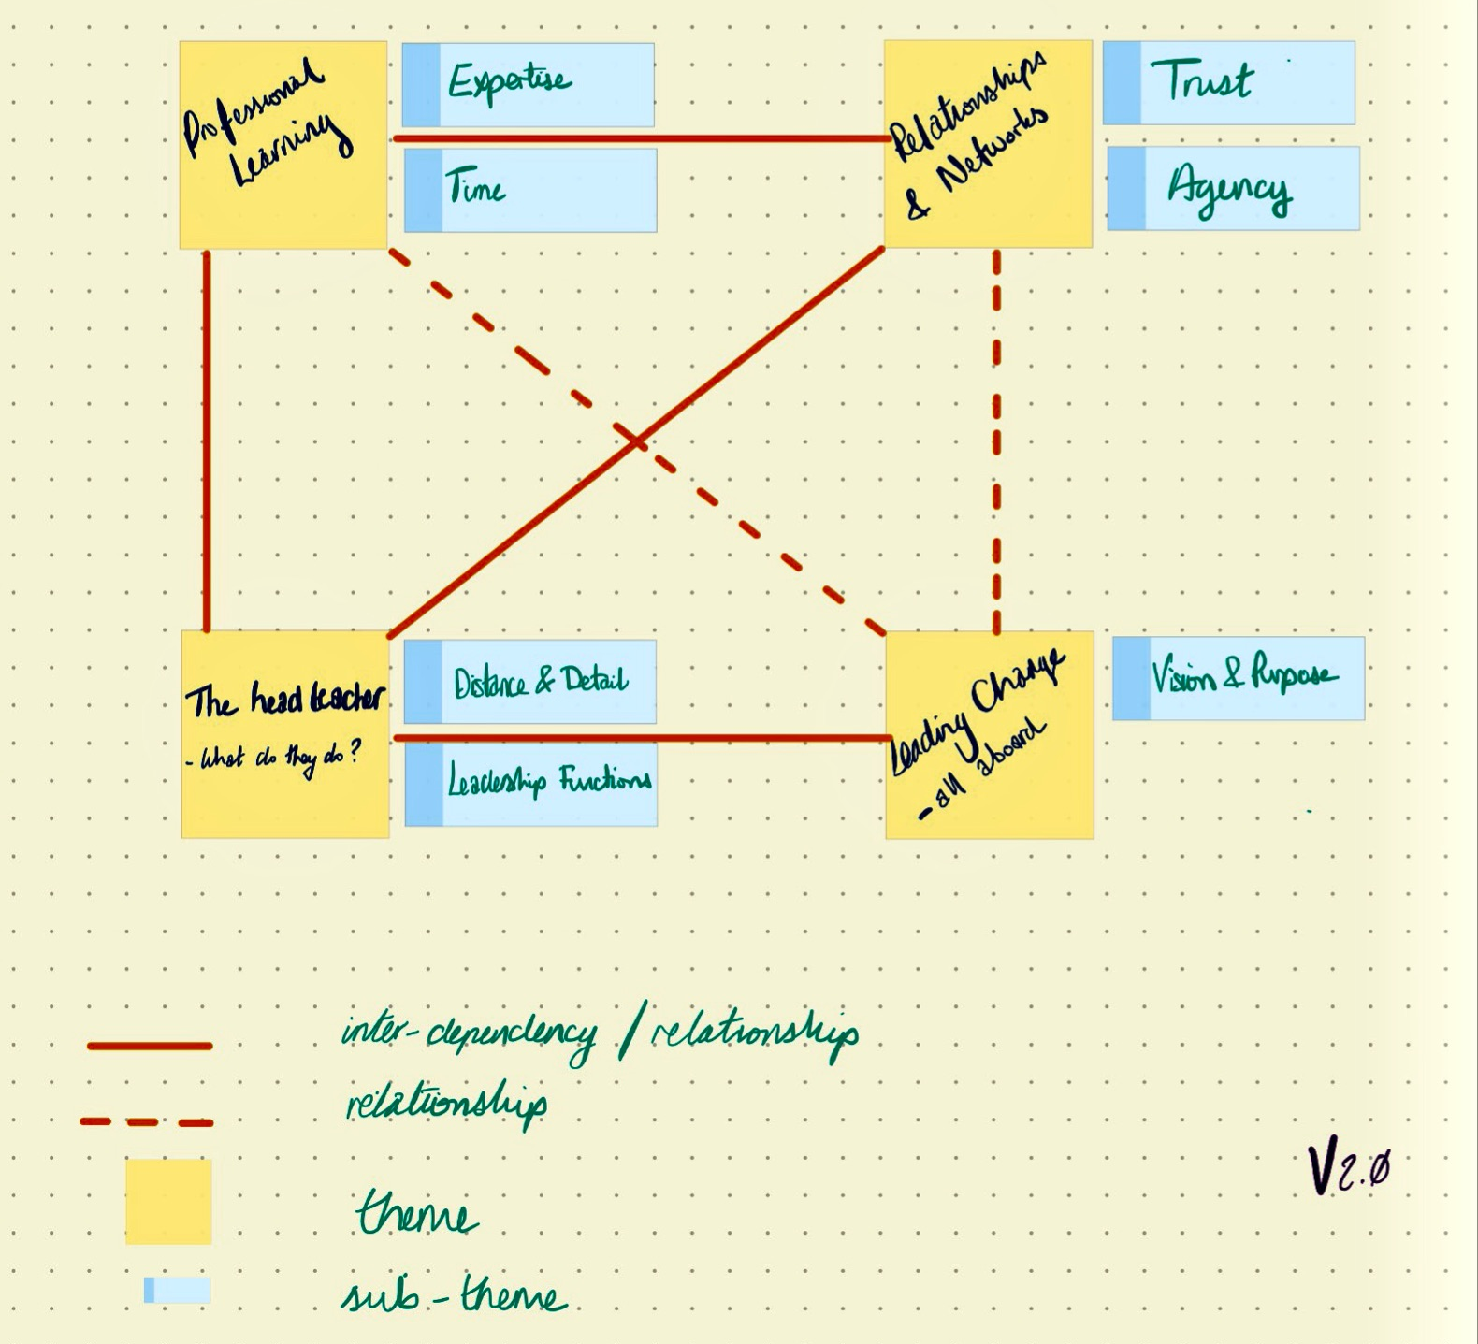
Figure 10. Example from my thematic mapping process

Refining, Defining and Naming Themes
Analytical refinement requires the process of writing and as such, the final two phases of RTA blend into one. A key part of this particular phase is writing theme definitions as a means of establishing the ability to further refine them and simultaneously testing their robustness (Braun and Clarke, 2022). Writing definitions for the themes presented a much needed opportunity to consider any potential lack of depth across my theme names, prompting me to ask if they told the story of my dataset. It also led me to further consider the warning from Braun and Clarke (2022), regarding the need to be careful between creating topic summaries and labelling themes that are built around ‘its own distinct central organising concept’ (p.77). Themes must have clear definitions, tell their individual story and show how they fit within the wider research narrative (Byrne, 2022; Gray, 2018; Williams and Mosser, 2019). The outcome of this phase was a set of refined, defined and named themes as detailed in Figure 11.
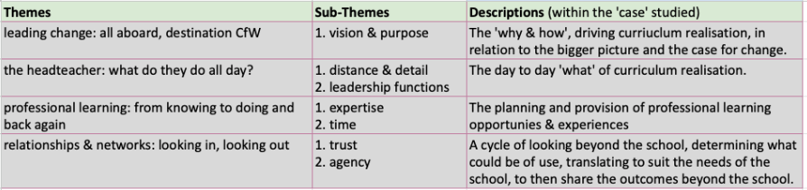
Figure 11. Refined themes, sub themes and definitions
Analysis of Themes
In order to explore the ways in which a head teacher influences curriculum implementation and uses national policy to do so, I have presented my findings through four rich themes, developed as an outcome of RTA.
Leading Change: all aboard, destination CfW
The manner in which the head teacher has planned and driven the necessary changes to process and practice, in order to realise CfW, is a central concept throughout the dataset. There is no doubt that the case for change has not only been communicated to staff, but it underpins the school’s vision, purposes and the participant’s own daily practices - they have bought in. As Participant A explained, ‘we had to work out what it means for us as a school and our children.’ The dataset demonstrates a consistent understanding of the why, this is not change for change-sake and this is not change that has lost contact with the underlying principles of education. The why behind this complex process was summed up simply and meaningfully by Participant E, when they expressed their understanding that ‘everything we do has to focus on the learner first and last or there is no point in doing it’.
However, despite this buy-in and willingness to follow, it is interesting to note that the dataset clearly establishes that the participants believe it to be the head teacher’s own vision. There is nothing to suggest a collective or co-constructed vision. Participant D, when referring to the head teacher, stated that ‘this is her vision of how she wants it to be and we're all involved in it’. Participant A echoes that it is ‘her vision, we do’ and Participant C reinforces the sentiment by disclosing that ‘I should imagine she made all the decisions about how she wanted it to be and how it should look.’ It is important to note at this juncture, that in the written form this may be perceived as a complaint or with negative connotations. It is important to note that this was not the case with any of the three participants, who made reference to this and other similar reflections. They were presented as a factual statement, if anything, with a degree of gratitude and positivity.
With Participant E asserting that ‘the SLT do all the thinking and planning, they have the understanding more than we do’, there is evidence of the inter-relationships between themes and sub-themes eg The Head Teacher and Professional Learning. The majority of the thinking, decision making and development is done centrally by senior leaders, before staff are ‘asked to look at stuff and feedback ideas’, (Participant E). Participant C explains that ‘the SLT do the thinking and work and we are then asked to give feedback on it because we are the ones in the classroom everyday.’ As we have seen, the findings have established clarity on the roles of the SLT and classroom practitioners, with the head teacher having set the initial vision and ensuring now that the process of curriculum implementation stays true to that vision.
The Head Teacher: what do they do all day?
Ensuring the school stays on course to realise curriculum reform and fulfil the principles of its vision, may not be as straightforward as it sounds. Additional complexity ensues because in the context of this study, the headteacher has an executive role, working across two schools and supported by a head of school in each one. For the purposes of this research, she is referred to as the head teacher. The difficulty for the HT in this case, is balancing the time constraints of leading two schools, whilst being involved strategically and operationally in the two separate organisations. Negative implications include an awareness that participants ‘don’t see the headteacher much’ (Participant E), whilst others are unsure about who to approach with a question because ‘the executive headteacher role is confusing’ (Participant A) - causing participants a sense of both detachment and uncertainty. The data shows participants answered superficially and were careful in selecting their wording, when asked about the relationship between the executive head role and the ongoing influence upon curriculum.
However, in terms of curriculum realisation and influencing change, this lack of ability to be embedded in the daily operations of the school, comes with a number of benefits. Firstly, ‘It works quite well because the head teacher is slightly detached from what is going on in the school so that they can make a clearer, unbiased judgement on the progress that the school is making’, (Participant D). Having worked in a similar role myself, my own experiences taught me that the distance does grant the head teacher a greater sense of unbiased perspective on the school. Secondly, it enables you to share both the strategic and operational responsibilities that accompany headship. In this way she has been able to share roles and responsibilities with her team and build a greater degree of mutual trust with senior leaders, there is significant evidence to show how the head teacher has utilised distributed leadership as a fundamental approach. The evidence from the data is overwhelming in terms of distributed leadership being the primary leadership style employed by the head teacher. So much so, that Participant E reflected that ‘she has a lot of trust in her assistant heads and her head of schools’ and is able to appreciate the freedoms this affords the head teacher, as their ‘involvement has almost been as a quality control assessment checker.’ The head teacher has taken the opportunity to develop her senior leadership team through first hand PL experiences.
Professional Learning: from knowing to doing
There was a wealth of data to demonstrate that PL(PL) is one of the key drivers towards ensuring staff, within this case, had a consistency of understanding in both knowing about curriculum for Wales and knowing how it will be realised in their school. Regular references to weekly PL, team meetings, leadership meetings, visiting trainers and attendance on external development opportunities can be seen through the dataset. The careful and deliberate nature of planning PL is clearly demonstrated by ‘a bespoke PL program that over the last three years has looked at individual needs of staff’ (Participant B). Moreover, Participant D explains the thinking behind the time and energy invested in providing high quality staff PL, as it needs to ‘support them with the PL that's needed to enable them to thrive.’
In particular, it became evident that expertise, in numerous guises, is given prominence and plays a crucial role in supporting staff readiness and willingness to engage in the processes of designing, development and realising of curriculum in their classrooms. The expertise used covered a broad range of sources which include members of the school staff, the head teacher, national policy documents, research studies, literature, external providers and online multimedia resources. There is a recognition of the status of the expert and that the professional experiences of others, is a contributing factor to being considered an expert. On explaining why they had referred to an external provider as an expert, Participant C explains that this particular expertise comes from ‘many different schools and different curriculums and you know, research, she does a lot of research on different curriculums throughout the world and then certainly, you know she's also an ex head teacher in an International School too.’ This is partnered with an understanding that different members of staff are experts in different subject matters with Participant A commenting that whilst the whole team will take the time to review and get to understand the digital competence framework, one of the senior leaders ‘will be the one to roll it out as that's her area of expertise, she leads DCF because she developed it and knows it inside out.’ Regardless of role, all participants saw the use of experts and expertise as a strength of the realisation of their curriculum. However, it is interesting to note that amongst those participants, who are not in leadership roles, there is a lack of critical reflection regarding expertise and at some points the evidence even suggests a sense of blanket-acceptance. It is important to note that the onus on deferring to experts and expertise as a mechanism for implementation, correlates with some of the findings in other themes, particularly in Relationships & Networks and The Head Teacher.
Despite the embedded nature of expertise in PL, and the lack of any evidence regarding critical challenge, it is interesting to consider that there is also evidence of high expectations of staff to independently engage and demonstrate agency in their own professional development. This was seen throughout the coding process and is a sub-theme within the Relationships & Networks theme. Participant A explained that there was ‘usually lots of reading goes out to staff’, including selected government guidance documents, education articles and literature, ahead of INSET days or PL sessions. It was acknowledged that investment in PL is paramount but at no stage during the data analysis was there evidence of it being overly burdensome or rushed, in fact to the contrary Participant C points out that the ‘head teacher is somebody that allows the facilitation of effective teams, so giving teams the time and space to unpick’, which serves to support Participant B in their appreciate of the ‘time and space that's needed for deep PL and conversations.’
Relationships & Networks: looking out, looking in
The impetus put upon time, deep learning and conversations extends beyond the perimeters of the school. One of the central themes in the dataset was that of relationships. There were two central concepts of this theme, those being trust in the SLT and trust in the head teacher. Participants indicated that there are strong and positive relationships within the school, of particular note was the evidence indicating the high degree of trust the staff and head teacher have in the senior leadership team along with the high levels of trust that the staff have in the head teacher. This latter trust appeared in the data as deeply rooted in two elements. Firstly, each participant’s perception of the school as being successful and receiving public attention, and secondly, the participants perception of the head teacher’s influence with the ‘Minister for Education’, ‘Welsh government policy makers’ and other ‘people in those circles’ (Participants A & D). The data implies that the head teacher’s close connection to such national decision makers could be the cause of a lack of challenge towards the head’s decisions and actions. There is some evidence to suggest that the lack of challenge is again due to whole-sale buy-in to those considered as experts and a feeling that the head teacher’s ideas must be right, particularly if she is closely connected to policy decisions.
Participant C explained that the head teacher is the main conduit of information into the PL and dialogue, as ‘she's constantly in touch with the most up-to-date research, or the most up-to-date people who know the research, or you know those connections that she's got the networks that she makes.’ It was at this point in the interview that I noted ‘conduit or gatekeeper’ in my reflexive journal. On reflection, following the RTA, I am confident that the head teacher takes on both roles, ensuring that the information and influence coming from outside is in keeping with the vision and direction of the school. This is paired with the clear pattern of evidence relating to the power of the relationships and networks that staff belong to beyond the school, with a palpable sense of pride from all participants, when referring to either their own involvement, or that of others, with external groups and networks.
There is an impressive and far reaching range of external networks including CfW pioneer networks, regional consortia, international schools, local primary school cluster, Ashoka Foundation and The National Academy for Educational Leadership, (Participants A - E). The why behind what is clearly a part of the head teacher’s strategic thinking is shared by Participant C, ‘you would hope that networking and you know the professional development you get around it would help them (the staff). However, the thinking behind it goes beyond doing it only for the sake of developing the individuals as Participant A explains, ‘it's about visiting different people and seeing how things are done and taking back the good things or the things that we think would work in our school’ and ‘it's about them engaging with other professionals, then bringing in external people that might then have a vested interest in the school (Participant D).

Chapter 6 Discussions and Implications for Future Research
The findings from this research study identify a number of ways in which the head teacher influences curriculum implementation. The process of thematic analysis has allowed me to identify relationships between the themes (see Figure 10). These relationships are not all equal and as such, the thematic mapping attempts to demonstrate the differences in the relationships. Exploring the types of relationship and the ways in which we are able to determine them, is a consideration for future research.
When considering the role that the headteacher has played, and continues to play in shaping and realising curriculum, the participant responses imply that ‘implementation is approached in terms of learning, adaptation and exploration (Hill and Hupe, 2022). Based upon the evidence, the case has not approached realising CfW merely as a surface level adjustment to existing practices, but instead carefully considered planning and understood it to be something far more complex. Working towards the realisation of CfW, within the context of this case, has clearly demonstrated the benefits of deep rooted change, one that bases itself in addressing relationships, culture, communication, practices and professional learning (Tyack & Cuban, 1995; Hargreaves & O’Connor, 2018; Huffman, 2003). Such ‘leadership behaviours have been shown to increase teacher motivation (Barnett & McCormick, 2003), increase teachers’ commitment to organisational change (Yu, Leithwood & Jantzi, 2002) and positively affect organisational conditions’ (Lam, Wei, Pan & Chan, 2002; Lam & Pang, 2003; Leithwood & Jantzi, 1999). Throughout the reflexive analysis process, presenting the case for change through a well communicatd vision, has been a consistent feature across the data. This has been regardless of role in the school or professional experience in terms of time and range of organisations. Whilst the evidence clearly demonstrates that those outside of leadership roles, believe the school vision to belong to the head teacher, there is no indication that this has hindered the participants ability to be engaged and enthused by bringing CfW to life in their classrooms and across the school. I think repeating the study, within the same cluster but with a school that wasn’t a pioneer school, would provide an interesting basis for exploring the relationship that pioneer school experiences may or may not have with the themes driving curriculum realisation,
There was no sense of lacking ownership of the vision, curriculum design or resources which may have arisen as an outcome of the senior leadership team doing the initial thinking and drafting. The findings suggest that this is, in part, due to the ongoing opportunities to critique, trial and provide feedback on each part of the school curriculum development. It is important to reiterate my earlier point about the participants’ acceptance of this process as not just a given, but seeing it as a positive feature of curriculum development.
In the context of Wales’ reforms this indicates that autonomy and agency may not solely be related to the freedoms of individuals at the chalk face but also to the organisations those individuals find themselves in, and even beyond, to the strategic infrastructure operating to enable schools to be effective. This is all the more vital because as (Sinnema et al, 2020) point out ‘ the curriculum for Wales does not focus on a desired endpoint, but is instead a starting point for the curriculum decision-making of teachers and schools.’
The research highlighted both a range and depth of influences that the head teacher has upon curriculum realisation. The data provides evidence to suggest that all the participants understood the head teacher’s influence to be multifaceted and the leader of change within the school, driving every aspect of that change and central to all four themes. It was interesting to note that such is the head teacher’s influence, even when the participants could not draw upon first hand experience or provide examples of the head teacher’s involvement in a particular aspect of change, they were confident in assuming that she was the one who had made the decisions and determined the action. This particular influence, upon the team, is no doubt an outcome of their prior experiences in how the head teacher has executed her leadership roles. This resonates with Goleman (2005, p.3), finding that ‘no matter what leaders set out to do… their success depends on how they do it. Two distinct approaches to the how of leadership as originally outlined by Max Weber in 1948, are transactional and transformational leadership. Kuhnert and Lewis (1987, p.648) define transactional leadership ‘as a cost-benefit exchange between leaders and their followers. Whereas transformational leadership involves shifts in the beliefs, the needs, and the values of followers.’ It is widely accepted that transactional and transformational leadership behaviours are not usually exclusive (Avolio, Bass and Jung, 2019). As such, in the context of Wales’ education reforms, it would be interesting to explore the relationship between realising CfW and transformational leadership practices. Using a recognised model for transformational leadership, such as that developed by Bass’ (1985), would provide a focussed lens for carrying out deductive RTA.
In terms of PL experiences, all the participants were positive about the impact upon themselves as individuals and the organisation. Curriculum implementation can be described as a ‘process of interpretation, mediation, negotiation and translation, involving a double movement of systems changing while individuals and groups… change at the same time’, (Priestley et al, 2021, p.273). The study has revealed a relationship between the closely managed direction from the leaders, and the development of agency and trust amongst the staff. There is some evidence suggesting that the tight control of establishing the purpose and early processes of implementation, was a necessity of the time and stage of where they were on their reform journey - ensuring knowing about as a precursor to knowing how to do. However, the evidence is clear in demonstrating that PL has thus far created a strong sense of collective understanding, professional confidence and a culture of curriculum practices built upon CfW, PL as the main vehicle for increasing professional agency and practitioner freedoms. ‘Top-down leadership doesn’t last even if you get a lot of the pieces right’, Fullan (2015, p.24), with there being no shortage of those in support and who advocate the potential solution as providing the profession with greater involvement in decision making, through the increased autonomy, agency and flexibility (Welsh Government, 2019; Harris and Jones, 2019; Gouedard, Pont and Huang, 2020; Mouraz and Cosme, 2021). As the capabilities and confidence of the staff grows, the data from all participants regardless of role, suggests that the dynamic has recently begun to shift away from some of the top-down approaches i.e. leaders make and staff critique, towards greater freedoms for the practitioners. Advocating the need to avoid complete autonomy and freedoms without infrastructures, Tikkanen, (2020, p.547) cites a number of studies, including Honig,(2004), Petko et al. (2015) and Kawai et al. (2014), all of which reaffirm that bottom up change often fall short due to a lack of leadership and administrative support. They can work for a short period but do not grow or spread to other schools.
Whilst the focus of this research was solely the head teacher, the evidence serves to highlight the importance of three features of the team as a whole. FIrstly, the value in clarity of roles and expectations for staff; secondly, the well established relationships within the school, based upon trust; and finally, a key feature of the significant progress with implementing CfW being due to the wider networks and connections made beyond the school. ‘The terms leader and leadership have been conceptualised in a diversity of ways depending on the investigator’s frame of reference, level of analysis, academic pedigree, and taken-for-granted assumption’ (Korukonda & Hunt, 1991, p.19). Supporting the findings in this study, Leithwood & Riehl (2003), advocate that ‘leadership is a function more than a role... leadership encompasses a set of functions that may be performed by many different persons’ (p. 3). The professional experiences of the staff allow them to confidently articulate the dynamics of their team and the benefits of working with those outside of their school. A recurring theme at each stage of the data was the ability of the head teacher to make and use external networking to benefit the school. The deliberate nature of this work, with the intention of making improvements for staff and learners, establishes this as collaborative professionalism (Hargreaves and O’ Connor, 2018). The evidence demonstrates strong links to all 10 tenets of collaborative professionalism (p.7), yet there is no specific reference, be that explicitly or implicitly, to collaborative professionalism. This suggests that the participants are unaware of the research and concept of collaborative professionalism, yet the head teacher has established processes and a culture that echoes its fundamentals. It would be interesting to consider how further research, within the same case, could focus specifically upon the relationships between a culture of collaborative professionalism and realisation of CfW.

Chapter 7 Limitations
There are a number of acknowledged and fundamental limitations to any qualitative case study. Those of particular relevance to this study include limited generalizability, researcher subjectivity and bias, limited scope, time intensive and the potential lack of rigour. This latter point is particularly pertinent due to my lack of experience as a researcher but developing my research skills is the very purpose of this assignment. Further to this, the specific limitations of concern to me were two fold. Firstly, the limited documentation shared by the school meant the documentation analysis was potentially not as rich as it might have been. Secondly, of concern was my insider and known researcher status.

It was the insider and known researcher limitation that I worked most diligently to address. My concerns related to me negatively impacting the quality of data I collected. As an insider researcher, who has worked closely with staff for a number of years, a head teacher and former policy lead for CfW, there was the potential of a lack of openness and honesty. As mitigation I planned carefully, worked systematically throughout the process, reassured participants of confidentiality, remained objective and reflexive throughout data collection, keeping a reflexive journal and recording my critical considerations of the process (See Appendix A). Reflecting on the process, I believe being known gave me the ability to engage with and make the participants feel relaxed in a natural way (Bonner and Tolhurst, 2002; Brannick & Coghlan, 2007; Gray 2018). I also believe all participants to have been open and honest in giving me full and rich responses.
Whilst Yin (2018) argues that case studies are able to provide full and detailed descriptions, he is also quick to point out that due to their focus upon a specific context, it is not easy to generalise beyond the case itself. Despite this view being shared by (Creswell, 2013), once again it is Pring’s (2000; 2017) assertion that provides balance and a counter consideration that whilst cases will be different in many ways, we must understand that they will also have commonalities.
Limitations are not restricted to the case alone, with one of the most difficult to navigate criticisms of case study research relating to the subjectivity and researcher bias, if the researcher is seeking to immerse themselves in the data and experiences of the case then collects, analysis and presents the data, then it is inevitable that subjectivity will be a dominant feature of the study (Merriam, 1998), in fact it is this very closeness, immersion and engagement that allows the researcher to extract a depth of data.

Chapter 8 Recommendations
This study explored the perspectives and voice of LSAs, teachers and leaders working in a primary school. At the outset of this study, it was established that there is a distinct gap in the knowledge base when it comes to realising Curriculum for Wales. The findings could be of interest to anyone working in those capacities in school, those who work in policy development or school improvement. There are potential lessons for those seeking to evaluate and reflect upon approaches to the realisation of CfW, with there also being potential value for the implementation of other school based education policies.

The research found that not only do head teachers influence curriculum implementation but they do so in numerous ways and to varying depths. Based upon the evidence, head teacher influence on curriculum implementation is complex and firmly embedded in the social construction processes of both the strategic and operational functions of a school. I recommend that schools do not approach realisation of CfW merely as a surface level adjustment to existing practices, but instead consider the benefits of deep rooted organisational change, one that embraces and immerses itself in: leadership for change; purposeful staff relationships; powerful professional networks; and deliberate professional learning (Biesta, 2010; Hargreaves & O’Connor, 2018; Huffman, 2003; Priestley et al, 2021; Tyack & Cuban, 1995). The following four recommendations are an outcome of the findings of this study, inclusive of and with reference to the existing knowledge base.

- Leadership for Change: developed as a bridge between the national requirements of CfW and the contextual needs of your learners and staff. The curriculum vision, purpose and process that move CfW from the national policy to practice in your classrooms should be underpinned by a robust, well communicated and contextualised case for change (Fullan 2010; Holmes et al, 2012)
- Purposeful Staff Relationships: established through professional behaviours that demonstrate increasing levels of trust in a dynamic way between class practitioners and leaders. This should begin with centralised support and direction, working towards increasing professional agency. (Hargreaves & O’Connor, 2018; Priestley et al, 2021)
- Powerful Professional Networks: cycles of active looking beyond the school, identifying what is needed from leadership for change, translate and synthesise to meet your need and then seek to share the outcomes beyond the school. (Campbell, 2021; Harris & Jones, 2010; Hargreaves & O’Connor, 2018a; 2018b)
- Deliberate Professional Learning: built upon knowing about before trying to do. Aligning curriculum realisation needs with external expertise and development of your own experts. Opportunities and dedicated time for staff to know, plan, act and reflect, individually and collectively. (Brodie, 2019; Mouraz & Cosme, 2021; Stewart, 2014)
Word Count - 13789
References

Aldous, D., Evans, V., Lloyd, R., Heath-Diffey F. & Chambers F. (2022) Realising curriculum possibilities in Wales: teachers’ initial experiences of re-imagining secondary physical education, Curriculum Studies in Health and Physical Education, 13:3, 253-269, DOI: 10.1080/25742981.2022.2125816 (Accessed 24.6.23)

Asselin M. E. (2003). Insider research: Issues to consider when doing qualitative research in your own setting. Journal for Nurses in Staff Development, 19(2), 99–103.

Attride-Stirling, J. (2001). Thematic networks: an analytic tool for qualitative research. Qualitative research, 1(3), 385-405.

Avolio, B., Bass., B.M. & Jung, D.I. (2019). Re-examining the components of transformational and transactional leadership using the Multifactor Leadership Questionnaire. Journal of Occupational and Organizational Psychology (1999), 72, 441–462 Printed in Great Britain 441 1999 The British Psychological Society

Azevedo, V., Carvalho, M., Fernandes-Costa, F., Mesquita, S., Soares, J., Teixeira, F. and Maia, Â. (2017) Interview transcription: conceptual issues, practical guidelines, and challenges. Revista de Enfermagem Referência, 4(14), pp.159-167.

Ball, S.J., Maguire, M., & Braun, A. (2012). How Schools Do Policy: Policy Enactments in Secondary Schools (1st ed.). Routledge.

Bashan, B. & Holsblat, R. (2017) ‘Reflective journals as a research tool: The case of student teachers’ development of teamwork’, Cogent Education, 4(1). DOI: 10.1080/2331186X.2017.1374234 (Accessed 18.6.23)

Bass, B.M. (1985). Leadership and performance beyond expectations. New York: Free Press.

Basu, M. (2020) Importance of Research in Education. Available at SSRN: https://ssrn.com/abstract=3703560

Bediako, S. (2019) Models and concepts of curriculum implementation, some definitions and influence of implementation.

Bendikson, L., Robinson, V., & Hattie, J. (2012) Principal instructional leadership and secondary school performance. Set: Research Information for Teachers. New Zealand Council for Educational Research.

Biesta, G.J.J. (2010) Good education in an age of measurement: Ethics, politics, democracy. Boulder

Blyth, W.A.L. (1993) Subsidiarity in education: the example of British primary humanities, The Curriculum Journal, 4:2, 283-294, DOI: 10.1080/0958517930040209 (Accessed 18.6.23)

Brannick, T., & Coghlan, D. (2007). In defense of being "native": The case for insider academic research. Organizational Research Methods, 10(1), 59–74.

Brodie, K. (2019) ‘Teacher agency in professional learning communities’,
Professional Development in Education. DOI: 10.1080/19415257.2019.1689523 (Accessed 10.4.23)

Bonner, A., & Tolhurst, G. (2002). Insider-outsider perspectives of participant observation. Nurse researcher. 9. 7-19. 10.7748/nr2002.07.9.4.7.c6194.

Braun, V., & Clarke, V. (2006) ‘Using thematic analysis in psychology’, Qualitative Research in Psychology, 3(2), pp. 77-101. DOI: 10.1191/1478088706qp063oa (Accessed 17.6.23)

Braun, V., & Clarke, V. (2019). Reflecting on reflexive thematic analysis. Qualitative Research in Sport, Exercise and Health, 11(4), 589-597.

Byrne, D. (2022) A worked example of Braun and Clarke’s approach to reflexive thematic analysis. Qual Quant 56, 1391–1412 .

Campbell, C. (2021) ‘Partnership working and collaborative professionalism for educational improvement in Ontario, Canada’, Die deutsche Schule, 113 (1), pp. 74-84. DOI: 10.25656/01:22076 (Accessed 17.6.23)

Carroll, C., Patterson, M., Wood S., Booth, A., Rick, J. & Balain, S. (2007) A conceptual framework for implementation fidelity

Castro Superfine, A., A. Marshall and C. Kelso (2015) “Fidelity of implementation: bringing written curriculum materials into the equation”, The Curriculum Journal, Vol. 26/1, pp. 164- 191,

Castleberry, A. and Nolen, A., (2018) Thematic analysis of qualitative research data: Is it as easy as it sounds?. Currents in pharmacy teaching and learning, 10(6), pp.807-815.

Chavez, C. (2008). Conceptualizing from the inside: Advantages, complications, and demands on insider positionality. The Qualitative Report, 13(3), 474-494. Retrieved from http://www.nova.edu/ssss/QR/QR13-3/chavez.pdf

Creswell, J. W. (1998). Qualitative inquiry and research design: Choosing among five traditions. Thousand Oaks, CA: Sage.

Creswell, J. W. (2013). Qualitative inquiry and research design: Choosing among five traditions (3rd ed.). Thousand Oaks, CA: Sage.

Crotty, M. J. (1998) The Foundations of Social Research: Meaning and Perspective in the Research Process. London: SAGE.

Cohen, L., Manion, L., & Morrison, K. (2018) Research Methods in Education (8th ed.). London: Routledge.

Cuban, L. (1993) The Lure of Curricular Reform and Its Pitiful History. The Phi Delta Kappan, 75(2), 182-185. Retrieved May 4, 2021,

Denzin, N. K. (1989). Interpretive interactionism. Newbury Park, CA: Sage.

Denzin, N. K., & Lincoln, Y. S. (Eds.). (2018). The Sage handbook of qualitative research. Sage.

Department for Education and Skills, (2017) Education in Wales: Our National Mission. Welsh Government: OGL.

Doyle, S. (2013) Reflexivity and the Capacity to Think. Qualitative Health Research.;23(2):248-255.

Dwyer, S. C., & Buckle, J. L. (2009). The Space Between: On Being an Insider-Outsider in Qualitative Research. International Journal of Qualitative Methods, 8(1), 54–63. https://doi.org/10.1177/160940690900800105

Elliott, J. (1994) The Teacher's Role in Curriculum Development: an unresolved issue in English attempts at curriculum reform, Curriculum Studies, 2:1, 43-69, DOI: 10.1080/0965975940020103 (Accessed 21.6.23)

Fereday, J., & Muir-Cochrane, E. (2006). Demonstrating rigor using thematic analysis: A hybrid approach of inductive and deductive coding and theme development. International Journal of Qualitative Methods, 5(1), 80-92.
Flick, U. (2014) An Introduction to Qualitative Research (6th ed). London: SAGE.

Fleming, J. (2018). Recognizing and resolving the challenges of being an insider researcher in work-integrated learning [special issue]. International Journal of Work-Integrated Learning, 19(3), 311-320.

Floyd, A. & Arthur, L. (2012). Researching from within: External and internal ethical engagement. International Journal of Research & Method in Education, 35(2), 171-180. doi: 10.1080/1743727X.2012.670481 (Accessed 21.6.23)

Forde, C., Torrance, D., Mitchell, A., McMahon, M., & Harvie, J. (2022). Education governance and the role of the headteacher: The new policy problem in Scottish education. Management in Education, 36(1), 18–24.

Fullan, M. (2000). Leadership for the Twenty-First Century, in M. Fullan (ed.), The Jossey-Bass Rader on Educational Leadership (San Francisco: Jossey-Bass), 156-163.

Fullan , M. 2010 . “ The Awesome Power of the Principal .” Principal 89 4 : 10 – 12.

Fullan, M. (2016) The New Meaning of Educational Change, Fifth Edition, Teachers College Press,

Gatley, J (2020) Can the New Welsh Curriculum achieve its purposes? The Curriculum Journal Vol. 31, No. 2, June 2020, pp. 202–214, John Wiley & Sons Ltd on behalf of British Educational Research Association.DOI: 10.1002/curj.26

Geertz, C. (1973). The interpretation of cultures: Selected essays. New York: Basic Books.
Ponterotto, J.G., 2006. Brief note on the origins, evolution, and meaning of the qualitative research concept thick description. The qualitative report, 11(3), pp.538-549.

Gouëdard, P., Pont B. & Huang S., (2020) OECD Curriculum Reform: A Literature Review To Support Effective Implementation OECD Working Paper No. 239

Gray, D. E. (2018) Doing Research in the Real World (4th ed). London: SAGE.

Grattan Institute, issuing body. (2010). Grattan Institute report. http://grattan.edu.au/publications/reports/

Guest, G., MacQueen, K. M., & Namey, E. E. (2012). Applied thematic analysis. SAGE Publications.

Hadfield, M., & Ainscow, M. (2018) Inside a self-improving school system: Collaboration, competition and transition, The Journal of Educational Change, Springer.

Hairon, S., Chua, C. S. K., & Neo, W. L. (2018). School-based curriculum development in Singapore: a case study of a primary school. Asia Pacific Journal of Education, 38(4), 518-532.

Handelzalts, A., Nieveen, N., Van den Akker, J. (2019). Teacher Design Teams for School-Wide Curriculum Development: Reflections on an Early Study. In: Pieters, J., Voogt, J., Pareja

Hanushek, E. A., Link, S., & Woessmann, L. (2013). Does school autonomy make sense everywhere? Panel estimates from PISA. Journal of Development Economics, 104, 212-232.

Fullan, M., & Hargreaves, A. (2012). Reviving teaching with ‘professional capital’. Education week, 31(33), 30-36.

Hargreaves, A. & O’Connor, M, (2018a). Solidarity with solidity: The case for collaborative professionalism. Phi Delta Kappan, 100(1), pp.20-24.

Hargreaves, A. & O’Connor, M. (2018b) Collaborative Professional When Teaching Together Means Learning For All. California: Corwin

Harris, A. and Jones, M., (2010). Professional learning communities and system improvement. Improving schools, 13(2), pp.172-181.

Hill, M. and Hupe, P. (2022) Implementing Public Policy. 4th edn. SAGE Publications.

Holmes, K., Clement, J., & Albright. J. (2013) The complex task of leading educational change in schools, School Leadership & Management,33:3, 270-283, DOI: 10.1080/13632434.2013.800477 (Accessed 15.5.23)

Huffman, J. (2003). The Role of Shared Values and Vision in Creating Professional Learning Communities. NASSP Bulletin, 87(637), 21–34. https://doi.org/10.1177/019263650308763703

Humes, W. (2023) Scottish education. A crisis of confidence and trust, FORUM, 65(1), 19-29. https://doi.org/10.3898/forum.2023.65.1.05 (Accessed 10.4.23)

Jover, G. (2002). Rethinking Subsidiarity as a Principle of Educational Policy in the European Union. In: Ibáñez-Martín, J.A., Jover, G. (eds) Education in Europe: Policies and Politics. Springer, Dordrecht.

Lamb, J., & Branson, C. M. (2015). Educational change leadership through a new zonal theory lens: Using mathematics curriculum change as the example. Policy Futures in Education, 13(8), 1010–1026. DOI: 10.1177/1478210315588840 (Accessed 12.4.23)

Leithwood, K. and Jantzi, D., 1999. Transformational school leadership effects: A replication. School effectiveness and school improvement, 10(4), pp.451-479.

Leithwood, K., & Jantzi, D. (2005). Transformational leadership. The essentials of school leadership, 31, 43

Marshall, C., & Rossman, G. B. (2016). Designing qualitative research. Sage.

Massoud, M. (2022) The price of positionality: assessing the benefits and burdens of self-identification in research methods. J Law Soc. 49: S64– S86. https://doi.org/10.1111/jols.12372 (Accessed 10.4.23)

Merriam, S. B. (1998). Qualitative research and case study applications in education. Jossey-Bass Publishers.

Miles, M. B., Huberman, A. M., & Saldaña, J. (2014). Qualitative data analysis: A methods sourcebook (3rd ed.). SAGE Publications.

Nowell, L. S., Norris, J. M., White, D. E., & Moules, N. J. (2017). Thematic analysis: Striving to meet the trustworthiness criteria. International Journal of Qualitative Methods, 16(1), 1-13.

Nyhamn, F., & Hopfenbeck, T. (2014) From political decisions to change in the classroom:
successful implementation of education policy. CIDREE Yearbook 2014. Oslo, Norway: Udir.

OECD. (2017) The Welsh Education Reform Journey: A Rapid Policy Assessment, Implementing Education Policies, Paris: OECD Publishing.

Ortlipp, M., 2008. Keeping and using reflective journals in the qualitative research process. The qualitative report, 13(4), pp.695-705

Ozga, J. (1999). Policy research in educational settings: Contested terrain. McGraw-Hill Education (UK).

Patton, M. Q. (2015). Qualitative research & evaluation methods: Integrating theory and practice. Sage.

Prendergast, M. & Treacy, P. (2017) Curriculum reform in Irish secondary schools (7) (PDF) Journal of Curriculum Studies Curriculum reform in Irish secondary schools – a focus on algebra.

Priestley, M., Philippou, S., Alvunger, D. & Soini, T., (2021) Curriculum making: A conceptual framing. In Curriculum making in Europe: Policy and practice within and across diverse contexts. Emerald Publishing Limited.

Priestley, M., Alvunger, D., Philippou, S. & Soini, T. (2021) Curriculum Making in Europe: Policy and Practice within and Across Diverse Contexts, Emerald Publishing Limited,

Priestley, M., Biesta, G.J.J., Philippou, S. & Robinson, S. (2015) The teacher and the curriculum: exploring teacher agency. In D. Wyse, L. Hayward & J. Pandya (Eds.),The SAGE Handbook of Curriculum, Pedagogy and Assessment. London: SAGE Publications Ltd

Priestley, M., Biesta, G.J.J., S. & Robinson, S. (2012) Teachers as agents of change: An exploration of the concept of teacher agency Working paper no. 1, Teacher Agency and Curriculum Change

Priestley, M., Biesta, G. and Robinson, S., (2015) Teacher agency: An ecological approach. Bloomsbury Publishing.

Pring, R. (2000), The ‘False Dualism’ of Educational Research. Journal of Philosophy of Education, 34: 247-260.

Ryle, G. (1971). Collected papers. Volume II collected essays, 1929-1968. London: Hutchinson.

Roblin, N. (eds) Collaborative Curriculum Design for Sustainable Innovation and Teacher Learning. Springer.

Sahlberg, P. (2006) Education Reform for Raising Economic Competitiveness. Journal of Educational Change, 7(3), 23–31.

Saldaña, J. (2016). The coding manual for qualitative researchers. Sage Publications.

Sethuraman, K. and Suresh, J., 2014. Effective leadership styles. International Business Research, 7(9), p.165.

Shufutinsky, Anton. (2020). Employing Use of Self for Transparency, Rigor, Trustworthiness, and Credibility in Qualitative Organizational Research Methods.

Sinnema, C. (2015) The Ebb and Flow of Curricular Autonomy: Balance Between Local Freedom and Prescription in National Curriculum cited in The SAGE Handbook of Curriculum, Pedagogy and Assessment. Sage Publishing

Smyth, A., & Holian, R. (2008). Credibility Issues in Research from within Organisations. In P. Sikes & A. Potts (Eds.), Researching education from the inside (pp. 33 - 47). New York, NY: Taylor & Francis.

Stenhouse, L. (1978) Cultures, Attitudes and Education. Journal of the Royal Society of Arts, 126(5268), 735-745. Retrieved May 8, 2021, from http://www.jstor.org/stable/41372850

Stewart, C. (2014). Transforming professional development to professional learning. Journal of adult education, 43(1), 28-33.

Thijs, A., & Akker, J. van den (2009). Curriculum in Development. Enschede: SLO
Tyack, D. & Cuban, L. (1995) Tinkering toward Utopia. Social Service Review, 71(3), 503–506.

Tight, M. (2017). Understanding case study research: Small-scale research with meaning. Sage.

Tufford, L., & Newman, P. (2012). Bracketing in Qualitative Research. Qualitative Social Work, 11(1), 80–96. https://doi.org/10.1177/1473325010368316 (Accessed 10.4.23)

Viennet, R., & Pont, B. (2017). Education policy implementation: A literature review and proposed framework.

Welsh Government. (2019) Draft curriculum for Wales 2022: A guide to curriculum for Wales 2022.

Wermke, W., & Salokangas, M. (2015). Autonomy in education: theoretical and empirical approaches to a contested concept. Nordic Journal of Studies in Educational Policy, 2015(2), 28841.

Williams, W. (1975). Implementation Analysis and Assessment. Policy Analysis, 1(3), 531–566.

Williams, M. and Moser, T., (2019) The art of coding and thematic exploration in qualitative research. International Management Review, 15(1), pp.45-55.

Wollscheid, S., Stensaker, B., & Bugge, M.M. (2019). Evidence-Informed Policy and Practice in the Field of Education: The Dilemmas Related to Organizational Design. European Education, 51, 270 - 290.

Yin, R. K. (2018) Case study research: Design and methods (6th ed). London: Sage.

APPENDICES

APPENDIX A - Critical evaluation of research process

APPENDIX B - Participant Information

APPENDIX C - Interview Schedule

APPENDIX D - Research Questions, Interview Questions & Prompts

APPENDIX E - Application for Ethical Approval (Approved)

APPENDIX F - Participant Consent Form

APPENDIX G - Data Management Plan

APPENDIX H - Excerpts of codebook

APPENDIX I - Excerpts of reflexive journal

APPENDIX A - Critical evaluation of research process

As someone who is new to research and preparing to move forward into doctoral research, I have enjoyed keeping a reflexive research journal, reflecting and evaluating upon my role as a researcher and the processes of this case study.

As difficult as it is to reflect upon, I need to be honest and be critically reflective of the fact that I have found it difficult to fully engage with this research over the past eighteen months. Whilst returning to this study has reignited the belief that I am able to reach my goal, I continue to struggle with sustaining concentration and articulating my thoughts in my writing, this is in no way a reflection of the pure joy that I get from the times that I was able to lose myself in the work.

This study has taught me a tremendous amount about both myself and the trials of conducting research. I have a long standing habit of questioning everything, which has stood me in good stead to begin my journey as a researcher. Engaging in an area of study that is rooted so deeply in my own experiences and beliefs has also brought its own challenges. It is difficult to articulate the sense of pride and ownership that I feel over my experiences working with the development of Curriculum for Wales - so much so that I had some concerns about my ability to remain reflexive with engaging with the participants and data. I enjoyed engaging with the participants, listening to their responses and examining the data - all apart from my mental block with editing and engaging with the transcripts, I experienced very few significant emotional responses and found that I quite enjoyed challenging myself to remain unbiased. I enjoyed probing and delving into the details, during the interviews except on the occasions I caught myself trying to analyse something that the participants had said, which meant as a consequence I wasn’t able to focus on what they were saying in the present.

The reflexive journal was an incredibly worthwhile process, prompting me to move my thinking between the present study and what was to come. It was whilst I was making entries in the journal or engaging in the RTA process that I was able to immerse myself and get lost in the process. I have a number of points regarding my learning as a researcher and considerations for my future research. I am happy with my research design, as a learning experience and am considering why and how I could include an element of deductive RTA, alongside inductive RTA for my thesis. I am also considering the potential of either doing a comparative case study in two or more schools, as I am considering how my research might be more generalizable. I don’t think the documentation analysis added much depth to the dataset and I believe it was the nature of the documentation that I accessed. I need to consider in more detail, the pros and cons of alternative forms of data collection. I believe the range of participant roles worked very well to gain a wider perspective on the RQs. I was initially concerned about my research questions yielding the data I needed but was pleased with the data available to me through the RTA process.
If I were to replicate this study, time allowing, I would look to increase the sample size but retain the participant roles. Whilst there may be potential in including governors or other stakeholders, I question the richness they would be able to add with my current RQs.

There remains a gap in the knowledge base regarding CfW and as such I am likely to building on this research. Whilst retaining a focus on curriculum realisation, I am considering how I could explore the relationships between organisational culture, transformational leadership behaviours and professional networks with CfW realisation. I am also intending on exploring the efficacy of the CfW national policy documents, potentially using the Bacchi policy analysis framework.

APPENDIX B - Participant Information

STAFF PARTICIPANT INFORMATION SHEET
Title of Research Project: Moving between the Macro and Meso: In what ways do head teachers influence the implementation of Curriculum for Wales, in their schools?
Introduction
My name is Ty Golding and I am currently an executive headteacher working between two primary schools, one in Barry and the other in Llantwit Major. This is a research project being undertaken by myself, as part of my work towards a professional education doctorate. Cadoxton Primary School has agreed to take part in the study and as a researcher representing the University of Wales Trinity Saint David, I wish to meet with and collect information from your child/ren’s school.
I would like to invite you to take part in the research study. Please take time to read the following information carefully. If anything is unclear or you wish for more information, please do not hesitate to contact me. There is also a Research Introduction Document which contains further details about the research study.
Aims of the Research:
The aims of the research are to explore how head teachers are influencing curriculum implementation, in light of our education reform and the new national curriculum in Wales i.e. Curriculum for Wales.
Why have I been asked to take part?
You have been asked to take part as you are a member of staff / governor, in Cadoxton Primary School. The school has been asked to take part in this study as it is representative of primary schools across Wales, who are involved in the Welsh Government’s Pioneer Schools process.
What does the study involve?
You will be invited to participate in an interview with one of the researchers. This interview will be held at a day, time and location convenient for you. This will be arranged with the researcher.
What are the benefits of taking part?
From September 2022, all primary schools in Wales, will be working from a new national curriculum framework. This study will help us to better understand how headteachers are working to achieve this in their own schools.
What are the possible risks?
The study poses few risks. Interview participation is voluntary, all discussions will be confidential and your involvement will be anonymised. The timings will ensure minimal disruption to your day. I am seeking your views on the new curriculum and the school’s approaches.
What will happen to my contributions to the study?
Participation in the interview will be audio-recorded and kept until transcription is complete. You will be anonymised during transcription, and the recording will be deleted following the transcription. Anonymised transcriptions will be kept on a secure and encrypted online drive. This anonymised data will be stored for 5 years (as per the University’s Ethics Committee regulations) following the conclusion of the study, before deletion. The data will be used for the purposes of my research only and may be used as the basis for an academic journal article(s) or other publication.
The right to withdraw from the study
You have the right to withdraw from the voluntary interview at any point. If you choose to take part in the voluntary interview, you have the right to request that the data is not used. If you would like to withdraw your involvement after the conclusion of the interview, contact the researcher and request removal of the transcript. However, following final analysis and the writing of the report, you will be unable to request removal of your contribution.
Who is organising or sponsoring the research?
The research has been approved and is supported by University of Wales Trinity Saint David. It is being conducted as part of my work towards a professional education doctorate.
What if I don’t want to take part?
It is up to you to decide whether or not you would like to participate in this study. Deciding not to take part will have no impact upon your role or relationships within the school.
Safeguarding
If any information is disclosed during the study which gives rise to concern about an individual or child’s safety or wellbeing, it will be referred to the school’s safeguarding officer. If any information is disclosed regarding crime or terrorism, it will be referred to the school and the police.
Who do I contact about the study?
Name: Ty Golding Email: goldingT1@hwbcymru.net Telephone: 01446 792368
If you have any concerns or complaints about this study, or the conduct of individuals conducting this study, then please contact:
Jane Waters-Davies. Research Supervisor. University of Wales Trinity Saint David (UWTSD).
jane.waters-davies@uwtsd.ac.uk

APPENDIX C - Interview Schedule

Interview Schedule
1. | Recap the key information from the Research Introduction Document  Explanation of the purpose and scope of the study, the use of data, ethical considerations and the duration (Cohen, Manion and Morrison, 2018).  Verbally share information on Participant Information Form  Remind / explain to participants that this is part of my work towards EdD  Ensure participants understand that the recording of the interview will be deleted from my phone / mac after uploading to Hwb
2. | Reminder of informed consent, right to withdraw and anonymity
3. | RECORD! - voice memo & teams audio
4. | Semi-structured interview
5. | Opportunity for participants to add any further information
6. | Notes to end:  - Thank you for the contribution. Revisit the the limited research in this area  - Verbal debrief  - Next steps are to transcribe the interview, analyse and extract themes

APPENDIX D - Research Questions, Interview Questions & Prompts

Research Questions | Interview Questions
1a. Does the head teacher influence curriculum implementation? | Direct and specific questions  Direct and specific questions relating to what the terms mean to individuals and in relation to the shared definition of curriculum, Curriculum for Wales (CfW) and implementation within the setting.
1b. In what ways does the head teacher influence curriculum implementation? | Open-ended questions  Reflection of participants' own understanding, with reasoning to support their responses  Open-ended questions designed to elicit an understanding of how teachers’ interpret curriculum and CfW implementation, within the case. This will include participants’ perspectives on the role of the headteacher in preparing for and implementing curriculum.
2. In what ways are head teachers using national policy guidance and resources to support the local curriculum implementation? | Open-ended questions  Open-ended questions designed to explore national policy, guidance and resourcing processes within the practice setting. Questions will seek to discover how these processes are perceived and evaluated by participants through the lens of CfW implementation. Questions will seek to provide detailed and rich descriptions of the activities that contribute towards curriculum implementation. Questions will seek to understand the challenges and limitations of ‘national materials’ and their application within school.

Questions & Prompts | Critical Reflection  How does the question/prompts support the research? Why use them?
Curriculum
Q1. Pre-emptive: clarification of language
We are going to be talking about curriculum and implementation of curriculum.  Firstly I’m interested in what does the term curriculum implementation mean to you? | Ascertain how the participant defines and understands the term ‘curriculum implementation’..
Prompts
Define… Curriculum - Implementation - Curriculum Implementation

What is your understanding of what CfW is and is trying to achieve?

Curriculum at 2 levels - National to Local
There is a shared definition of curriculum, as determined within Curriculum for Wales.

Curriculum includes all the learning experiences and assessment activities planned in pursuit of agreed purposes of education. (Donaldson, SF - Rec 1)

How do you think this definition supports or challenges your view of curriculum?

Has your perspective/philosophy developed or changed since the advent of CfW?
Q2. Derived from RQ1a
Now I’ve got an understanding of your perspective on curriculum implementation, I’m interested in the role your / you as the headteacher has had in curriculum implementation. All of the following questions will explore the role of the headteacher from your perspective.
What role (functions) does your head teacher play in curriculum implementation?
What type of leadership style has the head teacher employed in the approach to curriculum implementation?
Has the head teacher led this directly?
Delegated responsibility to others?
Worked collaboratively?
Facilitator?
Leader?
Not involved?
Prompts
What is your headteacher’s vision and philosophy for the curriculum?  Is your head teacher the leader of curriculum implementation in your school?  How do you think your head teacher developed their own understanding of Curriculum for Wales?  What do you understand by the terms curriculum design and curriculum development?  Are you able to describe your / your head teacher’s involvement with the curriculum design process? What is your curriculum design process?  Are you able to describe your / your head teacher’s involvement in any ongoing curriculum development processes?  What has been the impact of the head teacher’s role in design & development, on curriculum implementation?  How has your head teacher led curriculum design within your school?  Can you give me some examples? | Defining of terms  Clarify the conceptual understanding of Curriculum, Curriculum for Wales and implementation.  Defining terms
How do you know that curriculum implementation is a result of the head teacher’s involvement? | Direct question to clarify understanding
Q3. Derived from RQ1b
In what ways does the head teacher (continue to) influence curriculum implementation? | Ascertain the participants awareness and understanding of the head teacher’s role in the activity and actions behind curriculum implementation.
Prompts
Led - delegated - facilitated  Can you give some examples of how the head teacher has done this?  - tasks  - activities  - routines -  - documentation  - staff structures  How does the head teacher move between the strategy and the detail of curriculum implementation?  Who has been involved? | Direct question to clarify understanding of what activity has happened within the school, related to curriculum implementation.
What is your perspective (the depth) of your headteacher’s knowledge and understanding of Curriculum for Wales?  How has this shaped curriculum implementation within your school?  How has the design and development of curriculum been a whole school focus? | Direct question to determine the perceived understanding of the headteacher, and how this has influenced curriculum implementation.  Direct question in relation to the activity, roles and reach of curriculum implementation across the school.
In your experience, how well do you feel that the headteacher has prioritised curriculum (design and development) implementation? In what ways?  Curriculum Design & Development?  Reading & Research?  PLD?  Self Eval?  SIP?  Vs everyday challenge, COVID etc  What do you see as your role in supporting the headteacher with curriculum implementation?  What does the headteacher do to enable your role in curriculum implementation? | Personal reflection upon how curriculum has been prioritised in the school and the individuals role within this.
National Policy & Guidance
RQ2
Now I have an idea of your understanding of curriculum and Curriculum for Wales, I am interested in your understanding of what has guided your headteacher’s work  In what ways has your head teacher used national policy, guidance and resources to support the local curriculum implementation? | Ascertain the participant’s awareness, understanding and interpretation of how ‘national policy guidance and resources’ has been used to support CfW implementation.
Prompts
Can you give me some examples of the national policy or guidance that your headteacher has used for curriculum implementation, as a school? | Direct question to clarify understanding
Which of the these has had the biggest influence on your own /your headteacher’s understanding / actions regarding curriculum implementation? Why?  Successful Futures  Hwb - (incl related materials)  National Mission  Revised Professional Standards  SLO Cymru  NAPL  Talk Pedagogy  National Conversations  LA, Regional & NAEL support (has HT accessed to enable school implementation?)  Estyn support materials  ALN Act  Wider publications & resources (Beyond Wales?):  OECD publications  Bringing the profession back in  Visible Learning in Action  Specific Research / Evidence | Personal open-ended question to add depth to responses  Generic open-ended question to elicit awareness of activities / processes within the practice setting
Are there any specific examples of your head teacher using policy / guidance documents/ resources / research to support or challenge your own / school’s thinking of curriculum implementation? | Personal reflection upon impact of using national policy and guidance
To what extent do you think that staff understand and feel included in CfW and your school’s approaches to implementation? | Open-ended question to discover how staff understand CfW and the whole school approaches?
What do you consider as the key factors that challenge curriculum implementation?  What do you consider as the key factors that enable curriculum implementation?  Can you give some examples?  Is there anything inside the school context?  Is there anything outside the school context? | Generic open-ended question to elicit awareness of factors within/beyond the practice setting
What has proved to be the biggest challenge to your own understanding, thinking and doing of curriculum implementation? Why?  What has proved to be the biggest support with your own understanding, thinking and doing of curriculum implementation? Why?  Has the headteacher had a role in providing this support and challenge? | Personal open-ended question to add depth to responses


APPENDIX E - Application for Ethical Approval (Approved)
PG2 / E1 FORM

APPLICATION FOR ETHICAL APPROVAL

In order for research to result in benefit and minimise risk of harm, it must be conducted ethically. A researcher may not be covered by the University’s insurance if ethical approval has not been obtained prior to commencement.

The University follows the OECD Frascati manual definition of research activity: “creative work undertaken on a systematic basis in order to increase the stock of knowledge, including knowledge of man, culture and society, and the use of this stock of knowledge to devise new applications”. As such this covers activities undertaken by members of staff, postgraduate research students, and both taught postgraduate and undergraduate students working on dissertations/projects.

The individual undertaking the research activity is known as the “principal researcher”.

Ethical approval is not required for routine audits, performance reviews, quality assurance studies, testing within normal educational requirements, and literary or artistic criticism.

Please read the notes for guidance before completing ALL sections of the form.

This form must be completed and approved prior to undertaking any research activity. Please see Checklist for details of process for different categories of application.

SECTION A: About You (Principal Researcher)
1 | Full Name: |  | Tyrone Golding
2 | Tick all boxes that apply: |  | Member of staff: | ☐ | Honorary research fellow: | ☐
 | Undergraduate Student | ☐ | Taught Postgraduate Student | x | Postgraduate Research Student | ☐

3 | Institute/Academic Discipline/Centre: | University of Wales Trinity Saint David
4 | Campus: | Swansea
5 | E-mail address: | GoldingT1@hwbcymru.net  0550909@student.uwtsd.ac.uk
6 | Contact Telephone Number: | 07983986815
 | For students:
7 | Student Number: | 0550909
8 | Programme of Study: | Professional Doctorate in Education
9 | Director of Studies/Supervisor: | Jane Waters-Davies

SECTION B: Approval for Research Activity
1 | Has the research activity received BVBVVVVBapproval in principle?  (please check the Guidance Notes as to the appropriate approval process for different levels of research by different categories of individual) |  | YES | x | NO | ☐
 |  |  |  |  | Date
2 | If Yes, please indicate source of approval (and date where known): Approval in principle must be obtained from the relevant source prior to seeking ethical approval | Research Degrees Committee |  | ☐
2 |  | Institute Research Committee |  | ☐
2 |  | Other (write in)  Jane Waters-Davies |  | x | October 21
SECTION C: Internal and External Ethical Guidance Materials
 | Please list the core ethical guidance documents that have been referred to during the completion of this form (including any discipline-specific codes of research ethics, location-specific codes of research ethics, and also any specific ethical guidance relating to the proposed methodology). Please tick to confirm that your research proposal adheres to these codes and guidelines. You may add rows to this table if needed.
1 | UWTSD Research Ethics & Integrity Code of Practice | x
2 | UWTSD Research Data Management Policy | x
3 | British Educational Research Association (2019) Ethical Guidelines for Educational Research (4th Edition). Available at: https://www.bera.ac.uk/publication/ethical-guidelines-for-educational-research-2018-online  (Accessed 6 May 2021) | x

SECTION D: External Collaborative Research Activity
If there are external collaborators then you should gain consent from the contact persons to share their personal data with the university. If there are no external collaborators then leave this section blank and continue to section E.
1 | Institution
2 | Contact person name
3 | Contact person e-mail address
4 | Is your research externally funded? |  | YES | ☐ | NO |  | ☐
5 | Are you in receipt of a KESS scholarship? |  | YES | ☐ | NO |  | ☐
6 | Are you specifically employed to undertake this research in either a paid or voluntary capacity? | Voluntary | YES | ☐ | NO | ☐
7 |  | Employed | YES | ☐ | NO | ☐
8 | Is the research being undertaken within an existing UWTSD Athrofa Professional Learning Partnership (APLP)? | If YES then the permission question below does not need to be answered. | YES | ☐ | NO |  | ☐
9 | Has permission to undertake the research has been provided by the partner organisation? | (If YES attach copy)  If NO the application cannot continue | YES | ☐ | NO |  | ☐

Where research activity is carried out in collaboration with an external organisation
10 | Does this organisation have its own ethics approval system? | YES | ☐ | NO | ☐
 | If Yes, please attach a copy of any final approval (or interim approval) from the organisation (this may be a copy of an email if appropriate).

SECTION E: Details of Research Activity
1 | Indicative title: | Moving between the Macro and Meso: What is the role of the head teacher in their schools’ implementation of Curriculum for Wales?
2 | Proposed start date: | February 2022 | Proposed end date: | May 2022
Introduction to the Research (maximum 300 words per section)
Ensure that you write for a Non-Specialist Audience when outlining your response to the points below:
- Purpose of Research Activity
- Proposed Research Question
- Aims of Research Activity
- Objectives of Research Activity
Demonstrate, briefly, how Existing Research has informed the proposed activity and explain
- What the research activity will add to the body of knowledge
- How it addresses an area of importance.
3 | Purpose of Research Activity  The purpose of this research is to contribute to the knowledge base in Wales’ education system to support ongoing implementation of the new Curriculum for Wales (CfW). There is currently a knowledge gap when it comes to the realisation of CfW. As we find ourselves amidst a global pandemic and facing the statutory implementation date of September 2022 (Welsh Government 2020, p.2), there is a need to grow the curriculum knowledge base in Wales, broaden the debate regarding the most effective means to deliver Curriculum for Wales and support schools to successfully realise the curriculum. This research is an inductive exploration of the ways in which head teachers intend to, and are perceived to, influence the implementation of CfW, in their own school settings. It will initially seek to establish whether they perceive themselves or are perceived by others as influencing implementation or not. Supplementary to this, I will also be seeking to understand the ways in which those same head teachers make use of the available national policy and support materials to enable their organisation to implement the new curriculum.  (this box should expand as you type)
4 | Research Question  Moving between the Macro and Meso: What is the role of the head teacher in their schools’ implementation of Curriculum for Wales?  - a. What role does the head teacher play in curriculum implementation?  b. In what ways might the head teacher influence curriculum implementation, in their school?  - In what ways are head teachers using national policy guidance and resources to support the local curriculum implementation?  (this box should expand as you type)
5 | Aims of Research Activity  This research aims to explore the roles of head teachers in influencing curriculum implementation in their own schools, in light of Curriculum for Wales and wider education reforms.  (this box should expand as you type)
6 | Objectives of Research Activity  The objectives of this research are:  - Outline the requirements of implementing CfW  - Define the terms curriculum and implementation, in the context of CfW  - Identify and synthesize the existing body of knowledge regarding curriculum implementation and leadership of curriculum change  - Explore the ways in which head teachers influence curriculum change in their schools by undertaking a case study. The case in this instance is CfW, more specifically, its implementation in one primary school.  - Analyse the data through the ontological and epistemological perspectives, contributing to the knowledge base and supporting implementation.  - Contribute to the body of knowledge regarding curriculum implementation and leadership of curriculum change  (this box should expand as you type)
Proposed methods (maximum 600 words)
Provide a brief summary of all the methods that may be used in the research activity, making it clear what specific techniques may be used. If methods other than those listed in this section are deemed appropriate later, additional ethical approval for those methods will be needed. You do not need to justify the methods here, but should instead describe how you intend to collect the data necessary for you to complete your project.
7 | Methodology  This is a qualitative study that will be undertaken in a primary school that is within the same local authority as my own, recognising that I will be working ‘within an organisation, group or community where the researcher is also a member’ (Fleming, 2018, p.311). It is universally recognised that ‘qualitative inquiry is not a neutral activity’ (Cohen, Manion and Morrison 2018, p.33) and as the researcher I will need to address the positionality related considerations, through an understanding that ‘the subjectivity of the researcher and of those being studied becomes part of the research process’ (Flick, 2018, p.7).  Case Study  The purpose of this study is an in-depth exploration of the role of the head teacher within the challenges involved in implementation of CfW in schools; as such it is an instrumental case study. The ‘case’ acts as an instrument for focusing on curriculum implementation. The ‘case’ being Curriculum for Wales, as it is enacted in one school. Within case study methodology, arguably the researcher becomes ‘the primary instrument or medium through which the research is conducted’ (Lofland et al, 2006, p.3 cited in Xu & Storr, 2012, p.1)  Semi-Structured Interviews  I will undertake semi-structured interviews with ten participants (see section G.11 for details of participants and the approach to sampling).  Interviews will:  - Include introductions, clearly explaining the purpose, aims and timings of the research study (Cohen, Manion & Morrison, 2018)  - Include clear explanations of ethical considerations and data protection  - Have varying numbers of questions, dependent upon responses and emergent findings  - Include an option to further explore responses  - Follow an interview aide-memoire  - Last no longer than 60 mins  The aide-memoire, whilst not prescribing the course of the interview, will include prompts in relation to participant’s knowledge, understanding, experiences, perceptions and perspectives of key elements which will include: CfW and implementation (national and local context); head teacher decisions and actions; their own roles; and any perceived strengths and limitations in implementation. All interviews will be audio recorded.  Documentary Analysis  To gain a greater depth of understanding, support convergence and coherence of data studied and analysed, I will be analysing the following documents:  - Self Evaluation and improvement plans  - Relevant school policy or review documents  - Minutes of leadership, planning and staff meetings  - Newsletters and stakeholder communication  Data Analysis  As an inductive thematic analysis, the constant comparative method (Glaser & Strauss, 1967) will be used ‘to organise and simplify the complexity of the data into meaningful and manageable codes, categories and themes’, (Peel, 2020, p.7). Analysis will be organised in order to address each of the research questions:  - a. What role does the head teacher play in curriculum implementation?  b. In what ways might the head teacher influence curriculum implementation, in their school?  - In what ways are head teachers using national policy guidance and resources to support the local curriculum implementation?  The approach in this study will be the simultaneous analysis of data along with the research work. Peel (2020) advocates six stages that I will follow in the analysis. These being, ‘(1) collecting; (2) engaging with; (3) coding; (4) generating the code categories; (5) conceptualising the themes; and (6) contextualising and representing the findings’.  The methods above will follow the Ethical Guidelines for Educational Research (British Educational Research Association (BERA), 2019), ensuring participants are treated fairly and there is no bias or discrimination towards participants.
Location of research activity
Identify all locations where research activity will take place.
8 | Research activities will take place within a Primary School setting.  Interviews to take place in a designated comfortable and suitable room, such as the school meeting room or board room, at a mutually convenient time.  Interviews with learners will take place only with written consent, be held at a time that does not interfere with learning time or required breaks. They will be held in a comfortable room, familiar to the learners and with a familiar adult present.  If I am unable to access the school due to Covid-19, then the research activity will take place online using Microsoft Teams software. Learners will be interviewed online with a familiar adult present online.
Research activity outside of the UK
If research activity will take place overseas, you are responsible for ensuring that local ethical considerations are complied with and that the relevant permissions are sought. Specify any local guidelines (e.g. from local professional associations/learned societies/universities) that exist and whether these involve any ethical stipulations beyond those usual in the UK (provide details of any licenses or permissions required). Also specify whether there are any specific ethical issues raised by the local context in which the research activity is taking place, for example, particular cultural and/or legal sensitivities or vulnerabilities of participants. If you live in the country where you will do the research then please state this.
9 | N/A  (this box should expand as you type)

10 | Use of documentation not in the public domain: Are any documents NOT publicly available? | NO | x
10 |  | YES | ☐
11 | If Yes, please provide details here of how you will gain access to specific documentation that is not in the public domain and that this is in accordance with the current data protection law of the country in question and that of England and Wales.  N/A  (this box should expand as you type)

 | Does your research relate to one or more of the seven aims of the Well-being of Future Generations (Wales) Act 2015? | YES | NO
12 | A prosperous Wales | ☐ | x
13 | A resilient Wales | ☐ | x
14 | A healthier Wales | x | ☐
15 | A more equal Wales | ☐ | x
16 | A Wales of cohesive communities | x | ☐
17 | A Wales of vibrant culture and thriving Welsh language | x | ☐
18 | A globally responsible Wales | ☐ | x
19 | If YES to any of the above, please give details:
This research study focuses upon the implementation of Curriculum for Wales. It supports the development of the Well-being of Future Generations Act through exploring how headteachers influence the implementation of a curriculum which itself is driven by four overarching purposes i.e.
- Ambitious, capable learners who are ready to learn throughout their lives.
- Enterprising, creative contributors who are ready to play a full part in life and work.
- Ethical, informed citizens who are ready to be citizens of Wales and the world.
- Healthy, confident individuals who are ready to lead fulfilling lives as valued members of society.

The research aims to provide support to school leaders and the wider education system in developing and implementing Curriculum for Wales, in order that learners are able to represent the four purposes at the age of 16 and beyond.

(this box should expand as you type)

SECTION F: Scope of Research Activity
 | Will the research activity include: | YES | NO
1 | Use of a questionnaire or similar research instrument? | ☐ | x
2 | Use of interviews? | x | ☐
3 | Use of focus groups? | ☐ | x
4 | Use of participant diaries? | ☐ | x
5 | Use of video or audio recording? | x | ☐
6 | Use of computer-generated log files? | ☐ | x
7 | Participant observation with their knowledge? | ☐ | x
8 | Participant observation without their knowledge? | ☐ | x
9 | Access to personal or confidential information without the participants’ specific consent? | ☐ | x
10 | Administration of any questions, test stimuli, presentation that may be experienced as physically, mentally or emotionally harmful / offensive? | ☐ | x
11 | Performance of any acts which may cause embarrassment or affect self-esteem? | ☐ | x
12 | Investigation of participants involved in illegal activities? | ☐ | x
13 | Use of procedures that involve deception? | ☐ | x
14 | Administration of any substance, agent or placebo? | ☐ | x
15 | Working with live vertebrate animals? | ☐ | x
16 | Procedures that may have a negative impact on the environment? | ☐ | x
17 | Other primary data collection methods. Please indicate the type of data collection method(s) below. | ☐ | x
 | Details of any other primary data collection method:  (this box should expand as you type) | ☐ | x
If NO to every question, then the research activity is (ethically) low risk and may be exempt from some of the following sections (please refer to Guidance Notes).

If YES to any question, then no research activity should be undertaken until full ethical approval has been obtained.

SECTION G: Intended Participants
If there are no participants then do not complete this section, but go directly to section H.

 | Who are the intended participants: | YES | NO
1 | Students or staff at the University? | ☐ | x
2 | Adults (over the age of 18 and competent to give consent)? | x | ☐
3 | Vulnerable adults? | ☐ | x
4 | Children and Young People under the age of 18? (Consent from Parent, Carer or Guardian will be required) | x | ☐
5 | Prisoners? | ☐ | x
6 | Young offenders? | ☐ | x
7 | Those who could be considered to have a particularly dependent relationship with the investigator or a gatekeeper? | ☐ | x
8 | People engaged in illegal activities? | ☐ | x
9 | Others. Please indicate the participants below, and specifically any group who may be unable to give consent. | ☐ | x
 | Details of any other participant groups:  (this box should expand as you type) | ☐ | x

Participant numbers and source
Provide an estimate of the expected number of participants. How will you identify participants and how will they be recruited?
10 | How many participants are expected? | 10 (maximum)
11 | Who will the participants be? | All participants will be employed or wider stakeholders at the Primary School eg learners, governors and parents
12 | How will you identify the participants? | Participants will be selected using a non-probability sampling.  Purposive sampling will be used to identify participants based on the requirements of the research study. Participants will be selected based on the following criteria:  - Head teacher  - Senior Leader  - Experienced Teacher - teaching 5 years or more  - Teacher - teaching less than 5 years  - Learning Support Assistant  - Dependent upon emerging enquiries and time permitting - three learners & two governors  There is limited gain in selecting a sample at random if they will have nothing to contribute to the study. As such participants will be hand-picked according to their role in school, in order to meet the specific needs of the study and thus providing multiple experiences and perspectives (Cohen, Manion and Morrison, 2018, p.218-219).  The two teachers will be selected at random from two separate lists, one listing those with five or more years of teaching experience and another listing those with less than five years of experience.  The three learners will be selected at random from Progression Step three representatives on the school council. The two governors will be purposively selected for their roles as Chair and Vice-Chair of the Governing Body Curriculum & Standards committee, as they are most likely to have had the greatest involvement with the headteacher and senior leaders regarding curriculum. Again, there is limited gain in speaking to governors who have had minimal or no involvement in the detail of curriculum development and reform readiness.

 | Information for participants: | YES | NO | N/A
13 | Will you describe the main research procedures to participants in advance, so that they are informed about what to expect? | x | ☐ | ☐
14 | Will you tell participants that their participation is voluntary? | x | ☐ | ☐
15 | Will you obtain written consent for participation? | x | ☐ | ☐
16 | Will you explain to participants that refusal to participate in the research will not affect their treatment or education (if relevant)? | x | ☐ | ☐
17 | If the research is observational, will you ask participants for their consent to being observed? | x | ☐ | ☐
18 | Will you tell participants that they may withdraw from the research at any time and for any reason? | x | ☐ | ☐
19 | With questionnaires, will you give participants the option of omitting questions they do not want to answer? | ☐ | ☐ | x
20 | Will you tell participants that their data will be treated with full confidentiality and that, if published, it will not be identifiable as theirs? | x | ☐ | ☐
21 | Will you debrief participants at the end of their participation, in a way appropriate to the type of research undertaken? | x | ☐ | ☐
22 | If NO to any of above questions, please give an explanation
N/A
(this box should expand as you type)

 | Information for participants: | YES | NO | N/A
24 | Will participants be paid? | ☐ | x | ☐
25 | Is specialist electrical or other equipment to be used with participants? | ☐ | x | ☐
26 | Are there any financial or other interests to the investigator or University arising from this study? | ☐ | x | ☐
27 | Will the research activity involve deliberately misleading participants in any way, or the partial or full concealment of the specific study aims? | ☐ | x | ☐
28 | If YES to any question, please provide full details
N/A
(this box should expand as you type)
SECTION H: Anticipated Risks

Outline any anticipated risks that may adversely affect any of the participants, the researchers and/or the University, and the steps that will be taken to address them.
If you have completed a full risk assessment (for example as required by a laboratory, or external research collaborator) you may append that to this form.
1 | Full risk assessment completed and appended? |  | Yes | ☐
1 |  |  | No | x
2 | Risks to participants  For example: sector-specific health & safety, emotional distress, financial disclosure, physical harm, transfer of personal data, sensitive organisational information
 | Risk to participants include:  - coercion  - feeling criticised if researcher asks specific questions relating to their professional practices, planning and decision making  - discomfort due length of interview  - perception of additional workload  Covid-19  Confidentiality  Risk to anonymity due to sample size (10)  Documents  Interviews and recordings  Risk of transfer of personal data  (this box should expand as you type) | How will you mitigate the Risk to Participant  I will reassure participants that the research is non-judgemental and does not impact upon their role within the school. I will employ regular check-ins to see if the participant requires a break, wishes to pause / stop for any reason or withdraw from the study.  I will provide clarity to participants at the start of the research using a briefing pack, answering any questions and communicating verbally throughout the research.  All participants will be required to provide consent in writing, prior to the research taking place and ongoing verbal consent throughout. All participants will be made aware of their right to withdraw at any time without explanation. Participants will be provided with a broad summary of the study findings, at the end of the research study.  All meeting times will be mutually agreed between myself and the participants. The meetings will need to appropriately fit into the school timetabling needs. I will be sure to not negatively impact upon the school environment, areas where the study takes place or are used by children and staff. I acknowledge my positionality throughout the research.  I will adhere to national Public Health Wales (PHW) guidance and the school risk assessments. All participants will have access to the necessary guidance and risk assessment documents.  All information will remain confidential. Participants will acknowledge understanding of this when they sign the consent form and this will also be reiterated in the briefing pack and through verbal reassurance.  This will form part of the voluntary written consent, briefing pack and verbal introductions. As part of the Data Protection Act (1998) and General Data Protection Regulation (GDPR), data will be treated anonymously and where required names will be anonymised. Data will be stored on Welsh Government’s all Wales online secure platform, Hwb and will follow the University’s Research Data Management Policy. The researcher will be the only individual with access to the data.  All documentation will remain confidential - see Section J: Data Protection and Storage. Any reference to participants will use a simple coding system in order to ensure their anonymity, whilst still allowing them to still be identifiable to myself. The key will be stored alongside all other digital data. If any participants wish to withdraw at any time and request their information to be deleted, their information will be deleted from the Hwb storage and then again from the ‘bin’. Once this has been done, it will cease to be retrievable and is permanently deleted at the next Hwb-Management Information System update.  Interviews will be recorded, transcribed and then deleted. I will actively encourage participants to be open in their responses. With the aim of mitigating against participants saying what they think I want to hear; I will be sure to attempt to qualify their answers through further information and requesting examples from their own contextual experiences.  The semi-structured interviews will allow opportunities for further probing, open questions, and more in-depth responses.  Personal data will be stored on Welsh Government’s all Wales online platform, Hwb. Hwb accounts are authenticated via Local Authority Management Information Systems. I am the only individual with access to the log in and password details and all information will be stored in my individual professional online space.  (this box should expand as you type)
3 | If research activity may include sensitive, embarrassing or upsetting topics (e.g. sexual activity, drug use) or issues likely to disclose information requiring further action (e.g. criminal activity), give details of the procedures to deal with these issues, including any support/advice (e.g. helpline numbers) to be offered to participants. Note that where applicable, consent procedures should make it clear that if something potentially or actually illegal is discovered in the course of a project, it may need to be disclosed to the proper authorities
N/A

(this box should expand as you type)
4 | Risks to the investigator  For example: personal health & safety, physical harm, emotional distress, risk of accusation of harm/impropriety, conflict of interest
 | Risk to the investigator:  As the former head of Welsh Government’s curriculum design and development team, I may have innate emotional reactions to data.  Risk that the data is unreliable and/or responses are bias due to the positionality of the researcher  Risk of collecting insufficient data through attrition and non-response. This is particularly high for this research due to the low level of participants selected through purposive sampling.  Risk of accusations of coercion made against the researcher by the participants  Unforeseen ethical implications  (this box should expand as you type) | How you will mitigate the risk to the investigator:  I will conduct myself in a professional manner and respect the opinions and experiences of participants. All ethical guidelines will be considered and followed to mitigate any additional risk.  I will reiterate the purpose of the study and that it is non-judgemental. Responses will not result in any adverse consequences or negatively impact upon their roles. There will be minimised impact on participants. All data will be anonymous.  To mitigate against the unconscious bias of the researcher, a thematic analysis of data will be used and the analysis will be discussed with participants for accuracy. Any reference to participants will use a simple coding system to ensure their anonymity, whilst still allowing them to still be identifiable to myself. The key will be stored alongside all other digital data. This will be highlighted in a Data Management Plan.  The process will be transparent, and I will be an overt researcher. If a participant decides to withdraw, this will be accepted with no coercion or unprofessionalism. Participant’s data will be handled following BERA guidelines which state what should and should not be used in the research.  There is a risk that participants will move to a different school during the study. Participants who meet the same criteria will be added as replacements.  Written consent will be obtained prior to the research study. All learners will have written consent from their parent/carer and will always have a trusted/familiar adult present during any interviews. Consent will state that engagement in the research is of the participant's own free will.  Events occurring during the research study which result in unforeseen ethical implications will be reported to the Ethics Committee. I will stop the research process until the university’s committee has agreed with modifications to mitigate risk.  (this box should expand as you type)
5 | University/institutional risks  For example: adverse publicity, financial loss, data protection
 | Risk to University:  Improper conduct of the researcher  Fabrication and falsification  Plagiarism  Failure to meet ethical guidelines | How will you mitigate the Risk to University:.  I will always conduct myself in a professional manner. I will follow the University's ‘Research Ethics & Integrity Code of Practice’ and ‘The Ethical Guidelines for Educational Research’ (British Educational Research Association (BERA), 2019).  I will ensure all analysis and findings are a true reflection of the data gathered.  I will ensure all data and other forms of contributions are attributed and referenced correctly.  I will ensure that ethical guidelines are agreed by the university and followed within the research study.
6 | Environmental risks  For example: accidental spillage of pollutants, damage to local ecosystems
 | Risk to the environment:  I believe that this research study will pose no risk to the environment.  (this box should expand as you type) | How you will mitigate the risk to environment:  (this box should expand as you type)

 | Disclosure and Barring Service
 | If the research activity involves children or vulnerable adults, a Disclosure and Barring Service (DBS) certificate must be obtained before any contact with such participants. | YES | NO | N/A
7 | Does your research require you to hold a current DBS Certificate? | x | ☐ | ☐
8 | If YES, please give the certificate number. If the certificate number is not available please write “Pending”; in this case any ethical approval will be subject to providing the appropriate certificate number. | 001043607768

SECTION I: Feedback, Consent and Confidentiality

1 | Feedback  What de-briefing and feedback will be provided to participants, how will this be done and when?
Participants will have the opportunity to review and request auditions/ subtractions from any interview transcripts, prior to the completion of the study
Participants will receive a summary of the findings, at the end of the study.
(this box should expand as you type)
2 | Informed consent  Describe the arrangements to inform potential participants, before providing consent, of what is involved in participating. Describe the arrangements for participants to provide full consent before data collection begins. If gaining consent in this way is inappropriate, explain how consent will be obtained and recorded in accordance with prevailing data protection legislation.
All participants will receive an electronic research introduction pack prior to the start of the research. They will also have the opportunity to contact me with any concerns, questions or discussion points.:
- Study purpose, questions and aims
- Participant rights eg confidentiality, anonymity, right to withdraw
- Expectations of researcher and participant behaviours
- Research methodology
- Management of data eg GDPR and ethical guidelines
- Agreed complaints procedures

An overview of the information will also be reiterated with the participants prior to the start of each session. Voluntary consent will be requested using a standard written consent form template, and ongoing consent sought throughout the data collection process.

Informed consent will follow BERA (2019) guidelines.

In addition, consent will also be requested and obtained from the Governing Body prior to the study begins.

(this box should expand as you type)
3 | Confidentiality / Anonymity  Set out how anonymity of participants and confidentiality will be ensured in any outputs. If anonymity is not being offered, explain why this is the case.
All participants will be treated respectfully and are entitled to privacy and confidentiality. This will be achieved through the anonymity of data in accordance with the Data Protection Act (DPA) (1998). The researcher will ensure that all references to names are anonymised. All information is to be stored securely adhering to General Data Protection Regulation (GDPR, 2016).

(this box should expand as you type)

SECTION J: Data Protection and Storage

 | Does the research activity involve personal data (as defined by the General Data Protection Regulation 2016 “GDPR” and the Data Protection Act 2018 “DPA”)? | YES | NO
1 | “Personal data” means any information relating to an identified or identifiable natural person (‘data subject’). An identifiable natural person is one who can be identified, directly or indirectly, in particular by reference to an identifier such as a name, an identification number, location data, an online identifier or to one or more factors specific to the physical, physiological, genetic, mental, economic, cultural or social identity of that natural person. Any video or audio recordings of participants is considered to be personal data. | x | ☐
 | If YES, provide a description of the data and explain why this data needs to be collected:
2 | The Information Commissioner’s Office (ICO) states that personal data only includes information relating to natural persons who can be indirectly identified from that information in combination with other information. This information includes:  - Sampling of participants will result in identifiable information, this is part of the purposive sampling process  - Consent forms contain personal identifiable information. Required to identify consent and confirm expectations of the researcher and participants  (this box should expand as you type)
 | Does it involve special category data (as defined by the GDPR)? | YES | NO
3 | “Special category data” means sensitive personal data consisting of information as to the data subjects’ –  (a) racial or ethnic origin,  (b) political opinions,  (c ) religious beliefs or other beliefs of a similar nature,  (d) membership of a trade union (within the meaning of the Trade Union and Labour Relations (Consolidation) Act 1992),  (e) physical or mental health or condition,  (f) sexual life,  (g) genetics,  (h) biometric data (as used for ID purposes), | ☐ | x
 | If YES, provide a description of the special category data and explain why this data needs to be collected:
4 | N/A  (this box should expand as you type)

 | Will data from the research activity (collected data, drafts of the thesis, or materials for publication) be stored in any of the following ways? | YES | NO
5 | Manual files (i.e. in paper form)? | ☐ | x
6 | University computers? | ☐ | x
7 | Private company computers? | ☐ | x
8 | Home or other personal computers? | ☐ | x
9 | Laptop computers/ CDs/ Portable disk-drives/ memory sticks? | ☐ | x
10 | “Cloud” storage or websites? | x | ☐
11 | Other – specify: | ☐ | x
12 | For all stored data, explain the measures in place to ensure the security of the data collected, data confidentiality, including details of backup procedures, password protection, encryption, anonymisation and pseudonymisation:
Personal data will be stored on the Welsh Government’s all Wales online platform, Hwb. Hwb accounts are authenticated via Local Authority Management Information Systems (MIS), so there is minimal risk of unauthorised access. Hwb accounts are password protected, securely encrypted and are subject to multi-factor authentication enhanced control. I am the only person with access to the account.

(this box should expand as you type)

 | Data Protection
 | Will the research activity involve any of the following activities: | YES | NO
13 | Electronic transfer of data in any form? | ☒ | ☐
14 | Sharing of data with others at the University outside of the immediate research team? | ☐ | x
15 | Sharing of data with other organisations? | ☐ | x
16 | Export of data outside the UK or importing of data from outside the UK? | ☐ | x
17 | Use of personal addresses, postcodes, faxes, emails or telephone numbers? | ☐ | x
18 | Publication of data that might allow identification of individuals? | ☐ | x
19 | Use of data management system? | ☐ | x
20 | Data archiving? | ☐ | x
21 | If YES to any question, please provide full details, explaining how this will be conducted in accordance with the GDPR and Data Protection Act (2018) (and any international equivalents, where appropriate):
All digital data will be stored on Hwb. the all-Wales learning platform. Hwb accounts are authenticated via Local Authority Management Information Systems (MIS), so there is minimal risk of unauthorised access. Hwb accounts are password protected, securely encrypted and are subject to multi-factor authentication enhanced control. I am the only person with access to the account.

Data will include sound files and transcriptions.

(this box should expand as you type)
22 | List all who will have access to the data generated by the research activity:
Ty Golding - researcher
(this box should expand as you type)
23 | List who will have control of, and act as custodian(s) for, data generated by the research activity:
Ty Golding - researcher
(this box should expand as you type)
24 | Give details of data storage arrangements, including security measures in place to protect the data, where data will be stored, how long for, and in what form. Will data be archived – if so how and if not why not.
A Data Management Plan will detail how the data will be collected, analysed, stored. Research data will be stored securely to mitigate the risks of loss, corruption or unauthorised access.

In accordance with the University’s Research Data Management Policy, data will be retained in a safe and secure way. Personal data will be stored on Welsh Government’s all Wales online platform, Hwb. Hwb accounts are authenticated via Local Authority Management Information Systems (MIS), so there is minimal risk of unauthorised access. Hwb accounts are password protected, securely encrypted and has multi-factor authentication enhanced control. I am the only person with access to the account. ICO guidelines state that personal data must not be stored for any longer than is necessary. Data will be stored for the duration of the research study and until successful completion of this module. It will then be deleted appropriately.

All storage of data will comply with the DPA and GDPR guidelines.

(this box should expand as you type)
25 | Please indicate if your data will be stored in the UWTSD Research Data Repository (see https://researchdata.uwtsd.ac.uk/ ). If so please explain. (Most relevant to academic staff)
N/A

(this box should expand as you type)
26 | Confirm that you have read the UWTSD guidance on data management (see https://www.uwtsd.ac.uk/library/research-data-management/) | YES | x
27 | Confirm that you are aware that you need to keep all data until after your research has completed or the end of your funding | YES | x

SECTION K: Declaration
The information which I have provided is correct and complete to the best of my knowledge. I have attempted to identify any risks and issues related to the research activity and acknowledge my obligations and the rights of the participants.

In submitting this application I hereby confirm that I undertake to ensure that the above named research activity will meet the University’s Research Ethics and Integrity Code of Practice which is published on the website: https://www.uwtsd.ac.uk/research/research-ethics/
1 | Signature of applicant: |  | Date: 18.12.21

For STUDENT Submissions:
2 | Director of Studies/Supervisor: | Jane Waters-Davies | Date:  21-12-21
3 | Signature: | J.M.Waters-Davies | Date:  21-12-21

For STAFF Submissions:
4 | Academic Director/ Assistant Dean: |  | Date:
5 | Signature: |  | Date:

Checklist: Please complete the checklist below to ensure that you have completed the form according to the guidelines and attached any required documentation:
x | I have read the guidance notes supplied before completing the form.
x | I have completed ALL RELEVANT sections of the form in full.
x | I confirm that the research activity has received approval in principle
☐ | I have attached a copy of final/interim approval from external organisation (where appropriate)
☐ | I have attached a full risk assessment (where appropriate) ONLY TICK IF YOU HAVE ATTACHED A FULL RISK ASSESSMENT
x | I understand that it is my responsibility to ensure that the above named research activity will meet the University’s Research Ethics and Integrity Code of Practice.
x | I understand that before commencing data collection all documents aimed at respondents (including information sheets, consent forms, questionnaires, interview schedules etc.) must be confirmed by the DoS/Supervisor, module tutor or Academic Director.

RESEARCH STUDENTS AND STAFF ONLY
All communications relating to this application during its processing must be in writing and emailed to pgresearch@uwtsd.ac.uk , with the title ‘Ethical Approval’ followed by your name.
You will be informed of the outcome of your claim by email; therefore it is important that you check your University and personal email accounts regularly.
STUDENTS ON UNDERGRADUATE OR TAUGHT MASTERS PROGRAMMES should submit this form (and receive the outcome) via systems explained to you by the supervisor/module leader.
This form is available electronically from the Academic Office web pages: https://www.uwtsd.ac.uk/academic-office/appendices-and-forms/

PG2 / E1 FORM
References

British Educational Research Association (2019) Ethical Guidelines for Educational Research (4th Edition). Available at: https://www.bera.ac.uk/publication/ethical-guidelines-for-educational-research-2018-online
(Accessed 6 May 2021)

Fleming, J. (2018) ‘Recognizing and resolving the challenges of being an insider researcher in work-integrated learning’, International Journal of Work-Integrated Learning, Special Issue.

Flick, U. (2018) An Introduction to Qualitative Research. London: Sage Publications.

General Data Protection Regulation (GDPR): Regulation (EU) 2016/679 of the European Parliament and of the Council of 27 April 2016 on the protection of natural persons with regard to the processing of personal data and on the free movement of such data, and repealing Directive 95/46/EC.

Glaser, B. G. & Strauss, A. L. (1967). The Discovery of Grounded Theory. Strategies for Qualitative Research. Chicago: Aldine.

Information Commissioner’s Office (2018) Guide to the General Data Protection Regulation (GDPR). Available at: https://ico.org.uk (Accessed 6 May 2021)
Peel, Karen L. (2020) "A Beginner's Guide to Applied Educational Research using Thematic Analysis," Practical Assessment, Research, and Evaluation: Vol. 25 , Article 2. DOI:https://doi.org/10.7275/ryr5-k983
UWTSD (2020) Research Ethics & Integrity Code of Practice. Available at: https://www.uwtsd.ac.uk/media/uwtsd-website/content-assets/documents/research/research-ethics-integrity-code-practice.pdf (Accessed 6 May 2021)

Welsh Government. (2020) Curriculum for Wales: A journey to 2022.

Xu, M. A., & Storr, G. B. (2012). Learning the Concept of Researcher as Instrument in Qualitative Research. The Qualitative Report, 17(21), 1-18. Available at http://nsuworks.nova.edu/tqr/vol17/iss21/2

APPENDIX F - Participant Consent Form

PARTICIPANT CONSENT FORM
Title of Project: Moving between the Macro and Meso: In what ways do head teachers influence the implementation of Curriculum for Wales, in their schools?
Name and Contact Details of Researcher:
Name: Ty Golding Email: tjgolding@gmail.com Telephone: 01446 792368

If you have any concerns or complaints about this study, or the conduct of individuals conducting this study, then please contact: Jane Waters-Davies. Research Supervisor. University of Wales Trinity Saint David (UWTSD).
jane.waters-davies@uwtsd.ac.uk
_____________________________________
I have been given a copy of this form and the Participant Information Sheet ☐
I confirm that I have read and understood the Participant Information Sheet for the above study. I have had the opportunity to consider the information, ask questions and have had these answered satisfactorily. ☐
I understand that my participation is voluntary and that I am free to withdraw at any time. ☐
I understand that the information collected about me may be used to support other research in the future, and may be shared anonymously with other researchers. ☐
I agree that, if I take part in the interview, this will be recorded and the recording will be transcribed and used as data. The recording and this data will be stored for the duration of the study only and will not be used for purposes other than as part of the study. ☐
I agree to take part in the above study. ☐
Name of Participant: Date:
Signature:

APPENDIX G - Data Management Plan

Title of Project: Moving between the Macro and Meso: In what ways do head teachers influence the implementation of Curriculum for Wales, in their schools?
Research Aims & Objectives
Research Aims
This research aims to

- Establish if head teachers influence curriculum implementation
- Explore the ways, and extent to which, head teachers influence curriculum implementation
- Explore how head teachers use national policy guidance and resources roles to support curriculum implementation
- Offer an insight into how head teachers may be supported with curriculum implementation

Research Objectives
The objectives of this research are:
- Define the terms curriculum and implementation, in the context of CfW
- Identify and synthesise the existing body of knowledge regarding curriculum implementation and leadership of curriculum change
- Explore the perceptions of how head teachers influence curriculum change by undertaking qualitative research, through a case study. The case in this instance is CfW, more specifically, its implementation in one primary school.
- Analyse the data through the ontological and epistemological perspectives, contributing to the knowledge base and supporting implementation.
- Contribute to the body of knowledge and influence practice, in terms of curriculum implementation and leadership of curriculum change.

To understand the research area more deeply, the literature review critically examines empirical evidence and descriptive information, regarding curriculum implementation and school leadership. It articulates both the challenges and limitations found, offering background and reasoning for this study.

This data plan was developed in order to support application for ethical approval and ensure there is a robust and systematic process underpinning the research. s

Type of Data | Personal Data  Purposive sampling will be used to identify participants based on the requirements of the research study. Participants will be selected based on the following criteria:  - Head teacher  - Senior Leader  - Experienced Teacher - teaching 5 years or more  - Teacher - teaching less than 5 years  - Learning Support Assistant  - Dependent upon emerging enquiries and time permitting - three learners & two governors  All participants will receive an electronic research introduction pack prior to the start of the research. They will also have the opportunity to contact me with any concerns and questions.  An overview of the information will also be reiterated with the participants prior to the start of each session. Voluntary consent will be requested using a standard written consent form template, and ongoing consent sought throughout the data collection process.  Informed consent will follow BERA (2019) guidelines.  In addition, consent will also be requested and obtained from the Governing Body prior to the study starting.
Data Collection | All documentation will remain confidential - see Section J: Data Protection and Storage. Any reference to participants will use a simple coding system in order to ensure their anonymity, whilst still allowing them to still be identifiable to myself. The key will be stored alongside all other digital data. If any participants wish to withdraw at any time and request their information to be deleted, their information will be deleted from the Hwb storage and then again from the ‘bin’. Once this has been done, it will cease to be retrievable and is permanently deleted at the next Hwb-Management Information System update.  Interviews will be recorded, transcribed and then deleted. I will actively encourage participants to be open in their responses. With the aim of mitigating against participants saying what they think I want to hear; I will be sure to attempt to qualify their answers through further information and requesting examples from their own contextual experiences.  The semi-structured interviews will allow opportunities for further probing, open questions, and more in-depth responses.
Data Storage
Data Retention
Data Security | Personal data will be stored on Welsh Government’s all Wales online platform, Hwb. Hwb accounts are authenticated via Local Authority Management Information Systems. I am the only individual with access to the log-in and password details, via two-factor authentication log in procedures and all information will be stored in my individual professional online space.
Data Sharing | The data will be used for research purposes, exploring how head teachers influence implementation of Curriculum for Wales. The research study will be take the form of a two part assignment and will be accessible to university tutors.

APPENDIX H - Excerpts of codebook

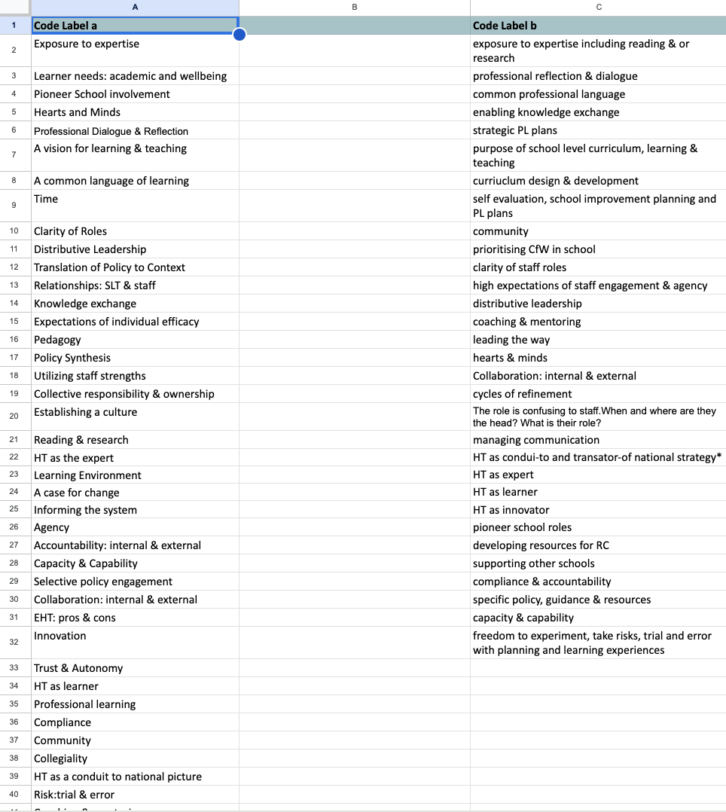

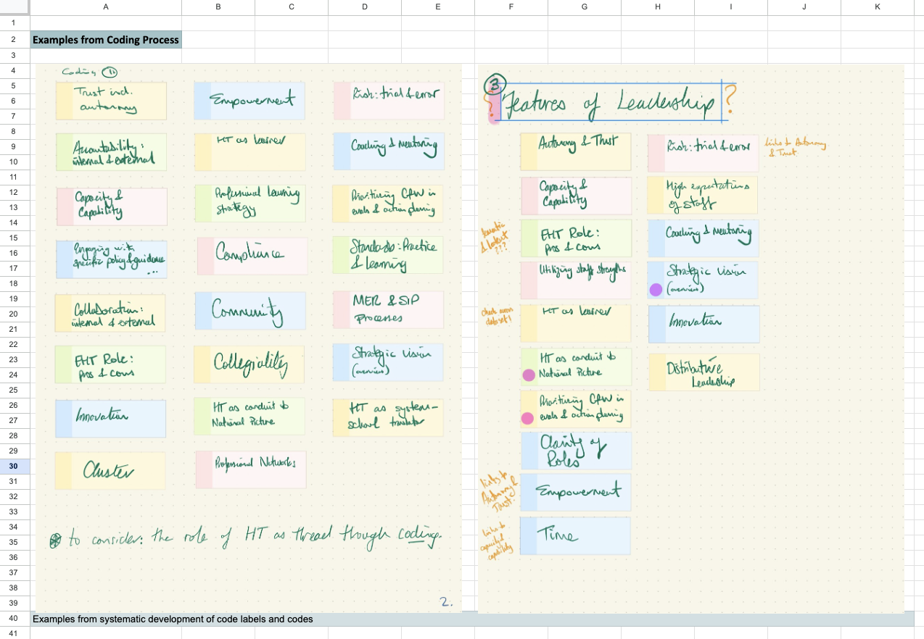
Excerpt of developing code labels

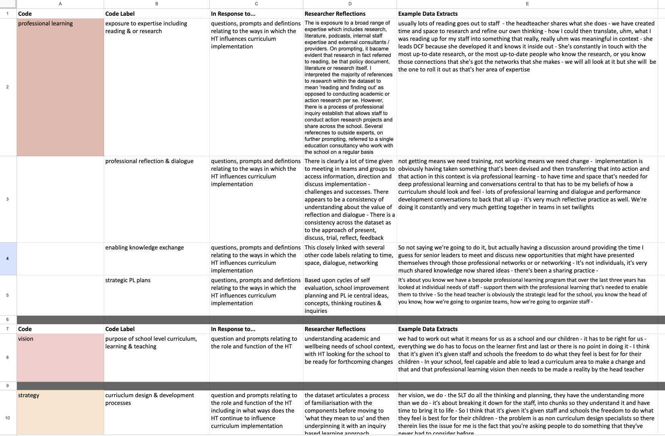
Excerpt of coding

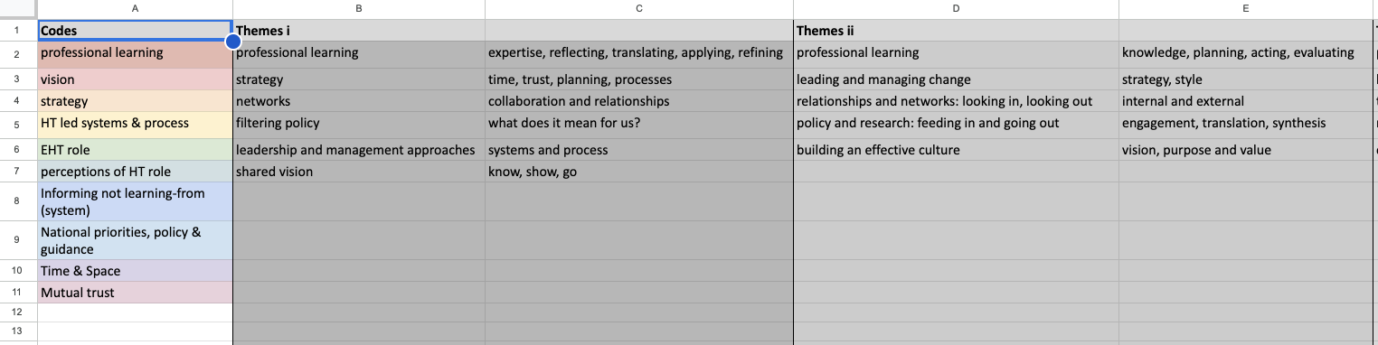
Excerpt of refining codes and Initial theme development

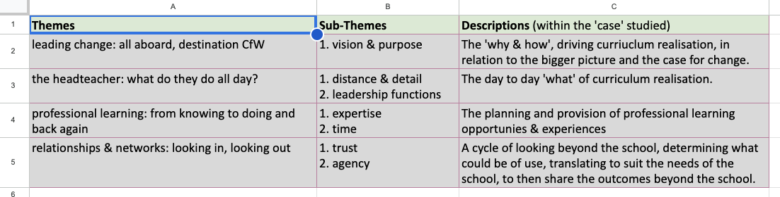
Final Themes

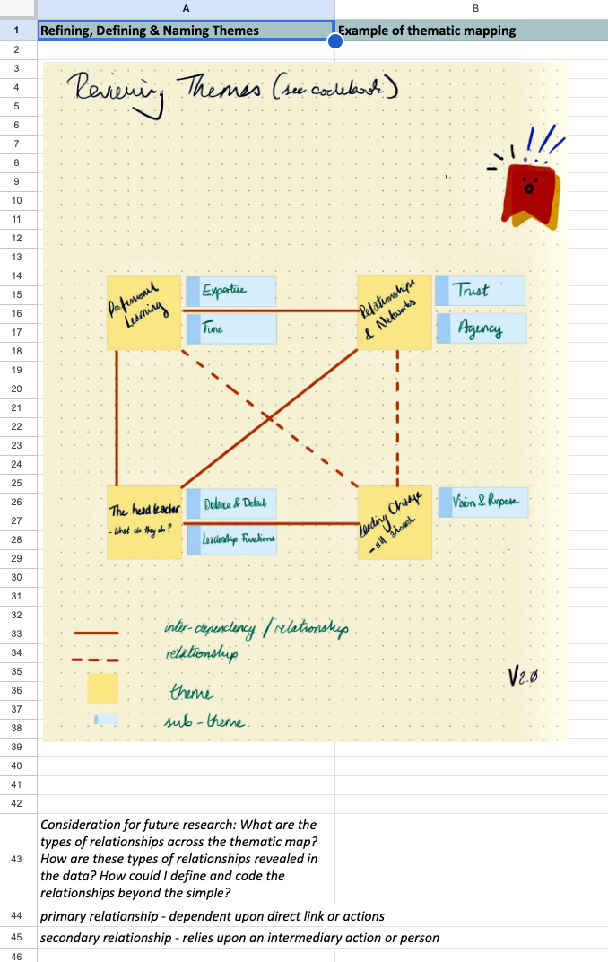
Example of thematic mapping process

APPENDIX I - Excerpts of reflexive journal


