Geraint Jones 1908119

cOMPUTATIONAL THINKING DESIGN AND IMPLEMENTATION OF LEGOMIND STORM

Computational Thinking- Design and Implementation of a Lego MindStorms Solution
UML
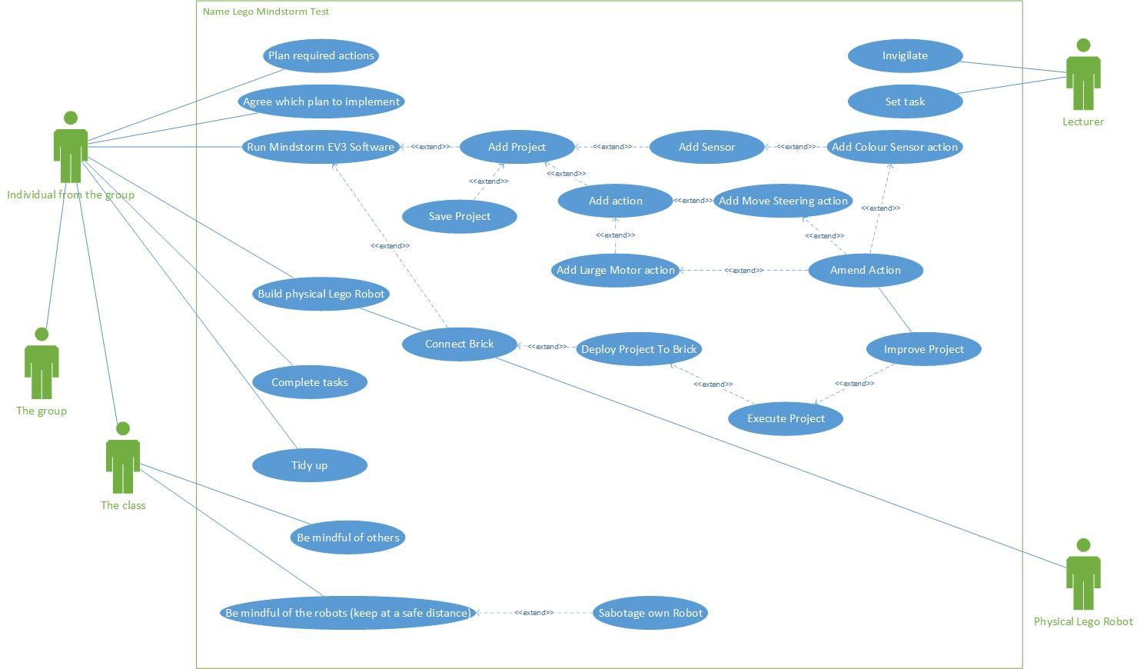
Name of use case : Mindstorm Test
Created By : | Geraint Jones | Last updated by: | 19/01/2020
Date created : | 12/01/2020 | Last revision date : | 19/01/2020
Description : | Flow of task to complete Mindstorm test
Actors : | Lecturer, Physical Lego Robot, The Class, The Group, Individual from the group
Preconditions : | - Tasks are set  - Date and time for the group exercises are set  - Location is set  - For each group there is a computer device with Mindstorm EV3  - For each group there is a complete Lego Mindstorm kit  - Lecturer is set  - Individuals plan require actions
Postconditions : | - The appropriate room remains available for the group exercises  - There are no IT issues to prevent the exercises  - Enough members of each group arrive  - Lecturers is available
Flow : | - Be mindful of others  - Be mindful of the robots  - Lecturer Invigilates  - Group decides which plan to implement  - Group runs Mindstorm EV3 software  - Group creates a project, based on the planned task  - Group creates physical robot  - Group connects Brick to physical robot  - Group loads Project to Brick  - Group executes Project  - Group Improves Project  - Complete tasks  - Tidy up
Alternative Flows : | 4. In step 4 of the normal flow the group may decide the plan selected wasn’t correct  1. Group revisits plans  2. Group selects a new plan
Exceptions : | 2. In step 2 of the normal flow if the group identifies the task cannot be completed  1. No longer be mindful of the robots  2. Put robot in harms way of another group  3. Sabotage own robot
Requirements : | The following requirements must be met before execution of the use case  - The group must be assembled  - The Lego Mindstorm kits must be available  - Computer devices with Mindstorm EV3 installed must be available  - A Lecturers is available

BPMNs
Main
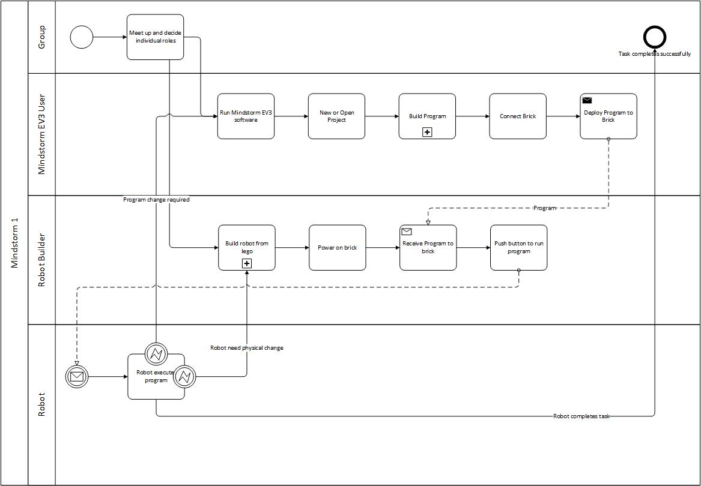

Build program sub processes
Rectangle
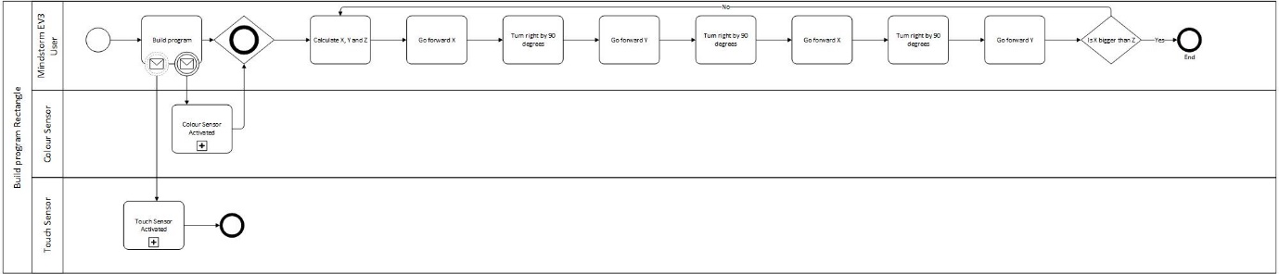
Triangle
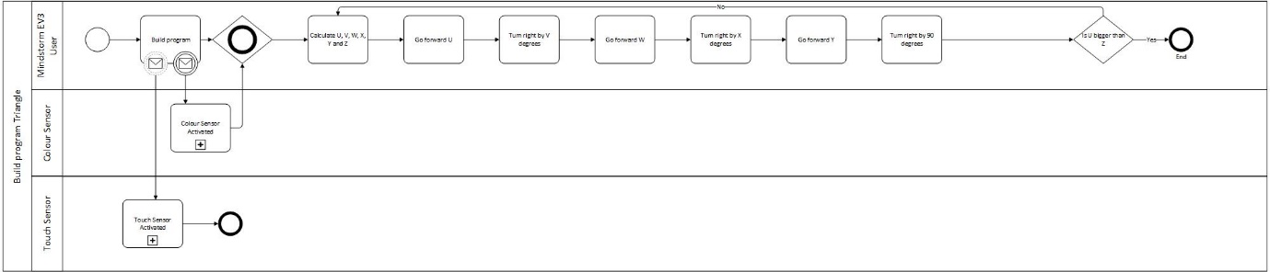
Circle in a square
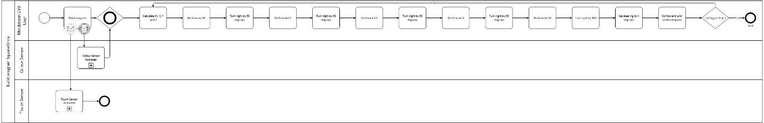
Joined symbol
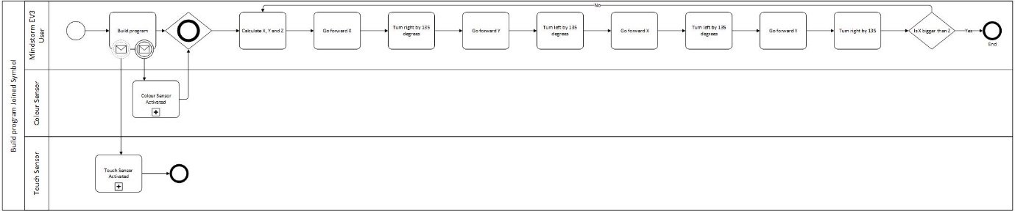
Colour Sensor
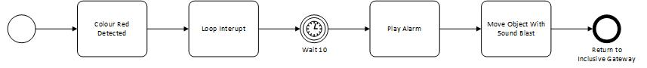
Touch Sensor
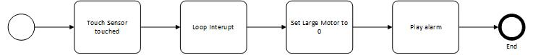
Evidence of MindStorms solutions to problems provided below:
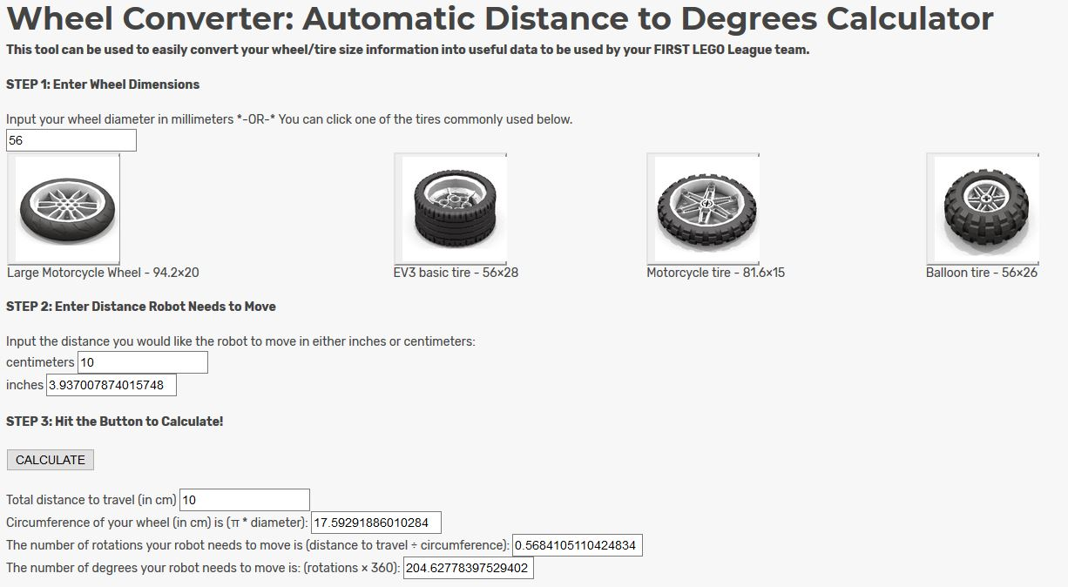
We began by using EV3: Lessons wheel calculator to determine our values.

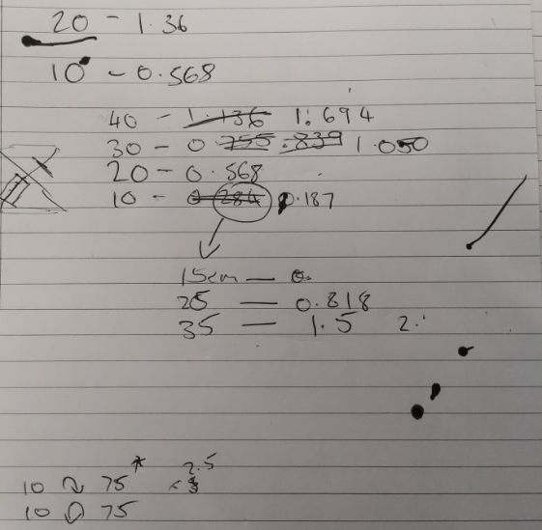

We had to adjust our initial workings as there was inconsistencies perhaps due to the surface and traction of the pen.

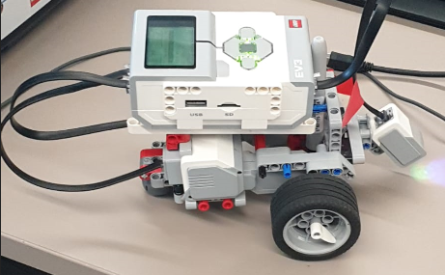
While a few of the team began working out the rotation values the rest built the robot.

The first shapes attempted were the rectangles as displayed below:
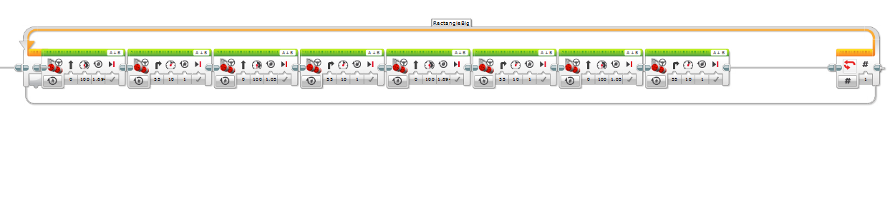
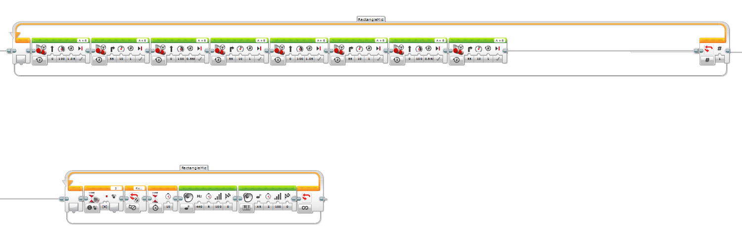
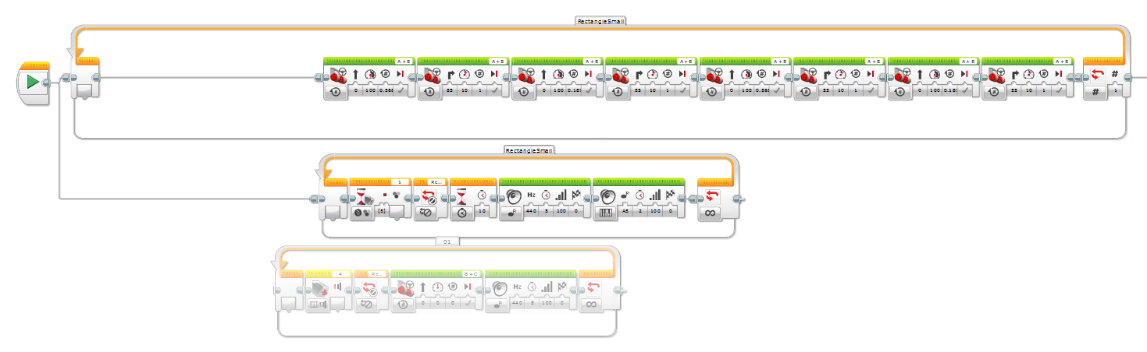
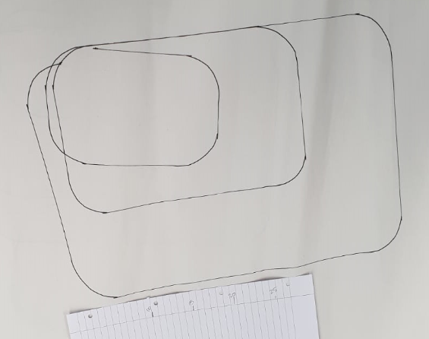
We programmed 3 rectangles to be drawn with values that increased each time.

We then attempted a tringle using a similar method:

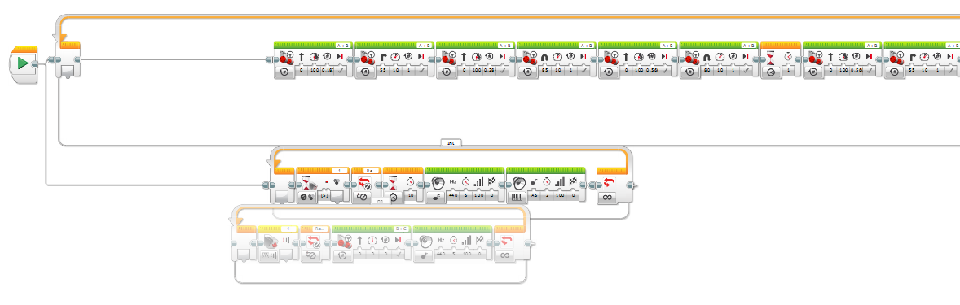
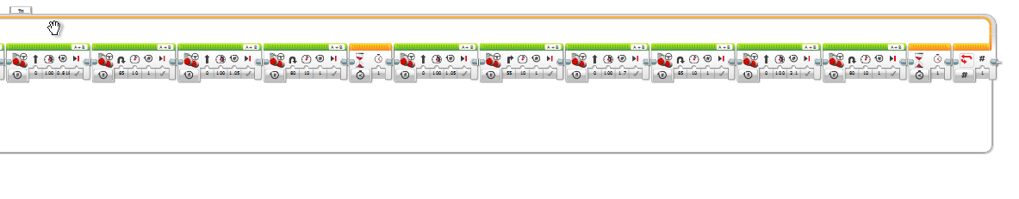
With some adjustments to the values we were able to draw three triangles with relatively decent accuracy.

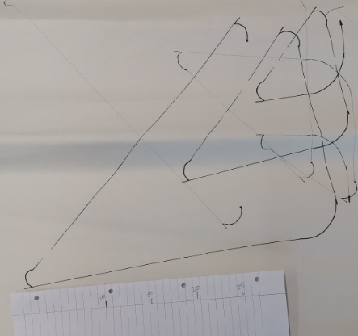

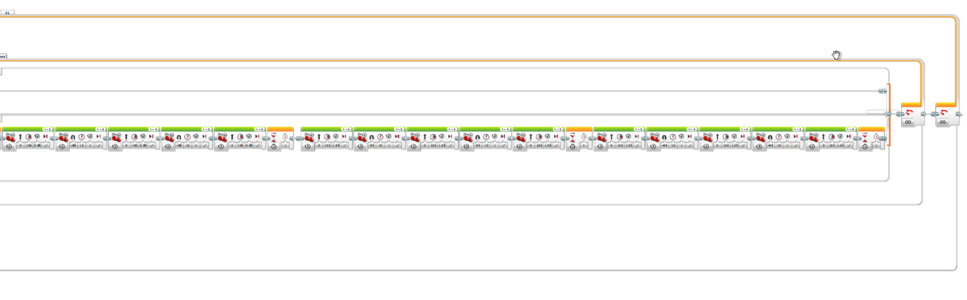
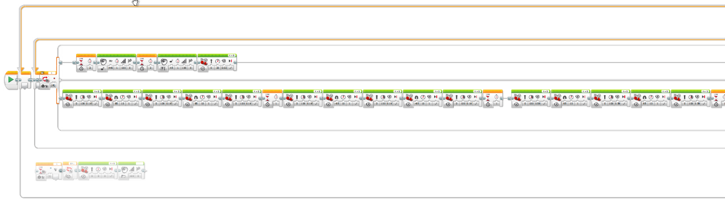
The next shape attempted was the join symbol:

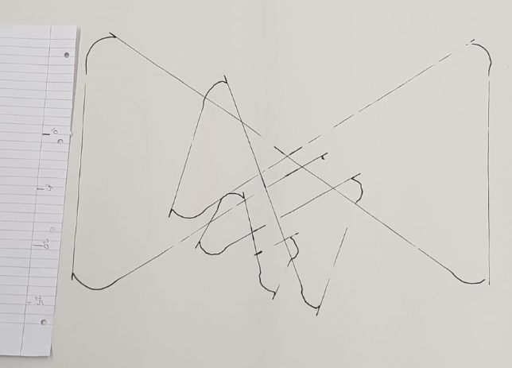

We finally attempted the circle within the square but were unable to complete it:
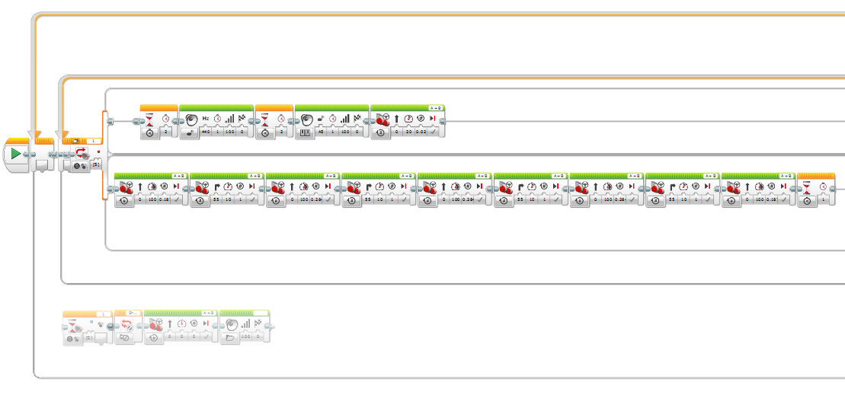
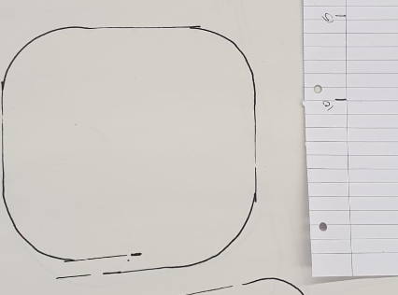

We also attempted to programme a light sensor to detect red tape, stop, play a tone and then continue with the shape. This was successful and presented to David. The problems arose when we added another colour so eventually, we ended up disconnecting that part of the process.


