



Lecturer: Kelvin Lake Module Code: M6X00408

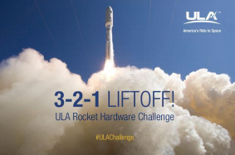

BEng MAnufacturing Systems

Aaron Pritchard – P151481

Advanced Computational Methods:
ULA Rocket Hardware Design
Aaron C. L. Pritchard Wh.Sch.
University of Wales Trinity St David

Executive Summary
This paper acknowledges and utilises the benefits of Topology Optimization in order to determine if an optimal design is possible. The task is to reduce the material required while maintaining mechanical strength to maintain the component remains fit for purpose. The material, weight, size, forces present, and specifications of the final design have been set by ULA. They ran project ‘Atlas V’ and required further development of a bracket used to secure a working platform to the vehicle interface during grounding.
The results of the study are discussed further, analysing positive and negative outcomes of the final design and what the next steps would be prior to manufacturing ready for use.
The report doesn’t draw any findings related to whether the optimised part could reach a final design stage and still remain within the boundary conditions, but rather highlight the benefits and purpose of topology optimization and the possibilities within manufacturing by utilising this tool. The report discusses the cost implications, material usage, mechanical considerations and safety requirements that must be considered.

Table of Contents
List of Figures 3
1. Introduction 4
2. Stock Design 5
3. Topology Optimization 9
4. Proposed Design Using Topology Optimisation 11
5. Critical Analysis of Proposed Design 15
6. Conclusion 19
7. Bibliography 21

List of Figures
_________________________________________________________________________
Figure 1 - ULA Atlas V Rocket at Ground Processing (Carson, 2019) 4
Figure 2 - Location of Support Bracket on Atlas V Exploded View (GRABCAD, 2017) 5
Figure 3 - Stock Part in Design Studio for GENESIS (Design Studio for GENESIS, 2019) 5
Figure 4 - Nodular Display in Topology Optimization (Design Studio for GENESIS, 2019) 6
Figure 5 - Topology (a) Continuous Case (b) Discrete Approach (Saadlaoui, et al., 2017) 7
Figure 6 - Support Bracket Technical Drawings (GRABCAD, 2017) 7
Figure 7 - FDM Process (Hashmi, et al., 2014) 8
Figure 8 - Topology Optimization Example of an Automotive Control Arm (Abaqus, 2020) 9
Figure 9 - Topology Optimization Test Cycles Reducing Material Volume (Design Studio for GENESIS, 2019) 10
Figure 10 - Requirements for Optimised Bracket Design 11
Figure 11 - Topology Optimization Results (Design Studio for GENESIS, 2019) 13
Figure 12 - Topology Optimization Result (Design Studio for GENESIS, 2019) 13
Figure 13 - Topology Optimized Part in SolidWorks (SolidWorks, 2019) 15
Figure 14 - Hole Diameter on Proposed Design (Design Studio for GENESIS, 2019) 16
Figure 15 - Material Surrounding Hole (Design Studio for GENESIS, 2019) 16
Figure 16 - Stress Locations From Topology Optimization Testing (Design Studio for GENESIS, 2019) 17
Figure 17 - Displacement From Topology Optimization Testing (Design Studio for GENESIS, 2019) 18

1. Introduction
In an ever-increasing market, Additive Manufacturing (AM) was estimated to be worth USD 7.97 billion in 2018, rising to a predicted USD 23.33 billion by 2026 with automotive and aerospace industries stimulating the market demand (Reports and Data, 2019). AM provides popular industrial means of producing complex mechanical parts when traditional methods are not viable. Designers benefit from great freedom by utilising AM and its associated manufacturing techniques. It is stated by (Saadlaoui, et al., 2017) that designers can benefit from numerical topology optimization tools which stimulate structures with complex shapes to exactly meet the mechanical constraints while requiring as little material as possible.
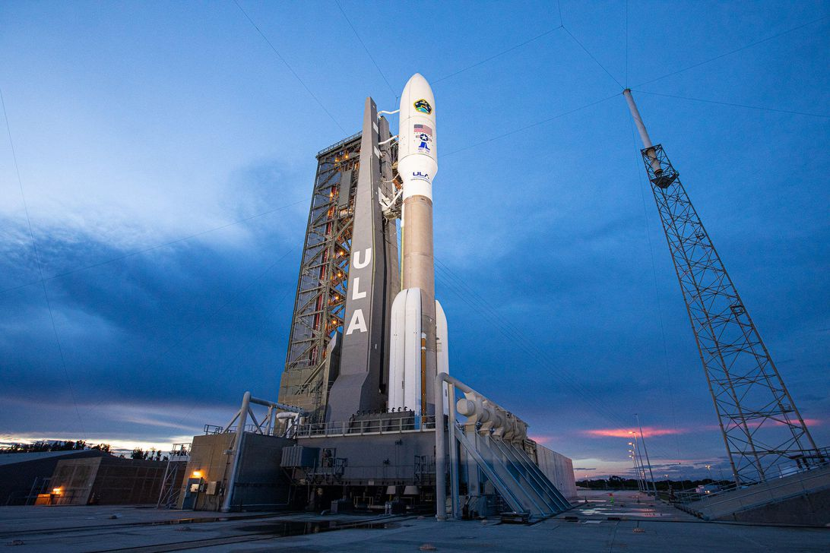
This report presents the topology optimization of a linearly elastic component subject to specified calculated loads that it will experience in operation. The component under analysis is an internal boat tail support bracket. The bracket is used during ground processing in numerous locations around the vehicles upper stage to provide a support point for working platforms. The bracket remains with the rocket during flight and therefore other factors require further analysis and proposed changes. The weight of the rocket will directly affect the flight mechanics, such as propulsion forces required and fuel efficiency, and this means a lighter sum of all components so that fuel and flight dynamic benefits will ensue.
Figure 1 - ULA Atlas V Rocket at Ground Processing (Carson, 2019)

2. Stock Design
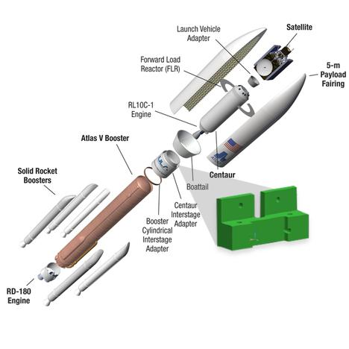
The location of the stock support bracket is inside the payload fairing of the rocket. The payload fairing (Figure 2) is used to protect the internals of the spacecraft against aerodynamic forces during the early portion of the launch phase as it leaves the atmosphere (NASA, 2020).
Figure 2 - Location of Support Bracket on Atlas V Exploded View (GRABCAD, 2017)
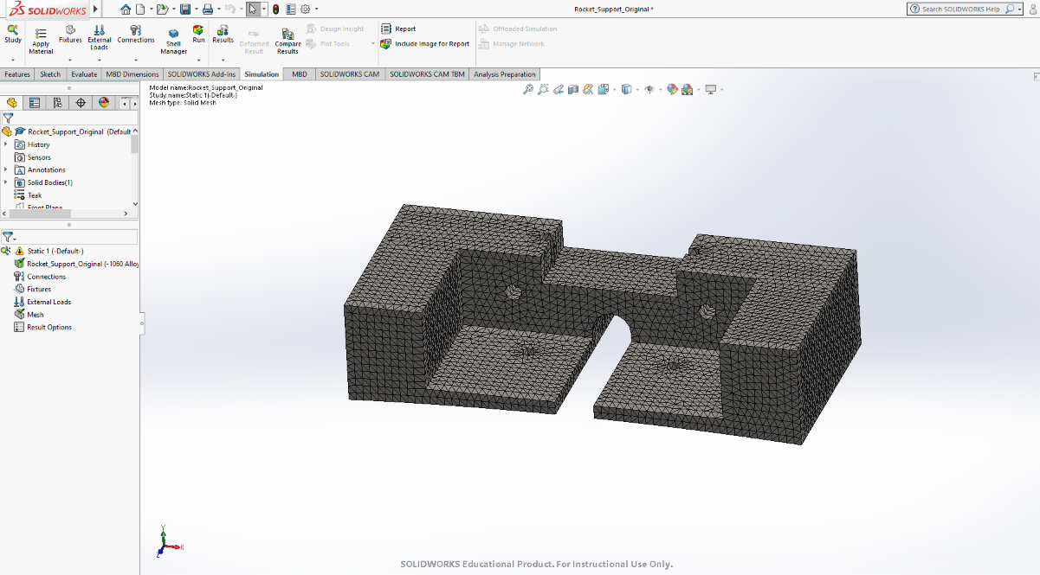
The current design (Figure 3) features four mounting holes for the vehicle interface side, and two holes for the weight bearing face.
Figure 3 - Stock Part in Design Studio for GENESIS (Design Studio for GENESIS, 2019)
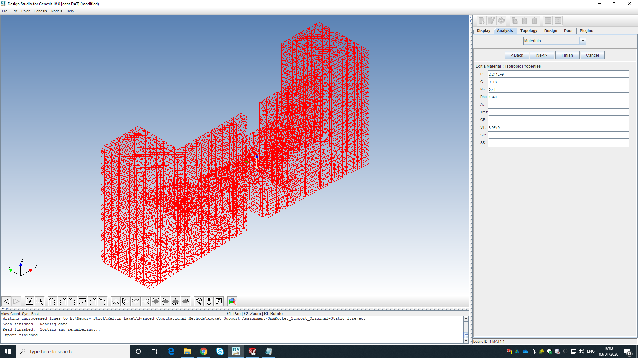
During the TO study, boundary conditions are set. Fixed points of geometry and forces acting on the part are specified by selecting which nodes are under their designated stresses. The nodular image used to select the required conditions is shown in Figure 4.
Figure 4 - Nodular Display in Topology Optimization (Design Studio for GENESIS, 2019)

The size of the stock part is stated as critical and must not be exceeded during the optimisation procedure, therefore providing the hole positions are untouched, the surround material can only be reduced accordingly. The design brief also states that “the minimum edge distance surrounding all bolt holes shall be two times the diameter of the bolt hole”.
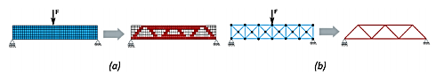
Considering the boundary conditions of the part for any additional manufacturing and TO, such as fixed points of geometry and forces, the manufacturing process of the part will rely directly on the mass of the material. The cost of the part is therefore down to the volume of material required rather than the complex production method, which is the opposite to subtractive manufacturing. To improve the cost efficiencies of the part, reduction in the volume of material needed for production is vitally important. Topology is not necessarily to identify the most suitable shape when altering the stock part, but instead find the optimal distribution of material and void regions inside the defined boundaries. Figure 5 shows the two potential methods of design with topology, the removal of material by identifying shape and voids (a) and creating the optimum design prior to manufacturing any part first (b).
Figure 5 - Topology (a) Continuous Case (b) Discrete Approach (Saadlaoui, et al., 2017)

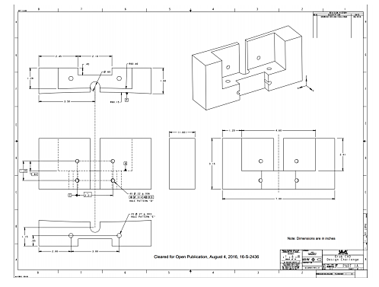
The technical drawings for the current design are shown in Figure 6. Once a topology study has been completed, areas of high stress concentration and displacement can be identified, and the modification of this part can be carried out.
Figure 6 - Support Bracket Technical Drawings (GRABCAD, 2017)
The material requirement for this project is Polyetherimide (PEI), known as Ultem 9085 by its trade name. It is a high flow, amorphous, transparent blend according to its creator, Sabic Innovative Plastics (2020). The material is a desirable choice due to its mechanical properties. It boasts relatively low density compared to other traditionally used materials for similar processes, and strong flame, smoke and toxicity resistant properties (Bagsik & Schoppner, 2011). PEI is compatible with Fused Deposition Modelling (FDM), a process shown in Figure 7, which allows the additive manufacturing process of complex shapes to be viable. FDM is a process in which a physical object is created as an exact replica from a CAD model by uniquely fusing layer by layer deposits of the material being used through an accurate nozzle (Hashmi, et al., 2014). The manufacturing process and material choice therefore make an optimal design from a topology study possible.
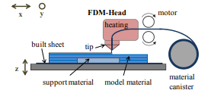
Figure 7 - FDM Process (Hashmi, et al., 2014)

3. Topology Optimization
In the last few decades, topology optimization (TO) has expanded significantly due to its ability to successfully address practical engineering problems in a variety of fields (Bing-Chung & Kikuchi, 2001). The development of this field can be found originally in studies by Kohn and Strang (1986) and Bendsoe and Kikuchi (1988). Bendsoe and Kikuchi initially approached their studies to optimise structures subjected to a single static load, work which continued with Kikuchi in the 90s (1991) and multiple loads using a homogenization method. Homogenization is the process of making something uniform or similar (Oxford Dictionaries, 2020). The basis of their thesis was to optimise the material properties of the part/structure in question with overall minimum material amount compliance.
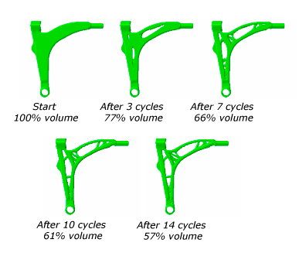
TO as a tool is used to shorten the development process by adding value to the initial design with an automated procedure (Abaqus, 2020). In order to optimise the model correctly for the purpose specified, tailoring what areas are optimised is critical to quality (CTQ). Weight, size and minimising maximal nodal stress concentrations are some areas for consideration, also altering the shape of a component for applications where aerodynamics plays a part but where a strength component is still essential. TO software programmes are intelligent enough to analyse specific nodal values experienced or calculate a specific volume reduction requested. In order to develop an optimized solution, TO programmes will run multiple cycles whereby the original design will be stripped back step by step until the optimal design specifications are obtained as shown in Figure 8 and Figure 9.
Figure 8 - Topology Optimization Example of an Automotive Control Arm (Abaqus, 2020)
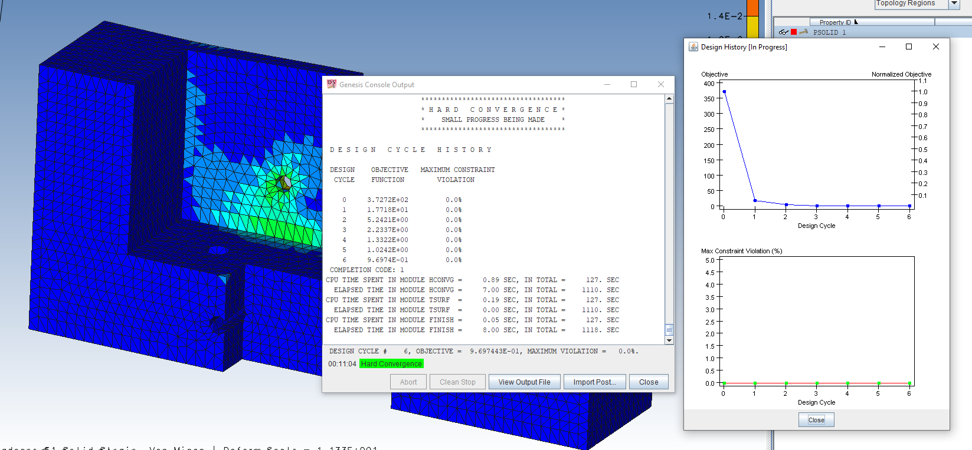
Figure 9 - Topology Optimization Test Cycles Reducing Material Volume (Design Studio for GENESIS, 2019)

With TO being a mathematical and automated process, the optimum design can often display gaps and separations within the solid structural body. These inconsistencies can therefore be corrected by a CAD engineer who can alter the optimized solution while maintaining the structural soundness of the component. Due to this, the final part usually varies from the best solution predicted by TO calculations (Saadlaoui, et al., 2017).

4. Proposed Design Using Topology Optimisation
To utilise TO, Design Studio for GENESIS (DSG) was the chosen software package for the task. DSG is a design orientated and post-processor graphical interface for the GENESIS Structural Analysis and Optimization Software (VR&D, 2019). In effect, is enables users to display finite element models and optimize the results from a design perspective. Thus, reducing the amount of material required to create a part while testing it is still fit for purpose before any physical model is created.
A series of static FEA studies were produced. Using different mesh sizes, assuming the FEA model with the finest mesh was the most accurate result based, it was decided after a draft mesh size that 3mm provided accuracy in results due to very small variance when reduced. Von mises stress and deformation of the part variance reduced when the mesh got smaller, therefore 3mm enabled a quicker processing time and accuracy balance.
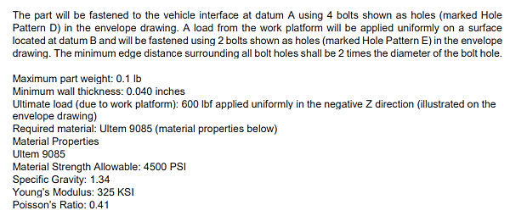
The desired characteristics of the stock part following the topology optimization were stated in the design brief, this is shown in Figure 10. The design brief states how the bracket is mounted securely to the vehicle interface and the working platform, therefore the hole positioning on the brackets must remain identical to ensure the bracket is still compatible with its intended purpose.
Figure 10 - Requirements for Optimised Bracket Design

The maximum weight of the bracket is stated as 0.1lbs (45.3592g). The task states that “the bracket remains with the upper stage of the rocket during flight” and that the vehicle weight has a first order effect on the performance of the system”. This information highlights the importance of “minimising weight to dramatically improve payload weight to orbit”. With a maximum weight being a critical component of the new design requirements, it is essential to calculate how much material needs to be removed in order to reduce the weight sufficiently and establish if the part is still fit for purpose. In order to calculate the weight of the stock part to create a baseline, the design CAD file was opened using SolidWorks and a volume of 325.57${cm}^{3}$ was established. The material used for the bracket part is Ultem 9085. According to Materialise (2019), a company innovating product development using an in-depth knowledge of Additive Manufacturing, Ultem 9085 has a density of 1.34g/${cm}^{3}$.The current and target weight of the two parts were calculated:

$$Volume of Original Part=325.56998{cm}^{3}$$
$$Mass of Original Part=Volume ×Density=436.26g$$
$$Topology Target= <45.3592g$$
$$Topology Optimisation=0.1035=45.15g$$

It was calculated that to sufficiently complete the task remaining under the maximum weight target, the amount of material required to be removed was 89.65%. The resultant TO tests is displayed in Figure 11.
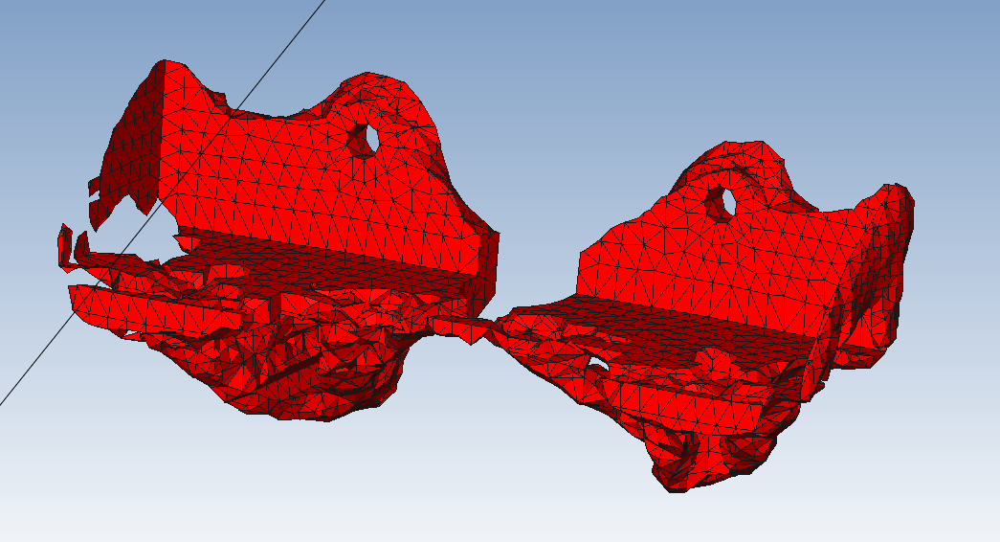
Figure 11 - Topology Optimization Results (Design Studio for GENESIS, 2019)

Figure 12 portrays the optimized sat inside the original design whilst under stress and experiencing deformation. This demonstrates the amount of material removed and how the core material remaining is situated around the areas of the part experiencing the most stress.
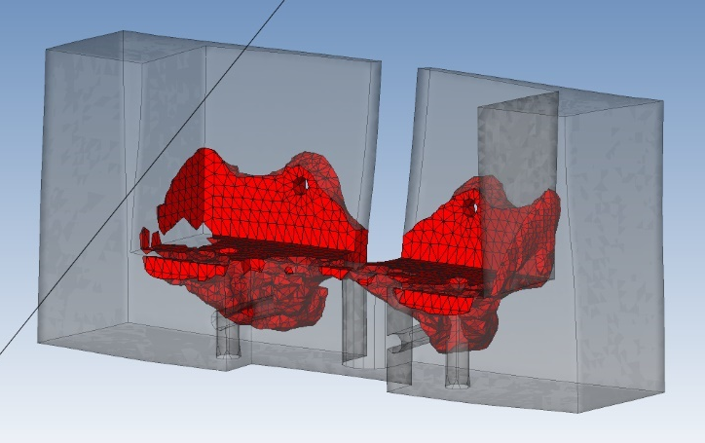
Figure 12 - Topology Optimization Result (Design Studio for GENESIS, 2019)
The design brief states that the minimum wall thickness once the required amount of material had been removed was to remain no less than 0.040 inches (1.016mm). Thus, when the topology results are created, the design can be transferred to a design package such as SolidWorks where a practical mould can be created based on the topology results and wall thickness measured to ensure it suffices. During this phase, the topology design may need altering in order to meet such requirements. Likewise, SolidWorks and DSG can run stress/strain analysis and static load testing on the optimized part and test to see if it could withstand the ultimate load in the brief of “600 lbf (2668.93N) applied uniformly in the negative Z direction” i.e. Across datum B on the technical drawings.

5. Critical Analysis of Proposed Design
Although TO operates with material properties and stresses asserted onto parts, design alterations are often required to ensure the part is fit-for-purpose, safe, possible to be manufactured and in some cases remains aesthetically pleasing. The TO results developed under the test conditions and requirements conducted in this report provided a result with potential positive and negative outcomes. Once created, the TO result needs to be examined by design and manufacturing teams to create a product using computer-aided design (CAD) software. The TO result was transferred to SolidWorks to give the part shown in Figure 13.
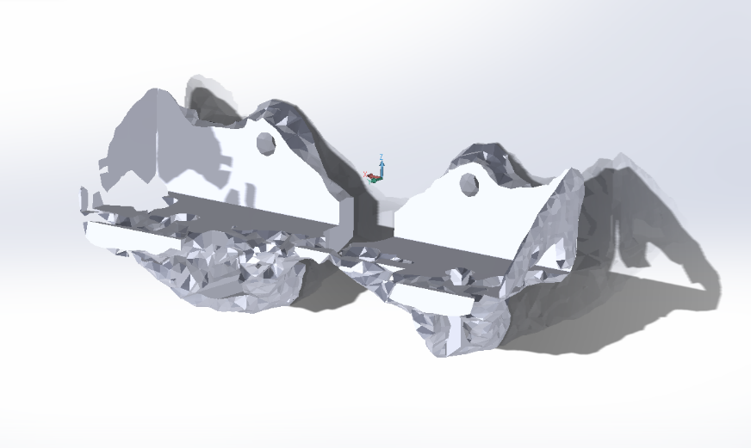
Figure 13 - Topology Optimized Part in SolidWorks (SolidWorks, 2019)

When analysing the proposed design, it has to meet the criteria stated in the design brief. One area of requirement was the material surrounding the holes be at least twice the diameter of the holes. The diameter of the hole shown in Figure 14 measures 0.0054mm, however the material surrounding the hole (Figure 15) is only 0.002mm, therefore failing the criteria with the current design.
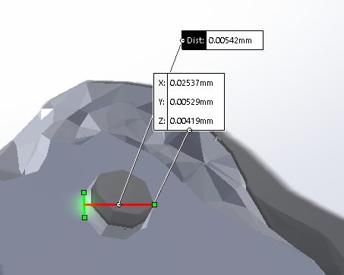
Figure 14 - Hole Diameter on Proposed Design (Design Studio for GENESIS, 2019)
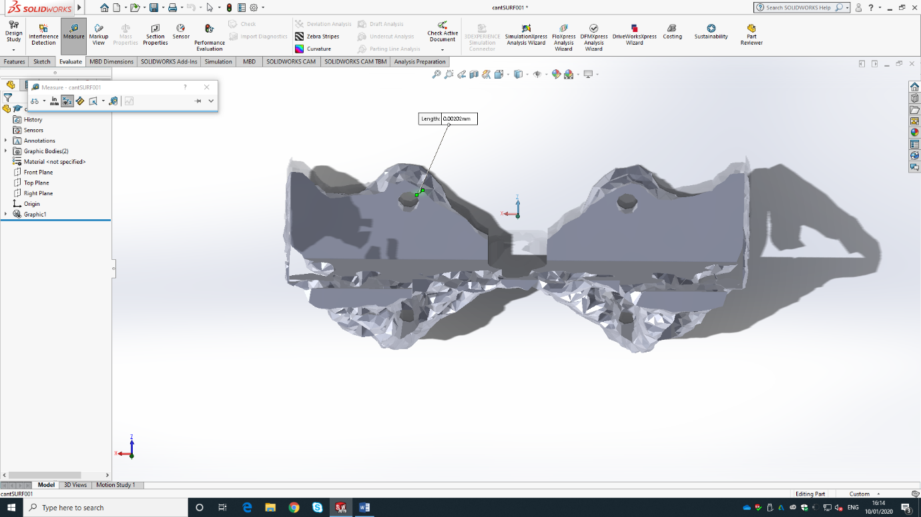
Figure 15 - Material Surrounding Hole (Design Studio for GENESIS, 2019)

The TO result demonstrates that it is not possible to reduce the material usage and the resultant weight to within the specified targets using the TO software. The design shows that the mounting holes which are paramount to the part fitting the other components involved in the larger assembly, are still intact and present however, the holes are not within specification and some material has been removed from around the entrance and exit positions of those holes. Further development and testing are required in order to assess if this is acceptable or if the part may become susceptible to weaker areas when placed under load. Highlighted in Figure 16 are the areas of stress witnessed in the part during loading. This highlights that the area under most stress is around the mounting holes on the back face which mount to the vehicle interface.

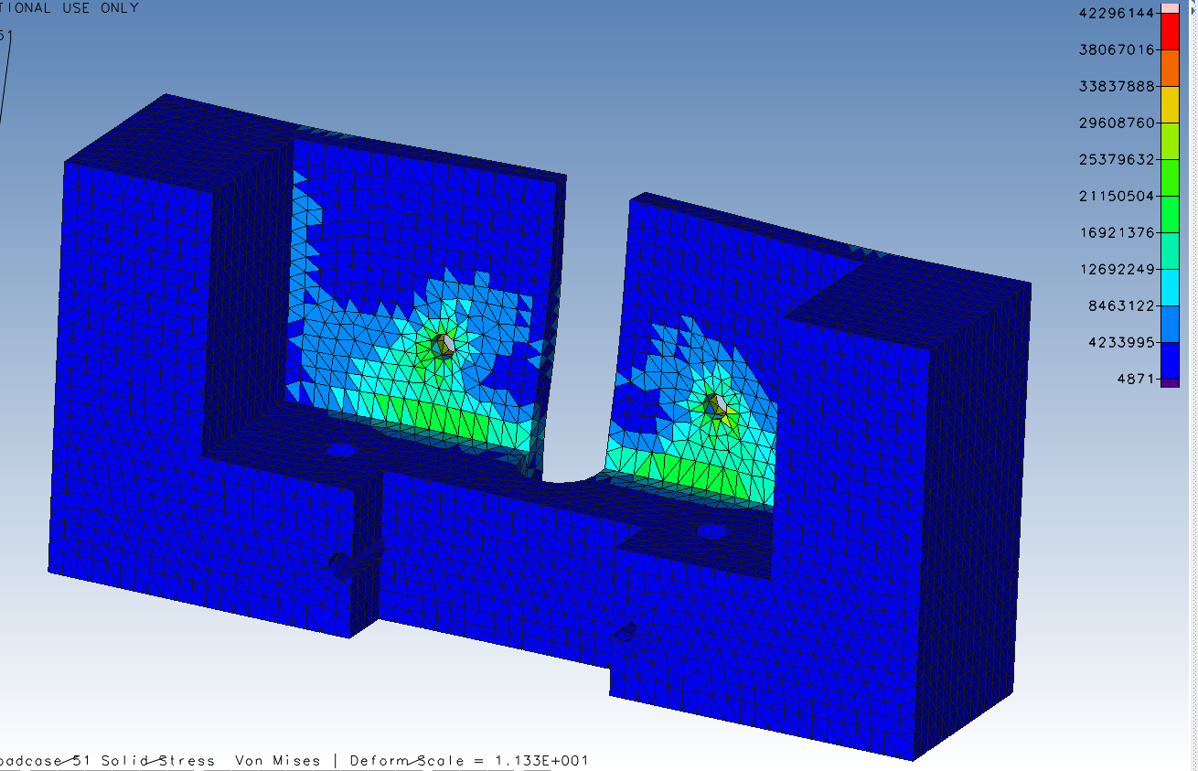
Figure 16 - Stress Locations From Topology Optimization Testing (Design Studio for GENESIS, 2019)

Considering the areas of highest stress, displacement requires consideration. Displacement according to The University of Pittsburgh (2020) is a vector that represents a movement of a point in a body due to applied loads between the initial and final points. The shape and size of the body do not change. The areas of highest stress, combined with larger displacement can result in a weak area more likely to fail under load. The displacement results from the TO shown in Figure 17 indicate that the largest displacement, highlighted in red, is witnessed furthest away from the higher stressed fixed points. The areas of high displacement are removed during the TO and therefore a future examination of the newly designed part would indicate if removal of this material has reduced the displacement witnessed. It is worth noting that the deformation scale for the optismed part to prevent unrealistic doformation in the TO results.
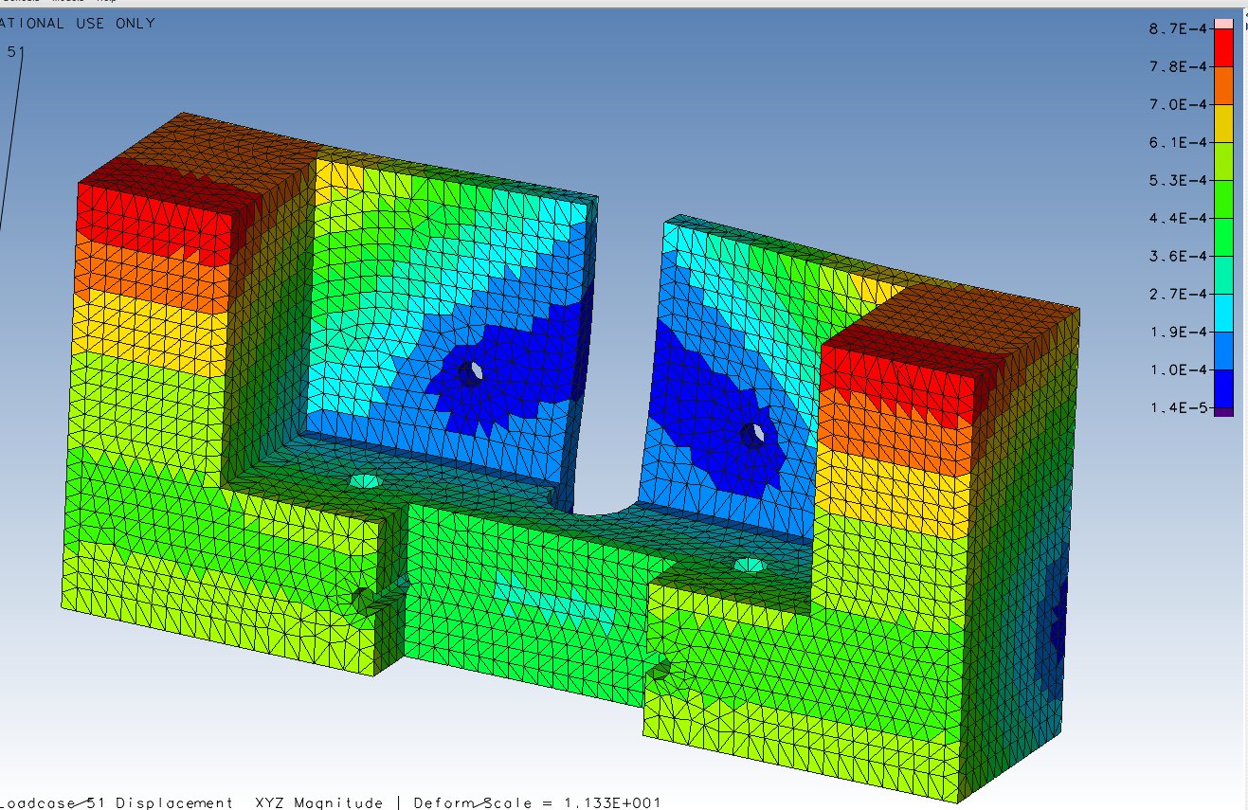
Figure 17 - Displacement From Topology Optimization Testing (Design Studio for GENESIS, 2019)

6. Conclusion
This report has identified that Topology Optimization is a very useful and powerful tool within manufacturing. It is not stand-alone, it requires other considerations such as material possibilities, purpose requirements and safety factors to be considered for the optimal numerical design to be implemented successfully. As stated in the report, the optimised part is different to the final part, this calls upon further investment into the design engineering department in order to get the most out of TO while ensuring that the final design meets all criteria that TO has failed to achieve.
The stress loads placed upon the part during testing were given by the design brief. These forces would need to be verified in order to confirm the original design, and the new one, are both fit for purpose. These assumptions have been allowed in this report due to them being provided by the company setting the task for their project.
One possible discrepancy requiring attention which was picked up upon visual inspection of the TO part, was the removal of material around the entrance and exit locations of the mounting holes. Further static load testing would be required to test its suitability, however when creating the final part from the results this may be an area that will be overwritten. The most important consideration due to the task requirements is to ensure that the final model which can be created initially as a prototype for purpose, must remain under the weight threshold when filling in the voids created in the TO design, voids which may produce areas of weakness when placed under loading.
Topology has reduced costs for manufacturers by ensuring quality remains high while material usage remains as low as is feasible, this is through decades of process perfecting by studies such as those of Bendsoe and Kikuchi. Due to the rapid growth within the AM industry, self-funded research by large companies has also driven the growth rate of the field. The material reduction possibilities combined with the consistent growth in advanced manufacturing processes such as FDM, make topology outputs even more accessible and viable in a wider range of manufacturing industries than ever before. Combining TO and advanced processes such as FDM for example, may result in the perfect compromise between mechanical strength and material savings being achieved.
Topology advancements and capabilities have also spread up the production time required for implementing new initiatives. In an industry which is continuously advancing at such a rate, it is paramount that production capabilities strive to improve in relation to what is demanded from manufacturers relating to their TO and AM goals. Recognising that a reduction in material usage has massive benefits to process time and cost, it also reduces the damage done to the ecosystem and the world as a whole. If all manufactures can reduce material usage and waste while utilising the advanced technologies used in AM across other areas of industry such as packaging and construction for example, the possibilities are endless.

7. Bibliography
Abaqus, 2020. About Structural Optimization. [Online]
Available at: https://abaqus-docs.mit.edu/2017/English/SIMACAEANLRefMap/simaanl-c-optover.htm
[Accessed 07 January 2020].
Bagsik, A. & Schoppner, V., 2011. Mechanical Properties of Fused Deposition Modeling Parts Manufactured With Ultem*9085, Boston: Antec.
Benardini, J., Duc, M. T., Beaudet, R. A. & Koukol, R., 2014. Implementing Planetary Protection Measures on the Mars Science Laboratory. Astrobiology, January.
Bendsoe, M. P. & Kikuchi, N., 1988. Generating Optimal Topologies in Structural Design Using a Homogenization Method. Comput. Methods Application Mechanical Engineering, 71(2), pp. 197-224.
Bing-Chung, C. & Kikuchi, N., 2001. Topology Optimization with Design-dependent Loads. Finite Elements in Analysis and Design, Volume 37, pp. 57-70.
Carson, E., 2019. Watch Video of ULA's Atlas V Rocket Blast Off From Florida. [Online]
Available at: https://www.cnet.com/news/watch-video-of-ulas-atlas-v-rocket-blast-off-from-florida/
[Accessed 07 January 2020].
Department for Business Innovation & Skills, 2010. Manufacturing in the UK: An economic analysis of the sector. [Online]
Available at: https://assets.publishing.service.gov.uk/government/uploads/system/uploads/attachment_data/file/31785/10-1333-manufacturing-in-the-UK-an-economic-analysis-of-the-sector.pdf
[Accessed 24 October 2019].
Design Studio for GENESIS, 2019. Topology Optimization. London: GENESIS.
GRABCAD, 2017. 3-2-1 Liftoff! ULA Rocket Hardware Challenge. [Online]
Available at: https://grabcad.com/challenges/3-2-1-liftoff-ula-rocket-hardware-challenge
[Accessed 07 January 2020].
Hashmi, S., Batalha, G. F., Van Tyne, C. J. & Yilbas, B., 2014. Comprehensive Materials Processing. s.l.:Elsevier.
Kohn, R. V. & Strang, G., 1986. Optimal Design in Elasticity and Plasticity. Numer. Methods Engineering, Volume 22, pp. 183-188.
Krishnamoorthy, K., 2009. Quality Assurance in NDT, Toronto: Atomic Energy of Canada Ltd.
Materialise, 2019. Ultem 9085. [Online]
Available at: https://www.materialise.com/en/manufacturing/materials/ultem-9085
[Accessed 06 January 2019].
NASA, 2020. Payload Fairing. [Online]
Available at: https://mars.nasa.gov/mer/mission/launch-vehicle/payload-fairing/
[Accessed 07 January 2020].
Oxford Dictionaries, 2020. Homogenization. [Online]
Available at: https://www.lexico.com/definition/homogenization
[Accessed 07 January 2020].
Reports and Data, 2019. Additive Manufacturing Market To Reach USD 23.33 Billion by 2026. [Online]
Available at: https://www.globenewswire.com/news-release/2019/03/18/1756526/0/en/Additive-Manufacturing-Market-To-Reach-USD-23-33-Billion-By-2026.html
[Accessed 07 January 2020].
Saadlaoui, Y., Milan, J.-L., Rossi, J.-M. & Chabrand, P., 2017. Topology Optimization and Additive Manufacturing: Comparison of Conception Methods Using Industrial Codes. Journal of Manufacturing Systems, Volume 43, pp. 178-186.
Sabic Innovative Plastics, 2020. Ultem Resion 9085. [Online]
Available at: https://www.sabic.com/en/search/products-search?q=ultem%209085
[Accessed 07 January 2020].
SolidWorks, 2019. ULA Rocket Hardware Design, Bridgend: SolidWorks.
Suzuki, K. & Kikuchi, N., 1991. A Homogenization method for Shape and Topology Optimization. Comput. Methods Application MEchanical Engineering, Volume 93, pp. 291-318.
The Manufacturer, 2019. Manufacturing Statistics. [Online]
Available at: https://www.themanufacturer.com/uk-manufacturing-statistics/
[Accessed 24 October 2019].
University of Pittsburgh, 2020. Statics and Mechanics of Materials, Pittsburgh: University of Pittsburgh.
VR&D, 2019. Design Studio for GENESIS: Graphical Pre- and Post- processing Software. [Online]
Available at: http://www.vrand.com/products/design-studio-for-genesis/
[Accessed 06 January 2019].

