
Callum Jones
2305269
ACHA5012
ACMA5007
Project Planning

Contents
- Contents page 2
- Introduction page 3
- Team roles page 4
- Overall tasks page 6
- My tasks page 7
- Milestones page 10
- Gateway objectives page 11
- Possible areas of concern page 12
- Gantt chart page 13
- References page 14

Introduction
My project team was tasked to design and build a working protype for an active rear wing that will be attached to the rear of a morgan.
“Design-Build-Test” are the main objectives given to us to increase the lap times of the car around a track. The focus from the manufacture is ‘performance’, this will work by increasing down force on the rear axle and increasing drag in braking zones to improve declaration. This will need to complete with 5 different areas of accuracy and production levels: Aerodynamics, Structural design, Control systems design, Mechanical components and Vehicle performance assessment. I will speak more about them later and their various teats that need to be completed.
Our manufacturer has specified certain contains in their technical regulations. 11 different types of regulations that need to be adhered to. Each of the regulations are more specific to certain roles for example ‘3 Wing confarreation’, one states ‘the wing can be a twisted wing concept but not multi-element.’ This would be something the aero team would need to follow.

Team roles
Group 4
First Name | Surname | Role
Callum | Jones | Project manager
Cody | Surridge | Structural design
Aeron | Tollet | Stimulation
Aron | Evans | Aerodynamics
Jake | Hicks | Control systems
Kowsar | Kashim | Control systems
nick | Davey | Aerodynamics
My role
My personal role is project manager, this is mainly because as I talked to the group and asked everyone what the were good at and what roles they would want to complete. This naturally put me as the role of project manager, with the information from my team on there interest, skills and what they would like to learn more about I allocated roles.
Project managers require specific skills and personality traits to be able to oversee projects from start to completion with control and corporation. Leadership skills is obvious an extremally important skill that is required but there are different aspects to leadership like decision making and conflict resolution.
A project manager also needs to be adaptable, decisive, and skilled in managing expectations. Personality traits like leadership, emotional intelligence, and a high degree of organization are crucial for collaboration, maintaining team morale, and ensuring that projects stay on track. Balancing technical knowledge with interpersonal skills is key to delivering successful outcomes.
Belbin’s team roles is a established model that can identify 9 different roles by asking simple questions that Identify someone’s personality. After answering the questions there are 9 different roles that are possible. I tried this and I was placed into team worker,
‘Helps the team to gel, using their versatility to identify the work required and complete it on behalf of the team.
Strengths: Co-operative, perceptive and diplomatic. Listens and averts friction.
Allowable weaknesses: Can be indecisive in crunch situations and tends to avoid confrontation.
Don't be surprised to find that: They might be hesitant to make unpopular decisions.’
https://www.belbin.com/about/belbin-team-roles
I agree with this assignment of my skills and personality to a certain degree, as I believe that I am not hesitant to make unpopular decisions.

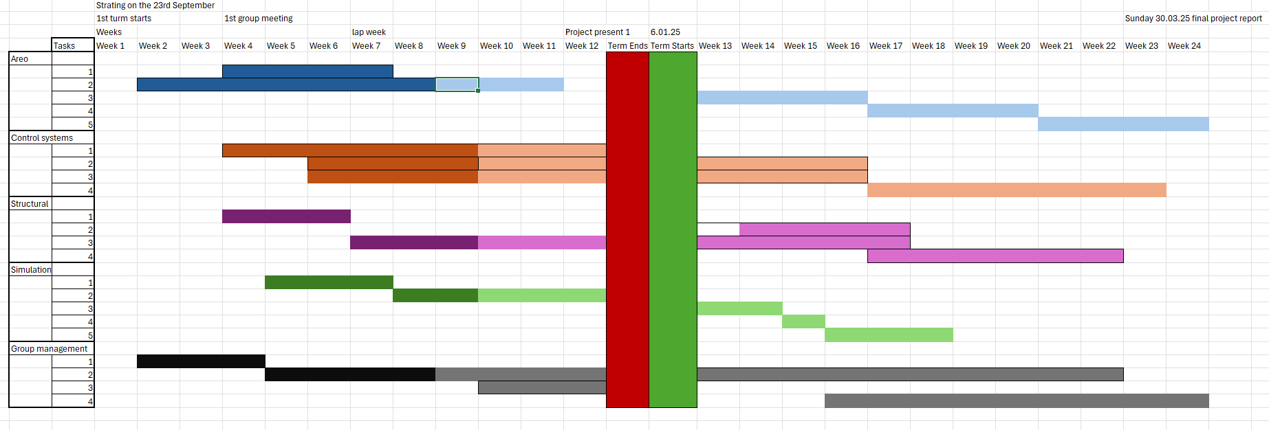
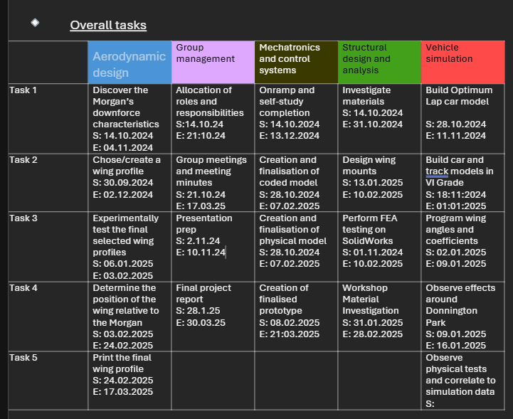
My personal tasks
As I am project manager, I don’t really have many specific tasks that I have to complete my job is to ensure that my team completes their personal tasks. To ensure this I have run meetings once a week to hear feedback from everyone and have a discussion on what way everyone wants the project to go. During the meetings I have been taking minutes/notes so on what each individual will be completing that week so next meeting I can track what they have done or no. this allows me to offer assistance to whoever might be struggling or on the ither hand give more responsibilities and new tasks to anyone who is excelling.
I listed my personal tasks as.
- Allocation of roles and responsibilities
- Group meetings and meeting minutes
- Presentation prep
- Final project report
1st tasks were simple and done in our second lesson and was only one hour as I have explained earlier. Each member already had their own idea of what role they wanted to complete so there was no arguments or hard decisions to make.
2nd, group meetings and meeting minutes. At the start of every week, I book a room in the library and speak to each member of the team. This is to make sure everyone is happy and all heading in the same direction to complete the project with everyone’s input and sheared vision. In the meetings I was there to help answer questions and gather ideas form everyone and use that to make well informed decisions to better understand each individual view of their own task and the project as a whole. Secondly taking notes in the meetings was important as I was able to see what my team members doing form meeting to meeting and how they were getting on and if they needed any help or more tasks. Having these reference documents, I am able to capture import information and my team members personal tasks to help focus them and encourage them. Finaly as there are a register if one person cannot make it, I can speak to them at a later data one on one to see how they are doing and getting on with their work. This will take one to two hours each week and possible another hour for anyone that has missed the meeting or wants a personal meeting with me.
3rd, on the 10.12.25 we have a group presentation so show what we have completed halfway through the project. Everyone in the group will need to speak for three minutes about their person talks, I will introduce the project and finish of it at the end wrapping up the presentation. For this I will need to make a power point, and everyone will send me the personal power point to be added to mine. Secondly, I have planned a meeting to practice the presentation, so nobody is nervous, and everyone understands their own personal slides and the timing of the presentation as we are restricted on time.
4th, at the end of the project there will be a final presentation will display all our research, data and a working prototype. Most likely will take a while I have set two weeks to complete this although I will be stating the moment the next turn starts as there will be a larger amount of information to display, everyone in the group will make their own slides for the power point like the 1st presentation on the 10.12.25. I will need to compile with into one document and similar again to the 1st presentation, I will run a session running through it to ensures everyone is able to speak to the crowd secondly to ensure will finish in the correct time and finally, each member will speak coherent and care to best show there work off.
Bill of materials
As I am project manager I will not personally costs for materials, tools or utilities, although if this was a real project I would have to play salaries, insurance and office space. Luckly, I do not have to pay me team members as they work for free and a good grade. Secondly office space, as the library is filled with large rooms to hold meeting in for free all I do is book them and make sure everyone turns up. There are no fixed costs or variable costs. I don’t have to help the electronic and mechanical members with their matais as they do have a cost, and we have a budget of £10,000. This budget is only of the materials with is more than enough to cover everything, more to stop people going overboard on expensive and super high-tech parts and materials.
Special equipment, same again I don’t personally use any special equipment, although members of my team do that they include:
- Wind tunnel
- 3d printer
- CAD software
- Electronics like motors, Arduino and capacitors and many more.
- Coding software
- Mat lab
- Simulation software

Milestones
My milestones in the project are all group related and are predominately the completion of everyone’s else’s tasks to a professional standard.
1st is initiation and planning, the object is to establish the projects objectives, scope and deliverables. This includes team roles and a timeline, with all that information it allows me and my team to have a clear understanding of our collective goals, resources and timeline.
2nd Requirements and understanding of the design brief.
3rd Conceptual Design and Preliminary Work/ CAD
4th Final detailed design
5th Presentation
6th Prototype and testing
7th Design optimization
8th Final testing
9th Final presentation
As I have already stated earlier these are all extremely general as it is my job to ensue all of these are meet by each individual member given their respective role. For example, 3, conceptual design and preliminary work (cad) is manly aimed at the aero and structure members. Aero need to model a wing that give the car the best down force potential with little drag through trail and error and testing using specialist software and using our in-house wing tunnel by 3d printing different wing shapes and trying them out.

Gateway objective
A gate way object major milestone that is critical objective that will allow progress to move on, with out completing this it may cause delays and future problems until it has been completed.
There for as I don’t have any tasks set in stone, I am more here to ensues the smoothness of the project, I don’t really have a pivotal task that’s stops the flow for the project as a whole. Although the 1st presentation naturally holds up the flow to my team members personal tasks as they must spend time writing the own slides and send valuable team meetings time running through and practicing their own slides. I do believe this to me an important gateway objective as after the presentation is completed everyone is able to spend all the time focusing on the completion of their own tasks and the accuracy, professionalism of the final polished product.
This will be completed by, making a PowerPoint presentation where I will make and introduction to genal project and our team’s goals and the direction we have decided to go in. After that I will let my other members of the team talk for 3 minutes and about the own data, finding and what work they have done and finishing with what they still need to complete before the final product is completed. 3 slides maximum each, after everyone has spoken, I will round up everything that has been spoken about and a quick look into what the final product will be like.
Most importantly, we only have a maximum of 30 minutes for everyone to speak so we will need to practice so each member speaks coheranlty and at a professional standard, so their words are clear and easy to hear.

Possible areas of concern
I believe that not everyone in the team will have prepared their slides for the PowerPoint in time for our practice presentation. This will be a problem as although most the team can practice their own part; we will not be able to have a full run though therefore we will not know how long our presentation is and if we are too short or will run over the allotted time. If we run over, we will be cut off and have the possibility of not getting all the information over and missing out on a full professional presentation. I have already tried to mitigate this by at the start of the project is have asked everyone to keep notes of what they have done including all their mistakes, any data they have collected, every design they have made and finally any research they have collected. With all of this they already have a base to start their personal slides.
Secondly, I believe that as we proceed more and more into the project people’s motivation will decrease as the team members have assignments to be completed so there for the workload will decrease. There are not many ways to mitigate this as I don’t have any power over any of my team members like the ability to punish or reward them, although by setting small targets and goals for each member. This allows them to see their personal improvement week to week and how their little efforts each week can help move the project as a whole forward. Taking out the daunting aspects of the project as a whole and narrowing it down two smaller more digestible parts.
‘Ambiguity can be demotivating. Keep your team members motivated by establishing clear and achievable goals for their parts of every project.
Ensure that everyone understands their role and responsibilities within the team. When your team knows what is expected of them, they can focus on their tasks with confidence and enthusiasm.
If they are accountable for certain aspects of each project, they are also more likely to communicate when there are issues. If you encourage your team to be solution focused, they are more likely to come with a solution to the team issue or their issue, resulting in more productive solutions for everyone.’
https://howtobasically.co.uk/7-key-factors-that-drive-team-motivation/
looking online for ways to motivate my team I found this; this backs my theory and will boost the way I look at how I give out specific tasks.

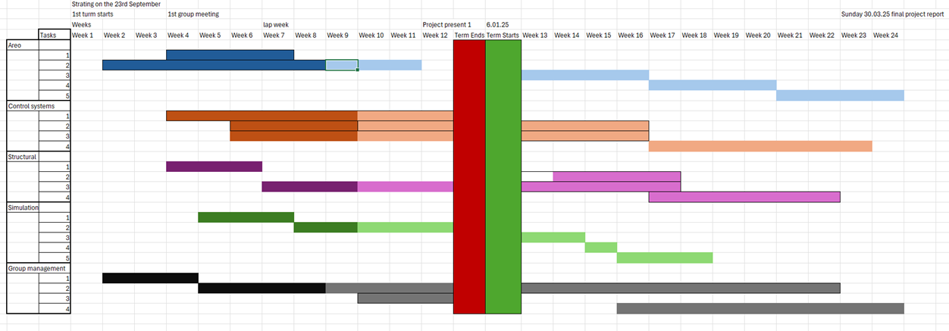
Gnatt chart

Reference list
Belbin (2010). The Nine Belbin Team Roles. [online] Belbin. Available at: https://www.belbin.com/about/belbin-team-roles [Accessed 24 Nov. 10AD].
Turner, J. (2023). 7 key factors that drive team motivation. [online] How To Basically. Available at: https://howtobasically.co.uk/7-key-factors-that-drive-team-motivation/ [Accessed 24 Nov. 17AD].

