

Strategic Management (LCMB7003)

Strategic Analysis of Samsung Electronics

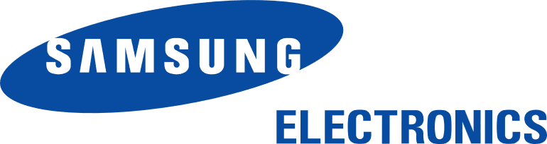

Student name: Amit Jagdishbhai Jikadra
Student Number: 2526285
Lecturer: Hoang Nguyen
Word count: 5172
Submission Date: 12th August 2026

Table of Contents
Section 1 3
1. Organisational Context and Overview 3
2. Evaluation of external and internal factors 6
2.1 PESTLE analysis 6
2.2 Opportunities and Threats 9
2.3 Internal Environment Analysis with VRIO 11
2.4 SWOT Analysis 14
3. Comprehensive and Holistic View of the Organisation 18
3.1 Introduction 18
3.2 Balanced Scorecard 18
3.2.1 Financial Perspective 18
3.2.2 Customer Perspective 19
3.3.3 Internal Business Processes 21
3.3.4 Learning and Growth 23
4. Strategic Choices and Implementation 25
4.1 Business-Level Strategic Choices 25
4.2 Differentiation Strategy for the Organisation 26
4.3 Recommendation for Business Strategy 31
4.4 Implementation Challenges and Mitigation Strategies 32
Section 2: Reflective Account of the Research and Analytical Process 35
Reference list 38

Section 1

1. Organisational Context and Overview
Samsung Electronics Co., Ltd. is one of the largest technology firms in the world, with its headquarters in Suwon, South Korea and founded in 1969 (Samsung, 2026). The report will provide its insights into Samsung's Premium Galaxy S-Series phones launched in the domestic market of South Korea because the domestic market is the company's innovation centre and the best-selling market. The vision of the company is to "Inspire the World, Create the Future" (Samsung, 2026).
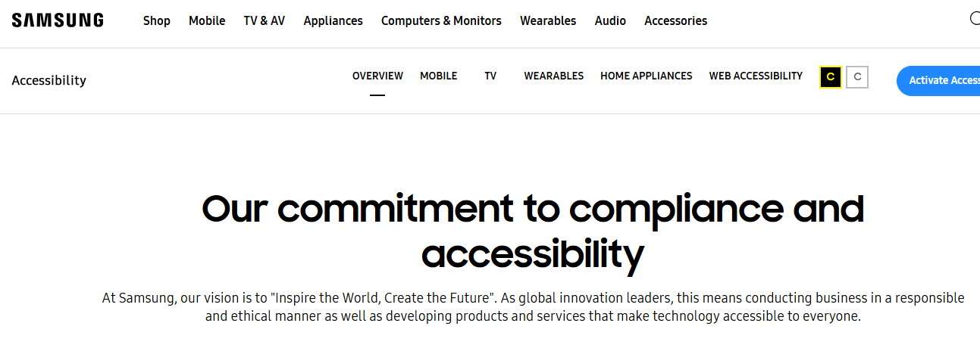
Figure 1: Vision of Samsung
(Source: Samsung, 2026)
The mission of the company is to devote its talent and technology to creating superior products and services that contribute to a better global society (Samsung, 2026). To achieve this, Samsung sets a high value on its people and technologies. Samsung operates in a vertically integrated manner (Samsung Electronics, 2023), producing all necessary components for its devices at its production facilities including processors, OLED displays, chips, and smartphone hardware that help keep prices low, speed up innovations, and have full control of the quality of the end products.
Samsung is operating its business in the extremely competitive premium smartphone market that is characterized by very fast progress in technology, rapidly changing life cycles of products and high demand for smartphone devices with artificial intelligence (AI) technologies. The main rivals of Samsung in South Korea are Apple, whose iPhone Pro models compete directly with Galaxy S-Series (McFarlane, 2026), and Google which began to introduce its line of premium Pixel smartphones. Despite the fierce competition from other leaders, Samsung remains the leading smartphone producer in South Korea. According to Counterpoint Research, Samsung’smarket is share is 49.88% in South Korea while Apple’s market share is sold about 34.59% in the country as of July 2026 (Statcounter, 2026).
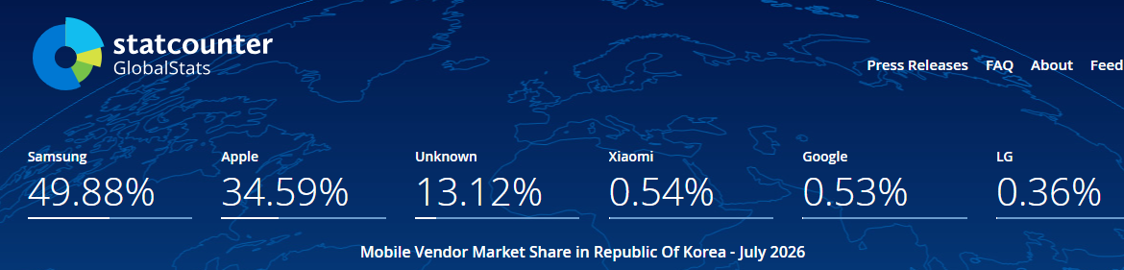
Figure 2: Market share of Samsung and Apple in South Korea
(Source: Statcounter, 2026)
Samsung’s strong financial performance is indicative of its continued market leadership. In Q2 FY2026 fiscal year, the company generated revenues of KRW 171.5 trillion (Samsung Newsroom, 2026).
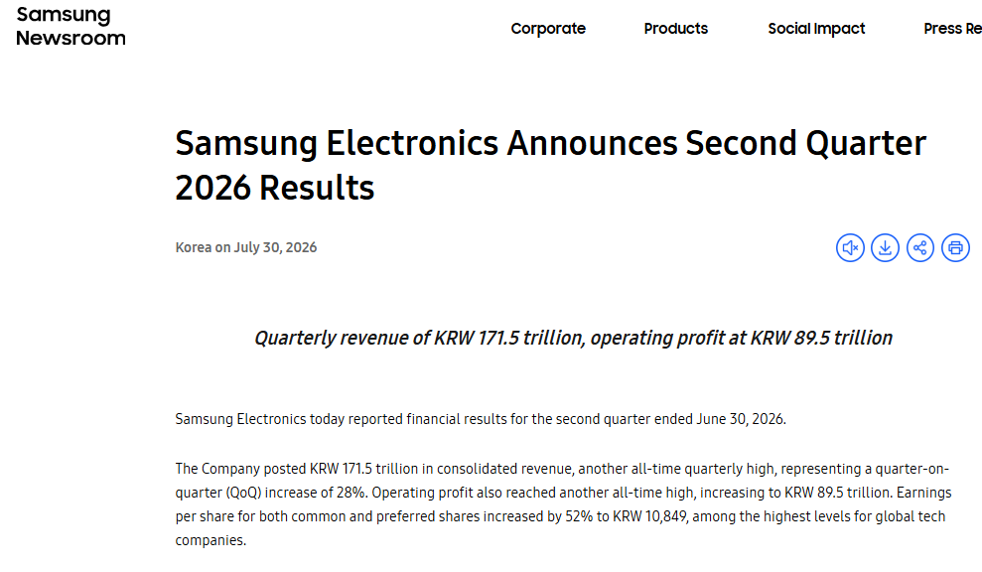
Figure 3: Financial performance of Samsung
(Source: Samsung Newsroom, 2026)
The company invested KRW 37.7 trillion into research and development showcasing continued focus on technological leadership in various domains including Galaxy AI, smartphone device innovation and advancements in semiconductor technologies.
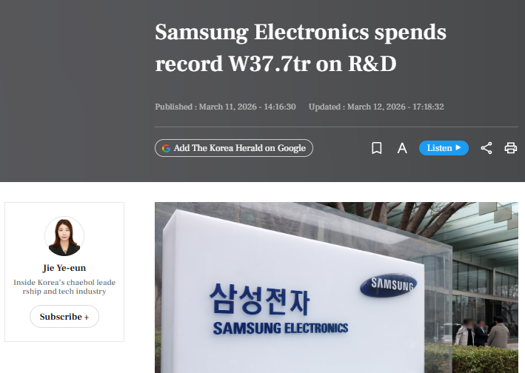
Figure 4: Samsung’s investment in R&D
(Source: Ye-eun, 2026)
As a result of these competencies, the Premium Galaxy S-Series has become the flagship product of the company which is characterized by the unique combination of numerous advanced AI capabilities, premium design, high-quality camera technology and seamless integration into the entire Galaxy ecosystem.

2. Evaluation of external and internal factors

2.1 PESTLE analysis
Political factors
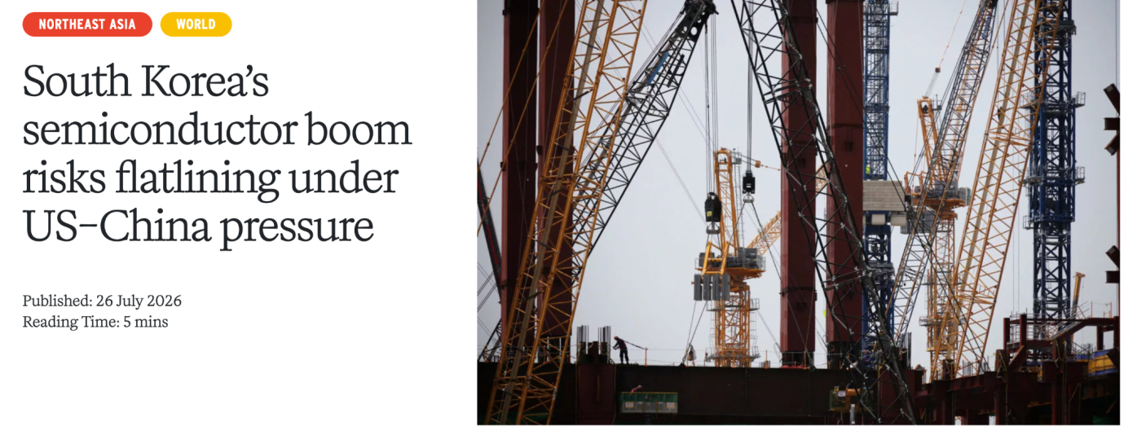
Figure 5: Semiconductor boom risks of South Korea.
(Source: Kim and Bai, 2026)
South Korea was able to position itself as a global leader in semiconductor manufacturing home to companies like Samsung. South Korea has revealed an unusual KRW 340 trillion semiconductor investment in 2026 (SMA Lawfirm, 2026). The semiconductor exports of South Korea reached $44.8 billion in 2026 (Kim and Bai, 2026). However, the regulatory compliance is bound to Washington policies. South Korea is dependent upon China for market and production base, inducing competing pressures for Samsung.
Economic factors
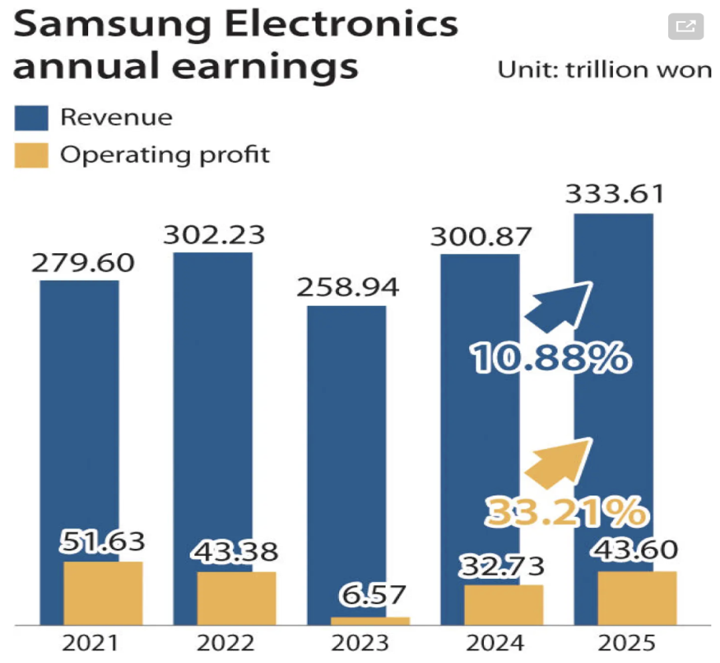
Figure 6: Annual sales of Samsung
(Source: JAE-LIM, 2026)
The real GDP growth was upgraded to 3.0% for 2026, which was more than the previous year estimate of 2.0% (Lee, 2026). The annual sales of Samsung increased from 333.61 trillion in 2025, which is 10.88% more than previous year (JAE-LIM, 2026). Issues like carriers’ subsidy dynamics, inflation and trade-in schemes are a critical lever for S-Series volume in Korea. The mobile memory costs of Samsung increased to 107%, this component cost inflation put extreme margin pressure on Mobile experience of Samsung (TrendForce, 2026). Therefore, the company had to focus on supply chain strategies and pricing.
Social factors
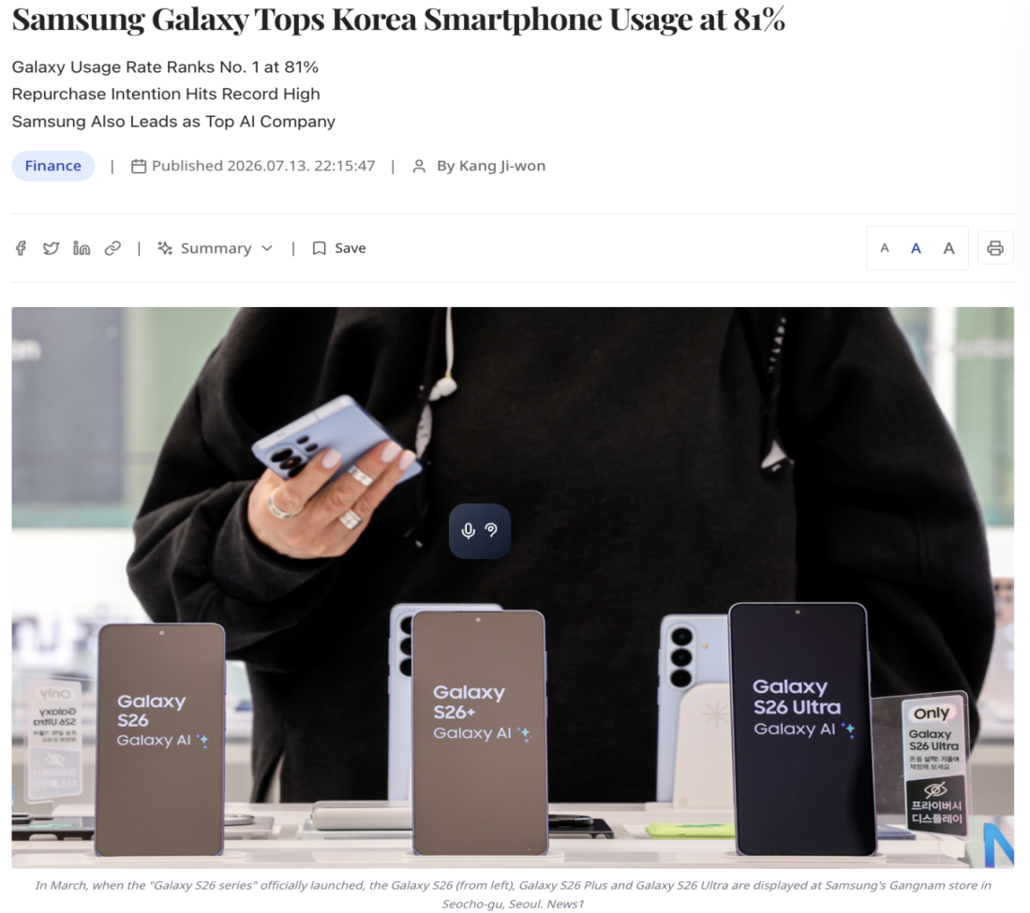
Figure 7: Smartphone usage of Samsung in South Korea
(Source: Daily, 2026)
Samsung is one of the major active electronics brands within South Korea, almost 81% of the domestic smartphone users use Samsung Galaxy (Daily, 2026). A shift in consumer preferences was observed within the age groups of 20s that select brands independently. This affects the long-term brand loyalty. Almost 46% of Koreans prefer using “Useful AI” for photo editing, summarization and translation (Yoon Min-sik, 2024).
Technological factors
The advanced domestic tech ecosystem of South Korea supports the premium Galaxy S25 and S26 series of Galaxy. The 5G infrastructure penetration is at 97.4% and has a market value of $8.65 billion (Sourceready, 2025). The OLED Display of Samsung provided a 41% share of global revenue in 2025 (Bryans, 2026). Computational photography advances are primary differentiators for Samsung S-series.
Legal factors
The Personal Information Protection Act (PIPA) and AI governance guidelines need strict on-device data management within South Korea. This Law has been revised and introduced a penalty ceiling of 10% of total turnover on CEOs (Min, 2026).The Fair Labeling and Advertising Act (FAOC) is another law within South Korea which monitors misleading marketing campaigns. Companies like Samsung might face penalties of KRW 30 million in case of false advertise (iclg, 2026).
Environmental factors
South Korea has implemented E-waste & circularity mandates such as the EPR regimes. The recycling targets and tighter collection increase compliance and reverse logistics costs. Sustainability reports of Samsung highlighted that the application of recycled plastic components in all electronics was 33.7% in 2025 (Samsung Newsroom, 2026). Scope 1-3 reporting expectations like supplier emissions motivate Samsung to heighten green procurement for S-Series components.

2.2 Opportunities and Threats
Opportunities
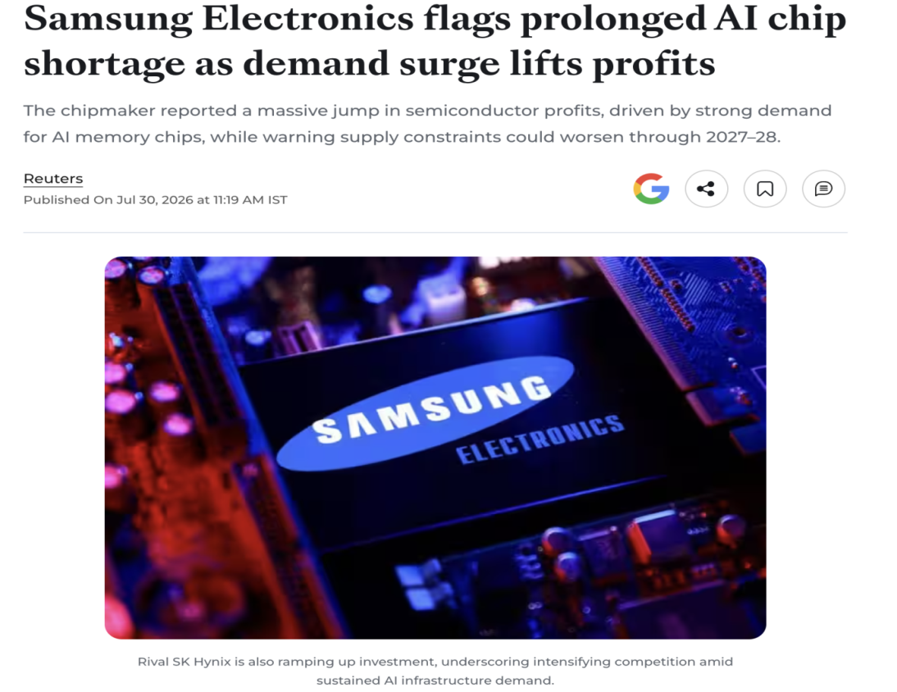
Figure 8: Increase in demand and profit
(Source: AI, 2026)
South Korea’s KRW 340 trillion semiconductor investment and 97.4% 5G penetration might be utilised by Samsung (Sourceready, 2025). This will be an opportunity for the S-Series carrier-bundled upgrades and AI-differentiation. The semiconductor division of Samsung gained an operating profit of 89.2 trillion in 2026 (AI, 2026). This helped in securing priority access to advanced memory and AI-optimised components for Galaxy S-Series flagships. The 81% of domestic Galaxy share and 46% of Koreans preferring “useful AI” will be an opportunity for Samsung in driving B2B/B2G contracts and premium ASPs. 41% global OLED revenue share of Samsung will be an opportunity to support technical methods for flagships (Bryans, 2026).
Threats
The margin pressure for Samsung will be acute as the mobile memory costs increased 107% (TrendForce, 2026). This is a threat for pricing/ supply chain trade offs during inflation and carrier-subsidy dynamics of S-series profitability. The geopolitical exposure is also a threat for Samsung as US export controls and dependence on China induces compliance issues. Legal factors like the revised 10% turnover penalty of PIPA might raise compliance costs for AI feature marketing (Min, 2026). Environmental mandates like ERP expansion might increase the reverse-logistics costs of Samsung despite 33.7% recycled plastic usage in the previous year (Samsung Newsroom, 2026).

2.3 Internal Environment Analysis with VRIO
Resources | Valuable | Rare | Inimitable | Organised | Competitive impact
Vertical integration and component control | Yes | Yes | Yes | Yes | Sustained competitive advantage
Brand equity and premium positioning | Yes | Yes | Yes | Yes | Sustained competitive advantage
Scale manufacturing and global distribution | Yes | Yes | Yes | Yes | Sustained competitive advantage
High R&D intensity and cost pressure | Yes | No | No | Yes | Temporary competitive advantage
Table 1: VRIO analysis
(Source: Self-Made)
Vertical integration and component control (Strength)
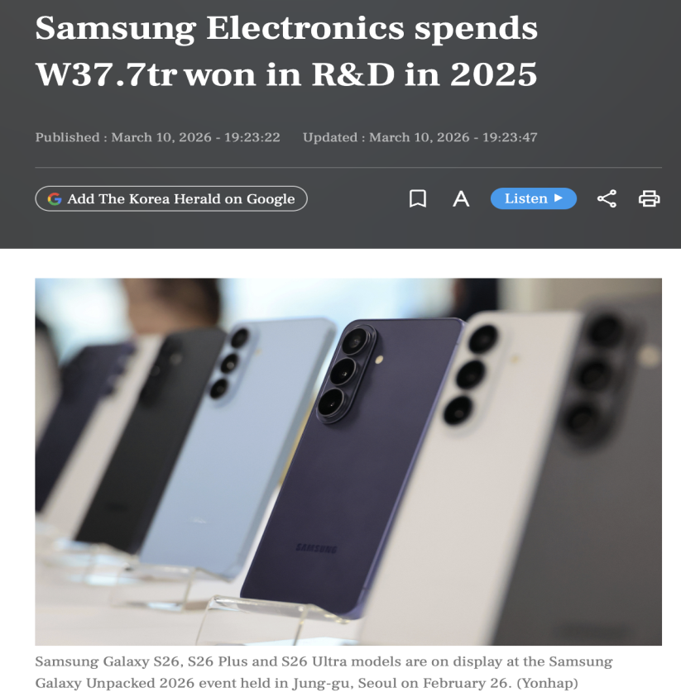
Figure 9: Expenditure of Samsung on R&D
(Source: Yonhap, 2026)
The ability of Samsung to manufacture and design components like image sensors, OLED panels and DRAM/NAND is a key strength. This helps the Galaxy S-Series supply, cost and speed advantages that few rivals might match up to. The organisation recorded a full year R&D expenditure of KRW 37.7 trillion (Yonhap, 2026). Samsung holds almost 40% presence within the DRAM market and 35% within the NAND flash market (Kalm, 2025). The Samsung Display (SDC) controls 50% share of the mobile OLED market (UBIResearchNet, 2026). The VRIO analysis highlights that this resource is valuable, the scale and technology are rare. The multi-decade capex is hard to imitate and it is well organised through cross-division roadmaps. This contributes to the sustained competitive advantage of this element.
Brand Equity and Premium Positioning (Strength)
The brand strength of Samsung supports premium pricing and shelf priority for the handsets of Galaxy S-Series handsets. The brand value of Samsung increased by 8.9% to $ 97.4 billion in 2026 and ranked 8th among international technology brands (Zhang, 2026). The Galaxy S25 series achieved 20.22 to 22 units within the first 6 months (Binay Konwar, 2025). This highlights the key strengths in premium positioning of Samsung. Samsung holds the leading position within the smartphone market in Q1 2026 with 65.4 million shipments and 22% share (Shaik, 2026). The premium mix shift and constant top-two market share signifies this resource is valuable, rare, inimitable and organised. Therefore, the competitive implication of this resource will be sustained competitive advantage.
Scale Manufacturing and Global Distribution (Strength)
The multi-country manufacturing footprint of Samsung and retail collaborations ensures rapid high-volume S-Series rollouts and localised pricing. The total revenue of Samsung in 2025 was KRW 333.6 trillion, which enabled economies of scale that lowered the per-unit cost of flagships (Samsung Newsroom, 2026a). Samsung also has the ability to mass produce Z-Series, A-Series and S-series across several plants to decrease supply shocks. Samsung manufactures ultra premium to mid-premium tiers and increases feature diffusion. The company was able to secure a dominant 35.2% unit sales share in international commercial displays (Samsung Newsroom, 2026c). These coordinated logistics and scale are valuable, and rare in the Android market. Scale manufacturing and global distribution of Samsung is difficult to imitate and is supported by integrated planning systems, which highlights sustained advantage.
High R&D Intensity and Cost Pressure (Weakness)
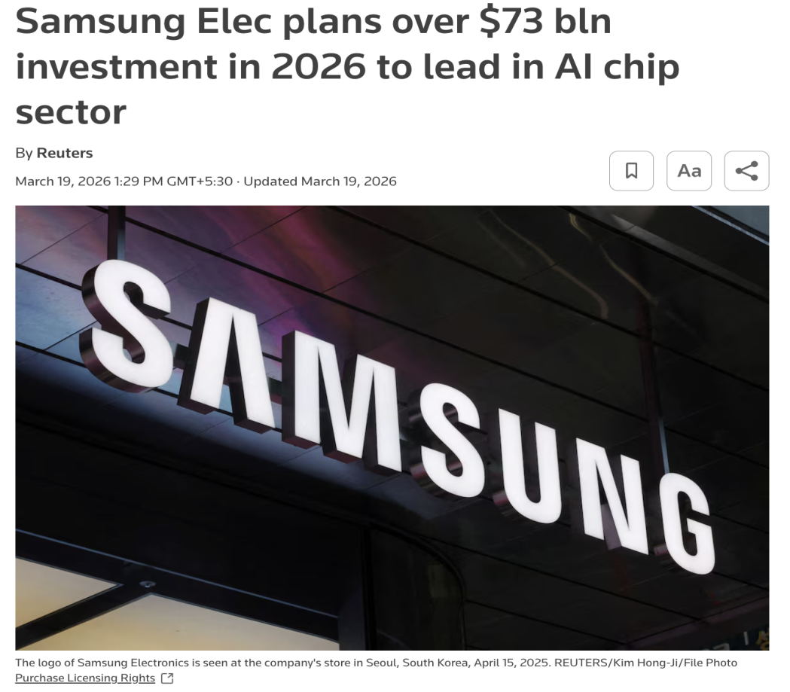
Figure 10: Investment plan of Samsung for R&D
(Source: Reuters Staff, 2026)
R&D is strength of Samsung, however, the scale required investment induces structural cost pressure for the S-Series. Samsung had announced a plan of investing more than $73.24 billion on R&D and semiconductor capital (Reuters Staff, 2026). This increased the cost pressure for Samsung in comparison to the 2025 semiconductor capex of KRW 47.5 trillion (Chen, 2026). The motive of Samsung is to keep pace with AI data center demands from tech organisations like AMD and Nvidia. The financial burdens of staying competitive threaten the long-term margins and exposes vulnerabilities across non-memory divisions. The heavy innovation of Samsung leads to relative weakness in cost-focused segments despite valuable and organised attributes. However, this resource is not inimitable or rare which will lead to temporary advantage of Samsung.

2.4 SWOT Analysis
Strengths
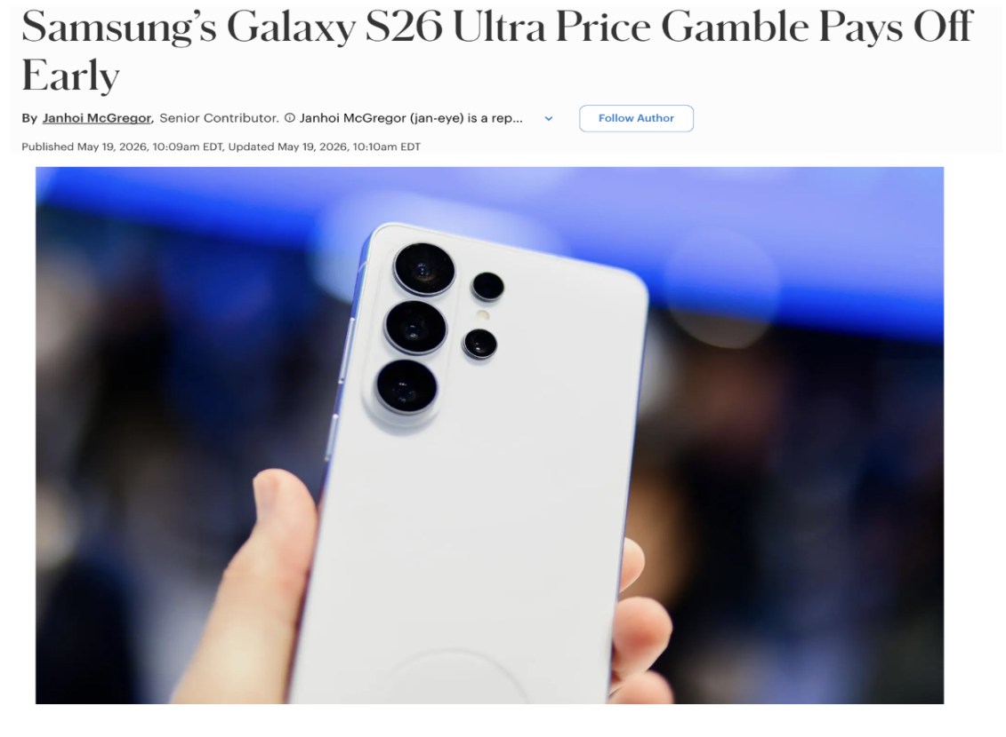
Figure 11: Increase in global sales of Samsung Galaxy
(Source: Shaik, 2026)
Samsung Galaxy S26 series achieved 13% global sales increase during initial 6 weeks in comparison to the S25 line (McGregor, 2026). Samsung was able to pass 3 million sales in South Korea faster than the preceding generation within the first seven days (Shaik, 2026). The suppliers of South Korea including Samsung Display held 49.6% of international AMOLED smartphone panel share in 2026 (Rathore, 2026). The brand value of Samsung reached $90.5 billion (Samsung, 2025). All four Galaxy S25 models sold 20.22 million in comparison to 18.02 million for S24 models (Peter, 2025). Samsung was leading the global smartphone market in 2026 with 22% share sales volume ahead of Apple at 20% (Techinasia, 2026).
Weaknesses
Despite the hardware leadership of Samsung, the services and software lag behind Apple’s ecosystem. This limits switching power and recurring revenue for Samsung. The elimination of lower capacity storage tiers like base 128 GB option raised entry level flagship purchase costs to $900 baseline (Wong, 2026). The increase of 3.4% year over year compared to A24 Ultra will increase the manufacturing cost of S25 Ultra to $484 (Brecher, 2025). Memory-price volatility might compress the flagship profitability of Samsung. The complete focus of Samsung on Android acts as a barrier to the end-to-end service subscriptions. This makes high-end Galaxy S buyers prone to switching on the basis of hardware factors.
Opportunities
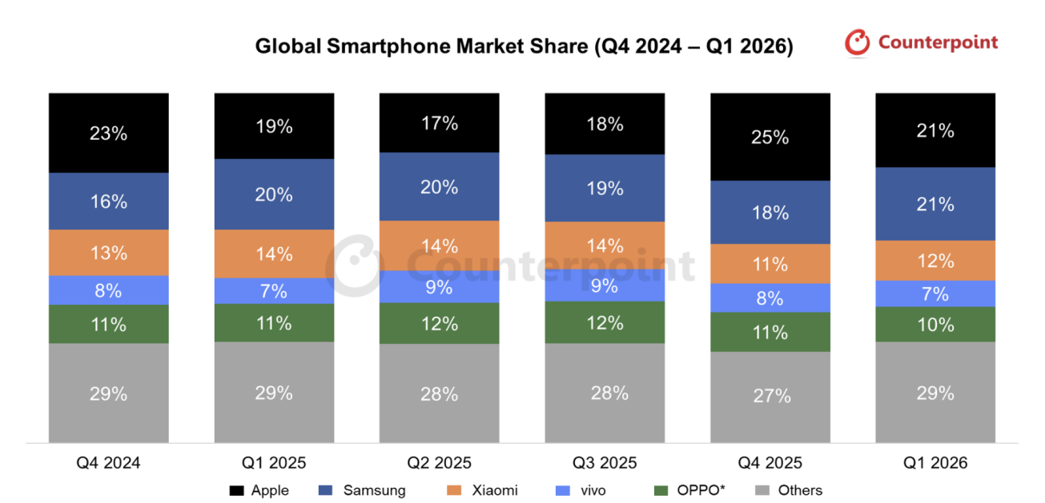
Figure 12: Market share of Samsung
(Source: counterpointresearch, 2026a)
The incorporation of AI is one of the key objectives of Samsung, which has helped in the positioning of “Galaxy AI”. This has helped in gathering the attention of younger customers in their 20’s. Gen AI capabilities will lead to an increase in the global Average Selling Price, which surpassed $400 for the first time (counterpointresearch, 2026). The launch momentum of Galaxy S26 in 2026 led to an increase in shipments and currently, Samsung holds 21% of the market share similar to Apple (counterpointresearch, 2026a). The simultaneous marketing of the flagships like Galaxy S25 Ultra offers an entry premium buffer.
Threats
Intense margin pressure and competitive risks are major threats faced by Samsung in the case of the premium Galaxy S Series. The annual shipments of Apple increased by 18% in ten years, whereas market share of Apple reduced by 5.8% in a decade (Harris, 2025). Shortage of memory and increase in component cost led to 4% year-on-year market decline in 2026 (Omdia, 2026). Premium foldable and flagship models from competitors like Xiaomi, Honor and Huawei are eroding market share of Samsung. The increase in semiconductor and electronics import tariffs in Western markets is a threat for inflating the final retail price of Galaxy S-Series.

3. Comprehensive and Holistic View of the Organisation

3.1 Introduction
Introduced by Kaplan and Norton, the Balanced Scorecard translated Samsung Electronics' strategy into financial and non-financial performance measures. For Premium Galaxy S-Series smartphones in South Korea, the framework supported strategic decision-making, operational excellence, customer value, innovation, and sustainable competitive advantage through continuous performance evaluation.

3.2 Balanced Scorecard

3.2.1 Financial Perspective
The financial perspective was the focus on improving the profitability of Samsung Electronics, revenue growth and the value for the shareholders. Galaxy S-Series smartphones with innovative features, high premium prices and Galaxy AI's leading technology contributed to bolstering financial performance. For the first quarter of 2025, Samsung Electronics' consolidated revenue was KRW 79.14 trillion, and the operating profit was KRW 6.7 trillion (Samsung, 2025). Despite difficult semiconductor market conditions, quarterly sales of Galaxy S25 helped drive record revenue. Samsung Electronics revealed that the amount of R&D investment in the first quarter of this year has reached 9 trillion won (about $6.31 billion) (Eun-jin, 2025). These would enable sustainable financial growth and enhance competitiveness and market leadership in the premium smartphone market in South Korea.
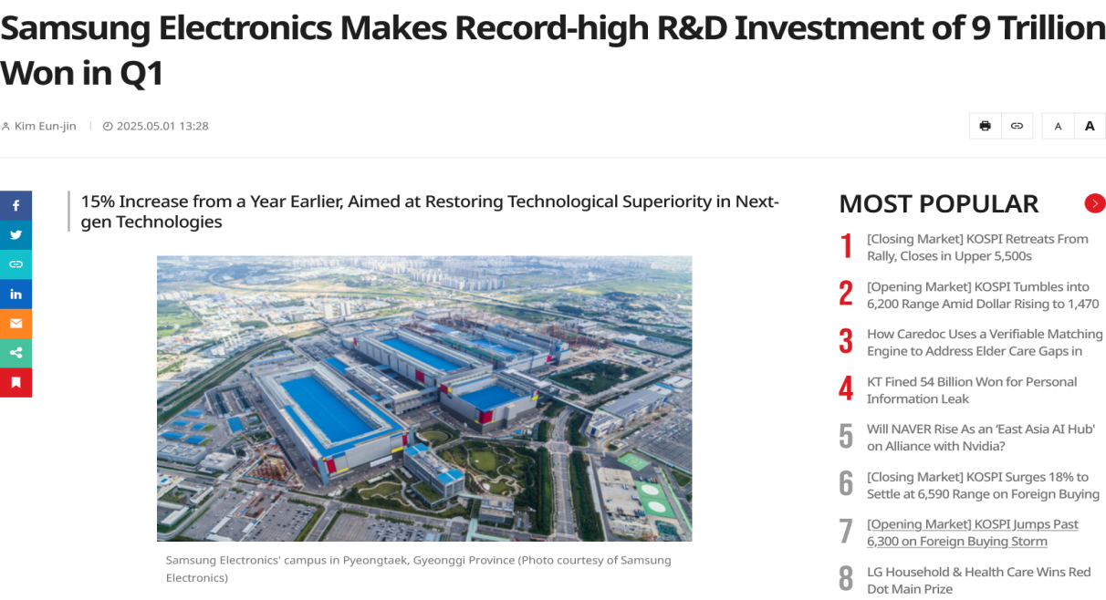
Figure 13: Samsung Electronics Makes Record-high R&D Investment
(Source: Eun-jin, 2025)
Objectives
- Sustain revenue growth through innovation.
- Increase high-margin services revenue.
- Maintain strong profitability.
Measures / KPIs
- Total revenue growth.
- Gross profit margin.
- Services revenue share.
- Return on investment (ROI).
Targets
- Expand services revenue to reduce reliance on hardware.
- Maintain high profit margins despite competitive markets.
Initiatives
- Development of new technologies including augmented reality and artificial intelligence
- Investment in global retail and digital services infrastructure

3.2.2 Customer Perspective
Customer perspective focused on customer satisfaction, customer loyalty and premium smartphone experiences that Samsung Electronics were creating for customers. Advanced Galaxy AI, strong cameras and custom mobile services boosted customer relationships with the new Galaxy S-Series smartphones. Samsung has shipped 2 million Galaxy S25 smartphones in South Korea (Hyun-young, 2026). The milestone has been reached at a quicker pace than the previous Galaxy S24 series, reflecting better adoption rates in domestic markets. Samsung said that there was a keen interest in the Galaxy AI's personalisation features and camera performance among buyers of high-end smartphones during the launch period (Jin, 2025). The sales performance suggested that customers in South Korea are becoming more confident in the sales of these Galaxy smartphones, which also had greater demand for premium Galaxy smartphones, and their brand loyalty was also increasing. The smartphones feature upgraded Galaxy AI capabilities, integration with Google Gemini and customisations for daily smartphone use. These innovations were designed to enhance customer value through offering smarter mobile experiences than simply relying on hardware enhancements.
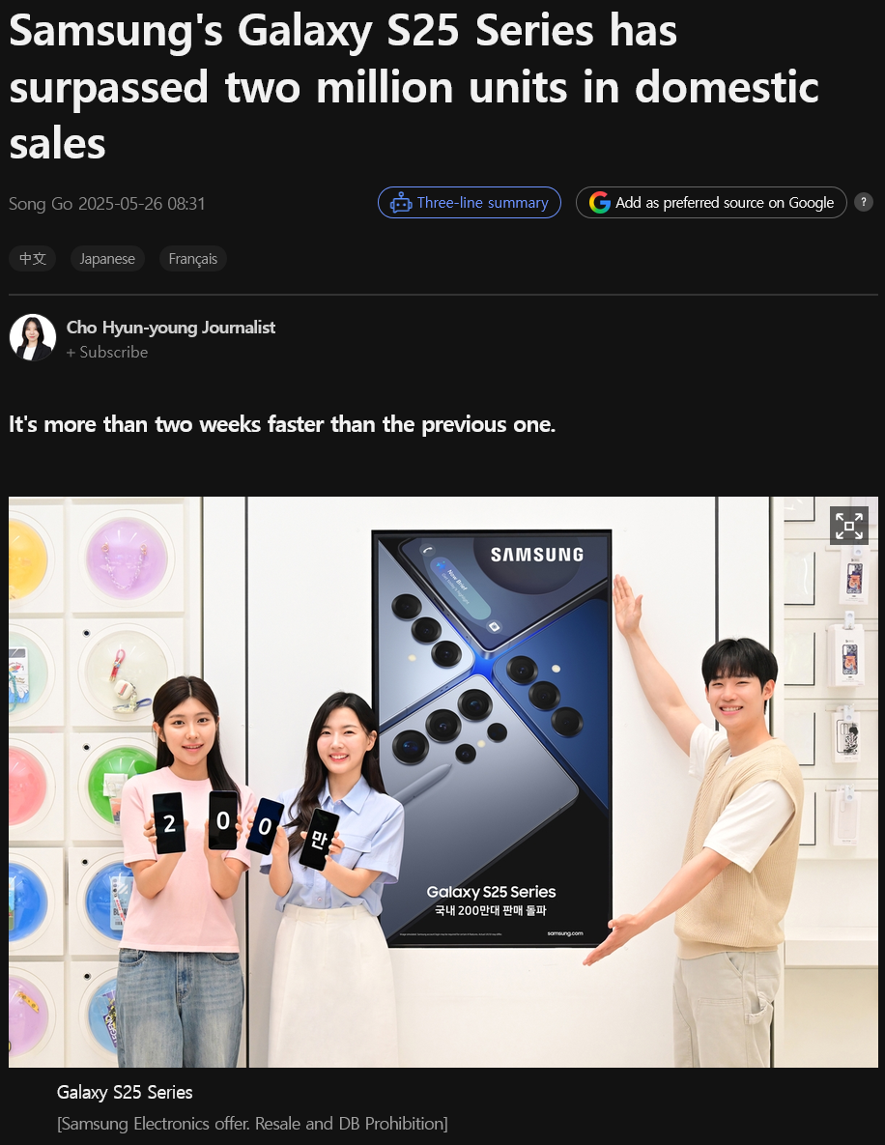
Figure 14: Domestic sales of Samsung's Galaxy S25 Series
(Source: Hyun-young, 2026)
Objectives
- Deliver high-quality innovative products
- Strengthen brand loyalty and trust
- Expand global market reach
Measures / KPIs
- Customer satisfaction ratings
- Global smartphone market share
- Active Apple device installations
- Growth in services subscriptions
Targets
- Increase ecosystem usage and cross-device integration
- Expand presence in emerging markets
Initiatives
- Continuous improvement of Samsung smartphones and watch products.
- Enhanced privacy protection features.
- Expansion of Samsung retail stores and online platforms.

3.3.3 Internal Business Processes
The internal business process perspective evaluates the extent to which Samsung Electronics enhanced its operational efficiency, product quality, innovation and manufacturing performance. Samsung added more advanced semiconductor manufacturing, including bulk silicon, to enhance internal processes for manufacturing the Premium Galaxy S-Series smartphones and for developing future technology. Samsung announced additional details of its leading semiconductor manufacturing technologies. These include the latest generation of 2nm process nodes as well as the first generation of 1.4nm process (Shaik, 2026a). These enhancements were proof of improved manufacturing capability, enhanced operational performance and continued technological innovation for long-term competitive advantage. In fact, Samsung aims to convert its home and overseas factories into AI-powered manufacturing plants by 2030 as it strives for innovation in manufacturing (Korea Herald, 2026). This will improve quality and productivity, and large-scale use of AI in environmental health and safety management will further boost work safety.
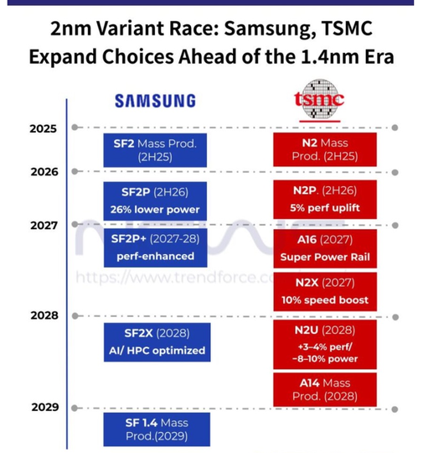
Figure 15: Samsung and TSMC expand choices
(Source: Shaik, 2026a)
Objectives
- Improve product innovation and development speed.
- Strengthen sustainable supply chain management.
- Enhance operational efficiency.
Measures / KPIs
- R&D expenditure levels.
- Product development cycle time.
- Supply chain sustainability metrics.
Targets
- Accelerate innovation cycles.
- Reduce carbon emissions across supply chains.
Initiatives
- Collaboration with suppliers to adopt renewable energy.
- Expansion of recycling and resource recovery programmes.
- Implementation of advanced manufacturing technologies.

3.3.4 Learning and Growth
The learning and growth perspective was used to assess Samsung Electronics' ability to build employee capabilities, innovation, leadership, and digital knowledge to propel forward. A South Korea-based company revealed it would expand its workforce by 60,000 people worldwide in the next five years. The majority of its hires will be in artificial intelligence (AI), the biotechnology sector and semiconductor chips. Samsung will hire around 12,000 employees per year for the next five years (Shaik, 2025). The recruitment programme aimed to build the organisational capacity and support long-term growth of the business by developing future technologies. Samsung will provide practical training for manufacturing and technology and a job placement program to 1,000 young unemployed people outside the Seoul metropolitan region (Du-yong, 2026). Samsung will be operating the program based on the experience gained from the operation of "Hope Stepping Stone 2.0", which has enabled youth to stand out on their own and become self-reliant in work and the economy, and training facilities built by the affiliates.
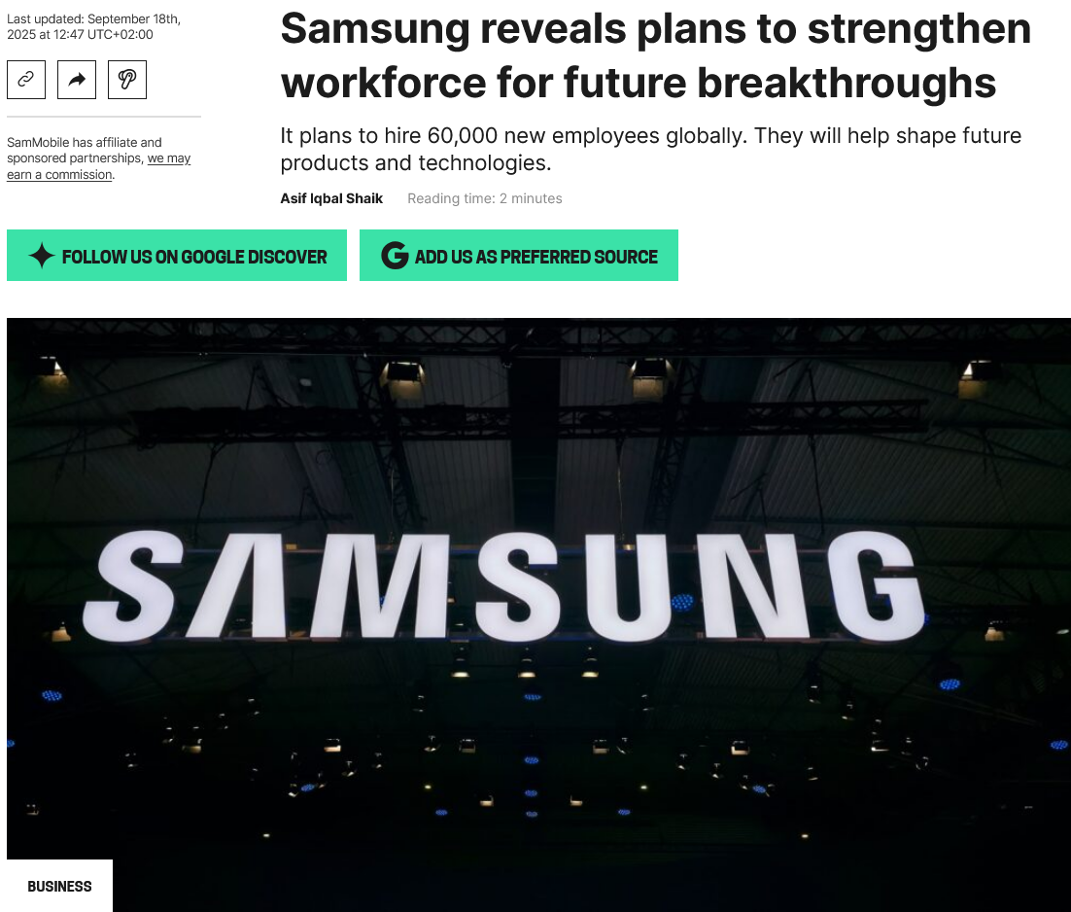
Figure 16: Samsung reveals plans to strengthen workforce
(Source: Shaik, 2025)

Objectives
- Foster innovation and creativity.
- Improve employee engagement and diversity.
- Strengthen technological expertise.
Measures / KPIs
- Employee retention rates.
- Diversity and inclusion metrics.
- Number of patents and technological innovations.
Targets
- Build a highly skilled and diverse workforce.
- Maintain Samsung’s reputation as an innovation leader.
Initiatives
- Employee development and leadership training programmes.
- Diversity and inclusion initiatives.
- Partnerships with universities and research institutions.

4. Strategic Choices and Implementation

4.1 Business-Level Strategic Choices
- (i) Cost Leadership Strategy
Samsung's Exynos chipsets saw their market share rise from 5% during the first half of 2025 to 8% (Shaik, 2026b). This strategy confirmed an increase in cost efficiency, better supply chain control and higher profitability.
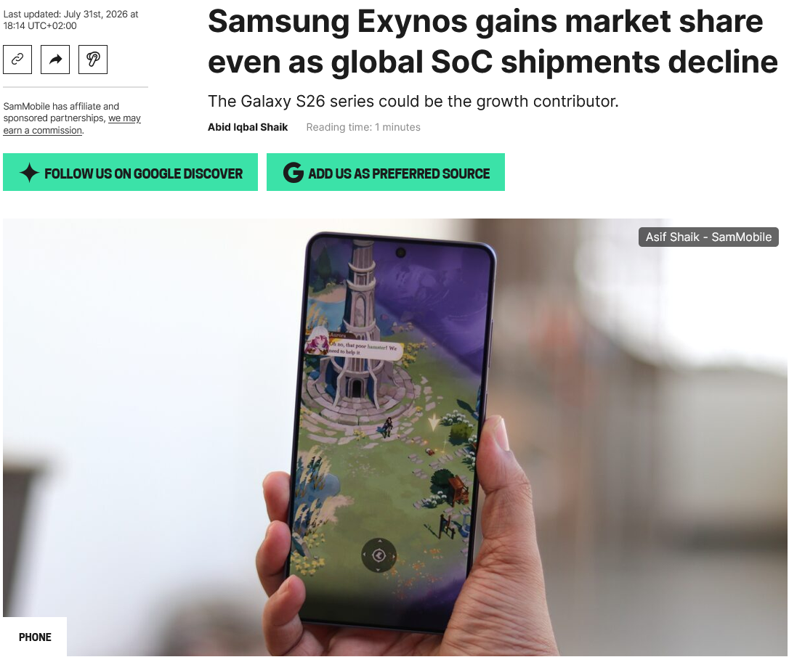
Figure 17: Samsung Exynos gains market share
(Source: Shaik, 2026b)
- (ii) Differentiation Strategy
In 2025, Samsung's Galaxy S25 Ultra is the sole high-end Android phone to feature in the world's top ten selling smartphones list (Shaik, 2026c). This accomplishment suggested a higher level of preference for the brand and a competitive advantage by means of innovation.
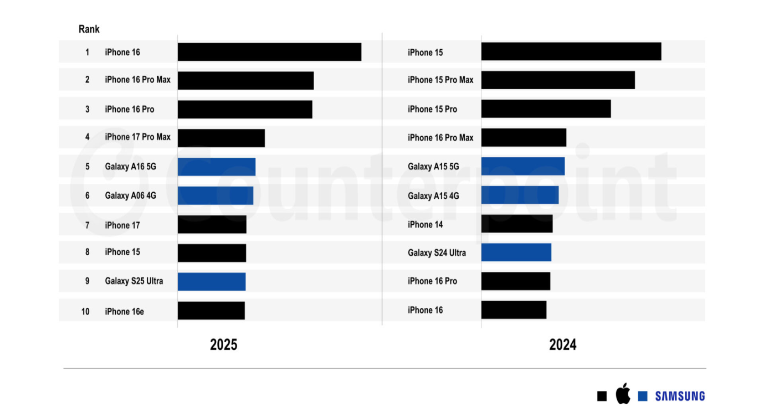
Figure 18: Top high-end Android phone
(Source: Shaik, 2026c)

4.2 Differentiation Strategy for the Organisation
- Threat of New Entrants
New entry was still not considered to be high due to Samsung's brand reputation; technology investment and distribution networks were considered as entry barriers. Samsung Electronics' smartphones captured 82% of cumulative sales in the first seven months of 2025, which is 4% higher than the same period in 2024 (YNA.CO.KR, 2025).
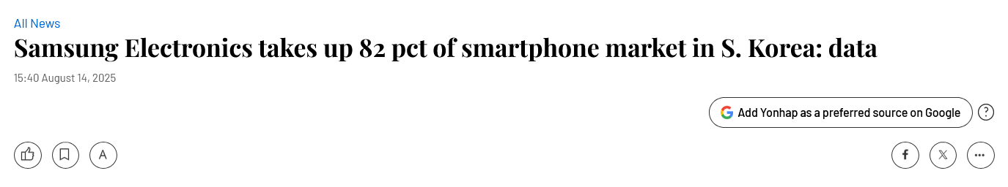
Figure 19: Samsung Electronics takes up 82 pct of smartphone market
(Source: YNA.CO.KR, 2025)
- Bargaining Power of Buyers
Buyer power was still high as customers could easily compare the premium smartphones they were buying. These smartphones, which featured models priced from $800 and up, accounted for 73.2% of the market in South Korea, more than 10% higher than a year before (Retail Asia, 2026).
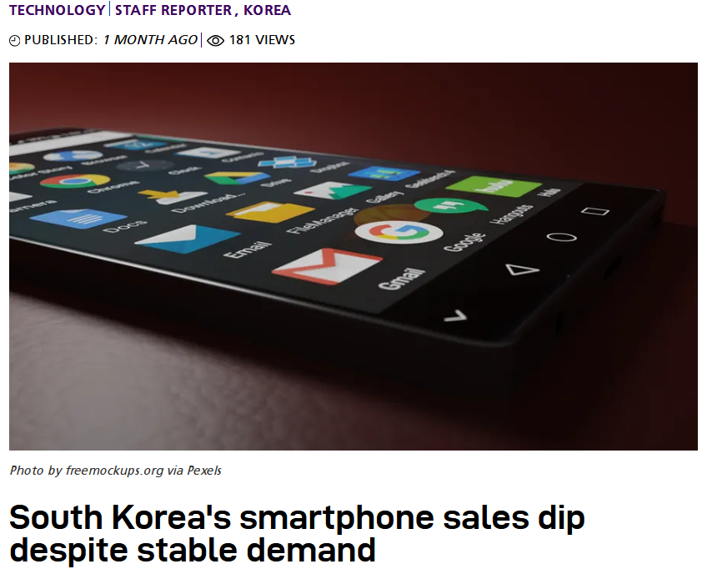
Figure 20: South Korea's smartphone sales dip despite stable demand
(Source: Retail Asia, 2026)
- Bargaining Power of Suppliers
The power of the suppliers was still moderate, as there was still a shortage of artificial intelligence chips globally. The South Korean conglomerate is under contract with the world's five largest data centre providers and is close to inking commitments with five other data centre providers (Jin and Yang, 2026).
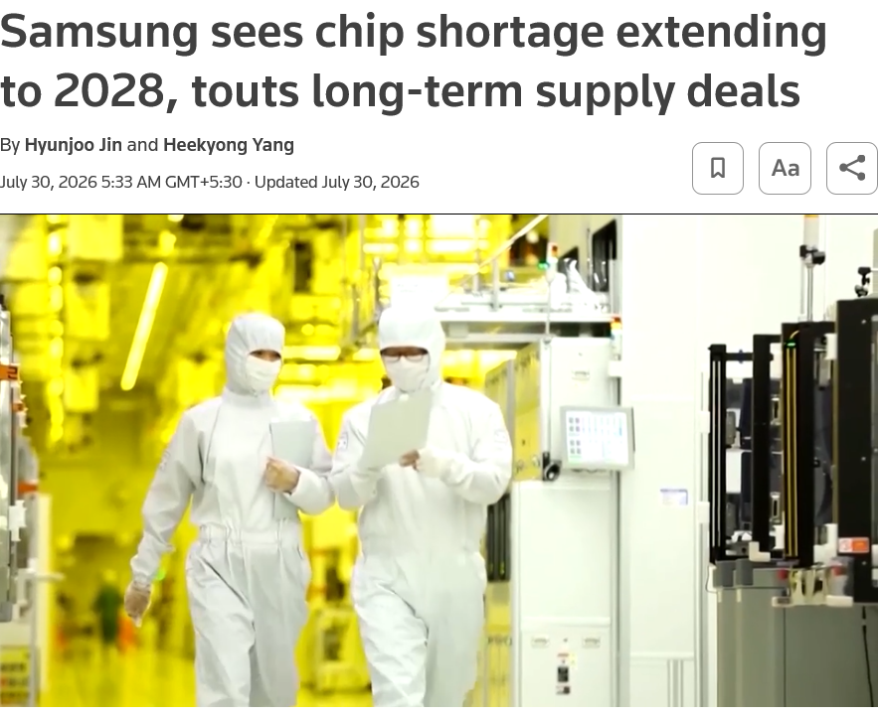
Figure 21: Samsung sees chip shortage extending to 2028
(Source: Jin and Yang, 2026)
- Threat of Substitutes
The risk of substitutes was moderate as tablets, foldable smartphones and refurbished smartphones appealed to price-sensitive consumers. The number of active smartphones in the globe increased by 2% in 2025 as the replacement cycle for new devices grew to almost 4 years, coupled with the higher share of second-life smartphone devices in use (Pathak and Chauhan, 2026).
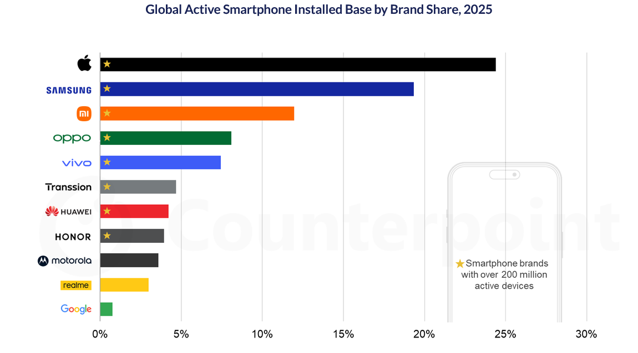
Figure 22: Active Smartphone Installed Base
(Source: Pathak and Chauhan, 2026)
- Competitive Rivalry
Competition was not high in South Korea as the premium smartphone market was intensified by continuous innovation and artificial intelligence. Samsung Galaxy S26 Ultra 5G held 43% market share, whereas Apple iPhone 17 held 6% (Counterpoint Research, 2026).
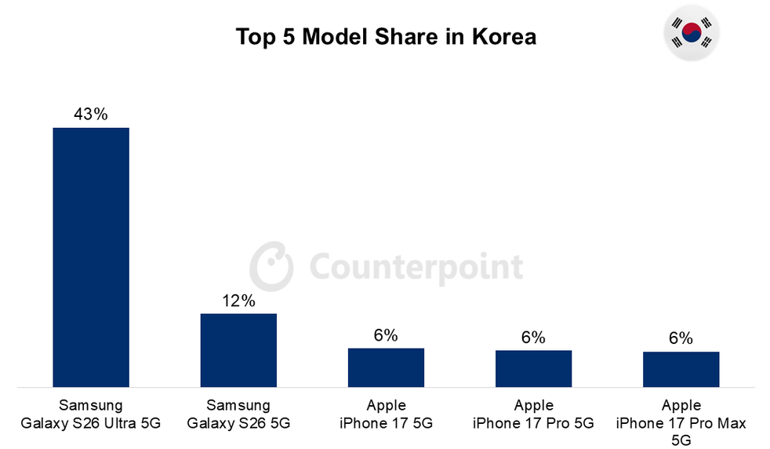
Figure 23: Top 5 Smartphone Models Share For 8 Countries
(Source: Counterpoint Research, 2026)
SAFe Framework
- Suitability
Galaxy S25's domestic sales surpassed 3 million units as of August 2025, earlier than the previous model, maintaining the high level of differentiation (Yoon-seung, 2025). There was strong demand, which showed the preference of the customers towards high-quality innovation and Galaxy AI features.
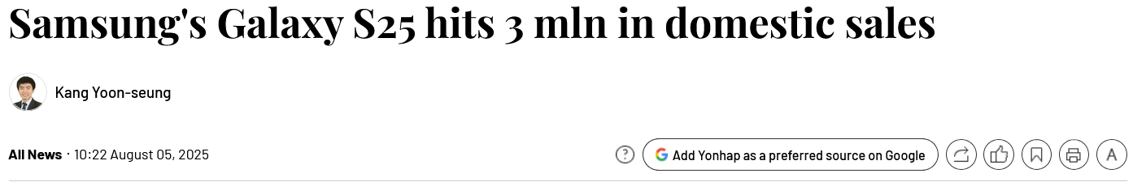
Figure 24: Samsung's Galaxy S25 hits 3 mln in domestic sales
(Source: Yoon-seung, 2025)
- Acceptability
Differentiation remained acceptable because Samsung is able to obtain a contract for semiconductors valued at 22.8 trillion (Boram, 2025). The agreement enhanced future technology investments, facilitated premium smartphone innovation and boosted long-term confidence of shareholders in the company's business growth.
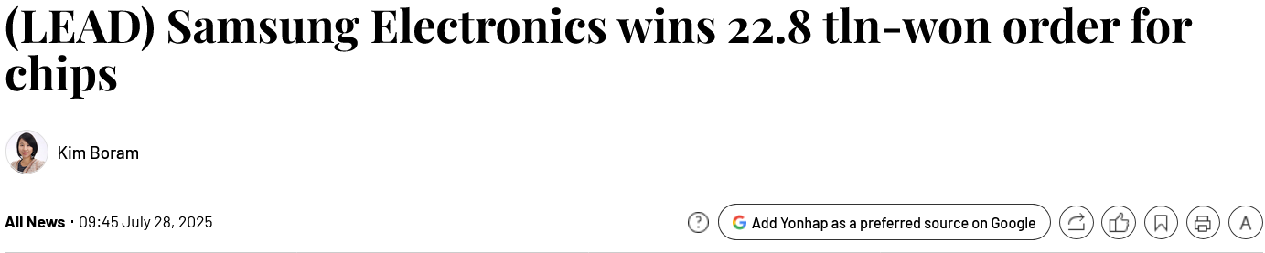
Figure 25: (LEAD) Samsung Electronics wins 22.8 tln-won order for chips
(Source: Boram, 2025)
- Feasibility
Differentiation is still possible as Samsung poured a record high KRW 37.7 trillion into research and development in 2025, and its investment in facilities reached KRW 52.7 trillion, thereby enhancing the capability of the future in high-class smartphone development (Boram, 2026).

4.3 Recommendation for Business Strategy
Differentiation was still Samsung's most suitable positioning, as unique innovation provided sustainable competitive advantages that could not be out-competed on price alone. Game Theory was the basis for this with 6 principles. Key competitors according to player identification were Apple, Xiaomi and HONOR. In 2025, for instance, HONOR released the Magic V5, a new foldable smartphone with multiple AI capabilities for high-end customers (Honor, 2025). This launch demonstrated competitors continuously differentiated products through innovation instead of price reductions. Strategic moves worked to prevent competitor reaction and foster continual innovation.
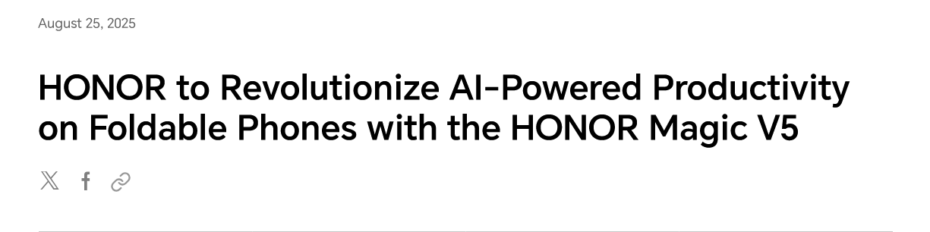
Figure 26: AI-Powered Productivity on Foldable Phones
(Source: Honor, 2025)
Payoff analysis showed that premium innovation led to premium customer and profit but not to price competition. Signalling intentions has boosted market confidence by launching flagship products consistently. Xiaomi 15 Ultra, with Leica-based cameras and flagship-grade imaging capabilities, is another example that comprises Xiaomi's advanced imaging technologies for smartphone users (Min-kuk, 2025). Differentiation showed that the innovative products were able to influence customers' preference for the brand in premium markets.
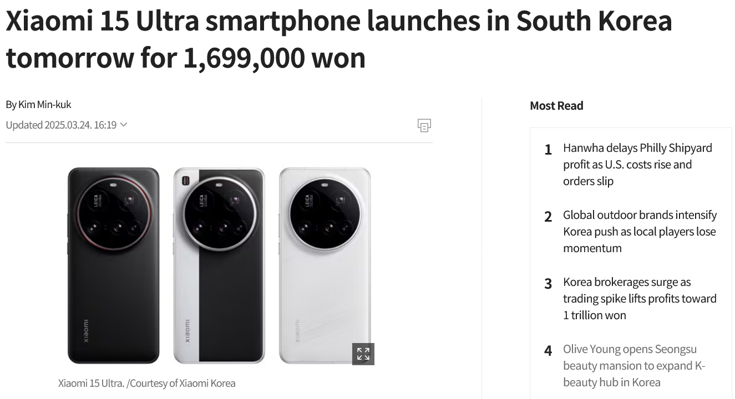
Figure 27: Xiaomi 15 Ultra smartphone launched in South Korea
(Source: Min-kuk, 2025)

4.4 Implementation Challenges and Mitigation Strategies
- Challenge 1 – Rising Component Costs
Samsung has implementation issues when increased memory and component costs cut the profits of the smartphones. The price of the main components of smartphones like DRAM and NAND flash has risen significantly, and the manufacturers have been increasing the price of their phones accordingly, one after another (Dong-wan, 2026).
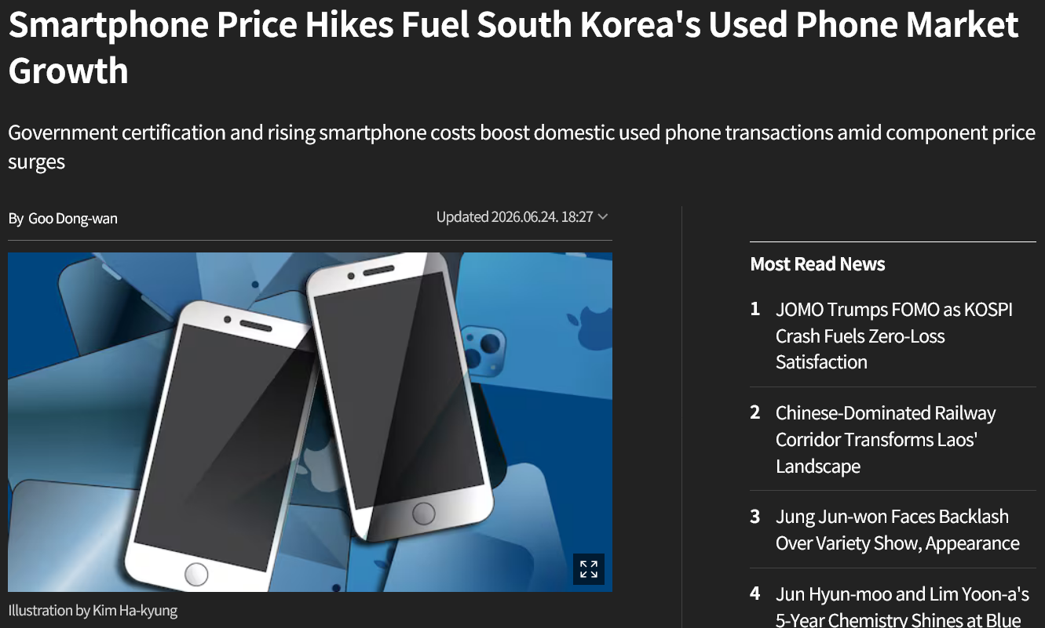
Figure 28: Smartphone Price Hikes Fuel South Korea's Used Phone Market Growth
(Source: Dong-wan, 2026)
Mitigation Strategy
Manufacturing costs would be lowered with long-term supplier agreements, control of component costs and continuous production innovations. The activitie would help boost profit levels, continue to keep the smartphones competitive in the market, and help in successful implementation of the differentiation strategy.
- Challenge 2 – Tariff and Export Policy Uncertainty
South Korean and Taiwanese chip makers could be slapped with tariffs of about 100% on semiconductor imports, which could raise the cost of production, curb consumer demand and complicate long-term smartphone business planning, according to Kim and Lee (2026).
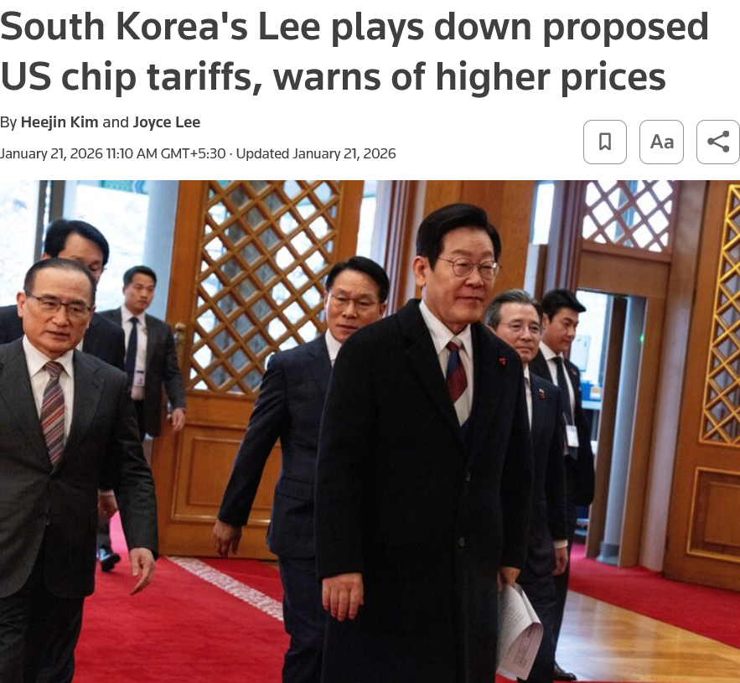
Figure 29: South Korea's Lee plays down proposed US chip tariffs
(Source: Kim and Lee, 2026)
Mitigation Strategy
Expanding international supplier relations and inventory management would minimise tariff risks. The action would help to keep the volume of smartphone production stable, enhance business resilience, and strengthen Samsung's competitive edge in premium smartphone markets.

Section 2: Reflective Account of the Research and Analytical Process
Introduction
The aim to be met with this reflection is to explore the research, analysis and preparation process behind the strategic management report for Samsung Electronics' Premium Galaxy S-Series in South Korea. To structure the reflection methodically, Gibbs' Reflective Cycle (1988) has been taken as a guide. As this cycle contains six stages, it has made the analysis of the methods and the reflection on the learning process possible.
Description
The assignment was to conduct a thorough strategic analysis of Samsung Electronics with special interest in its flagship Premium Galaxy S Series in South Korea. The work started with the collection of reliable secondary data such as official documents, financial documents, data on market shares, and technological trends. I tried to use a set of strategic frameworks in investigating the information gathered. First, I performed a PESTLE analysis for the evaluation of the external environment and then investigated opportunities and threats (Qadri and Tariq, 2025). Next, I applied VRIO and SWOT analysis that enabled me to evaluate Samsung Electronics internally. After environmental investigation, I created a Balanced Scorecard for establishing financial and non-financial goals based on the information obtained during the previous stages of analysis. Finally, I assessed the business strategy of Samsung and the ways the company competes against Apple and Xiaomi.
Feelings
Initially, I was very intimidated by the volume of information surrounding a global technology giant on the scale of Samsung. It was difficult to grasp the ongoing influx of new products, complicated semiconductor supply chains, and constantly changing market shares (Xiong et al., 2025). I was worried that I would use information that was not up to date and that wasn't made relevant enough to the Galaxy S-Series analysis in South Korea. But, as soon as I began to arrange the unprocessed data into categories based on PESTLE and VRIO model, the anxiety got settled and turned into confidence. I felt a nice sense of intellectual satisfaction when I was able to link the Samsung's investment in R&D with the differentiation strategy, which was oriented to the Balanced Scorecard's perspective of Learning and Growth, and the amount of R&D investments in KRW 37.7 trillion. When I completed the stage of strategic recommendations, I was totally immersed and happy as I could come up with one story from inconsistent market data.
Evaluation
After reflection, there were benefits and challenges to my research process.
- The good things: Easy access to accurate and very detailed information was very positive. Such information included Samsung’s 49.88% market share in South Korea and 97.4% penetration in terms of 5G infrastructure. Balanced score card method was very useful as well. Using this method, I could not simply limit my analysis to financial tools, but I was able to pay attention to customer satisfaction and internal operations as well.
- The challenges: The most challenging aspect was conducting the VRIO analysis. It proved to be very difficult to clearly differentiate between "temporary" and "sustained" competitive advantage in Samsung's case study, especially in relation to the company's high R&D intensity level, which is valuable and leads to very high costs. It was also challenging to make sure that the result of the SWOT analysis was not just a repetition of the previous PESTLE analysis results but was, in fact, incorporated into internal strengths and external market realities.
Analysis
The process of drafting this report brought out the complicated circumstances surrounding strategic management in the extremely competitive tech industry. I found out that analysing a company's strategy is not just a systematic procedure but is, rather, an ongoing process of making references to various concepts (Pereira et al., 2025). For example, the outside risk emerging due to the memory costs surge stated as not less than 107% rise in mobile memory costs led to the conclusions made concerning the importance of long-term contracts with suppliers presented in the risk mitigation strategy. This case showed me that the external macro-dimensions always need to match the internal business processes. The Balanced Scorecard was very useful for this situation since it became the main connection between Samsung's big idea to "Inspire the World, Create the Future" and its detailed operational indicators.
Conclusion
To sum up, this review was a fascinating learning process that enhanced my research and analytical skills. If I had the time to go through the review once again, I would spend more time at the beginning of the project on giving the relationship between the data sources I had selected. Although there was enough secondary research carried out, it would have really enhanced the analysis if the primary qualitative data were included. The primary qualitative data can involve the consumer surveys revealing their opinions about the Galaxy AI advantages. Besides, it would be interesting to analyse the differences of competitive strategies in greater detail.
Action Plan
Moving forward, I will adopt an integrated method for my strategic analysis.
- Framework mapping: I will create a visual map to connect external influences (PESTLE) with internal strategy (VRIO / SWOT) so that a coherent course of events can be produced from the start when preparing the reports in the future.
- 2. Varied data sourcing: I will search for more qualitative industry reports and consumer behaviour studies so that when combined with my extensive quantitative data on the financial side I can have a comprehensive view of brand equity.
- 3. Regular practice: I will continue to use the Balanced Score Card in a variety of industries because it seems to be the piece of business methodology that is critical to bringing high level business strategy and down to the level of practical business planning.

Reference list
AI, E.E. (2026). Samsung electronics flags prolonged ai chip shortage as demand surge lifts profits. [online] ETEnterpriseai.com. Available at: https://enterpriseai.economictimes.indiatimes.com/news/industry/samsung-electronics-projects-ai-chip-shortage-to-last-through-2028-boosting-profits-amidst-rivals-investment-surge/132728453.
Binay Konwar (2025). Galaxy S25 series crosses 22 million sales, S25 Edge hits 1 million. [online] SammyGuru. Available at: https://sammyguru.com/galaxy-s25-series-crosses-22-million-sales-s25-edge-hits-1-million/.
Boram, K. (2025). (LEAD) Samsung Electronics wins 22.8 tln-won order for chips. Available at: https://en.yna.co.kr/view/AEN20250728002051320
Boram, K. (2026). Samsung Electronics spends 37.7 tln won in R&D in 2025. Available at: https://en.yna.co.kr/view/AEN20260310010200320?section=economy-finance%2Feconomy&utm
Brecher, H. (2025). Samsung Galaxy S25 ultra: BoM analysis reveals higher production costs due to expensive Snapdragon 8 elite. [online] Notebookcheck. Available at: https://www.notebookcheck.net/Samsung-Galaxy-S25-Ultra-BoM-analysis-reveals-higher-production-costs-due-to-expensive-Snapdragon-8-Elite.1066994.0.html.
Bryans, J. (2026). display’s big six post strongest results in years as oled shift pays off. [online] Display Daily. Available at: https://displaydaily.com/displays-big-six-post-strongest-results-in-years-as-oled-shift-pays-off/.
Chen, M. (2026). Samsung’s $73B semiconductor investment 2026: AI chip strategy. [online] Tech Insider. Available at: https://tech-insider.org/samsung-73-billion-semiconductor-investment-2026/.
Counterpoint Research (2026). Top 5 Smartphone Models Share For 8 Countries. Available at: https://counterpointresearch.com/en/insights/top-5-smartphone-model-share-8-countries
counterpointresearch (2026a). Counterpoint insights | technology market research and industry analysis firm. [online] Counterpointresearch.com. Available at: https://counterpointresearch.com/en/insights/global-smartphone-share.
counterpointresearch (2026b). Welcome to zscaler directory authentication. [online] Counterpointresearch.com. Available at: https://counterpointresearch.com/en/insights/Global-Smartphone-Average-Selling-Price-Breaches-%24400-for-First-Time-in-a-Quarter.
Daily, S.E. (2026). Samsung galaxy tops korea smartphone usage at 81%. [online] Seoul Economic Daily. Available at: https://en.sedaily.com/finance/2026/07/13/samsung-galaxy-tops-korea-smartphone-usage-at-81-percent.
Dong-wan, G. (2026). Smartphone Price Hikes Fuel South Korea's Used Phone Market Growth. Available at: https://www.chosun.com/english/industry-en/2026/06/24/BOGB3YKLCBDFVEAPKFLEQG6BA4/
Du-yong, J. (2026). Samsung launches regional youth training to boost jobs across South Korea. Available at: https://biz.chosun.com/en/en-it/2026/07/30/KKL3QV3N6BENJDOTNYYSCVM4DY/
Eun-jin , K. (2025). Samsung Electronics Makes Record-high R&D Investment of 9 Trillion Won in Q1. Available at: https://www.businesskorea.co.kr/news/articleView.html?idxno=241443
Harris, A. (2025). Apple and Samsung smartphone rivalry unveiled in new data | app developer magazine. [online] App Developer Magazine. Available at: https://appdevelopermagazine.com/apple-and-samsung-smartphone-rivalry-unveiled-in-new-data/.
Honor. (2025). HONOR to Revolutionise AI-Powered Productivity on Foldable Phones with the HONOR Magic V5. Available at: https://www.honor.com/global/news/honor-ai-magic-v5/
Hyun-young, C. (2026). Samsung's Galaxy S25 Series has surpassed two million units in domestic sales. Available at: https://www.yna.co.kr/view/AKR20250526019600017
iclg (2026). Consumer Protection Laws and Regulations Report 2026 Korea. [online] ICLG. Available at: https://iclg.com/practice-areas/consumer-protection-laws-and-regulations/korea/.
JAE-LIM, L. (2026). Samsung beats estimates as 2025 profitability rises 33% on chip supercycle. [online] koreajoongangdaily. Available at: https://www.koreajoongangdaily.com/business/samsung-beats-estimates-as-2025-profitability-rises-33-on-chip-supercycle/11929282.
Jin, H. (2025). Samsung unveils AI smartphones with Qualcomm chips, teases slimmer Galaxy phones. Available at: https://www.reuters.com/technology/samsung-unveils-galaxy-s25-phone-with-qualcomm-chips-enhanced-ai-features-2025-01-22/
Jin, H. and Yang, H. (2026). Samsung sees chip shortage extending to 2028, touts long-term supply deals. Available at: https://www.reuters.com/world/asia-pacific/samsung-q2-profit-jumps-19-fold-ai-chip-demand-offsets-mobile-loss-2026-07-30/
Kalm, D.V. (2025). Samsung: undervalued memory leader. [online] alphaspread.com. Available at: https://www.alphaspread.com/magazine/corporate-highlights/samsung-undervalued-memory-leader.
Kim, H and Lee, J. (2026). South Korea's Lee plays down proposed US chip tariffs, warns of higher prices. Available at: https://www.reuters.com/world/asia-pacific/south-koreas-lee-plays-down-proposed-us-chip-tariffs-warns-higher-prices-2026-01-21/
Kim, H. and Bai, Z. (2026). South Korea’s semiconductor boom risks flatlining under US–China pressure. [online] East Asia Forum. Available at: https://eastasiaforum.org/2026/07/25/south-koreas-semiconductor-boom-risks-flatlining-under-us-china-pressure/.
Korea Herald. (2026). Samsung Electronics to shift to AI-driven autonomous factories by 2030. Available at: https://www.koreaherald.com/article/10684735
Lee, J. (2026). south korea forecasts 2026 economic growth at 5-year high on ai chip boom. Reuters. [online] 14 July. Available at: https://www.reuters.com/world/asia-pacific/south-korea-forecasts-2026-economic-growth-5-year-high-ai-chip-boom-2026-07-14/.
McFarlane, G. (2024). how apple and samsung compare ... and coexist. [online] Investopedia. Available at: https://www.investopedia.com/articles/markets/102714/how-apple-and-samsung-compare-and-coexist.asp.
McGregor, J. (2026). Samsung’s galaxy S26 ultra price gamble pays off early. Forbes. [online] 19 May. Available at: https://www.forbes.com/sites/jaymcgregor/2026/05/19/samsung-galaxy-s26-ultra-price-gamble-increased-sales/.
Min, K. (2026). South Korea overhauls PIPA and ties fines to CEO accountability | IAPP. [online] IAPP.org. Available at: https://iapp.org/news/a/south-korea-overhauls-pipa-and-ties-fines-to-ceo-accountability.
Min-kuk, K. (2025). Xiaomi 15 Ultra smartphone launches in South Korea tomorrow for 1,699,000 won. Available at: https://biz.chosun.com/en/en-it/2025/03/24/BELX4P5Q6RFMBLBXBSCZJVZGBM/
Omdia (2026). Omdia: Global smartphone market down 4% in 2q26 while Apple and Samsung soared. [online] Omdia. Available at: https://omdia.tech.informa.com/pr/2026/july/global-smartphone-market-down-4-percent-in-2q26-while-apple-and-samsung-soared.
Pathak, T. and Chauhan, K. (2026). Active Installed Base: 8 Smartphone OEMs Top 200 mn; Nearly 1 in 4 is an iPhone. Available at: https://counterpointresearch.com/en/insights/Active-Installed-Base-8-Smartphone-OEMs-Top-200-mn-Nearly-1-in-4-is-an-iPhone
Pereira, M. D. S., de Castro, B. S., Cordeiro, B. A., de Castro, B. S., Peixoto, M. G. M., da Silva, E. C. M., and Gonçalves, M. C. (2025). Factors of customer loyalty and retention in the digital environment. Journal of Theoretical and Applied Electronic Commerce Research, 20(2), 71. https://www.mdpi.com/0718-1876/20/2/71
Peter (2025). Sales numbers show the galaxy S25 series was 12.2% ahead of the S24 By the end of june. [online] GSMArena.com. GSMArena. Available at: https://www.gsmarena.com/sales_numbers_show_the_galaxy_s25_series_was_122_ahead_of_the_s24_by_the_end_of_june-news-68942.php.
Qadri, A. U., and Tariq, M. (2025). SWOT and PESTLE Analyses in Strategic Business Planning. International Journal of Modern Research in Management, 2(01), 34-44. https://www.ijournalmrm.com/index.php/IJMRM/article/download/15/15
Rathore, Y. (2026). Samsung holds the OLED crown, but China has half the kingdom. [online] Sammy Fans. Available at: https://www.sammyfans.com/2026/05/15/samsung-holds-the-oled-crown-but-china-has-half-the-kingdom/.
Retail Asia (2026). South Korea's smartphone sales dip despite stable demand. Available at: https://retailasia.com/technology/news/south-koreas-smartphone-sales-dip-despite-stable-demand
Reuters Staff (2026). Samsung Elec plans over $73 BLN investment in 2026 to lead in AI chip sector. Reuters. [online] 19 Mar. Available at: https://www.reuters.com/business/samsung-electronics-plans-over-73-bln-investment-lead-ai-chip-sector-2026-03-19/.
Samsung (2025). Samsung Electronics Announces First Quarter 2025 Results. Available at: https://news.samsung.com/global/samsung-electronics-announces-first-quarter-2025-results
Samsung (2025). Samsung Electronics ranks 5th in global brands for the sixth consecutive year. [online] Samsung.com. Available at: https://news.samsung.com/global/samsung-electronics-ranks-5th-in-global-brands-for-the-sixth-consecutive-year.
Samsung (2026a). Accessibility & compliance | samsung us. [online] Samsung us. Available at: https://www.samsung.com/us/sustainability/accessibility/.
Samsung (2026b). Leadership & Mission | About Us. [online] Samsung. Available at: https://www.samsung.com/us/about-us/leadership-and-mission/.
Samsung (2026c). Samsung’s Heritage | About Us. [online] Samsung. Available at: https://www.samsung.com/us/about-us/leadership-and-mission/heritage/.
Samsung Electronics (2023). Samsung electronics sustainability report 2023. [online] Samsung Electronics. Available at: https://www.samsung.com/global/sustainability/media/pdf/Samsung_Electronics_Sustainability_Report_2023_ENG.pdf.
Samsung Newsroom (2026). Samsung electronics announces second quarter 2026 results. [online] Samsung Global Newsroom. Available at: https://news.samsung.com/global/samsung-electronics-announces-second-quarter-2026-results.
Samsung Newsroom (2026a). Samsung Electronics announces fourth quarter and FY 2025 results. [online] Samsung Global Newsroom. Available at: https://news.samsung.com/global/samsung-electronics-announces-fourth-quarter-and-fy-2025-results.
Samsung Newsroom (2026b). Samsung electronics releases 2026 sustainability report, expanding water replenishment efforts. [online] Samsung Global Newsroom. Available at: https://news.samsung.com/global/samsung-electronics-releases-2026-sustainability-report-expanding-water-replenishment-efforts.
Samsung Newsroom (2026c). Samsung retains no. 1 position in global commercial displays market for 17th consecutive year. [online] Samsung Global Newsroom. Available at: https://news.samsung.com/global/samsung-retains-no-1-position-in-global-commercial-displays-market-for-17th-consecutive-year.
Shaik, A.I. (2026). Samsung regains top spot in the smartphone market. [online] SamMobile. Available at: https://www.sammobile.com/news/samsung-tops-smartphone-market-q1-2026/.
Shaik, I. A. (2025). Samsung reveals plans to strengthen the workforce for future breakthroughs. Available at: https://www.sammobile.com/news/samsung-plans-strengthen-workforce-future-breakthroughs/
Shaik, I. A. (2026a). Samsung could begin making its most advanced 2nm chips next year. Available at: https://www.sammobile.com/news/samsung-begin-making-most-advanced-2nm-chips-2027/
Shaik, I. A. (2026b). Samsung Exynos gains market share even as global SoC shipments decline. Available at: https://www.sammobile.com/news/samsung-exynos-gains-market-share-even-as-global-soc-shipments-decline/
Shaik, I. A. (2026c). Galaxy S25 Ultra was the only high end Android phone in the world's top ten selling phones. Available at: https://www.sammobile.com/news/galaxy-s25-ultra-only-high-end-android-phone-worlds-top-ten-selling-phones/
SMA Lawfirm (2026). Korea Semiconductor Investment Incentives 2026: Complete Tax Credit and Grant Guide | Start Company Korea. [online] Start Company Korea. Available at: https://www.startcompanykorea.com/posts/korea-semiconductor-investment-incentives-2026-complete-guide/.
Sourceready (2025). SourceReady. [online] SourceReady. Available at: https://www.sourceready.com/report/detail/south-korea-mobile-devices-market-report-2025.
Statcounter (2026). Mobile Vendor Market Share Republic Of Korea | Statcounter Global Stats. [online] StatCounter Global Stats. Available at: https://gs.statcounter.com/vendor-market-share/mobile/south-korea/#monthly-202601-202607.
Techinasia (2026). Tech in Asia. [online] Techinasia.com. Available at: https://www.techinasia.com/news/samsung-retakes-top-smartphone-spot-q1-2026.
TrendForce (2026). [News] Memory 1Q26 Price Surge: Samsung Flags 146% ASP Jump, SK hynix Sees Mid-60% DRAM Gains. [online] TrendForce. Available at: https://www.trendforce.com/news/2026/05/18/news-memory-supercycle-drives-1q26-price-surge-samsung-flags-146-asp-jump-sk-hynix-sees-mid-60-dram-gains/.
UBIResearchNet (2026). 2025 OLED Market: Samsung Leads Revenue at 48%, LG Rises to 21% | UBIResearchNet. [online] UBIResearchNet. Available at: https://en.ubiresearchnet.com/2025-oled-market-share-revenue-samsung-lg-dominance/.
Wong, A. (2026). TechNave. [online] TechNave. Available at: https://technave.com/gadget/Smartphone-storage-is-set-to-grow-in-2026-despite-rising-costs-46067.html.
Xiong, W., Wu, D. D., and Yeung, J. H. (2025). Semiconductor supply chain resilience and disruption: insights, mitigation, and future directions. International Journal of Production Research, 63(9), 3442-3465. https://www.tandfonline.com/doi/pdf/10.1080/00207543.2024.2387074
Ye-eun, J. (2026). Samsung Electronics spends record W37.7tr on R&D - The Korea Herald. [online] The Korea Herald. Available at: https://www.koreaherald.com/article/10691933.
YNA.CO.KR (2025). Samsung Electronics takes up 82 pct of smartphone market in S. Korea: data. Available at: https://m-en.yna.co.kr/view/AEN20250814007400320
Yonhap (2026). Samsung Electronics spends W37.7tr won in R&D in 2025 - The Korea Herald. [online] The Korea Herald. Available at: https://www.koreaherald.com/article/10691307.
Yoon Min-sik (2024). 80% of young Korean workers turn to AI for solutions: report - The Korea Herald. [online] The Korea Herald. Available at: https://www.koreaherald.com/article/3462848.
Yoon-seung, K. (2025). Samsung's Galaxy S25 hits 3 mln in domestic sales. Available at: https://en.yna.co.kr/view/AEN20250805003300320
Zhang, A. (2026). Samsung brand value reaches US$97.4 billion in 2026: report. [online] Business Today Middle East. Available at: https://businesstoday.me/tech-news/samsung-brand-value-reaches-us97-4-billion-in-2026-report/.

