ARTIFICIAL INTELLIGENCE FOR
CREDIT RISK ASSESSMENT
A Leakage-Safe Multiclass Comparison of Logistic Regression and Random Forest
━━━━━━━━━━━━━━━━━━━━━━━━━━━━
Module | ACCA7026
Assessment | Component 1 – Machine Learning Model
Student name | Mahmmad Alfaj Munirmiya Malek
Student ID | 2520650
Word count | 3000 words (excluding references and tables)

Table of Contents
Abstract 3
1. Introduction and Problem Statement 4
2. Related Work 4
3. Methodology 5
3.1 Dataset, Outcome Maturity and Target Design 5
3.2 Leakage Control and Preprocessing 6
3.3 Models, Hyperparameter Optimisation and Evaluation 7
4. Experiments and Results 8
5. Critical Discussion 10
5.1 Predictive Performance, Generalisation and Imbalance 10
5.2 Explainability and Credit-Risk Drivers 11
5.3 Fairness, Ethics and Responsible Deployment 12
6. Conclusion and Recommendations 13
References 14

Abstract
This work constructs and critically analyzes a leakage-safe credit-risk pipeline on the sample of the OpenIntro Lending Club. The snapshot of 10,000 loans initial Sprouted showed 9,375 unresolved Current accounts and so analyzing the snapshot would result in a harsh right-censor as well as yield inaccurate accuracy were it to be utilized as a traditional default/non-default datum. The initial experiment therefore had 625 resolved observations and categorized the observations as Repaid, Early Delinquency or Severe Delinquency. Pipelines with logistic regression and random forest models were trained through preprocessing pipelines and fine-tuned with stratified cross-validation and evaluated on an untouched 20 percent hold-out set. Random Forest demonstrated better hold-out, accuracy 0.656, balanced accuracy 0.436, macro-F1 0.432 and severe-delinquency recall 0.333, than Logistic Regression macro-F1 0.367 and severe recall 0.067. However, Random Forest exhibited material overfitting, and neither of the models met deployment gates of balanced accuracy, severe-class recall or train-test stability. SHAP, permutation importance, coefficients and subgroup error analysis enhanced transparency without determining demographic fairness since there were no protected attributes and subgroups had few supporters. The answerable finding is not to assert that the model is operationally successful, but that a transparent research prototype has found the defining cloning of data, validation and dictatorial needs to apply trustworthy credit-risk in action.
Keywords - credit risk, Logistic Regression, Random Forest, class imbalance, SHAP, fairness, model governance

1. Introduction and Problem Statement
Credit scoring dictates the access to finance at the expense of asymmetric losses of lenders: It is often more expensive to approve a borrower who goes technologically bankrupt than it is to turn away a low risk applicant. Nonlinear interactions and heterogeneous borrower profiles can be modeled using machine learning, although it is not enough to be able to predict higher apparent performance in a regulated decision environment. Recent surveys persistently discover that obstacles such as imbalance in the classes, inconsistency of the dataset, poor validation and harsh transparency are common [2], [3]. Simultaneously, the EU AI Act categorizes systems that are deployed to analyze the creditworthiness of natural persons as high-risk since mistakes can cause financial exclusion and discrimination [19].
The report here answers those questions by providing the reproducible comparison of Logistic Regression and Random Forest with the OpenIntro data of loans of the type loans_full_schema [1]. The technical objective is not to maximise the accuracy as much as to establish whether a model is able to separate Repaid, Early Delinquency and Severity Delinquency loans and control leakage and quantification of uncertainty as well as explaining predictions and analysing subgroup errors. Headline accuracy is thus not a priority in the analysis as compared to macro-F1, balanced accuracy and severe-delinquency recall. This focus is critical as even a classifier of the dominant-class can seem successful with no risky loans identified.
The report provides four content of the assessment criteria: quality synthesis of current literature on credit-risk and responsible-AI; justifiable and leakage-safe approach; comparison of evidence-based linear and ensemble classifiers and deployment advice based on the evidence of discrimination, calibration, fairness, and governance.

2. Related Work
Logistic Regression: This is one that has stood the test of time in credit scoring since the coefficients can be translated into consistent, audit-able scorecards. It has a structural weakness of failure to capture thresholds or interactions: a linear log-odds specification is not a guarantee of such features. Dumitrescu et al. show that decision-tree effects have the potential to enhance the Logistic Regression without compromising the interpretability [4]. Random Forest directly overcomes this weakness by using bootstrapped trees and randomly selecting features, creating lesser variance in each tree and nonlinear boundaries. Reviews however warn that ensemble gains are data-dependent but frequently reported, without proper treatment of imbalance, censoring or explainability [2], [3]. Interpretable ensemble research also maintains that performance and transparency cannot be designed separately but instead, they should be co-designed as one unit [6].
In lending, explainability has a specific consequence. Bussmann et al. model explanations based on Shapley to relate predictive output to borrower attributes [5], whereas Hlongwane et al. map Shapley values into interpretable credit-scorecard formats [7]. Such techniques can be employed to diagnostic transparency, but after-the-fact importance is not a causal fact and can be fragile when predictors are correlated. The current study in question is thus a triangulation of coefficients, permutation importance, partial dependence and SHAP instead of use of a single explanation method.
This research into the imbalance raises the issue of learning costs and the choice of metrics. According to recent findings, a balanced approach may help improve the minority detection, although the performance differs depending on the data set, and the use of synthetic sampling can affect the observed distribution of features [12], [14], [15]. Discrimination is also different to probability calibration: a classifier might rank the borrowers correctly, but give inaccurate probabilities, which is not desirable when the threshold is tied to pricing, or provisioning or human judgment [13].
Overall accuracy cannot give fairness. Kozodoi et al. demonstrate that the criteria of fairness may be conflicting with profitability and each other [8]; Bono et al. conclude that the substitution of logit with ensembles does not necessarily produce or remove subgroup differences [9]. Hurlin et al. then have fairness as a quantifiable attribute that needs data of the types of protected groups and estimates of the variables responsible [10]. Such results render subgroup analysis in this report a narrow error audit rather than demonstrate the legal or demographic fairness of this report.

3. Methodology

3.1 Dataset, Outcome Maturity and Target Design
The dataset is composed of 10,000 Lending Club loans composed of 55 variables [1]. To give an initial exploration of the data, there were 9,375 observations (93.75%) labeled Current. Such accounts were not yet of a mature status thus categorizing them as low risk would equate not yet defaulted with successfully repaid. The primary cohort was used to minimize right-censoring by excluding Current accounts and stratifying resolved statuses into three classes of Operation: Fully Paid to Repaid; In Grace Period and Late (16-30 days). The resultant 625 loan group consisted of 447 Repaired, 105 Early Delinquency and 73 Severe Delinquency cases.
This design is slimmer as compared to lifetime probability-of-default modelling. It approximates the performance that is seen among resolved loans and not the likelihood of all newer loans eventually defaulting. It is a material distinction, and is maintained during the interpretation. High accuracy on unresolved data was not adopted in a separate full-snapshot sensitivity experiment to justify deployment but to show the risk to do so.
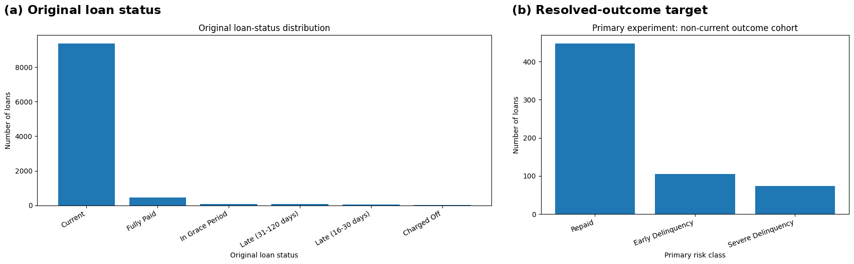
Figure 1. Original status distribution and the resolved-outcome primary target. Source: author’s Colab analysis.
Table 1. Primary outcome design and class composition
Primary class | Mapped statuses | n | Share
Repaid | Fully Paid | 447 | 71.52%
Early Delinquency | In Grace Period; Late (16–30 days) | 105 | 16.80%
Severe Delinquency | Late (31–120 days); Charged Off | 73 | 11.68%

3.2 Leakage Control and Preprocessing
Stratification was applied to divide the data 80:20 and preprocess it before fitting any preprocessing. The number of observations used in training set was 500 and by holding 125 in the hold-out set there were only 15 Severe Delinquency cases. Fields derived with outcomes (paid total, paid principal, paid interest and paid late fees) lack completion due to their disclosure of repayment behaviour that would be unknown to the applicant. Identifiers, target fields and inappropriate high-cardinality variables were not included as well. Grades and sub-grades created by the lender, interest and instalment calculated were left out of the core model since they encode a prior decision in the underwriting process and also can result in circular validation or the bias of historical policy.
Numerical missing were imputed and scaled, categorical variables were imputed and one-hot encoded. The variables were engineered to incorporate loan-to-income, credit-utilisation and log-transformed monetary. Any changes were summed up in scikit-learn pipelines to ensure that each cross-validation fold learns only imputation, scaling and categories of its training subset. This design stops the error of leakage that comes about as a result of preprocessing the entire data set then validation is carried out.

3.3 Models, Hyperparameter Optimisation and Evaluation
The transparent linear baseline was done using Multinomial Logistic Regression. A grid search was used to estimate the strength of regularisation and the weighting of classes with five-fold stratified cross-validation to maximise macro-F1. The model that was chosen took C = 0.1 and medium inverse-frequency class weights. Random Forest was used as the nonlinear ensemble. Tree count, maximum depth, feature subsampling, minimum split/leaf size and class weightings were assessed using randomised search; the configuration used was 321 trees with depth 8, square-root feature sampling, minimum split and leaf size of 8, and class weights of equal variance.
Post-selection stability analysis was done by repeated stratified cross-validation on the training part but the independent generalisation test was done on the untouched hold-out set. Measurements were accuracy, balanced accuracy, macro/weighted F1, per-class precision/recall, multiclass ROC-AUC, average precision, Brier score, confusion matrices and calibration curves. Sampling uncertainty was measured by bootstrap confidence intervals. Only training out-of-fold probabilities with F2 (ranking recall highly but precision less) a severe-class threshold was selected. This was not believed to be a better statistical model but policy sensitivity. Interpretation of the model relied on the use of Logistic Regression coeficients, permutation importance, partial dependence and SHAP. The rate of error by homeownership and type of application was compared using fairness analysis since the characteristics are not protected.
Choice of metrics was a choice-directed one. Accuracy represents total correctness but is biased in favour of Repaid loans; balanced accuracy represents evenly across the classes, whether a model with high overall accuracy is only accurate on the majority of the classes; macro-F1 indicates the overall performance given the observed distribution; and weighted F1 indicates aggregate performance given the observed distribution. The precision of severe is used to estimate the proportion of severe alerts which are valid, where severe-recall is used to estimate the proportion of truly severe loans identified. These numbers suggest various costs: low recall results in risky loans remaining unknown, low precision has more manual inspection, and can over-charge applicants. ROC-AUC was again used to rank on a threshold-independent basis, although average precision and precision/recall curves were used on the rare classification. The reliability diagrams and Brier score tested the ability of the probabilities to make downstream risk judgments. There was no single metric that was considered adequate, the choice of the candidates needed a consistent pattern in discrimination and class-specific error, calibration and stability.

4. Experiments and Results
Random Forest was the first in repeated cross-validation but the absolute performance was low. It had a mean cross-validated macro-F1 of 0.383 +/- 0.037 versus 0.358 +/- 0.047 with Logistic Regression. Random Forest yields accuracy of 0.656, balanced accuracy of 0.436, macro-F1 of 0.432 and macro ROC-AUC of 0.608 on the hold-out data. Accuracy of Logistic Regression was 0.616, balanced accuracy 0.368, macro-F1 0.367 and macro ROC-AUC 0.611. The close ROC-AUC values suggest that the main benefit of Random Forest was obtained due to the realised class decisions and not the material stronger ranking at all thresholds.
Most of the baselines achieved 0.712 accuracy but 0.333 balanced accuracy, 0.277 macro-F1 and a value of zero Severe Delinquency recall. This outcome proves the reason why accuracy could not be discussed as the major criterion. Random Forest performed well in recognizing 5 out of the 15 severe cases (recall 0.333; precision 0.294), compared to only 1 recognized by the Logistic Regression (recall 0.067; precision 0.083). Nonetheless, the confusion matrix of the Random Forest also indicates that 10 severe cases were missed and there was massive confusion between Repaid and Early Delinquency.
Uncertainty was large. Random forest macro-F1 bootstrap 95%intervals were 0.323 -0.528 and severe recall 0.091 -0.600; and the same Logistic Regression quantiles were 0.290 -0.449 and 0 -0.236. The overlap of the intervals implies that Random Forest is the more preferable candidate in this sample not as one that is decidedly superior as a population model. The overfitting was also strong: Random Forest training has macro-f1 of 0.911 (against repeated-cv 0.383 and test 0.432). The train-test gap (0.568 vs 0.367) also occurred with Logistic Regression which was less flexible.
The severe threshold of 0.177, as obtained during the training, produced a higher test severe recall (0.867), but the accuracy and macro-F1 were reduced to 0.328 and 0.236 respectively; Early Delinquency recall dropped to zero. The threshold thus transformed the system into a high- alert screening rule as opposed to enhancing multiclass classification. Most (majority) classifier in the full-snapshot sensitivity experiment: In the full-snapshot sensitivity experiment, a majority classifier scored 0.982 accuracy since the Performing loans dominated; the Random Forest scored 0.982 accuracy but found no high-risk cases. This reiterates the fact that null results can transform an ineffective model into a good model.
Table 2. Repeated cross-validation and hold-out performance
Model | CV macro-F1 | Test accuracy | Balanced accuracy | Macro-F1 | Macro ROC-AUC | Severe recall
Majority baseline | — | 0.712 | 0.333 | 0.277 | 0.500 | 0.000
Logistic Regression | 0.358 ± 0.047 | 0.616 | 0.368 | 0.367 | 0.611 | 0.067
Random Forest | 0.383 ± 0.037 | 0.656 | 0.436 | 0.432 | 0.608 | 0.333

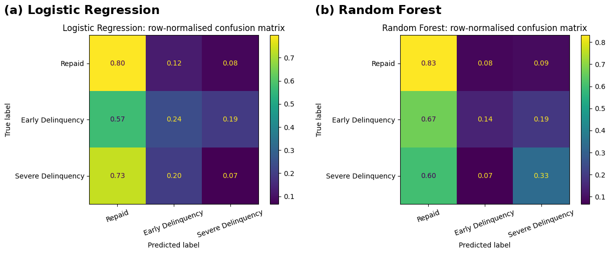
Figure 2. Normalised hold-out confusion matrices. Source: author’s Colab analysis.
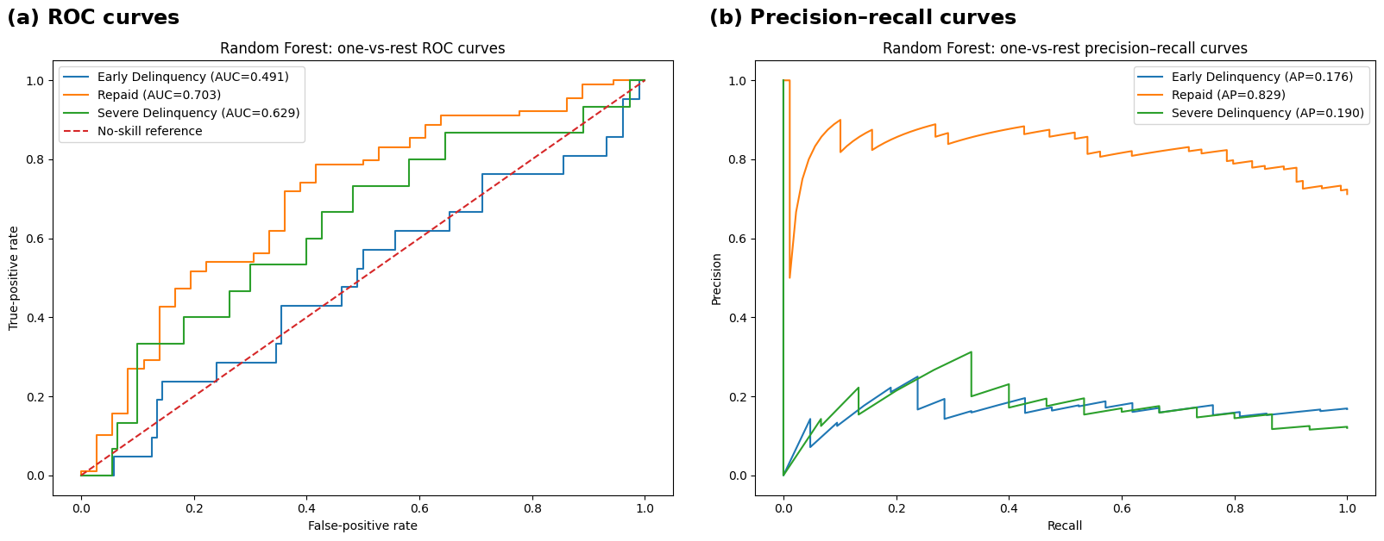
Figure 3. Random Forest one-versus-rest discrimination curves. Source: author’s Colab analysis.

5. Critical Discussion

5.1 Predictive Performance, Generalisation and Imbalance
The empirical results are conditional in agreement with the current literature. Ensemble techniques tend to be more effective than linear models since trees capture nonlinearities and interactions [2], [4] and here Random Forest did indeed increase the macro -F1 and severe recall. However the reward was minimal in comparison to uncertainty and had a very large training-validation gap. The weakness here was not the inadequacy of the algorithmic complexity but the 625-case resolved cohort, just 73 cases with severe outcomes all, and high-dimensional encoded feature space. It is probable that adding a more complicated model would add variance without being balanced by expanding the outcome sample and coverage of time.
The sensitivity of the class-weight and oversampling also yielded no additional material improvement compared to tuned pipeline. This would not conflict with the findings of studies that have gotten improvements through balancing [12], [14], [15]; it indicates that resampling is not a universal solution. With a small group of participants, reproducing and simulated minority participants cannot generate new information on default mechanisms. Similarly, the repeated-CV macro-F1 did not go up by more than one cross-validation standard deviation (0.009) when lender-derived grade and pricing variables were added. Leaving them out was thus well warranted both statistically and in governance.
Calibration evidence also restricts operational use. Though the low severe-class Brier score (0.121 if the random forest) was lower than the extreme cases which included 0.126 (126), the probability estimates were calculated using a small number of severe cases. Official probabilities can only be determined by evaluating probabilities outside of rankings, as calibration research points out [13]. They would need increased size of the temporal validation data set, and post-hoc calibration fitted without contaminating the ultimate test period, before probabilities could be applied to pricing or expected-loss decisions.
Table 3. Random Forest deployment-gate assessment
Gate | Required | Observed | Outcome
Macro-F1 improvement over majority | ≥ 0.05 | +0.155 | Pass
Balanced accuracy | ≥ 0.50 | 0.436 | Fail
Severe Delinquency recall | ≥ 0.50 | 0.333 | Fail
Train–test macro-F1 gap | ≤ 0.15 | 0.480 | Fail

5.2 Explainability and Credit-Risk Drivers
Interpretability outcomes were informative but it is necessary to interpret them as associations. The permutation importance of random Forests ranked the loan-to-income, credit-account counts, homeownership, total credit lines and income per open account as some of the best variables. The significance of affordability and credit-file structure were supported by SHAP and partial-dependence outputs. Severe Delinquency was positively related to various categories of states, rent status, total credit utilisation and missing employment length but a number of other state and account variables yielded negative coefficients.
These are merely diagnostic patterns, and not causal ones. Geography, wealth and market conditions could be represented by state and homeownership; correlated variables can redistribute significance among SHAP and permutation metrics. That is why the direction and uncertainty (with a warning of against causal interpretation) should be shown in an explainable interface. It is supported in the literature that Shapley methods should be used to enhance transparency in credit decisions [5], [7], [11], yet the quality of the explanation not justifies the target but drives bias out of it.
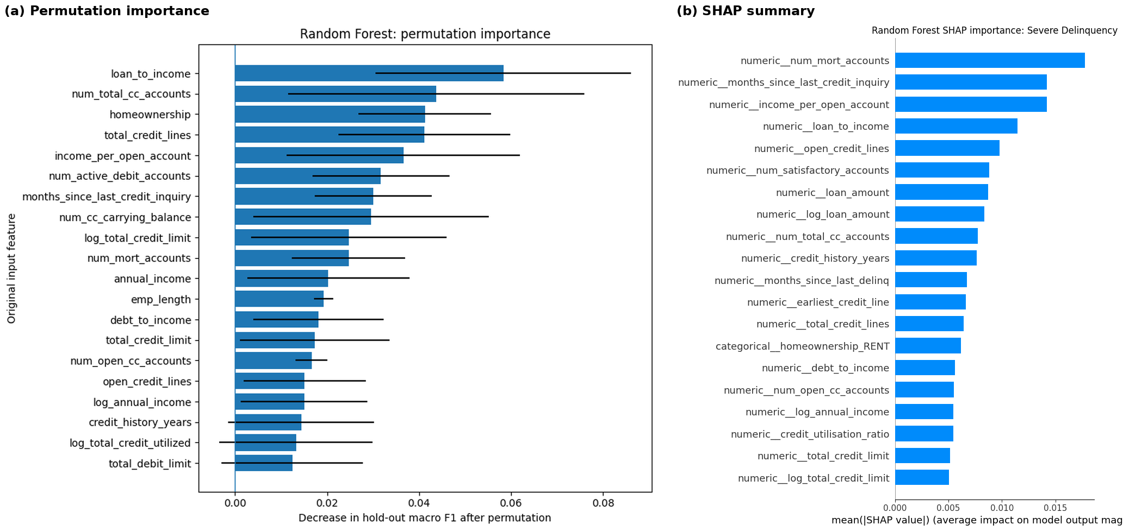
Figure 4. Random Forest global explanation using permutation importance and SHAP. Source: author’s Colab analysis.

5.3 Fairness, Ethics and Responsible Deployment
No legally significant finding of fairness could have occurred as age, gender, race, ethnicity and disability were not available. The subgroup audit identified heterogeneously severe recall: 0 of mortgage holders, 0.50 of renters and owners; 0.308 of individual applications, and 0.50 of joint applications. Those values were founded on extremely minor denominators--no subgroup had ten extreme cases--and thus they are unstable and not capable of creating disparate treatment or impact. In line with the body of fairness research, the exclusion of the role of a variable does not render a model fair since, proxies and past selection can persist [8], [10].
The deployment must thus be controlled by a controlled human-in-the-loop design and not by automated approval or rejection. The AI RMF by NIST demands that the risks are controlled, modeled, quantified and addressed lifecycle [16]. Guidance in the financial sector also emphasizes the wise use, documentation, engagement with the data-protection and AI law [17], [18]. Creditworthiness systems fall under the high-risk categories in the EU AI Act in which the data quality, documentation, human control, accuracy, robustness, and monitoring are controlled [19]. Minimum controls within the scope of this model would encompass adverse-action reason review, challenger models, drift monitoring, protected-group testing on lawful data, manual escalation and an appeal pathway.
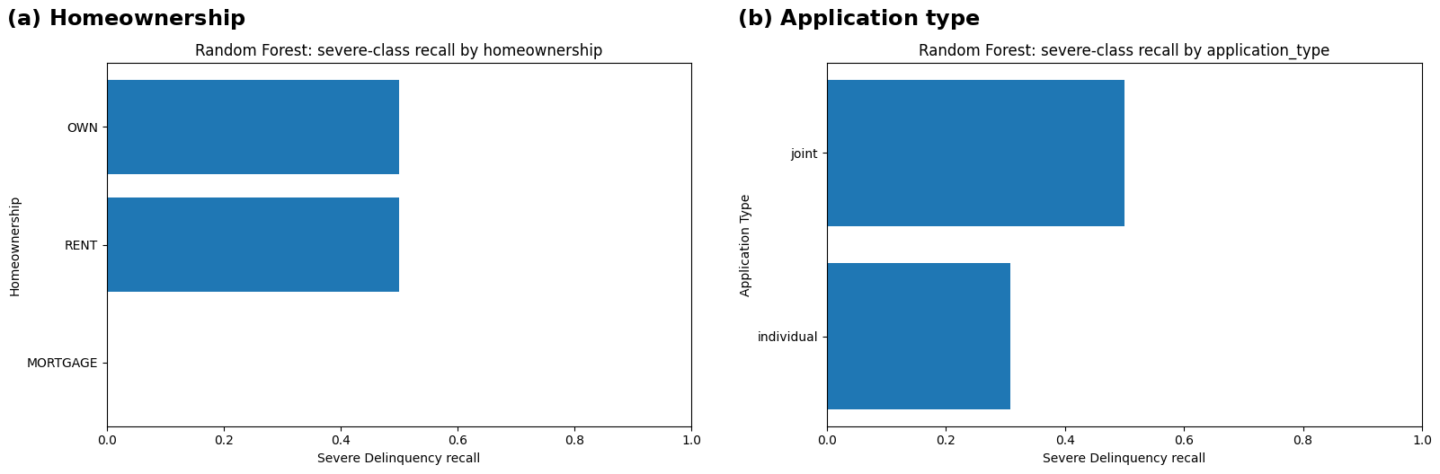
Figure 5. Severe-delinquency recall by observable subgroups; estimates are unstable because subgroup support is small. Source: author’s Colab analysis.

6. Conclusion and Recommendations
The research adopted the necessary linear and ensemble models in a leakage-safe, reproducible pipeline and proved that Random Forest was the more powerful research subject. It had higher hold-out macro-F1 of 0.432 and severe recall of 0.333 than Logistic Regression, but was not operationally adequate. Three of the deployment gates were failing: the balanced accuracy was less than 0.50, severe recall was less than 0.50 at the default decision rule, and the train-test gap was more than 0.15. Only threshold lowering generated excess alerts and ruined multiclass performance, and it raised the performance of severe recall.
Retaining the model still to research, as opposed to lending decisions, is therefore the major recommendation. This should be developed with a significantly bigger portfolio of mature loans, time test validation, clearly observed windows, probabilities calibrated and documented cost matrices, and independent validation. Protected attributes should only be gathered or connected under the right legal framework in order to allow true fairness testing. The final approach would be to use a complete explanation along with oversight from a person, ongoing follow-up, and appeal on the part of the borrower. This step would eliminate the real problem revealed in the experiment: not the sophistication of the model but rather the incompleteness of the outcomes and evidence of governance when the crucial decision is made.

References
[1] OpenIntro, “Loan data from Lending Club—loans_full_schema,” OpenIntro documentation, accessed Jul. 22, 2026.
[2] S. Shi, R. Tse, W. Luo, S. D’Addona, and G. Pau, “Machine learning-driven credit risk: A systemic review,” Neural Computing and Applications, vol. 34, pp. 14327–14339, 2022.
[3] A. A. Montevechi, R. de C. Miranda, A. L. Medeiros, and J. A. B. Montevechi, “Advancing credit risk modelling with machine learning: A comprehensive review of the state-of-the-art,” Engineering Applications of Artificial Intelligence, vol. 137, art. 109082, 2024.
[4] E. Dumitrescu, S. Hué, C. Hurlin, and S. Tokpavi, “Machine learning for credit scoring: Improving logistic regression with non-linear decision-tree effects,” European Journal of Operational Research, vol. 297, no. 3, pp. 1178–1192, 2022.
[5] N. Bussmann, P. Giudici, D. Marinelli, and J. Papenbrock, “Explainable machine learning in credit risk management,” Computational Economics, vol. 57, pp. 203–216, 2021.
[6] Y. Liu, F. Huang, L. Ma, Q. Zeng, and J. Shi, “Credit scoring prediction leveraging interpretable ensemble learning,” Journal of Forecasting, vol. 43, no. 2, pp. 286–308, 2024.
[7] R. Hlongwane, K. Ramabao, and W. Mongwe, “A novel framework for enhancing transparency in credit scoring: Leveraging Shapley values for interpretable credit scorecards,” PLOS ONE, vol. 19, no. 8, art. e0308718, 2024.
[8] N. Kozodoi, J. Jacob, and S. Lessmann, “Fairness in credit scoring: Assessment, implementation and profit implications,” European Journal of Operational Research, vol. 297, no. 3, pp. 1083–1094, 2022.
[9] T. Bono, K. Croxson, and A. Giles, “Algorithmic fairness in credit scoring,” Oxford Review of Economic Policy, vol. 37, no. 3, pp. 585–617, 2021.
[10] C. Hurlin, C. Pérignon, and S. Saurin, “The fairness of credit scoring models,” Management Science, published online Nov. 14, 2024.
[11] C. N. Nwafor, O. Nwafor, and S. Brahma, “Enhancing transparency and fairness in automated credit decisions: An explainable novel hybrid machine learning approach,” Scientific Reports, vol. 14, art. 25174, 2024
[12] S. Han, H. Jung, P. D. Yoo, A. Provetti, and A. Calì, “NOTE: Non-parametric oversampling technique for explainable credit scoring,” Scientific Reports, vol. 14, art. 26070, 2024.
[13] T. Silva Filho, H. Song, M. Perello-Nieto, R. Santos-Rodriguez, M. Kull, and P. Flach, “Classifier calibration: A survey on how to assess and improve predicted class probabilities,” Machine Learning, vol. 112, no. 9, pp. 3211–3260, 2023.
[14] M. E. F. Milli, İ. Deveci Kocakoç, and S. Aras, “Investigating the effect of class balancing methods on the performance of machine learning techniques: Credit risk application,” İzmir Journal of Management, vol. 5, no. 1, pp. 55–70, 2024.
[15] J. Zhang, R. Calabrese, and Y. Dong, “A novel generalised extreme value gradient boosting decision tree for the class imbalanced problem in credit scoring,” Journal of the Operational Research Society, vol. 76, no. 8, pp. 1513–1530, 2025.
[16] E. Tabassi, Artificial Intelligence Risk Management Framework (AI RMF 1.0), NIST AI 100-1. Gaithersburg, MD, USA: National Institute of Standards and Technology, 2023.
[17] European Banking Authority, “Follow-up report on the use of machine learning for internal ratings-based models,” Aug. 2023.
[18] Bank of England and Financial Conduct Authority, “The AI Public-Private Forum: Final report,” Feb. 2022
[19] European Parliament and Council of the European Union, Regulation (EU) 2024/1689 laying down harmonised rules on artificial intelligence, Official Journal of the European Union, 2024.

