

Databases and Application Development

Module Code: | ACCA5026
Assignment Title: | Database Design & Implementation
Student Name: | Ioana Catalina Sava
Student number: | 2329918
Submission Deadline: | Thursday 2nd April 2026  14:00
Table 1: Course and student informations.
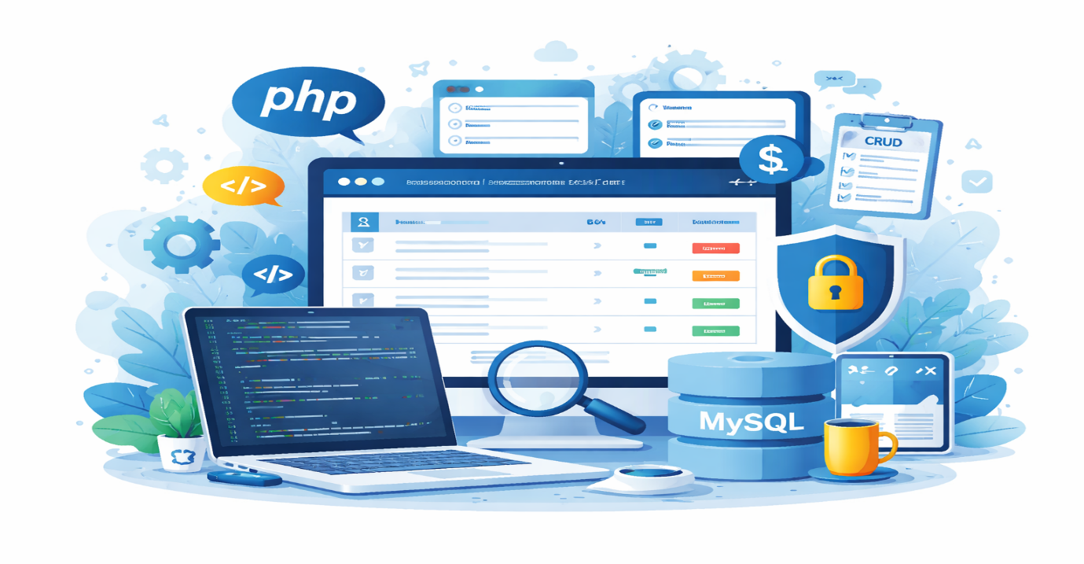
Figure 1: Representation of the PHP and MySQL

Table of Contents

Introduction 3
Database Design 4
Website Functionality 5
What is SQL Injection 6
SQL Injection Vulnerabilities in the website 7
Preventing SQL Injection 10
Conclusion 12
References 13

Introduction
Modern web applications increasingly rely on dynamic technologies that allow data to be stored, managed, and displayed through interaction with databases. Database-driven websites are widely used because they enable information to be updated efficiently and presented to users in real time. In this project, a database-driven website was developed using PHP and MySQL to demonstrate the concepts learned during the module. The website focuses on the television series The Simpsons and allows users to browse information about episodes and characters stored in a structured relational database.
The main aim of the project was to design and implement a functional web application that connects to a database and displays dynamic content. The website includes several public pages where users can explore episode and character information, as well as a login system that allows registered users to access additional features. Once logged in, users are able to add, edit, and delete episode records, demonstrating the implementation of CRUD operations (Create, Read, Update, Delete). The system also includes a search and filtering feature that enables users to find specific episodes based on title or season.
Security is an important aspect of any database-driven application, especially when user input is involved. Web applications often process data submitted through forms, which can introduce vulnerabilities if not handled properly. One of the most common threats is SQL Injection, where attackers attempt to manipulate database queries by inserting malicious SQL code into input fields. If not prevented, such attacks can allow unauthorized access to sensitive data or modification of the database. SQL injection continues to be a significant risk in modern web applications, highlighting the need for secure coding practices [1].

Database Design
The website developed for this project uses a MySQL relational database called simpsons to store and manage the information presented on the site. A relational database was selected because it provides a clear and structured way to organise data into separate tables while still allowing those tables to be connected through defined relationships. This makes the website easier to maintain and update, while also supporting dynamic content generation through PHP and SQL queries. By storing information in a database rather than in static web pages, the system becomes more flexible and practical for an interactive website.
The database contains four main tables: episodes, seasons, characters, and users. The episodes table stores the main episode information, including the title, episode number, air date, and description. The seasons table stores information about each season, such as the season number and year released. The characters table contains the names, role types, and short descriptions of important Simpsons characters. The users table stores the login details of registered users who are able to access additional functionality, such as adding, editing, and deleting episode records. This structure allows the website to separate different types of information clearly while still supporting all required features.
The database design follows the principles of normalisation, which is an important process in relational database design. Normalisation helps reduce unnecessary repetition of data and improves consistency. For example, season information is not repeated in every episode record. Instead, the episodes table contains a season_id field that links each episode to the corresponding record in the seasons table. This relationship is created using a foreign key, which helps maintain data integrity and ensures that each episode belongs to a valid season. Research shows that normalization plays a key role in reducing redundant data and improving the reliability and maintainability of database systems [2].
Each table also includes a primary key to uniquely identify its records. For example, episode_id identifies each episode, while season_id, character_id, and id identify records in the other tables. These keys make it easier for PHP to retrieve, update, and delete records accurately. Relational database design principles emphasize reducing redundancy and improving data consistency by defining structured relationships between tables [3]. Overall, the database design provides a clear, organised, and reliable structure that supports the website’s dynamic content, search functionality, login system, and CRUD operations.

Website Functionality
The website created for this project is a database-driven web application built with PHP and MySQL. Its main purpose is to present information about The Simpsons in a clear and interactive way. Instead of relying on static pages, the website retrieves information directly from the database and displays it dynamically. This means that when data in the database changes, the content shown on the website changes as well, which makes the site easier to maintain and more practical for real use [4].
The public part of the website includes a homepage, an episodes page, and a characters page. The homepage introduces the purpose of the website and explains what users can do on the site. The episodes page is one of the most important sections because it displays episode information stored in the database, including the season number, episode number, title, and air date. It also includes a search box and a season filter, allowing users to find specific episodes more easily. The characters page displays information about important Simpsons characters, including their names, role types, and short descriptions. Together, these pages demonstrate how PHP can be used to retrieve and present dynamic database content in an organised way [4].
The website also includes a user login system. Registered users can log in using their username and password stored in the users table. After logging in, additional options become available on the episodes page. These options allow the user to add, edit, and delete episode records. This means the website supports full CRUD functionality for episode management. The add and edit pages use forms to collect data such as title, season, air date, and description, while the delete option removes a selected record from the database. These features show how database-driven websites can support both information display and user interaction through data management tools [5].
Overall, the website combines dynamic content, search functionality, user authentication, and CRUD operations in a single system. This makes it a practical example of how PHP and MySQL can be used together to build a functional and interactive information-based website [5].

What is SQL Injection
SQL Injection is one of the most common and dangerous security vulnerabilities affecting database-driven web applications. It occurs when an attacker is able to insert malicious SQL commands into an input field that is later executed by the database. Many websites rely on user input from forms, search fields, or login pages to create SQL queries. If this input is not properly validated or protected, attackers may manipulate the query and gain unauthorized access to the database. This can lead to serious consequences such as exposing confidential information, modifying stored data, or even deleting entire database tables [6].
In a typical SQL Injection attack, the attacker attempts to manipulate the structure of a SQL query by inserting special characters or SQL statements into input fields. For example, in a login form that directly inserts user input into a SQL query, an attacker could enter a specially crafted value designed to bypass authentication. Instead of checking the correct username and password combination, the database may interpret the injected code as part of the query and return unintended results. As a result, attackers may gain access to restricted areas of the system without knowing valid login credentials [7].
SQL Injection attacks are particularly dangerous because they target the communication between the application and its database. Since databases store critical information such as user accounts, passwords, and application data, a successful attack can compromise the entire system. In some cases, attackers may use SQL Injection not only to retrieve information but also to modify or delete records. This can cause significant damage to the integrity of the application and may result in loss of important data. Furthermore, attackers can sometimes use SQL Injection to escalate privileges or gain administrative access to the system [8].
One of the main reasons SQL Injection vulnerabilities occur is improper handling of user input. When developers directly concatenate user input into SQL queries without validation or parameterization, the database cannot distinguish between legitimate data and malicious commands. As a result, the database executes whatever SQL code is included in the query. Because many web applications rely heavily on user input, protecting these inputs becomes a critical part of secure web development.
Modern web development practices emphasize the importance of protecting applications against SQL Injection. Techniques such as prepared statements, parameterized queries, and input validation help ensure that user input is treated only as data and not as executable SQL code. By separating the structure of the SQL query from the user input, these methods significantly reduce the risk of injection attacks. As research highlights, implementing secure coding practices and proper database query handling remains one of the most effective strategies for preventing SQL Injection vulnerabilities in modern web applications [6].

SQL Injection Vulnerabilities in the website
Even though the website developed in this project includes several security protections, it is still important to understand where SQL Injection vulnerabilities could potentially occur. In database-driven applications, vulnerabilities usually appear in places where user input is processed and sent to the database. These areas often include login forms, search fields, and administrative forms that allow users to insert or modify data. If user input is not properly handled, attackers may attempt to manipulate SQL queries by inserting malicious commands into these fields [9].
One of the most common potential entry points for SQL Injection attacks is the login form. In many web applications, the login process involves checking the username and password entered by the user against records stored in a database. If the application directly inserts user input into a SQL query without proper protection, attackers may attempt to bypass authentication by inserting specially crafted SQL code. For example, an attacker could attempt to modify the query logic so that the database returns a valid result even when incorrect credentials are provided. Because authentication systems interact directly with sensitive user data, they are often targeted by attackers attempting SQL Injection attacks [10].
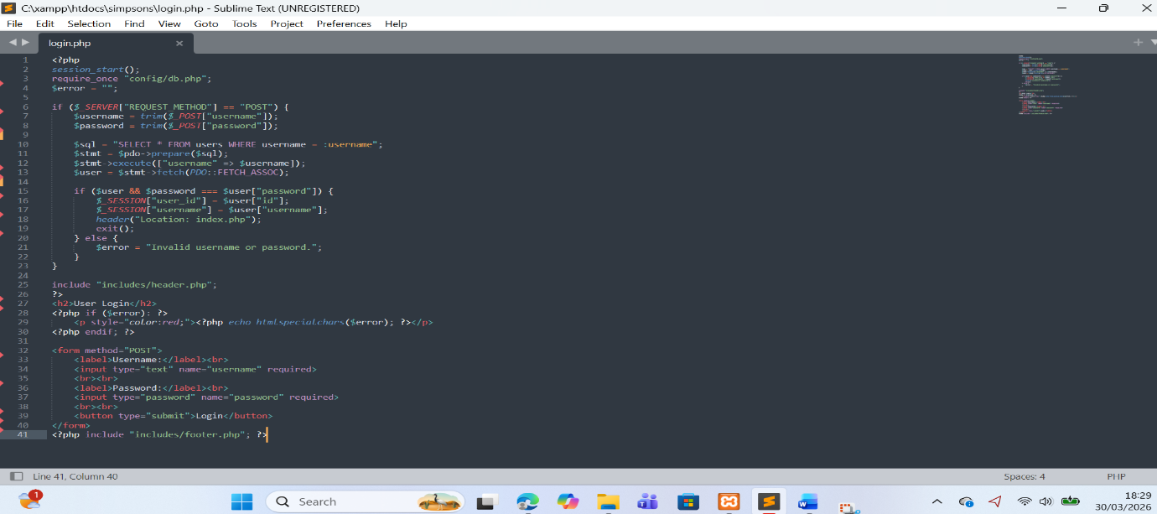
Figure 3: Prepared statement used in the login system to prevent SQL injection.
Another potential vulnerability area in this website is the search functionality implemented on the episodes page. Search forms typically allow users to input text that is later used in SQL queries to retrieve matching results from the database. If search input is not validated or protected, attackers could attempt to inject malicious SQL code into the search field. This could allow them to manipulate the query or access additional data stored in the database. For this reason, search functionality must always handle user input carefully to prevent malicious manipulation of database queries.
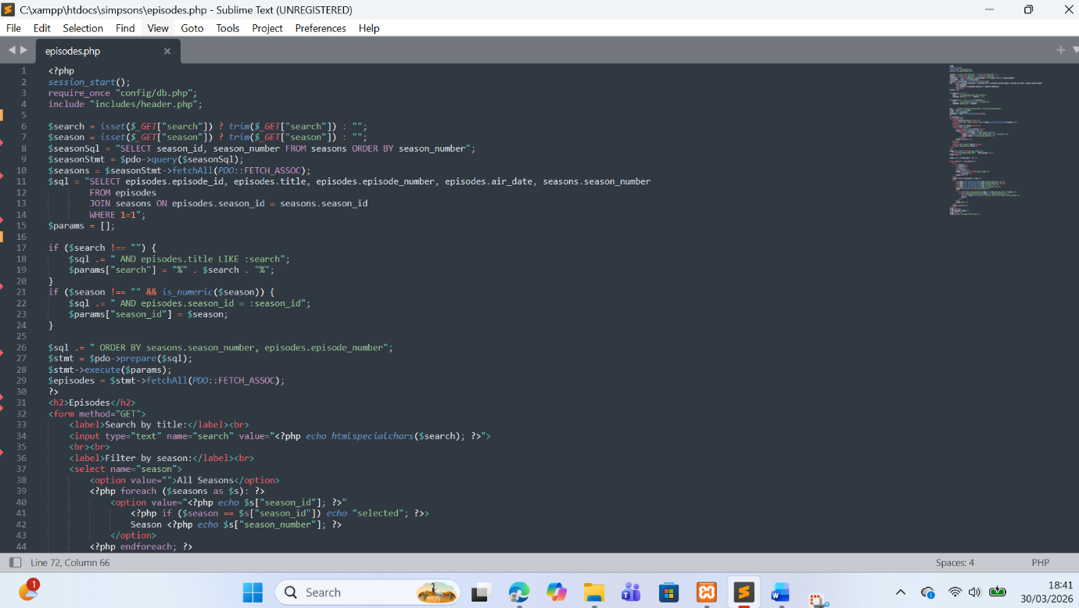
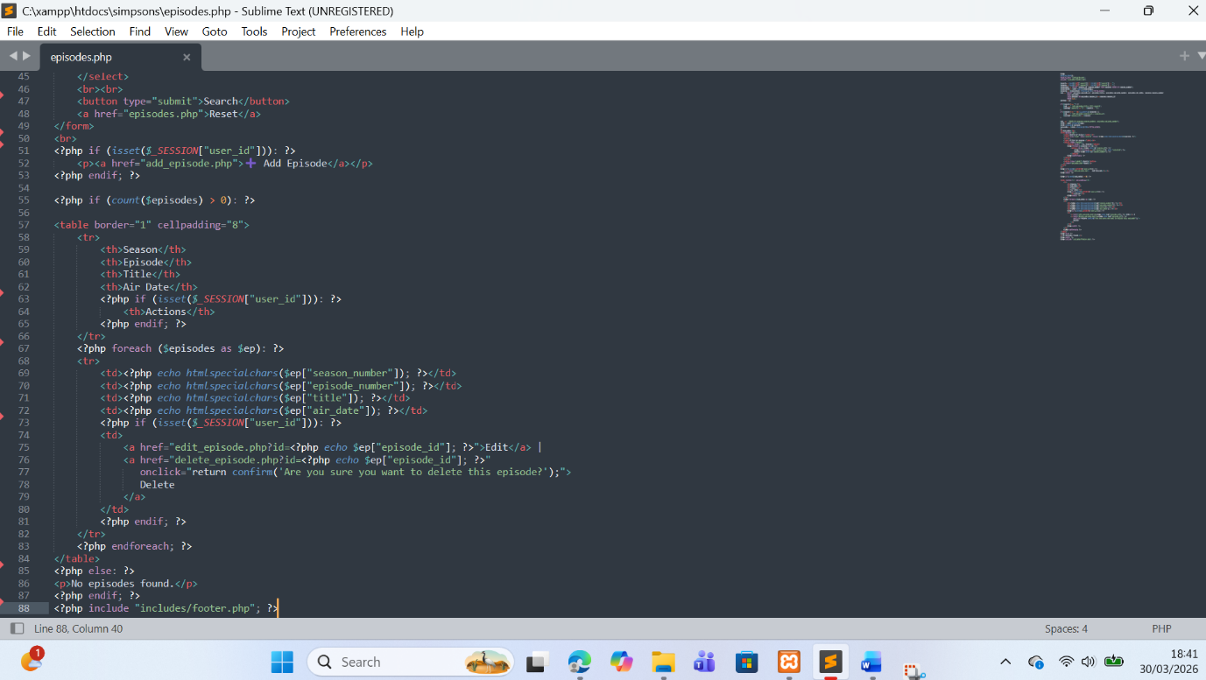
Figure 4: Secure query used in the episode search functionality.
Administrative forms also represent possible entry points for SQL Injection vulnerabilities. In this project, registered users can add, edit, and delete episode information through forms available after logging into the website. These forms collect data such as episode titles, descriptions, and dates, which are then stored in the database. Without proper security mechanisms, attackers could potentially exploit these forms to inject harmful SQL commands. Because these pages interact directly with the database and allow data modification, protecting them is essential for maintaining data integrity and preventing unauthorized changes [9].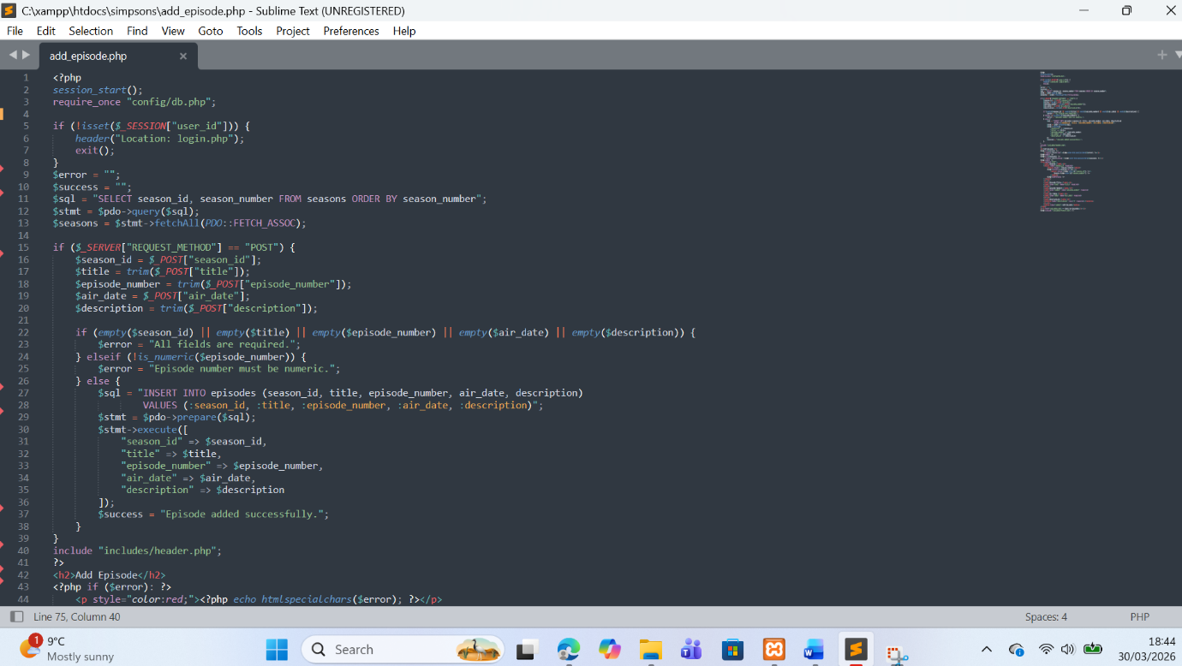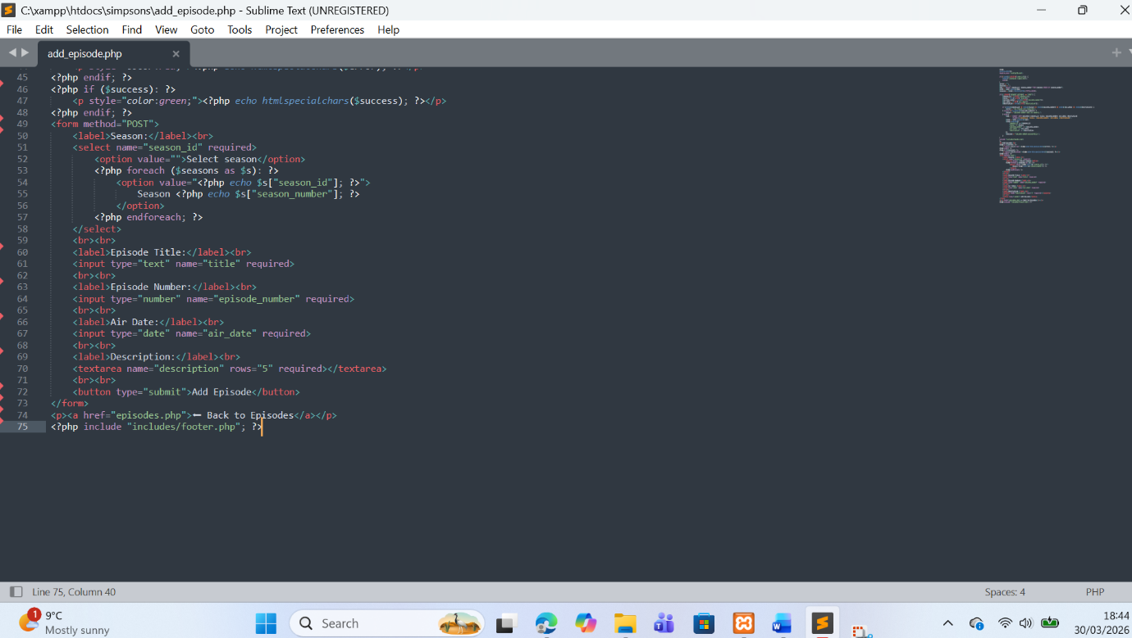
Figure 5: Prepared statement used when inserting episode data into the database

Preventing SQL Injection
Preventing SQL Injection is an essential aspect of developing secure database-driven web applications. Since SQL Injection attacks rely on manipulating user input, one of the most effective ways to prevent them is by ensuring that user data is handled safely before it reaches the database. Modern web development frameworks and programming practices emphasize the importance of separating user input from SQL query logic. By doing so, applications can ensure that any data provided by users is treated strictly as input rather than executable database commands [11].
One of the primary techniques used to prevent SQL Injection in this project is the use of prepared statements with PHP Data Objects (PDO). Prepared statements allow developers to define the structure of a SQL query first and then pass user input separately as parameters. This means that even if a user attempts to insert malicious SQL commands into an input field, the database will interpret the input only as data rather than part of the SQL query itself. In the developed website, prepared statements are used in several important areas such as the login system, search functionality, and administrative forms that insert or update data in the database. This significantly reduces the risk of SQL Injection attacks.
Another important security measure implemented in the website is input validation. Before processing user input, the application checks whether the provided data matches the expected format. For example, fields such as episode numbers are validated to ensure they contain numeric values, while required fields must not be left empty. Input validation helps prevent unexpected or malicious values from being processed by the application and improves the overall reliability of the system.
In addition to protecting database queries, the website also uses output escaping to protect against malicious scripts being displayed in the browser. The PHP function htmlspecialchars() is used when displaying data retrieved from the database. This function converts special characters into safe HTML entities, preventing potentially harmful code from being executed in the browser. Escaping output is an important security practice that complements SQL Injection protection and helps protect users from additional vulnerabilities such as cross-site scripting (XSS) attacks. Secure coding practices such as prepared statements, validation, and proper output handling remain among the most effective strategies for protecting modern web applications from injection-based attacks [12].
Figure 6: Escaping output using htmlspecialchars() to prevent malicious code execution.

Conclusion
In conclusion, this project demonstrated the development of a database-driven website using PHP and MySQL, combining both functionality and basic security practices. The website allows users to explore information about The Simpsons through dynamically generated pages connected to a relational database. By organising data into structured tables and retrieving it using SQL queries, the application is able to present content in an efficient and flexible way. Features such as search and filtering improve the user experience by making it easier to locate specific information within the database.
An important aspect of the project is the implementation of a user login system, which enables registered users to interact with the website beyond simple browsing. After logging in, users can perform CRUD operations, including adding, editing, and deleting episode records. This demonstrates how web applications can combine data management with user interaction, making the system more practical and interactive. These features highlight key concepts in web development, such as form handling, session management, and database integration.
Security considerations were also taken into account during development. Since the website processes user input through forms and search fields, it is important to protect against common vulnerabilities such as SQL Injection. The use of prepared statements ensures that user input is treated as data rather than executable SQL code, reducing the risk of malicious attacks. Additionally, input validation and output escaping using functions like htmlspecialchars() help protect both the database and the user interface from harmful input.
Overall, the project provides a clear example of how a database-driven website can be designed and implemented using PHP and MySQL. It demonstrates the importance of combining functionality, usability, and security when developing modern web applications, while also reinforcing the practical skills learned throughout the module.

References

[1] B. Arasteh et al., “Detecting SQL Injection Attacks by Binary Gray Wolf Optimizer,” Neural Computing and Applications, vol. 36, 2024.
[2] M. Hardini, “Application of Database Normalization in Increasing Data Storage Efficiency,” Journal of Information Technology and Computer Science, 2025.
[3] P. L. Soto, “Relational Databases for Behavioral Science,” Behavior Analysis Research and Practice, Springer, 2025.
[4] S. Marín, J. J. Amorós, and J. A. García, “Dynamic Content Generation Using PHP and MySQL: A Case Study,” Journal of Web Engineering, vol. 21, no. 3, pp. 198–215, 2023.
[5] M. B. Elshenawy and H. Elshafey, “Secure CRUD Operations in Web Applications: A Modern Approach Using Prepared Statements,” International Journal of Advanced Computer Science and Applications, vol. 14, no. 2, pp. 112–120, 2024.

[6] A. Paul, “SQL Injection Attack: Detection, Prioritization and Prevention,” Journal of Information Security and Applications, vol. 77, 2024.
[7] M. Alenezi and K. Almustafa, “A Survey of SQL Injection Detection and Prevention Techniques,” IEEE Access, vol. 10, pp. 114562–114579, 2022.
[8] S. Singh and P. Kumar, “SQL Injection Attacks and Defense Mechanisms in Web Applications: A Comprehensive Study,” International Journal of Information Security Science, vol. 12, no. 1, pp. 45–58, 2023.
[9] M. Alenezi and K. Almustafa, “A Survey of SQL Injection Detection and Prevention Techniques,” IEEE Access, vol. 10, pp. 114562–114579, 2022.
[10] H. Shahriar and M. Zulkernine, “Mitigating SQL Injection Attacks in Web Applications,” Journal of Information Security and Applications, vol. 70, 2023.
[11] M. Alenezi and K. Almustafa, “A Survey of SQL Injection Detection and Prevention Techniques,” IEEE Access, vol. 10, pp. 114562–114579, 2022.
[12] A. Paul, “SQL Injection Attack: Detection, Prioritization and Prevention,” Journal of Information Security and Applications, vol. 77, 2024.

