
Name – Declan Thomas

Student Number – 1908075

Course – HND Quantity Surveying (Part Time)

Module – Material Science and Building Services

Assignment Title – Construction Materials

Lecturer – Allan Nantel

Table of Contents
- Front Cover
- Table of Contents
- Introduction, Steel Framed Building & Steel Climatic and Environmental Resistance
- Steel Climatic and Environmental Resistance
- Steel Production Process and its Environmental Impact & Ease of Assembly and Adaptation
- Concrete Framed Building, Climatic and Environmental Resistance & Concrete Production Process and its Environmental Impact
- Concrete Production Process and its Environmental Impact & Ease of Assembly and Adaptation of Concrete
- Comparing both materials
- Bibliography

Introduction
Within this assignment I shall be selecting two existing habitable buildings currently around the world, one a concrete frame and one of a steel frame. I shall then report on the details of their original design planning, construction and they potential impact and the consideration to sustainability. During the report I shall be analyzing the framing material of each chosen building by comparing and contrasting them by discussing in detail the likely durability and climatic resistance of materials and also the likely impact of frames materials original production process, whilst also discussing the ease of assembly and of its potential ease of adaption to different building shapes and use within the life cycle of the building.
Steel Framed Building
For the steel framed building, I have chosen to use the world famous Burj Khalifa. The Burj Khalifa currently stands as the world’s tallest free-standing building/structure in the world. The structure is over 828 meters high and includes 160 stories within the building. The Burj Khalifa has broken many impressive records not only as the world’s tallest structure and free standing structure but records such as tallest service elevator in the world, highest outdoor observation deck in the world, highest number of stories in the world, highest occupied floor in the world and many more.
(https://www.burjkhalifa.ae/en/the-tower/facts-figures/, n.d.)
Climatic and Environmental Resistance
The construction of the Burj Khalifa consists of 45,000 m3 of concrete weighing over 110,000 tonnes which was used to construct the concrete and steel pilled foundation. The foundations consist of 192 piles which have been excavated down to 50 meters. Each pile has the capacity of 3,000 Tonnes. The Burj construction will have used more than 39,000 tonnes of steel rebar through the project. The floor plan of the Burj Khalifa is a ‘Y’ shaped. This provides a stable structure for the building which will help the structure reduce the wind forces towards the building. Also, by having the ‘Y’ shaped floor plan it allowed the building to have a full view of the Persian Gulf. The ‘Y’ shape provides stiffness in both torsionally and alongside. The central core is served to resist any torsional movement. As the Burj towers into the sky, the width and shape of the building decreases in size and diminishes, this allows less wind effects, movement and velocity. During the construction phase, there was many wind-loading tests being carried out on the structure to ensure the structure was being built effectively. The Burj has the capacity to withstand earthquakes up to a 7.0 magnitude.

(htt1) (htt2) (https://theconstructor.org/structures/structural-details-burj-khalifa-concrete-grade-foundations/20512/, n.d.)
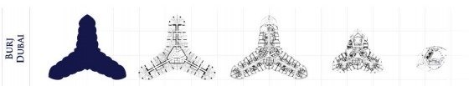
(https://sites.google.com/site/burjkhalifatower/calendar, n.d.)

The Steel used in the Burj allows the structure to build very tall and wide while being lightweight and strong while being precise and predictable allowing it to have excellent quality control. As the Burj is constructed as a steel structure it provides a long-term durability, meaning the steel quality will be able to last a long time without becoming damaged. The strength of steel can be stronger than concrete when the strength to weight ratio is compared. The steel also allows the structure to have architectural shaping and great flexibility. In addition to all the benefits, the use of a steel framed building offers an environmental and sustainable benefit as the steel last a long time and is reusable. The steel can also be recyclable several number of times without the properties within the steel being affected.
The Burj Khalifa is a sustainable development as structure is so large it can accommodate a large amount of people on a small footprint. This can reduce and save agricultural land from other developments and can also reduce carbon emissions. As the population is increasing daily, a development like the Burj will encourage more development to be more vertical as it occupies less space and can hold a large amount of population in its development. The unique architectural design of the Burj Khalifa’s fully glazed facade and solar shading allows the design and construction of the development to make it environment friendly. There are 378 solar panels on the Burj which is located on the roof. By having the solar panels, it saved up to 3,200 kilo watts of power a day. Knowing this information makes the structure energy efficient and sustainable.
(https://www.go-green.ae/greenstory_view.php?storyid=1008, n.d.) (https://www.burjkhalifa.ae/en/the-tower/facts-figures/, n.d.)
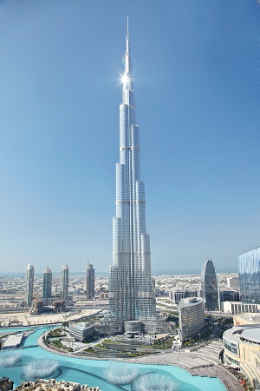

Production Process and its Environmental Impact
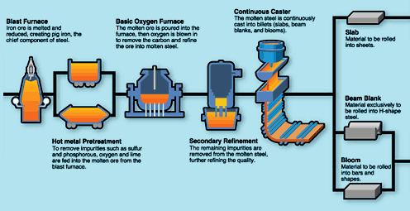
The Steel production process begins as raw inputs of Iron Ore, Limestone and Coke are heated in a blast furnace. The molten Iron will then go into BOS (Basic Oxygen Furnace) where the molten Iron will then be made into molten Steel. The molten steel will then go on to continuous casting where it is then passed through to the hot rolling meaning the steel can be formed into many various shapes such as long products or flat products.
(https://www.jfe-steel.co.jp/en/works/west/process.html, n.d.)
The steel production has a few environmental issues such as air pollution, waste contaminants, hazardous wastes and solid wastes. The major environmental impacts are from the steel mills. The main greenhouse gas emission released from the steel production is Carbon Dioxide, which is usually released from the blast furnace. The coke production is also another pollution source from the steel production. Many air emissions get released from the coke ovens such as coke oven gas, naphthalene, ammonium compounds, crude light oil, Sulphur and coke dust. In the production of steel, it produces waste such as slag, limestone and iron ore impurities. These waste products collect at the top of the molten iron.
(http://www.greenspec.co.uk/building-design/steel-products-and-environmental-impact/, n.d.)
Ease of Assembly and Adaptation
The erection of structural steelwork consists of the assembly of steel components into a frame on site. The processes involve lifting and placing components into position, then bolting or welding them together. The steel is usually carried out by mobile elevating work platforms such as a mobile crane and a tower crane. The steel beams are prefabricated off site then are transported to site when needed. The crane shall then place the beams into place. By having the steel prefabricated off site, it will not take up any room on site and will minimize maintenance. The adaptation of a steel frame can be very is simple. The steel can be cut, added or taken away as long as it doesn’t affect the structure.

(https://www.steelconstruction.info/Construction, n.d.)

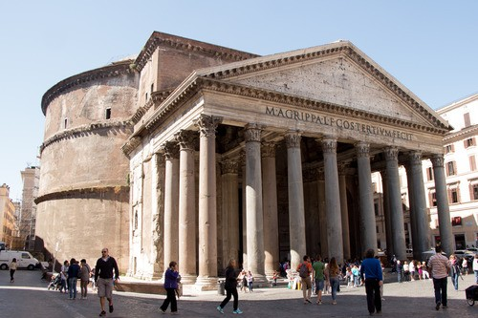
Concrete Framed Building
For the concrete framed building, I have chosen to use the Pantheon. The Pantheon is an ancient structure based in Rome, which was completed around 126-128 A.D and is thought to have been designed as a temple for the roman gods. The Pantheon is largest non-reinforced solid concrete dome.
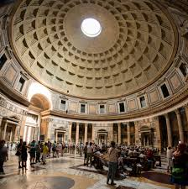
The Pantheon is primarily made from concrete, bricks and granite columns. The Pantheon is roughly 142 feet in diameter and contains a concrete dome at the top which has a 27 feet wide opening which has no covering allowing light, rain and all weathers into the Pantheon. But intelligently the Pantheon has a gently sloping floor and 22 hidden holes which helps allow drain water that comes through the opening.
(https://www.history.com/topics/ancient-greece/pantheon, n.d.)
(https://www.lonelyplanet.com/italy/rome/attractions/pantheon/a/poi-sig/389093/359975, n.d.) (https://www.ancient.eu/Pantheon/, n.d.)

Climatic and Environmental Resistance
As the Pantheon is made by concrete it allows the unique structure to remain durable for a long time as concrete has an unparalleled strength. By having a large amount of strength in the concrete this allows the structure to have longevity and becomes durable in any environment. Also, as the structure is concrete, the material shall remain strong as the material does not burn, rust or even rot. This can be due to the additives that can be added to the concrete. Concrete can also endure very high temperatures for a long period of time.
Production Process and its Environmental Impact
The production of concrete starts with the manufacture of cement. To begin the production process for concrete, the raw materials are to be extracted. The raw materials which are to be used are Limestone, shale, silica and iron oxide. Once the raw materials have been mined the materials are crushed and milled into fine powders. After the heating process from the kiln, we then are left with clinker. The clinker is then put through a grinding mill with gypsum, this then produces cement.
The cement added with aggregates and water will then produce concrete. Once mixed the cement acts and a binder that will hold everything together, the water will start the chemical reaction and the aggregates provide the strength.
(http://www.greenspec.co.uk/building-design/cement-materials-and-manufacturing-process/, n.d.)
The production process of concrete has a high impact on the environment. During the process of creating concrete, the process releases a high amount of carbon dioxide. This is led to 5% of the world’s total of carbon dioxide emissions, just caused by the process of concrete. By burning the fossil fuels to generate the heat that is required to produce cement, resales carbon dioxide. Also, the transportation of the concrete has an environmental effect by release emissions such as vehicle pollution, energy consumption and noise.
Another process that causes environmental issues are quarrying/mining for Limestone. This process creates dust, noise, visual impacts on the environment and causes land degradation.
(http://www.greenspec.co.uk/building-design/environmental-impacts-of-concrete/, n.d.)
Ease of Assembly and Adaptation
Concrete is usually poured as a liquid state. Concrete can be poured into a site-specific form and then will cured on site or Concrete can produced into a precast concrete product that is produced by casting concrete into a mold which is then cured in a controlled environment. The precast concrete can then be transported to site and put into place.
Admixtures can be added to the concrete as it can change the characteristics of the concrete that can be best fit for the mixture.
The Admixtures are used to;
- Improve the workability of the fresh concrete.
- To reduce the water content and increase the strength for a given water-cement ratio.
- To increases the durability of the concrete and harden the cement.
- To retard setting time or increase it.
- To increases concrete resistance to freezing.

The Main Admixtures used;
- Air entering agents – to improve the durability and workability of the concrete mix.
- Accelerators – Accelerate the setting time.
- Retarders – Retard the setting time, necessary in hot conditions to reduce premature stiffening of the concrete.
- Waters Reducers – Reduces water content and makes high strength concrete and allows water-cement ratio increases workability.
- Super Plasticizers – Increases flow of concrete and reduces the water ratio.
When Laying concrete, the increases of workability can be vitality important because if the concrete is more workable it becomes easier to be shaped and placed without any segregation.
When the life of the concrete building comes to an end, demolition shall take place. Once demolished the concrete can be passed through a recycling process. The recycled concrete can be used as many sources of aggregates.

Comparing both materials

Both steel and concrete are the most common and important materials in the construction industry, but both have different strength and weakness. Steel is a ductile material that has high tensile strength and concrete is a brittle material with a high compressive strength. Concrete is a regularly used material for construction while steel is now gaining momentum for its flexibility and reduced construction time. Steel has a fast erection time which allow the building to be occupied a lot sooner and will reduce labour costs. Also, as the steel is prefabricated off site, it will speed up the construction. Concrete take longer to construct as the mold will need to be formed and then poured, also the setting time will need to be dependable on the weather. Whereas steel can be installed in any weather, dependent on the wind factor. Both materials are durable, but steel can be more durable than concrete. To make concrete more durable reinforced steel can be added. Concrete is cheaper than steel but if reinforced steel is added to concrete the price will increase. Steel is more expensive than concrete, but a smaller building will benefit from concrete rather than steel. The production process of both the materials produces a large amount of carbon dioxide, which has an environmental impact. Both steel and concrete have a long life, however steel can rust and become unsafe and concrete will last long in certain environment if the correct additives are added. However, Steel in failure can be rectified by removing and replacing with new steel by way of welding or bolt ons, whereas in concrete failure this is a lot harder as you cannot easily remove and replace the failed aspect.

Bibliography
(n.d.). Retrieved from https://coderedsafety.com/blog/safety-features-in-the-worlds-highest-building-the-burj/
(n.d.). Retrieved from https://www.burjkhalifa.ae/en/the-tower/design-construction/
http://www.greenspec.co.uk/building-design/cement-materials-and-manufacturing-process/. (n.d.). Retrieved from http://www.greenspec.co.uk/building-design/cement-materials-and-manufacturing-process/
http://www.greenspec.co.uk/building-design/environmental-impacts-of-concrete/. (n.d.). Retrieved from http://www.greenspec.co.uk/building-design/environmental-impacts-of-concrete/
http://www.greenspec.co.uk/building-design/steel-products-and-environmental-impact/. (n.d.). Retrieved from http://www.greenspec.co.uk/building-design/steel-products-and-environmental-impact/
https://sites.google.com/site/burjkhalifatower/calendar. (n.d.). Retrieved from https://sites.google.com/site/burjkhalifatower/calendar
https://theconstructor.org/structures/structural-details-burj-khalifa-concrete-grade-foundations/20512/. (n.d.). Retrieved from https://theconstructor.org/structures/structural-details-burj-khalifa-concrete-grade-foundations/20512/
https://www.ancient.eu/Pantheon/. (n.d.). Retrieved from https://www.ancient.eu/Pantheon/
https://www.burjkhalifa.ae/en/the-tower/facts-figures/. (n.d.). Retrieved from https://www.burjkhalifa.ae/en/the-tower/facts-figures/
https://www.burjkhalifa.ae/en/the-tower/facts-figures/. (n.d.). Retrieved from https://www.burjkhalifa.ae/en/the-tower/facts-figures/
https://www.go-green.ae/greenstory_view.php?storyid=1008. (n.d.). Retrieved from https://www.go-green.ae/greenstory_view.php?storyid=1008
https://www.history.com/topics/ancient-greece/pantheon. (n.d.). Retrieved from https://www.history.com/topics/ancient-greece/pantheon
https://www.jfe-steel.co.jp/en/works/west/process.html. (n.d.). Retrieved from https://www.jfe-steel.co.jp/en/works/west/process.html
https://www.lonelyplanet.com/italy/rome/attractions/pantheon/a/poi-sig/389093/359975. (n.d.). Retrieved from https://www.lonelyplanet.com/italy/rome/attractions/pantheon/a/poi-sig/389093/359975
https://www.steelconstruction.info/Construction. (n.d.). Retrieved from https://www.steelconstruction.info/Construction

