ASSESSMENT SPECIFICATION

Course Work
(Written Report)
Programme: BA Business Management
Module Code: LCBB5000
Module: Data Handling and Business Intelligence



Zhivko Plamenov Panev
Student ID: 2109289
Lecturer: Dr Eric Osei
Internal Verifier: Dr Md Nazmul Hasan

Table of Contents
Introduction 3
Part 1 3
Tutorial for building a Pivot Table on Excel 4
Discussion for Most profitable line by Payment 11
Performance of Branches for Supermarket 12
Sales Performance by Gender 13
Using SPSS to analyse customer rating 14
Part 2-Advantages and disadvantages of using SPSS or Excel 16
Excel- Overview 17
SPSS-Overview 17
Data mining cycle 18
Conclusion 18
References 19

Introduction
Data Handling and Business Intelligence are two important matters to discuss in large organisations or businesses where large amounts of data are available. This information could inform us of where our organisation needs to improve. This coursework will explore data manipulating and extracting information from it using Excel.
This report will include a tutorial on developing a pivot table in Excel. We will also discuss some practices in the business using analysing tools and software to support the decision-making process in the business world out there. Nowadays, we meet more and more data to be used for businesses to apply their strategies and set their targets (reference). This is why Data analysis and Data mining cycles are crucial for every organisation which seek growth of its revenue and establish its performance to grow. We can analyse and extract knowledge from the numbers using Excel, SPSS, Tableau and other software, which sometimes say nothing more than a numeric value. Ratings, gross incomes, and other accounting figures are easy to identify and analyse when using formulas in excel. SPSS is, on the other hand, a powerful tool for running statistical analyses on a large amount of data.

Part 1
For this part, the following sections will clearly show how a PivotTable has been developed on Excel Software, which is part of the Microsoft Excel Office Package. We gave a thousand rolls with raw data, which we will use to build and analyse a pivot table for this task.
The information we are given includes Invoice Identification Number, branch, city, customer type, gender, product line, unit price, quantity, tax5%, total price including tax, date, time of purchase and payment method, Cost of goods, gross margin percentage, gross income and rating provided from customer.
A couple of tasks are required to use the given data; the data link for download is https://www.kaggle.com/datasets/aungpyaeap/supermarket-sales.
Data Visualisation Dashboard to be produced for the following variables:
Invoice ID per Total Sales, Gross Margin % per Product Line, Date per Total Sales, COGS per product line, and Product line per Customer Ratings

This report will express the entire workings with screenshots for building a Pivot Table in Excel.
First, we will start with downloading the data from the webpage; after we`ve downloaded the file, we identify that the file is in CVC format. The file formats are essential for every analyser as errors will be produced when analysing the data if they don`t match the type of software format. To avoid any issues with our analysis, we will re-save the file in xls file format, which Excel uses.

Tutorial for building a Pivot Table on Excel
Pivot Tables are one of Excel`s most powerful tools; a pivot table allows us to extract knowledge from extensive data (Večeřa, 2022).
Step 1
Opening the file in Excel, then go to the tab Insert. In the Tables group, click Pivot Table.
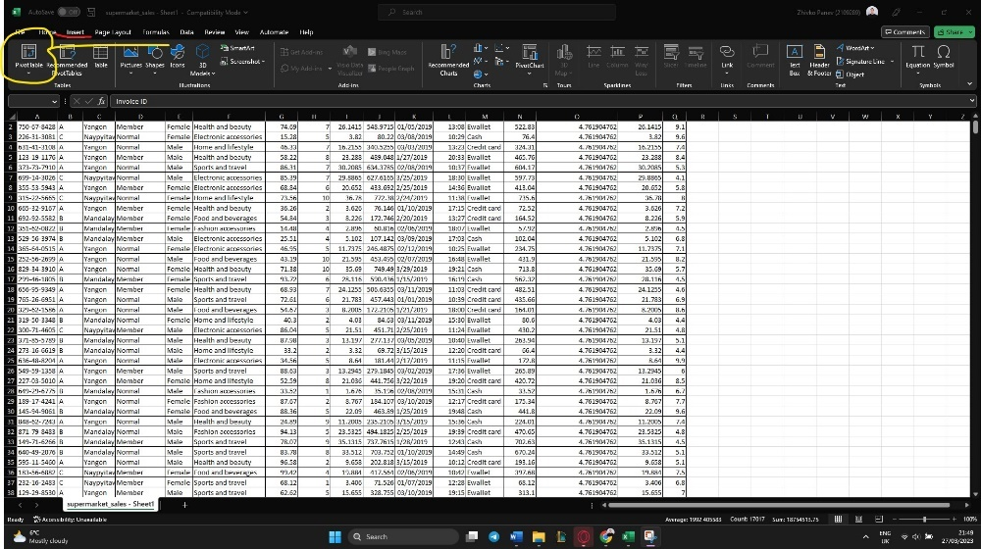

Step 2
Excel will automatically detect the range of your pivot table; double-check if all the cells you need are included. Then, Excel will be given automated instructions to insert your pivot table on the new spreadsheet.
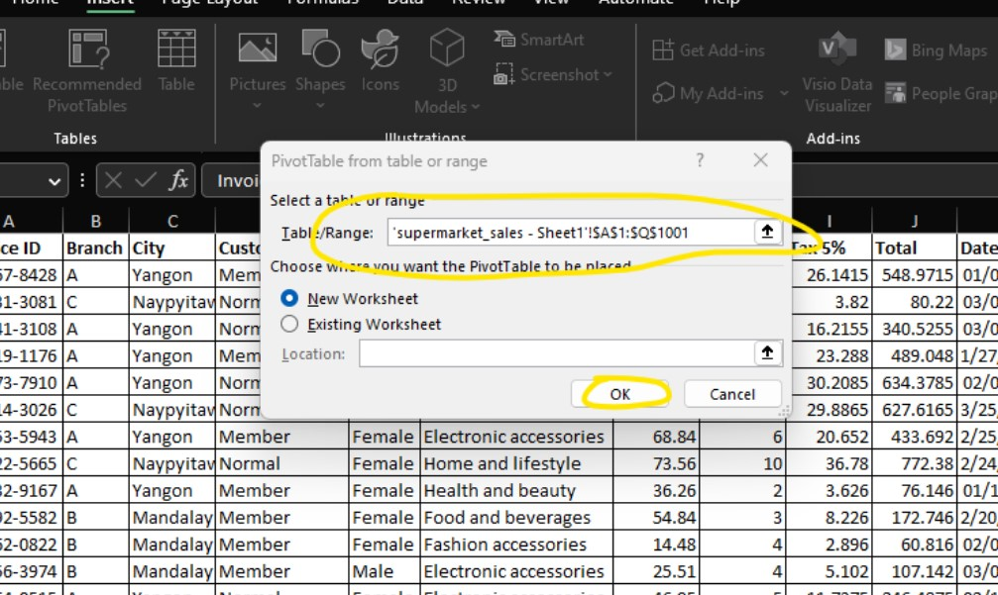
Step 3
Now we can go on our spreadsheet having a pivot table. There, we will see a list of our variables and fields pane at the right end of the screen. Product field to the rows area, amount field to the values area and country field to the filters area.
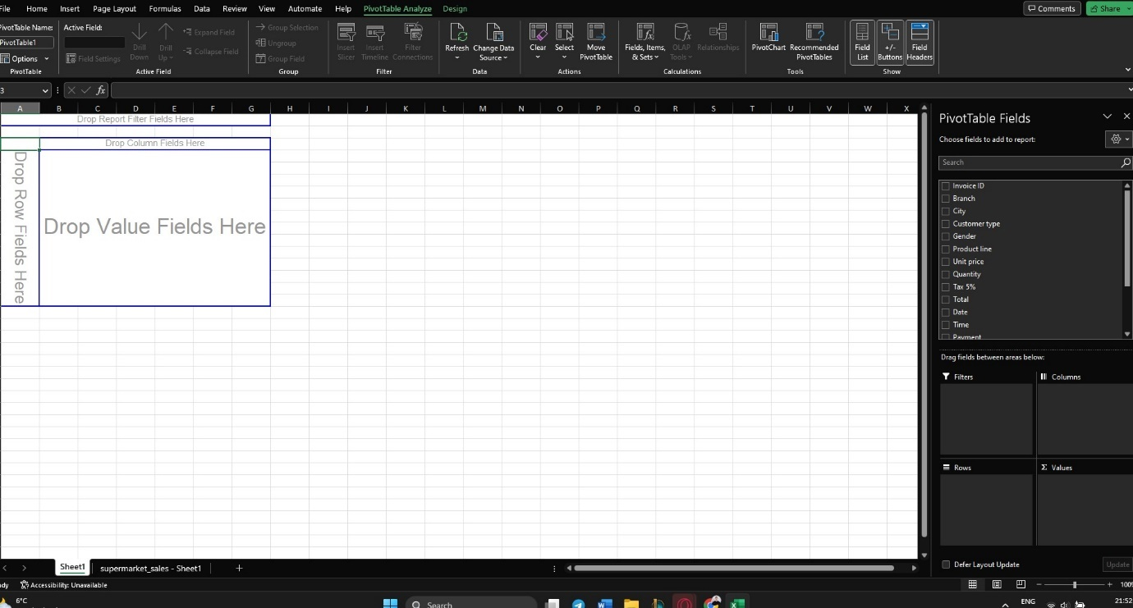

Step 3
After we produced our pivot tables, we had to allocate our variables and values to filter and analyse using the pivot chart provided by Excel.
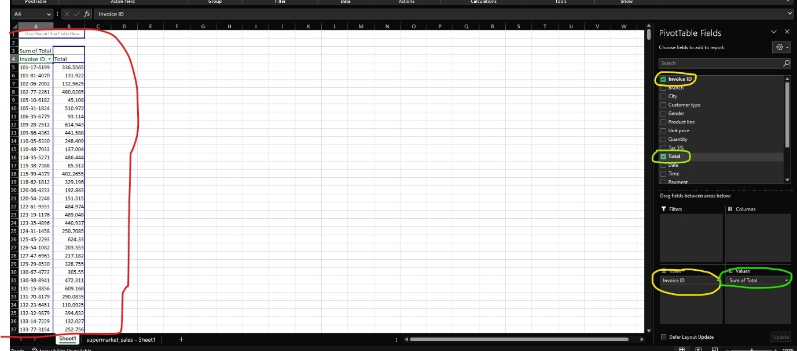
After allocating the variables and the values, we can produce a chart in Excel to visualise the data. Clicking on the icon Pivot Chart Excel will allow us to choose the most appropriate chart or graph to visualise our data.

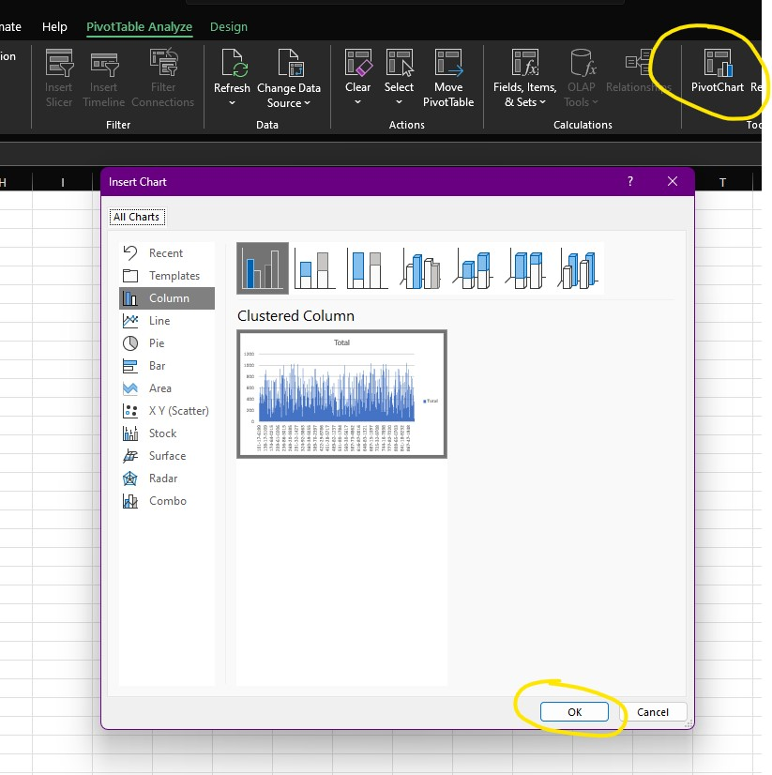

Then we click Okay to produce the chart:
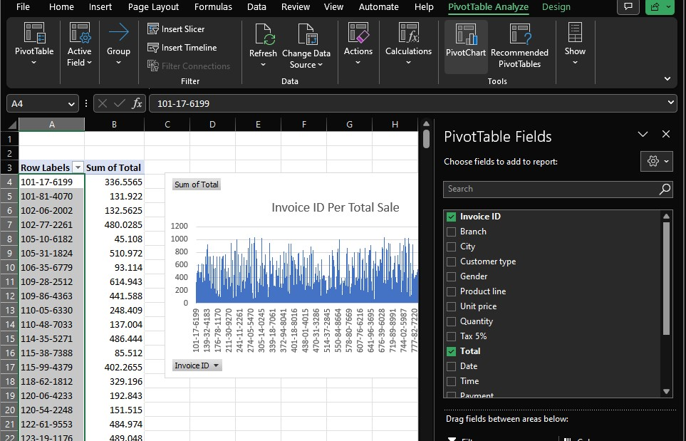
To sort out our information, we can click in any cell on the sum of the total, then right-click on the mouse to sort the pivot table fields.
We can edit the chart elements and style from the boxes in the top-right corner.
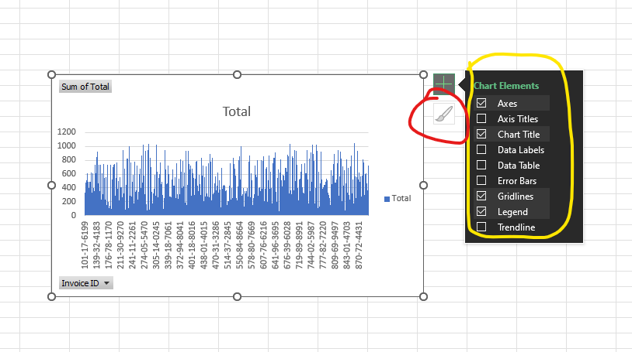

Sometimes we can change the label content so the information makes more sense to us as we applied the percentage option for calculating the gross margin income here. We can identify in the data that the gross margin is the same for each product line, but after analysing it with the right tools, we can see a slight difference between the product line per cent of income.
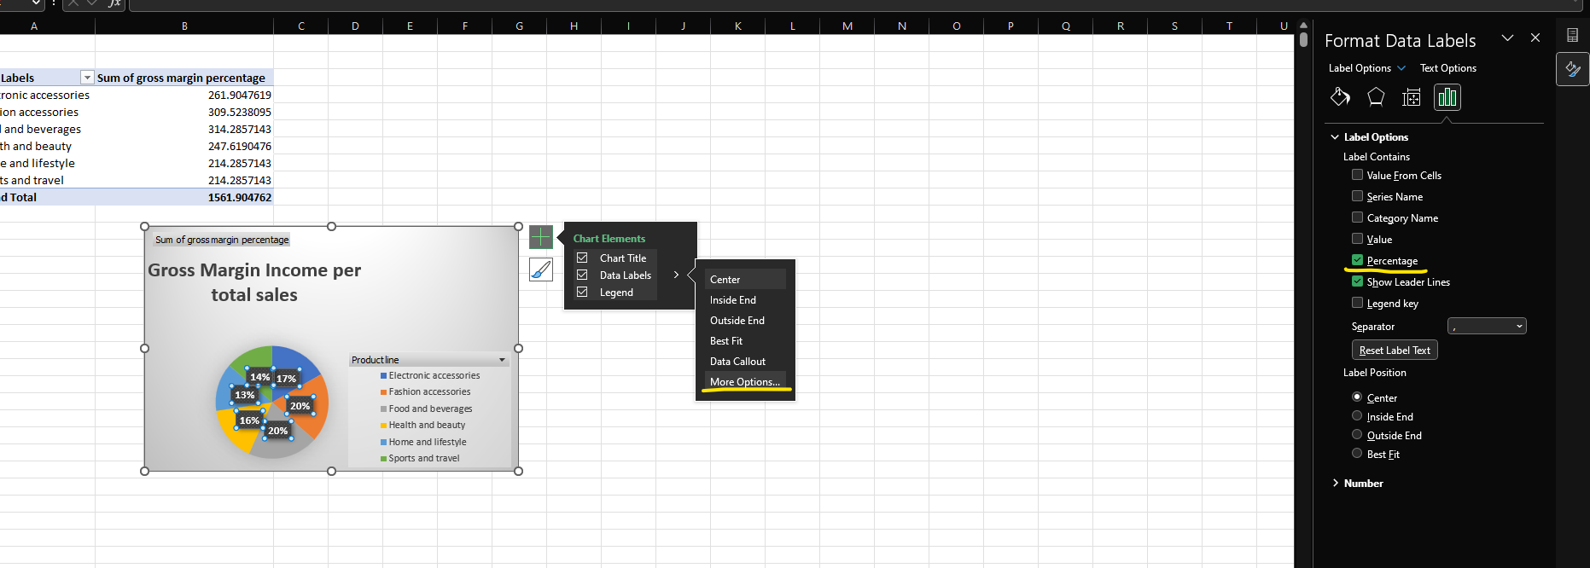
Using Excel, we have wild options of data editing tools to make our data make more sense; in this situation, we also changed the number category from general to currency to clarify the information for our purpose.
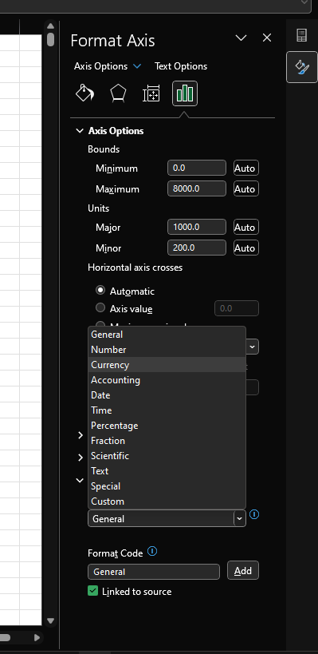
After identifying some of the required actions and providing screenshots to support the build of a pivot table on Excel, we will now produce a dashboard which includes the needed tasks, charts and graphs to analyse the data for the Supermarket sales year 2019.
Pivot tables are a quick and powerful way for individuals to analyse large datasets (Kopf, 2020). Using excel, no coding skills are required to produce a dashboard like the one shown below.
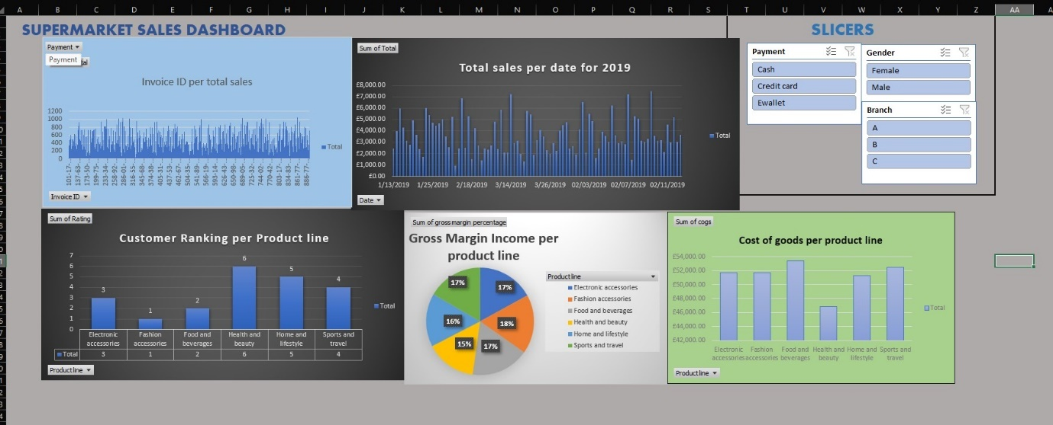
On our dashboard, we added slicers to help us analyse the information from the figures in our spreadsheet. To produce a slicer, tap and press insert slicer on the Pivot Chart Analyse.
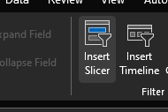
Once we click insert slicer, we will get a box with variables from which we can choose our slicer.
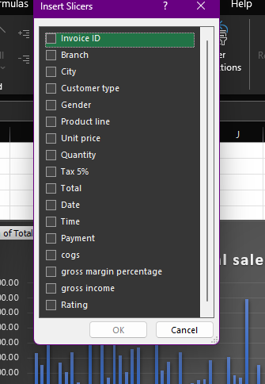
Once we have everything in hand is reasonable to allow the connections between the charts and graphs so the slicers we`ve applied will affect each area of your attention.
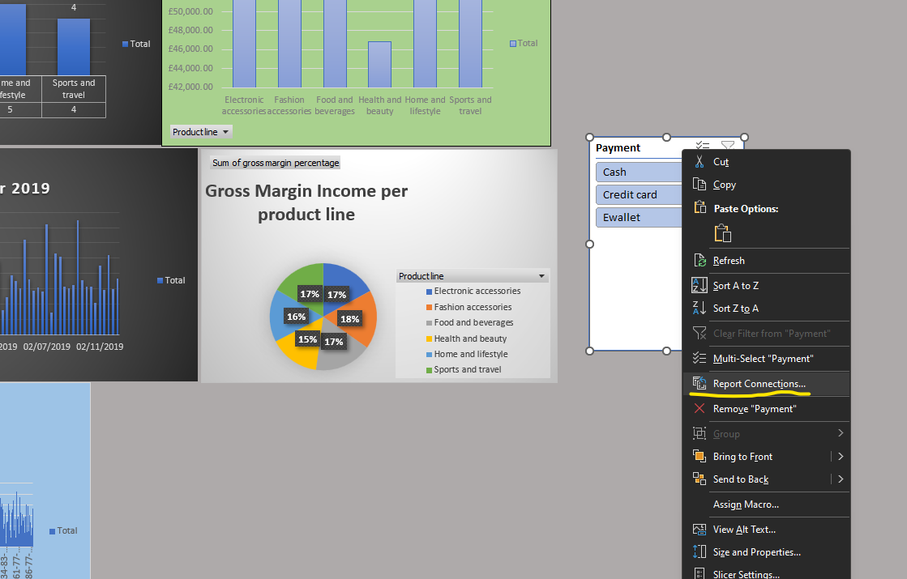
Press right-click on your dashboard and find report Connections; then, from there, you can add all the charts you need to interact with your slicer by ticking the box.
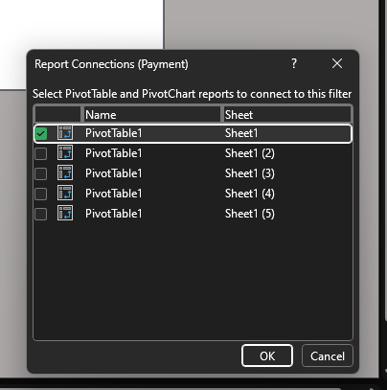

Discussion for Most profitable line by Payment
When large amounts of data are given to deliver quick filtering in a spreadsheet, we can use the slicers to provide us with buttons in the pivot table for fast filtering (Alexander, 2016). Using the slicers helps to understand quickly what exactly is currently displayed. In our store, we have three payment methods: cash, payment by card and e-wallet. The figures below will show a change in the gross-profit income based on payment methods.
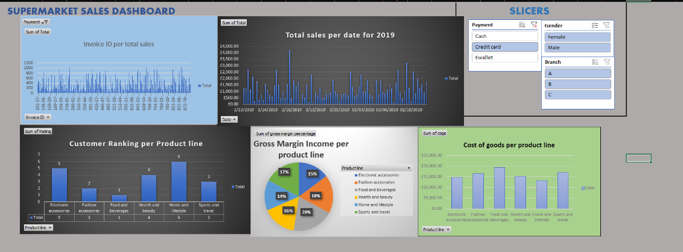
Payment By Credit Card is more likely to be made for Sports and Travel goods.
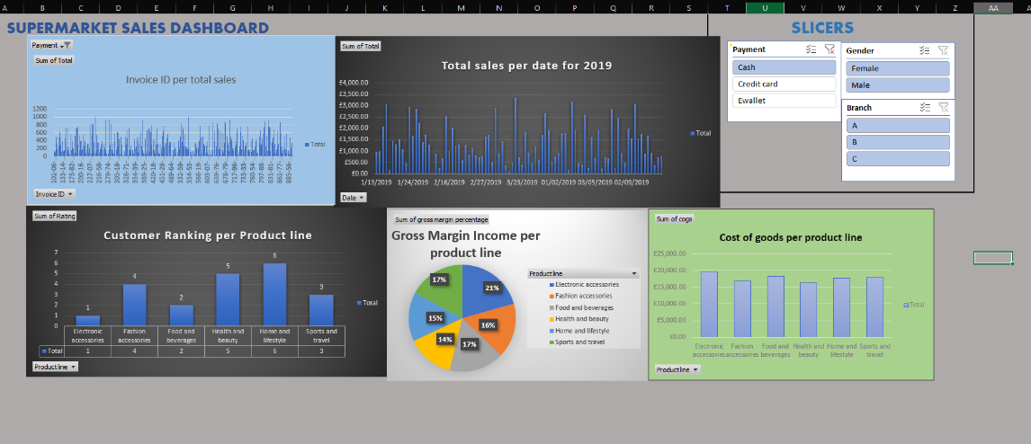
Customers at our store are more likely to pay by cash when buying electronic accessories.
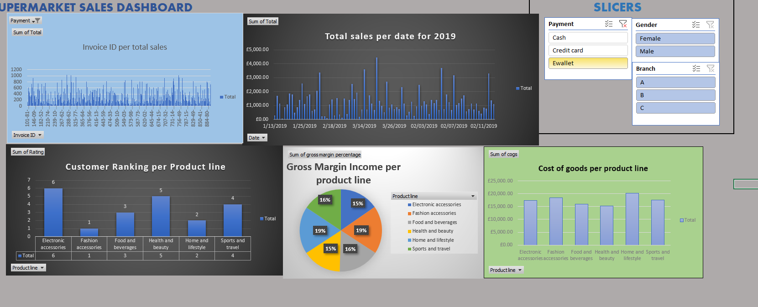
The customers in our market are more likely to spend money through their e-wallet for Home and Lifestyle.

Performance of Branches for Supermarket
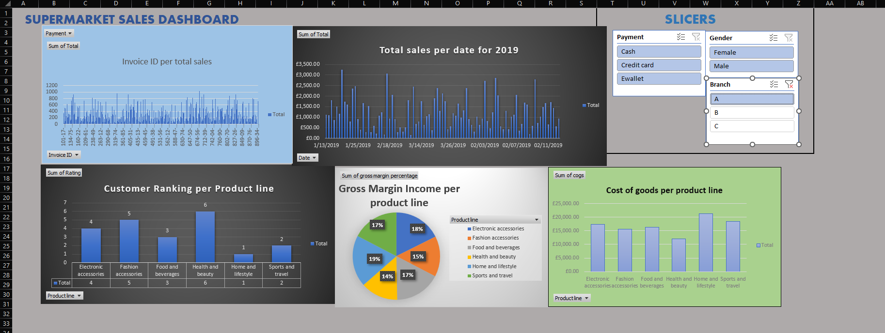
Performance for Branch A
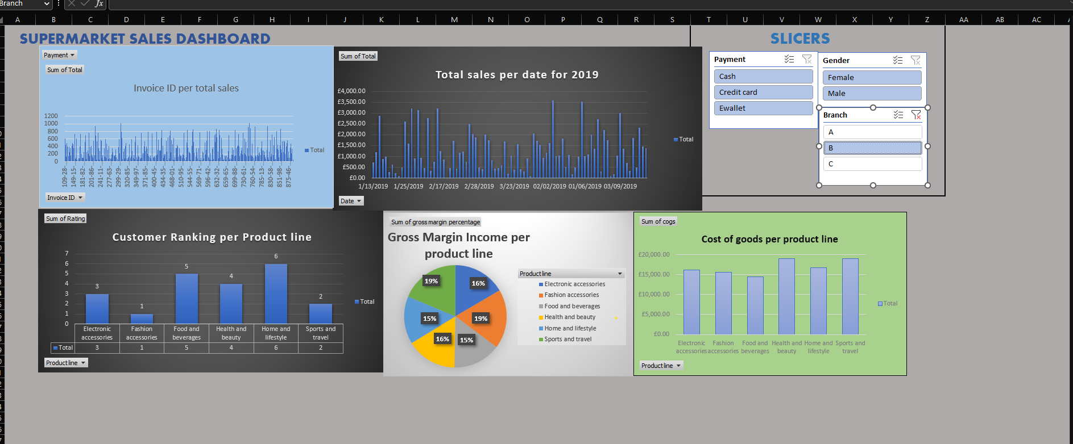
Performance for Branch B
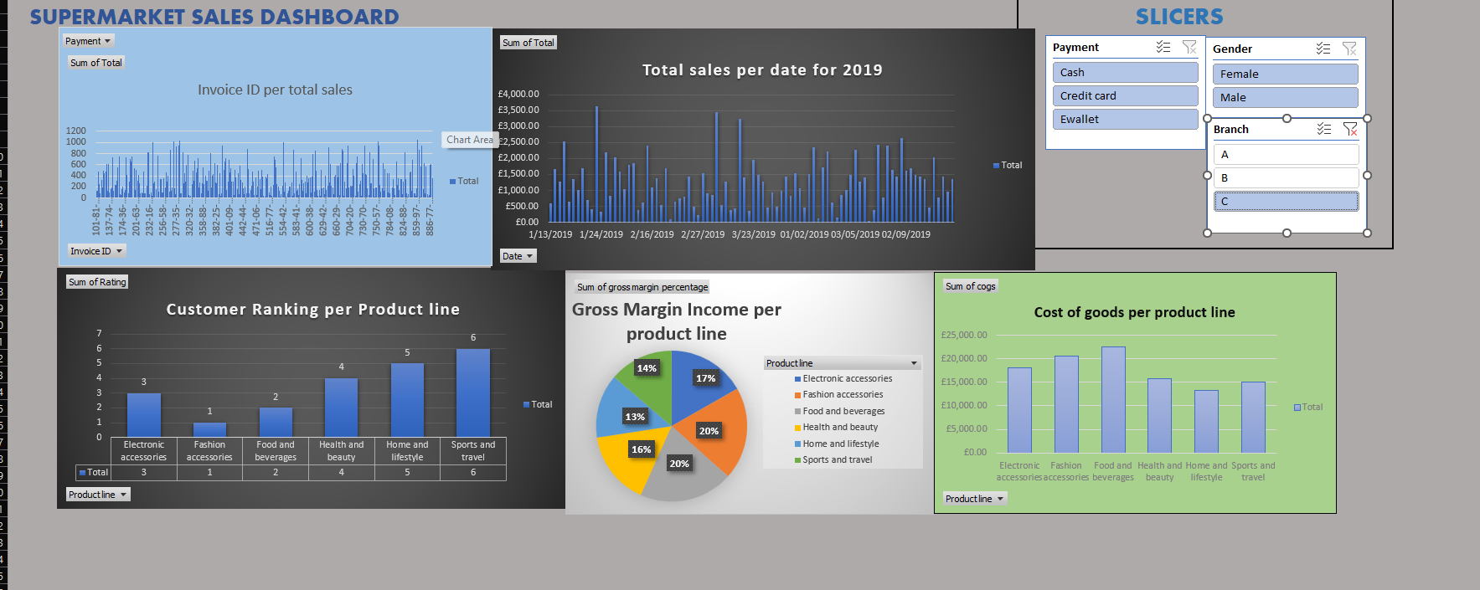
Performance for Branch C

Sales Performance by Gender
This section will look at what the data could tell us when using a slicer by Gender.
In the screenshots below, we can see the difference between the purchasing habits of the males and females in our supermarket data. The males spend more on Sports and Travel and Home and Lifestyle goods. This is good for the business as the cost of goods based on our data is less than some other product lines. This means the patterns in males are profitable for the store.
Females are spending more on Health and Beauty goods, the product line with the lowest cost of goods. Females are the better group for this particular store to target and develop new products for their needs.
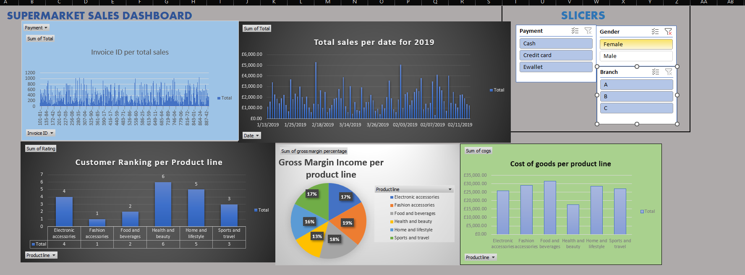
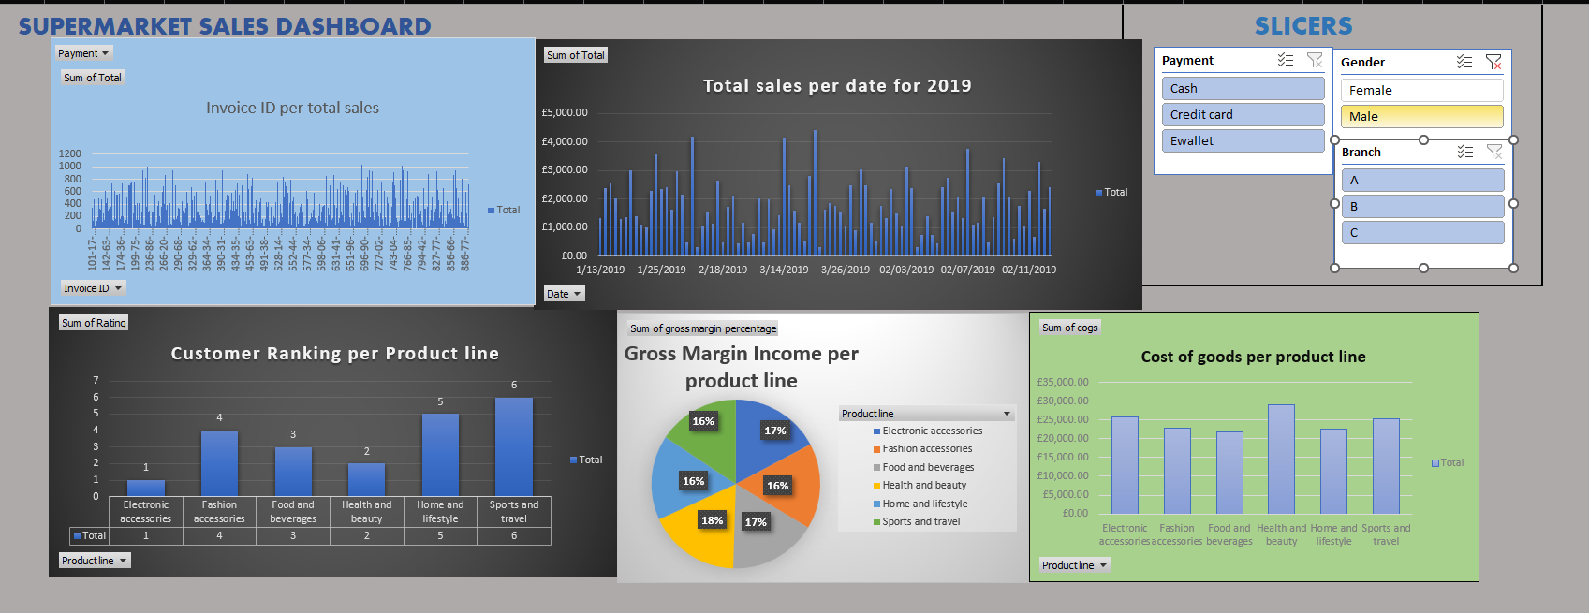

Using SPSS to analyse customer rating

This section will follow generating a complex table on SPSS; the table will run statistic checks for Mode, Median, Range and Standard Deviation; for this, we need to bring a brief idea of what this all means.
The Mode value is the most frequently occurring figure; this measure central tendency that can help us to identify the most popular choice of customer trends or most common characteristics (Hayes, 2023). The median is the middle number in order, and mode is the most common. Then we have a range representing the most significant number minus the smallest.
Standard Deviation could tell the analysers how spread the data with its purpose. A low standard deviation will mean the data focuses on its purpose (Bhandari, 2023). Still, a high standard deviation will mean that there is much more information behind the data, not only for its purpose.
For this statistic analyse, we would extract only the column Ratings from our xls file Supermarket Sales Store for 2019. Once we have a new and transparent sheet including only the rating column, we will load SPSS statistics and the file in the program.
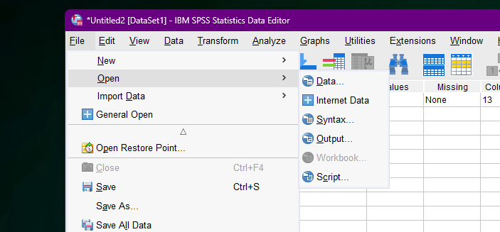

We have the ratings now loaded on SPSS.
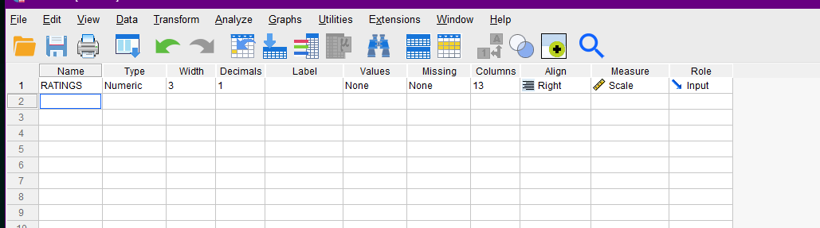
The second step is to find the right tool for your needs. For this one, we would follow the steps:
Analyse > Descriptive Statistics > Frequencies
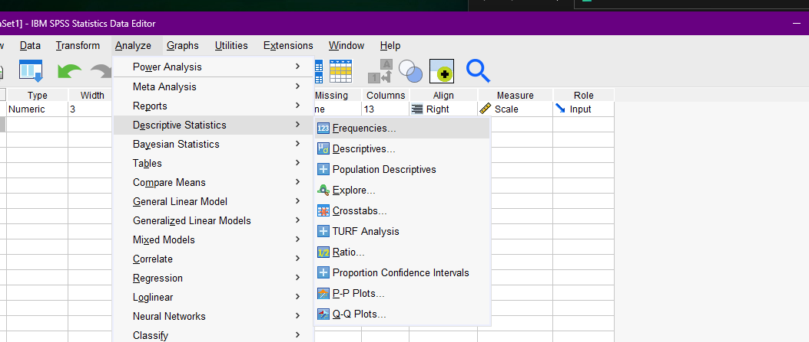
Once here, we should click Statistics at the right corner of the showing window.
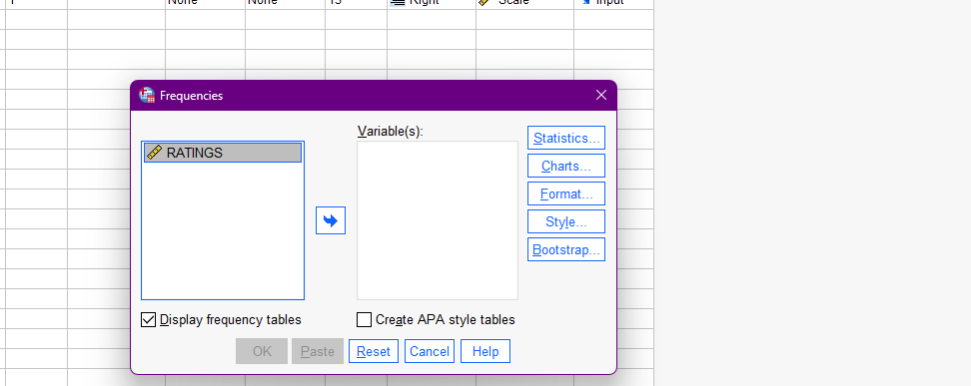
After we open the Statistics menu, we are now where we need to be, so let`s choose the statistics we will need: Mode, Median, Mean, Range and Standard Deviation for ratings.
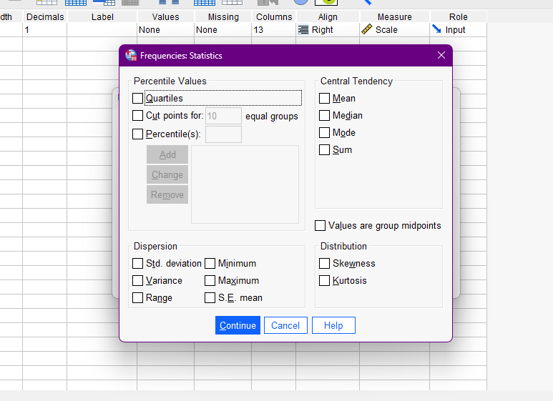
After choosing the boxes you need, the press continues.
And the SPSS Software should produce tables like the one below showing the needed information.
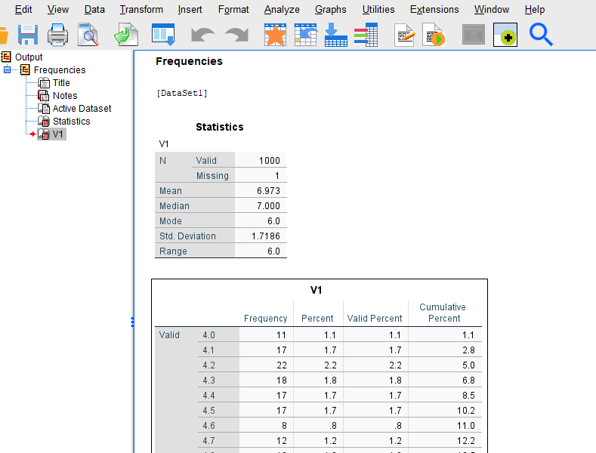

Part 2-Advantages and disadvantages of using SPSS or Excel

This section will discuss the advantages and disadvantages of using Excel and SPSS. Both software is widely popular and spread worldwide (Abott, 2016). Excel is software part of the Microsoft Office package built to support and develop better decisions within the business industry. The massive usage of Excel nowadays pushes most individuals looking for management or administrative jobs to have the skills and knowledge to apply simple tasks to Excel. SPSS, or Statistical Package for the Social Sciences, is a software with hundreds of tools to apply different filters on more significant amounts of data. However, this is more costly for the business, so we meet small organisations to use excel. Let`s look at some of the pluses and minuses of both software.
Behind all decisions driven by data, a Data cycle is applied to study and research your information patterns. The data mining cycle is where the model of the filter is matching up the needs of the business. This part of the report will have a brief overview of the process of the Data mining cycle.

Excel- Overview
Business nowadays commonly excels in business, finance, accounting, and other areas where large amounts of data are delivered and need managing and analysing. Microsoft Excel is a spreadsheet software tool part of the Microsoft Office suite of productivity tools and is widely used for analysing and manipulating data (Petlier, 2013). Excel is a tool where we can enter numbers, text, or formulas to build calculations delivering the analysis we need; once we analyse the data and have it organised, we can also use visual representations of data, such as data charts and graphs.
Excel is a cost-effective option for many businesses in their analyses. It is widespread and available to many people, so many are familiar with the program. Excel is flexible. This tool allows users to apply tasks from basic data entry to complex statistical analysis.
As an individual working as a pricing support, my role strictly involves using excel for analysing information, applying calculations, and keeping track of where the business is. Calculating the sum of labour hours and applying cost margin, gross profit margin, etc., are some of the calculations we use to clarify the best price to win in the market. Using Excel helps produce reports relevant to the business situation so that the managers can make the right decision for the company’s future. Another advantage of Excel is the visual presentation of data. Having the option to produce graphs and charts brings an opportunity to create easy and customised useful for business dashboards to report daily the data that needs to be collected. This helps companies to understand their data and to appeal to the numbers visually.
The main disadvantage of excel is that we often need more statistical capabilities.
Excel can perform basic statistical tests, but often the software is prone to errors when dealing with large datasets or complex analyses. Another one is the need for more data manipulation tools. While Excel has some basic data manipulation capabilities, it is less robust than SPSS. This can make it difficult to clean and prepare raw data for decision-makers.

SPSS-Overview
SPSS, or Statistical Package for the Social Sciences, is a popular software statistical analysts use. One of the main advantages is the ability to handle large datasets. The software can handle thousands of variables and millions of cases. It also has various tools for data manipulation, such as merging datasets, recording variables and creating new variables.
SPSS has over 100 statistical procedures, including regression and factor analysis. This software can also generate complex tables and graphs, easily customised and applied to relevant needs. The interface is user-friendly and making easy for non-experts to use.
One main disadvantage of SPS is its cost; SPSS can be expensive software, especially for small businesses or individuals who only need to conduct casual data analysis. In addition, SPS can be difficult to learn for individuals with some background in statistics. Another disadvantage here is that SPSS is limited to data visualisation capabilities. Simultaneously, we can create complicated and complex tables and graphs, and it can be challenging to customise them to meet specific needs.

Data mining cycle
Data mining is extracting knowledge or insights from large amounts of data; this practice is usually applied when using the data for statistical techniques (Kuonten, 2004). The data mining cycle is a framework that shows the steps in data mining. Typically, the data mining process includes six stages.
- Data collection involves gathering data from various sources, sorting it out, giving it a sense of information, and preparing it for analysis.
- Data pre-processing is the second step involving transforming the data to ensure that it is accurate and usable for analysis, ensuring the format is also ready for analysis.
- Exploration- this step identifies patterns and trends.
- Modelling – this step is to create a model that can be used to make predictions and identify trends in the raw data
- Model Evaluation- this step evaluates the model to determine its accuracy and effectiveness.
- Deployment- here, deploying the model in a real-world setting and monitoring its performance

An excellent practical example of the data mining cycle is using data mining techniques to identify fraudulent credit card transactions or fraudulent payments. In this example, following the six steps of collecting data on credit card transactions regarding each transaction, pre-processing the data and cleaning it out will help us remove duplicates. We are exploring the data to identify patterns and trends that might indicate fraudulent activity, such as transactions outside of cardholders spending patterns. After determining this, we can locate a model to apply for filtering fraudulent transactions based on the marks and trends identified from the data regarding the user. Later we can deploy the model in a real-world setting, such as the credit card company`s fraud detection system and monitor customers' spending. A notification or an email could be sent to the client once the model of the data cycle identifies a fraud transaction. Therefore, the company could stop it on time and avoid losing resources from claims in the business.

Conclusion
Excel and SPSS have advantages and disadvantages; we can apply the right tool by matching the organisation’s needs. Having our data filtered and organised will help the business grow and make a truth-driven decision regarding its performance. Identifying areas for improvement and weaknesses in the operation process are just two examples of what kind of information the data can hide behind the numbers. Acknowledging the data could help companies to reach their future goals.
Overall, the Data mining cycle provides a structured approach for companies. This approach can extract knowledge and insights from a large amount of data; later, decision-makers can use the information to improve business processes.

References
Abott, M. L., (2016). Using Statistics in the social and health sciences with SPSS and Excel, N/A: John Wiley and Sons 2016.
Alexander, M., (2016). What Are Pivot Table Slicers, N/A: Dummies.
Bhandari, P., (2023). Statistics. [Online]
Available at: https://www.scribbr.co.uk/stats/standard-deviation-meaning/
[Accessed 03 2023].
Hayes, A., (2023). Math and Statistics. [Online]
Available at: https://www.investopedia.com/terms/m/mode.asp
[Accessed 03 2023].
Kopf, D. (2020). DASHBOARD CONFESSIONAL. [Online]
[Accessed 03 2023].
Kuonten, D., (2004). Data Mining And Statistics: What is the Connection?, N/A: Robert S. Seiner.
Petlier, J., (2013). My First Excel Chart. [Online]
Available at: https://peltiertech.com/my-first-excel-2013-chart/
[Accessed March 2023].
Večeřa, M., (2022). What is a Pivot Table and how to create it: complete guide for 2022, N/A: Lumeer.

