DS 1 JORGE PATRICIO MENA MENA

My Screenshots/Photos
- Please add 4–6 screenshots or photos of your digital life.
- You can use your phone or laptop.
- For each screenshot, write one or two sentences explaining what it shows.

Screenshot/Photo 1

I often use Instagram to scrolling reels; I watch reels about my friends or people on the wed side. For many reasons; I spend time on this app because I like virtual visit different areas.

Screenshot/Photo 2

WHATSSAPP, Is the main app I use to keep in touch whit my family.
Because my family live on Ecuador, I usually keep in touch with my brothers and sisters, but my parents don’t use mobile phone are old school.

Screenshot/Photo 3
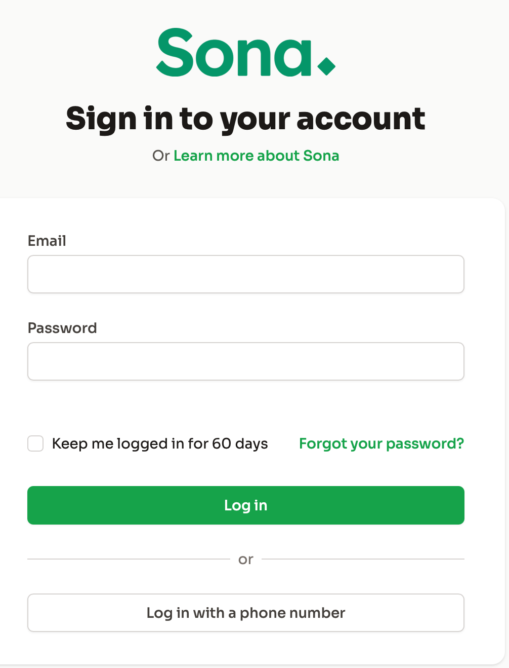
Sona is the app that typically used in a business setting. I use it to track my time at work (clock in and clock out) and to check overtime, workdays, and days off and how many hours I work on the weed.

Screenshot/Photo 4

Slack is a communication app used in the workplace. I use it every day to check update, delivery information, and instructions from my company and I check the process the batch how much or how many need for open the bar.

Screenshot/Photo 5

Amazon is large company that specialises in online shopping. I frequently use it to buy household items and personal products from home, I often look for deals.

Screenshot/Photo 6

Google Map is the main app I use to find direction and plan my journeys between home and work, It helps me choose the best route for my travel.
On the morning is to much difficult use transport especially buses

My Short Reflection
- Write 5–8 simple sentences about your digital life.
- You can use the sentence starters below if helpful.
I use digital tools to communicate with my family and to help me at work and for distraction in the time travel between home and my job.
I feel confident when I use WhatsApp because I use this app about 16 years.
I want to improve my digital skills and learn how to use new applications.
I often use WhatsApp, Slack, Sona, Google Map and Amazon
Sometimes I feel nervous when I must learn something new on a computer.
I hope this module will help me upgrade about my skills is so difficult came again return study
Digitals skills are important for me because around the my live need use app for job , home or just for distraction the focus.

Sentence starters
- I use digital tools to …
- I feel confident when I …
- I want to improve …
- I often use these tools: …
- I sometimes feel nervous about …
- I hope this module will help me …
- Digital skills are important for me because …
You can write more if you want.

Submission Checklist
Before you submit, please check:
​​​ ☒ I added 4–6 screenshots
☒ I wrote short sentences for each screenshot
☒ I wrote my short reflection
☒ My work is my own
☒ My file opens correctly
​​☒ My file opens correctly

