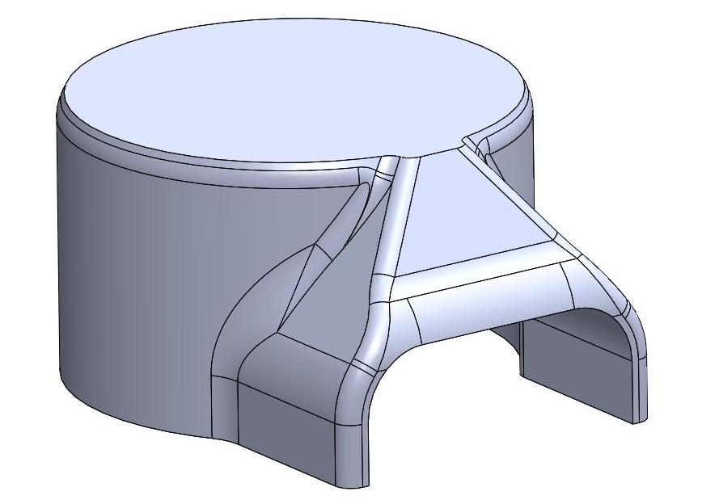
Manufacturing Process and Material Selection
Materials and Introduction to Manufacturing, M4X01163
Richard Leadbeater, 1902951

UWTSD - SA1
HNC Advanced Manufacturing Operations
Table of Contents
Introduction 2
Identification 2
Tradition Manufacturing 3
3-D Printing 4
Advantages and comparison of manufacturing techniques 4-5
Conclusion 5-6
Bibliography 7

Introduction:
This technical investigation is based upon a component that is part of Port Talbots Hot Strip Mill water supply. There are a number of different water systems in use within the Hot Mill, each having a different quality (cleanliness) and pressures. To manufacture a steel coil product that is ‘right first time’ also providing the best mechanical care for the kit in the Hot Strip Mill, then the importance of manufacturing in ideal conditions is critical, which these systems support. This report would depict the issues that the Hot Strip Mill experiences with the systems instruments and the concept of a component that controls these issues. The component would be investigated in its design and manufacturing properties and the optimisation of its production.

Identification:
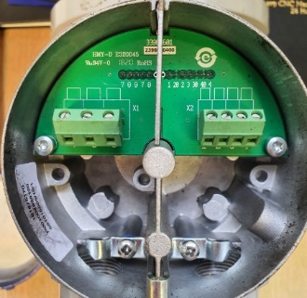
The critical rolling conditions are key in the production principles of the Hot Mill, Roll coolant reduces the variation of the roll profile due to non-uniform thermal expansion meaning that without roll coolant the strip would ‘spoil’/crack the work roll due to the constant rolling pressures and increasing temperatures. There are three main types of water supply to the Mill are called ‘service’ water, ‘descaling’ water and ‘roll coolant’ water. Roll coolant water is of the highest quality, followed by descaling water, then service water being the lowest quality water. Water pressures for the three systems are typically 3.5bar for service water, 8-10bar for roll coolant water and 150-180bar for the descaling water. The importance of monitoring the systems that feed the process is essential to result in a quality product and a reliable mill. The instrument that is required for the examining of the water pressure and availably to the mill is a ‘flow meter’, the system engineers have often noticed a discrepancy of pressures or even a flat line in measurements which indicates of a malfunctioning flow meters and expectations are correct as flow meters have been found flooded with water due to the conditions in the basements of the mill where water leaks are common due to an aging mill. Figure 1.1 shows the diagnostics of the roll coolant feed to finishing mill stand ‘F9’, where it is showing an erratic readings giving a good example of an malfunctioning flow meter. This report will document the design and development of a solution to the malfunctioning flow meters by the use of a cover. The design would be a simple concept that sits on top of the flow meter cap with an aperture that allows the cables to access the electrical components in the flow meter seen in Figure 1.0. Figure 1.1 was captured from Tata steel Hot Rolled Products Mimic page where engineers have operating data of the strip mills performance.
Figure 1.0


Traditional manufacturing:
Figure 1.1

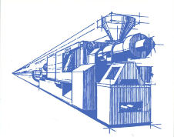
As this product is an ‘inhouse’ project development which did not initially undergo a traditional manufacturing processes, but for the investigation of this report it will be analysed. Original methods of manufacturing of this component would be injection moulding. Injection moulding is the most common method for mass manufacturing plastic products examples include toys, subassembly parts for electrical products, automotive parts and cell phones/accessory’s. The first procedure in manufacturing a new product for injection moulding would be to machine a mould which can be expensive, as one article quotes on “Moldchina”, “the material of a mold also greatly affects the cost, since the price of a mold can vary from USD 2,000 to 10,000.”. The injection moulding machine operates by funnelling the raw plastic material ‘resin’ through a hopper that feeds the material into a the injection barrel which drives the resin through a reciprocating screw which has a heating element that surrounds it. The resin melts as the reciprocating screw drags it towards the nozzles end this is referred to as drag flow, drag flow causes the polymer molecules to slide over each other creating frictional heat which also helps heat the material, temperatures are controlled by thermocouples and the machines set up. The molten plastic flows past the front of the screw through indentations and check rings prevent it from a reverse flow motion this forces the plastic into the mould pushing air out of vents. Coolant flows through channels inside the mould, just beneath the surface of the cavity, this speeds up the cooling process the material needs to take before being ejected by ejector pins. This results in witness marks on the surface on the final product so it is important in the features of the design to include these ejector pins where it not visible to the consumer. The remaining material that is left on the final product is named a ‘sprue’ which connected the injection moulding unit to the mould and would need further processing. Material’s that can be processed by this manufacturing technique are polymers in their thousands as Dominick V.Rosato explains in ‘Injection molding handbook’, “There are basically two types of plastic materials molded. Thermoplastics(TPs), which are predominantly used can go through repeated cycles of heating/melting and cooling/solidification” the handbook then goes on to explain “Thermosets(TSs), upon their final heating become permanently insoluble and infusible. During heating they undergo a chemical (cross-linking)change”. Materials that are most common in these types are Acrylonitrile Butadiene Styrene, Polyethylene, Polycarbonate and Polyamide(Nylon) which are all thermoplastic materials. Figure 1.2 shows a drawing of an injection moulding machine.
Figure 1.2

3-D printing
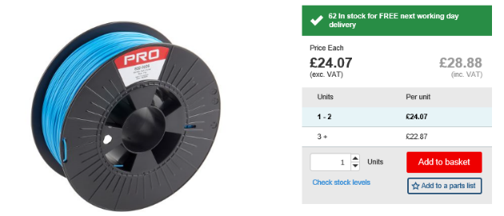
3-D printing technology is already changing the way manufacturers produce components, 3-D printing is part of a process called ‘Additive manufacturing’ where a component is built as a layer-by-layer deposition. The process that this product was manufactured by was Fused Deposition Modelling (FDM) and quoted by P. Dudek “In recent years, FDM technology (Fused Deposition Modelling) has become one of the most widely-used rapid prototyping methods for various applications.” FDM is one of the cheapest printing methods with the machine that tata steel provided to print this component was £1900 named ‘CraftbotXL’. The Material that this machine uses is Poly lactide Acid (PLA) which is a biodegradable plastic and can be printed at low temperatures, PLA is robust and less brittle due to a low shrinkage factor the suppliers that tata steel purchases material from is found in Figure 1.3. There are other thermoplastics used in this process such as ‘acrylonitrile butadiene styrene’, ‘polymide’, ‘polylactide’ and ‘polycarbonate’ . The advantage of bonding two material is adopted in this process as ‘Fuda Ning’ , ‘Weilong Cong’ describe in an article “there is a critical need to improve the strength of FDM-fabricated pure thermoplastic parts to overcome the limitations. One of the possible methods is adding reinforced materials (such as carbon fibers) into plastic materials to form thermoplastic matrix carbon fiber reinforced plastic (CFRP) composites. In CFRP composites, the carbon fibers can be used to support the load. Meanwhile, the thermoplastic matrix can be used to bind and protect the fibers and transfer the load to the reinforcing fibers. Currently, thermoplastic matrix CFRP composites are widely used in many applications, such as fuselage of Airbus A350 aircraft, components in automotive, blades of wind turbine, and endoscopic surgery”. The process in which the ‘CraftbotXL’ operates is from an initial design that was sketched up for the purpose of this report and designed on the modelling software ‘solid works’ which allows users to sketch a design in the 3 dimensional plain. This was the blue print of the component and was converted to the machine by a STL file, that was created to be compatible with the 3D-printer. The CraftbotXL would datum set itself for the file and before starting the program the machine heats up the temperature control units in the nozzle and the heated bed, on which the product is printed. The Material also known as filament feeds into the extrusion head which is attached to a 3-axis system making the nozzle accessibly to the X,Y and Z coordinates. The melted material is deposited layer at a time with a opposite printing direction to form a strong bond and structure, solidification starts after leaving the extrusion nozzle. Once the machine had finished its program the product did not need any further processes which is one of the first advantage of using additive manufacturing techniques.

Advantages and comparison of manufacturing techniques.
Figure 1.3
The use of FDM for this project was beneficial for the purpose of the product, the Hot strip mill was only in need for an order of 90 ‘flow meter covers’ which was not be cost effective, if the process of injection moulding was chosen then costs would of made this production unsustainable. Injection moulding would of involved more processes to develop this part these would of included the design & milling of moulds, setting mould and calibrations of injection moulding machine, operating machine and filing sprue off final product. The chosen process was justified by the sense of cost for the company as the purchase prices of a new flow meter range from £1500-2200 shown in figure1.4. The manufacturing cost of FDM process was only the material which was multiped by hours in which it took to print the part, the printing was 13hours and a system to calculate the price was used, totalling to £4.80. The malfunctioning flow meters total of an average of 2 a year meaning a minimum loss in flow meters is £3000, the payback time for the flow meter covers would be less than 2 months in operation. The cost to manufacture this component in injection moulding processes would be in the thousands due to mould and machine costs, the pay back calculation would mean it would have to be a mass produced part to reap the benefits of that technique . Fused Deposition Modelling methods allows modification of products and a wide variety of thermoplastic materials, this technology can also be used in the medical fields to develop customized prosthetics. Modification to this product was an advantage that was widely taken advantage of as there are three types of flow meters on the hot strip mill these are shown in figures 1.5,1.6,1.7. The operating of the 3-D printing when producing this part was successful the design features an aperture that would of failed in the printing stage if it didn’t have material to build on, so the design featured a inclining sledge to support the material so it can protect as much of the equipment as possible. Modification to moulds are not possible in the injection moulding method and a complete re design and manufacture of a mould would have to be produced to update a product to new standards, so if the customer needs development the current product then the prototype may not sell incurring a loss of business.

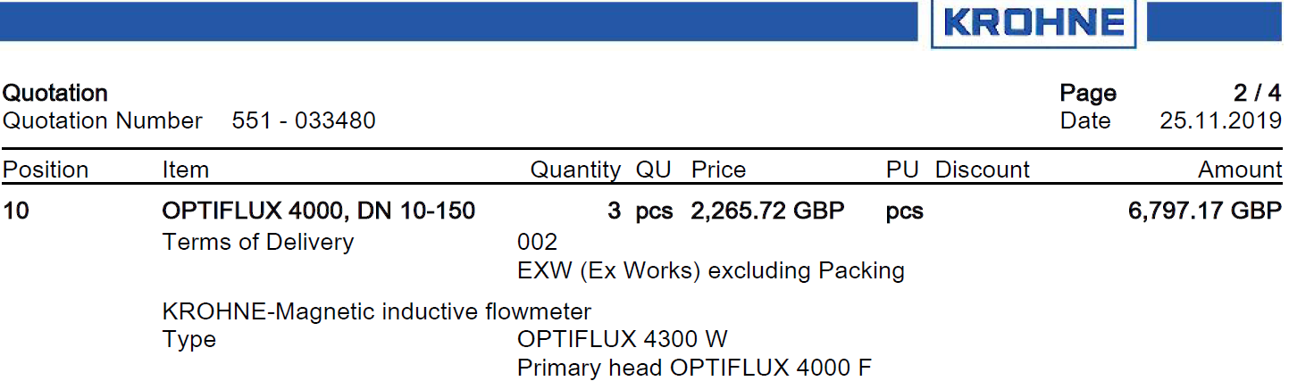
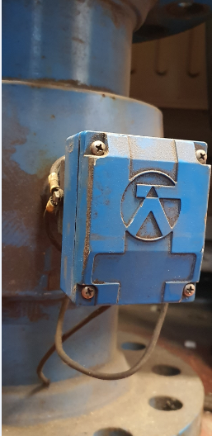

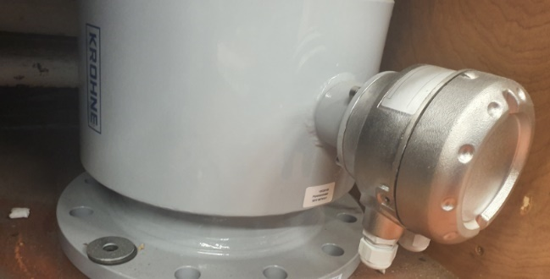
Figure 1.4


Figure 1.5

Figure 1.6

Conclusion:
Figure 1.7

The final Product of this report was a success for the need of a solution to the issues experienced in the Hot Mill, the conditions that these expensive instruments were located in caused a loss in production time and ‘cash’. The ‘Flow Meter Cover’ was a simple but effective answer to the problem and production to meet the order is underway, the production of this component was not only satisfying to watch but a quality part was developed. The investigation and development of this product has gained the designers knowledge of the upcoming manufacturing techniques and benefits further ideas for the use of 3-d printing. The disadvantages of using Fused Deposition Modelling was the time frame in which the order will be completed in, the three prototypes range from 8 to 13 hours to produce meaning it might be a 3 month time lead to manufacture 90 parts. Traditional manufacturing techniques may need the correct environments and set ups with costly outcomes but the production quantities are larger and processed in under minutes. Figure 1.8 &1.9 show the final product on the CraftbotXL printing machine used for this report, the inside cavity is shaped to fit correctly onto the flowmeter. Figure 2.0 shows the protype in the working environment of the Hot Mill, where the main pipework has developed corrosion over time. Although this is a small change to the system the outcome is a benefial.

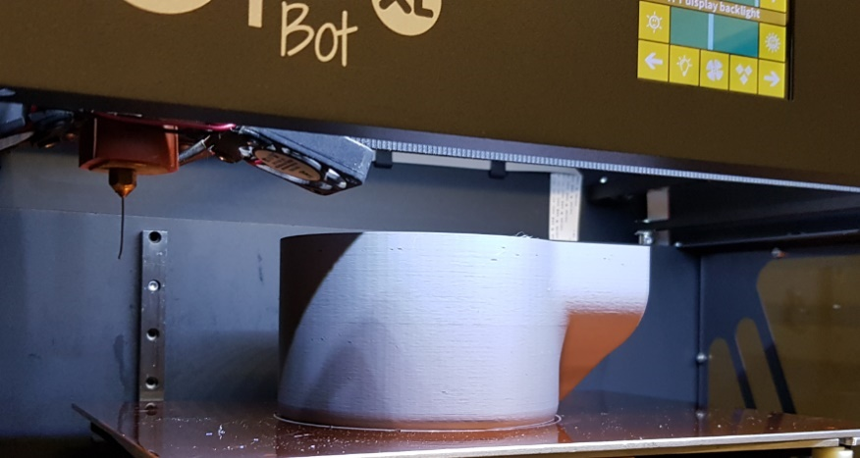
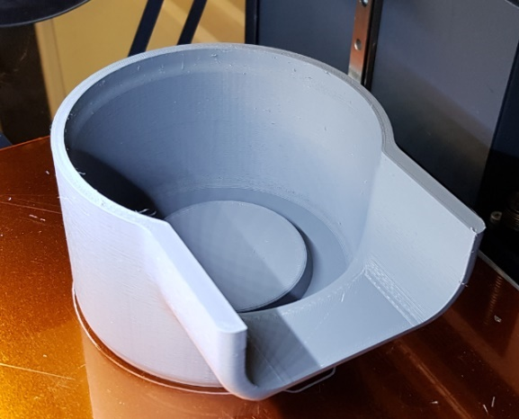

Figure 1.8

Figure 1.9

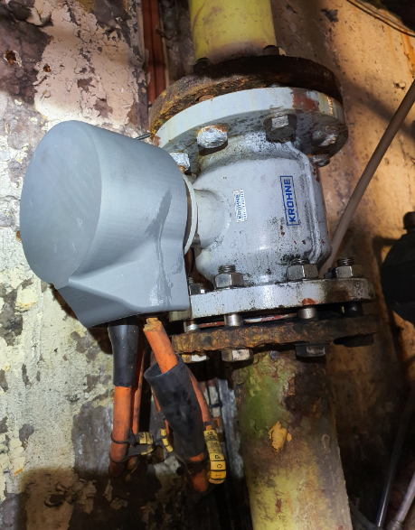

Figure 1.9

Bibliography
Figure 1.0: own photograph of electrical components in flow meter
Figure1.1 : Tata steel Hot Rolled Products Mimic http://1.66.83.27/mr_tl/daily_checks/sixty_day_trend.php?check_nr=117
Article 1 : moldchina https://www.moldchina.com/injection-molding-cost/
Injection Molding Handbook by Dominick V.Rosato, Donald V.Rosato and Marlene G.Rosato https://books.google.co.uk/books?hl=en&lr=&id=4VHxBwAAQBAJ&oi=fnd&pg=PR29&dq=materials+used+in+injection+molding+&ots=5IzS7ivx1H&sig=Wrqsot6nSHEB9gCNRhVN5Zlp3OQ&redir_esc=y#v=onepage&q&f=false
Figure 1.2: Injection Molding Handbook by Dominick V.Rosato, Donald V.Rosato and Marlene G.Rosato ‘Title Page’ https://books.google.co.uk/books?hl=en&lr=&id=4VHxBwAAQBAJ&oi=fnd&pg=PR29&dq=materials+used+in+injection+molding+&ots=5IzS7ivx1H&sig=Wrqsot6nSHEB9gCNRhVN5Zlp3OQ&redir_esc=y#v=onepage&q&f=false
P. Dudek in Archives of Metallurgy and Materials, Published 31.12.2013 http://journals.pan.pl/dlibra/publication/102133/edition/88150/content
Additive manufacturing of carbon fiber reinforced thermoplastic composites using fused deposition modeling by Fuda Ning Weilong Cong Jingjing Qiu Junhua Wei Shiren Wang, published October 2015. https://www.sciencedirect.com/science/article/pii/S1359836815003777#bib27
Figure 1.3: https://uk.rs-online.com/web/p/3d-printing-materials/8320226/
Figure 1.4 : quotation attachment for in house Purchase A.Davies@KROHNE.com
Figure 1.5, 1.6, 1.7, 1.8, 1.9 &2.0 : own photograph of three different types of flow meters and final product.

