HND Construction Management Level 5
Digital Surveying

Assignment 1
Part 1
Surveying can be classified based on different factors. Outline these factors and discuss in detail different types of surveying under one of the factors.
Part 2
Briefly describe the application of digital surveying technologies in surveying listed building giving examples of appropriate tools to be used and the information to be collected from the survey.
The essay must also incorporate the use of diagrams and figures to illustrate the text.
A list of references is required and all referencing is to be clearly indicated throughout the essay

Introduction
Early centuries surveying has evolved from basic principles of measuring height, distance and angles of the earth’s surface e.g. using body parts elbow to fingers, feet, mathematics etc. developing into the use of traditional methods such as pacing, survey tapes and modern digital technology such as GPS, laser and photographic imagery.
Classification of Surveying
- Primary
Surveying can be classified into primarily two categories of surveying:
- Plane - surveying areas of the earth that are flat planes. This survey is carried out for small project areas less than 250km2 and the curvature of earth is not included in distances. The line which connects these points are straight lines and the triangles made by joining these lines are Plane triangles. It is the most common and straightforward survey method used, and

- Geodetic surveying - the earth’s surface is considered as a curve therefore the line which connects these points are curves and the triangles made joining these lines are spherical triangles. Geodetic surveys are suitable for large areas more than 250km2. This type of surveys provide a good degree of accuracy.

- Purpose
These are classification of surveying based on purpose:
- Cadastral survey – this is a type of public land survey which assists in defining boundaries and land area calculations for towns, municipalities etc. Useful when transferring ownership of land from one person to another.
- City Survey - provides information for planning expansions or developments, locating physical features and configuration of land, the construction of water supplies, sewage lines etc.
- Construction survey – used by architects, engineers, builders to provide grades, reference lines, dimensions, location, elevation of structures. Also helps to analyse the field data for engineering works such as the construction of roads, railways, sewage pipelines etc.
- Forestry survey – to assist with forestry management/production and conservation of forest land.
- Hydrographic survey - involves surveying of water bodies such as lakes, streams, reservoirs, harbours, oceans etc to help with flood control, water supply, hydro-electric power etc. It also helps in determining the sea level calculation, water depth calculation, dredging analysis, etc.
- Industrial survey – provide information for installation of heavy equipment and accurate dimensional layouts for ship building, construction of aircraft etc.
- Mine survey – determines location points of underground activities due to mining or potential mining projects.
- Photogrammetric survey – cameras are positioned on aircraft to assess ground activities.
- Route survey – earthwork quantities, construction of highways, railways, pipelines, canals and other linear projects.
- Topographic survey – to assess shape of the ground, elevation of hills, rivers, mountains for potential roadways, town construction and bridges, relief of ground surface water. It consists of horizontal, vertical, and angular measurements.

- Method
Classification of surveying based on method :
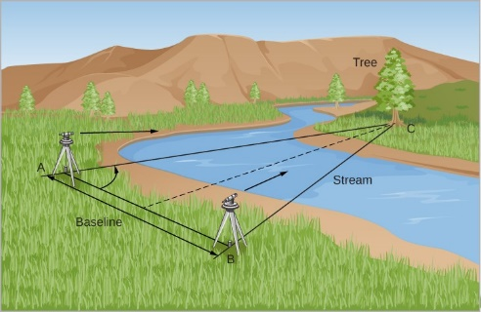
Triangular
This surveying method measures the angles in a triangle formed by three survey control points. Using trigonometry and the measured length of just one side, the other distances in the triangle are calculated (using the Sine Rule). This is used for hills and undulating areas.
Prodyogi (2020) What is Triangulation in Surveying? Available at:https://www.prodyogi.com/2021/01/what-is-triangulation-in-surveying.html (Accessed on: 3rd December 2021)
Trilateration
Is an electronic process of measuring distances and calculating angles using the Cose Rule.
Prodyogi (2021) Trilateration Surveying - Working, Applications & Advantages Available at: https://www.prodyogi.com/2021/08/trilateration-surveying.html (Accessed on 3rd December 2021)
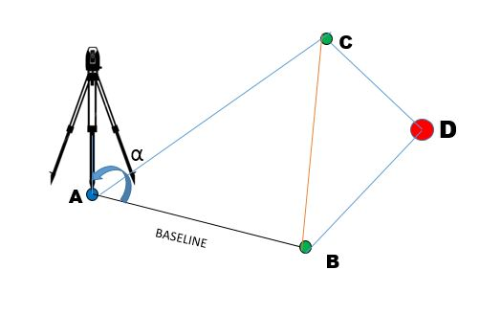

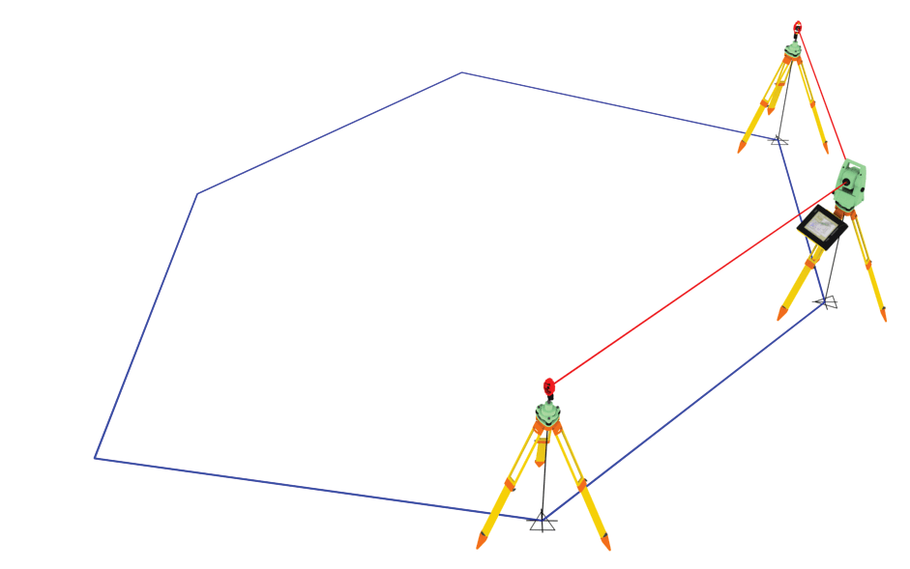
Traversing
This type of surveying connects the survey lines to form a framework. The length can be measured either using tapes or electronic devices for distances measurement. This method gives an opportunity to double check accuracy of calculations.
Dream Civil (2021) Traversing in Surveying | 3 Types of Traversing | Objectives of Traversing Available at: https://dreamcivil.com/traversing-in-surveying/ (Accessed on: December 3rd 2021)

- Equipment
I have decided to elaborate on the classification based on instruments for surveying:
These are the Traditional and direct methods of linear measurement:
Walking/Pacing - A pace is defined as one step and a natural pace of a person is between 700-950mm therefore is it important to use the Pacing Factor which is the measured distance divided into the number of paces. For example, if I measured with a tape a distance of 90m and walked a 100 paces the PF will be 90m / 100 = 0.90m. Pace will vary on different terrains, so it is advisable to chose a plain, dry and level ground to undertake the pacing survey.
Tapes –there are two types - steel tapes (3mm – 30m distance) accuracy is 1 in 10,000 and fibreglass tapes accuracy is lower 1 in 1000 (30mm – 30m lengths. The disadvantages of using tapes are they do not stand length, sag, become twisted. Although tapes can be very useful on site if digital equipment is not available or is broken.


Amazon (2021) Draper 51089 Fibreglass Surveyors Tape, 50m/165' Available at: https://www.amazon.co.uk/Draper-Tools-51089-Fibreglass-Surveyors/dp/B00UNJTJW8/ref=asc_df_B00UNJTJW8/?tag=googshopuk-21&linkCode=df0&hvadid=226606326869&hvpos=&hvnetw=g&hvrand=6459208859545894955&hvpone=&hvptwo=&hvqmt=&hvdev=c&hvdvcmdl=&hvlocint=&hvlocphy=9045402&hvtargid=pla-426064101572&psc=1&th=1&psc=1 (Accessed on 5th December 2021)

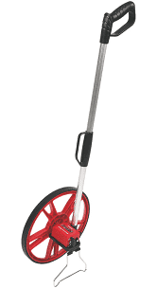
Wheels and rods can be used to supplement other equipment e.g. odometer wheel counts revolutions of distance.

RS Online (2021) RS PRO Metric Measuring Wheel 10000m Available at: https://uk.rs-online.com/web/p/measuring-wheels/1755055?cm_mmc=UK-PLA-DS3A-_-google-_-CSS_UK_EN_Hand_Tools_Whoop-_-Measuring+Wheels_Whoop+(2)-_-1755055&matchtype=&pla-328208572530&gclid=CjwKCAiA5t-OBhByEiwAhR-hmz1KFNsGgfnMAfcNn1ee5EggStkHwXVloNYtyHcXnls9edu-mCP4JhoCO6kQAvD_BwE&gclsrc=aw.ds (Accessed on 5th December 2021)
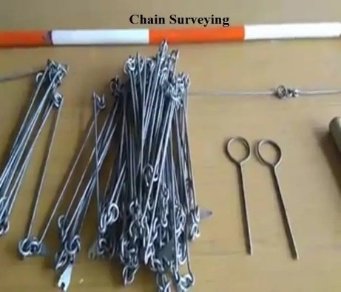
Chain surveying uses chains, arrows, pegs and ranging rods and is a simpler way of undertaking a survey and is suitable for smaller areas. The areas are split into triangles and the sides of the triangles are measured this is called triangulation.

Civil Knowledge (2021) Chain Surveying: Principle, Procedure, offset, Instrument, errors Available at: https://www.civilknowledges.com/chain-surveying/ (Accessed on 5th December 2021)
Tacheometric surveying is angular surveying in which horizontal and vertical distance are calculated from the angular measurements. This method uses transit theodolite with a stadia diaphragm for taking measurements and is preferable when a direct method of surveying is not possible.
Levelling instruments are used for construction building levels, route construction, the relative height of different points above or below the surface. It consists a tripod, changing plate, level and levelling staff (3 persons).
Theodolite surveying involves a tripod, plumb bob, ranging road tape and theodolite. These are used to measure horizontal and vertical angles and can be used underground for mining operations or activities. It is one of the precise methods of surveying and helps to find the level difference, setting out, prolonging survey lines of the area.
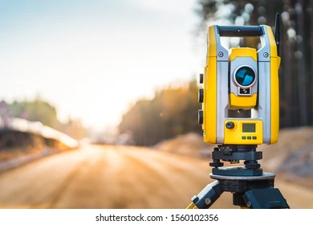

Shutterstock (2021) Theodolite Images Available at:https://www.google.com/search?q=theodolite+survey+image&rlz=1C1FGUR_enGB844GB844&oq=theo&aqs=chrome.0.69i59j69i57j46i131i433i512j0i433i512j46i199i291i433i512j0i512j46i199i465i512j0i512j46i131i433i512j46i433i512.15544j0j4&sourceid=chrome&ie=UTF-8 (Accessed on 5th December 2021)
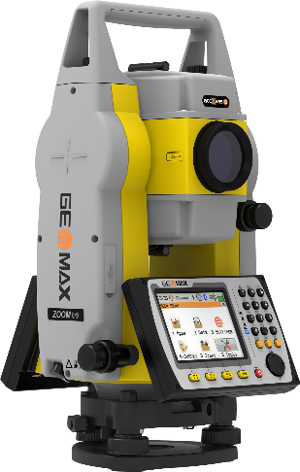
Total Stations consist of tripod, detail pole and prism and measures distance and angles. There are infrared and red laser modes that allows to measure where access is restricted e.g. railways, motorway white lines, elevations. The data collected can be downloaded and transferred onto appropriate software.

A1 Survey (2021) Geomax Zoom 50 - Intelligent Conventional Total Station Available at: https://www.a1surveyequipment.net/Geomax-Zoom-50---Intelligent-Conventional-Total-Station (Accessed 5 December 2021)
Laser scanners consist of tripod, detail pole, prism, reflected target and scanner. This method is used for historical buildings and areas with limited access e.g. pipework installations. The data collected in downloaded and transferred onto appropriate software.
Photogrammetric survey
This is a photographic system with GPS strapped to aircraft to take photographs for making measurements. It is possible to prepare maps and 3D diagrams from these photographs. These are used to make virtual models of historical structures. Photogrammetric surveys cover a large area for surveying and they are less time-consuming. However with new drone technology photogrammetry is becoming more favourable these days as it is a more affordable option.
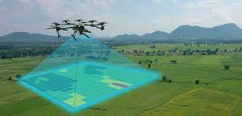
Pilot Institute (2020) The 5 Best Drones for Mapping and Surveying Available at: https://pilotinstitute.com/drone-mapping/ (Accessed on 5th December 2021)

GNNS System (GPS)
Consists of GPS station and rover, data logger/pad, tripod and pole. It is used to measure distance to satellites to triangulate and work out your position and therefore creates accurate data but needs to be left in position for at least 4 hours.
The following video shows APGLOS GPS system which has been developed to do land surveying. It consists carbon rods, tablet holder, GPS receiver. Once the device is switched on you have to name the first point before starting the survey.
Apglos (2020) GPS equipment for land surveying: all you need to know to do your first land survey (Video) Available at: https://www.youtube.com/watch?v=3cvEUfNCnzM (Accessed on: 5th December)
Thermal camera
Used to identify thermal bridging, heat loss, detection of poor detailing, damage or construction errors in a building. The thermal outputs are then measured and is very useful information to provide in report for final decision making on surveying a building.
Moisture meter/Protimeter
This detects areas of damp water ingress, moisture, damp and humidity levels in a building and provides useful information to decision making in the final assessment report.

Part 2
Introduction
A listed building is a historical structure which is of national importance and needs to be surveyed to identify its condition and needs additional maintenance, renovation and restoration. A detailed building plan/elevation, present conditions, and retro fit/renovation plan is needed to fulfil the local authority building legislation. There is a listed grade II building in Kidwelly, which is included on the British Listed Buildings website.
British Listed Buildings (2020) Kidwelly Town Hall Available at: https://britishlistedbuildings.co.uk/300011880-kidwelly-town-hall-kidwelly/photos/245536#.Ydh439DP3IU (Accessed on: 10th December 2021)
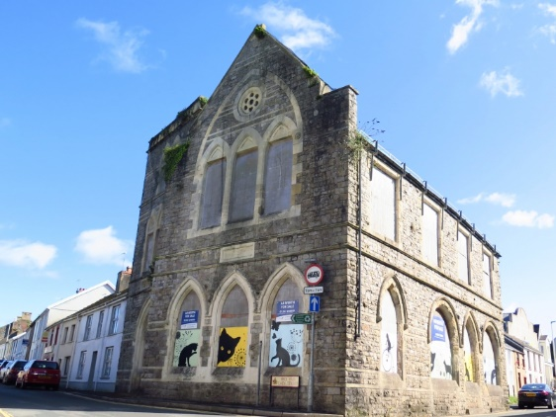
It was built 130 years ago and according to Wales Online "It's one of the oldest historical buildings in Wales. It is a bone of contention that it has been allowed to get so bad in a relatively short period of time."
Research, Preparation and Planning
It is important to do research and obtain historical data about the building (as built drawings and building construction files). Preparation and planning is crucial and getting permission to enter the building to undertake a survey to ascertain vacancy. Adhering to Construction (Design & Management) Regulations 2015 and to health and safety rules and regulations under the Health and Safety Act is important and to have appropriate safety tools and apparel before entering the building.
Health and Safety Executive (2020) Health and safety in the construction industry Available at:www.hse.gov.uk/construction/index.htm (Accessed on: 7th December 2021)
Once you have all historical information, plans and drawings and appropriate safety gear you will need to establish which digital surveying equipment is necessary to undertake a full survey to give the data and results you need to make an informed decision.

Initial Assessment
An initial assessment on the external, internal, grounds and surfaces of the listed building in required.
I would take digital photographs of the stone walls, rendering, windows, doors, and any signs of cracking, rotten wood, etc. I would use a tachometer camera to check the condition of the walls, the cavity structure, whether the damp proofing is good, to ascertain what materials were used for DPC. I would count the number of doors, windows and identify type of materials and their condition( if wood and whether they are rotten). To identify if there are signs of any cracking within the walls and window and door frame, the stairs and to assess whether they are extremely bad, sufficient or good. Protimeter digital hand held device would be used to check walls for dampness, moisture and humidity levels to ascertain whether they need to be repaired or renovated.
I would use the hand held Disto/laser beam measuring device to calculate the room areas, volumes and angled slopes on the first floor as it is an ideal devise as opposed to using tapes if there are any obstructions in the rooms.
If the stairs are unsafe then I would use a telescopic camera to take pictures of its condition and first floor. Same devise to take pictures of the roof and gutters outside and would identify the type of roof, whether it is asbestos, gutters and drainpipes, as well as signs of movements around the chimney, DPC and flashings, and their condition and need for replacing or repair.
Thermal and moisture cameras would be used to pick up any loss of heat, damp and humidity within the building as well as the floors. The material for the floors will have to identified e.g. wood, concrete and whether the floors are suspended or hung floors. The camera would pick whether there is any dampness on any wooden floors or DPC materials, any heat loss and whether materials have disintegrated or rotted and in need of replacing or repair.
A fibre optic scope would be used by a specialist to check drainage and sanitation. This survey would identify the size, shape and condition of the drainage system and any water or sewage blockages, need for replacement pipes, or fix the blockages.
Using the digital lasers I would measure outside areas e.g. roof, walls and gothic style windows and measure the land at the back of the listed building with an APGLOS GPS system to give an accurate measurement of boundaries and fences with adjoining properties. With all the measurements and data collected completed it can be downloaded onto appropriate software.
Rating element of building
During the initial assessment I will assess the condition of roof, wall, floor, ceiling, stairs, pipes etc. and will be rated 1-5, with 5 being GOOD – No repair. 4 being FAIR – Structurally sound, in need of minor repairs, showing lack of general maintenance. POOR being 3 – Repair OR further investigation urgently required for public safety. VERY BAD being 2 – defects that are serious and need to be properly looked/repaired, replaced or investigated urgently. Not Inspected being 1 – Further investigation required.
To assess the overall condition of the building I would consider all the evidence I have collected and will assess the whole condition of the building, using the same marking principle above.
Producing Technical Report
On planning the technical report I will ensure that all survey data has been recorded/collected accurately and clearly and followed guidance from Royal Institute of Chartered Survey (RICS). I will use the RICS recommended template to produce a clear and accurate detailed technical survey report ensuring that the summary and body of the report includes the constructional principles and risks, exterior, interior, services and grounds and the appropriate rating for each element as well as an overall rating. Ensure also that appendices include all drawings, on site sketches/dimensions of special features.

Reference List
Amazon (2021) Draper 51089 Fibreglass Surveyors Tape, 50m/165' Available at: https://www.amazon.co.uk/Draper-Tools-51089-Fibreglass-Surveyors/dp/B00UNJTJW8/ref=asc_df_B00UNJTJW8/?tag=googshopuk-21&linkCode=df0&hvadid=226606326869&hvpos=&hvnetw=g&hvrand=6459208859545894955&hvpone=&hvptwo=&hvqmt=&hvdev=c&hvdvcmdl=&hvlocint=&hvlocphy=9045402&hvtargid=pla-426064101572&psc=1&th=1&psc=1 (Accessed on 5th December 2021)
RS Online (2021) RS PRO Metric Measuring Wheel 10000m Available at: https://uk.rs-online.com/web/p/measuring-wheels/1755055?cm_mmc=UK-PLA-DS3A-_-google-_-CSS_UK_EN_Hand_Tools_Whoop-_-Measuring+Wheels_Whoop+(2)-_-1755055&matchtype=&pla-328208572530&gclid=CjwKCAiA5t-OBhByEiwAhR-hmz1KFNsGgfnMAfcNn1ee5EggStkHwXVloNYtyHcXnls9edu-mCP4JhoCO6kQAvD_BwE&gclsrc=aw.ds (Accessed on 5th December 2021)
Civil Knowledge (2021) Chain Surveying: Principle, Procedure, offset, Instrument, errors Available at: https://www.civilknowledges.com/chain-surveying/ (Accessed on 5th December 2021)
Shutterstock (2021) Theodolite Images Available at:https://www.google.com/search?q=theodolite+survey+image&rlz=1C1FGUR_enGB844GB844&oq=theo&aqs=chrome.0.69i59j69i57j46i131i433i512j0i433i512j46i199i291i433i512j0i512j46i199i465i512j0i512j46i131i433i512j46i433i512.15544j0j4&sourceid=chrome&ie=UTF-8 (Accessed on 5th December 2021)
A1 Survey (2021) Geomax Zoom 50 - Intelligent Conventional Total Station Available at: https://www.a1surveyequipment.net/Geomax-Zoom-50---Intelligent-Conventional-Total-Station (Accessed 5 December 2021)
Pilot Institute (2020) The 5 Best Drones for Mapping and Surveying Available at: https://pilotinstitute.com/drone-mapping/ (Accessed on 5th December 2021)
Apglos (2020) GPS equipment for land surveying: all you need to know to do your first land survey (Video) Available at: https://www.youtube.com/watch?v=3cvEUfNCnzM (Accessed on: 5th December)
Health and Safety Executive (2020) Health and safety in the construction industry Available at:www.hse.gov.uk/construction/index.htm (Accessed on: 7th December 2021)
British Listed Buildings (2020) Kidwelly Town Hall Available at: https://britishlistedbuildings.co.uk/300011880-kidwelly-town-hall-kidwelly/photos/245536#.Ydh439DP3IU (Accessed on: 10th December 2021)

Bannister, A. (1998) Surveying 7th Edn. Harlow:

